Exhibitor:
Contact Person: |  |  |  |  |  | Phone #:
Address:
City: |  |  |  |  | State: |  | Zip Code:
e-Mail Address:

Rental fee: Outside Space |  | ….....................................(per linear foot).. |  | $10.00
Number of linear feet needed  Total linear feet reserved for you |  | …......................................................
Electricity Needed: $50.00 flat fee |  |  | ………………………………………… | $
Total Due | ….......................................…....................................... |  |  | $
Make Checks Payable to: Clearwater County Agricultural Society
SEND TO: Clearwater County Agricultural Society, c/o Vendor Superintendent, PO Box 909, Bagley, MN 56621
e-Mail Address: clearwatercountyfair6@gmail.com

Space Reservation is on a 1st come, 1st serve basis.

Exhibitor Rules
The following rules govern the use of rented exhibit space:
- No exhibitor will be permitted to distribute or display any advertising materials anywhere on the grounds outside their properly rented space.
- Exhibitors, please check in at the fair office before setting up.
- The fair board reserves the right to amend these rules if in its judgment is it deemed advisable.
- Renters are responsible for booth area supplies. If electricity is needed, indicate above by adding $50 to your rental request.
- The association will take every precaution in its power for the protection of exhibits but cannot be responsible for any loss or damage that may occur in the delivery, exhibition, or removal of exhibits.
- Set up day is Tues, July 31, 2025 or the morning of Wed, August 1, 2025. Tear down is 8:00pm Sun, August 3, 2025. NO SOONER. If you leave earlier then 8pm, you may not be allowed to return the following year.
- The sale of any type of weapon is strictly forbidden.
- Items needed to reserve a booth:
  - Signed Contract (this form)
  - Completed ST-19 Operator Certificate of Compliance
  - Copy of Food License if applicable
  - Certificate of Insurance
  - Payment for site
- No booth refunds due to cancellations after July 21, 2025
Signature: |  | Date:

In order to plan arrivals and proper placement, please answer the following questions:
- What type of booth do you have?
  - Tent with Table ⃞
  - Trailer pulled by a vehicle ⃞
  - Single unit ⃞
- Looking at your trailer, hitch & serving window. Which photo applies to you?
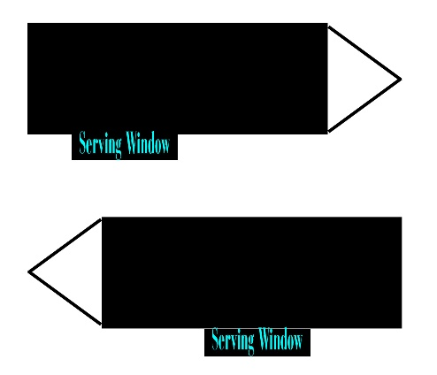
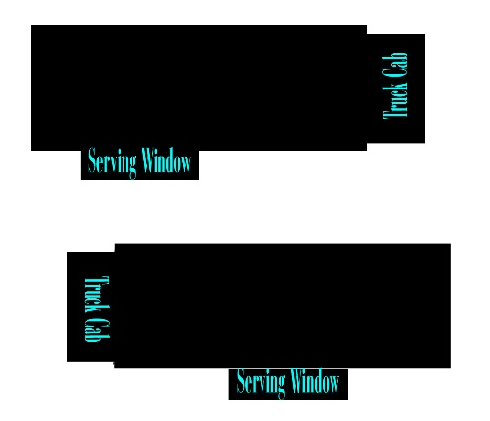
- Additional supply trailer

