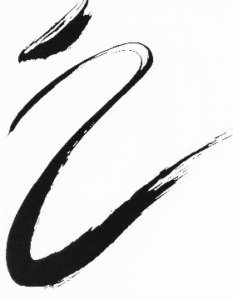
Class Schedule
Fall 2020 / Spring 2021
September 1st – May 15th
Monday Tuesday Wednesday Thursday Friday Saturday
9:00-10:15am  Adult Ballet II |  | 8:15-9:30am  Ballet III/IV  9:45-10:45am  Pointe  11:00-12:00  Rehearsal/Variations |  |  | 9:00-10:15am  Ballet III
4:00-4:45pm  Private  and Semi-private Lessons* | 3:45-5:00pm  Ballet IV | 3:45-5:00pm  Ballet III/IV | 4:00-4:45pm  Modern II  (Ballet III & IV dancers) | 3:45-4:30pm  T.B.A. | 10:15-11:15am  **Repertory  Composition I  Composition II
4:00-4:45pm  Modern I  (Ballet I & II dancers) | 5:00-5:45pm  Stretch and Strengthening II | 5:30-6:30pm  Character  or Stretch and Strengthening  (Ballet II, III & IV dancers) | 4:45-6:00pm  Ballet II | 4:30-5:45pm  Ballet II/III | 11:15-5:00pm  Nutcracker  &  Spring Concert Rehearsals
4:45-6:00pm  Ballet II | 5:00-5:45pm  Pre-Ballet  (Ages 5-8) | 5:45-6:30pm  Children’s Movement  (Ages 3-5) | 6:00-7:30pm  Ballet III | 5:45-6:30pm  Beginning Pointe | 11:15-5:00pm  Nutcracker  &  Spring Concert Rehearsals
6:00-7:30pm  Ballet III/IV | 5:45-6:45pm  Children’s  Ballet I | 6:30-7:45pm  Ballet IV | 7:30-8:30pm  Pointe I | 6:30-7:30pm  Hip Hop  (Ballet II & up dancers) | Sunday  10:00-5:00pm  Nutcracker  &  Spring Concert Rehearsals
7:30-8:30pm  Pointe I/II | 6:45-8:00pm  Ballet I/II  Teen/Adult | 7:45-8:30pm  Pointe II |  | 6:30-7:30pm  Hip Hop  (Ballet II & up dancers)
Please refer to the studio brochure for specific class requirements concerning the Classical Ballet Program.
- *By special arrangement with the director.
- **Repertory (Sept.-December) Composition I (Jan.-March) Composition II (March-May).

