Green Bay
School
of
Dance

Northeast Wisconsin’s premiere school of Classical Ballet,
featuring professionally trained, experienced faculty.

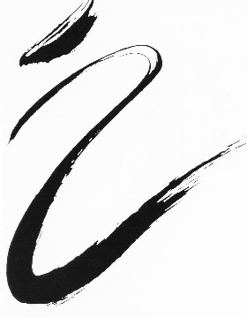
2021 / 2022
Brochure

Green Bay School of Dance

129 S. Washington St.
Green Bay, WI 54301

(920) 413-1090

Email: GBSDBallet2020@gmail.com

Visit us at: Greenbayschoolofdance.com

The Green Bay School of Dance has a Fall/Spring session that meets from August 30th - May 14th and a Summer session that meets during the months of June, July and August.

PAYMENT AND FEE INFORMATION
Registration All students at the GBSD must fill out a registration form.
Session Fees The session fee may be divided in to two payments with ½ due September 1st and the other ½ due January 3rd. Special monthly payment arrangements may also be made by filling out the appropriate lines on the registration form. Monthly payments can be made with a credit card, cash or checks. Families that chose to pay by check, should submit nine checks post-dated to correspond with the due dates on the registration form. These checks should be attached to the form. Walk-in and placement classes are payable before class begins.
Discounts Figure the exact discount by taking 5% of the total session fee (excluding registration fee). Only one discount is applicable per student per session.
A. Make one payment for the entire session by 8/30/2021 and receive a 5% discount.
B. Families with two or more dancers receive a 5% discount.
Late Registration and Late Payment Students may enroll at the GBSD at any time during the session. However, we do not prorate session fees. A 1.5% per month finance charge will be added to all past due accounts. All NSF or cancelled checks are subject to a $35 service charge.

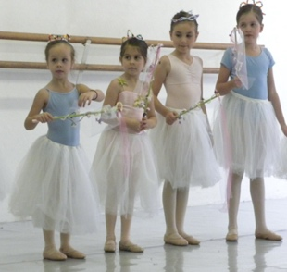
STUDIO INFORMATION
Class Time All classes will start on time. Dancers arriving late may be asked to observe and not participate. Late admission is at the sole discretion of the instructor. Classes may end 5 minutes early for questions and special attention.
Studio Hours The studio will open 15 minutes before the first class of the afternoon and close 15 minutes after the last class of the evening. Please be on time if you are picking someone up at the studio. Parents please tell your children to wait for their ride inside of the building.
Class Size Each class has an enrollment cap. After the class fills, interested dancers will be placed on a waiting list. The studio reserves the right to cancel classes with insufficient enrollment.
Dress and Classroom Etiquette Proper dress and shoes are required for all classes. Dancers should be properly warmed-up and ready to dance when the class begins and should be aware of proper classroom etiquette. Hair must be in a proper bun for ALL ballet classes. Please note the dress code listed under dress requirements. For safety reasons, gum, jewelry, and watches are not allowed in class. Dancers who forget their shoes will not be allowed to participate.
Make-up Lessons Dancers may make up any lessons missed due to illness or vacation. Credit will not be issued for missed lessons and make-up lessons will not carry over into the following session. Dancers enrolled in the Classical Ballet Program may make up lessons in any appropriate class.
Parents and Guests Parents and guests may observe class by appointment only and should wait in the green room during class time. Special days will be set aside for parents to observe their children in class. Children must be accompanied by an adult when waiting in the green room. Upper level ballet classes may be observed at any time with the permission of the instructor.
Cell Phones Cell phones are not allowed on or near the dance floor area. Parents and dancers should turn the cell phone ringer off when they enter the studio, so as not to disrupt the class.
Snow Days For safety reasons, classes will not meet at GBSD when the Green Bay Public Schools are closed due to inclement weather. Classes cancelled due to inclement weather will not be made up.
Office Hours Parents and dancers are always welcome to schedule an appointment with the school director. All concerns about progress, class placement, etc. should be taken up with the director and not the teacher.
No Refunds
Refunds will not be made under any circumstances or for any reasons (personal, social, medical, etc.). This policy also applies to any fees that are payable. Before you register, we ask that you check your calendar, weigh your other commitments and understand clearly that you are making a commitment to attend classes from early September thru mid-May.

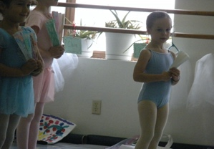
Fees for the 2021/2022
August 30th - May 14th Session

½, ¾ or 1 Hour Classes: $460
(including Children’s Movement, Pre-Ballet, Children’s Ballet I, Stretch and Strength, Character, Jazz, Modern, Pointe)
1 ¼ or 1 ½ Hour Classes: $485
(including Ballet II, III, IV Technique Classes)
Pre-professional Classical Ballet Program: $2,400
Walk-in and Placement Classes: $20
Youth America Grand Prix, private and semi-private lessons must be arranged through the director.

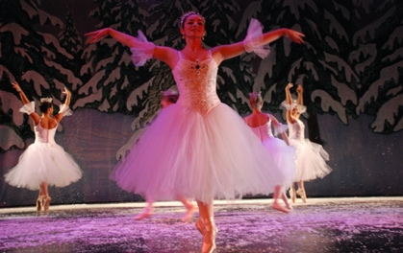
Minimum Weekly Requirements
for the Classical Ballet Program

Children’s Movement, Pre-ballet, and Children’s Ballet I meet once each week ($460)
Ballet II has two technique classes each week ($970)
Ballet II/III and III has three technique classes each week ($1,455 plus pointe)
Ballet IV has four technique classes each week ($1,940 plus pointe)
The Pre-professional Classical Ballet Program ($2,400) This fee includes all technique and pointe classes. All other classes are offered at a 50% discount.
Dancers en pointe must be registered for a minimum of three technique classes each week.

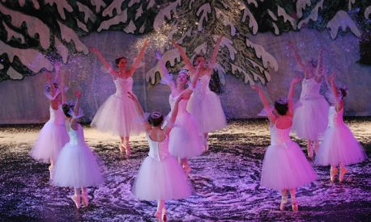
Dress Requirements

BOYS IN BALLET White shoes, socks, T-shirt. Black tights.
GIRLS IN BALLET Pink tights, pink shoes, hair in a bun, appropriate color & style leotard
Mirella Leotard & Danskin Tights (Mirella Leotard Style #’s M202, M210, M201)
Color & Style Requirements
CHILDREN’S MOVEMENT - Seafoam Green
PRE-BALLET - Pale Pink
CHILDREN’S BALLET I - Copen Blue
BALLET II - Burgundy
BALLET III - Marine Blue
BALLET IV - Black
PRE-PROFESSIONAL - Black
Adult BALLET I & I/II - any color
Dancers must have proper attire when attending classes. Please consult with the director about precise brand, color and style requirements before purchasing dancewear. Skirts are allowed at the discretion of the teacher and must match the dancer’s leotard. T-shirts, sweatshirts, and shorts are not allowed after class begins.

Green Bay School of Dance
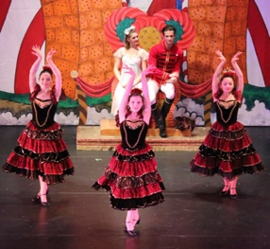
The purpose of the Green Bay School of Dance is to provide a high-quality educational setting for dancer training. The studio has a professional and knowledgeable staff and offers classical ballet lessons for all ages and levels throughout the year. A pre-ballet program is designed for children ages 3-6 to prepare them for entrance into the ballet format. The GBSD has been serving Green Bay and the surrounding community for over 38 years. Although the school has a special interest in developing young dancers and bringing them to a pre-professional level, the faculty is well aware that many students do not have an interest in pursuing a career in dance. The school treats everyone equally in the classroom and feels that the rewards of structured dancing can be highly beneficial no matter what avenues the students eventually pursue. Discipline, poise, physical stamina, mental focus, and art are all a part of dance at the Green Bay School of Dance.

Pre-Professional Program
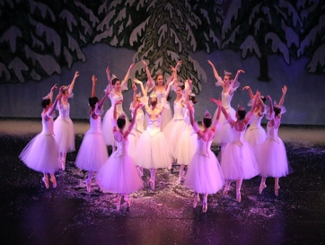
The purpose of this program is to intensify the training so that the dancer is better prepared for entrance into college dance programs, performing arts high schools, and competitive summer workshop auditions. Past participants have been accepted into and received full scholarships to attend many different summer programs and performing arts high schools including: Kansas City Ballet, Carolina Ballet, Ballet Chicago, Masters Ballet, Milwaukee Ballet, The Rock, Joffrey Midwest, Ballet Met, Harid Conservatory, Pacific Northwest Ballet, Boston Ballet, San Francisco Ballet, Walnut Hill, Ballet West, Central Pennsylvania Youth Ballet, Masters Ballet, North Carolina School of the Arts, Houston Ballet, Royal Winnipeg Ballet, Dance Theatre of Harlem, American Ballet Theatre, Alvin Ailey and the School of American Ballet. Many of the pre-professional program alumni have gone on to dance with prestigious companies throughout the United States, including Carolina Ballet, Pacific Northwest Ballet, Ohio Ballet, Dance Kaleidoscope, Nashville Ballet, Jose Limón Dance Company, Memphis Ballet, and Milwaukee Ballet. Pre-professional dancers pay a set fee that covers all ballet and pointe classes. They also receive a 50% discount on all other scheduled classes, such as Modern, Stretch, & Character. For information regarding benefits, responsibilities, schedules, and costs, etc., please call the school director.

Train for the Youth America Grand Prix (YAGP) 2021/2022
The Youth American Grand Prix is the world’s largest non-profit international ballet competition for pre-professional students ages 9-19. They provide annual competitions all over the US and throughout the rest of the world. Each regional competition also provides master classes by some of ballet’s premier teachers and directors.
There are several annual regional competitions. Usually, two competitions are hosted nearby in Chicago. There are three levels. Pre-competitive (ages 9-11), Juniors (ages) 12-14 and, by far the most competitive, Seniors (ages 15-19). Soloists must compete with a classical variation selected from the YAGP rule book with an option to also compete in the contemporary category.
Training for the YAGP is a wonderful opportunity to push oneself to a new technical level and dare to perform before professionals in the field. It is an opportunity to see other dancers who work hard to achieve and to dance on the stage with the future performers in this art form. Competing as a soloist may not be right for you. We have other options for dancers still interested in experiencing this exciting competition.
If you are interested in finding out if the YAGP is right for you, please contact Timothy Josephs at GBSDBallet2020@gmail.com or call (920) 413-1090 or (920) 433-9510.
NEWDO The NORTHEASTERN WISCONSIN DANCE ORGANIZATION is a Wisconsin non-profit corporation. The mission of NEWDO is to promote professional level works of classical dance for the community of Northeastern Wisconsin. NEWDO produces the Green Bay Nutcracker Ballet each holiday season, an annual spring concert at the University Theatre, and the Emerging Choreographers Showcase in summer. NEWDO has performed with other area arts organizations such as the Green Bay Civic Symphony, the Holiday Pops, and the Green Bay Symphony. NEWDO also provides scholarship funds for dancers that participate in the NEWDO Summer Intensives. Dancers from the Green Bay School of Dance have the opportunity to perform with NEWDO.
GBSD FACULTY
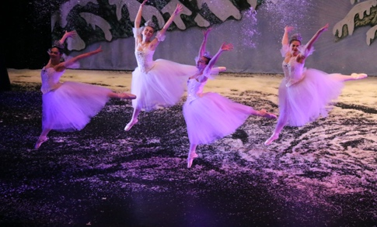
TIMOTHY JOSEPHS: Timothy has been the director of the Green Bay School of Dance since 1983. He is also the Artistic Director of the Northeastern Wisconsin Dance Organization and the choreographer for the Green Bay Nutcracker Ballet. Timothy has been the Ballet Instructor at the University of Wisconsin-Green Bay since 2010. He was the Artistic Director/Choreographer for the Wisconsin Ballet Theatre and a recipient of a Wisconsin Arts Board and National Endowment for the Arts Choreography Grant and Wisconsin Dance Council Leadership Award.
DIANE DANHIEUX: Ballet and Pointe Instructor. Diane was the director of Terpsichore School of Dance in Iowa City as well as director of the Talented and Gifted Young Dancer Program at the University of Iowa. She worked with the Joffrey Ballet and Washington Ballet. She performed with Wisconsin Ballet Theatre and was a guest dancer with numerous East Coast companies.
BARB GALLAGHER: Children's Movement and Pre-Ballet Instructor. Barb has been teaching at Green Bay School of Dance since 1996. She is a Kindergarten Teacher at Oconto Falls Elementary. She brings her passion and training in Early Childhood Education and dance to provide high level instruction for our youngest dancers.
ANGIE FLANAGAN: Modern Dance, Ballet and Pointe Instructor. Angie received a BFA in Dance from the Conservatory of Music and Dance in Kansas City, MO. She studied at the Martha Graham School of Contemporary Dance in New York City, Oberlin Dance Collective in San Francisco, Homer Bryant in Chicago, The Kansas City Ballet and Westport Ballet in Kansas City, Mo and the Atlanta Ballet Summer Intensive. Her performance experience includes Wylliams Henry Contemporary Dance, City in Motion and Ole Dance of Spain in Kansas City and Deeply Rooted Productions, Winifred Haun and Dancers and The Flying Griffin Circus in Chicago. She worked with the award winning Lookingglass Theatre and The Actors Gymnasium and was the director of The Actors Gymnasium's satellite Circus and Performing Arts Camp in Chicago.
KRISTEN THRONE: Ballet, Character and Pointe Instructor. Kristen earned a BA in Elementary Education from the University of Illinois in Champaign, IL. She also earned her Elementary certification from the Royal Academy of Dance. Kristen studied in the Chicago area at the Judith Svalander School of Ballet, Ellis-DuBoulay School of Ballet, and Homer Bryant. She has also attended summer intensives at Joffrey Ballet New York and Milwaukee Ballet. Her performance experience includes the Judith Svalander Dance Theater and guest artist work for the University of Illinois and Northeast Wisconsin Dance Organization. Kristen is also a co-founder of the Green Bay Dance Collective, a master class instructor in the Midwest area, and served as a board member for the Wisconsin Dance Council. In addition to her work with the Green Bay School of Dance, she is currently an elementary school teacher and rehearsal mistress for NEWDO. Kristen enjoys sharing her expertise and love of dance education with the Green Bay School of Dance students.
JAMIE GISSENDANER: Hip Hop Instructor. Jamie began her dance training at a very young age. She fell in love with Ballet, Modern, Hip Hop and Jazz. Jamie has trained at the Baltimore School for the Arts, Carol Maxwell Ballet Studios, Morton Street Dance Studio, Academy of International Ballet and Alvin Ailey Summer Dance Intensive. She has taken numerous classes at Broadway Dance Center in New York City. She danced under the direction of Debbie Allen, performing at the Kennedy Center in Washington, D.C. She was co-captain of the Temple University Dance Team. She also performed in numerous student performances with the Temple University Dance Department. Jamie has attended several dance conventions. While attending Temple, she was selected to represent the Philadelphia 76rs Dance Team for five consecutive basketball seasons. She was also in several commercial, promotional and charity events for the 76rs Dance Team. She is the Co-Founder and member of Cayenne Entertainment Performing Arts Company. Jamie is also a Registered Nurse with a background in Trauma and Emergency Care.
BETH CHECK: Ballet Instructor. Beth danced briefly with GBSD and went on to train at the Milwaukee Ballet Academy. From there, she was a trainee with Nashville Ballet and Ballet Met. She attended summer intensives with Ballet West and on full scholarship with Alonso King's Lines Discovery Project. Professionally, she has performed in many contemporary and classical ballets, including: The Nutcracker, Cinderella, La Bayadere, Midsummer Night's Dream and Serenade. Beth completed Ballet Pedagogy Studies under Maria Torjia and taught youth ballet classes at Children's Theater of Columbus.
KIRSTY GUNGER: Ballet Instructor. Kirsty is the owner/director of Celebration Dance. She began her formal dance training in South Africa through the Royal Academy of Dance and continued her studies in the US after emigrating with her family at age 15. Kirsty maintained a classical ballet focus in her studies, but added contemporary, modern, and jazz to her repertoire, developing a great love for the heart and soul in dance expression. She has taught all levels of ballet, jazz, contemporary, and modern dance for over 25 years. Kirsty also toured with a professional theatrical dance company for two and a half years both nationally and internationally in countries including China, Brazil, and Peru, as well as off-Broadway in New York City.
Former faculty and guest teachers include:
Taylor Ayotte, Marisa Cerversis, Elliot Feld, Ted Kivitt, Valery Lantratov, Jane Meredith, Janel Meindersee, Natasha Posey, Dameon Nagel, Randi Osetek,, David Parsons, Cyndie Shepard, Marlene Skog, Yung Yung Tsui, Vivian Tomlinson and, McKenzie Van Oss.

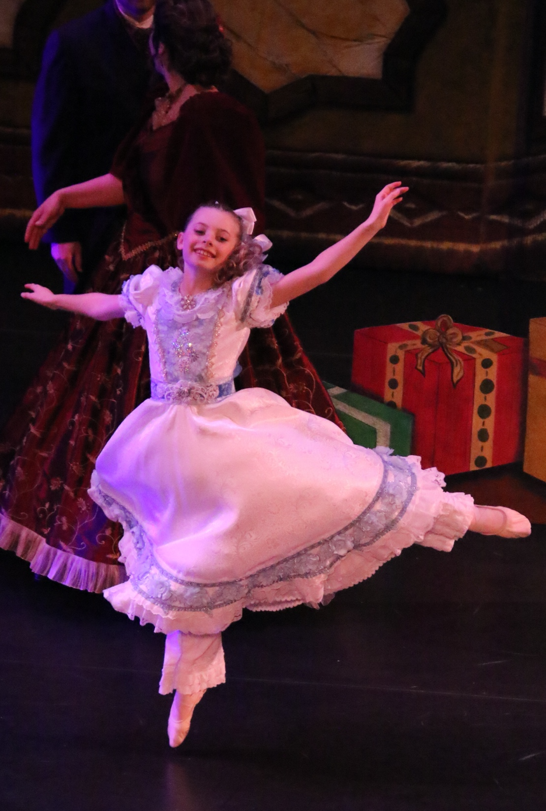

GBSD Calendar
-Important Dates-
August 30th Fall/Spring Session Begins
Sept. 4th & 5th Nutcracker Auditions
December 20-Jan.1st Winter Intensive
March 21st -26th Spring Break
Spring T.B.A. NEWDO Spring Concert
May 2nd - 7th Parents Observation Week
May T.B.A. GBSD Spring Showcase
May 14th Fall/Spring Session Ends
June 6th - Aug. 6th Workshops and Summer Session 2022

GBSD Classes will not meet on these days
Sept. 4th Nutcracker Auditions
Sept. 6th Labor Day
Sept. 11th Nutcracker Orientation
Nov. 20th Holiday Parade
Nov. 22nd-27th Green Bay Nutcracker Ballet
Dec. 20th -Jan 1st Winter Break
Jan. 17th Martin Luther King Day
March 21st -26th Spring Break
April 15th -17th Easter Break

Please make note on your calendar of when the studio is closed.

For questions and more information, call
(920) 413-1090
E-Mail: GBSDBallet2020@gmail.com Visit: www.Greenbayschoolofdance.com
Green Bay School of Dance
129 South Washington Street
Green Bay, WI 54301

