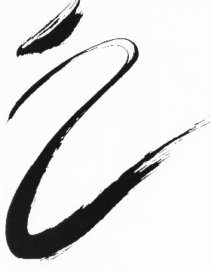
Class Schedule
Fall 2025 / Spring 2026
August 25th – May 9th
Monday Tuesday Wednesday Thursday Friday Saturday
 |  | 10:00-11:15am  Adult Ballet I/II |  |  | 9:00-10:15am  Ballet III
4:00-4:45pm  Variations  (Ballet II & II/III  dancers) | 3:45-5:00pm  Ballet III/IV | 3:45-5:00pm  Ballet III/IV | 4:00-4:45pm  Modern II  (Ballet III & IV dancers) | 3:45-4:30pm  T.B.A. | 10:15-11:15am  **Repertory  Composition I  Composition II
4:45-6:00pm  Ballet II | 5:00-5:45pm  Pre-Ballet  (Ages 4-7) | 5:00-5:45pm  Character or Stretch  (Ballet II, III & IV dancers) | 4:45-6:00pm  Ballet II | 4:30-5:45pm  Ballet II/III | 11:15-5:00pm  Nutcracker  &  Spring Concert Rehearsals
6:00-7:30pm  Ballet III/IV | 5:45-6:45pm  Children’s  Ballet I | 6:00-7:30pm  Ballet IV | 6:00-7:30pm  Ballet III | 5:45-6:30pm  Beginning Pointe | 11:15-5:00pm  Nutcracker  &  Spring Concert Rehearsals
7:30-8:30pm  Pointe I/II | 6:45-8:00pm  Ballet I/II  Teen/Adult | 7:30-8:30pm  Pointe II | 7:30-8:30pm  Pointe I | 6:30-7:30pm  T.B.A. | Sunday  10:00-5:00pm  Nutcracker  &  Spring Concert Rehearsals
Please refer to the studio brochure for specific class requirements concerning the Classical Ballet Program.
- *By special arrangement with the director.
- **Repertory (Sept.-December) Composition I (Jan.-March) Composition II (March-May).

