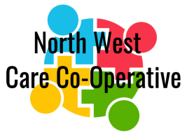 | ‘A Co-operative approach to safe, quality care, under your control and informed by your experience’  ‘Together we can live life well’  Company limited by guarantee without share-holders  Registered Office: Sension House, Denton Drive, Northwich, CW9 7LU  Company No: 11676038 Care Quality Commission ID: 1-5637274181  Email: nwcarecoop@gmail.com Telephone: 01606 331853  Website: nwcarecoop.co.uk

North-West Care Co-Operative (NWCC) Programme of Events
2024
Date | Time | Event | Venue
2nd November | 12noon to 2pm | PA Meeting | Port & Anchor, Ellesmere Port
23rd November | 10am to 2pm | Xmas Craft Fayre | LIVE, New Scene, Wirral Way
7th December | 6pm to Midnight | NWCC Xmas Do | Chester Golf Club, Upton
2025
Date | Time | Event | Venue
26th April | 9.30am to 3pm | London Marathon | Memorial Court, Northwich
25th April | 12-4pm | No limits Festival | Memorial Court, Northwich
31st May | TBC | A day at the races | Chester Racecourse
3rd June | 10am- ?? | Making day (wreaths. pot painting, bird feeders) | Disability Positive, Northwich
7th June | 11-4pm | Makers Market (Bendrigg Fundraiser) | Chester Market Hall
13th June | 10-1pm | Supporting members ‘moving forward’ meeting | Disability Positive. Northwich
11th June | 3-5:30pm | Safety Central visit | Lymm
2nd September | TBC | Alicia & Tess’ Boat trip | Llandudno
21st September | TBC | Chester Business Charity Walk | Chester Racecourse
10-12th October |  | Bendrigg Activity Weekend | Bendrigg Outdoor Centre

