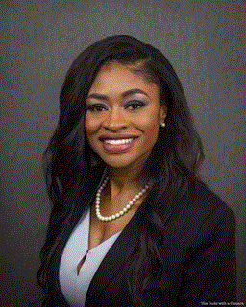 The Honorable Tangi C. Smith, SFC(ret) enlisted into the United States Army in June, 1996 and retired in May, 2017 after a distinguished and exciting career of 21 years. Born on October 22, 1976 to James Earl and Linda Dixon. She was raised in a small town in eastern North Carolina. Tangi joined the United States Army in June 1996 and retired in June 2017 from Fort Campbell, Kentucky. She was an Orthopedic Technician and later converted to a 68W Combat Medic.
Her duty stations consist of Fort Jackson SC, Joint Base San Antonio TX, Friedberg Germany, Fort Campbell KY, Walter Reed National Military Medical Center in Washington DC, Various Bases in South Korea, United States Army Recruiting Command as a Healthcare Recruiter in Huntsville, AL (with duty in Miami FL) and Miami Military Entrance Processing Station (MEPS) . She has 2 combat deployments, one of which she served as the senior medical personnel on her Forward Observation Base (FOB) and various of awards and citations.
While actively serving in the Army; she’s been a guest speaker for organizations such as “The Butterfly Society”, “The Big Hat affair” Tangi wrote for ‘ Convenient Shopper ‘ a local advertising magazine, and hosted the “TREVA and KEVIN SHOW,” a weekly morning show in Nashville, TN that has audiences in Tennessee, Kentucky and Northern Alabama.
Barely a year after her retirement Tangi won the 2018 midterm election for Montgomery County Commissioner District 8 (Clarksville, Tennessee) up seating a 16 year incumbent with over 60 percent of the vote. She is also the Founder and Executive Director of Woman Elevated, INC “a veteran outreach nonprofit organization “She currently has the only women veteran transition house in middle Tennessee.
She is a Certified Law of Attraction Life Coach and the facilitator of Red Carpet Ready, a ministry for women of all ages seeking motivation and encouragement dealing with life’s trials. Tangi is currently working on her masters in psychology and her ultimate goal is to obtain her doctorate. She is has been married to CW2 Keemon Smith for over 20 years; he is currently stationed at Schofield Barracks Hawaii and they have 1 child currently attending Clark Atlanta University in Atlanta, GA.
“From a young age Tangi discovered that success depended solely on her own ability to make it happen. She learned how to discover a need and find a solution. She is often referred to as the “problem solver” .She has always had a burning desire to succeed and help others. “

