Life Balance Wheel

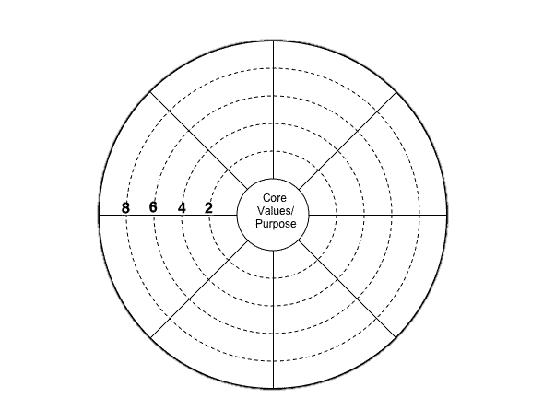

Each area of the wheel represents an area of your life. These areas are:

* **Family Relationships**
* **Work Performance**
* **Spiritual Wellness**
* **Emotional Wellness**
* **Physical Wellness**
* **Social relationships**
* **Intellectual Development**
* **Financial Wellness**

Color in each area from the center, indicating how well you feel you are doing in that part of your wellness. Will your wheel roll evenly? (Do this on a regular basis to determine how much progress you are making.)

What can you do to fully develop each area of your personal wellness? Balanced wheels roll more readily, and larger wheels require fewer revolutions (less energy) to cover the distance.