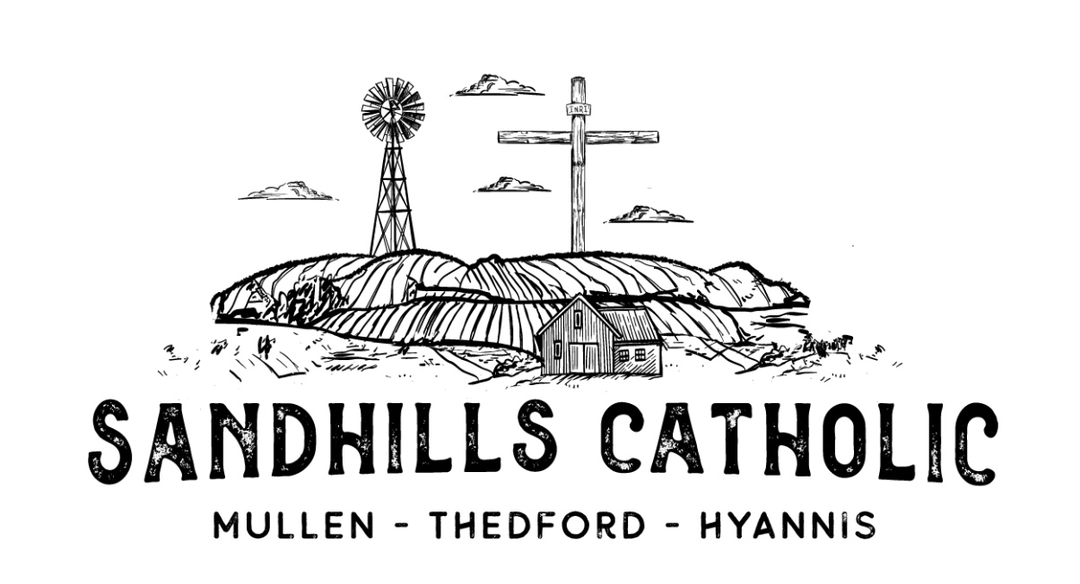
Marriage Request Form
Please print all information clearly. All information is kept confidential

Today’s Date: _________________________ Date Requested for Wedding________________________

Name of Bride: (first)___________________________ (Middle)__________________________ (Maiden)______________________________

Religion of Bride:__________________________________ Is Bride Baptized: yes / no

Birth date:___________________________________________ Is Bride Confirmed: yes / no

Phone Number:______________________________________

Mailing Address:________________________________________________________________________________________________________

Name of the Parish you attend:________________________________ How often do you attend:_________________________

Name of Groom: (first)____________________________ (Middle)___________________________ (Last)_______________________________

Religion of Groom:__________________________________ Is Groom Baptized: yes / no

Birth date:___________________________________________ Is Groom Confirmed: yes / no

Phone Number:______________________________________

Mailing Address:________________________________________________________________________________________________________

Name of the Parish you attend:________________________________ How often do you attend:_________________________

The Marriage Preparation Process:
The Sandhills Catholic Community rejoices with you over your engagement! A marriage is more than just one single day. God the Father gave us marriage as a beautiful witness to self-giving love, and a vocation in holiness. The Church chooses to follow the Trinity and all His teachings. Thus, we recognize that Marriage is a valid and major Sacrament. We do not take this lightly, and desire to help you live that great Sacrament in love and joy. As such, please be advised of the following concerning the marriage preparation process:
- The Diocese of Grand Island requires that the Parish Priest be contacted at least 9/6 months before the wedding date to set up the preparation process.
- You both will need to provide valid and current (issued within the last 6 months) Baptismal Certificate. When asking for this document please ask that ALL notations be filled in.
- You will get to attend a Natural Family Planning Course, the Parish Priest will direct you on this.
- Freedom to marry forms will be given to you, if needed, and must be returned at least 3 months prior to the wedding ceremony.
- The date of your celebration will be confirmed and held once you discuss that date with the Parish Priest. We strongly suggest you do not book any reception dates or make invitations until your date in the Church is confirmed, and the Priest knows and recorded that you are free to marry.
- The wedding Mass or Liturgy of the Word planning sheet will be discussed as part of the preparation.

