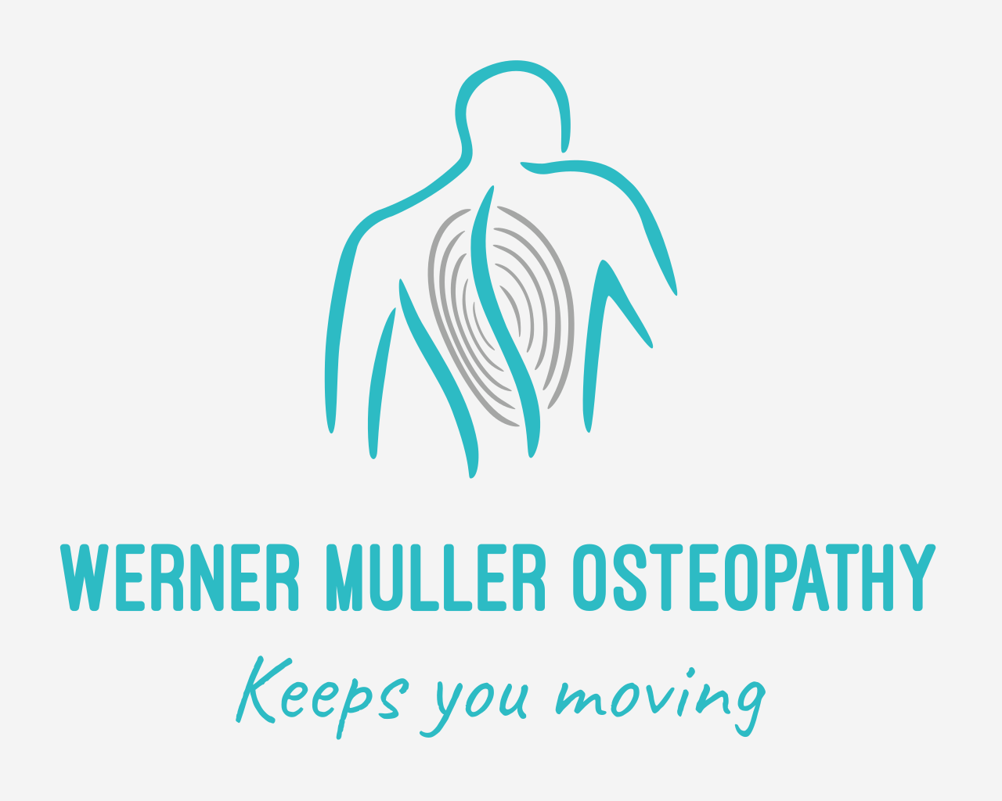

**Werner Muller Osteopathy**

Good Hub, Rm 12

98-100 Goodwood Road

Goodwood SA 5034

(m) 0430 088 303

(e) [wmosteopathy@gmail.com](mailto:wmosteopathy@gmail.com)

[www.wmosteopathy.com.au](http://www.wmosteopathy.com.au)

**New Patient Information Form**

Name: ______________________________________________ DOB: _____/_____/______

Address: ____________________________________________ Postcode: ______________

Home Phone: (____)________________ Mobile: _______________ Work (___)_________________

Email: _________________________________________________

Private Health Fund: ______________________________________

GP Name & Location: _______________________________________________________________

□ I consent to Werner Muller Osteopathy notifying my GP that I am having Osteopathic treatment *(if required).*

Emergency contact name & number: ________________________ (___)_______________________

Your occupation: ___________________________________________________________________

**Please fill out this section *(if applicable):***

Pension/Concession number: ________________________________

Medicare number: ___ ___ ___ ___ ___ ___ ___ ___ Ref No: ______

Department of Veterans’ Affairs card number: _____________________

TAC Claim number: _________________________________________

* Date of accident: _____________________________________

Worksafe Claim number: _____________________________________

* Employer: ___________________________________________
* Date of injury: ________________________________________

Would you like to opt in to: □ SMS reminders □ Appointment emails □ Newsletter emails

***Privacy policy:*** *The information that we collect from you allows our Osteopathic Practitioner/s to assess your health and provide you with the utmost care possible. The information will ONLY be used for these purposes in strict adherence to the National Privacy Principles of the State and National Government’s privacy legislation. You have the right to obtain access to your health records with Werner Muller Osteopathy at any point in time upon request (a small printing fee may be involved).*

By signing this form I acknowledge that I have given Werner Muller Osteopathy consent for the above stated

______________________________________________ _________________

*Patient signature* *Date*

**New Patient Medical History**

*Please indicate on the diagram what area you are having assessed/treated today.*

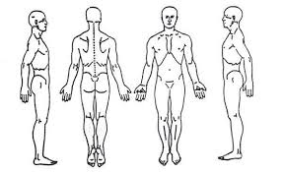

What is the main purpose of your visit today? _______________________________________________

____________________________________________________________________________________

How would you describe what you’re feeling? _______________________________________________

____________________________________________________________________________________

Do you experience pins & needles? _______________________________________________________

What makes it better? __________________________________________________________________

____________________________________________________________________________________

What makes it worse? _________________________________________________________________

____________________________________________________________________________________

When did you first notice this feeling? _____________________________________________________

Have you experienced this before? _______________________________________________________

Other professionals seen before in the past: □ Osteo □ GP □ Physio □ Chiro □ Massage

□ Specialist □ Others *(Please list):* _______________________________________________________

Any investigations or tests? □ X-rays □ Ultrasound □ MRI scan □ CT scan □ Bloods □ Other/s

List any medications & supplements you are currently taking: ___________________________________

____________________________________________________________________________________

____________________________________________________________________________________

Do you have or have you had any of the following? *(please tick)*

□ High/Low Blood pressure □ High cholesterol □ Heart disease

□ Blood clot □ Breathing issues □ Pins & needles

□ Headaches □ Migraines □ GIT issues

□ Asthma □ Rheumatoid Arthritis □ Osteoarthritis

□ Muscular injury □ Joint injury □ Ligament injury

□ Disc problems □ Fracture □ Surgery

□ Stroke □ Trauma/Accident □ Major infection

□ Incontinence □ Allergies □ Pregnancy

Is there anything else you believe you need to inform your Osteopathic practitioner of?

____________________________________________________________________________________

____________________________________________________________________________________

____________________________________________________________________________________

____________________________________________________________________________________

**Adult Osteopathic treatment informed consent**

Osteopathy is a recognised manual therapy for the care of many musculoskeletal related conditions. However, much like anything you must recognise that there are slight risks associated with all health care procedures or treatments. This includes Osteopathic Manual Techniques, which you must be informed about. All of our Practitioners are registered with the Australian Health Practitioners Regulation Agency (AHPRA). Our philosophy is to look at the body as ONE WHOLE UNIT to find the primary source of your problem. Our Osteopathic Practitioners will aim to help you understand what your body is going through so that you will leave with a better knowledge about what your body’s limitations are and how to prevent and manage your problem down the track.

Normal treatment effects:

The initial 24-48 hours after an Osteopathic treatment you may experience mild temporary post-treatment soreness. There may also be temporary exacerbation of your symptoms or underlying condition. Please be advised that this is considered to be normal, as your body is responding to the treatment.

As part of your Osteopathic treatment, your treating practitioner may also use other treatment techniques and adjuncts stated below. Please kindly indicate by ticking the boxes below if you would like to consent to have these treatment techniques and adjuncts as a part of your treatment;

□ Neck and spinal manipulation

I have had the opportunity to discuss the proposed care with my Practitioner below. I have disclosed all relevant health and medical information. I also acknowledge that I have had the opportunity to question the nature, extent and purpose of care of my Osteopathic treatment. I understand that I can withdraw consent to treatment at any time.

Our Privacy Statement sets out the policy of Werner Muller Osteopathy with respect to the way in which we collect, use, disclose, store, secure and dispose of Personal Information about our patients. The information that we collect from you allows our Practitioner/s to assess your health and provide you with the utmost care possible. The information will ONLY be used for these purposes in strict adherence to the National Privacy Principles of the State and National Government’s privacy legislation.

I confirm that I have read and understood ALL the information above; I hereby acknowledge my consent to the proposed Osteopathic care by the treating practitioner below.

**Patient name:** ______________________________**Patient signature:** __________________________

**Osteopath’s name:** ___________________________**Osteopath’s signature:** ____________________

**Dated:** ____/____/_____