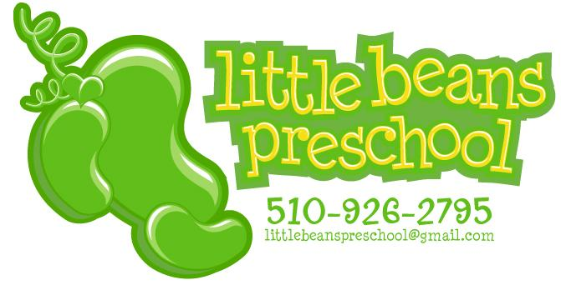

Little Beans Preschool: Waitlist application/Pre-enrollment

Date:

Child’s Name and D.O.B.

Guardian’s name(s) and contact information:

Desired start Date: Full or Part Time enrollment:
Please tell us a bit about your child, and your current child care situation:

Date received:

