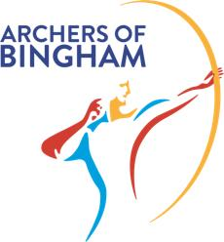
Archers of Bingham – Casual clothing order form

Name
Email address
Phone number

Please use the table below to place your order. The first line (shaded) is an example of how this form should be completed.
Please feel free to add additional lines to the table should you want more than five items.

Item code | Item description | Size | Colour | Name to be printed under logo (leave blank if you don’t want a name) | Quantity | Cost/item | Total cost
UC507 | Hoodie | M | Navy/Sky | SALLIE | 2 | £24.50 | £49.00

Total order cost £
Payment by BACS: NatWest Sort Code: 60-02-41 Account: 21583684

Pay by cheque: Bingham Leisure Centre Archery Club

Find out more on the website: https//binghamarchery.co.uk/club-clothing

Please return completed form to Sallie Seymour: records.blcac@gmail.com

