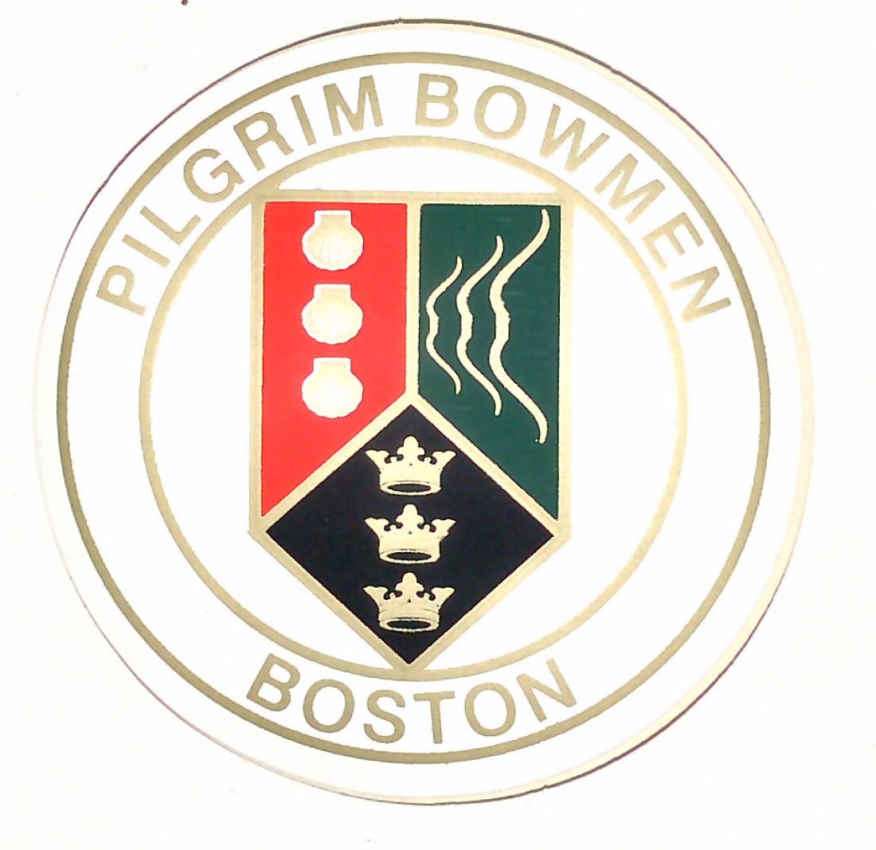
PILGRIM BOWMEN
BOSTON

BRASS MONKEY SHOOT
AMERICAN ROUND
SHORTER DISTANCES ON REQUEST
Sunday, 16th FEBRUARY, 2020
Sighters – 11.00am
Venue: Mayflower Sports Ground, Rosebery Avenue, BOSTON PE21 7QR
Entry Fee: Seniors £8.00 – Juniors £6.00
Entries to:-
Ian Clayton, 80 Tattershall Road, BOSTON, PE21 9LP
Email: glenhurst@btinternet.com
Phones: 01205 363976 or 07812 682 123
Closing Date 10th February, 2020
Data Protection: When you enter a competition the following data may be collected and shared with tournament organisers, scoring systems and other competitors; for example, target lists and results lists may be published: first name, gender, bow style, date of birth/age category, email, address, phone number, Club (and ID), County (and ID), Region (and ID), Round (unless defined by age), Disabled (Y/N), Disability information.
Photography: Please register with the organiser if you wish to take photographs
Special Requirements: If you require special arrangements because of disability or otherwise, please notify at time of entry
Please note that target faces which have already been shot may be used
……………………………………………………………………………………………………………………………………………………………………………………………………………………………
Name | Club | AGB No | G/L/J | R/L Hand | Style | Fee

Contact Details: Name…………………………………………………………………………………………………………………

Address……………………………………………………………………………………………………………

Phone……………………………………………Email…………………………………………………………

