THE FOURTEENTH SUNDAY AFTER PENTECOST
August 30, 2026

“The cross is laid on every Christian. The first Christ-suffering which every man must experience is the call to abandon the attachments of this world. It is that dying of the “old man” which is the result of his encounter with Christ.
As we embark upon discipleship we surrender ourselves to Christ in union with his death--we give over our lives to death. Thus it begins: the cross is not the terrible end to an otherwise godfearing and happy life, but it meets us at the beginning of our communion with Christ.
When Christ calls a man, he bids him come and die. It may be a death like that of the first disciples, who had to leave home and work to follow him, or it may be a death like Luther’s, who had to leave the monastery and go out into the world.
But it is the same death every time--death in Jesus Christ, the death of the old man at his call. Jesus’ summons to the rich young man was calling him to die, because only the man who is dead to his own will can follow Christ. In fact every command of Jesus is a call to die, with all our affections and lusts.
But we do not want to die, and therefore Jesus Christ and his call are necessarily our death as well as our life. The call to discipleship, the baptism in the name of Jesus Christ, means both death and life. The call of Christ, his baptism, sets the Christian in the middle of the daily arena against sin and the devil.
Every day he encounters new temptations, and every day he must suffer anew for Jesus Christ’s sake. The wounds and scars he receives in this fray are living tokens of this participation in the cross of his Lord ...”

Dietrich Bonhoeffer, Twentieth Century Lutheran Pastor and Martyr
The Cost of Discipleship

In the Name of Jesus

GATHERING

INTRODUCTION

The prophet Jeremiah speaks of the incurable wound of his suffering, yet finds in God's words the delight of his heart. When Peter doesn't grasp Jesus' words about suffering, Jesus tells the disciples they will find their lives in losing them. Such sacrificial love is described by Paul when he urges us to associate with the lowly and not repay evil with evil. In worship we gather as a community that we might offer ourselves for the sake of our suffering world.

Augustine, Bishop of Hippo, died 430

Augustine was one of the greatest theologians of the Western church. A native of North Africa, he recovered from a debauched young adulthood through the influence of his mother, Monica, and Bishop Ambrose of Milan. Besides writing influential theological books, he served as bishop of Hippo, in present-day Algeria.

Moses the Black, monk, martyr, died around 400

Converted from life as a thief and a robber to Christianity, Moses was an Ethiopian who became a desert monk at Skete. The change in his heart and life had a profound impact on his native country. He was murdered when Berber bandits attacked his monastery.

PRE-SERVICE MUSIC Better is One Day New Song Praise Band
(Matt Redman)

ANNOUNCEMENTS

As you are able please rise

CONFESSION AND ABSOLUTION

P: In the name of the Father and of the Son and of the Holy Spirit.

C: Amen.

P: “Test me, O LORD, and try me; examine my heart and my mind.” (Psalm 26: 2) We
are called this Day to lose our life so that God may give us a new life tuned to the mind
and will of Christ. Letting go of our will and desire for control opens us to the mercies
of God, by which we are made whole. Let us therefore confess our sins, that “(God’s)
love may be before our eyes, and we may walk faithfully with Him.” (Psalm 26: 3)

Silence for self-examination and reflection is kept

P: Most merciful God,

C: We confess that we have sinned against You in thought, word, and deed. Our love
has not been genuine. (Romans 12: 9) We have not loved one another with mutual
affection. (12: 10) We have been impatient in suffering and weak in prayer. (12:
12) We have repaid evil with evil, and sought vengeance against those who have
hurt us. (12: 17) We desire only to save our lives instead of losing them for You
and Your service (Matthew 16: 25). For the sake of Your Son, Jesus Christ, have
mercy on us . By Your Holy Spirit renew in us Your grace, that this and every day
we may follow You into new life for us and for Your world.

P: “If you turn back, I will take you back, and you shall stand before Me ... I am with you
to save you and deliver you.” (Jeremiah 15: 19-20) In fulfillment of that Word, Jesus
Christ went to Jerusalem to suffer, die, and rise into God’s new life that He bestows
upon you now. For as a called and ordained minister of the Church of Christ, and by
His authority, I therefore declare to you the entire forgiveness of all your sins, in the
name of the Father and of the Son and of the Holy Spirit.

C: Amen.

GATHERING SONG NSB 82 The Church Song

GREETING AND PRAYER OF THE DAY

P: The grace of our Lord Jesus Christ, the love of God, and the communion of the Holy
Spirit be with you all.

C: And also with you.

P: Let us pray. O God, we thank You for Your Son Who chose the path of suffering for
the sake of the world. Humble us by His example, point us to the path of obedience,
and give us strength to follow His commands; through Your Son, Jesus Christ our
Savior and Lord.

C: Amen.

The assembly is seated

WORD

FIRST READING Jeremiah 15: 15-21

The book of Jeremiah contains six personal laments or complaints. Today's reading is the second of these laments. Here the prophet complains that his faithful preaching of the word of God has brought only angry violence from his hearers. While God responds with a promise of support, note that God does not promise that Jeremiah's task will be easy or painless.

O LORD, You know;
remember me and visit me,
and bring down retribution for me on my persecutors.
In Your forbearance do not take me away;
know that on Your account I suffer insult.
¹⁶Your words were found, and I ate them,
and Your words became to me a joy
and the delight of my heart;
for I am called by Your name,
O LORD, God of hosts.
¹⁷I did not sit in the company of merrymakers,
nor did I rejoice;
under the weight of Your hand I sat alone,
for You had filled me with indignation.
¹⁸Why is my pain unceasing,
my wound incurable,
refusing to be healed?
Truly, You are to me like a deceitful brook,
like waters that fail.
¹⁹Therefore thus says the LORD:
If you turn back, I will take you back,
and you shall stand before Me.
If you utter what is precious, and not what is worthless,
you shall serve as My mouth.
It is they who will turn to you,
not you who will turn to them.
²⁰And I will make you to this people
a fortified wall of bronze;
they will fight against you,
but they shall not prevail over you,
for I am with you
to save you and deliver you,
says the LORD.
²¹I will deliver you out of the hand of the wicked,
and redeem you from the grasp of the ruthless.

The Word of the Lord.

Thanks be to God.

THE PSALM: Psalm 26: 1-8 Read responsively

¹Give judgment for me, O LORD, for I have lived with integrity;
I have trusted in the LORD and have not faltered.

²Test me, O LORD, and try me;
examine my heart and my mind.

³For Your steadfast love is before my eyes;
I have walked faithfully with You.

⁴I have not sat with the worthless,
nor do I consort with the deceitful.

⁵I have hated the company of evildoers;
I will not sit down with the wicked.

⁶I will wash my hands in innocence, O LORD,
that I may go in procession round Your altar,

⁷singing aloud a song of thanksgiving
and recounting all Your wonderful deeds.

⁸LORD, I love the house in which You dwell
and the place where Your glory abides.

SECOND READING Romans 12: 9-21

Paul writes to the Roman Christians who have experienced rejection and ridicule as a result of their faith. He instructs them on how to live as Christians in an unfriendly world.

Let love be genuine; hate what is evil, hold fast to what is good; ¹⁰love one another with mutual affection; outdo one another in showing honor. ¹¹Do not lag in zeal, be ardent in spirit, serve the Lord. ¹²Rejoice in hope, be patient in suffering, persevere in prayer. ¹³Contribute to the needs of the saints; extend hospitality to strangers.
¹⁴Bless those who persecute you; bless and do not curse them. ¹⁵Rejoice with those who rejoice, weep with those who weep. ¹⁶Live in harmony with one another; do not be haughty, but associate with the lowly; do not claim to be wiser than you are. ¹⁷Do not repay anyone evil for evil, but take thought for what is noble in the sight of all. ¹⁸If it is possible, so far as it depends on you, live peaceably with all.
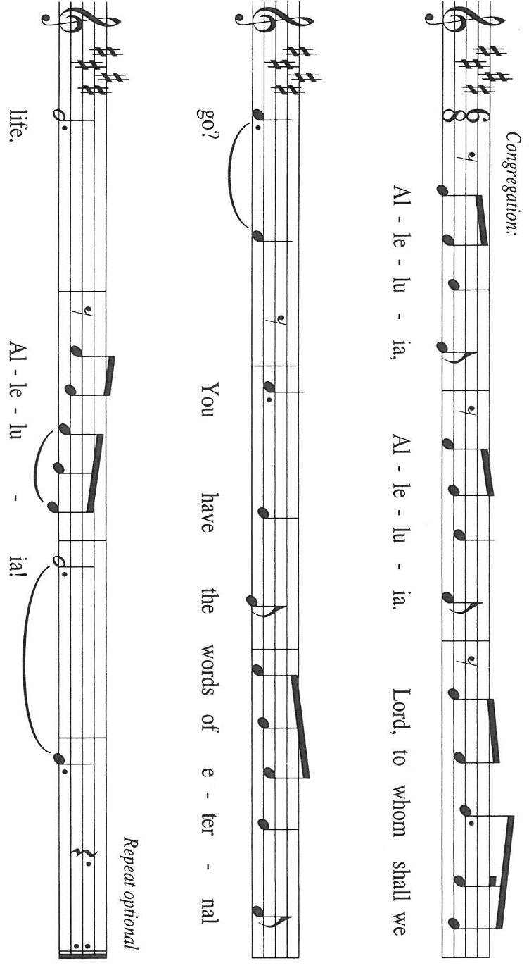
¹⁹Beloved, never avenge yourselves, but leave room for the wrath of God; for it is written, "Vengeance is Mine, I will repay, says the Lord." ²⁰No, "if your enemies are hungry, feed them; if they are thirsty, give them something to drink; for by doing this you will heap burning coals on their heads." ²¹Do not be overcome by evil, but overcome evil with good.

The Word of the Lord.

Thanks be to God.

As you are able please rise

THE VERSE Sung twice

THE HOLY GOSPEL Matthew 16: 21-28

After Peter confesses that Jesus is "the Messiah, the Son of the living God," Jesus reveals the ultimate purpose of his ministry. These words prove hard to accept even for a disciple whom Jesus has called a "rock."

P: The Holy Gospel according to St. Matthew, the sixteenth chapter.

C: Glory to You, O Lord!

From that time on [after Peter's confession], Jesus began to show His disciples that He must go to Jerusalem and undergo great suffering at the hands of the elders and chief priests and scribes, and be killed, and on the third day be raised. ²²And Peter took Him aside and began to rebuke Him, saying, "God forbid it, Lord! This must never happen to You." ²³But He turned and said to Peter, "Get behind me, Satan! You are a stumbling block to Me; for you are setting your mind not on divine things but on human things."
²⁴Then Jesus told His disciples, "If any want to become My followers, let them deny themselves and take up their cross and follow Me. ²⁵For those who want to save their life will lose it, and those who lose their life for My sake will find it. ²⁶For what will it profit them if they gain the whole world but forfeit their life? Or what will they give in return for their life?
²⁷"For the Son of Man is to come with His angels in the glory of His Father, and then He will repay everyone for what has been done. ²⁸Truly I tell you, there are some standing here who will not taste death before they see the Son of Man coming in His kingdom."

P: The Gospel of the Lord.

C: Praise to You, O Christ.

The assembly is seated

THE SERMON

Silence for reflection follows the sermon

As you are able please rise

THE HYMN OF THE DAY 798 Will You Come and Follow Me
(Stanza 2 – Women; Stanza 4 – Men)

THE APOSTLES’ CREED

A: God has made us His people through our Baptism into Christ. Living together in trust
and hope, we confess our faith.

C: I believe in God, the Father almighty,
creator of heaven and earth.

I believe in Jesus Christ, His only Son, our Lord.
He was conceived by the power of the Holy Spirit
and born of the virgin Mary.
He suffered under Pontius Pilate,
was crucified, died, and was buried.
He descended into hell.
On the third day He rose again.
He ascended into heaven,
and is seated at the right hand of the Father.
He will come again to judge the living and the dead.

I believe in the Holy Spirit,
the holy catholic Church,
the communion of saints,
the forgiveness of sins,
the resurrection of the body,
and the life everlasting. Amen
THE PRAYER OF THE CHURCH

A: Jesus calls us to follow Him. As He laid down His life in intercession for the world, let
us intercede in behalf of the Church, the world, and all those in need.

A: That the Church may be sustained when it suffers for the sake of the world and
courageous in taking up the cross and following Jesus, let us pray to the Lord:

C: Lord, hear our prayer.

A: That we in this assembly may in this week rejoice in hope, be patient in suffering, and
persevere in prayer, let us pray to the Lord:

C: Lord, hear our prayer.

A: That all who suffering in body or spirit, especially: David Jocelyn; Terry Wolter;
Jeff Timmrick; Rob Steinborn; Martha Schroeder; Pastor Dale Zylstra; Mark
Tannehill; Jeff Seifert; Debbie Martin; Jon Samuelson; Hazel Miller; Dale
Thomas; and Amanda Seedorf may be strengthened by the Christ Who suffers with
us and for us, let us pray to the Lord:

C: Lord, hear our prayer.

A: That those celebrating birthdays, especially Verne Lee and Joan Seifert; and
anniversaries, especially Paul and Lora Brooks may be filled with grace this day and
every day and grow in grace in the days ahead, let us pray to the Lord:

C: Lord, hear our prayer.

A: That with all the faithful followers of Jesus, especially Augustine of Hippo, Bishop,
and Moses the Black, monk and martyr, whom we commemorate this Day, who
have gone before us we may be received into God’s everlasting Kingdom at the coming
of His Son, let us pray to the Lord:

C: Lord, hear our prayer.

P: Most High God, Your ways are not our ways, yet Your ways bear life. Hear the petitions
of Your assembled people. Pour out upon Your world the faith to hear Your call and
the courage to answer it. We ask this in the name of Jesus, Who is one with You and
the Holy Spirit, one God, now and forever.

C: Amen.

MEAL

THE PEACE

P: The peace of the Lord be with you always.

C: And also with you.

The assembly is seated

THE OFFERING

THE VOLUNTARY

As you are able please rise

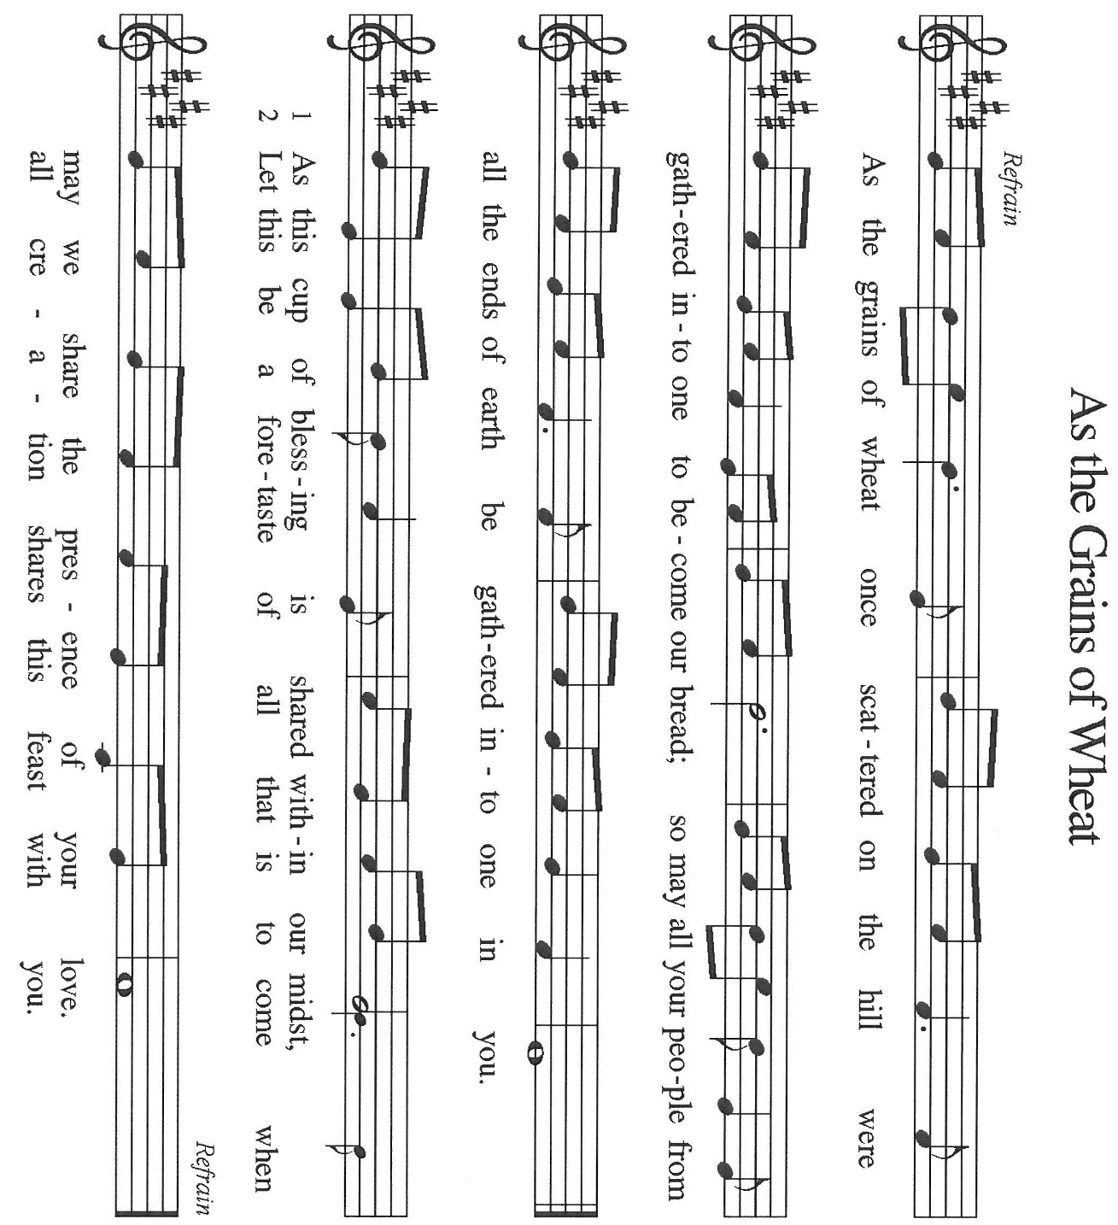
THE OFFERTORY As the Grains of Wheat

THE OFFERTORY PRAYER

A: Let us pray. Gracious God,

C: We come again to Your altar, where Your love and glory abides. We bring You
our gifts, ourselves, and our lives. Receive them for the sake of Your Son, Jesus
Christ, and use them to extend Your life and love to the world. We ask this in the
name of Jesus the Lord. Amen.

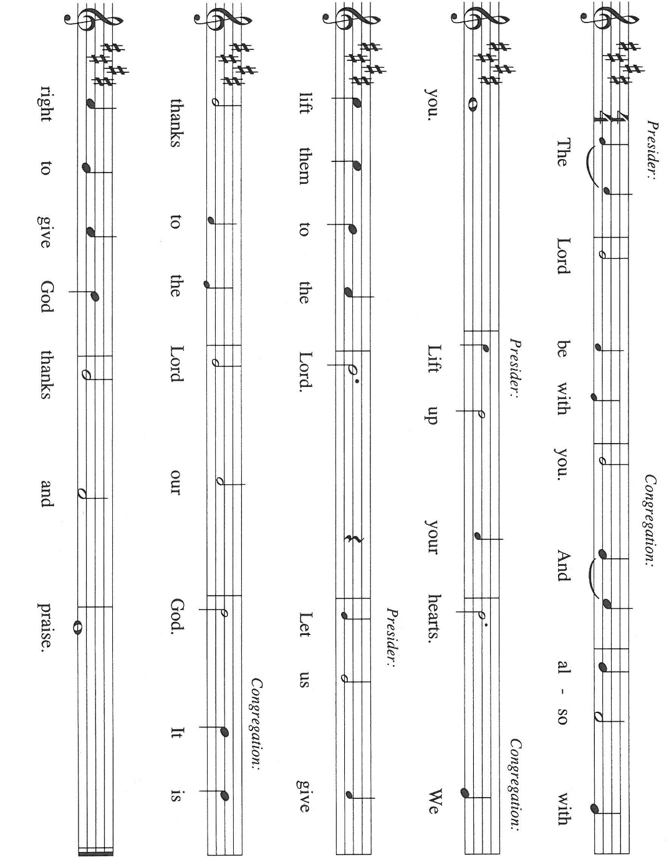
THE GREAT THANKSGIVING

P: It is our duty and delight …join their unending hymn:

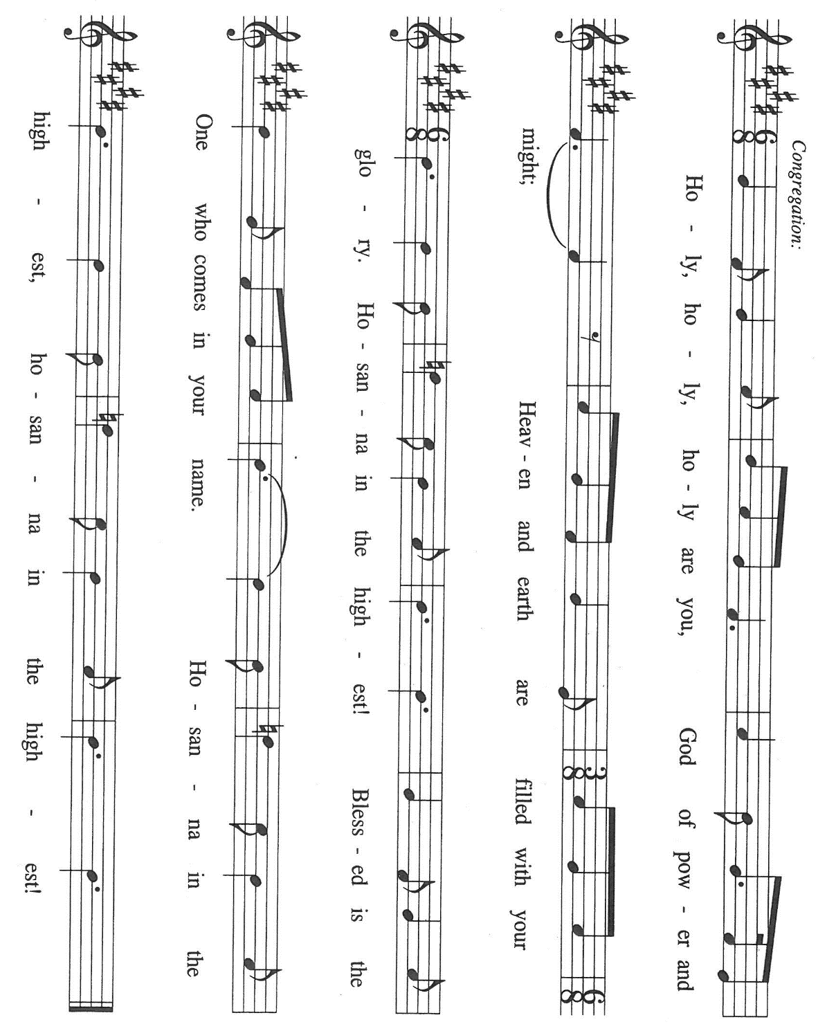

P: Blessed are You, O Lord our God, Creator of heaven and earth.
For in great love You dwell among us, and in Your glory there is life.
You chose Israel to make Your name and blessings known.
Through slavery and rescue, exile and return Your love remained faithful.
You sent prophets to turn Your people’s hearts back to You.

From them You raised up Jesus, the Messiah, Your only-begotten Son.
In Him we are called by Your name, O Lord, God of hosts.
In the night ... “Do this for the remembrance of Me.”
As often as we eat ... we proclaim the Lord’s death until He comes.

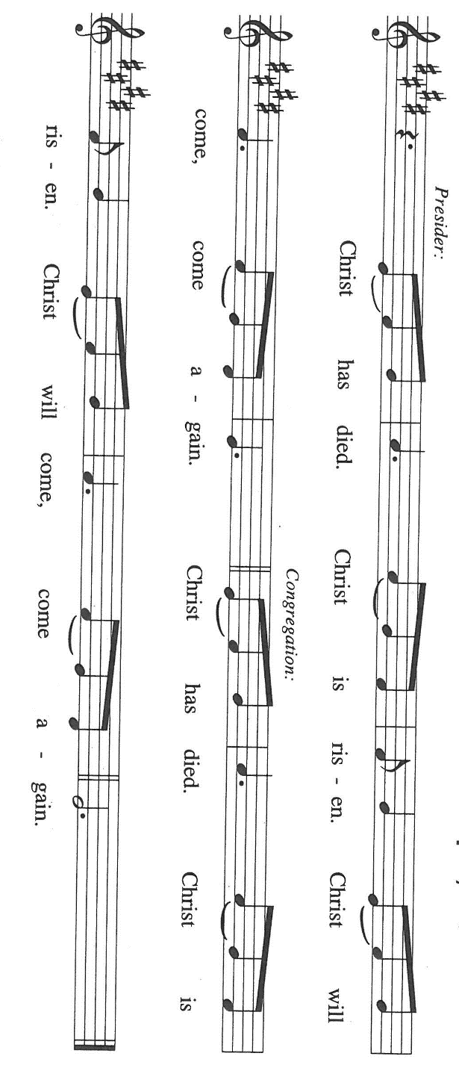

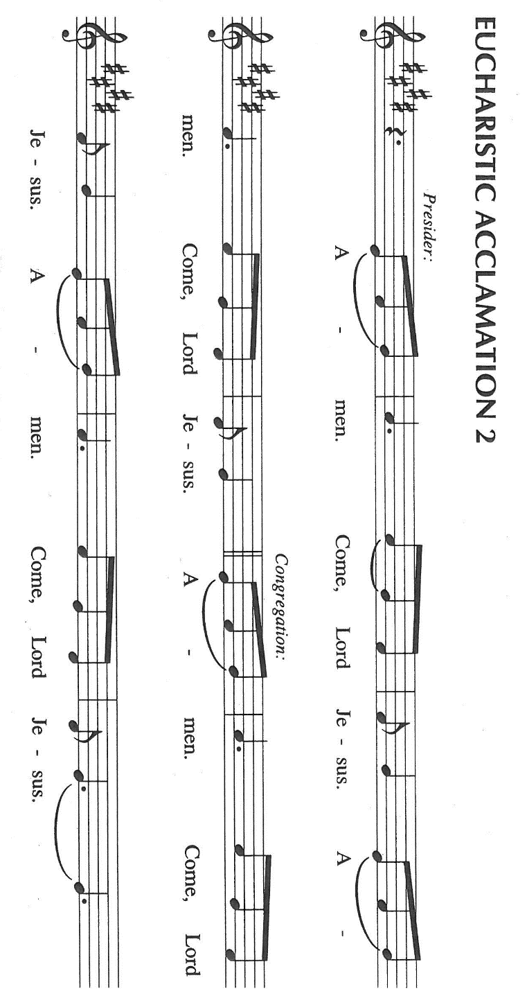

P: With this bread and cup we remember the life our Lord offered for us.
He suffered at the hands of sinners, died, and was raised on the third day.
He promised to return in glory with His angels to judge the world.

As we await His coming, we ask You: send Your Spirit on us and this bread and wine.
Strengthen us in faith and love, and grant us the courage to take up the cross and follow
Him in loving service to all the world.

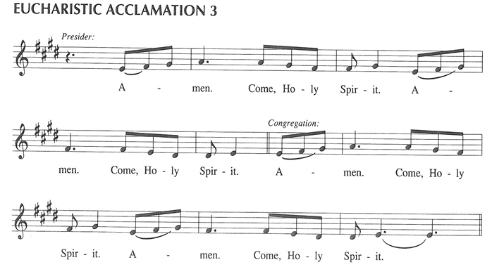

P: To You, O God: Father, Son, and Holy Spirit, be all honor and glory, in Your holy
Church, in heaven and on earth, now and forever.

C: Amen!

THE LORD’S PRAYER

P: With trust in God Whose providence nourishes and sustains us, let us now pray as Jesus
taught us:

C: Our Father, Who art in heaven, hallowed be Thy name.
Thy Kingdom come, Thy will be done on earth as it is in heaven.
Give us this day our daily bread, and forgive us our trespasses, as we forgive those
who trespass against us.
And lead us not into temptation, but deliver us from evil.
For Thine is the Kingdom, and the power, and the glory, forever and ever. Amen.

INVITATION TO THE MEAL

P: Behold the living Bread come down from heaven. Those who eat of it will never die.
Behold the cup of eternal life. Those who drink of it will life forever. God’s holy gifts
for God’s holy people. Come, for all is now ready.

The assembly is seated

THE DISTRIBUTION Lamb of God (see p. 13)

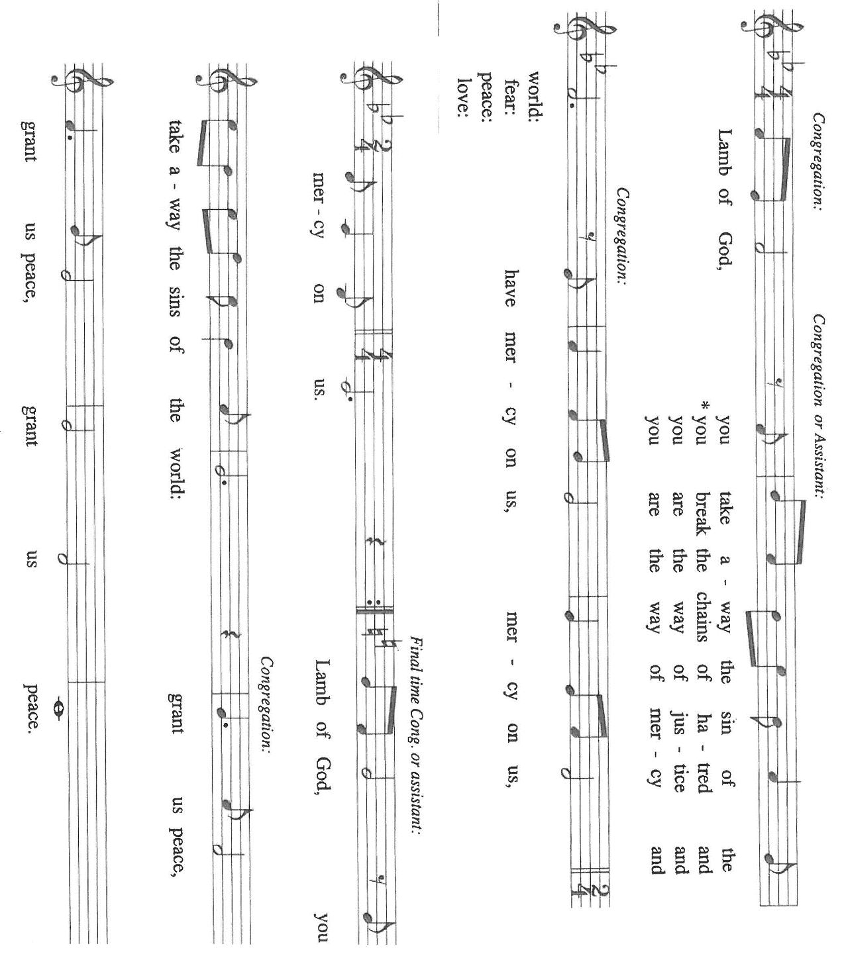

HYMN DURING DISTRIBUTION 879 For the Beauty of the Earth

ELW 336 Lamb of God

ELW 492 Eat This Bread, Drink This Cup

NSB 90 ‘Tis So Sweet to Trust in Jesus
NSB 14 Bind UsTogether

As you are able please rise

THE POST-COMMUNION BLESSING

P: The Body and Blood of our Lord Jesus Christ strengthen you and keep you in His grace.

C: Amen.

THE POST-COMMUNION PRAYER
A: Let us pray. Lord Jesus, You have gathered us around Your altar and fed us with Your Bread of Life. By our eating and drinking, set our minds on Your thoughts and our feet on Your way. Having received Your life, help us to lose ours for Your sake and for the sake of the world You died and rose to save. You are the Lord forevermore.
C: Amen.
SENDING
THE BENEDICTION
P: Almighty God: Father, Son, and Holy Spirit bless you now and forever.
C: Amen.
SENDING SONG 547 Sent Forth by God’s Blessing
THE DISMISSAL
A: Go in peace to love and serve the Lord.
C: Thanks be to God!
THE POSTLUDE
To God Alone Be Glory

The Meditation is from Richer Fare for the Christian People. Gail Ramshaw, ed. (New
York: Pueblo Publishing Company, 1990) 60-61.

The Prayers, Introduction to the Lord’s Prayer, and Invitation to the Meal are adapted from
Prayers for Sundays and Seasons. Year A. Peter J. Scagnelli. (Chicago: Liturgy
Training Publications, 1998) 114-115.

The musical setting of the liturgy, “Now the Feast and Celebration” by Marty Haugen, is
used by permission of GIA Publishers, Inc. OneLicense.net License #A-702836.



SUMMER BIRTHDAYS
Anyone who had a birthday during June, July or August, will be celebrated today, August 30th. Come on down to the St. Paul room after this morning’s service for birthday cake, coffee or water and an abundance of fellowship!

MISSION OF THE MONTH FOR AUGUST 2026
Mission of the Month for August 2026 is for Michigan City Area Schools – we will be collecting money to support different projects in various elementary schools in Michigan City through Donors Choose. Donors Choose provides a list of teacher-led classroom projects that need funding. Please consider donating to help fund our local teachers’ classroom projects. Checks can be written to St. Paul and can be marked for MCAS and placed in the offering plate. Noisy coin offering will also support the mission of the month. To see a full list of projects, visit www.donorschoose.org and search for Michigan City.

PANCAKE BREAKFAST
There will be a pancake breakfast at St. Paul Lutheran Church, 818 Franklin Street in Michigan City on Saturday, September 12th from 8:30 am – 11:00 am and everyone is welcome! Menu includes pancakes, sausage, scrambled eggs, orange juice, and coffee – all for just $5. Come join us for food and fellowship!

SEPTEMBER 2026 MONTHLY MISSION:
SHRINER’S CHILDREN’S HOSPITAL
We all know Shriner’s from their commercials and their little red hats, but nearly 20,000 children each year get to know Shriner’s Children’s Hospital in Chicago for their incredible pediatric specialty care. The hospital opened in March of 1926 with 60 beds.
60 0% of patients suffered with polio and often lived at the hospital for up to a year. Over the next few decades, an orthopedic residency, bone rodding surgery, halo ring implantation, cleft lip and palate repair, pediatric spinal cord injury surgery, and motion analysis services were added. Our very own little one, Maggie Brooks, has been visiting Shriner’s in Chicago since four weeks old to correct bilateral clubfoot, a condition where she was born with both feet turned inward and upward. Shriner’s offers care to all families no matter their ability to pay or insurance status. They even have financial assistance programs that help reimburse for transportation or lodging if needed.
At Shriner’s Chicago, every child who is inpatient receives a handmade blanket and goody bag upon arrival to the hospital. We will be collecting the following items to help fill their goody bags:
Small cars or toys
Card games
Small activity books
New or gently used children’s books
Please place items in the bin in the outer narthex. If you would like to support Shriner’s financially, please make checks out to St. Paul’s and mark for Shriner’s Children’s Hospital and place in the offering plate. Noisy coin offering will also go towards the mission of the month. Thank you for your generosity!

ANNOUNCEMENTS

Please remember to mail your offering to the Church Office at 818 Franklin Street, Michigan City, IN 46360. Another alternative is to give on-line through Tithe.ly. Please see your closure letter for information on how to set up a Tithe.ly account.

St. Paul Members are reminded to have a loved one contact the office if you are hospitalized. Many times, the Pastor doesn’t know someone is in the hospital. If you call and leave a message, please tell us at which hospital the patient is located.

BIRTHDAYS: Jan Paholski (9/2); Judy Litchford (9/2); Verne Lee (9/7);
Joan Seifert (9/8)

ANNIVERSARIES: Paul & Lora Brooks (9/6)

PRAYER CONCERNS: Debbie Martin; Mark Tannehill; Kathy Stein; Jan Paholski; Laura Dovey; Bill Hazelgrove; Al Levenhagen; Carl Wipperman; Major Payne.

OFFICE HOURS: Libby will be in the office on Mondays, Wednesdays, and Fridays; volunteers will cover Tuesdays and Thursdays.

Monday & Wednesday 8:00 a.m. – 5 p.m.
Tuesday & Thursday 9:00 a.m. – 12:00 p.m.
Friday 8:00 a.m. – 12:00 p.m.

If you are listening to the worship broadcast on the radio and would like to watch the Sunday morning service live stream follow these steps:

(1) If you have You Tube available on your TV, search for
St. Paul Lutheran Church Michigan City, IN.

(2) The direct link on the computer is https://
www.youtube.com/channel/UC5AIPNaKr3QN50984jGOa1g

(3) This link is also on the main page of the church’s website in
the church section and will continue to be posted weekly on the St.
Paul Facebook page.

And it will always be available on the radio broadcast Sunday mornings at 11:00 a.m.
on WEFM (95.9), and on the local cable access station #99 for the previous week’s
service on Sundays at 4:00 p.m. and the current service on Wednesdays at 7:00 p.m.
and Fridays at 8:30 p.m.

To send e-mail to the church office, please use the following addresses:

Pastor Mark Reshan: seniorpastor@stpaulmichigancity.com

Church Office Secretary (Libby Pollock): churchsecretary@stpaulmichigancity.com

Church Treasurer (Karen Fleming): finance@stpaulmichigancity.com

2026 Church Council:

Pastor - Mark Reshan

President - Donna Knoll

Vice President - Jan Bakken

Secretary - Judy Hunt

Treasurer - Karen Fleming

Members: Sue Koziel; Jim Schraidt; Trish Sprague; Bob Kiser; Barry Anderson; and
Pam Soule

Worship Attendance:

Wednesday, August 19, 2026 Organ Concert @12:15 p.m. 31

Saturday, August 22, 2026 @ 4:00 p.m. 27

Sunday, August 23, 2026 @ 9:00 a.m. 71

TOTAL 129

Copies of the minutes from the June 25, 2026 and July 23, 2026 Church Council meetings are on the back table in the upper Narthex. They were approved by the council via email.

Good News Newsletter: If you have an article or anything you want included in The Good News please send it to the following e-mail address: splcgoodnews@gmail.com. Pastor Pamela Thiede will be using this e-mail address to assemble The Good News each month. The deadline for getting information to Pastor Pamela will be the 20th of each month.

Next week’s lessons are Ezekiel 33: 7-11; Psalm 119: 33-40; Romans 13: 8-14;
Matthew 18: 15-20 for those of you who like to study them in advance.

ACTIVITIES, EVENTS & MEETINGS
SEPTEMBER 2026

Monday, August 31, 2026 @ 7:00 p.m. Women’s Bible Study/St. Paul Room

Tuesday, September 1, 2026 @ 10:0 a.m. Altar Guild Meeting/St. Paul Room

Wednesday, September 2, 2026 @ 10:00 a.m. God’s Purls

@ 4:30 p.m. NO CHOIR TODAY

Thursday, September 3, 2026 Faith Circle?

Saturday, September 5, 2026 @ 4:00 p.m. 15th Pentecost Worship Service/Sanctuary

Sunday, September 6, 2026 @ 9:00 a.m. 15th Pentecost Worship Service/Sanctuary
with coffee after

Wednesday, September 9, 2026 @ 10:00 a.m. God’s Purls

@ 11:00 a.m. – close GIVE Back @ Swingbelly’s

@ 3:45 p.m. Worship & Music Comm. Mtg./Luther House

@ 4:30 p.m. Choir Rehearsal/Sanctuary

Saturday, September 12, 2026 @ 8:30 a.m. – 11:00 a.m. PANCAKE BREAK FAST/St. Paul Room

@ 4:00 p.m. 16th Pentecost Worship Service/Sanctuary

Sunday, September 13, 2026 @ 9:00 a.m. 16th Pentecost Worship Service /Sanctuary
with coffee after

Monday, September 14, 2026 @ 1:00 p.m. Hope Circle/St. Paul Room

@ 7:00 p.m. Women’s Bible Study/St. Paul Room

Wednesday, September 16, 2026 @ 10:00a.m. God’s Purls

@ 4:30 p.m. Choir Rehearsal/Sanctuary

Saturday, September 19, 2026 @ 9:00 a.m. – 3:00 p.m. Stained Glass Window Tour

@ 4:00 p.m. 17th Pentecost Worship Service/Sanctuary

Sunday, September 20, 2026 @ 9:00 a.m. 17th Pentecost Worship Service/Sanctuary with coffee after

Monday, September 21, 2026 @ 2:00 p.m. Finance Comm.Meeting/Luther House

@3:00 p.m. Executive Board Meeting/Luther House

@7:00 p.m. Women’s Bible Study/St. Paul Room

Wednesday, September 23, 2026 @ 10:00 a.m. God’s Purls

@ 4:30 p.m. Choir Rehearsal/Sanctuary

Thursday, September 24, 2026 @ 3:00 p.m. Church Council Meeting/St. Paul Room
Saturday, September 26, 2026 @ 4:00 p.m. 18th Pentecost Worship Service/Sanctuary

Sunday, September 27, 2026 29:00 a.m. 18th Pentecost Worship Service/Sanctuary with coffee after

Monday, September 28, 2026 @ 7:00 p.m. Women’s Bible Study/St. Paul Room

Wednesday, September 30, 2026 @ 10:00 a.m. God’s Purls

PLEASE NOTE:
God’s Purls are still meeting every week on Wednesdays at 10:00 a.m. but they are no longer meeting in the St. Paul Room at the church. If you have any questions or concerns please contact Judy Mutchler at (219) 229-4764.

Thank$ for $haring
Thank you to all who participate in our Give-Back opportunities each month. We earned $108 from our GIVE BACK at 5 Guys on July 15, 2026. Our GIVE BACK will be at Swingbelly’s on Wednesday, September 9, 2026 from 11:00 am—Close. Here are two coupons. One for you and one for a friend.

