-
February, 2026
MARK: MY WORDS

It always seems to arrive so quickly. As of this writing, it has been only a little more than a week since the Twelve Days of Christmas ended. The decorations throughout the church building were just taken down and packed away until next year. We celebrated The Epiphany and The Baptism of Our Lord and entered into the weeks of the Epiphany season. And in a little more than a month Ash Wednesday and Lent will once again be upon us.
Perhaps that proximity is a good thing. Just as Easter is not only a Day but a full seven-week season (and, a weekly celebration every time we gather on the Lord’s Day), so Lent is not merely a series of weeks between Epiphany and Easter.
The theme of Lent, of course, is “repentance,” a re-orientation of our hearts, minds, and actions away from words and actions that separate us from God and one another toward a way of life that brings God’s mercy and hope, joy and healing to all. (See below) “Repentance” isn’t only for Lent’s Forty Days. It is, as Martin Luther taught us, a daily act arising from our Baptism in which we put off our “old” ways and re-clothe ourselves with Christ.
We heard John the Baptist call us to “repent” in Advent; and in the Gospel reading for the Third Week after The Epiphany, Jesus begins His public ministry in Matthew by echoing John’s words, “Repent, for the Kingdom of Heaven has come near.” Ash Wednesday reminds us that this turning is a life-long process, guided and empowered by the Holy Spirit given to us in our Baptism.
With the exception of the First week in Lent, when the Gospel reading is Matthew’s account of Jesus’ testing in the wilderness following His Baptism, all the Gospel texts are from John: the conversation between Jesus and Nicodemus; Jesus and the Samaritan woman at the well; the healing of the blind man; and the raising of Lazarus.
An excerpt from an essay in our worship resource, Sundays and Seasons, helps us to focus on the goal of these forty days:

Throughout the season, we are called to put our priorities in order. Throughout scripture we receive the invitation to examine ourselves. Are we storing up treasure in heaven (Matt. 6:20)? Are we bringing our questions to Jesus with hearts wide open to being transformed (John 3:1-17)? Are we being as rigorously honest in all our doings as the woman at the well (John 4)? Have we truly embraced the good news as both Martha, sister of Lazarus, and Mary, Mother of God, did (John 11:27; Luke 1:38)? Are we celebrating Jesus with the pilgrims in Jerusalem, crying, “Hosanna! God save us!” (Matt. 21:9)?
Lent is a 40-day reminder that it is God who saves. God saves us through the ministry of almsgiving as our hearts are opened to the injustices of our world. God saves us through fasting as the concerns of our hearts are reorganized when we meditate on Jesus and all that we truly hold dear. God saves us through prayer as we join Nicodemus in learning that in Jesus we are reborn; we join the woman at the well in understanding God’s unconditional love for her and the entire neighborhood; we stand with the blind man in receiving God’s healing of body and restoration to beloved community. In all the stories of this Lenten season, let us remember that the agency always belongs to our God.
With trusted Matthew and John as our guides, may God grant us a holy, renewing, and refreshing Lenten journey.



We will once again offer two liturgies on Ash Wednesday on February 18: the first at 10:00 a.m. and an evening service at 7:00 p.m. This officially begins the Forty Days of Lent leading toward the Three Great Days of Maundy Thursday, Good Friday, and the Vigil of Easter.
As we have noted in the past, the word “Lent” is drawn from an Olde English word meaning, ‘springtime.’ Lent is the time to do a “spring cleaning” of those words, actions, motivations, and intentions that are harmful and draw us away from God and our neighbor. It is a solemn time, to be sure, but it is also the season in which we especially focus on the promises of our Baptism that enable us to confess those sins and be found by the mercy of God that, as we sing each week, “creates a clean heart” in us.
By scheduling two services that day, we hope to provide the best opportunities to begin this yearly journey together. Make plans to be with us so that we may encourage and strengthen one another for the Lenten disciplines of prayer, fasting, and helping the poor.


CHURCH OFFICE CLOSURE

The church office will be closed on Monday, February 16, in honor of Presidents’ Day. It will re-open on Tuesday, February 17, at 8:00 a.m.



MID-WEEK LENTEN SERVICES

As has been our tradition, we will offer five mid-week Lenten services of Evening Prayer following Ash Wednesday and leading into Holy Week. Once again, we will use the beloved musical setting of Marty Haugen’s “Holden Evening Prayer” as the musical basis of our weekly worship services complemented by some Scripture readings, a brief homily, and some hymns.
This year we will utilize a series from our worship resource, Sundays and Seasons, based upon part of the Rite of the Affirmation of Baptism. Since the Sacrament is at the heart of our Lenten observance it seems good to revisit the promises we make to do something in response to God’s gracious gift of naming and claiming us as His own and drawing us into His mission to the world through water and the Spirit.
The theme is, “Continuing in the Covenant of Baptism,” and deals with five aspects of to what Baptism calls us as members of the Body of Christ. The schedule is:

Wednesday, February 25 “I Believe in God the Father Almighty”

Wednesday, March 4 “I Believe in Jesus Christ, His only Son, Our Lord”

Wednesday, March 11 “He Descended Into Hell”

Wednesday, March 18 “I Believe in the Holy Spirit”

Wednesday, March 25 “I Believe in the Resurrection of the Body,
and of the Life Everlasting”

All services will begin at 6:00 p.m. and will conclude by 6:30 p.m. As always, we hope that you will attend these liturgies as part of your Lenten discipline and preparation for Holy Week and Easter.



ANNIVERSARY YEAR REMINDERS

Last month’s newsletter laid out a schedule of events for this entire 150th anniversary year. Two important dates are on the horizon to which attention is needed.
The first is concerning the banquet following the special worship service on March 15. Seating will be limited to 120 persons. Reservations will begin to be received on February 1. This is first-come, first-served. Once we reach the 120-person limit, no more reservations will be accepted; so get your reservation in quickly. There will be no charge for tickets to the meal. Reservation forms will be printed in February's bulletins and can be filled out and placed in the offering plate. This is our preferred method of making a reservation. However, if you are unable to attend a service in February and would like to reserve a seat for the dinner, please email the church at churchsecretary@stpaulmichigancity.com with your name and how many seats you would like reserved.
The other upcoming event is the special liturgy on March 15. We are honored to have Bishop Timothy Graham of the Indiana-Kentucky Synod as the guest preacher that day. We will also invite former pastors and interns to be our guests. The theme for the Day, as well as for the entire year, is a line from our anniversary hymn, “Serving You Whom We Proclaim.” The hymn was written some years ago specifically for the anniversary of a congregation. It is sung to the familiar tune of Joyful, Joyful, We Adore Thee.
On this day we will reflect upon what Gospel fruits God has enabled St. Paul to produce over the years as well as look forward to what our mission and ministry might look like moving forward. There will be NO Saturday worship on March 14.

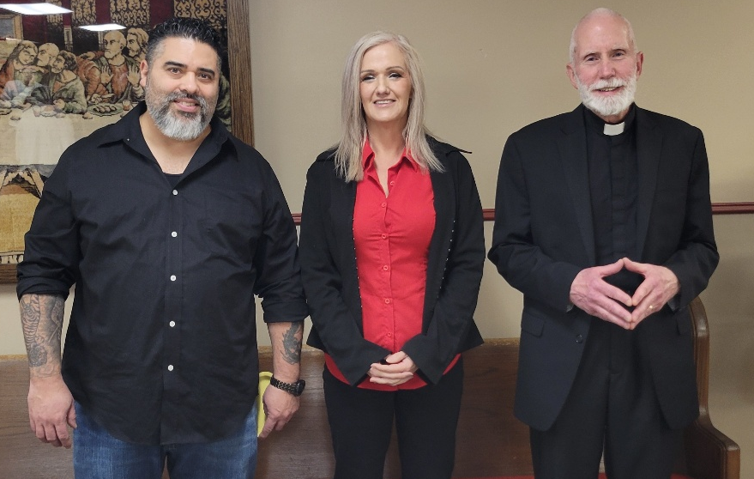
WELCOME, NEW MEMBERS

On January 11, we were privileged to receive Angela Cook and her fiancé, Frank Chavez, into membership. They have been worshiping with us for several months and are excited to have found a church home. Angela is a truck driver. She provided the many bags of new pillows that her warehouse was going to throw away to several shelters here in town. Frank works for ComEd in Illinois. Angela and Frank will be married here at church on February 28 and are excited about finding ways to join us in our ministry to the neighborhood and community. Welcome, Angela and Frank!


WORSHIP CLOSURE INFORMATION

With the especially unpredictable nature of this winter’s weather, it is good to once again offer a reminder about how to find out whether worship has been canceled due to extreme weather conditions. There are two sources for that information:
- The church Facebook page (www.facebook.com/stpaulmichigancity)
- You may dial the church office number (219-874-7293) and when the automated menu begins press the # button for a recorded announcement.
We will post the information no later than noon on Saturday, making every effort to ensure that everyone is informed as quickly as possible should such an action be taken by the Church Council.


THE COMMEMORATION OF MARTIN LUTHER

February 10 is the Commemoration of Martin Luther on the church calendar. This article has appeared in the last several years’ February newsletter, but it is always good to have our understanding of the person for whom our denomination is named renewed. Many Lutherans are unaware of details of Luther’s life; and since we, as a church body, take our name from him, it is always good to re-acquaint ourselves with that knowledge.
Throughout the church year we remember and give thanks for the lives, witness, and examples of many of the heroines and heroes of the faith. February brings an especially important one for us who share a Lutheran heritage and history.
On February 18, 1546, Martin Luther died at the age of 62 in his hometown of Eisleben, Germany. He had long suffered from poor health due to a variety of illnesses and conditions: Ménière's disease, vertigo, fainting, tinnitus, a cataract in one eye, arthritis, kidney and bladder stones, an ear infection that ruptured an ear drum, and angina.
As one would expect, as his condition worsened, so did his mood, his writings, and his sermons. It was during this time that he wrote some of his most hateful and incendiary comments about the Jewish people of Germany and Europe. Those are some of the most shameful aspects of his legacy; and over the last several decades, Lutherans worldwide have recognized the harm that they brought and repented of his vitriol to those against whom his writings were used as justification for oppression and violence.
Like all of us, Luther was a complex person. He is regularly included in the group of those who had some of the greatest influence on historical developments of his time but also one whose failings, shortcomings, and sins are as great as his accomplishments. In his own words, he, with the rest of us, are “saints and sinners” at the same time, and always in need of the gracious and merciful compassion and forgiveness God grants in Christ that he so powerfully articulated and championed throughout his life and ministry.
His famous last words are: “We are all beggars. It is true.” Perhaps that better sums up his theology and teaching better than the dozens of volumes of his sermons and teachings that we possess. That belief fits particularly well in the Lenten season in which this commemoration falls. May God grant us, with Luther, the humility, the will, the faith and hope to “beg” God for His mercy and receive it always with joy, trust, and thanksgiving.


MONTHLY MISSION: MAKERSPACE AT THE MICHIGAN CITY PUBLIC LIBRARY

The Makerspace is a place where young people can tinker, design, craft, create, and explore. It includes a variety of equipment and projects for guided exploration and hands-on learning in the STEAM areas (science, technology, engineering, arts, and math). Some of the items currently available are art supplies (markers, crayons, colored pencils, glue sticks), etch-a-sketch, rubiks cube, building toys, and 3D printers. Lots of youth visit the Makerspace, and many of the art supplies could use a refill. We will be collecting art supplies or other STEAM supplies. Please place your supplies in the bin in the outer narthex. If you wish to make a monetary donation, please make checks out to the church marked for the Makerspace and place them in the offering plate. Thank you for your generous donations to our community!



IN MEMORY OF GRANDPARENTS NORMAN & DOROTHY KRIESEL
General Fund from Terry & Kristi Milzarek

IN MEMORY OF ALLEN KRING
General Fund from Terry & Kristi Milzarek

IN MEMORY OF ROGER MILZAREK
General Fund from Terry & Kristi Milzarek

IN MEMORY OF KEVIN THIEDE
Organ Fund from Janet Bakken, Marion Joseph, Walter & Marguerite Hampton,
Rev. Pamela Thiede


February Birthdays February Anniversaries
1 Jary Tannehill 20 Tim & Laura Mellen
2 Heather Hazel 21 Charles & Sherry Payne
5 Richard Cains
7 Susan Koziel
Martha Schroeder
10 Janet Priebe-Protas
Emma Haring
12 Susan Green
14 Wayne Dolson
16 Barbara Bass
19 Kimberly Summers
22 Kelly Neulieb
Aaron Petri
24 Molly Robbins
26 Karen Schacht
27 Chip Claussen
27 Suzann Dolson



Long-Term Prayer List

Barry Anderson John Bennitt Robert Bernth
Lucas Bradshaw Laura Dovey Christine Kiser
Bethany Manning Debbie Martin Shirley McCarty
Sarah McNabb Jan Paholski Grace Romine
Martha Schroeder Jeanie Boatman Shepple Joyce Stark
Kathy Stein Mark Tannehill Kathy Thielman
David Weiss Fred Weiss Brian Wiseman



Monday 8:00 a.m. – 5 p.m.
Tuesday 9:00 a.m. – 12:00 noon
Wednesday 8:00 a.m. – 5 p.m.
Thursday 9:00 a.m. – 12 noon
Friday 8:00 a.m. – 12 noon

St. Paul Lutheran Church Staff
Pastor Rev. Mark Reshan
Secretary Libby Pollock
Accompanists Jary Tannehill, Mark Tannehill, Jacob Tannehill
Custodian Mark Kloess

Thank$ for $haring
Last month’s Give-back at Five Guys raised $114. Thank you to all who participated.

This month, are going to Galveston on Thursday, February 5. Here are two coupons—one for you and one for a friend.



