-
September, 2026
MARK: MY WORDS

It will be a festive month. There are three minor commemorations in a row on the church calendar that we will be celebrating.
First up is Holy Cross Day, which falls on September 14 (this year on Monday). In the year 326 A.D., Helena, mother of Emperor Constantine, the first Christian Emperor of the Roman Empire, made a pilgrimage to the Holy Land to find holy relics. Tradition says that she had a pagan temple that was built over the tomb of Jesus and she found the Holy Sepulcher where Jesus was buried and with it three crosses. To test the authenticity of the crosses, Helena had a dying woman touch them. Touching the first two crosses did nothing; but upon touching the third cross, the woman began to miraculously recover. Thus, Helena knew she had found the True Cross. She ordered a church to be built on the site. This day celebrates Jesus’ victory over the powers of sin, evil, and death on the cross.
Next up is the Day of St. Matthew, September 21 (on Monday this year). Although we celebrated his day last year because it fell on a Sunday; in this church year, we have been reading
from Matthew’s Gospel, so it seemed good and right to once again honor him for his story of Jesus.
Finally, we will observe the Day of St. Michael and All Angels, September 29 (on a Tuesday this year). Once again, as with the Day of St. Matthew, we celebrated this Day last year; and while we hold up Michael and the other angelic beings mentioned in Scripture, the day is called, “St. Michael and All Angels.” The word malak in Hebrew, that is usually translated as “angel,” more literally means, “messenger.” On this day, we also give thanks for the ways in which God uses each of us to bring the “message” of what He has done, what He is doing, and what He promises to do for us and the world through the crucified and risen Jesus.
These three days not only break up the monotony of the many weeks of Pentecost; but they also center us in the heart of our faith and proclamation (Holy Cross), drive us deeper into this church year’s story of Jesus (Day of St. Matthew), and strengthen us for our work in bearing the news and story of Jesus to others (St. Michael and All Angels).



The office will be closed on Monday, September 7, for Labor Day. It will reopen on
Tuesday, September 8, at 9:00 a.m.

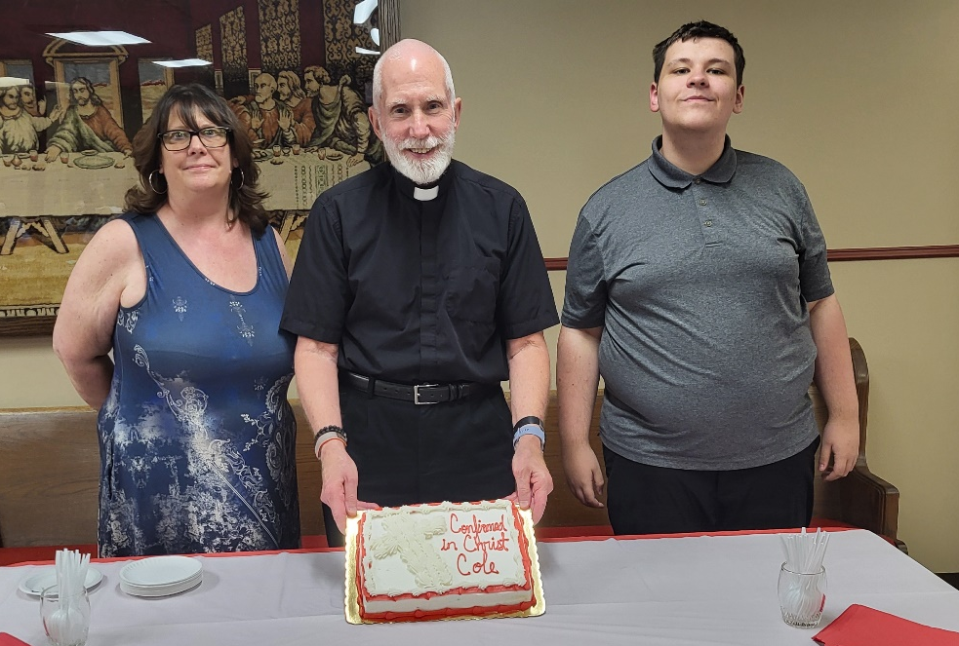
Heidi Ponder, Pastor Reshan, Cole Ponder
On Saturday, August 29, we celebrated the Confirmation of Cole Ponder, son of Heidi and grandson of Judy Gleason, and joyfully received him as the newest confirmed member of our community of faith.



INSTALLATION OF MUSICIANS
September is traditionally the time when we thank and recognize our many gifted musicians and formally install them for their ministry in the coming year. On September 13, on which we will be observing the festival of Holy Cross Day, we will again commission them for their Spirit-led leadership of our worship and praise.



St. Paul will host a pancake breakfast in the St. Paul Room on Saturday, September 12, from 8:30 – 11:00a.m.; and everyone is welcome. The menu will include pancakes, sausage, scrambled eggs, orange juice, and coffee—all for just $5. Children under 4 are free. Come join us for food and fellowship!


Our fall Bible study sessions will return for a 6-week period beginning Wednesday, September 9, and ending Wednesday, October 14. Classes begin at 9:15 a.m. and run until 10:15 a.m. As in the past, we will examine the texts for the upcoming week to provide background information and a deeper understanding of the cultural and historical factors surrounding the events of the readings.
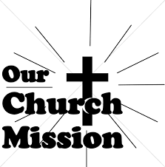
SEPTEMBER MONTHLY MISSION
SHRINER’S HOSPITAL FOR CHILDREN

We all know Shriner's from their commercials and their little red hats. Nearly 20,000 children each year get to know Shriner's Hospital for Children in Chicago for their incredible pediatric specialty care. The hospital opened in March of 1926 with 60 beds; 60% of their patients suffered with polio and often lived at the hospital for up to a year. Over the next few decades, an orthopedic residency, bone rodding surgery, halo ring implantation, cleft lip and palate repair, pediatric spinal cord injury surgery, and motion analysis services were added. Our very own little one, Maggie Brooks, has been visiting Shriner's in Chicago since she was four weeks old to correct bilateral clubfoot, a condition where she was born with both feet turned inward and upward. Shriner's offers care to all families no matter their ability to pay or insurance status. They even have financial assistance programs that help reimburse for transportation or lodging if needed.
At Shriner's Chicago, every child who is an inpatient receives a handmade blanket and goody bag upon arrival to the hospital. We will be collecting the following items to help fill their goody bags:
- Small cars or toys
- Card games
- Small activity books
- New or gently used children's books
Please place items in the bin in the outer narthex. If you would like to support Shriner's financially, please make checks out to St. Paul's, write “Shriner's Hospital” on the memo line; and place your donation in the offering plate. The noisy coin offering will also go towards the mission of the month. Thank you for your generosity!



IN MEMORY OF DIANE WALTZ
General Fund from Mitzi McGlone

IN MEMORY OF RICHARD CAINS, SR.
General Fund from Melinda Nagle, Wayne & Suzann Dolson


Happy belated birthday to Sandy Galinowski, who celebrated her birthday on August 31. We apologize for missing her special day.

September Birthdays September Anniversaries
1 Benjamin Crozier 4 Michael & Becky Greenlaw
2 Jan Paholski 6 Paul & Lora Broos
Judy Litchford 15 Richard & Pamela Henderson
5 Sarah Payne Al & Sue Green
7 Verne Lee
8 Joan Siefert
9 Mary Knapp
10 Nan Larson
11 Trish Sprague
13 Kalen Sprague
15 Richar Colins
James Krueger
16 Clay Payne
17 Hannah Tannehill
19 Kay Peglow
20 Daniel Otteresn
Laurie O’Hara
21 Ronwynn Jones
22 Helen Wiese
Sue Peiffer
23 Martin Tannehill
27 Katherine Crozier
28 Donna Knoll



Long-Term Prayer List

Lucas Bradshaw Laura Dovey Bethany Manning
Debbie Martin Shirley McCarty Jan Paholski
Martha Schroeder Jeanie Boatman Shepple Kathy Stein
Mark Tannehill Kathy Thielman Delores Williams
Brian Wiseman

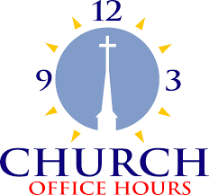

Monday 8:00 a.m. – 5 p.m.
Tuesday 9:00 a.m. – 12:00 noon
Wednesday 8:00 a.m. – 5 p.m.
Thursday 9:00 a.m. – 12 noon
Friday 8:00 a.m. – 12 noon

St. Paul Lutheran Church Staff
Pastor Rev. Mark Reshan
Secretary Libby Pollock
Accompanists Jary Tannehill, Mark Tannehill, Jacob Tannehill
Custodian Mark Kloess

Thank$ for $haring

Last month, we raised $155 from the Give Back at Holly’s. Thanks to every who participated.

This month, we are going to Swingbelly’s on Wednesday, September 9. Here are two coupons—one for you and one for a friend.

