**THE TWELFTH SUNDAY AFTER PENTECOST**

**August 31, 2025**

“God treats Jesus--and us--in the same way as the host in the parable: he cares for those who are humiliated and turns away the proud. We can see that fully only in the death and resurrection of Jesus. In (a story) which anyone can understand, today’s (reading) provides the essence of what we might call distinctive Christianity, specifically the way in which God deals with people ...”

“ ... We must not invite the rich to our tables but the poor, because the rich simply repay the compliment by inviting us back: the poor can’t do that. Only then is it evident what being good is.

God seems to have a predilection for those who do not belong to the elite or the religious clan. So Luke weaves a second parable into his story: “When you give a feast, invite the poor, the maimed, the lame and the blind.” But who does that? Nobody--apart from the community of God, the church in its celebration of the eucharist.

That is the only table to which not only friends and relatives are invited but also the cripples, the blind, the maimed and the oppressed. We can come to it in wheelchairs, with a broken and tormented heart; even our enemies may come. Here we already experience a vision of the future in which all those who are humiliated and discriminated against are exalted ... here we come together for the feast, the gathering which the people of the future share together ...”

“ ... The liturgy thus provokes us to act outside the liturgy in accordance with this vision of the coming kingdom of God among us, celebrated here symbolically in anticipation, because we cannot make it reality.

At the same time what we do here in the liturgy subjects what we do outside the liturgy to severe criticism. Despite all our good intentions, outside the liturgy we shall fail in our task ... To recognize this in penitence is already to be open to what is possible through grace, through the work of God in us.

So we have moved from the middle-class table to what the gospel calls the eschatological banquet, where without any failure in communications everyone may sit in the place of honor.”

**Edward Schillebeeckx**

***God Among Us: The Gospel Proclaimed***

**✠ In the Name of Jesus ✠**

**✠ GATHERING ✠**

**INTRODUCTION**

Invited and inviting—that is the nature of the church. By God's grace in holy baptism we have a place at the banquet table of the Lord. When, by the power of that same Spirit, humility and mutual love continue among us, the church can be more inviting still.

**Augustine, Bishop of Hippo, died 430**

*Augustine was one of the greatest theologians of the Western church. A native of North Africa, he recovered from a debauched young adulthood through the influence of his mother, Monica, and Bishop Ambrose of Milan. Besides writing influential theological books, he served as bishop of Hippo, in present-day Algeria.*

**Moses the Black, monk, martyr, died around 400**

*Converted from life as a thief and a robber to Christianity, Moses was an Ethiopian who became a desert monk at Skete. The change in his heart and life had a profound impact on his native country. He was murdered when Berber bandits attacked his monastery.*

**PRELUDE**

**ANNOUNCEMENTS**

*As you are able please arise*

**BAPTISMAL HYMN 448 *This Is the Spirit’s Entry Now***

**THE GREETING AND PRAYER OF THE DAY**

P: The grace of our Lord Jesus Christ, the love of God, and the communion of the Holy

Spirit be with you all.

**C: And also with you.**

*The assembly is seated*

**THE SACRAMENT OF HOLY BAPTISM**

**Presentation**

*Candidates for baptism, sponsors, and parents gather with the ministers at the font.*

*The presiding minister may address the assembly in these or similar words:*

In baptism our gracious heavenly Father frees us from sin and death by joining us to the death and resurrection of our Lord Jesus Christ. We are born children of a fallen humanity; by water and the Holy Spirit we are reborn children of God and made members of the church, the body of Christ. Living with Christ and in the communion of saints, we grow in faith, love, and obedience to the will of God.

*Sponsors for each candidate, in turn, present the candidates:*

I present ***Leona Harper***for baptism.

*The presiding minister addresses parents or others who bring for baptism children who are not able to answer for themselves:*

Called by the Holy Spirit, trusting in the grace and love of God, do you desire to have ***Leona Harper***baptized into Christ?

*Response:*

I do.

*The presiding minister continues:*

As you bring ***Leona Harper***to receive the gift of baptism, you are entrusted with responsibilities:

to live with her among God's faithful people,

bring her to the word of God and the holy supper,

teach her the Lord's Prayer, the Creed, and the Ten Commandments,

place in her hands the holy scriptures,

and nurture her in faith and prayer,

so that she may learn to trust God,

proclaim Christ through word and deed,

care for others and the world God made,

and work for justice and peace.

Do you promise to help ***Leona Harper***grow in the Christian faith and life?

*Response:*

I do.

*The presiding minister addresses sponsors:*

Sponsors, do you promise to nurture ***Leona Harper***in the Christian faith as you are empowered by God's Spirit, and to help her live in the covenant of baptism and in communion with the church?

*Response:*

I do.

*The presiding minister addresses the assembly:*

People of God, do you promise to support ***Leona Harper*** and pray for her in her new life in Christ?

**We do.**

*As you are able please rise*

**Profession of Faith**

*The presiding minister addresses candidates for baptism as well as the parents and sponsors of young children. The assembly may join in the responses.*

I ask you to profess your faith in Christ Jesus, reject sin, and confess the faith of the church.

Do you renounce the devil and all the forces that defy God?

*Parents and sponsors:*

I renounce them.

Do you renounce the powers of this world that rebel against God?

*Parents and sponsors:*

I renounce them.

Do you renounce the ways of sin that draw you from God?

*Parents and sponsors:*

I renounce them.

*The presiding minister addresses the candidates and the assembly.*

Do you believe in God the Father?

**I believe in God, the Father almighty,**

**creator of heaven and earth.**

Do you believe in Jesus Christ, the Son of God?

**I believe in Jesus Christ, His only Son, our Lord.**

**He was conceived by the power of the Holy Spirit**

**and born of the virgin Mary.**

**He suffered under Pontius Pilate,**

**was crucified, died, and was buried.**

**He descended into hell.**

**On the third day He rose again.**

**He ascended into heaven,**

**and is seated at the right hand of the Father.**

**He will come again to judge the living and the dead.**

Do you believe in God the Holy Spirit?

**I believe in the Holy Spirit,**

**the holy catholic church,**

**the communion of saints,**

**the forgiveness of sins,**

**the resurrection of the body,**

**and the life everlasting. Amen.**

**Thanksgiving at the Font**

*Water may be poured into the font before or during the thanksgiving. At the font, the presiding minister begins the thanksgiving:*

The Lord be with you.

**And also with you.**

Let us give thanks to the Lord our God.

**It is right to give our thanks and praise.**

Blessed are You, O God, maker and ruler of all things. Your voice thundered over the waters at creation. You water the mountains and send springs into the valleys to refresh and satisfy all living things.

Through the waters of the flood You carried those in the ark to safety. Through the sea You led Your people Israel from slavery to freedom. In the wilderness You nourished them with water from the rock, and You brought them across the river Jordan to the promised land.

By the baptism of His death and resurrection, Your Son Jesus has carried us to safety and freedom. The floods shall not overwhelm us, and the deep shall not swallow us up, for Christ has brought us over to the land of promise. He sends us to make disciples, baptizing in the name of the Father, and of the Son, and of the Holy Spirit.

Pour out Your Holy Spirit; wash away sin in this cleansing water; clothe the baptized with Christ; and claim Your daughters and sons, no longer slave and free, no longer male and female, but one with all the baptized in Christ Jesus, Who lives and reigns with You in the unity of the Holy Spirit, one God, now and forever.

**Amen.**

*The assembly is seated.*

**Baptism**

*The presiding minister baptizes each candidate. The candidate is immersed into the water, or water is poured on the candidate's head, as the presiding minister says:*

***Leona Harper*** I baptize you in the name of the Father, and of the Son, and of the Holy Spirit.

**Amen.**

**You belong to Christ,**

**in Whom you have been baptized.**

*The presiding minister continues:*

Let us pray.

We give you thanks, O God that through water and the Holy Spirit you give your daughters and sons new birth, cleanse them from sin, and raise them to eternal life.

*Laying both hands on the head of each of the newly baptized, the minister prays for each:*

Sustain ***Leona Harper*** with the gift of Your Holy Spirit: the spirit of wisdom and understanding, the spirit of counsel and might, the spirit of knowledge and the fear of the Lord, the spirit of joy in Your presence, both now and forever.

**Amen.**

*The presiding minister marks the sign of the cross on the forehead of each of the baptized. Oil prepared for this purpose may be used. As the sign of the cross is made, the minister says:*

***Leona Harper*,** child of God, you have been sealed by the Holy Spirit and marked with the cross of Christ forever.

**Amen.**

**Welcome**

*A lighted candle may be given to each of the newly baptized (to a sponsor of a young child) as a representative of the congregation says:*

Let your light so shine before others

that they may see your good works

and glorify your Father in heaven.

*The ministers and the baptismal group face the assembly. A representative of the congregation leads the assembly in the welcome.*

Let us welcome the newly baptized.

**We welcome you into the body of Christ and into the mission we share:**

**join us in giving thanks and praise to God**

**and bearing God's creative and redeeming word to all the world.**

**THE PRAYER OF THE DAY**

P: The grace of our Lord Jesus Christ, the love of God, and the communion of the Holy

Spirit be with you all.

**C: And also with you.**

P: Let us pray. O God, You resist those who are proud and give grace to those who are

humble. Give us the humility of Your Son, that we may embody the generosity of Jesus

Christ, our Savior and Lord.

**C: Amen.**

*The assembly is seated*

**✠ WORD ✠**

**FIRST READING Proverbs 25: 6-7**

*The Book of Proverbs is known as wisdom literature. Proverbs presents a view of life that is orderly, simple, and practical. The truth of the advice on humility in the presence of the ruler is self-evident.*

6Do not put yourself forward in the king's presence

or stand in the place of the great;

7for it is better to be told, "Come up here,"

than to be put lower in the presence of a noble.

The Word of the Lord.

**Thanks be to God.**

**THE PSALM: Psalm 112 Read responsively**

1Hallelujah! Happy are they who fear the LORD

     and have great delight in God's commandments!

**2Their descendants will be mighty in the land;**

**the generation of the upright will be blessed.**

3Wealth and riches will be in their house,

     and their righteousness will last forever.

**4Light shines in the darkness for the upright;**

**the righteous are merciful and full of compassion.**

5It is good for them to be generous in lending

     and to manage their affairs with justice.

**6For they will never be shaken;**

**the righteous will be kept in everlasting remembrance.**

7They will not be afraid of any evil rumors;

     their heart is steadfast, trusting in the LORD.

**8Their heart is established and will not shrink,**

**until they see their desire upon their enemies.**

9They have given freely to the poor, and their righteousness stands fast forever;

     they will hold up their head with honor.

**10The wicked will see it and be angry; they will gnash their teeth and pine away;**

**the desires of the wicked will perish.**

**SECOND READING Hebrews 13: 1-8, 15-16**

*The epistle to the Hebrews is a theological treatise that addresses many issues related to Christian doctrine. At the end of the letter, however, we find a list of exhortations that indicate faith is not only a matter of what we believe, but also of how we live.*

1Let mutual love continue. 2Do not neglect to show hospitality to strangers, for by doing that some have entertained angels without knowing it. 3Remember those who are in prison, as though you were in prison with them; those who are being tortured, as though you yourselves were being tortured. 4Let marriage be held in honor by all, and let the marriage bed be kept undefiled; for God will judge fornicators and adulterers. 5Keep your lives free from the love of money, and be content with what you have; for He has said, "I will never leave you or forsake you." 6So we can say with confidence,

"The Lord is my helper;

I will not be afraid.

What can anyone do to me?"

7Remember your leaders, those who spoke the word of God to you; consider the outcome of their way of life, and imitate their faith. 8Jesus Christ is the same yesterday and today and forever.

15Through Him, then, let us continually offer a sacrifice of praise to God, that is, the fruit of lips that confess His name. 16Do not neglect to do good and to share what you have, for such sacrifices are pleasing to God.

The Word of the Lord.

**Thanks be to God.**

*As you are able please rise*

**THE VERSE** Sung twice

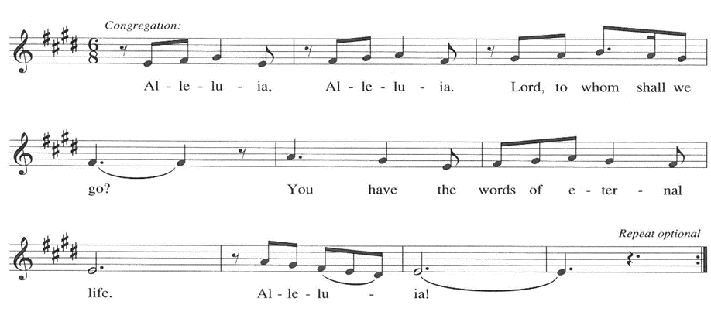

**THE HOLY GOSPEL Luke 14: 1, 7-14**

*In Luke's gospel, Jesus often tells parables about meals in order to illustrate God's unexpected grace and lead people to a faithful response. Here, we have two examples of these stories, one extolling humility and the other, inclusivity.*

P: The Holy Gospel according to St. Luke, the fourteenth chapter.

**C: Glory to You, O Lord!**

1On one occasion when Jesus was going to the house of a leader of the Pharisees to eat a meal on the Sabbath, they were watching Him closely. 7When He noticed how the guests chose the places of honor, He told them a parable.

8"When you are invited by someone to a wedding banquet, do not sit down at the place of honor, in case someone more distinguished than you has been invited by your host; 9and the host who invited both of you may come and say to you, 'Give this person your place,' and then in disgrace you would start to take the lowest place. 10But when you are invited, go and sit down at the lowest place, so that when your host comes, he may say to you, 'Friend, move up higher'; then you will be honored in the presence of all who sit at the table with you. 11For all who exalt themselves will be humbled, and those who humble themselves will be exalted."

12He said also to the one who had invited Him, "When you give a luncheon or a dinner, do not invite your friends or your brothers or your relatives or rich neighbors, in case they may invite you in return, and you would be repaid. 13But when you give a banquet, invite the poor, the crippled, the lame, and the blind. 14And you will be blessed, because they cannot repay you, for you will be repaid at the resurrection of the righteous."

P: The Gospel of the Lord.

**C: Praise to You, O Christ!**

*The assembly is seated*

**THE SERMON**

*Silence for reflection follows the sermon*

*As you are able please rise*

**THE HYMN OF THE DAY 532 *Gather Us In***

**THE PRAYER OF THE CHURCH**

A: Let us lift our hearts and voices in behalf of the Church, the world, and all those in need

of our prayers and the healing presence and power of God.

A: That we who serve God in our labor may joyfully give of ourselves without expecting

reward, let us pray to the Lord:

**C: Lord, hear our prayer.**

A: That in places of violence, war, and unrest, especially in Gaza, Ukraine, Kenya, Sudan,

Darfur, and Haiti there might come a genuine and lasting peace, let us pray to the Lord:

**C: Lord, hear our prayer.**

A: That ***Leona Harper,***newly baptized, may be filled with the Holy Spirit, lack no spiritual

gift, and grow into the fullness of new life in the Christ to Whom she has been joined,

let us pray to the Lord:

**C: Lord, hear our prayer.**

A: That those who labor might find contentment and fulfillment in their work, and those

who are unemployed or under-employed may be led to fuller opportunities to earn their

livelihood, let us pray to the Lord:

**C: Lord, hear our prayer.**

A: That our welcome in this assembly of all to the Lord’s Table might reflect the joy of

the great and promised Feast to come, let us pray to the Lord:

**C: Lord, hear our prayer.**

A: That those burdened in body, mind, or spirit, especially: **Martha Schroeder; Fred**

**Weiss; David Weiss; Barry Anderson; Lucas Bradshaw; Shirley Freels; Bob**

**Pheanis; Christine Kiser; John Bennitt; Mike Galinowski; Bill Hazelgrove; and**

**Jess Kalvaitis** might be bathed in the healing power of God, let us pray to the Lord:

**C: Lord, hear our prayer.**

A: That those celebrating birthdays, especially **Jan Paholski and Verne Lee; and**

**anniversaries, especially Paul and Lora Brooks** may be filled with grace this day

and every day and grow in grace in the days ahead, let us pray to the Lord:

**C: Lord, hear our prayer.**

A: That with all the saints, especially **Augustine, Bishop of Hippo, and Moses the Black,**

**monk and martyr** whom we commemorate this Day we too may walk Jesus’ way of

humble obedience and self-giving love, let us pray to the Lord:

**C: Lord, hear our prayer.**

P: We beseech You, O God, for Your peacefulness, Your humility, and Your love, both

for ourselves and for our world. Hear and grant our prayers according to Your gracious

and saving will, for the sake of Jesus Christ our Lord.

**C: Amen.**

**✠ MEAL ✠**

**THE PEACE**

P: The peace of the Lord be with you always.

**C: And also with you.**

*The assembly is seated*

**THE OFFERING**

**THE VOLUNTARY *Goodness of God*  New Song Praise Band**

**(Jen Johnson)**

*As you are able please rise*

**THE OFFERTORY 465 *As the Grains of Wheat***

**THE OFFERTORY PRAYER**

A: Let us pray. Almighty God,

**C: As You give strength and wisdom for our daily work, keep us grounded in Your**

**faithful love. Receive these offerings as a sign that we depend wholly on You, and**

**by this holy Sacrament, fill us with the heart and life of Christ. We ask this in the**

**name of Jesus the Lord. Amen.**

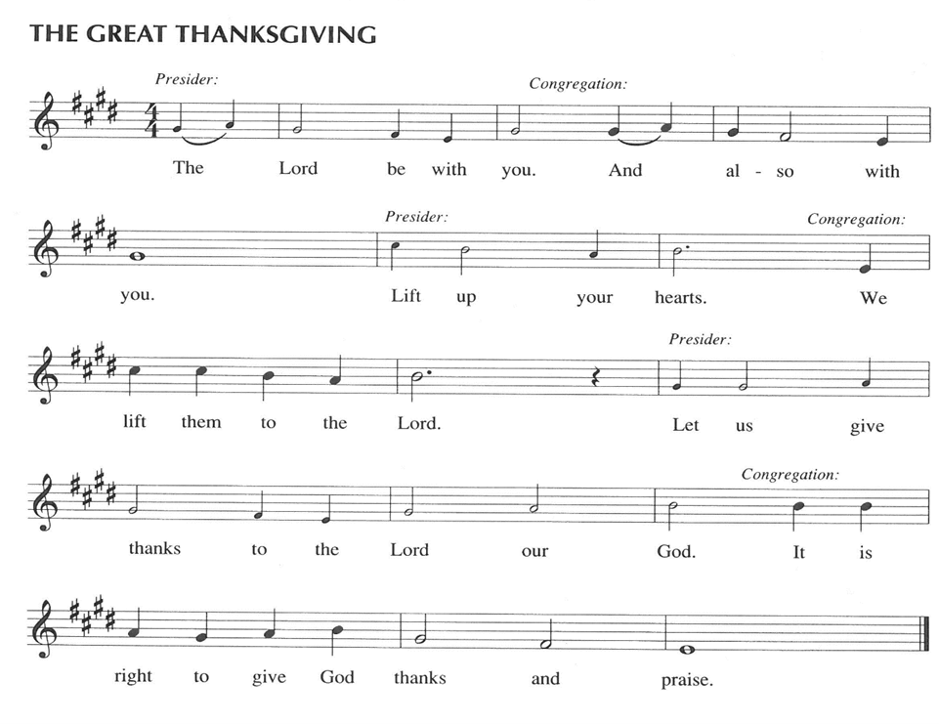

P: It is our duty and delight … join their unending hymn

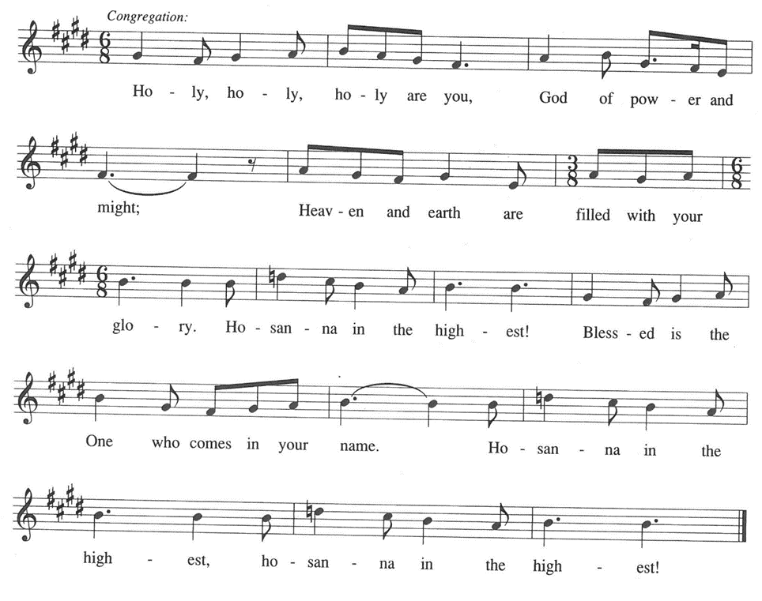

P: Exalted above all is Your name, God of Jacob, for You feed Your people, not only

for today but for eternity with Your good that truly satisfies.

When Your people hungered, You longed to feed them with the finest wheat, and

through the grace of Your servant Joseph turned famine into abundant

provision.

When You brought Your children out of slavery, You filled their mouths with good

things and led them to life in a land of plenty.

In the fullness of time, Your Son gave us a place of honor at the Banquet of salvation,

which is more than we could ever deserve.

Transforming God, as You exalt the humble and humble the exalted, pour Your grace

upon Your Church gathered to remember the dying and rising of Your Son.

Send Your Spirit upon this bread and cup that they may be for us the Body and Blood

of our Lord Jesus Christ,

Who, in the night ... “Do this for the remembrance of Me.”

As often as we eat ... we proclaim the Lord’s death until He comes.

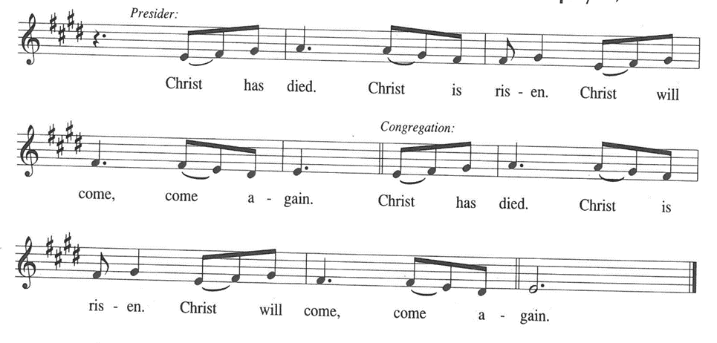

P: Inviting God, as in Your Son You beckon the poor and the crippled and the blind

and the lame,

Visit Your Church where it is poor, and make it reflect the wonder of Your love.

Renew Your people where they are crippled, that Your power may be made perfect

in weakness;

Empower Your children where they are blind, that they may know You more truly;

And uphold Your saints where they are lame, that they may find friends gracious

in support and strength with whom they may never be afraid.

Make Your Church a place of hospitality, that it may entertain angels unawares.

For in Christ You are the same yesterday, today, and forever, and in the power of

Your Spirit we shall never walk alone,

Heavenly Father, radiant in glory.

**C: Amen!**

**THE LORD’S PRAYER**

P: Gathered into one by the Spirit, let us pray as Jesus taught us:

**C: (Sung) Music is on the front page of the red hymnal**

**INVITATION TO THE MEAL**

P: This is the Lamb of God Who takes away the sin of the world. Blessed are those who

are called to the supper of the Lamb. God’s holy gifts for God’s holy people. Come,

for all is now ready.

*The assembly is seated*

**THE DISTRIBUTION “Lamb of God”**

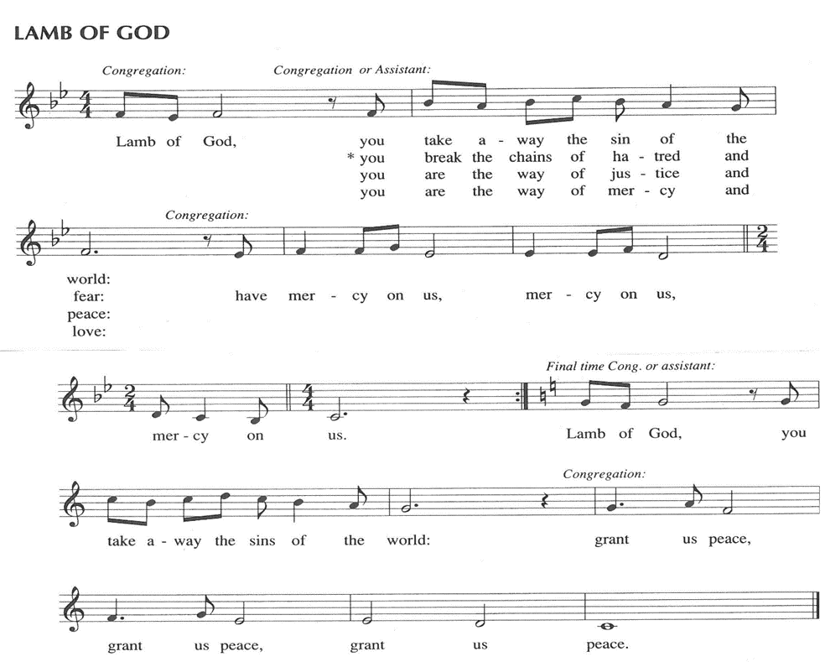

**HYMN DURING DISTRIBUTION 522 *As We Gather at Your Table***

**ELW 531 *The Trumpets Sound, The Angels Sing***

**ELW 641 *All Are Welcome***

**ELW 525 *You Are Holy***

*As you are able please rise*

**THE POST-COMMUNION BLESSING**

P: The Body and Blood of our Lord Jesus Christ strengthen you and keep you in His grace.

**C: Amen.**

**THE POST-COMMUNION PRAYER**

A: Let us pray. Lord Jesus Christ, once again You have prepared a place of honor for us

at Your Banquet of love. With great joy we celebrate Your obedience to the Father’s

gracious will. Let the Spirit of Your love rule us, that in humility we may embody the

grace of Your Kingdom. You are the Lord forevermore.

**C: Amen.**

**✠ SENDING ✠**

**THE BENEDICTION**

P: Almighty God: Father, Son, **✠** and Holy Spirit bless you now and forever.

**C: Amen.**

**THE SENDING SONG 538 *The Lord Now Sends Us Forth***

**THE DISMISSAL**

A: Go in peace to bear Christ’s love to all the world.

**C: Thanks be to God!**

**POSTLUDE**

**✠ To God Alone Be Glory ✠**

The Meditation is from *Richer Fare for the Christian People.* Gail Ramshaw, ed. (New

York: Pueblo Publishing Company, 1990) 199-200.

The musical setting of the liturgy, “Now the Feast and Celebration” by Marty Haugen, is

used by permission of GIA Publishers, Inc. OneLicense.net License #A-702836.

**ANNOUNCEMENTS**

**Please remember to mail your offering to the Church Office** at 818 Franklin Street, Michigan City, IN 46360**.** Another alternative is to give on-line through Tithe.ly. Please see your closure letter for information on how to set up a Tithe.ly account.

**St. Paul Members are reminded to have** a loved one contact the office if you are hospitalized. Many times, the Pastor doesn’t know someone is in the hospital. If you call and leave a message, please tell us at which hospital the patient is located.

**BIRTHDAYS: Jan Paholski (9/2); Verne Lee (9/7)**

**ANNIVERSARIES: Paul & Lora Brooks (9/6)**

**PRAYER CONCERNS:** Bev Coburn; Barry Anderson; John Bennitt; Judy

Gustum; Bob Pheanis; Larry Litchford, Sarah McNabb, Jeanie Boatman Shepple,

Debbie Martin, Mark Tannehill, Kathy Stein, Jan Paholski, Laura Dovey, Grace

Romine; Mike Galinowski and Bill Hazelgrove.

**OFFICE HOURS:** Libby will be in the office on Mondays, Wednesdays, and Fridays; volunteers will cover Tuesdays and Thursdays.

  Monday & Wednesday 8:00 a.m. – 5 p.m.

Tuesday & Thursday 9:00 a.m. – 12:00 p.m.

Friday 8:00 a.m. – 12:00 p.m.

**If you are listening to the worship broadcast on the radio and would like to watch the Sunday morning service live stream follow these steps:**

(1) If you have You Tube available on your TV, search for

**St. Paul Lutheran Church Michigan City, IN.**

(2) The direct link on the computer is [https://](https://www.youtube.com/channel/UC5AIPNaKr3QN50984jGOa1g)

[www.youtube.com/channel/UC5AIPNaKr3QN50984jGOa1g](https://www.youtube.com/channel/UC5AIPNaKr3QN50984jGOa1g).

   (3) This link is also on the main page of the church’s website in

the church section and will continue to be posted weekly on the St.

Paul Facebook page.

And it will always be available on the radio broadcast Sunday mornings at 11:00 a.m.

on WEFM (95.9), and on the local cable access station #99 for the previous week’s

service on Sundays at 4:00 p.m. and the current service on Wednesdays at 7:00 p.m.

and Fridays at 8:30 p.m.

**Sunday’s lessons are Deuteronomy 30: 15-20; Psalm 1; Philemon 1-21; and**

**Luke 14: 25-33** for those of you who like to study them in advance.

**To send e-mail to the church office**, please use the following addresses:

Pastor Mark Reshan: seniorpastor@stpaulmichigancity.com

Church Office Secretary (Libby Pollock): churchsecretary@stpaulmichigancity.com

Church Treasurer (Karen Fleming): finance@stpaulmichigancity.com

**2025 Church Council:**

Mark Reshan - Pastor

 Janet Bakken – President

 Donna Knoll – Vice President

 Judy Hunt – Secretary

 Karen Fleming – Treasurer

 Members: Paul Brooks, Diane Egilske, Sue Koziel, Judy Mutchler,

Jim Schraidt, Trish Sprague

**Worship Attendance:**

**Saturday , August 23, 2025 @ 4:00 p.m. 23**

**Sunday, August 24, 2025 @ 9:00 a.m. 75**

**TOTAL 98**

**Copies of the minutes from the May 1, 2025 and the June 26, 2025 Church Council meetings are on the back table in the upper Narthex. They were approved by the council via email.**

**The Good News Newsletter**: If you have an article or anything you want included in **The Good News** please send it to the following e-mail address: splcgoodnews@gmail.com. Pastor Pamela Thiede will be using this e-mail address to assemble **The Good News** each month. The deadline for getting information to Pastor Pamela will be the 20th of each month.

**DOES YOUR BIRTHDAY OCCUR IN THE SUMMER MONTHS?** If you wereborn during June, July orAugust, come to the Coffee Hour after the Sunday service on Sunday, August 31, 2025. Join us as we celebrate you and all those who have a summer birthday.

**AUGUST 2025 MISSION OF THE MONTH**

**The Mission of the Month for August: Michigan City Area Schools – It’s back to school time already!** Let’s help our area kids start the year out on a good note! We will be collecting money to support different projects in various elementary schools in Michigan City through Donors Choose. Donors Choose provides a list of teacher-led classroom projects that need funding. Flexible seating, music education, and classroom supplies are some of the options we can provide to our elementary schools. Please consider donating to help fund our local teachers’ classroom projects! Checks can be written to St. Paul Lutheran Church and can be marked for MCAS and placed in the offering plate. Noisy coin offering will also support the mission of the month. To see a full list of projects visit, [www.donorschoose.org](http://www.donorschoose.org) and search for Michigan City.

**2025 Financial Stewardship**

Weekly Church Operating Needs (x 2 weeks)

August 9 -10, 2025; August 16 -17, 2025: $ 10,600.00

General Fund (including General Memorials): $ 7,388.00

Overage/Shortage: — $ 4,202.50

Restricted Income (not including Memorials)

Supports IK Synod & Church wide Ministries: $ 139.00

Ministries in our Community/Congregation: $ 160.00

Capital Fund: $ 261.00

**September 2025 Mission of the Month**

The Mission of the Month for September 2025: ZERO Prostate Cancer

September is Prostate Cancer Awareness Month. Prostate cancer will affect about one in seven men in their lifetime and about 35,000 men will die from prostate cancer this year. Fortunately, if detected early, prostate cancer can be successfully treated, and new treatments are becoming available to extend the lives of men with advanced disease. ZERO is the largest prostate cancer support, education and advocacy organization in the United States. It offers free support and education services to prostate cancer patients, and advocates for research funding and improved prostate cancer treatment. Jim Schraidt is a fifteen-year prostate cancer survivor and a member of the Board of Directors of ZERO. He leads a monthly ZERO-sponsored support group that meets in Chicago with simultaneous virtual access. Jim is happy to answer questions about prostate cancer and ZERO, and more information can be found at <https://zerocancer.org>.

Checks can be written to St. Paul and can be marked for ZERO and placed in the offering plate.

Noisy coin offering will also support the mission of the month.

**ACTIVITIES, EVENTS & MEETINGS**

**AUGUST 2025**

**Saturday,** August 30, 2025 @ 4:00 p.m. Pent 12 Worship Service/Sanctuary

**Sunday,** August 31, 2025 @ 9:00 a.m. Pent 12 Worship Service/Sanctuary with Coffee after/St. Paul Room

**ACTIVITIES, EVENTS & MEETINGS**

**SEPTEMBER 2025**

**Monday, September 1, 2025 OFFICE CLOSED FOR LABOR DAY**

**Wednesday,** September 3, 2025 @ 10:00 a.m. God’s Purls/St. Paul Room

**Thursday,** September 4, 2025 Faith Circle

**Saturday,** September 6, 2025 @ 4:00 p.m. Pent 13 Worship Service/Sanctuary

**Sunday,** September 7, 2025 @ 9:00 a.m. Pent 13 Worship Service/Sanctuary with

coffee after in the St. Paul Room

**Monday,** September 8, 2025 @ 1:00 p.m. Hope Circle/Green Room

**Tuesday,** September 9, 2025 all day until close **GIVE BACK at Holly’s Restaurant**

@ 7:00 p.m. Estuary/Luther House

**Wednesday,** September 10, 2025 @ 10:00 a.m. God’s Purls/St. Paul Room

@ 4:30 p.m. Choir Rehearsal/Sanctuary

**Saturday,** September 13, 2025 @ 4:00 p.m. Pent 14 (Holy Cross Day) Worship

**Sunday,** September 14, 2025 @ 9:00 a.m. Pent 14 (Holy Cross Day) Worship

Installation of Musicians with coffee after/St. Paul Room

**Wednesday,** September 17, 2025 @ 9:15 a.m. Bible Study/Luther House

@10:00 a.m. God’s Purls/St. Paul Room

@ 4:30 p.m. Choir Rehearsal/Sanctuary

**Saturday,** September 20, 2025 @ 4:00 p.m. Pent 15 (Day of St. Matthew) Worship

**Sunday,** September 21, 2025 @9:00 a.m. Pent 15 (Day of St. Matthew) Worship with coffee after/St. Paul Room

**Monday,** September 22, 2025 @ 2:00 p.m. Finance Comm. Mtg./Luther House

@3:00 p.m. Executive Board Mtg./Luther House

**Tuesday,** September 23, 2025 @ 4:00 p.m. 150th Anniv. Comm. Mtg./Luther House

**Wednesday,** September 24, 2025 @ 9:15 a.m. Bible Study/Luther House

@ 10:00 a.m. God’s Purls/St. Paul Room

@ 4:30 p.m. Choir Rehearsal/Sanctuary

**Thursday,** September 25, 2025 @ 5:30 p.m. Church Council Mtg./St. Paul Room

**Saturday,** September 27, 2025 @ 4:00 p.m. Pent 16 (Day of St. Michael &All The Angels) Worship Service/Sanctuary

**Sunday,** September 28, 2025 @ 9:00 a.m. Pent 16 (Day of St. Michael &All The Angels) Worship with coffee after/St. Paul Room

Thank$ for $haring

Thanks to all who participate in the Give Back opportunities! Our next Give Back will be at Holly’s on Tuesday, September 9, 2025.  Here are two coupons—one for you and one for a friend.

