THE SEVENTH SUNDAY OF EASTER
Observed as The Ascension of Our Lord
May 17, 2026

“The next statement of the creed identifies Jesus as the one who “ascended into heaven, and is seated at the right hand of the Father.” Thereby, the creed reminds us that the friend of sinners is indeed at the reins of the universe. Far from being absent from them, he is where God is—in control of his world, and ruling it as a part of his love for the sinners he wills to befriend.
Like the statement about the descent to the netherworld, the confession of Jesus’ ascension makes no sense if it is taken as a cosmological or astronautical statement. The ascension was not like climbing up a ladder. Rather, it is imagery in the service of a profound theological truth: Jesus, who is the sinners’ friend, is not a pretender, a wishful thinker hoping that things will turn out for them in the end.
He is, in fact, in charge, and he is bringing about that good and gracious will of God which he spoke and lived.”

Frederick Niedner, Jr. and David Truemper
Keeping the Faith

The Ascension was a great and indescribable cause for joy, for in it the nature of humankind ascended, above the dignity of all the heavenly creatures, rising above the angelic order, above the sublimity of the archangels, until, received into the company of the eternal Father, it was made a sharer of the throne of God’s glory, to whose nature it was united in the Son. Therefore, the Ascension of Christ is our uplifting, for where the glory of Our Head shall go, there the hope of our body is called.
Let us then rejoice exceedingly with fitting joy, and let us be glad with devout thanksgiving. For on this day, not alone are we made sure heirs of paradise, but in Christ we have already reached the heights of heaven, and we have obtained more abundant gifts through the ineffable favor of Christ than we lost through the envy of the devil.

Leo
In the Name of Jesus

GATHERING

INTRODUCTION

In today’s readings the risen Christ ascends into heaven and his followers are assured that the Spirit will empower them to be witnesses throughout the earth. The disciples were told to not gaze up into heaven to look for Jesus (Acts 1:11); we find his presence among us as we proclaim the word and share the Easter feast. We too long for the Spirit to enliven our faith and invigorate our mission.

Matthias, Apostle

Matthias was the apostle added to the Twelve after Jesus' resurrection, as a replacement for the dead Judas Iscariot. He had traveled among the followers of Jesus throughout the Lord's ministry. Formerly commemorated on February 24, Matthias's celebration is moved to May 14 in agreement with most Western calendars.

PRE-SERVICE MUSIC The Ascension New Song Praise Band
(Phil Wyckham)

THE EASTER ACCLAMATION

P: Christ is risen and ascended! Alleluia!

C: He is risen and ascended indeed! Alleluia!

ANNOUNCEMENTS

As you are able please rise

THE GATHERING SONG NSB 63 Lord, I Lift Your Name on High

THE GREETING

P: Alleluia! Christ is risen!

C: Christ is risen indeed! Alleluia!

P: The grace of our Lord Jesus Christ, the love of God, and the communion of the Holy Spirit be
with you all.

C: And also with you.

THE HYMN OF PRAISE (see p. 3)
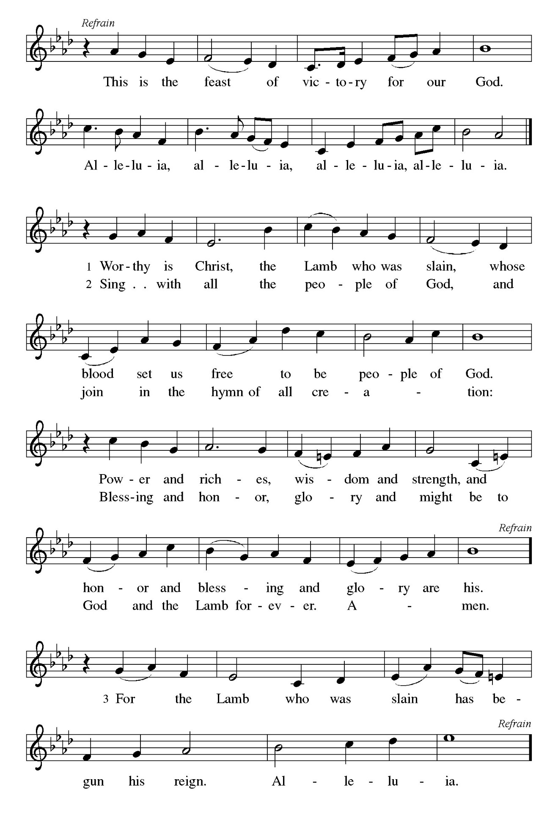
THE PRAYER OF THE DAY

P: The Lord be with you.

C: And also with you.

P: Let us pray. Almighty God, Your blessed Son, our Savior Jesus Christ, ascended far above all
heavens that He might fill all things. Mercifully give us faith to trust that, as He promised, He
abides with us on earth to the end of time, Who lives and reigns with You and the Holy Spirit,
one God, now and forever.

C: Amen.

The assembly is seated

WORD

FIRST READING Acts 1: 1-11

Before he is lifted into heaven, Jesus promises that the missionary work of the disciples will spread out from Jerusalem to all the world. His words provide an outline of the book of Acts.

In the first book, Theophilus, I wrote about all that Jesus did and taught
from the beginning
²until the day when He was taken up to heaven, after giving instructions through
the Holy Spirit to the apostles whom He had chosen.
³After His suffering He presented Himself alive to them by many convincing
proofs, appearing to them during forty days and speaking about the
kingdom of God.
⁴While staying with them, He ordered them not to leave Jerusalem, but to wait
there for the promise of the Father. "This," He said, "is what you have
heard from Me;
⁵for John baptized with water, but you will be baptized with the Holy Spirit
not many days from now."
⁶So when they had come together, they asked Him, "Lord, is this the time when
You will restore the kingdom to Israel?"
⁷He replied, "It is not for you to know the times or periods that the Father has
set by His own authority.
⁸But you will receive power when the Holy Spirit has come upon you; and
you will be My witnesses in Jerusalem, in all Judea and Samaria, and
to the ends of the earth."
⁹When He had said this, as they were watching, He was lifted up, and a cloud took
Him out of their sight.
¹⁰While He was going and they were gazing up toward heaven, suddenly
two men in white robes stood by them.
¹¹They said, "Men of Galilee, why do you stand looking up toward heaven?
This Jesus, who has been taken up from you into heaven, will come in
the same way as you saw Him go into heaven."

The Word of the Lord.

Thanks be to God.

THE PSALM: Psalm 47 Antiphon by Walter Pelz
Choir sings refrain first, followed immediately by the congregation and as indicated

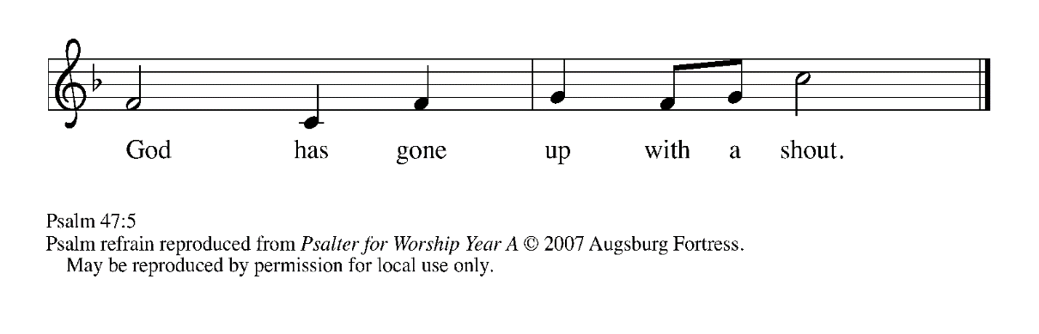

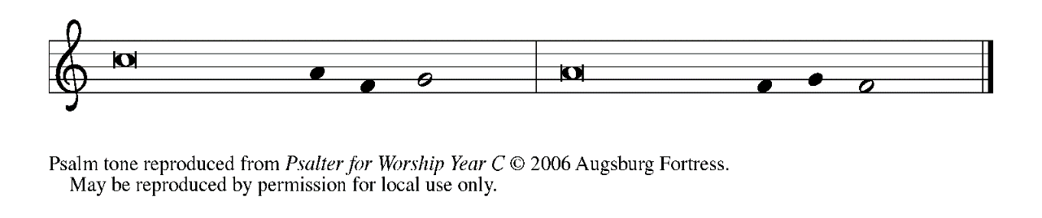

¹Clap your hands, | all you peoples;
shout to God with a | joyful sound.

²For the LORD Most High is | to be feared:
a great King over | all the earth,

³Who subdues the | peoples under us,
and the nations un- | der our feet;

⁴Who chooses our inheri- | tance for us,
the pride of Jacob, | whom God loves. REFRAIN

⁵God has gone up | with a shout,
the LORD with the sound | of the ram's horn.

⁶Sing praises to | God, sing praises;
sing praises to our | King, sing praises.

⁷For God is King of | all the earth;
sing praises | with a song.

⁸God reigns o- | ver the nations;
God is en- | throned on high.

⁹The nobles of the peoples have gathered as the people of the | God of Abraham.
The rulers of the earth belong to God, who is high- | ly exalted. REFRAIN

SECOND READING Ephesians 1: 15-23

The risen and exalted Christ reigns over the entire universe. The author of Ephesians prays that we would be given the wisdom to comprehend this and display it through love toward others.

¹⁵I have heard of your faith in the Lord Jesus and your love toward all the saints,
and for this reason
¹⁶I do not cease to give thanks for you as I remember you in my prayers.
¹⁷I pray that the God of our Lord Jesus Christ, the Father of glory, may give
you a spirit of wisdom and revelation as you come to know Him,
¹⁸so that, with the eyes of your heart enlightened, you may know what is the
hope to which He has called you, what are the riches of His glorious
inheritance among the saints,
¹⁹and what is the immeasurable greatness of His power for us who believe,
according to the working of His great power.
²⁰God put this power to work in Christ when He raised Him from the dead and
seated Him at His right hand in the heavenly places,
²¹far above all rule and authority and power and dominion, and above every
name that is named, not only in this age but also in the age to come.
²²And He has put all things under His feet and has made Him the head over
all things for the church,
²³which is His body, the fullness of him who fills all in all.

The Word of the Lord.

Thanks be to God.

As you are able please rise

THE VERSE

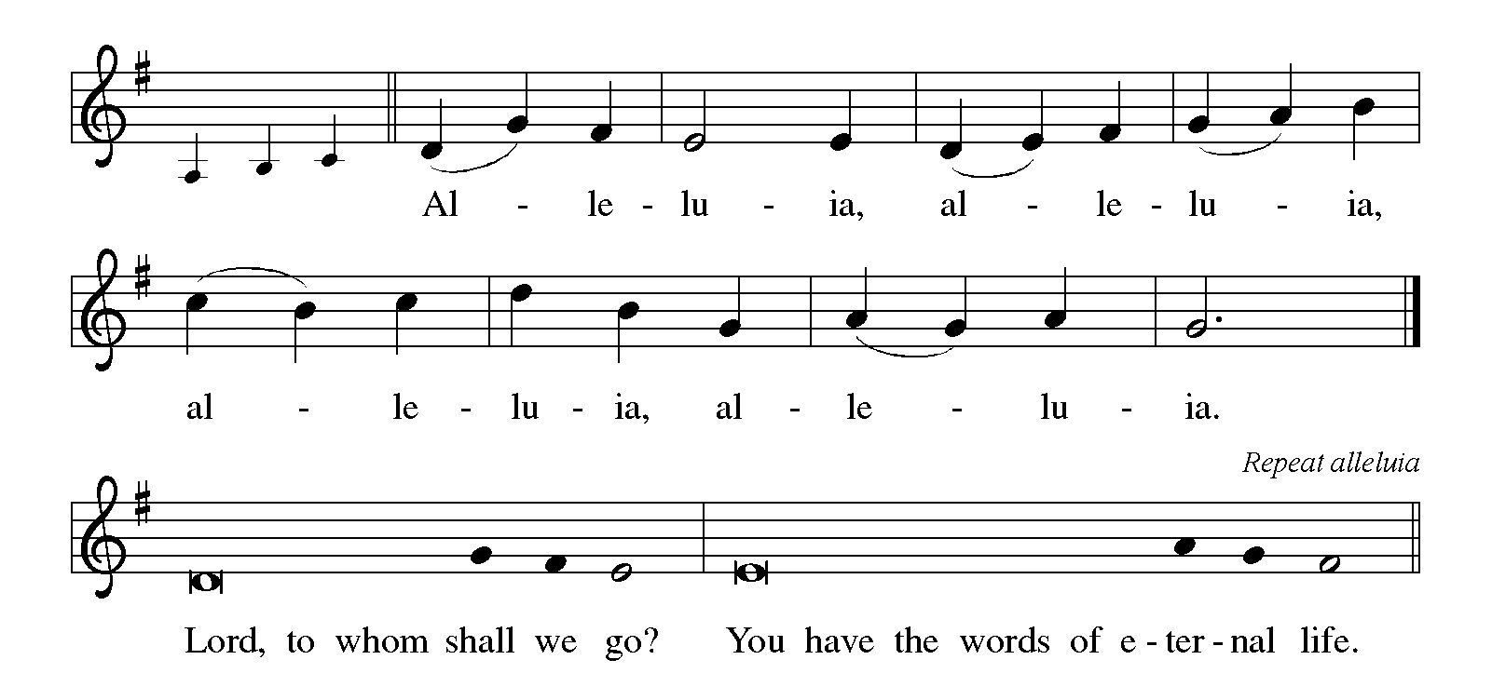

THE HOLY GOSPEL Luke 24: 44-53

On the day of his ascension, Jesus leaves his disciples with a commission, a blessing, and a promise of the Holy Spirit.

P: The Holy Gospel according to St. Luke, the twenty-fourth chapter.

C: Glory to You, O Lord!

⁴⁴Then He said to the disciples, "These are My words that I spoke to you while I was
still with you — that everything written about Me in the law of Moses,
the prophets, and the psalms must be fulfilled."
⁴⁵Then He opened their minds to understand the scriptures,
⁴⁶and He said to them, "Thus it is written, that the Messiah is to suffer and to rise
from the dead on the third day,
⁴⁷and that repentance and forgiveness of sins is to be proclaimed in
His name to all nations, beginning from Jerusalem.
⁴⁸You are witnesses of these things.
⁴⁹And see, I am sending upon you what My Father promised; so stay here in the
city until you have been clothed with power from on high."
⁵⁰Then He led them out as far as Bethany, and, lifting up His hands, He blessed them.
⁵¹While He was blessing them, He withdrew from them and was carried up into heaven.
⁵²And they worshiped Him, and returned to Jerusalem with great joy;
⁵³and they were continually in the temple blessing God.
P: The Gospel of the Lord.

C: Praise to You, O Christ!

The assembly is seated

THE SERMON The Rev. Dr. Frederick Niedner, Jr.

Silence for meditation follows the sermon

As you are able please rise

THE HYMN OF THE DAY 393 A Hymn of Glory Let Us Sing
(Stanza 2—Men; Stanza 4—Women)

THE NICENE CREED

A: God has made us His people through our Baptism into Christ. Living together in trust and
hope, we confess our faith.

We believe in one God,
the Father, the Almighty,
maker of heaven and earth,
of all that is, seen and unseen.

We believe in one Lord, Jesus Christ,
the only Son of God,
eternally begotten of the Father,
God from God, Light from Light,
true God from true God,
begotten, not made,
of one Being with the Father.
Through Him all things were made.
For us and for our salvation
He came down from heaven;
by the power of the Holy Spirit
He became incarnate from the virgin Mary, and was made man.
For our sake He was crucified under Pontius Pilate;
He suffered death and was buried.
On the third day He rose again
in accordance with the Scriptures;
He ascended into heaven
and is seated at the right hand of the Father.
He will come again in glory to judge the living and the dead,
and His kingdom will have no end.

We believe in the Holy Spirit, the Lord, the giver of life,
Who proceeds from the Father and the Son.
With the Father and the Son He is worshiped and glorified.
He has spoken through the prophets.
We believe in one holy catholic and apostolic Church.
We acknowledge one Baptism for the forgiveness of sins.
We look for the resurrection of the dead,
and the life of the world to come. Amen

THE PRAYER OF THE CHURCH

A: Our risen and ascended Lord offers up priestly intercessions before the throne of God. Let us
offer our prayers for the Church, the world, and all those who long for the grace of new life.

A: That the Church may faithfully witness to Jesus and repentance and forgiveness in His name,
we pray:

C: Hear us, risen Lord.

A: That the Jesus Who rules the world at the Father’s right hand might fill all leaders and nations
with wisdom, and all things with His Spirit of justice, reconciliation, and peace, we pray:

C: Hear us, risen Lord.

A: That we might be clothed with power from on high to be “taken up” into Jesus’ own love and
mission for the world, we pray:

C: Hear us, risen Lord.

A: That those in the healing professions: doctors, nurses, surgeons, therapists, aides, and
counselors might bring the immeasurable power of God’s healing love to the lonely, the
forgotten, the institutionalized, and the sick, especially: Mark Tannehill; Pastor Dale
Zylstra; Martha Schroeder; Jan Paholski; and Laura Dovey, we pray:

C: Hear us, risen Lord.

A: That those celebrating anniversaries, especially Fred and Judy LaBorn might be filled with
grace this day and every day and grow in grace in the days ahead, we pray:

C: Hear us, risen Lord.

A: That those who mourn, especially the family and friends of Javon Townsend, who
died in the post-prom party shooting, and Jeremiah Heard and Ginger White, who
were wounded, and other students traumatized by the violence, may be comforted
in their deep grief, we pray:

C: Hear us, risen Lord.

A: That with all the saints, especially Matthias, Apostle, whom we commemorate this Day, we
too might be received into the fullness of Christ’s everlasting rule and glory, we pray:

C: Hear us, risen Lord.

P: Ascended Lord, You have not left us, but gone before us into the heavenly glory. Raise these
our prayers to heaven, and present them to God in union with Your eternal sacrifice, that we
may know Your divine love in this life and may be one with You in the life to come.

C: Amen.

MEAL

THE PEACE

P: The peace of the risen Lord be with you always.

C: And also with you.

The assembly is seated

THE OFFERING

THE VOLUNTARY Fear Not, I Am With You St. Paul Senior Choir (L. Larson)

As you are able please rise

THE PRESENTATION OF GIFTS (see p. 10) This Joyful Eastertide

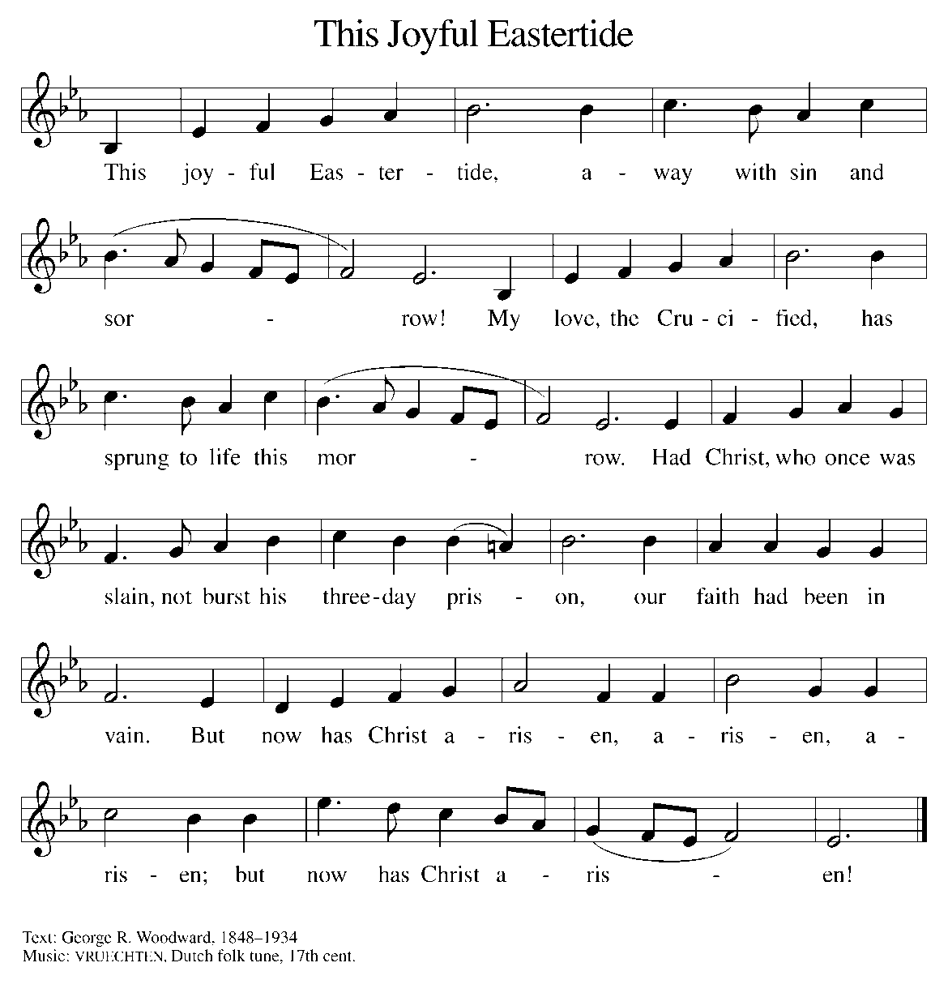

THE OFFERTORY PRAYER

A: Let us pray. Eternal God,

C: Our Savior Jesus Christ has promised to be with us until the end of time. Accept all we
offer You this day, and renew in us His risen and ascended life. We ask this in the name
of Jesus the Lord. Amen.

THE GREAT THANKSGIVING

P: The Lord be with you.

C: And also with you.

P: Lift up your hearts.

C: We lift them to the Lord.

P: Let us give thanks to the Lord our God.

C: It is right to give Him thanks and praise.

P: Holy God, You alone are holy.
You alone are God.
The universe declares Your praise:
Beyond the stars;
beneath the sea;
within each cell;
with every breath.

C: We praise You, O God.

P: Generations bless Your faithfulness;
Through the water;
by night and day;
across the wilderness;
out of exile;
into the future.

C: We bless You, O God.

P: We give You thanks for Your dear Son:
At the heart of human life;
near to those who suffer;
beside the sinner;
among the poor;
With us now.

C: We thank You, O God.

In the night ... “Do this for the remembrance of Me.”
As often as we eat ... we proclaim the Lord’s death until He comes.
Remembering His love for us on the way,
at the table,
and to the end,
we proclaim the mystery of faith:

C: Christ has died. Christ is risen. Christ will come again.

P: We pray for the gift of Your Spirit:
In our gathering;
within this Meal;
among Your people;
throughout the world.

Blessings, praise, and thanks to You,
Holy God,
through Christ Jesus,
by Your Spirit,
in Your Church,
without end.

C: Amen!

THE LORD’S PRAYER

P: Risen from the dead, Jesus lives to intercede for us and join us as He taught us to pray:

C: Our Father in heaven, hallowed be Your name.
Your Kingdom come, Your will be done on earth as in heaven.
Give us today our daily bread, and forgive us our sins, as we forgive
those who sin against us.
Save us from the time of trial, and deliver us from evil.
For the Kingdom, the power, and the glory are Yours, now and forever.
Amen.

INVITATION TO THE MEAL

P: Alleluia! Christ the Lamb of God has been sacrificed. Therefore, let us celebrate His Feast
with joy. Blessed are those who are called to the Supper of the Lamb. God’s holy gifts for
God’s holy people. Come, for all is now ready.

The assembly is seated

THE DISTRIBUTION (see p. 13) Lamb of God
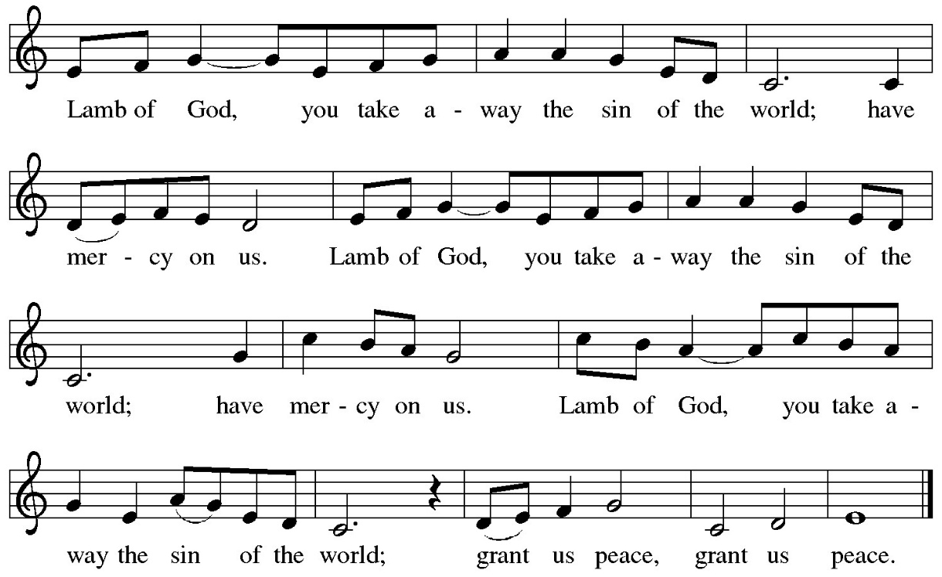

HYMN DURING DISTRIBUTION 604 O Christ Our Hope

ELW 634 All Hail the Power of Jesus’ Name

ELW 855 Crown Him With Many Crowns

NSB 86 The Power of Your Love

NSB 50 I Exalt Thee

As you are able please rise

THE POST-COMMUNION BLESSING

P: The Body and Blood of our Lord Jesus Christ strengthen you and keep you in His grace.

C: Amen.

THE POST-COMMUNION PRAYER

A: Let us pray. Heavenly Father, in the Eucharist we celebrate the Ascension of Your Son into
glory. May the gifts of His Body and Blood help us to rise with Him to the joys of heaven,
where He lives and reigns with You and the Holy Spirit, one God, now and forever.

C: Amen.

SENDING

THE BENEDICTION

P: May God the Father Who raised Christ from the dead open to you the gate of everlasting life.

C: Amen.

P: May God the Son Who burst from the grave give you joy as you celebrate His resurrection.

C: Amen.

P: May God the Holy Spirit Who brought you to birth in Baptism fill you with strength and peace.

C: Amen.

P: Almighty God: Father, Son, and Holy Spirit bless you now and forever.

C: Amen.

THE SENDING SONG 866 We Are Marching in the Light of God

THE DISMISSAL

A: Alleluia! Christ is risen!

C: He is risen indeed! Alleluia!

A: Go in the peace of Christ, alleluia!

C: Thanks be to God! Alleluia!

POSTLUDE

To God Alone Be Glory

The Meditation is from Keeping the Faith. A Guide to the Christian Faith. David Truemper and
Frederick Niedner, Jr. (Valparaiso University, Department of Theology, 1980). 67.

The Greeting, Peace, Offertory, Post-Communion Prayers, and Dismissal are from Sundays and
Seasons. Copyright 2000 Augsburg Fortress.

The Prayers are adapted from Prayers for Sundays and Seasons. Year B. Peter Scagnelli.
(Chicago: Liturgy Training Publications, 1996, 72-73.

ANNOUNCEMENTS

Please remember to mail your offering to the Church Office at 818 Franklin Street, Michigan City, IN 46360. Another alternative is to give on-line through Tithe.ly. Please see your closure letter for information on how to set up a Tithe.ly account.

St. Paul Members are reminded to have a loved one contact the office if you are hospitalized. Many times, the Pastor doesn’t know someone is in the hospital. If you call and leave a message, please tell us at which hospital the patient is located.

ANNIVERSARIES: Fred & Judy LaBorn (5/19)

PRAYER CONCERNS: Debbie Martin; Mark Tannehill; Kathy Stein; Jan Paholski; Laura Dovey; Bill Hazelgrove; Al Levenhagen; Carl Wipperman; Major Payne.

OFFICE HOURS: Libby will be in the office on Mondays, Wednesdays, and Fridays; volunteers will cover Tuesdays and Thursdays.

Monday & Wednesday 8:00 a.m. – 5 p.m.
Tuesday & Thursday 9:00 a.m. – 12:00 p.m.
Friday 8:00 a.m. – 12:00 p.m.

If you are listening to the worship broadcast on the radio and would like to watch the Sunday morning service live stream follow these steps:

(1) If you have You Tube available on your TV, search for
St. Paul Lutheran Church Michigan City, IN.

(2) The direct link on the computer is https://
www.youtube.com/channel/UC5AIPNaKr3QN50984jGOa1g

(3) This link is also on the main page of the church’s website in
the church section and will continue to be posted weekly on the St.
Paul Facebook page.

And it will always be available on the radio broadcast Sunday mornings at 11:00 a.m.
on WEFM (95.9), and on the local cable access station #99 for the previous week’s
service on Sundays at 4:00 p.m. and the current service on Wednesdays at 7:00 p.m.
and Fridays at 8:30 p.m.

To send e-mail to the church office, please use the following addresses:
Pastor Mark Reshan: seniorpastor@stpaulmichigancity.com
Church Office Secretary (Libby Pollock): churchsecretary@stpaulmichigancity.com
Church Treasurer (Karen Fleming): finance@stpaulmichigancity.com

2026 Church Council:
Pastor - Mark Reshan
President - Donna Knoll
Vice President - Jan Bakken
Secretary - Judy Hunt
Treasurer - Karen Fleming

Members: Sue Koziel; Jim Schraidt; Trish Sprague; Bob Kiser; Barry Anderson; and
Pam Soule

Worship Attendance:
Saturday, May 9, 2026 @ 4:00 p.m. 25
Sunday, May 10, 2026 @ 9:00 a.m. 62
TOTAL 87

Copies of the minutes from the March 26, 2026 and April 23, 2026 Church Council meetings are on the back table in the upper Narthex. They were approved by the council via email.

The Good News Newsletter: If you have an article or anything you want included in The Good News please send it to the following e-mail address: splcgoodnews@gmail.com. Pastor Pamela Thiede will be using this e-mail address to assemble The Good News each month. The deadline for getting information to Pastor Pamela will be the 20th of each month.

Next week’s lessons are Acts 1: 6-14; Psalm 68: 1-10, 32-35; 1Peter 4: 12-14; 5: 6-11; John 17: 1-11 for those of you who like to study them in advance.

MISSION OF THE MONTH FOR MAY 2026
The Dolly Fund at Lubeznik Center for the Arts is our Mission of the Month for May 2026. The Dolly Fund is an endowment fund that supports scholarships for students age 7- 18 to LCA’s art classes for youth. It was initiated by Paul Marshall, in honor of his late wife and former LCA director, Dolly Marshall. Dolly had a life-long belief that arts education for children was crucial to their development. Some of the classes LCA offers are abstract painting, mixed media for young artists, figure drawing, digital illustration, abstract landscapes, poetry and performance workshops, printmaking, and much more!
Please make checks payable to St. Paul and mark for the Dolly Fund and place in the offering. Noisy coin offering for the month of May will also go to support the Dolly Fund. Thank you for your generosity each month! Lora

2026 Financial Stewardship

Weekly Church Operating Needs (x 2 weeks)
May 2-3 & May 9-10, 2026: $ 13,154.50

General Fund (including General Memorials): $ 9,920.00

\Overage/Shortage: — $ 3,234.59

Restricted Income (not including Memorials)
Supports IK Synod & Church wide Ministries: $ 454.00

Ministries in our Community/Congregation: $ 50.00

Capital Fund: $ 227.00

Memorials
General Fund $ 120.00

ACTIVITIES, EVENTS & MEETINGS
MAY, 2026

Sunday, May 10, 2026 @ 9:00 a.m. 6 Easter Worship Service/Sanctuary
MOTHER’S DAY with coffee after
Monday, May 11, 2026 @ 1:00 p.m. Hope Circle/Green Room
Wednesday, May 13, 2026 @ 9:15 a.m. Bible Study/Luther House
@ 10:00 a.m. God’s Purls/St. Paul Room
@ 3:30 p.m. Worship & Music Mtg./Luther House
@ 4:30 p.m. Choir Rehearsal/Sanctuary
Saturday, May 16, 2026 @ 4:00 p.m. 7 Easter Worship Service/Sanctuary

Sunday, May 17, 2026 @ 9:00 a.m. 7 Easter Worship Service/Sanctuary with coffee after
Monday, May 18, 2026 @ 2:00 p.m. Finance Comm.Mtg./Luther House
@ 3:00 p.m. Executive Board Mtg./Luther House
Wednesday, May 20, 2026 @ 10:00 a.m. God’s Purls/St. Paul Room
@ 4:30 p.m. Choir Rehearsal/Sanctuary
Thursday, May 21, 2026 @ 3:00 p.m. Church Council/St. Paul Room
Saturday, May 23, 2026 @ 4:00 p.m. Vigil for Pentecost Worship Ser- vice/Sanctuary

Sunday, May 24, 2026 @ 9:00 a.m. Day of Pentecost Worship Service/ Sanctuary w/coffee after
Monday, May 25, 2026 is MEMORIAL DAY/OFFICE IS CLOSED
Wednesday, May 27, 2026 @ 10:00 a.m. God’s Purls/St. Paul Room
@ 4:30 p.m. Choir Rehearsal/Sanctuary
Saturday, May 30, 2026 @ 4:00 p.m. The Holy Trinity Worship Service

Sunday, May 31, 2026 @ 9:00 a.m. The Holy Trinity Worship Service/ Sanctuary w/ coffee after

