THE FOURTH SUNDAY AFTER PENTECOST
June 21, 2026

“Cheap grace means grace as bargain basement goods, cut-rate forgiveness, cut-rate comfort, cut-rate sacrament; grace as the church’s inexhaustible pantry, from which it is poured out without hesitation or limit. It is grace without price, without costs ... Cheap grace means grace as doctrine, as principle, as system. It means forgiveness of sins as a general truth; it means God’s love as merely a Christian idea of God ... Cheap grace is grace without discipleship, grace without the cross, grace without the living, incarnate Jesus Christ ...
Costly grace is the gospel which must be sought again and again, the gift which has to be asked for, the door at which one has to knock again and again.
It is costly, because it calls to discipleship; it is grace, because it calls us to follow Jesus Christ. It is costly, because it costs people their lives; it is grace, because it gives them their lives. It is costly, because it condemns sin; it is grace, because it justifies the sinner.
Above all, grace is costly, because it was costly to God, because it costs God the life of God’s Son--“you were bought with a price”--and because nothing can be cheap to us which is costly to God.”

Dietrich Bonhoeffer, Martyr
The Cost of Discipleship

“…we don't need Jesus to cast a sword on earth -- we do that pretty well without his help. We don't need Jesus to turn family members against other family members -- we do that pretty well without his help. We need Jesus to show us how not to draw our "swords" of anger and revenge, of death and destruction. We need Jesus to show us how to take up our crosses in love and forgiveness for our enemies -- even when they are our family members -- and even when they may be our own selves.
Not only do we need to hear about Jesus' help, but we need to shout the message to a world estranged from itself and from its God.”
Brian Stoffregen
In the Name of Jesus

INTRODUCTION
Jeremiah knew the frustration of having his words rejected. Jesus declares that his words may not bring peace, but division. In baptism we are buried with Christ that we may walk in newness of life. As we take stands for the sake of justice and lose our lives for the sake of others, we need not be afraid. The hairs of our head are counted. In baptism we are marked with the cross of Christ forever.

Onesimos Nesib, translator, evangelist, died 1931
Onesimos was born in Ethiopia. Captured, enslaved, and taken to Eritrea, he was there freed by Swedish missionaries. He translated the Bible into his native Oromo and returned to preach there.
GATHERING
PRELUDE
ANNOUNCEMENTS

As you are able please rise

CONFESSION AND ABSOLUTION

P: In the name of the Father and of the Son and of the Holy Spirit.

C: Amen.

P: “Should we continue to sin in order that grace may abound? By no means! How can we who
have died to sin go on living in it?” (Romans 6: 1-2) Come, let us repent of our sin, that out
of its death God may again raise us in Christ to “walk in newness of life.” (Romans 6: 4)

Silence for self-examination and reflection is kept

P: Most merciful God,

C: We confess that we have sinned against You in thought, word, and deed. Fearful and
anxious, we have not been faithful witnesses to You. (Matthew 10: 26). We have been
hesitant to acknowledge to others our faith in Christ. (10: 32) By our actions and our
silence we have denied being Your disciples. (10: 33) We have sought to gain our lives
rather than lose them in service to the Gospel. (10: 39) Forgive our sin, O Lord. Deliver
us from our fear. Resurrect us in grace, and send us in the power of Your Spirit to speak
and live Your Word with courage and joy.

P: “We know that our old self was crucified with (Christ) so that the body of sin might be
destroyed, and we might no longer be enslaved to sin. For whoever has died is freed from sin.
So must consider yourselves dead to sin and alive to God in Christ Jesus.” (Romans 6: 6-7,
11) God makes you alive again in Christ through His Word: as a called and ordained minister
of the Church of Christ, and by His authority, I declare to you the entire forgiveness of all your
sins, in the name of the Father and of the Son and of the Holy Spirit.

C: Amen.

GATHERING HYMN (see p. 3) Before the Waters Nourished Earth
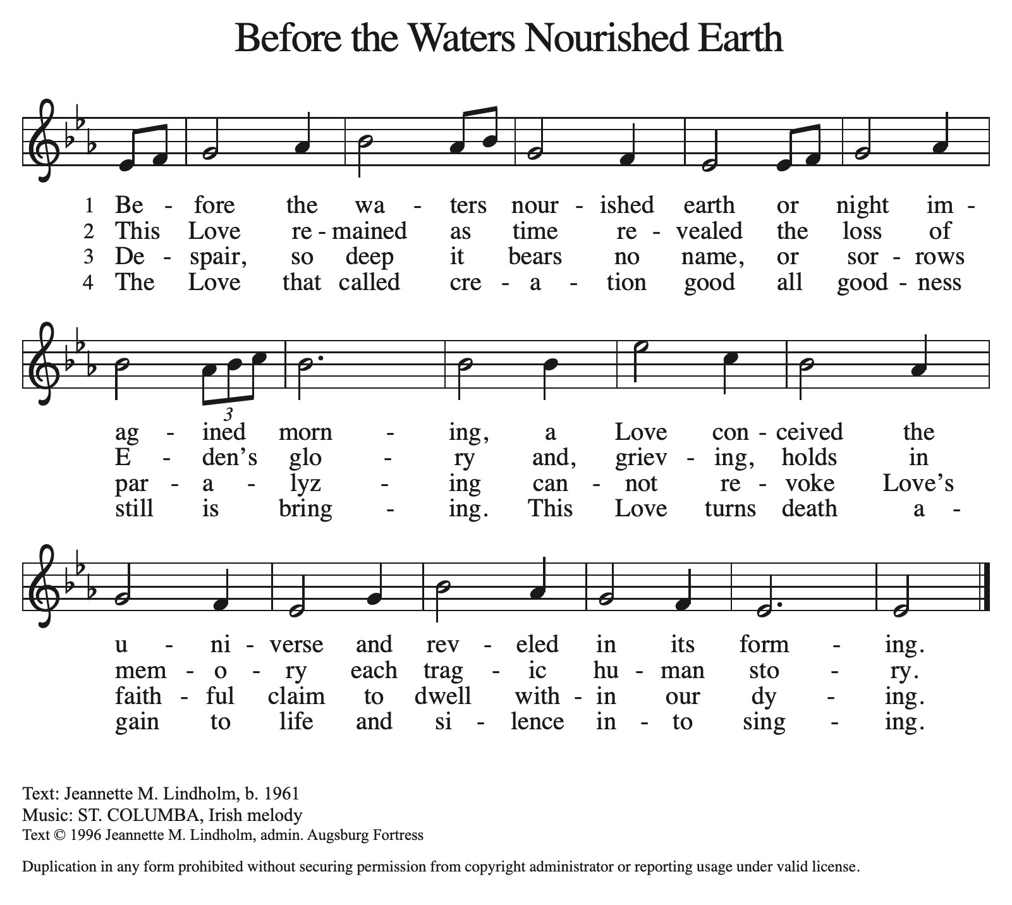
THE GREETING AND PRAYER OF THE DAY
P: The grace of our Lord Jesus Christ, the love of God, and the communion of the Holy Spirit be
with you all.

C: And also with you.

P: Let us pray. Teach us, good Lord God, to serve You as You deserve, to give and not to count
the cost, to fight and not to heed the wounds, to toil and not to seek for rest, to labor and not to
ask for reward, except that of knowing that we do Your will, through Jesus Christ, our Savior
and Lord.

C: Amen.

The assembly is seated

WORD

FIRST READING Jeremiah 20: 7-13

Jeremiah's message of doom earns him only contempt and persecution. Having been beaten, placed in stocks, and then released by Pashur, one of the temple priests, Jeremiah cries out in heart-wrenching lament. Nevertheless, the prophet remains confident of God's care and concludes with resounding praise.

O LORD, You have enticed me,
and I was enticed;
You have overpowered me,
and You have prevailed.
I have become a laughingstock all day long;
everyone mocks me.
⁸For whenever I speak, I must cry out,
I must shout, "Violence and destruction!"
For the word of the LORD has become for me
a reproach and derision all day long.
⁹If I say, "I will not mention Him,
or speak any more in His name,"
then within me there is something like a burning fire
shut up in my bones;
I am weary with holding it in,
and I cannot.
¹⁰For I hear many whispering:
"Terror is all around!
Denounce him! Let us denounce him!"
All my close friends
are watching for me to stumble.
"Perhaps he can be enticed,
and we can prevail against him,
and take our revenge on him."
¹¹But the LORD is with me like a dread warrior;
therefore my persecutors will stumble,
and they will not prevail.
They will be greatly shamed,
for they will not succeed.
Their eternal dishonor
will never be forgotten.
¹²O LORD of hosts, You test the righteous,
You see the heart and the mind;
let me see Your retribution upon them,
for to You I have committed my cause.
¹³Sing to the LORD;
praise the LORD!
For He has delivered the life of the needy
from the hands of evildoers.

A: The Word of the Lord.

C: Thanks be to God.

THE PSALM: Psalm 69: 7-10, 16-18 Read responsively

⁷Surely, for Your sake I have suffered reproach,
and shame has covered my face.

⁸I have become a stranger to my own kindred,
an alien to my mother's children.

⁹Zeal for Your house has eaten me up;
the scorn of those who scorn You has fallen upon me.

¹⁰I humbled myself with fasting,
but that was turned to my reproach.

¹⁶Answer me, O LORD, for Your love is kind;
in Your great compassion, turn to me.

¹⁷Hide not Your face from Your servant;
be swift and answer me, for I am in distress.

¹⁸Draw near to me and redeem me;
because of my enemies deliver me.

THE SECOND READING: Romans 6: 1b-11

In the first part of his letter to the Romans, Paul says that God sent Christ to die for us while we were sinners and so, by grace, accepts us through baptism just as we are. Now, he clarifies that baptism also brings freedom from the slavery of sin and the possibility of beginning a new life.

Should we continue in sin in order that grace may abound? ²By no means! How can we who died to sin go on living in it? ³Do you not know that all of us who have been baptized into Christ Jesus were baptized into His death? ⁴Therefore we have been buried with Him by baptism into death, so that, just as Christ was raised from the dead by the glory of the Father, so we too might walk in newness of life.
⁵For if we have been united with Him in a death like His, we will certainly be united with Him in a resurrection like His. ⁶We know that our old self was crucified with Him so that the body of sin might be destroyed, and we might no longer be enslaved to sin.
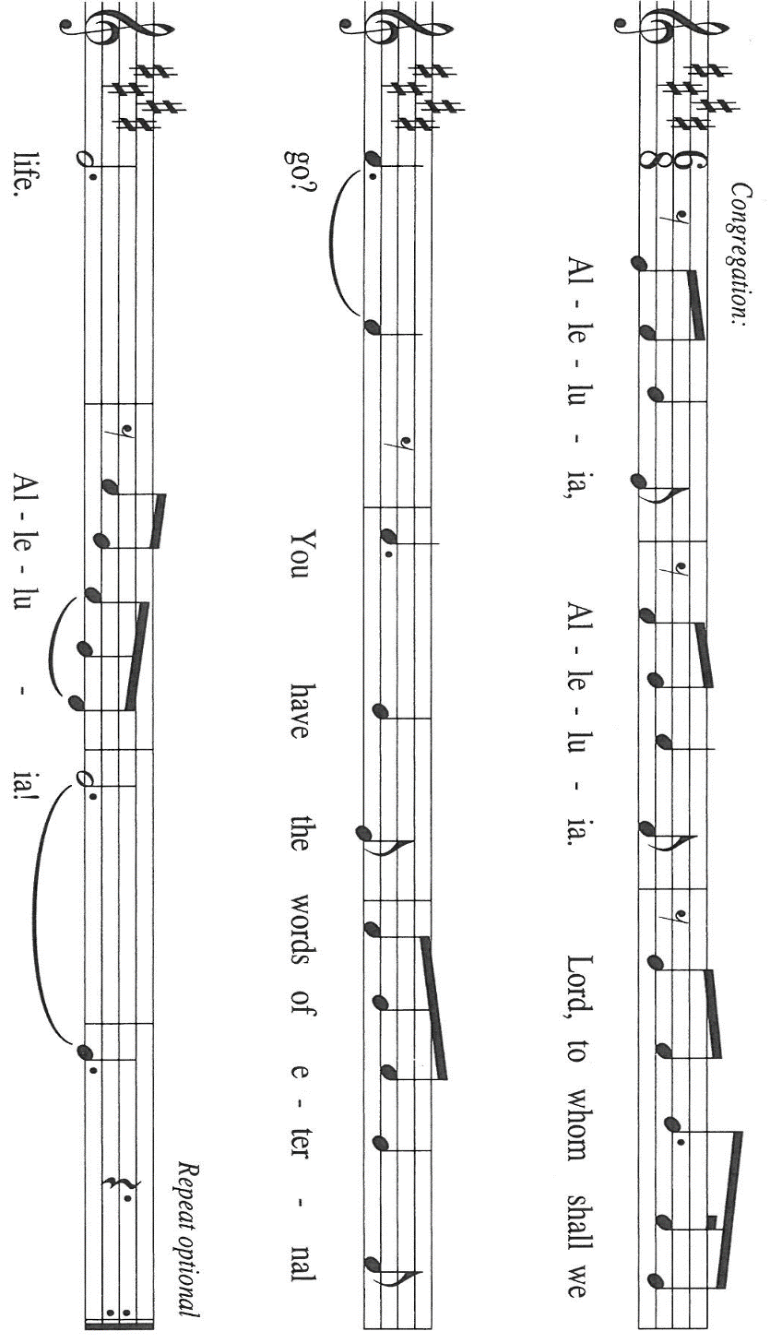
⁷For whoever has died is freed from sin. ⁸But if we have died with Christ, we believe that we will also live with Him. ⁹We know that Christ, being raised from the dead, will never die again; death no longer has dominion over Him. ¹⁰The death He died, He died to sin, once for all; but the life He lives, He lives to God. ¹¹So you also must consider yourselves dead to sin and alive to God in Christ Jesus.

The Word of the Lord.

Thanks be to God.

As you are able please rise

THE VERSE (Sung twice)

THE HOLY GOSPEL Matthew 10: 24-39

Moved by compassion for the crowds, Jesus has commissioned his twelve disciples to continue his work of preaching and healing. Now he warns them that their ministry will meet with opposition, requiring absolute trust in God and unswerving commitment to their Lord.

P: The Holy Gospel according to St. Matthew, the tenth chapter.

C: Glory to You, O Lord.

[Jesus said to the twelve:] "A disciple is not above the teacher, nor a slave above the master; ²⁵it is enough for the disciple to be like the teacher, and the slave like the master. If they have called the master of the house Beelzebul, how much more will they malign those of his household!
²⁶"So have no fear of them; for nothing is covered up that will not be uncovered, and nothing secret that will not become known. ²⁷What I say to you in the dark, tell in the light; and what you hear whispered, proclaim from the housetops. ²⁸Do not fear those who kill the body but cannot kill the soul; rather fear Him Who can destroy both soul and body in hell. ²⁹Are not two sparrows sold for a penny? Yet not one of them will fall to the ground apart from your Father. ³⁰And even the hairs of your head are all counted. ³¹So do not be afraid; you are of more value than many sparrows.
³²"Everyone therefore who acknowledges Me before others, I also will acknowledge before My Father in heaven; ³³but whoever denies Me before others, I also will deny before My Father in heaven.
³⁴"Do not think that I have come to bring peace to the earth; I have not come to bring peace, but a sword.
³⁵For I have come to set a man against his father,
and a daughter against her mother,
and a daughter-in-law against her mother-in-law;
³⁶and one's foes will be members of one's own household.
³⁷Whoever loves father or mother more than Me is not worthy of Me; and whoever loves son or daughter more than Me is not worthy of Me; ³⁸and whoever does not take up the cross and follow Me is not worthy of Me.
³⁹Those who find their life will lose it, and those who lose their life for my sake will find it."

P: The Gospel of the Lord.

C: Praise to You, O Christ!

The assembly is seated

THE SERMON

Silence for reflection follows the sermon

As you are able please rise

THE HYMN OF THE DAY NSB 4 (sung 2x) All Creation Worships You

THE APOSTLES’ CREED

A: God has made us His people through our Baptism into Christ. Living together in trust and
hope, we confess our faith.

C: I believe in God, the Father almighty,
Creator of heaven and earth.

I believe in Jesus Christ, His only Son, our Lord.
He was conceived by the power of the Holy Spirit
and born of the virgin Mary.
He suffered under Pontius Pilate,
was crucified, died, and was buried.
He descended into hell.
On the third day He rose again.
He ascended into heaven,
and is seated at the right hand of the Father.
He will come again to judge the living and the dead.

I believe in the Holy Spirit,
the holy catholic Church,
the communion of saints,
the forgiveness of sins,
the resurrection of the body,
and the life everlasting. Amen.

THE PRAYER OF THE CHURCH

A: Our God, the Almighty One, counts the hairs of our heads. Let us come therefore before God
with a sure confidence and hope, as we intercede for the Church, the world, and all those in
need.

A: That the Church may acknowledge Christ by boldly proclaiming God’s Word with courage
and power, let us pray to the Lord,

C: Lord, hear our prayer.

A: That those who suffer persecution for the faith, especially Christians in China, Indonesia,
Malaysia, India, and Nigeria, may be strengthened by the Spirit to persevere, let us pray to the
Lord:

C: Lord, hear our prayer.

A: That in place of the sin of hatred and the reign of war, especially in Ukraine; Lebanon; Iran;
the Middle East; Sudan, and Myanmar, the grace of forgiveness and peace of Christ might
flourish, let us pray to the Lord:

C: Lord, hear our prayer.

A: That this assembly may in this week be alive to God and open to the Spirit’s urgings to follow
Jesus into places of need, let us pray to the Lord:

C: Lord, hear our prayer.

A: That all fathers, grandfathers, and those who give fatherly care that may embody
and reflect Your own deep love and compassion for all Your children, let us pray to
the Lord:

C: Lord, hear our prayer.

A: That those who are afraid, worried, or burdened because of loneliness, addiction, disease, or
illness, especially: Pastor Dale Zylstra; Jon Samuelson; Verne Lee; Martha Schroeder;
Jean Warner; and Marvin Dirks may find wholeness and newness of life in Christ, let us
pray to the Lord:

C: Lord, hear our prayer.

A: That those celebrating birthdays, especially Beverly Coburn; Lou Ann Shebel; Dawn Fitzhugh and Helen Hill-Weaver; and anniversaries, especially Bill and Pam Hackett may be filled with grace this day and every day, and grow in grace in the days ahead, let us pray to the Lord:

C: Lord, hear our prayer.

A: That with all the saints, especially Onesimus Nesbit, whom we commemorate this Day Jesus
might one day acknowledge us before the Father in heaven, let us pray to the Lord:

C: Lord, hear our prayer.

P: We thank You, O God, that You are always more ready to listen than we are to pray. Hear our
petitions and grant them according to Your faithful love and mercy, through Your Son, Jesus
Christ our Lord.

C: Amen.

MEAL

THE PEACE

P: The peace of the Lord be with you always.

C: And also with you.

The assembly is seated

THE OFFERING

THE VOLUNTARY 10,000 Reasons New Song Praise Band
(Matt Redman & Jason Myrin)

As you are able please rise

THE PRESENTATION OF GIFTS (see p. 10) As the Grains of Wheat

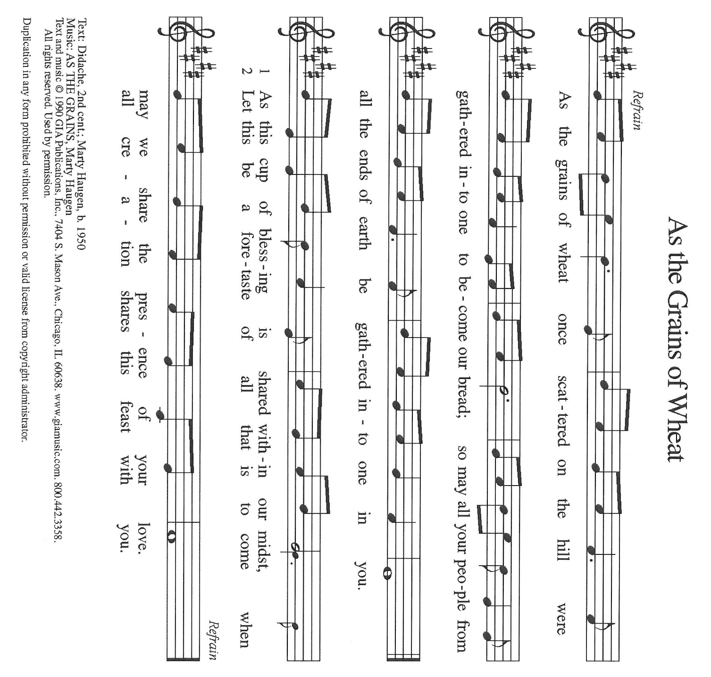

THE OFFERTORY PRAYER

A: Let us pray. Lord Jesus,

C: In Baptism we have been united in Your death and resurrection. By this holy Sacrament,
renew in us Your risen power. May Your life flow through us to others, and may these
gifts we offer proclaim Your love. You are the Lord forevermore. Amen.

THE GREAT THANKSGIVING
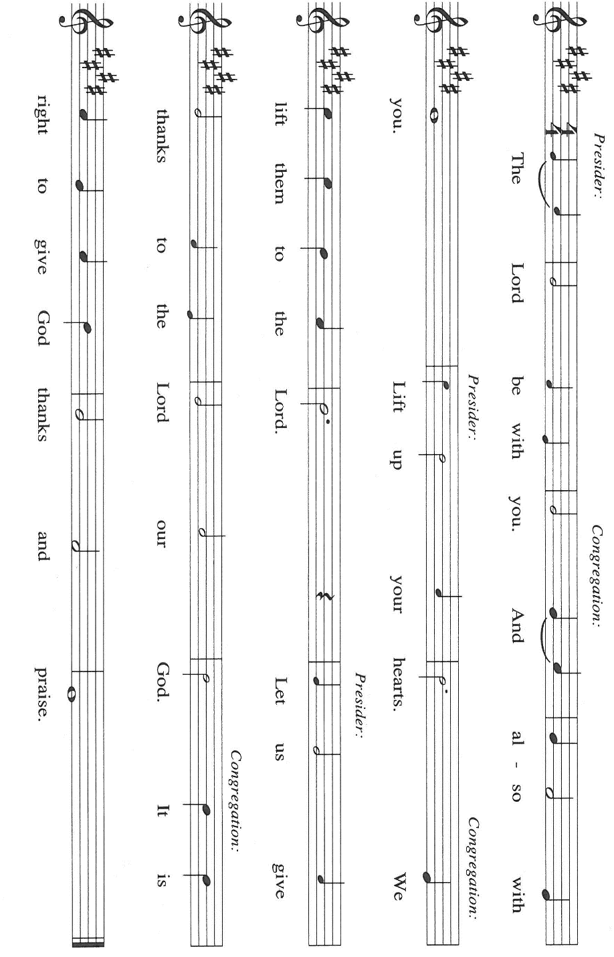

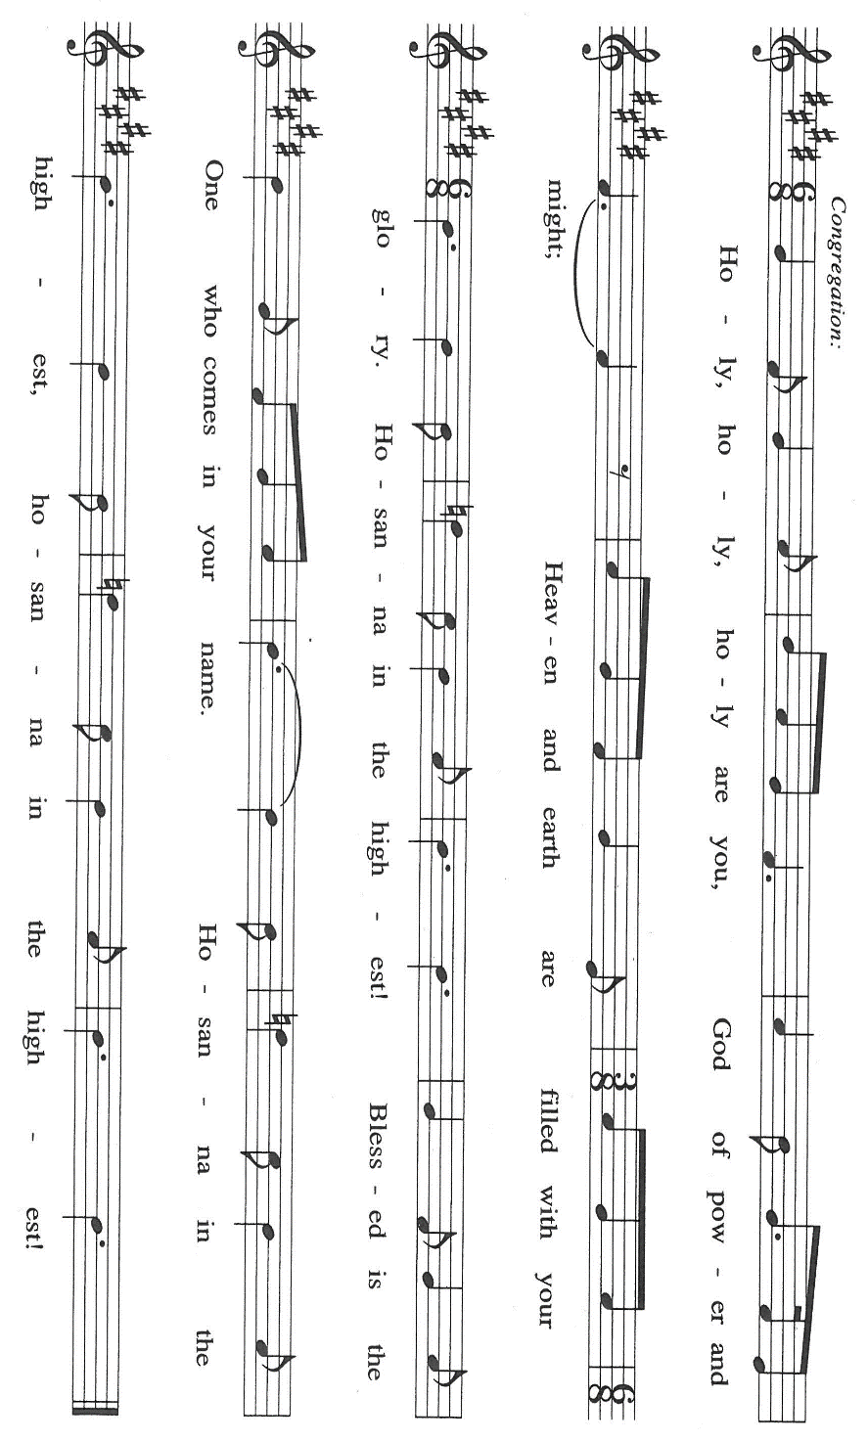

P: It is our duty and delight … join their unending hymn:

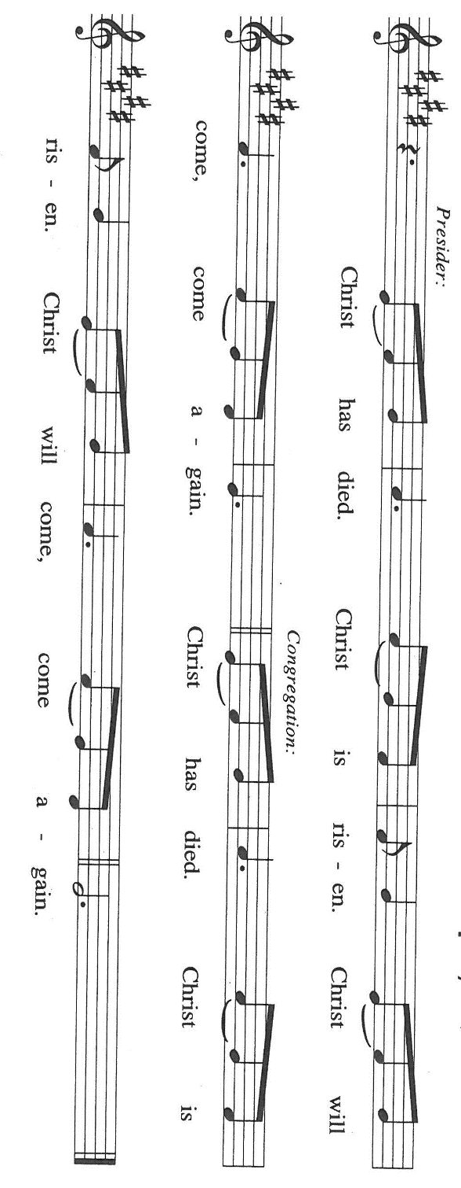
P: Holy God of light and darkness, Creator of heaven and earth,
You nourish and sustain us and all living creatures. You care for the fallen sparrows, and know
the very hairs of our head.
To bless all nations, You chose Israel as Your own. Through judges, priests, and prophets Your
Word burned in them with judgment and hope.

At the last Your Word took flesh in Your Son, Jesus Christ our Lord.
In Him we are dead to sin and alive to You.
In the night ... “Do this for the remembrance of Me.”
As often as we eat this bread ... we proclaim the Lord’s death until He comes.

P: Therefore, O God, with this bread and cup we remember His life and death for others.
Having been raised from death, He will never die again, but lives to You.
He will come again to share Your final Feast of victory over sin and death.
Send now we pray Your Holy Spirit on us and these Your gifts of bread and wine,
that we and all who share the Lord’s Body and Blood
May fearlessly proclaim Your Gospel in word and deed until, with all the saints, we
acknowledge You before Your throne into life everlasting.
P: To You, O God: Father, Son, and Holy Spirit, we all honor and glory, in Your holy
Church, in heaven and on earth, now and forever.

C: Amen!

THE LORD’S PRAYER

P: Because in Christ we have received the Spirit of adoption, as daughters and sons of God, we
dare to pray:

C: Our Father in heaven, hallowed be Your name.
Your Kingdom come, Your will be done on earth as in heaven.
Give us today our daily bread, and forgive us our sins, as we forgive
those who sin against us.
Save us from the time of trial, and deliver us from evil.
For the Kingdom, the power, and the glory are Yours, now and forever.
Amen.

INVITATION TO THE MEAL

P: This is the Lamb of God Who takes away the sin of the world. Happy are those who are called
to the Supper of the Lamb. God’s holy gifts for God’s holy people. Come, for all is now ready.

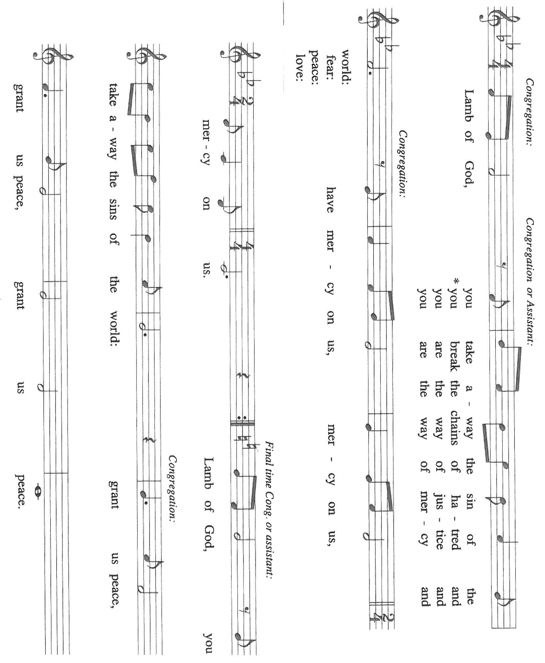
The assembly is seated

THE DISTRIBUTION Lamb of God

HYMN DURING DISTRIBUTION 781 Children of the Heavenly Father

ELW 490 Let All Mortal Flesh

ELW 471 Let Us Break Bread Together

ELW 487 What Feast of Love

ELW 472 Eat This Bread

As you are able please rise

THE POST-COMMUNION BLESSING

P: The Body and Blood of our Lord Jesus Christ strengthen you and keep you in His grace.

C: Amen.

THE POST-COMMUNION PRAYER

A: Let us pray. Lord our God, having fed us again through Word and Sacrament, You now send
us out to acknowledge You before others. Deliver us from doubt and fear, enliven us with
Your Spirit, and make us alive to You in Christ Jesus our Lord, in Whose name we pray.

C: Amen.

SENDING

THE BENEDICTION

P: Almighty God: Father, Son, and Holy Spirit bless you now and forever.

C: Amen.

THE SENDING HYMN 810 O Jesus, I Have Promised

THE DISMISSAL

A: Go forth with God’s blessing to love and serve the Lord.

C: Thanks be to God!

POSTLUDE

To God Alone Be Glory

The Meditation is taken from New Proclamation. Year A. Marshall D. Johnson, ed. (Minneapolis:
Fortress Press, 2002) 113.

The Prayers, Introduction to the Lord’s Prayer, and Invitation to the Meal are adapted from Prayers
For Sundays and Seasons. Year A. Peter J. Scagnelli. (Chicago: Liturgy Training Publications, 1998) 90-91.

The musical setting of the liturgy, “Now the Feast and Celebration” by Marty Haugen, is used by
permission of GIA Publishers, Inc. OneLicense.net License #A-702836.

ANNOUNCEMENTS

Please remember to mail your offering to the Church Office at 818 Franklin Street, Michigan City, IN 46360. Another alternative is to give on-line through Tithe.ly. Please see your closure letter for information on how to set up a Tithe.ly account.

St. Paul Members are reminded to have a loved one contact the office if you are hospitalized. Many times, the Pastor doesn’t know someone is in the hospital. If you call and leave a message, please tell us at which hospital the patient is located.

BIRTHDAYS: Beverly Coburn (6/21); Lou Ann Shebel (6/24); Dawn Fitzhugh (6/24); Helen Hill-Weaver (6/26)

ANNIVERSARIES: Bill & Pam Hackett (6/23)

PRAYER CONCERNS: Debbie Martin; Mark Tannehill; Kathy Stein; Jan Paholski; Laura Dovey; Bill Hazelgrove; Al Levenhagen; Carl Wipperman; Major Payne.

OFFICE HOURS: Libby will be in the office on Mondays, Wednesdays, and Fridays; volunteers will cover Tuesdays and Thursdays.

Monday & Wednesday 8:00 a.m. – 5 p.m.
Tuesday & Thursday 9:00 a.m. – 12:00 p.m.
Friday 8:00 a.m. – 12:00 p.m.

If you are listening to the worship broadcast on the radio and would like to watch the Sunday morning service live stream follow these steps:

(1) If you have You Tube available on your TV, search for
St. Paul Lutheran Church Michigan City, IN.

(2) The direct link on the computer is https://
www.youtube.com/channel/UC5AIPNaKr3QN50984jGOa1g

(3) This link is also on the main page of the church’s website in
the church section and will continue to be posted weekly on the St.
Paul Facebook page.

And it will always be available on the radio broadcast Sunday mornings at 11:00 a.m.
on WEFM (95.9), and on the local cable access station #99 for the previous week’s
service on Sundays at 4:00 p.m. and the current service on Wednesdays at 7:00 p.m.
and Fridays at 8:30 p.m.

To send e-mail to the church office, please use the following addresses:

Pastor Mark Reshan: seniorpastor@stpaulmichigancity.com

Church Office Secretary (Libby Pollock): churchsecretary@stpaulmichigancity.com

Church Treasurer (Karen Fleming): finance@stpaulmichigancity.com

2026 Church Council:

Pastor - Mark Reshan

President - Donna Knoll

Vice President - Jan Bakken

Secretary - Judy Hunt

Treasurer - Karen Fleming

Members: Sue Koziel; Jim Schraidt; Trish Sprague; Bob Kiser; Barry Anderson; and
Pam Soule

Worship Attendance:

Saturday, June 13, 2026 @ 4:00 p.m. 25

Sunday, June 14, 2026 @ 9:00 a.m. 69

TOTAL 94

Copies of the minutes from the April 23, 2026 and May 21, 2026 Church Council meetings are on the back table in the upper Narthex. They were approved by the council via email.

The Good News Newsletter: If you have an article or anything you want included in The Good News please send it to the following e-mail address: splcgoodnews@gmail.com. Pastor Pamela Thiede will be using this e-mail address to assemble The Good News each month. The deadline for getting information to Pastor Pamela will be the 20th of each month.

Next week’s lessons are Jeremiah 28: 5-9; Psalm 89: 1-4, 15-18; Romans 6: 12-23; Matthew 10: 40-42 for those of you who like to study them in advance.

ACTIVITIES, EVENTS & MEETINGS
JUNE 2026

Sunday, June 14, 2026 @ 9:00 a.m. 3 Pentecost Worship Service/Sanctuary with coffee after
Wednesday, June 17, 2026 @ 10:00 God’s Purls

@ 12:15 p.m. Roosevelt Organ Concert Series/Sanctuary

Saturday, June 20, 2026 at 4:00 p.m. 4 Pentecost Worship Service/Sanctuary

Sunday, June 21, 2026 @ 9:00 a.m. 4 Pentecost Worship Service/Sanctuary with coffee after
Monday, June 22, 2026 @ 2:00 p.m. Finance Committee Mtg./Luther House

Wednesday, June 24, 2026 @ 10:00 a.m. God’s Purls

No one scheduled for the Organ Concert Series on this date

@ 4:30 p.m. Choir Rehearsal/Sanctuary

Thursday, June 25, 2026 @ 3:00 p.m. Church Council Meeting/St. Paul Room

Saturday, June 27, 2026 @ 4:00 p.m. 5 Pentecost Worship Service/Sanctuary

Sunday, June 28, 2026 @ 9:00 a.m. 5 Pentecost Worship Service/Sanctuary with coffee after

CELEBRATING OUR NATION’S 250TH ANNIVERSARY

There will not be a worship service on Saturday, July 4th, 2026.
However, the Sunday, June 5, 2026 worship service will be at the usual time at 9:00 a.m. with coffee after.

JUNE MONTHLY MISSION
The Service League of Michigan City is a no-profit organization of volunteers that loans medical equipment and provides supplemental adult incontinence supplies to the residents of LaPorte County. Equipment loans are for three months and most items can be borrowed for free. As a non-profit, they maintain their services through the generosity of community donations, competitive grants, memorials and member support. The Service League receives no government funds. To help their generous mission, we will be collecting both monetary donations as well as the following items:
Disposable gloves
Disposable Gauze rolls, dressing pads and surgical tape
Disposable pull up and tab adult briefs (opened and unopened packages)
Please make checks payable to St. Paul and mark for Service League and place in the offering. Noisy Coin for the month of June will also go to support the Service League. Items can be placed in the bin in the outer Narthex. Thank you for your generosity each month! Lora

COMING SOON, OUR JULY MONTHLY MISSION:
Our Mission of the Month for July will be our Lutheran World Relief Kits, for school kits and for health kits. The order forms will be coming in our next bulletins. Thank you all for your generous giving!

