-
October, 2026
MARK: MY WORDS

These will be my final few newsletter articles before my retirement. Rather than look back over the years of my ministry here, I would like to look to what is ahead for the congregation. My thoughts will be organized around three themes:

- First, be patient. As others and I have tried to communicate, the process to call another pastor is not quick. It could easily extend into several years. Remember: after Pastor Matevia left Pastor Poole served as interim for three years before I was called. And that was at a time when there were pastors who served as interims in the synod. According to the bishop’s assistant, Pastor Priscilla Geerdes, who will be working with the Call Committee, there are no interim pastors in the synod right now.

That means that it is possible that the congregation will have to rely on supply pastors who come in on Saturdays and Sundays to lead worship and that will be the only pastoral presence throughout the week. And again, that arrangement could last for years. For example, St. Luke United on Coolspring, the other ELCA congregation in town, has been in that situation for two years; and another congregation in Highland has had the same arrangement for that long as well.

Right now congregations looking for a pastor are facing a “perfect storm” of circumstances that make that work particularly difficult: large numbers of “Baby Boomer” pastors (like me) are retiring. Seminary graduating classes are especially small, and the number of congregations seeking a pastor is high. As of October, 2025, (the latest list found on the synod website) 21 other congregations in the Indiana-Kentucky Synod were in the call process. Competition for desirable candidates is great.

- Second, be kind. There is a great deal of work to do by the congregation even before a Call Committee is formed. That alone will take many months. Once the Committee is established, they will have to wait for the Synod to forward one or more candidates to interview. That too can take several months if both the Committee and the candidate are interested in pursuing possibly calling that person. If there are no candidates, there is nothing the Committee can do until they receive a name from the Bishop’s office. Don’t blame what may seem to be no progress on the Committee. They can only work with what they will have. They will be as transparent as they are able along the way. No one will be trying to hide anything from the congregation.

- Finally, listen and pay attention. For months others and I in leadership have been trying to prepare the congregation for a potentially long wait for even an interim pastor. A summary of the process was sent to the congregation several months ago and will be included in this month’s edition as well. Yet, numerous people have asked me and others on Council, “Do we have someone yet?” Not hearing what is being said is what leads to misinformation and misunderstanding, and that causes problems. Stay informed, and if you have questions, talk to someone on council or the Call Committee who knows what is going on. Don’t rely on rumors or speculation from those who are not involved in the process.

The landscape within the Church is very different from when I arrived almost eighteen years ago. There are challenges we could not have imagined back then. You will need to walk this difficult path together. Support one another. Pray for the Committee and the Council. Trust that God will be at work through it all and lead the congregation and a candidate to one another so that His work in this place might continue fruitfully and faithfully. That will be my prayer for you.



SUPPLY PASTORS

The Bishop asked me to help arrange for supply pastors for a time after I leave. I made out a schedule from the second weekend in November through the middle of January to give the worship team some breathing room. As of this writing, all but three of the days have been filled. Those who have graciously agreed to serve include Pastor Dale Zylstra, Pastor Pamela Thiede, Pastor Mark Kloess, and Dr. Fred Niedner from Valparaiso University. We are grateful for their willingness to help and know that they will lead vibrant and nourishing worship.


HOMEBOUND/NURSING HOME VISITS

We are also working to arrange for lay ministers to bring Communion to our homebound, nursing home, and assisted living residents. We don’t want them to feel forgotten. Thus far we have two lay ministers who have volunteered to help, and we hope to add several others. If you have questions or desire a visit, please contact the church office.



HYMN FESTIVAL

The third and final celebration of our 150th anniversary year will be a Festival of Hymns on Sunday, October 25, 2026, at 4:00 p.m. Highlighted will be hymns for the Feast Days of Reformation, All Saints, and Christ the King.
A combined choir from St. Paul and the Harbor Country Singers of Three Oaks, Michigan, will be conducted by Maggie Martin, Director of the Singers and our Director of Music. Chuck Steck and the Michiana Brass will accompany many of the hymns through arrangements by composers Robert Hobby, Paul Manz, John Ferguson, and Walter Pelz.
The guest organist will be Dr. Steven Wente, Professor Emeritus of Church Music and University Organist at Concordia University, Chicago. He currently serves as Cantor (Music Director) at First Saint Paul’s Lutheran Church in Chicago. He has played here several times before.
Dr. Wente has stayed active as a teacher, workshop leader, and recitalist. He has led hymn festivals and concertized throughout the United States and in the Luther and Bach areas of Germany. He received his bachelor’s and master’s degrees from Concordia, River Forest, and the Doctor of Musical Arts in Organ Performance from Northwestern University in Chicago. He has composed hymn preludes for the Concordia Hymn Prelude Library and other denominational keyboard publications.
The hymns will be interspersed with Scripture texts and meditations appropriate to the season. Maggie, Steve, and I have striven to choose hymns that are familiar and that convey the hope, theme, and promise of each of the three seasons. We have selected some powerful arrangements. It will be a glorious afternoon of singing and worshiping.
There will be a reception following in the St. Paul Room with light refreshments served. We hope that you will join us for this wonderful conclusion to our anniversary year observation.



On Saturday, October 10, Sarah Payne and Nik Vance will be joined together as husband and wife at the Brewery Lodge in Michigan City. It will be my great joy to preside over their wedding. We rejoice with them and pray for God’s rich blessing on their marriage.

To commemorate Pastor Reshan’s Retirement there will be a luncheon in the St. Paul Room immediately following the service on Sunday, November 1, 2026. Chicken from Al’s Supermarket will be provided; please bring a dish to pass.
There will be no charge for the meal, but reservations are required due to the limited seating capacity of 120 persons in our fellowship hall. This is first come, first served. Once we reach the 120 person limit, no more reservations will be accepted.
If you are unable to attend a service in October and would like to reserve a seat for the luncheon, please email the church at churchsecretary@stpaulmicigancity.com or call the church office at (219) 874-7293 with your name, number of seats to reserve, and phone number.
Please respond in a timely manner and come enjoy great food and fellowship!

To reserve a seat, please fill out this form and place in the offering plate during October.

Name:__________________________________________________

Phone number:___________________________________________

# of seats to reserve:_______________________________________

If you have reserved a seat but are unable to attend, please let the church office know.

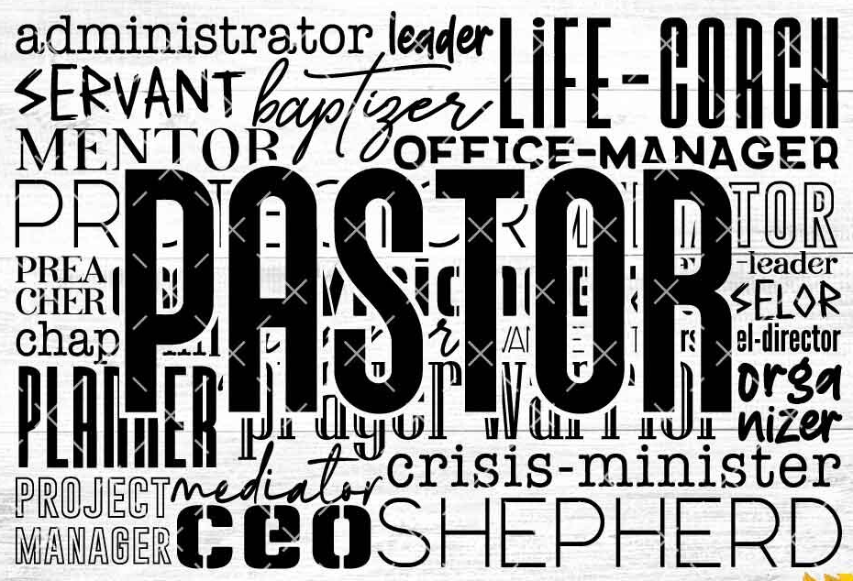

CALL PROCESS

Since it has been over twenty years since the congregation was involved in the Call Process, the Church Council asked me to summarize the steps so that everyone would understand what will occur both before and after I leave my service here. Feel free to ask me or any Council members about any questions or concerns that you might have.

- On August 27, Bishop Graham met with me and with the Council to lay out the process for calling a new pastor.

- In cooperation with the Council, an Interim Pastor is appointed by the Bishop (if there are candidates available to be interviewed). This person provides both weekday ministry and weekend worship on a full-time or part-time basis as determined by the Council.

- A workshop, “Exploring God’s Expectations” is scheduled by the Synod office for the Council to discern its health and mission. The names of those from the Synod who will conduct this workshop will be given to the Council, and the President of the Council will meet with these persons to discuss immediate leadership needs.

- A Call Committee of normally five or seven persons is appointed by the Council. They are to be representative of the congregation’s membership and concerns.

- Once the workshop has been completed, a meeting with the person from the Synod office who oversees the call process is scheduled with the Council and the Call Committee to give an overview of the process.

- A survey is conducted to determine needed leadership skills and interests. These will be included in the Ministry Site Profile, a thorough assessment of the congregation’s history, needs, and mission.

- Pastors who are looking to move to another congregation (or their first congregation after graduating from seminary) also fill out a detailed profile listing their skills, strengths, and interests for ministry.

- The Synod office will work to match the congregation’s needs with the gifts of potential candidates. One to three candidates’ names will be submitted to the Call Committee for consideration. They have the responsibility to interview all candidates to be considered for call.

- The Call Committee conducts an initial interview with the candidate(s) seeking call to determine whether the gifts and ministry style of the candidates match the needs of the congregation. If none of them are deemed suitable, they will be notified by the Committee that they are no longer being considered for the call. Additional names will then be requested by the Call Committee Chair from the Synod office.

- If a primary candidate has been selected by the Committee, their name is referred to the Council, and the other candidates are notified that they are no longer under consideration.

- The Council interviews the candidate and may either accept or decline the candidate. If declined, the process is repeated until the Call Committee and Council agree on a candidate to be recommended to the congregation.

- If the Council accepts the Committee’s recommendation, a congregational meeting is scheduled for consideration of the call. The Synod office is notified of the date and an Official Letter of Call and related materials are given to the Council.

- On that date the candidate preaches and leads worship, followed by an informal meeting with the congregation. A Call Meeting is conducted by a representative of the Bishop, at which time the Letter of Call and proposed compensation package is reviewed and acted on by the congregation. A two-thirds written ballot vote of eligible voting members is required to extend the call. The compensation package requires a simple majority vote.

- The completed Letter of Call and compensation form is signed by Council officers and forwarded to the Synod office. The Bishop then sends the call to the candidate. Upon receipt of the call, the candidate has 30 days in which to respond.

- With a positive response, a date is set for the start of service to the congregation. The synod office is notified and a date for the Installation Service is scheduled, at which time the candidate is installed by the Bishop or a Synod staff member.

- If the call is declined, the process resumes with the Call Committee interviewing further candidates.

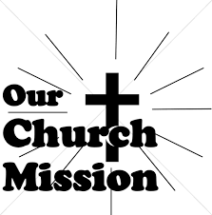

Thank you for your generous support of Michigan City Area Schools through the August Monthly Mission! We collected $1139. We were able to fully fund a solar system STEM project for the high ability classroom at Knapp, providing Project Hail Mary novels along with several different solar system projects and kits. We also donated to the special education classroom, providing supplies to help the classroom feel more inclusive and facilitate better learning.

Dear St. Paul Lutheran Church,
Thank you so much for helping to make this project a reality for my students! You mean the world to us! I cannot wait to see the fantastic STEM activities and learning carried out in our environment. Your generosity will hopefully help inspire the Scientific Minds of tomorrow! Again, many, many thanks.
With gratitude,
Ms. T

Thank you so much! I appreciate your support. Ms. Blakely

OCTOBER MONTHLY MISSION
WOODLAND CANCER CENTER CARE KITS

We will be collecting care kits for the Woodland Cancer Center in October. Please grab a bag or two from the bin in the outer narthex and fill it with small items that will help bring a smile to someone's face as they go through cancer treatments. Gender neutral socks, gloves, hats, snacks, Chapstick, gum, mints, candy, and small journals or activity books are just some examples of items to fill the care kits with. We will also collect monetary donations to go towards their fund that helps people with treatment expenses when needed. Please make checks out to St. Paul, mark for the Woodland Cancer Center in the Memo line, and place in the offering. Noisy coin will also support the mission of the month.


Happy belated birthday to Cole Ponder, who celebrated his birthday on September 26. We apologize for missing his special day.

October Birthdays October Anniversaries
1 Jacob Tannehill 4 James & Susan Tomsheck
2 Amy VanGemeren 9 James & Sandra Galinowski
4 Natalie Kendricks 21 Warren & Karen Schacht
5 Gary Larson 24 Kenneth & Ruth Baker
Cynthia Payeur James & Kimberly Summers
7 Dan McNabb
Milenda Simerlein
8 Anthony Gebbink
9 Judy Gustum
Carol Thomas
11 Laura Childers
12 George Martin
18 Richard Fleming, Jr.
25 Judith Mutchler
26 Bob Kiser
28 Sandra Sobecki
29 Kristen Schacht



Long-Term Prayer List

Lucas Bradshaw Laura Dovey Bethany Manning
Debbie Martin Shirley McCarty Jan Paholski
Martha Schroeder Jeanie Boatman Shepple Kathy Stein
Mark Tannehill Kathy Thielman Delores Williams
Brian Wiseman
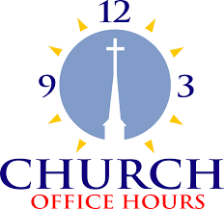

Monday 8:00 a.m. – 5 p.m.
Tuesday 9:00 a.m. – 12:00 noon
Wednesday 8:00 a.m. – 5 p.m.
Thursday 9:00 a.m. – 12 noon
Friday 8:00 a.m. – 12 noon

St. Paul Lutheran Church Staff
Pastor Rev. Mark Reshan
Secretary Libby Pollock
Director of Music Maggie Martin
Accompanists Jary Tannehill, Mark Tannehill, Jacob Tannehill
Custodian Mark Kloess

Thank$ for $haring

Last month, we raised $155 from the Give Back at Holly’s. Thanks to every who participated.

This month, we are going to Galveston on Thursday, October 1. Here are two coupons—one for you and one for a friend.

