**THE FESTIVAL OF THE HOLY TRINITY**

**The First Sunday after Pentecost**

**June 12, 2022**

“In Scripture, we see Jesus, and the One He calls “Father,” and their Spirit, always distinguishing themselves from one another, in mutual address and obedience and glorification: so it is at the great scene, beloved of the ancient church, of Jesus’ baptism, where the Father addresses the Son and sends the Spirit, and the Son hears and obeys the Father and receives the Spirit.

Yet we also see these three as, precisely by and in the life they live from and for one another, by their “relations,” one sole agent of salvation, one God Who creates and draws creation to the Kingdom. Nor are they one as a mere collective. Each points to the other as the one and only God; and it is in and by the mutuality of their relations that each subsists at all. The *doctrine* of the Trinity merely notes these facts; and the triune *name* is provided by Scripture as the appropriate name for such a God.”

**Robert W. Jenson**

“One of the most challenging elements of the secular age in which we live is a distinct loss of hope regarding the meaning of our everyday life. Paul offers in the second reading a profound and powerful understanding of hope that has the potential to give our people what they need and want but all too often struggle to find…”

“ …Paul, that is, roots our hope not only in the “things above” – that is, the transcendent promises of God – but also in the “things below” – our own struggles and suffering that are hallowed by God’s presence and love.

Why? Because Paul saw God take shape in the world and in his own life most concretely in the cross of Christ, the cross by which God dignifies and sanctifies all human suffering by promising to be there with us and for us, and the cross that we bear as we struggle to be faithful in this world. If God’s greatest revelation was made manifest in and through the struggle and suffering of a man hung on a tree, then what suffering of ours can ever truly be God-forsaken. Hence, God promises to be with us amid suffering, and even work through that to build character and endurance and increase our capacity for hope…”

“ …No tear shed, that is, goes unnoticed by God. No frustration or hurt or loss is unimportant to God. No tragedy – personal, communal, national, or global – is ignored by God, which means that God is present in our suffering and dignifies it by God’s presence.

But this passage isn’t only about tragedy. Precisely because God determined to make God’s own self known in the concrete form of Jesus and his suffering, we can look for God in the concrete, ordinary, and every day forms our lives take. In our relationships, in our jobs, hobbies, volunteer activities, and more. God hallows all of this by promising to use anything done for the good of the neighbor as a way to extend God’s love and concern to all of God’s beloved people…”

“We believe that this hope is not only true in the long run but powerful in the here and now as it hallows our daily labor, ordinary relationships, and our everyday struggles both routine and monumental as the places God desires to be.”

**David Lose**

**✠ In the Name of Jesus✠**

**✠ GATHERING ✠**

**INTRODUCTION**

*"O Lord our Lord, how majestic is your name in all the earth!" Today we celebrate the name of God: holy blessed Trinity. There is no other day quite like this one in the church’s year. There is no other god like ours. Praise Father, Son, and Holy Spirit!*

**Barnabas, Apostle**

*Barnabas was not numbered among the twelve apostles, but the book of Acts gives him that title. After Paul was converted to Christianity, Barnabas welcomed him to Jerusalem, and later the two traveled together on missionary journeys.*

**PRELUDE Come Thou All Mighty King Albert L. Travis**

**ANNOUNCEMENTS**

*As you are able please rise*

**THE PROCESSIONAL HYMN 408 *Come, Thou Almighty King***

The congregation faces the cross as it enters

**THE GREETING AND PRAYER OF THE DAY**

P: The grace of our Lord Jesus Christ, the love of God, and the communion of the Holy

Spirit be with you all.

C: **And also with you.**

P: Let us pray. God of heaven and earth, before the foundation of the universe and the

beginning of time You are the triune God: Author of creation, eternal Word of

salvation, life-giving Spirit of wisdom. Guide us to all truth by Your Spirit, that we

may proclaim all that Christ has revealed and rejoice in the glory He shares with us.

Glory and praise to You, Father, Son, and Holy Spirit, now and forever.

C: **Amen.**

*The assembly is seated*

**✠ WORD ✠**

**FIRST READING Proverbs 8:1-4, 22-31**

*In the Bible, wisdom has many faces. It is portrayed in terms sometimes human and sometimes divine. Often, it is personified as feminine. In this passage, wisdom is depicted not only as a creation of God, but also as part of God's creative activity.*

1Does not wisdom call,

and does not understanding raise her voice?

2On the heights, beside the way,

at the crossroads she takes her stand;

3beside the gates in front of the town,

at the entrance of the portals she cries out:

4"To you, O people, I call,

and my cry is to all that live.

22"The Lord created me at the beginning of His work,

the first of His acts of long ago.

23Ages ago I was set up,

at the first, before the beginning of the earth.

24When there were no depths I was brought forth,

when there were no springs abounding with water.

25Before the mountains had been shaped,

before the hills, I was brought forth--

26when He had not yet made earth and fields,

or the world's first bits of soil.

27When He established the heavens, I was there,

when He drew a circle on the face of the deep,

28when He made firm the skies above,

when He established the fountains of the deep,

29when He assigned to the sea its limit,

so that the waters might not transgress His command,

when He marked out the foundations of the earth,

30then I was beside Him, like a master worker;

and I was daily His delight,

rejoicing before Him always,

31rejoicing in His inhabited world

and delighting in the human race."

The Word of the Lord.

**Thanks be to God.**

**THE PSALM: Psalm 8** Antiphon by Mark Mummert

Choir sings refrain first, followed immediately by the congregation

and as indicated

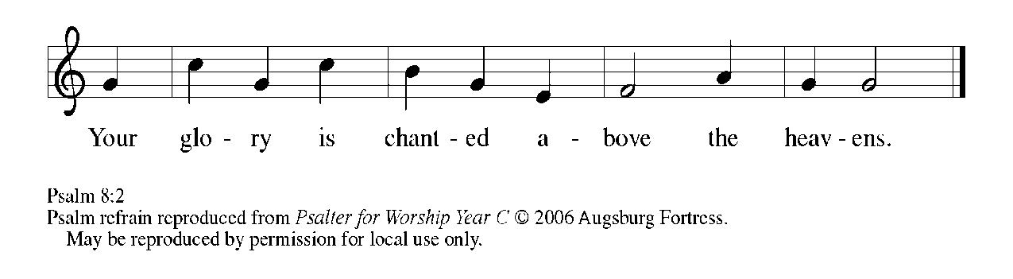

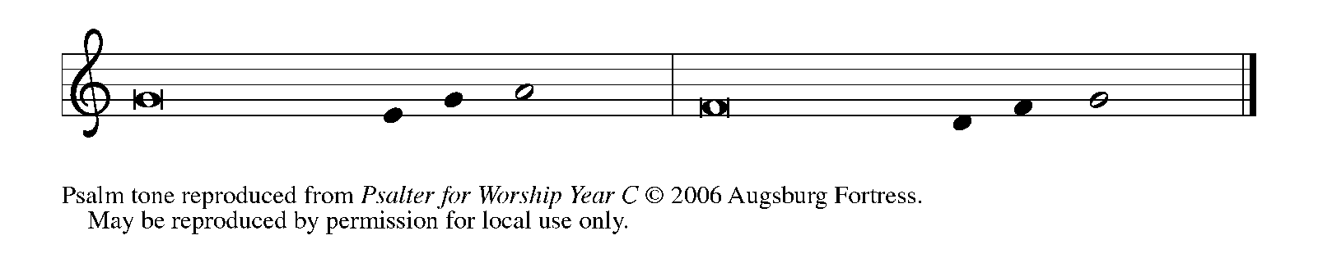

1O | LORD our Lord,

     how majestic is Your name in | all the earth!—

**2You Whose glory is chanted above the heavens out of the mouths of in- | fants and children;**

**You have set up a fortress against Your enemies, to silence the foe | and avenger.   REFRAIN**

3When I consider Your heavens, the work | of Your fingers,

     the moon and the stars You have set | in their courses,

**4what are mere mortals that You should be mind- | ful of them,**

**human beings that You should | care for them?   REFRAIN**

5Yet You have made them little less | than divine;

     with glory and hon- | or You crown them.

**6You have made them rule over the works | of Your hands;**

**You have put all things un- | der their feet:**

7all | flocks and cattle,

     even the wild beasts | of the field,

**8the birds of the air, the fish | of the sea,**

**and whatever passes along the paths | of the sea.**

9O | LORD our Lord,

     how majestic is Your name in | all the earth!   **REFRAIN**

**SECOND READING Romans 5:1-5**

*Paul describes the life of faith with reference to God, Jesus, and the Holy Spirit. Even now, we have peace with God through Jesus, and our hope for the future is grounded in the love of God that we experience through the Spirit.*

1Therefore, since we are justified by faith, we have peace with God through our Lord Jesus Christ, 2through Whom we have obtained access to this grace in which we stand; and we boast in our hope of sharing the glory of God. 3And not only that, but we also boast in our sufferings, knowing that suffering produces endurance, 4and endurance produces character, and character produces hope, 5and hope does not disappoint us, because God's love has been poured into our hearts through the Holy Spirit that has been given to us.

The Word of the Lord.

**Thanks be to God.**

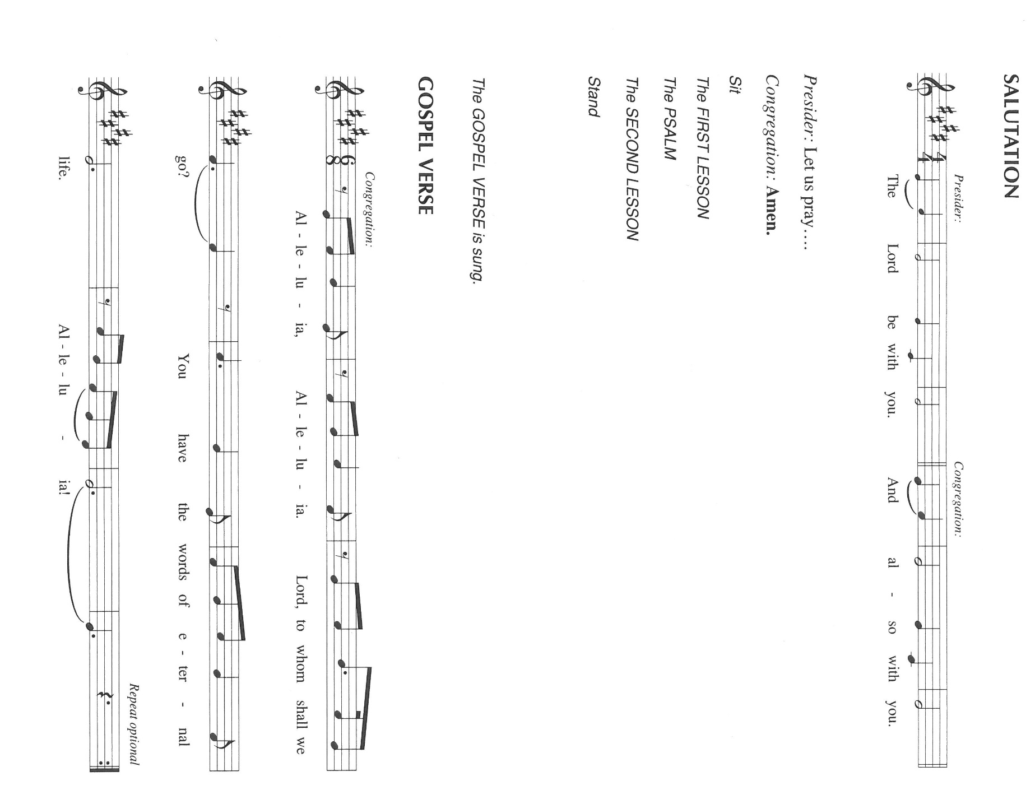*As you are able please rise*

**THE VERSE** (Sung twice)

**THE HOLY GOSPEL John 16:12-15**

*The Spirit, sent by the Father, reveals God's truth by glorifying the Son and making him known.*

P: The Holy Gospel according to St. John, the sixteenth chapter.

C: **Glory to You, O Lord!**

12"I still have many things to say to you, but you cannot bear them now. 13When the Spirit of truth comes, He will guide you into all the truth; for He will not speak on His own, but will speak whatever He hears, and He will declare to you the things that are to come.

14He will glorify Me, because He will take what is mine and declare it to you. 15All that the Father has is Mine. For this reason I said that He will take what is Mine and declare it to you."

P: The Gospel of the Lord.

C: **Praise to You, O Christ!**

*The assembly is seated*

**THE SERMON**

*Silence for meditation follows the sermon*

*As you are able please stand*

**THE HYMN OF THE DAY 412 *Come Join the Dance of Trinity***

**THE NICENE CREED**

A: God has made us His people through our Baptism into Christ. Living together in trust

and hope, we confess our faith.

C: **We believe in one God,**

**the Father, the Almighty,**

**maker of heaven and earth,**

**of all that is, seen and unseen.**

**We believe in one Lord, Jesus Christ,**

**the only Son of God,**

**eternally begotten of the Father,**

**God from God, Light from Light,**

**true God from true God,**

**begotten, not made,**

**of one Being with the Father.**

**Through Him all things were made.**

**For us and for our salvation**

**He came down from heaven;**

**by the power of the Holy Spirit**

**He became incarnate from the virgin Mary, and was made man.**

**For our sake He was crucified under Pontius Pilate;**

**He suffered death and was buried.**

**On the third day He rose again**

**in accordance with the Scriptures;**

**He ascended into heaven**

**and is seated at the right hand of the Father.**

**He will come again in glory to judge the living and the dead,**

**and His kingdom will have no end.**

**We believe in the Holy Spirit, the Lord, the giver of life,**

**Who proceeds from the Father and the Son.**

**With the Father and the Son He is worshiped and glorified.**

**He has spoken through the prophets.**

**We believe in one holy catholic and apostolic Church.**

**We acknowledge one Baptism for the forgiveness of sins.**

**We look for the resurrection of the dead,**

**and the life of the world to come. Amen**

**THE PRAYER OF THE CHURCH**

A: Confident in the Father’s steadfast love through Jesus Christ and sustained by the Holy

Spirit, let us pray for the Church, the world, and all people according to their needs.

A: That the Church may be guided into all truth, so it may profess before the world Your

majesty, mystery, and delight in all humanity, we pray:

C: **Holy Trinity, hear us.**

A: That this community of faith might, by the grace in which we stand, be daily conformed

ever more closely into the character of Christ, we pray:

C: **Holy Trinity, hear us.**

A: That in places and nations where unrest, warfare, terrorism and strife bring chaos and

suffering, especially in Ukraine; Nigeria; the Middle East; and El Salvador the wisdom

of God might bring about peace, justice, and safety for all who suffer, we pray:

C: **Holy Trinity, hear us.**

A: That the suffering of the grieving, the abused, the lonely, the forgotten, and the sick,

especially . . . might lead to endurance, and endurance to hope in Your never-failing

love, we pray:

C: **Holy Trinity, hear us.**

A: That those celebrating birthdays, especially **Janet Bakken and Iyve Benson**; and

anniversaries, especially **Tom and Amy Petri; Jim and Judy Gleason; and Doug**

**and Pam Kienitz** might be filled with grace this day and every day, and may grow in

grace in the days ahead, we pray:

C: **Holy Trinity, hear us.**

A: That with the saints, especially **Barnabas, Apostle** whom we commemorate this Day

we might be brought into Your everlasting community of glory and joy, we pray:

C: **Holy Trinity, hear us.**

P: O God, our Father from Whom all good things flow, we thank You and praise You.

Answer our prayer and bring us hope through Christ Your Son, Who celebrates life

with You in the unity of the Holy Spirit, now and forever.

C: **Amen.**

**✠ MEAL ✠**

**THE PEACE**

P: The peace of the Lord be with you always.

C: **And also with you.**

*The assembly is seated*

**THE OFFERING**

**CHOIR ANTHEM *God Hears Our Song*  St. Paul Senior Choir**

**(by Pepper Choplin)**

*As you are able please rise*

**THE OFFERTORY 465 *As the Grains of Wheat***

**THE OFFERTORY PRAYER**

A: Let us pray. Blessed Trinity,

C: **You sent Your Word to bring us Truth, and Your Spirit to make us holy. Bless**

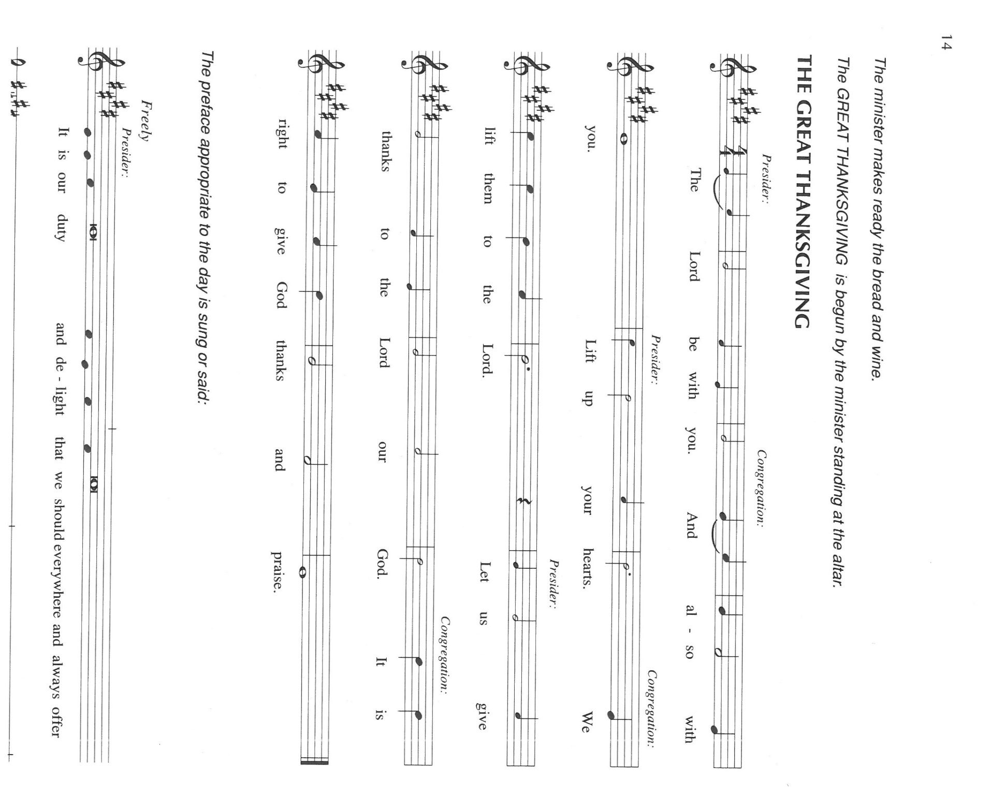 **now these gifts we bring before You. By Your Holy Spirit, may our eating and**

**drinking of the Body and Blood of Your Son make our lives blessed instruments**

**of Your love and grace. We ask this in the name of Jesus the Lord. Amen.**

**THE GREAT THANKSGIVING**

P: It is our duty and delight … and join their unending hymn:

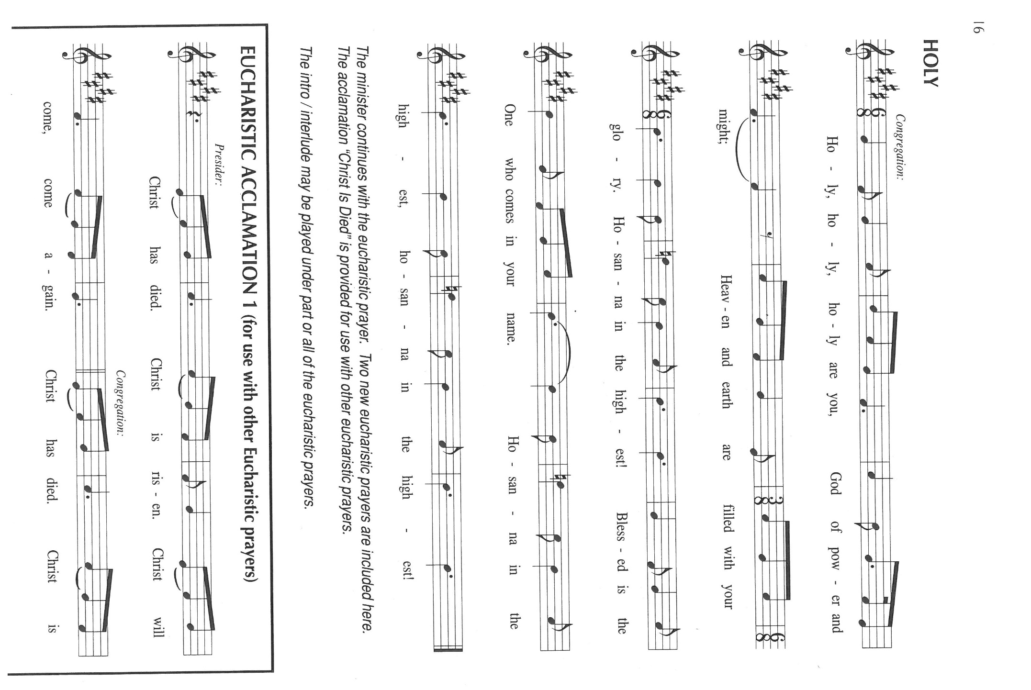

P: Threefold and glorious God, in Fatherly joy You created all things through the grace

of Your Word and the wisdom of Your Spirit.

In the depth of Your love for the world You gave Your only Son that all might come

to new life in Your Spirit.

You rolled away the stone by Your Fatherly hand and in the power of Your Spirit

raised Your incarnate Son from the dead.

In Your Fatherly mercy, You breathed Your Spirit on the fearful disciples, giving them

the fire of Your love to live as the Body of Your Son.

Lord God, there is none beside You; You are perfect in power, in love, and in purity.

You invite us to join You at Your heavenly Banquet that knows no end.

In this Meal we recall the sacrifice of Your Son and the sanctification of Your Spirit.

Send that Spirit upon us now, that we may be made ready to be Your companions,

and on these gifts of bread and wine, that they may be for us the Body and

Blood of Your Son, Jesus Christ our Lord,

Who, in the night ... “Do this for the remembrance of Me.”

As often as we eat ... we proclaim the Lord’s death until He comes.

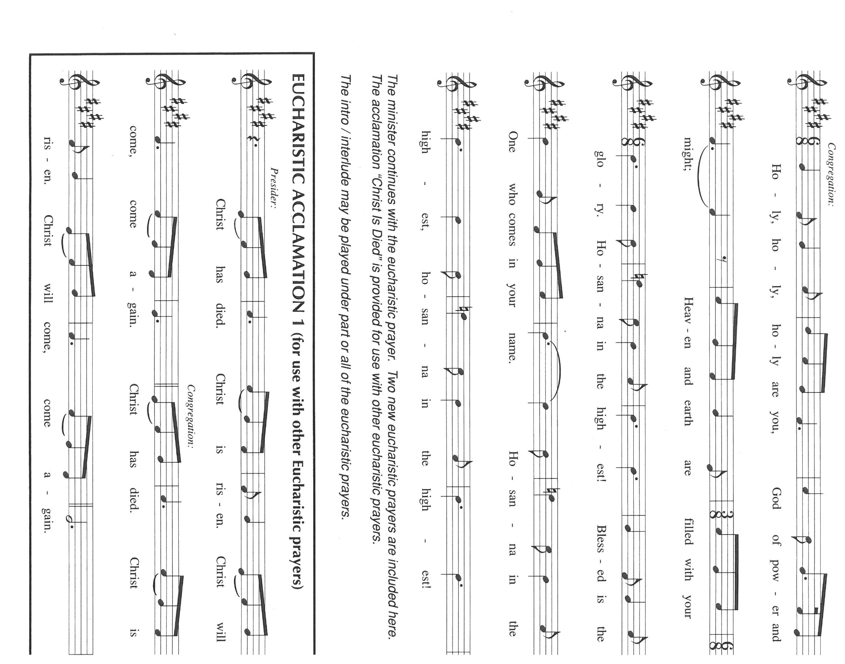

P: Triune God, in the dance of Your love we see Your nature as utter relationship.

Be close to all who struggle in relationship at home, in the workplace, across social

divides and national thresholds.

As Your three Persons gaze in shared attention look upon those whose lives goes

unrecognized.

As Your three Members work together in true partnership, uphold any who face the

struggles of their lives alone.

As Your Partners in threefold Unity relish one another in deep delight, revitalize those

who live without joy or hope.

Make Your Church a community across time and space that enjoys the gift of Your

life and imitates the wonder of Your love,

Until all come into Your presence and gaze upon Your glory,

God in Three Persons, blessed Trinity.

C: **Amen!**

**THE LORD’S PRAYER**

P: Gathered into one by the Spirit, let us pray as Jesus taught us:

C: **Our Father in heaven, hallowed be Your name. Your Kingdom come. Your will**

**be done on earth as it is in heaven. Give us this day our daily bread, and forgive**

**us our sins as we forgive those who sin against us. Save us from the time of trial**

**and deliver us from evil. For the Kingdom, the power, and the glory are Yours,**

**now and forever. Amen.**

**INVITATION TO THE MEAL**

P: This is the Lamb of God Who takes away the sin of the world Blessed are those who

are called to the Supper of the Lamb. God’s holy gifts for God’s holy people. Come,

for all is now ready.

*The assembly is seated*

**THE DISTRIBUTION “Lamb of God”**

*Those wishing to receive the Laying on of Hands, Anointing with Oil, and Prayer for Healing may go to Pastor at the side aisle*

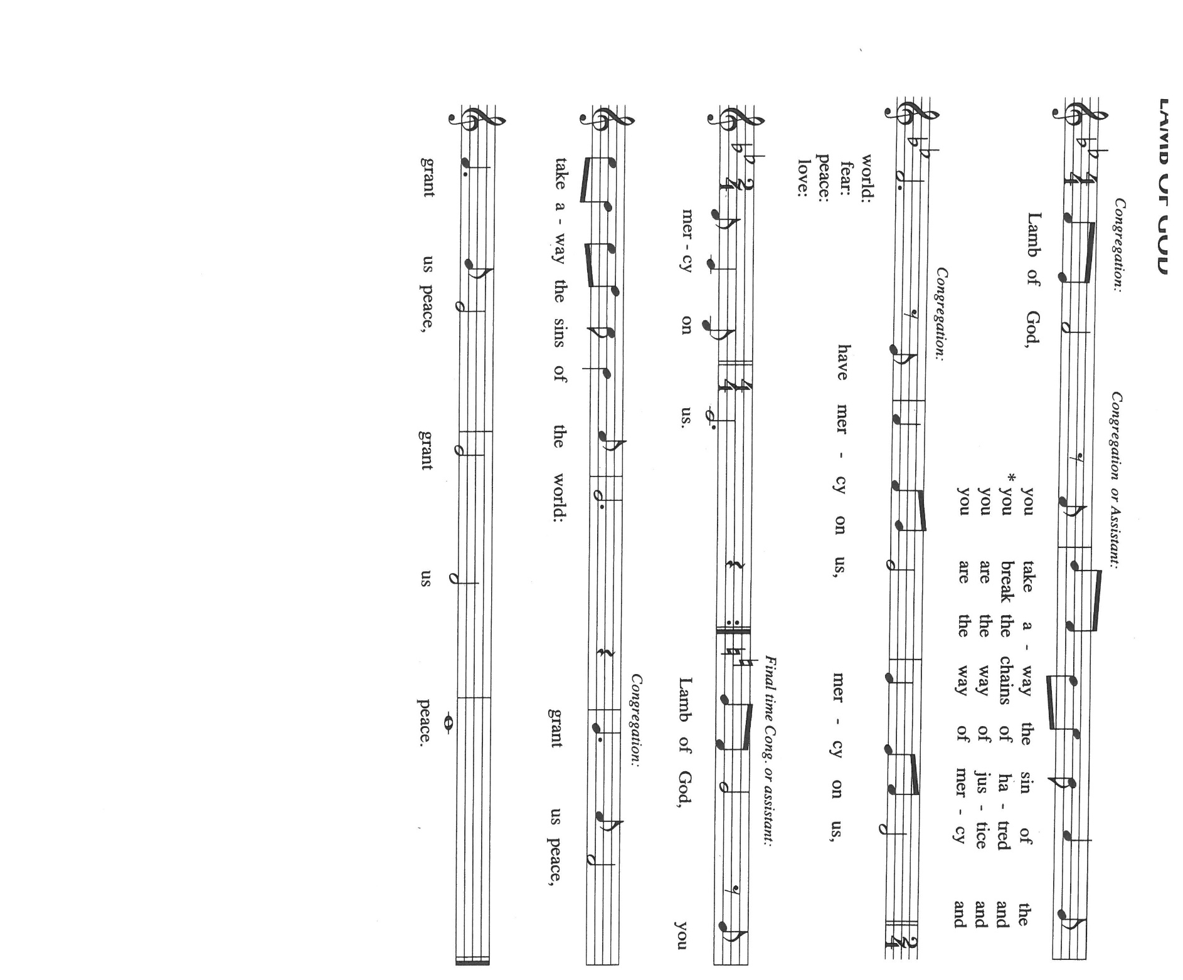

**HYMNS DURING DISTRIBUTION 413 *Holy, Holy, Holy***

**415 *Father Most Holy***

**834 *Immortal, Invisible, God Only Wise***

*As you are able please rise*

**THE POST-COMMUNION BLESSING**

P: The Body and Blood of our Lord Jesus Christ strengthen you and keep you in His grace.

C: **Amen.**

**THE POST-COMMUNION PRAYER**

A: Let us pray. Lord Jesus, we remember Your work through this holy Sacrament, and

rejoice for this insight into the Father’s love. By the wisdom of Your Spirit grant that

this Meal may bring us Your salvation and keep us faithful to the light of Your truth.

We bless You now and forever.

C: **Amen.**

**✠ SENDING ✠**

**THE BENEDICTION**

P: Almighty God: Father, Son **✠** and Holy Spirit, bless you now and forever.

C: **Amen.**

**THE RECESSIONAL HYMN 414 *Holy God, We Praise Your Name***

The congregation faces the cross as it leaves

**THE DISMISSAL**

A: Go in peace to bear Christ’s love to the world.

C: **Thanks be to God!**

**POSTLUDE *Holy God, We Praise Your Name* Robert Hobby**

***✠ To God Alone Be Glory✠***

The Meditation is from *A Large Catechism.* Robert W. Jenson. (Delhi, NY: American

Lutheran Publicity Bureau, 1991) 18.

The Eucharistic Prayer is adapted from *Eucharistic Prayers.* Samuel Wells and Abigail

Kocher. (Grand Rapids: Eerdmann’s Publishing Company, 2016) 186-87.

**ANNOUNCEMENTS**

**Please remember to mail your offering to the Church Office** at 818 Franklin Street, Michigan City, IN 46360**.** Another alternative is to give on-line through Tithe.ly. Please see your closure letter for information on how to set up a Tithe.ly account.

**St. Paul Members are reminded to have** a loved one contact the office if you are hospitalized. Many times, the Pastor doesn’t know someone is in the hospital. If you call and leave a message, please tell us which hospital the patient is at.

**Next Sunday’s lessons are Isaiah 65: 1-9; Psalm 22: 19-28; Galations 3: 23-29; Luke 8: 26-39** for those of you who like to study them in advance.

**Birthdays: Janet Bakken (6/14); Ivye Benson (6/14)**

**Anniversaries: Tom & Amy Petri (6/13); James & Judy Gleason (6/15);**

**Doug & Pamela Kienitz (6/15)**

**PRAYER CONCERNS:** Audrey Beyer, Ryan Krueger, Donna Bostater, Maxine Powell, Jim Tomscheck, Ken Mulder, Eloise Ponder, Mark & Jary Tannehill, Leonard Cross, George Ottersen and Annette Scroggin.

**If you requested someone’s name to be on the prayer list and are aware that they need continued imminent prayer then contact the church office and let us know.** Otherwise we will gradually transfer names to the long-term list.

**OFFICE HOURS:** Libby will be in the office on Mondays, Wednesdays, and Fridays; volunteers will cover Tuesdays and Thursdays.

Monday & Wednesday 8:00 a.m. – 5 p.m.

Tuesday & Thursday 9:00 a.m. – 12:00 p.m.

Friday 8:00 a.m. – 12:00 p.m.

**If you are listening to the worship broadcast on the radio and would like to watch the Sunday morning service live stream follow these steps:**

(1) If you have You.Tube available on your TV, search for

**St. Paul Lutheran Church Michigan City, IN.**

(2) The direct link on the computer is

<https://www.youtube.com/channel/UC5AIPNaKr3QN50984jGOa1g>.

 (3) This link is also on the main page of the church’s website in the church section and will continue to be posted weekly on the St. Paul Facebook page.

And it will always be available on the radio broadcast Sunday mornings at 11:00 a.m. on WEFM (95.9), and on the local cable access station #99 for the previous week’s service on Sundays at 4:00 p.m. and the current service on Wednesdays at 7:00 p.m. and Fridays at 8:30 p.m.

**To send e-mail to the church office**, please use the following addresses:

Pastor Mark Reshan: [seniorpastor@stpaulmichigancity.com](mailto:seniorpastor@stpaulmichigancity.com)

Church Office Secretary (Libby Pollock): [churchsecretary@stpaulmichigancity.com](mailto:churchsecretary@stpaulmichigancity.com)

Church Treasurer (Karen Fleming) and Bookkeeper (Billie Atchinson):

finance@stpaulmichigancity.com.

**The Good News Newsletter**: If you have an article or anything you want included in **The Good News** please send it to the following e-mail address: splcgoodnews@gmail.com. Pastor Pamela Thiede will be using this e-mail address to assemble **The Good News** each month. The deadline for getting information to Pastor Pamela will be the 20th of each month.

**WORSHIP ATTENDANCE for June 4 and 5, 2022**

**4:00 p.m. 25**

**9:00 a.m. 50**

**Total = 75**

**The Community Soup Kitchen serving out of First United Methodist is in need of volunteers.** Sunday through Tuesday is always need, as is occasionally Wednesdays and Thursdays. Hours are 9:30 a.m. to 1:15 p.m. and it is not necessary to stay the entire time. There is also a need for volunteers to be available to help pick up deliveries from the Food Bank when they arrive. If you are able to help please contact their church office at 872-7200.

**JUNE 2022 ACTIVITIES, MEETINGS AND SERVICES**

**Wednesday,** June 1, 2022 at 9:45 a.m. Bible Study/Luther House

at 10:00 a.m. God’s Purls/St. Paul Room

**Saturday,** June 4, 2022 at 4:00 p.m. Worship Service

**Sunday,** June 5, 2022 at 9:00 a.m. Worship Service

**Tuesday,** June 7, 2022 at 9:30 a.m. Charity Circle/Nursery (Green Room)

**Wednesday,** June 8, 2022 at 10:00 a.m. God’s Purls/St. Paul Room

at 6:00 p.m. Worship & Music Committee Meeting

at 7:00 p.m. Choir Rehearsal

**Saturday,** June 11, 2022 at 4:00 p.m. Worship Service

**Sunday,** June 12, 2022 at 9:00 a.m. Worship Service

**Monday,** June 13, 2022 at 12:30 p.m. Harmony Circle/Nursery (Green Room)

at 3:30 p.m. School Board Meeting/Luther House

**Tuesday,** June 14, 2022 from open to close **GIVE-BACK at Swingbelly’s**

**Wednesday,** June 15, 2022 at 10:00 a.m. God’s Purls/St. Paul Room

**Saturday,** June 18, 2022 at 4:00 p.m. Worship Service

**Sunday,** June 19, 2022 at 9:00 a.m. Worship Service

**Monday,** June 20, 2022 at 4:00 p.m. Finance Committee Meeting/St. Paul Room

at 5:30 p.m. Executive Board Meeting/Luther House

**Wednesday,** June 22, 2022 at 10:00 a.m. God’s Purls/ St. Paul Room

at 11:00 a.m. – Close **GIVE-BACK night at Chili’s in M. C.**

**Thursday,** June 23, 2022 at 5:00p.m. 150th Anniversary Committee Meeting/Luther House

at 5:30 p.m. Church Council Meeting/ St. Paul Room

**Saturday,** June 25, 2022 at 4:00 p.m. Worship Service

**Sunday,** June 26, 2022 at 9:00 a.m. Worship Service





