THE FIRST SUNDAY IN ADVENT
November 27, 2022

In a religious autobiography entitled Confessions, St. Augustine tells of hearing the singsong chant of a child intoning repeatedly, “Pick it up and read it.” Going back to Paul’s letters Augustine opened randomly to what we now designate as Romans 13:13: “Put on the Lord Jesus Christ,” and this Romans passage is designated as our second Bible reading on this Advent Sunday.
As the days continue to darken earlier during this season, we are summoned to the light at the end of the Advent tunnel. That light is Christ: chiefly as he is to come in glory at the end, but also, prefigured, as that coming is, by his earthly coming as the Christ of Christmas. But for now, look for the coming one at an hour you do not expect him.

Gerald Sloyan

Face to face with our limits,
Blinking before the frightful
Stare of our frailty,
Promise rises
Like a posse of clever maids
Who do not fear the dark
Because their readiness
Lights the search.
Their oil
Becomes the measure of their love,
Their ability to wait—
An indication of their
Capacity to trust and take a chance.
Without the caution or predictability
Of knowing the day or hour,
They fall back on that only
Of which they can be sure:
Love precedes them,
Before it,
No door will ever close.

T.J. O’Gorman

+ In the Name of Jesus +

INTRODUCTION

The new church year begins with a wake-up call: Christ is coming soon! In today's readings both Paul and Jesus challenge us to wake from sleep, for we know neither the day nor hour of the Lord's coming. Isaiah proclaims the day when God will gather all people on the holy mountain and there will be no more war or suffering. Though we vigilantly watch for the promised day of salvation, we wait for what we already have: Christ comes among us this day as the word and meal that strengthens our faith in the promises of God.

Isaac Watts, hymnwriter, died 1748

Thought by many to be the greatest hymnwriter in the English language, Watts as a youth was critical of the quality of the metrical psalter of the time. He wrote about 600 hymns—many based on the psalms, but others that are not.
Andrew, Apostle

The first of the disciples to be called by Jesus, Andrew quickly began to bring others to the Savior, including Simon Peter. The Bible also shows him leading some Greeks to meet Jesus, and he brought forward the boy with five loaves and two fish, with which Jesus fed thousands.

+ GATHERING +

PRELUDE

ANNOUNCEMENTS

As you are able please rise

CONFESSION AND ABSOLUTION

P: In the name of the Father and of + the Son and of the Holy Spirit.

C: Amen.

P: “ ...you know what time it is, how it is the moment for you to wake from sleep ... let us then lay aside the works of darkness and put on the armor of light; let us live honorably ... put on the Lord Jesus Christ.” (Romans 13:11,13-14) Let us confess the ways in which we need to “lay aside the works of darkness” that God may fill us with the bright light of Christ’s mercy and forgiveness.

Silence for self-examination and reflection is kept

P: Most merciful God,

C: We confess that we have sinned against You in thought, word, and deed. We need to be awakened to Your call to live honorably and justly (Isaiah 2:3). We are guilty of quarreling and jealousy (Romans 13:13). We have sought to satisfy our own desires instead of seeking Your will and way. We have lived unaware, unconcerned, and unprepared for Your return (Matthew 24:42-43). For the sake of Your Son, Jesus Christ, have mercy on us. Scatter the darkness of our hearts. Fill them with Your love and life. Make us ready for Your advent.

P: In your Baptism you have already “put on the Lord Jesus Christ” (Romans 13:14). Therefore, the light of God’s forgiveness is yours. Put aside the darkness, and rejoice in this Good News: as a called and ordained minister of the Church of Christ, and by His authority, I declare to you the entire forgiveness of all your sins, in the name of the Father and of + the Son and of the Holy Spirit.

C: Amen.

GATHERING HYMN 242 Awake, Awake, and Greet the New Morn

THE GREETING

P: In days to come, God’s holy mountain shall be raised above the hills; all nations shall stream to it.

C: Come, let us go up to the house of our God (Psalm 122:1).

P: The grace of our Lord Jesus Christ, the love of God, and the communion of the Holy Spirit be with you all.

C: And also with you.

THE KYRIE
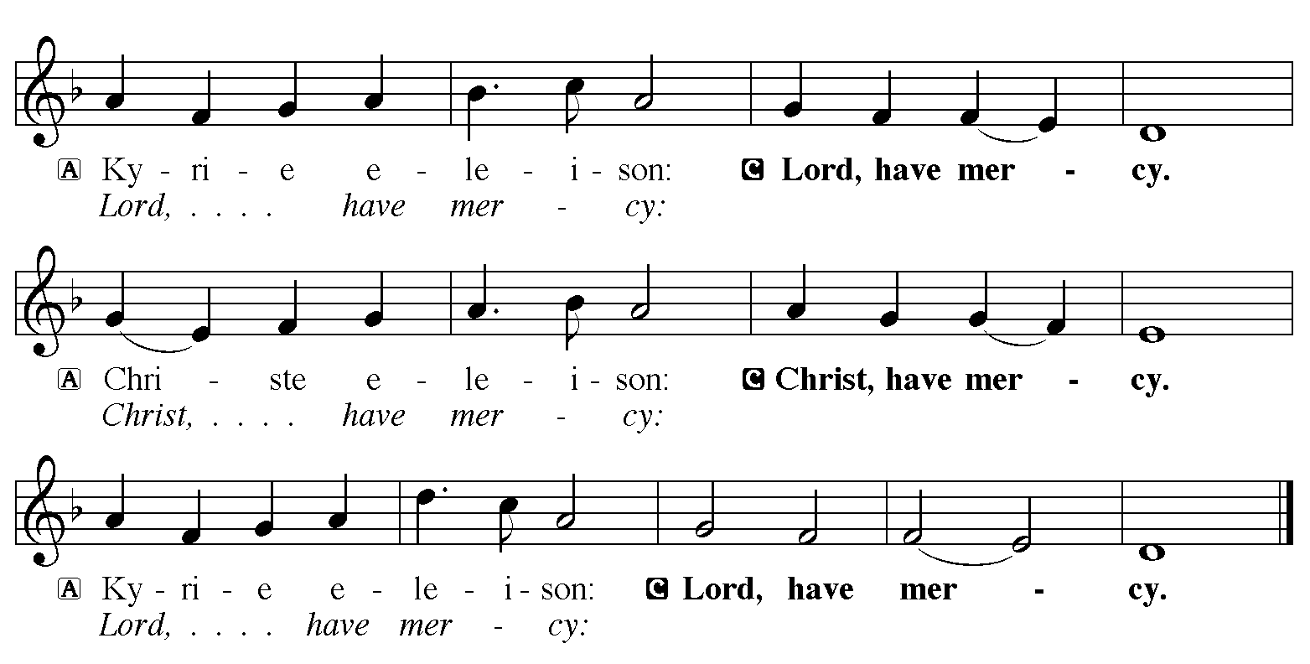

THE PRAYER OF THE DAY

P: The Lord be with you.

C: And also with you.

P: Let us pray.
Stir up Your power, Lord Christ, and come. By Your merciful protection save us from the threatening dangers of our sins, and enlighten our way in the way of Your salvation, for You live and reign with the Father and the Holy Spirit, one God, now and forever.

C: Amen.

The assembly is seated

+ WORD +

LIGHTING OF THE ADVENT LOG 240 Light One Candle to Watch for Messiah
Stanza 1

P: Let us pray. Blessed are You, O Lord our God, King of the universe. You call all nations to walk in Your light and to seek Your ways of justice and peace, for the night is past, and the dawn of Your coming is near. Bless us as we light the first candle on this log. Rouse us from sleep, that we may be ready to greet our Lord when He comes and welcome Him into our hearts and homes, for He is our light and our salvation. Blessed be God forever.

C: Amen.

THE FIRST LESSON Isaiah 2:1-5

The visionary message presented in this reading focuses on a future day when God establishes universal reign. At that time, the Lord will be recognized as God of all the earth. The prophet calls God's people to trust in the certainty of that reign even now.

The word that Isaiah son of Amoz saw concerning Judah and Jerusalem.
²In days to come
the mountain of the LORD's house
shall be established as the highest of the mountains,
and shall be raised above the hills;
all the nations shall stream to it.
³Many peoples shall come and say,
"Come, let us go up to the mountain of the LORD,
to the house of the God of Jacob;
that He may teach us His ways
and that we may walk in His paths."
For out of Zion shall go forth instruction,
and the word of the LORD from Jerusalem.
⁴He shall judge between the nations,
and shall arbitrate for many peoples;
they shall beat their swords into plowshares,
and their spears into pruning hooks;
nation shall not lift up sword against nation,
neither shall they learn war any more.
⁵O house of Jacob,
come, let us walk in the light of the LORD!

The Word of the Lord.

Thanks be to God.

THE PSALM: Psalm 122 Read responsively

¹I was glad when they said to me,
"Let us go to the house of the LORD."

²Now our feet are standing
within your gates, O Jerusalem.

³Jerusalem is built as a city
that is at unity with itself;

⁴to which the tribes go up, the tribes of the LORD,
the assembly of Israel, to praise the name of the LORD.

⁵For there are the thrones of judgment,
the thrones of the house of David.

⁶Pray for the peace of Jerusalem:
"May they prosper who love you.

⁷Peace be within your walls
and quietness within your towers.

⁸For the sake of my kindred and companions,
I pray for your prosperity.

⁹Because of the house of the LORD our God,
I will seek those who do you good.

SECOND READING Romans 13:11-14

Paul compares the advent of Christ to the coming of the dawn. We should anticipate his arrival and prepare for it as we would prepare to greet the new day.

Besides this, you know what time it is, how it is now the moment for you to wake from sleep. For salvation is nearer to us now than when we became believers; ¹²the night is far gone, the day is near. Let us then lay aside the works of darkness and put on the armor of light; ¹³let us live honorably as in the day, not in reveling and drunkenness, not in debauchery and licentiousness, not in quarreling and jealousy. ¹⁴Instead, put on the Lord Jesus Christ, and make no provision for the flesh, to gratify its desires.
The Word of the Lord.

Thanks be to God.

As you are able please rise

THE VERSE

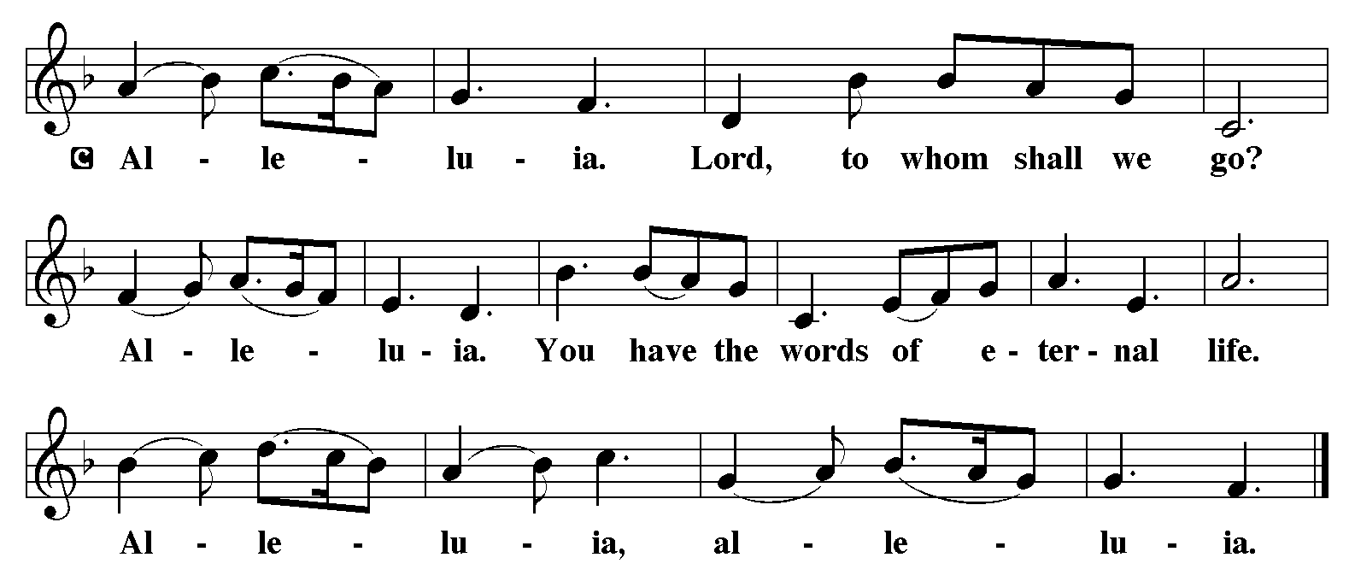

THE HOLY GOSPEL Matthew 24:36-44

Jesus describes his second coming as a sudden unexpected event that will bring salvation or judgment upon people caught up in the usual affairs of daily life. Therefore, he urges people to be alert and expectant.

P: The Holy Gospel according to St. Matthew, the twenty-fourth chapter.

C: Glory to You, O Lord!

Jesus said to the disciples, "About that day and hour no one knows, neither the angels of heaven, nor the Son, but only the Father. ³⁷For as the days of Noah were, so will be the coming of the Son of Man. ³⁸For as in those days before the flood they were eating and drinking, marrying and giving in marriage, until the day Noah entered the ark, ³⁹and they knew nothing until the flood came and swept them all away, so too will be the coming of the Son of Man.
⁴⁰Then two will be in the field; one will be taken and one will be left. ⁴¹Two women will be grinding meal together; one will be taken and one will be left. ⁴²Keep awake therefore, for you do not know on what day your Lord is coming. ⁴³But understand this: if the owner of the house had known in what part of the night the thief was coming, he would have stayed awake and would not have let his house be broken into. ⁴⁴Therefore you also must be ready, for the Son of Man is coming at an unexpected hour."

P: The Gospel of the Lord.

C: Praise to You, O Christ!

The assembly is seated

THE SERMON

Silence for reflection follows the sermon

As you are able please rise

THE HYMN OF THE DAY Band

THE NICENE CREED

A: God has made us His people through our Baptism into Christ. Living together in trust and hope, we confess our faith.

We believe in one God,
the Father, the Almighty,
maker of heaven and earth,
of all that is, seen and unseen.

We believe in one Lord, Jesus Christ,
the only Son of God,
eternally begotten of the Father,
God from God, Light from Light,
true God from true God,
begotten, not made,
of one Being with the Father.
Through Him all things were made.
For us and for our salvation
He came down from heaven;
by the power of the Holy Spirit
He became incarnate from the virgin Mary, and was made man.
For our sake He was crucified under Pontius Pilate;
He suffered death and was buried.
On the third day He rose again
in accordance with the Scriptures;
He ascended into heaven
and is seated at the right hand of the Father.
He will come again in glory to judge the living and the dead,
and His kingdom will have no end.

We believe in the Holy Spirit, the Lord, the giver of life,
Who proceeds from the Father and the Son.
With the Father and the Son He is worshiped and glorified.
He has spoken through the prophets.
We believe in one holy catholic and apostolic Church.
We acknowledge one Baptism for the forgiveness of sins.
We look for the resurrection of the dead,
and the life of the world to come. Amen

THE PRAYER OF THE CHURCH

A: As the Day of the Lord Jesus draws near, we are called to be awake, alert, and watchful in prayer.

A: Prepare the Church for Your advent, gracious God. Help us to grasp the urgency of the hour in which we live, that we may be bold and courageous in our witness. O Giver of hope,

C: Hear our prayer.

A: Prepare the nations for Your advent, gracious God. Turn their weapons into instruments of peace, so that they no longer learn war. O Giver of hope,

C: Hear our prayer.

A: Prepare our society for Your advent, gracious God. Turn us from our obsession with guns and violence, and comfort victims and families who grieve loss of life and fear of safety, especially those killed in the Colorado Springs shooting. O Giver of hope,

C: Hear our prayer.

A: Prepare this community for Your advent, gracious God. Teach us to live honorably, and to put on Christ in all our speech and deeds. O Giver of hope,

C: Hear our prayer.

A: Prepare those who suffer for Your advent, gracious God. Encircle those who are ill, especially . . . with peace and healing. O Giver of hope,

C: Hear our prayer.

A: As the Day of the Lord draws near, keep us faithful that we may join the saints, especially Andrew, Apostle; and Isaac Watts, hymnwriter, whom we commemorate this Day in everlasting light. O Giver of hope,

C: Hear our prayer.

P: You have called us, O God, to be Your people and the instruments of Your presence in the world. Grant us grace to discern Your will and the strength to do it, through Jesus Christ our Lord.

C: Amen.

+ MEAL +

THE PEACE

P: The peace of the Lord be with you always.

C: And also with you.

The assembly is seated

OFFERING

VOLUNTARY Band

As you are able please rise

THE OFFERTORY 490 Let All Mortal Flesh Keep Silence Stanzas 1,2

THE OFFERTORY PRAYER

A: Let us pray. God of love and power,

C: Your Word stirs within us the expectation of the coming of Your Son. Accept all we offer You this Day, and by our eating and drinking, make us ready for the advent of Christ, both now and in the age to come. We ask this in the name of Jesus the Lord. Amen.

THE GREAT THANKSGIVING

P: The Lord be with you.

C: And also with you.

P: Lift up your hearts.

C: We lift them up to the Lord.

P: Let us give thanks to the Lord our God.

C: It is right to give Him thanks and praise.

P: It is indeed right and salutary … we praise Your name and join their unending hymn:

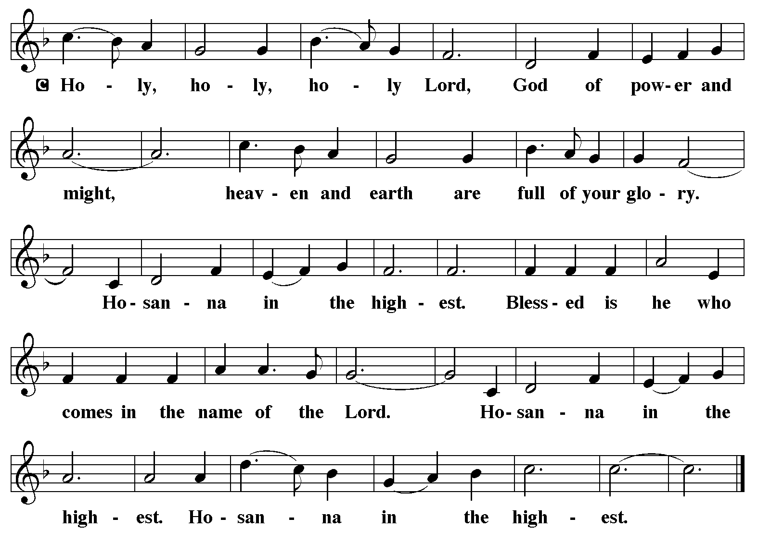

P: Covenant God, in the beginning You called Your creation good and flooded it with
beauty and bounty, with goodness and grace.
In the days of Noah You drowned Your creation to wash away sin and draw Your own
sons and daughters to Yourself.
Through Your covenant with Israel Your promises flowed to all nations, and in Jesus
Christ You drew us out of our waywardness into the relentless flood of Your
mercy.
His death was the drowning of our sin; His resurrection and ascension bless all nations
to stream toward You in glory.
Peacemaking God, in Christ You made an ending of the life of spears and swords, and
came to us with plowshares and pruning hooks, the tools of planting and
cultivating, that we might be fed.
In Him You showed us how to study war no more, how to lay down our swords and
shields, and how to feast with the Prince of Peace.
As You came to us to be our very food and drink, send Your Holy Spirit upon this bread
and cup, and make them be for us the Body and Blood of Your Son Jesus Christ;
Who, in the night ... “Do this for the remembrance of Me.”
As often as we eat ... we proclaim the Lord’s death until He comes.

C: Christ has died. Christ is risen. Christ will come again.

P: God of prophets and promises, as You turn swords into plowshares, take our sin and
reshape us for salvation.
Take our foolishness and bend us toward faith.
Take our hostility and refashion us for heaven in the crucible of Your love.
Stir Your Church with wakening hope, that soon and very soon we are going to see
our King.
Quicken our spirits with trust in that Day when we who have been blessed with such
hope will gather around Your throne with saints of every age, in praise and
thanksgiving to You,
One God: Father, + Son, and Holy Spirit.

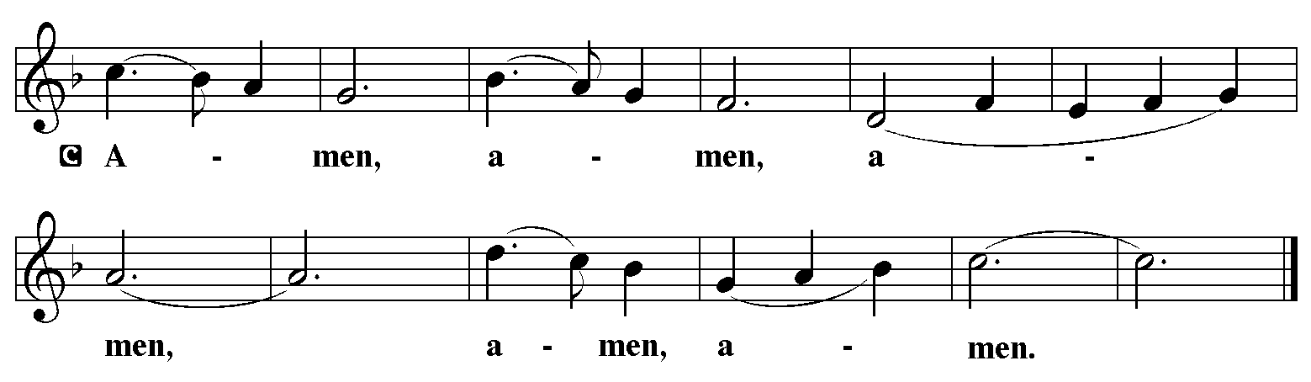

THE LORD’S PRAYER

P: Let us pray for the coming of God’s Reign as Jesus taught us:

C: Our Father in heaven, hallowed be Your name. Your Kingdom come. Your will be done on earth as it is in heaven. Give us this day our daily bread, and forgive us our sins as we forgive those who sin against us. Save us from the time of trial and deliver us from evil. For the Kingdom, the power, and the glory are Yours, now and forever. Amen.

INVITATION TO THE MEAL

P: Behold the Lord Whose advent we await, Who will come with glory on the Day of judgment. Blessed are those who are called to the Supper of the Lamb. God’s holy gifts for God’s holy people. Come, for all is now ready.

The assembly is seated

THE DISTRIBUTION

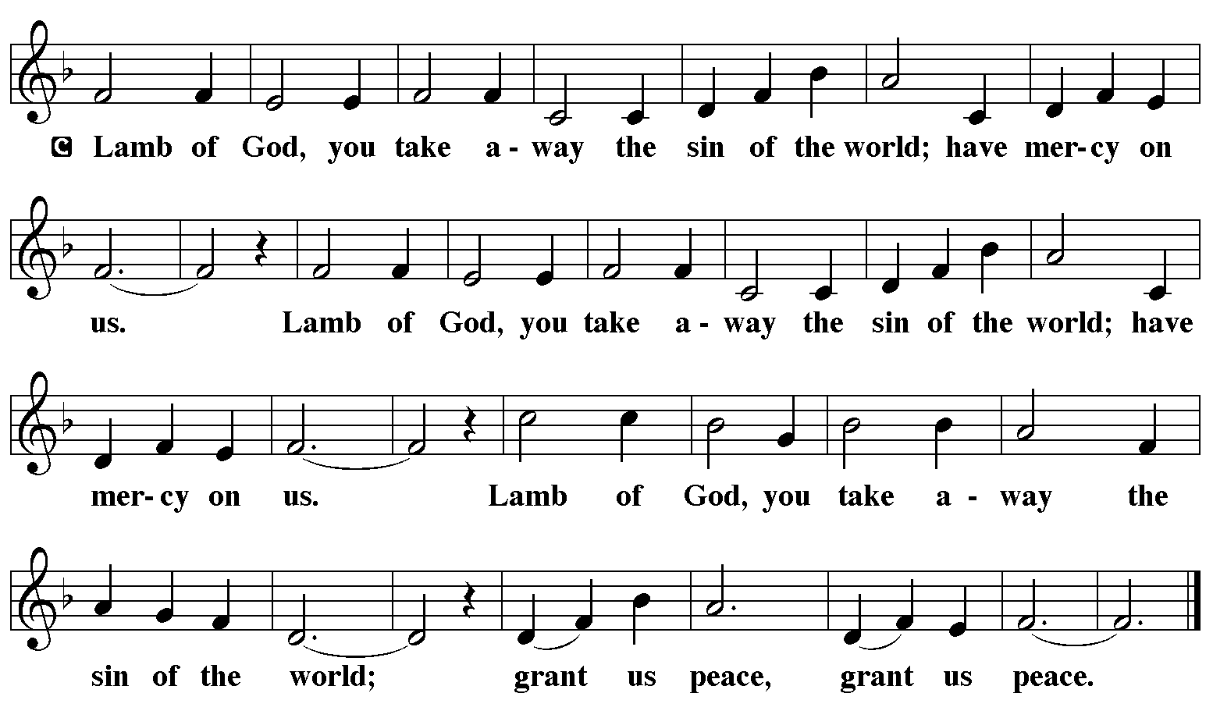

HYMN DURING DISTRIBUTION 253 He Came Down
715 Christ, Be Our Light
252 Each Winter as the Year Grows Older

As you are able please rise

THE POST-COMMUNION BLESSING

P: The Body and Blood of our Lord Jesus Christ strengthen you and keep you in His grace.

C: Amen.
THE POST-COMMUNION PRAYER

A: Let us pray. Lord Jesus Christ, we recognize Your coming in this Sacrament. Teach us how to keep awake and to watch for You through faithfulness, that Your advent may always make us ready to stand before You with hope and joy. You are the Lord forevermore.

C: Amen.
+ SENDING +
THE BENEDICTION

P: The Lord bless you and keep you. The Lord make His face shine on you and be gracious to you. The Lord look upon you with favor and + give you peace.

C: Amen.

SENDING SONG 677 This Little Light of Mine

THE DISMISSAL

A: Go in peace. Walk in the light of the Lord.

C: Thanks be to God!

+ To God Alone Be Glory +

The Meditations are from Sundays and Seasons. Year A. Copyright Augsburg Fortress 2016;
An Advent Sourcebook. T.J. O’Gorman, ed. (Chicago: Liturgy Training Publications,
1988) 33-4.

The Invitation to the Lord’s Prayer, the Prayers, and Holy Communion are from Prayers for Sundays and
Seasons. Year A. Peter J. Scagnelli. (Chicago: Liturgy Training Publications, 1998) 2-3.

The Rite for the Lighting of the Advent candle is from Sundays and Seasons. Year A. Copyright
Augsburg Fortress, 2014.

The Eucharistic Prayer is adapted from Eucharistic Prayers. Samuel Wells and Abigail Kocher.
(Grand Rapids: Eerdmann’s Publishing Company, 2016) 36-37.

ANNOUNCEMENTS

Please remember to mail your offering to the Church Office at 818 Franklin Street, Michigan City, IN 46360. Another alternative is to give on-line through Tithe.ly. Please see your closure letter for information on how to set up a Tithe.ly account.

St. Paul Members are reminded to have a loved one contact the office if you are hospitalized. Many times, the Pastor doesn’t know someone is in the hospital. If you call and leave a message, please tell us which hospital the patient is at.

Next Sunday’s lessons are: Isaiah 11: 1-10; Psalm 72: 1-7, 18-19; Romans 15: 4-13; and Matthew 3:1-12 for those of you who like to study them in advance.

PRAYER CONCERNS: Audrey Beyer, Ryan Krueger, Donna Bostater, Maxine
Powell, Jim Tomscheck, Eloise Ponder, Mark & Jary Tannehill, Marvin Dirks, Leonard Cross, George Ottersen, Patti Henoch, Valerie Waltz, Margie Torres, Dan Pursely, Jayla Jacobi. If you requested someone’s name to be on the prayer list and are aware that they need continued imminent prayer then contact the church office and let us know. Otherwise we will gradually transfer names to the long-term list.

There are some names on the long-term prayer list that have been listed for many months. We would like to keep the list current so if you requested them to be included please contact the church office and tell us whether you would still like them on the list: Robert Atwood; Laura Eilers-Straight; Terry Hygema; Jess Kalvaitis; Tom and Larry Lueth; Duane Ormsby; Cameron Rackard; Ryan Sirk; Jean Thomas; Heidi Happel; Christian Martinez; Ron Armer.

OFFICE HOURS: Libby will be in the office on Mondays, Wednesdays, and Fridays; volunteers will cover Tuesdays and Thursdays.

Monday & Wednesday 8:00 a.m. – 5 p.m.
Tuesday & Thursday 9:00 a.m. – 12:00 p.m.
Friday 8:00 a.m. – 12:00 p.m.

If you are listening to the worship broadcast on the radio and would like to watch the Sunday morning service live stream follow these steps:

(1) If you have You.Tube available on your TV, search for
St. Paul Lutheran Church Michigan City, IN.

(2) The direct link on the computer is
https://www.youtube.com/channel/UC5AIPNaKr3QN50984jGOa1g.

(3) This link is also on the main page of the church’s website in the church section
and will continue to be posted weekly on the St. Paul Facebook page.
And it will always be available on the radio broadcast Sunday mornings at 11:00 a.m. on WEFM (95.9), and on the local cable access station #99 for the previous week’s service on Sundays at 4:00 p.m. and the current service on Wednesdays at 7:00 p.m. and Fridays at 8:30 p.m.

To send e-mail to the church office, please use the following addresses:

Pastor Mark Reshan: seniorpastor@stpaulmichigancity.com

Church Office Secretary (Libby Pollock): churchsecretary@stpaulmichigancity.com

Church Treasurer (Karen Fleming): finance@stpaulmichigancity.com

The Good News Newsletter: If you have an article or anything you want included in The Good News please send it to the following e-mail address: splcgoodnews@gmail.com. Pastor Pamela Thiede will be using this e-mail address to assemble The Good News each month. The deadline for getting information to Pastor Pamela will be the 20th of each month.

WORSHIP ATTENDANCE for November 19 and 20, 2022
4:00 p.m. 17
9:00 a.m. 47
Total = 64

Support St. Paul School
Most of us (St. Paul Church members) are of the age to be grandparents or even great or great great grandparents. Our school has some students in need of someone to read to them or maybe to offer some instruction one on one. The students are from K-8 so you can choose an age that you’d be comfortable with. Please consider sharing your grandparenting skills with our students one time or regularly.
Contact Tracy McCay school principle at 219-874-7409 or a
School board member to schedule.

A beautiful new Christmas card featuring the wooden cross in our nave decorated from last Christmas will be available for purchase when they arrive shortly after thanksgiving. The cost is only $10.00 for 10 cards/envelopes. We have ordered 300 s make sure you get your order in by calling the office at 219-874-7293.

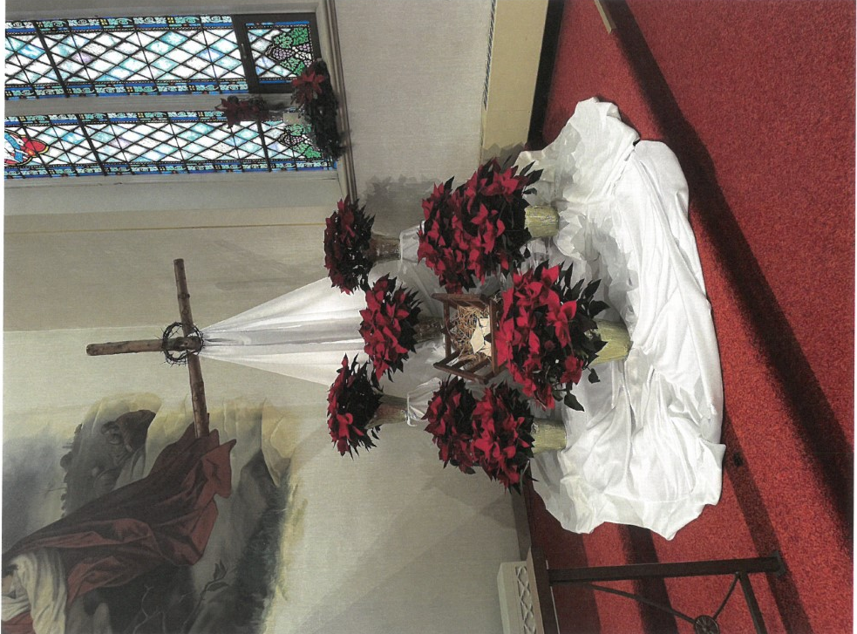

2022 Financial Stewardship

Weekly Church Operating Needs (x 2 weeks): $ 19,148.14
October 22 and 23, and 29 and 30, 2022
General Fund (including General Memorials): $ 9,317.00
Overage/Shortage: --$ 9,831.14

Restricted Income (not including Memorials)
Supports IK Synod & Church wide Ministries: $170.00
Ministries in our Community/Congregation: $ 50.00
Capital Fund: $370.00

General Fund $450.00

2022 Financial Stewardship

Weekly Church Operating Needs (x 2 weeks): $ 15015.68
October 8 and 9, and 15 and 16, 2022
General Fund (including General Memorials): $ 11,171.50
Overage/Shortage: --$ 3,844.18

Restricted Income (not including Memorials)
Supports IK Synod & Church wide Ministries: $380.00
Ministries in our Community/Congregation: $ 50.00
Capital Fund: $465.00

General Fund $345.00
Capital Fund $20.00

Thank$ for $haring

Thanks to all who attended the giveback at Hacienda. The church received $171.00 from that evening.
This month,we will see you at Holly’s! We’re giving you two coupons so you can invite a friend and give them their own coupon. Remember, the coupon is required for the Give-Back bucks.

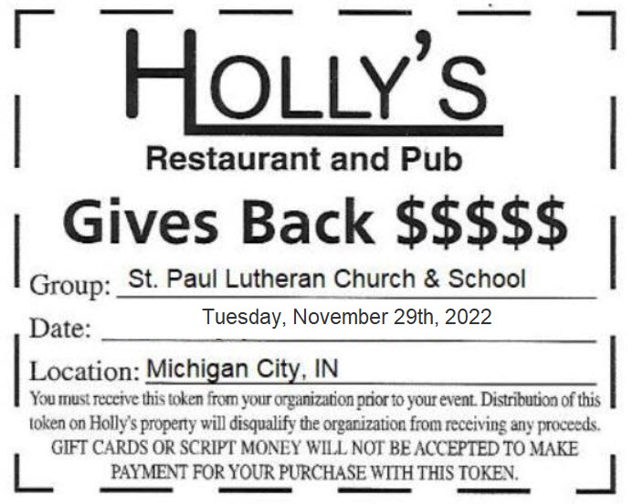

Activities, Events & Meetings
December 2022

Saturday, December 3, 2022 Worship Service at 4:00 p.m./2nd Saturday in Advnt

Sunday, December 4, 2022 Worship Service at 9:00 a.m./2nd Sunday in Advent

Tuesday, December 6, 2022 at 11:30 a.m. Altar Guild at Gelsosomo’s Pizza in M.C.

Wednesday, December 7, 2022 at 9:45 a.m. Bible Study/Luther House

at 10:00 a.m. God’s Purls/St. Paul Room

Saturday, December 10, 2022 at 4:00 p.m. Worship Service/3rd Saturday in Advent

Sunday, December 11, 2022 at 9:00 a.m. Worship Service/3rd Sunday in Advent

Monday, December 12, 2022 at 3:30 p.m. School Board Meeting/Luther House

Tuesday, December 13, 2022 at 11:30 a.m. Charity Circle at Sophia’s Restaurant

at 12:30 p.m. Harmony Circle/Nursery

at 7:00 p.m. Estuary/Luther House

Wednesday, December 14, 2022 at 9:45 a.m. Bible Study/Luther House

at 10:00 a.m. Advent Senior/Quiet Communion
Service with luncheon after

at 7:00 p.m. Choir Rehearsal

Saturday, December 17, 2022 at 4:00 p.m. Worship Service/4th Saturday in Advent

Sunday, December 18, 2022 at 9:00 a.m. Worship Service/4th Sunday in Advent

Monday, December 19, 2022 at 4:00 p.m. Finance Committee Meeting/Luther House

at 5:30 p.m. Executive Board Meeting/Luther House

Wednesday, December 21, 2022 at 9:45 a.m. Bible Study/Luther House

at 10:00 a.m. God’s Purls/St. Paul Room

at 7:00p.m. Choir Rehearsal

Thursday, December 22, 2022 at 5:00 p.m. Ann. Planning Comm. Mtg./Luther House

at 5:30 p.m. Church Council Meeting/St. Paul Room

Saturday, December 24, 2022 at 6:00 p.m. Christmas Eve. Worship Service

Sunday, December 25, 2022 at 9:00 a.m. Christmas Day Worship Service

Wednesday, December 28, 2022 at 9:45 a.m. Bible Study/Luther House
at 10:00 a.m. God’s Purls

