THE FIRST SUNDAY IN LENT
February 26, 2023

Whether we gaze with longing into the garden or with fear and trembling into the desert, of this we can be sure--God walked there first! And when we who have sinned and despoiled the garden are challenged now to face the desert, we do not face it alone; Jesus has gone there before us to struggle with every demon that has ever plagued a human heart. Face the desert we must if we would reach the garden, but Jesus has gone there before us.

James Healy

The Lord formed these words in my soul: “Therewith is the fiend overcome.” When he said these words, our Lord was referring to his blessed passion. On account of this, I laughed loud and long, which made those who were around me laugh too, and their laughter was a pleasure to me. I understood that we may laugh, comforting ourselves and rejoicing in God that the devil has been overcome.

Julian of Norwich

We have come to the beginning of our Lenten spring, the season to prepare the holy Passover that will bring our catechumens to the saving waters of rebirth, the Passover that will be, for those of us already initiated, a pilgrimage of conversion. Along the way we will be challenged to recognize Christ in the scriptures we read, in those we love and serve, and in those whom we so often neglect to love and serve—for surely Christ is most specially present in them.

Therefore, let us begin the journey!

Our procession is in the spirit of the pilgrimage of the Israelites, our forebears in the faith. We call upon the saints, our holy ancestors, who remind us that we do not journey alone. Let us move forward in joy, keeping our eyes fixed on the goal of our Lenten journey, which is Jerusalem, the holy city of God.

The Penitential Procession for the First Saturday/Sunday in Lent

In the Name of Jesus

INTRODUCTION

Today's gospel tells of Jesus' temptation in the desert. His forty-day fast becomes the basis of our Lenten pilgrimage. In the early church Lent was a time of intense preparation for those to be baptized at the Easter Vigil. This catechetical focus on the meaning of faith is at the heart of our Lenten journey to the baptismal waters of Easter. Hungry for God's mercy, we receive the bread of life to nourish us for the days ahead.

Elizabeth Fedde, deaconess, died 1921

Born in Norway and trained there as a deaconess, Fedde was asked to come and minister to the poor and to seamen in New York City. She established the Deaconess House in Brooklyn as well as Deaconess Hospital in Minneapolis.

GATHERING
PRE-SERVICE MUSIC Jesus Messiah Praise Band

ANNOUNCEMENTS

As you are able please rise

THE INVITATION TO THE PROCESSION

P: In the name of the Father, and of the Son, and of the Holy Spirit.

C: Amen.

P: The grace, mercy, and peace of God be with you all.

C: And also with you.

P: Lent is the church's journey to Easter and the saving waters of rebirth. With the church
throughout the world, we journey with catechumens who are preparing for baptism at
the Easter Vigil. For those of us already baptized, we continue our baptismal journey
of conversion, daily dying to sin that we might walk in newness of life.

Our procession today is in the spirit of the Israelites, as they journeyed through the
wilderness to the promised land. As we begin our Lenten pilgrimage, we join with the
universal church, supported by the saints of all times and places. We journey from
slavery to freedom, from darkness to light, from death to life. Let us go forth in joy, for
the goal of our journey is the new life of the resurrection, which will renew the world,
the church, and our lives.

THE GREAT LITANY 238

The congregation turns toward the cross as it processes around the nave

THE GREETING

P: The grace of our Lord Jesus Christ, the love of God, and the communion of the Holy
Spirit be with you all.

C: And also with you.

THE KYRIE

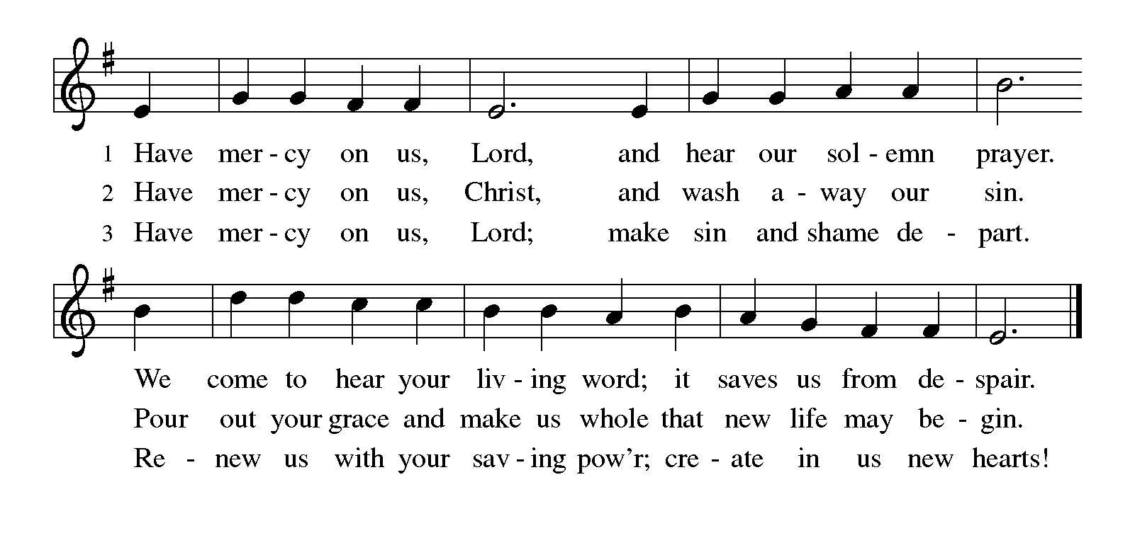
THE PRAYER OF THE DAY

P: The Lord be with you.

C: And also with you.

P: Let us pray. Lord God, our strength, the struggle between good and evil rages within
and around us, and the devil and all the forces that defy You tempt us with empty
promises. Keep us steadfast in Your word, and when we fall, raise us again and restore
us through Your Son, Jesus Christ, our Savior and Lord, Who lives and reigns with
You and the Holy Spirit, one God, now and forever.

C: Amen.

The assembly is seated
WORD

FIRST READING Genesis 2:15-17; 3:1-7

Human beings were formed with great care, to be in relationship with the Creator, creation, and one another. This passage recounts the first in a series of stories that depict the nature of human sin--wanting to be like God.

The LORD God took the man and put him in the garden of Eden to till it and keep it. ¹⁶And the LORD God commanded the man, "You may freely eat of every tree of the garden; ¹⁷but of the tree of the knowledge of good and evil you shall not eat, for in the day that you eat of it you shall die."
^{3:1}Now the serpent was more crafty than any other wild animal that the LORD God had made. He said to the woman, "Did God say, 'You shall not eat from any tree in the garden'?" ²The woman said to the serpent, "We may eat of the fruit of the trees in the garden; ³but God said, 'You shall not eat of the fruit of the tree that is in the middle of the garden, nor shall you touch it, or you shall die.' "
⁴But the serpent said to the woman, "You will not die; ⁵for God knows that when you eat of it your eyes will be opened, and you will be like God, knowing good and evil." ⁶So when the woman saw that the tree was good for food, and that it was a delight to the eyes, and that the tree was to be desired to make one wise, she took of its fruit and ate; and she also gave some to her husband, who was with her, and he ate.
⁷Then the eyes of both were opened, and they knew that they were naked; and they sewed fig leaves together and made loincloths for themselves.

The Word of the Lord.

Thanks be to God.

THE PSALM: Psalm 32 Antiphon by May Schwarz
Choir sings refrain first, followed immediately by the congregation
and as indicated
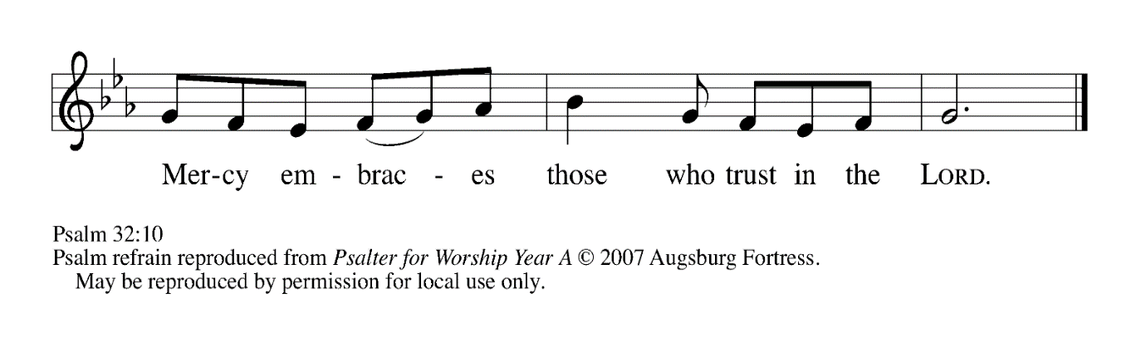
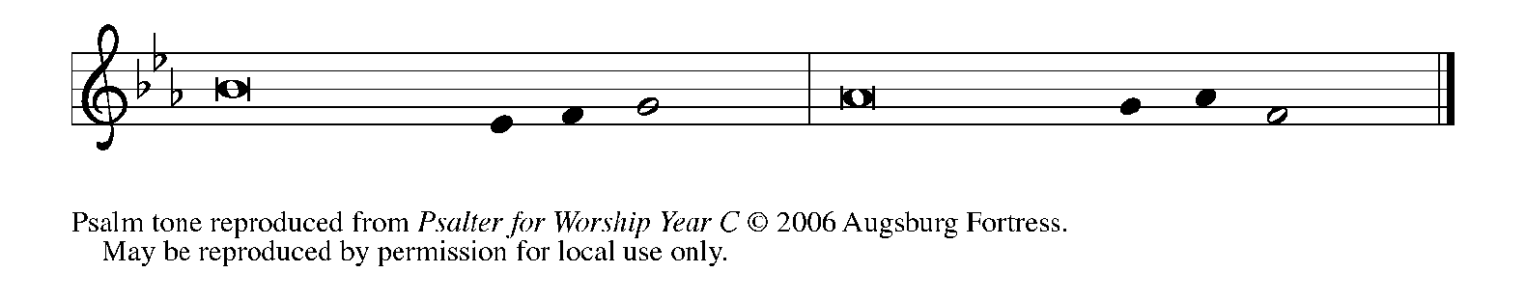

¹Happy are they whose transgressions | are forgiven,
and whose sin is | put away!

²Happy are they to whom the LORD im- | putes no guilt,
and in whose spirit there | is no guile!

³While I held my tongue, my bones with- | ered away,
because of my groaning | all day long.

⁴For Your hand was heavy upon me | day and night;
my moisture was dried up as in the | heat of summer. REFRAIN

⁵Then I acknowledged my sin to You, and did not con- | ceal my guilt.
I said, "I will confess my transgressions to the LORD."
Then You forgave me the guilt | of my sin.

⁶Therefore all the faithful will make their prayers to You
in | time of trouble;
when the great waters overflow, they | shall not reach them.
⁷You are my hiding-place; You preserve | me from trouble;
You surround me with shouts | of deliverance.

⁸"I will instruct you and teach you in the way that | you should go;
I will guide you | with My eye. REFRAIN

⁹Do not be like horse or mule, which have no | understanding;
who must be fitted with bit and bridle,
or else they will | not stay near you."

¹⁰Great are the tribulations | of the wicked;
but mercy embraces those who trust | in the LORD.

¹¹Be glad, you righteous, and rejoice | in the LORD;
shout for joy, all who are | true of heart. REFRAIN

SECOND READING Romans 5:12-19

Paul describes the effect of Jesus' obedience as analogous to that of Adam's disobedience. Through Christ, God has reversed the consequences of sin and death to offer the free gift of eternal life.

Just as sin came into the world through one man, and death came through sin, and so death spread to all because all have sinned--¹³sin was indeed in the world before the law, but sin is not reckoned when there is no law. ¹⁴Yet death exercised dominion from Adam to Moses, even over those whose sins were not like the transgression of Adam, who is a type of the one who was to come.
¹⁵But the free gift is not like the trespass. For if the many died through the one man's trespass, much more surely have the grace of God and the free gift in the grace of the one man, Jesus Christ, abounded for the many. ¹⁶And the free gift is not like the effect of the one man's sin. For the judgment following one trespass brought condemnation, but the free gift following many trespasses brings justification.
¹⁷If, because of the one man's trespass, death exercised dominion through that one, much more surely will those who receive the abundance of grace and the free gift of righteousness exercise dominion in life through the one man, Jesus Christ.
¹⁸Therefore just as one man's trespass led to condemnation for all, so one man's act of righteousness leads to justification and life for all. ¹⁹For just as by the one man's disobedience the many were made sinners, so by the one man's obedience the many will be made righteous.

The Word of the Lord.

Thanks be to God.

As you are able please rise

THE VERSE

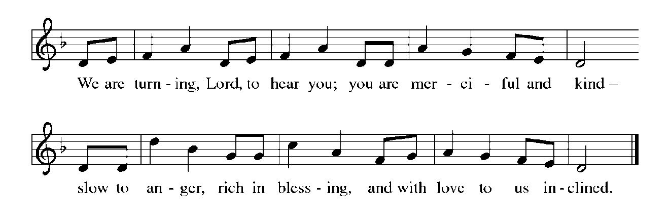
THE HOLY GOSPEL Matthew 4:1-11

Jesus experiences anew the temptations that Israel faced in the wilderness. As the Son of God, He endures the testing of the evil one.

P: The Holy Gospel according to St. Matthew, the fourth chapter.

C: Glory to You, O Lord!

¹Jesus was led up by the Spirit into the wilderness to be tempted by the devil. ²He fasted forty days and forty nights, and afterwards He was famished. ³The tempter came and said to Him, "If You are the Son of God, command these stones to become loaves of bread." ⁴But He answered, "It is written,
'One does not live by bread alone,
but by every word that comes from the mouth of God.' "
⁵Then the devil took Him to the holy city and placed Him on the pinnacle of the temple, ⁶saying to Him, "If You are the Son of God, throw Yourself down; for it is written,
'He will command His angels
concerning you,'
and 'On their hands they will bear you up,
so that you will not dash your foot against a stone.' "
⁷Jesus said to him, "Again it is written, 'Do not put the Lord your God to the test.' "
⁸Again, the devil took Him to a very high mountain and showed Him all the kingdoms of the world and their splendor; ⁹and he said to Him, "All these I will give You, if you will fall down and worship me."
"And Jesus said to him, 'Begone, Satan, begone, for it is written: You shall worship the Lord your God, and Him alone shall you serve.'"
¹¹Then the devil left Him, and suddenly angels came and waited on Him.

P: The Gospel of the Lord.

C: Praise to You, O Christ!

The assembly is seated

THE SERMON

Silence for reflection follows the sermon

As you are able please rise

THE HYMN OF THE DAY 325 I Want Jesus to Walk With Me

THE NICENE CREED

A: God has made us His people through our Baptism into Christ. Living together in trust
and hope, we confess our faith.

We believe in one God,
the Father, the Almighty,
maker of heaven and earth,
of all that is, seen and unseen.

We believe in one Lord, Jesus Christ,
the only Son of God,
eternally begotten of the Father,
God from God, Light from Light,
true God from true God,
begotten, not made,
of one Being with the Father.
Through Him all things were made.
For us and for our salvation
He came down from heaven;
by the power of the Holy Spirit
He became incarnate from the virgin Mary, and was made man.
For our sake He was crucified under Pontius Pilate;
He suffered death and was buried.
On the third day He rose again
in accordance with the Scriptures;
He ascended into heaven
and is seated at the right hand of the Father.
He will come again in glory to judge the living and the dead,
and His kingdom will have no end.

We believe in the Holy Spirit, the Lord, the giver of life,
Who proceeds from the Father and the Son.
With the Father and the Son He is worshiped and glorified.
He has spoken through the prophets.
We believe in one holy catholic and apostolic Church.
We acknowledge one Baptism for the forgiveness of sins.
We look for the resurrection of the dead,
and the life of the world to come. Amen

THE PRAYER OF THE CHURCH

A: Baptized into the paschal mystery of Jesus and led by the Spirit, let us offer our prayer
to God the Father with confidence and trust.

A: That the Church never seek to dominate or control, but instead conform to Christ’s
humble and faithful service, let us pray to the Lord:

C: Lord, have mercy.

A: That those preparing for Baptism in these days might be drawn into deeper trust in God,
let us pray to the Lord:

C: Lord, have mercy.

A: That this congregation might share our bread with the hungry, lift up the hurting, and
find fulfillment in loving our neighbor, let us pray to the Lord:

C: Lord, have mercy.

A: That those bedeviled by loneliness, grief, homelessness, and illness, especially . . .
might be borne up by God’s angels, let us pray to the Lord:

C: Lord, have mercy.

A: That with the faithful departed, especially Elizabeth Fedde, deaconness, whom we
commemorate this Day we too may one day be brought from the wilderness of life into
the garden of paradise, let us pray to the Lord:

C: Lord, have mercy.

P: Hear our prayers, O merciful God, as we eagerly await the Day of resurrection and
rebirth, through Your Son, Jesus Christ our Lord.

C: Amen.
MEAL
THE PEACE

P: The peace of the Lord be with you always.

C: And also with you.

THE OFFERING

THE VOLUNTARY Out in the Wilderness Praise Band

As you are able please rise

THE OFFERTORY

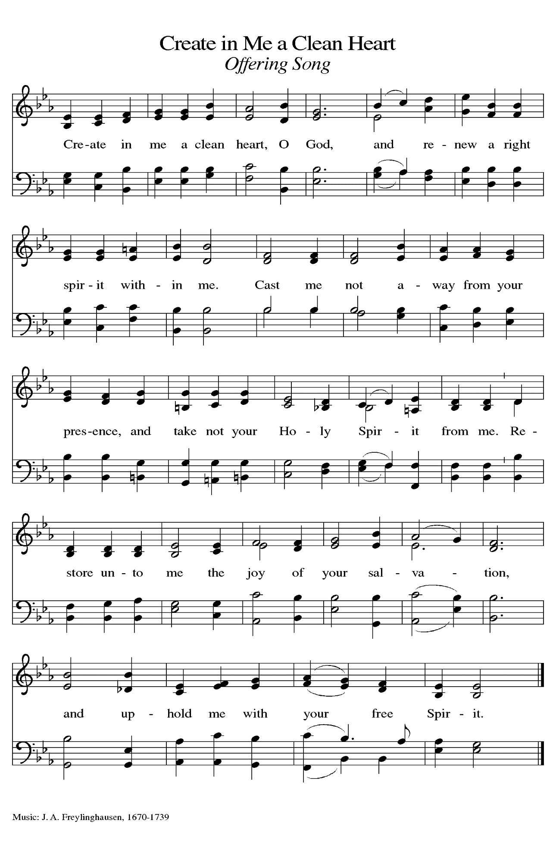
THE OFFERTORY PRAYER

A: Let us pray. God of mercy,

C: You bless us with gifts that sustain our lives; You transform us with the priceless
gift of grace. Receive and use these signs of Your blessings, and may our fasting,
prayer, and works of love be an offering of thanksgiving for all that You have
done for us in Christ our Lord. Amen.

THE GREAT THANKSGIVING

P: The Lord be with you.

C: And also with you.

P: Lift up your hearts.

C: We lift them up to the Lord.

P: Let us give thanks to the Lord our God.

C: It is right to give Him thanks and praise.

P: It is indeed right, our duty, and our joy … join their unending hymn:

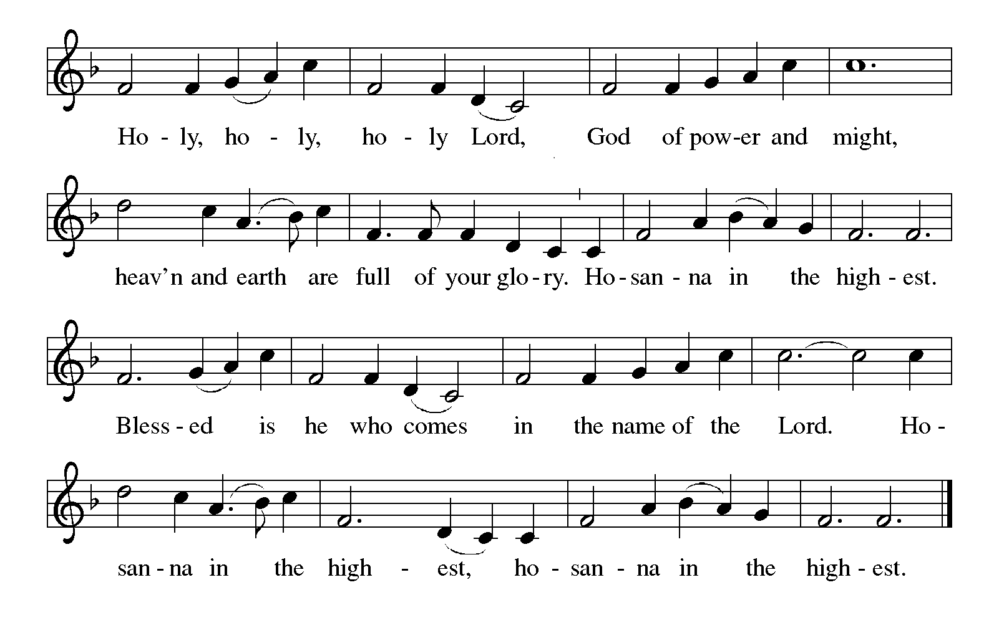
P: Praise and thanks are Yours, Lord God, because You remain faithful through our unfaith
and constant amid our failure.
Adam and Eve could see only scarcity, but You continue to offer us abundance.
Though sin came into the world and poisoned Your good creation, You nonetheless
Called the children of Abraham to be Your companions, and in Jesus You
faced the cost of our sin and received its poison into Your own Body,
transforming death into life.
Righteous God, in Jesus You were tempted to make stones into bread—but instead
in Him You make us living stones and You make bread become His Body.
Send down Your Holy Spirit, that we may be transformed into Your Body for the
life of Your world, and this bread and cup may become for us our strength
and our stay, the Body and Blood of Your Son Jesus Christ,
Who in the night ... “Do this for the remembrance of Me.”
As often as we eat ... we proclaim the Lord’s death until He comes.

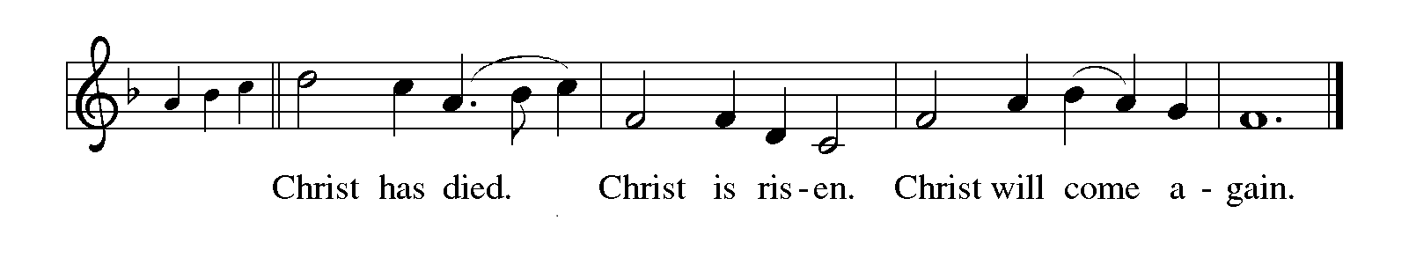
P: Justifying God, in Your patience You see the hunger of Your children: send upon us
Your Word that in Your living Bread we may never be hungry again.
In Your mercy You know Your people’s craving for drama and miracle: raise up
among us witnesses to the triumphs of Your grace, that we may see You face
to face.
In Your glory You hear Your fragile world’s cries for justice: shape in us the habits of
faithfulness, the disciplines of holiness, and the practices of peace, that we may
find Your justice as we walk with Your Son on the way of the cross,
Until that Day when You surprise us in the joy of resurrection, one God: Father,Son,
and Holy Spirit,
Full of grace and truth.

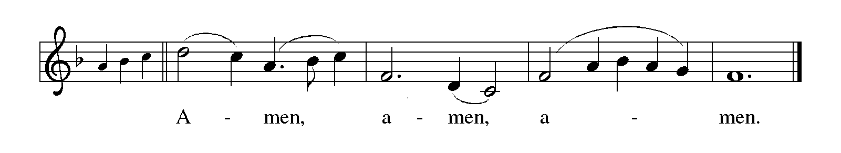

THE LORD’S PRAYER

P: While we were still sinners, Christ died for us, that, with confidence in God’s love for
us, we might dare to pray:

C: (Sung) Music is on the front cover of the red hymnal

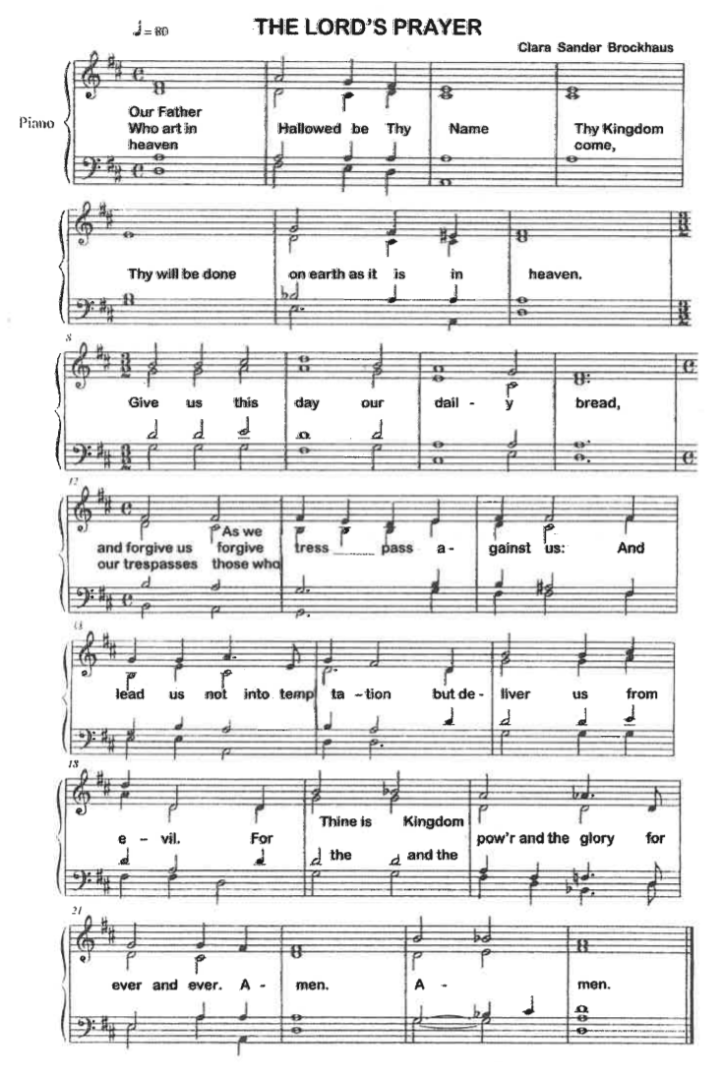
INVITATION TO THE MEAL

P: Behold our Savior Christ Jesus, Who abolished death and brought life through the
Gospel. Blessed are those called to the Banquet of the Lamb. God’s holy gifts for
God’s holy people. Come, for all is now ready.

The assembly is seated

THE DISTRIBUTION
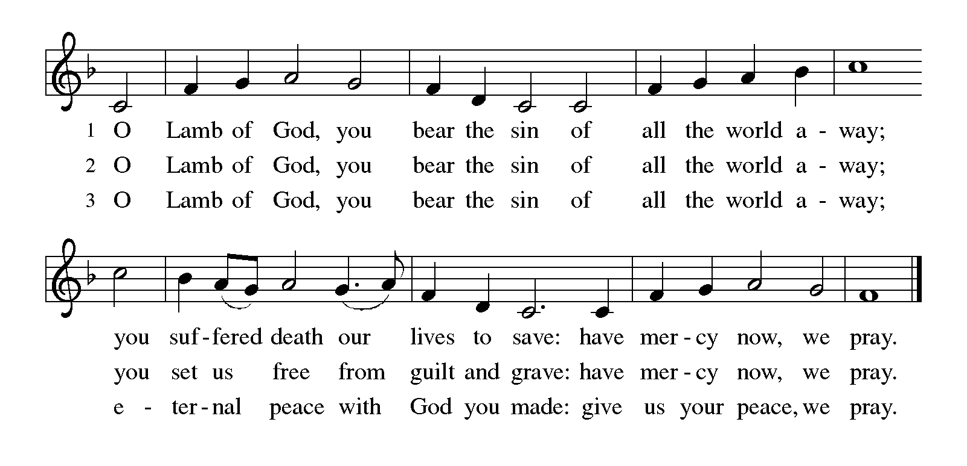
HYMN DURING DISTRIBUTION 802 Let Us Ever Walk With Jesus
602 Softly and Tenderly
NSB 90 ‘Tis So Sweet to Trust in Jesus
NSB 104 You Are My Hiding Place
As you are able please rise

THE POST-COMMUNION BLESSING

P: The Body and Blood of our Lord Jesus Christ strengthen you and keep you in His grace.

C: Amen.

THE POST-COMMUNION PRAYER

A: Let us pray. Everlasting God, we have tasted the good Food of Your Table of grace.
Nourished by the life of Your Son, may we live as children of the light, sharing Your
good news; through Jesus Christ our Lord.

C: Amen.
SENDING

THE BENEDICTION

P: Jesus took the form of a servant and was obedient to death, even death on a cross. May
you follow His example and share in the resurrection.

C: Amen.

P: Almighty God: Father, Son, and Holy Spirit bless you now and forever.

C: Amen.

SENDING SONG NSB 26 Cry of My Heart

THE DISMISSAL

A: Reconciled to God through Christ, let us go out into the world in peace.

C: Thanks be to God!

THE POSTLUDE

To God Alone Be Glory

The Meditations are from A Lenten Sourcebook: The Forty Days. Book One. J. Robert
Baker, et al., eds. (Chicago: Liturgy Training Publications, 1990) 60; and Sundays
and Seasons Online. Copyright 2019 Augsburg Fortress.

The Greeting, Prayers, Peace, Offertory, Post-Communion, and Dismissal are adapted
from Sundays and Seasons. Copyright 2001 Augsburg Fortress.

The Eucharistic Prayer is adapted from Eucharistic Prayers. Samuel Wells and Abigail
Kocher. (Grand Rapids: Eerdmann’s Publishing Company, 2016) 120-21.

The Prayers, Introduction to the Lord’s Prayer, and Invitation to the Meal are adapted from
Prayers for Sundays and Seasons. Year A. Peter J. Scagnelli. (Chicago: Liturgy
Training Publications, 1998) 30-31; and, Sundays and Seasons. Copyright 2010
Augsburg Fortress.

ANNOUNCEMENTS

Please remember to mail your offering to the Church Office at 818 Franklin Street, Michigan City, IN 46360. Another alternative is to give on-line through Tithe.ly. Please see your closure letter for information on how to set up a Tithe.ly account.

St. Paul Members are reminded to have a loved one contact the office if you are
hospitalized. Many times, the Pastor doesn’t know someone is in the hospital. If you call and leave a message, please tell us which hospital the patient is at.

Next Saturday’s lessons are: Genesis 12: 1-4a; Psalm 121; Romans 4: 1-5, 13-17; and John 3: 1-17 for those of you who like to study them in advance.

Birthdays: Gail Leffew (3/06)

PRAYER CONCERNS: Audrey Beyer, Donna Bostater, Maxine Powell, Jim Tomscheck, Eloise Ponder, Mark & Jary Tannehill, Leonard Cross, Margie Torres, Jayla Jacobi and Barbara Reichert.

OFFICE HOURS: Libby will be in the office on Mondays, Wednesdays, and Fridays; volunteers will cover Tuesdays and Thursdays.

Monday & Wednesday 8:00 a.m. – 5 p.m.
Tuesday & Thursday 9:00 a.m. – 12:00 p.m.
Friday 8:00 a.m. – 12:00 p.m.

If you are listening to the worship broadcast on the radio and would like to watch the Sunday morning service live stream follow these steps:
(1) If you have You.Tube available on your TV, search for
St. Paul Lutheran Church Michigan City, IN.

(2) The direct link on the computer is
https://www.youtube.com/channel/UC5AIPNaKr3QN50984jGOa1g.

(3) This link is also on the main page of the church’s website in the church sec-
tion and will continue to be posted weekly on the St. Paul Facebook page.

And it will always be available on the radio broadcast Sunday mornings at 11:00 a.m. on WEFM (95.9), and on the local cable access station #99 for the previous week’s service on Sundays at 4:00 p.m. and the current service on Wednesdays at 7:00 p.m. and Fridays at 8:30 p.m.

To send e-mail to the church office, please use the following addresses:

Pastor Mark Reshan: seniorpastor@stpaulmichigancity.com

Church Office Secretary (Libby Pollock): churchsecretary@stpaulmichigancity.com

Church Treasurer (Karen Fleming): finance@stpaulmichigancity.com

The Good News Newsletter: If you have an article or anything you want included in The Good News please send it to the following e-mail address: splcgoodnews@gmail.com. Pastor Pamela Thiede will be using this e-mail address to assemble The Good News each month. The deadline for getting information to Pastor
Pamela will be the 20th of each month.

WORSHIP ATTENDANCE for February 18 and 19, 2023
4:00 p.m. 37
9:00 a.m. 47
TOTAL 84

Warren Schacht has generously offered to convert audio tapes and cassettes to CD’s and VHS tapes to DVDs at no charge! He is currently converting our church audio tapes/cassettes and has extended the offer to anyone who is interested in updating their material. You may call him directly at: 219-448-1444 or email him at: w.schacht230@comcast.net. Thank you, Warren!

In an effort to save money on postage: yearly donation state-ments have been emailed to those members who have email. Any members without email will find your statements in your hanging file folder in the Narthex. If you are unable to attend church please let the church office know so we can send your statement through the regular mail.

The approved minutes of the December 20, 2022 Church Council meeting are on the table at the back of the church in the Narthex.

2023 Financial Stewardship

Weekly Church Operating Needs (x 2 weeks): $ 18,615.68
February 11 and12, and 18 and 19, 2023
General Fund (including General Memorials): $ 7,535.00
Overage/Shortage: -- $11,080.68

Restricted Income (not including Memorials)
Supports IK Synod & Church wide Ministries: $260.00
Ministries in our Community/Congregation: $ 60.00
Capital Fund: $ 510.00

General Fund: $210.00

ACTIVITIES, EVENTS & MEETINGS
February 2023

Saturday, February 25, 2023 at 4:00 p.m. Worship Service

Sunday, February 26, 2023 at 9:00 a.m. Worship Service
Wednesday, March 1, 2023 at 9:45 a.m. Bible Study/Luther House
at 10:00 a.m. God’s Purls/St. Paul Room
at 6:00 p.m. “Holden” Evening Prayer

