**THE TENTH SUNDAY AFTER PENTECOST**

**August 6, 2023**

Eternal Goodness, I shall contemplate myself in you.

By this light I shall come to know that you, eternal Trinity,

are table and food and waiter for us.

You, eternal Father, are the table that offers us as food,

the Lamb, your only-begotten Son.

He is the most exquisite of foods for us,

both in his teaching, which nourishes us in your will,

and in the sacrament that we receive in Holy Communion,

which feeds and strengthens us while we are pilgrim travelers in this life.

And the Holy Spirit is indeed a waiter for us,

who serves us this teaching by enlightening our mind’s eye with it

and inspiring us to follow it,

and who serves us charity for our neighbors

and the salvation of the whole world for the Father’s honor.

**Catherine of Siena**

**Fourteenth century**

God wills all persons to be saved.

Pray for the whole world,

bid this very earth to become a heaven.

Pray especially to be freed from greediness.

Pray to recognize others who are in need–

for there is no such thing as “my” bread.

All bread is *ours*

and is given to me through others.

For not only bread

but all things necessary for sustenance in this life

are given on loan to us

with others

and because of others

and for others

and to others, through us.

**Meister Eckhardt**

**Fourteenth century**

**INTRODUCTION**

In today's first reading God invites all who are hungry or thirsty to receive food and drink without cost. Jesus feeds the hungry multitude and reveals the abundance of God. At the eucharistic table we remember all who are hungry or poor in our world today. As we share the bread of life, we are sent forth to give ourselves away as bread for the hungry.

**Dominic, founder of the Order of Preachers (Dominicans), died 1221**

*Dominic was a Spanish priest who saw the wealth of the clergy as a stumbling block for the church, so he formed a movement, the Order of Preachers (commonly called Dominicans) devoted to itinerant preaching and living in poverty.*

**✠ GATHERING ✠**

**PRELUDE All Who Believe and Are Baptized**

**ANNOUNCEMENTS**

*As you are able please rise*

**BAPTISMAL HYMN 449 *We Know That Christ is Raised w/ Choir***

***Verse 1: Congregation***

***Verse 2: Choir — We share by water in His saving death.***

***Reborn, we share with Him in Easter life,***

***as living members of a living Christ.***

***Alleluia!***

***Verse 3: Congregation***

***Verse 4: w/Choir Descant — A new creation comes to life and grows***

***As Christ’s new body takes on flesh and blood.***

***The universe restored and whole will sing:***

***Alleluia!***

**THE GREETING**

P: The grace of our Lord Jesus Christ, the love of God, and the communion of the Holy

Spirit be with you all.

**C: And also with you.**

*The assembly is seated*

**THE SACRAMENT OF HOLY BAPTISM**

**Presentation**

*The presiding minister may address the assembly in these or similar words:*

In baptism our gracious heavenly Father frees us from sin and death by joining us to the death and resurrection of our Lord Jesus Christ. We are born children of a fallen humanity; by water and the Holy Spirit we are reborn children of God and made members of the church, the body of Christ. Living with Christ and in the communion of saints, we grow in faith, love, and obedience to the will of God.

*Sponsors for each candidate, in turn, present the candidates:*

I present ***Adalynn Rose Wavelene***for baptism.

*The presiding minister addresses parents or others who bring for baptism children who are not able to answer for themselves:*

Called by the Holy Spirit, trusting in the grace and love of God, do you desire to have ***Adalynn Rose Wavelene***baptized into Christ?

*Response:*

I do.

*The presiding minister continues:*

As you bring ***Adalynn Rose Wavelene***to receive the gift of baptism, you are entrusted with responsibilities:

to live with her among God's faithful people,

bring her to the word of God and the holy supper,

teach her the Lord's Prayer, the Creed, and the Ten Commandments,

place in her hands the holy scriptures,

and nurture her in faith and prayer,

so that she may learn to trust God,

proclaim Christ through word and deed,

care for others and the world God made,

and work for justice and peace.

Do you promise to help ***Adalynn Rose Wavelene*** grow in the Christian faith and life?

*Response:*

I do.

*The presiding minister addresses sponsors:*

Sponsors, do you promise to nurture ***Adalynn Rose Wavelene***in the Christian faith as you are empowered by God's Spirit, and to help her live in the covenant of baptism and in communion with the church?

*Response:*

I do.

*The presiding minister addresses the assembly:*

People of God, do you promise to support ***Adalynn Rose Wavelene***and pray for her in her new life in Christ?

**We do.**

**Profession of Faith**

*The presiding minister addresses candidates for baptism as well as the parents and sponsors of young children. The assembly may join in the responses.*

I ask you to profess your faith in Christ Jesus, reject sin, and confess the faith of the church.

Do you renounce the devil and all the forces that defy God?

*Parents and sponsors:*

I renounce them.

Do you renounce the powers of this world that rebel against God?

*Parents and sponsors:*

I renounce them.

Do you renounce the ways of sin that draw you from God?

*Parents and sponsors:*

I renounce them.

*The presiding minister addresses the candidates and the assembly.*

Do you believe in God the Father?

**I believe in God, the Father almighty,**

**creator of heaven and earth.**

Do you believe in Jesus Christ, the Son of God?

**I believe in Jesus Christ, His only Son, our Lord.**

**He was conceived by the power of the Holy Spirit**

**and born of the virgin Mary.**

**He suffered under Pontius Pilate,**

**was crucified, died, and was buried.**

**He descended into hell.**

**On the third day He rose again.**

**He ascended into heaven,**

**and is seated at the right hand of the Father.**

**He will come again to judge the living and the dead.**

Do you believe in God the Holy Spirit?

**I believe in the Holy Spirit,**

**the holy catholic church,**

**the communion of saints,**

**the forgiveness of sins,**

**the resurrection of the body,**

**and the life everlasting. Amen.**

**Thanksgiving at the Font**

*Water may be poured into the font before or during the thanksgiving. At the font, the presiding minister begins the thanksgiving:*

The Lord be with you.

**And also with you.**

Let us give thanks to the Lord our God.

**It is right to give our thanks and praise.**

Blessed are You, O God, maker and ruler of all things. Your voice thundered over the waters at creation. You water the mountains and send springs into the valleys to refresh and satisfy all living things.

Through the waters of the flood You carried those in the ark to safety. Through the sea You led Your people Israel from slavery to freedom. In the wilderness You nourished them with water from the rock, and You brought them across the river Jordan to the promised land.

By the baptism of His death and resurrection, Your Son Jesus has carried us to safety and freedom. The floods shall not overwhelm us, and the deep shall not swallow us up, for Christ has brought us over to the land of promise. He sends us to make disciples, baptizing in the name of the Father, and of the Son, and of the Holy Spirit.

Pour out Your Holy Spirit; wash away sin in this cleansing water; clothe the baptized with Christ; and claim Your daughters and sons, no longer slave and free, no longer male and female, but one with all the baptized in Christ Jesus, Who lives and reigns with You in the unity of the Holy Spirit, one God, now and forever.

**Amen.**

**Baptism**

*The presiding minister baptizes each candidate. The candidate is immersed into the water, or water is poured on the candidate's head, as the presiding minister says:*

***Adalynn Rose Wavelene***, I baptize you in the name of the Father, and of the Son, and of the Holy Spirit.

**Amen.**

**You belong to Christ,**

**in Whom you have been baptized.**

*The presiding minister continues:*

Let us pray.

We give you thanks, O God, that through water and the Holy Spirit you give your daughters and sons new birth, cleanse them from sin, and raise them to eternal life.

*Laying both hands on the head of each of the newly baptized, the minister prays for each:*

Sustain ***Adalynn Rose Wavelene*** with the gift of Your Holy Spirit: the spirit of wisdom and understanding, the spirit of counsel and might, the spirit of knowledge and the fear of the Lord, the spirit of joy in Your presence, both now and forever.

**Amen.**

*The presiding minister marks the sign of the cross on the forehead of each of the baptized. Oil prepared for this purpose may be used. As the sign of the cross is made, the minister says:*

***Adalynn Rose Wavelene*,** child of God, you have been sealed by the Holy Spirit and marked with the cross of Christ forever.

**Amen.**

**Welcome**

*A lighted candle may be given to each of the newly baptized (to a sponsor of a young child) as a representative of the congregation says:*

Let your light so shine before others

that they may see your good works

and glorify your Father in heaven.

*The ministers and the baptismal group face the assembly. A representative of the congregation leads the assembly in the welcome.*

Let us welcome the newly baptized.

**We welcome you into the body of Christ and into the mission we share:**

**join us in giving thanks and praise to God**

**and bearing God's creative and redeeming word to all the world.**

**THE PRAYER OF THE DAY**

P: The Lord be with you.

**C: And also with you.**

P: Let us pray. Gracious God, Your generosity waters the world with goodness, and You

cover creation with abundance. Awaken in us a hunger for the food that satisfies both

body and spirit, and with this food fill all the starving world; through Jesus Christ, our

Savior and Lord.

**C: Amen.**

*The assembly is seated*

**✠ WORD ✠**

**FIRST READING Isaiah 55: 1-5**

*In both ancient Near Eastern history and literature, the building of a temple and the feast held afterward signify the establishment of the kingdom of the temple's builder. Isaiah 54 recounts God's building of a new temple following the exile. Today's reading is the invitation to the feast.*

Ho, everyone who thirsts,

come to the waters;

and you that have no money,

come, buy and eat!

Come, buy wine and milk

without money and without price.

2Why do you spend your money for that which is not bread,

and your labor for that which does not satisfy?

Listen carefully to Me, and eat what is good,

and delight yourselves in rich food.

3Incline your ear, and come to Me;

listen, so that you may live.

I will make with you an everlasting covenant,

My steadfast, sure love for David.

4See, I made him a witness to the peoples,

a leader and commander for the peoples.

5See, you shall call nations that you do not know,

and nations that do not know you shall run to you,

because of the LORD your God, the Holy One of Israel,

for He has glorified you.

The Word of the Lord.

**Thanks be to God.**

**THE PSALM: Psalm 145:8-9, 14-21 Read responsively Choir**

8The LORD is gracious and full of compassion,

     slow to anger and abounding in steadfast love.

**9LORD, You are good to all,**

**and Your compassion is over all Your works.**

14The Lord upholds all those who fall

     and lifts up those who are bowed down.

**15The eyes of all wait upon You, O LORD,**

**and You give them their food in due season.**

16You open wide Your hand

     and satisfy the desire of every living thing.

**17You are righteous in all Your ways**

**and loving in all Your works.**

18You are near to all who call upon You,

     to all who call upon You faithfully.

**19You fulfill the desire of those who fear You;**

**You hear their cry and save them.**

20You watch over all those who love You,

     but all the wicked You shall destroy.

**21My mouth shall speak the praise of the LORD;**

**let all flesh bless God's holy name forever and ever.**

**SECOND READING Romans 9: 1-5**

*In his letter to the Romans, Paul proclaims the good news of Jesus Christ, through whom "nothing can separate us from the love of God." Then, his joy turns to sorrow as he considers those among God's people who have not received the gospel.*

I am speaking the truth in Christ--I am not lying; my conscience confirms it by the Holy Spirit--2I have great sorrow and unceasing anguish in my heart. 3For I could wish that I myself were accursed and cut off from Christ for the sake of my own people, my kindred according to the flesh. 4They are Israelites, and to them belong the adoption, the glory, the covenants, the giving of the law, the worship, and the promises; 5to them belong the patriarchs, and from them, according to the flesh, comes the Messiah, Who is over all, God blessed forever. Amen.

The Word of the Lord.

**Thanks be to God.**

*As you are able please rise*

**THE VERSE** Sung twice

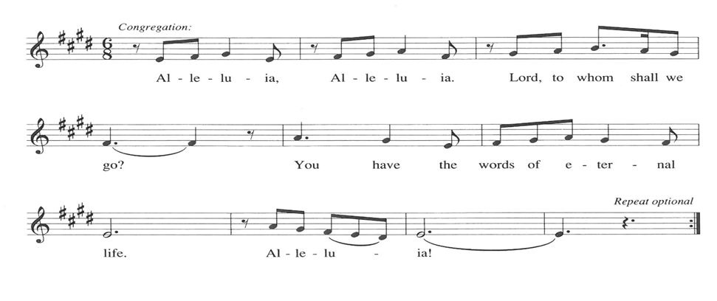

**THE HOLY GOSPEL Matthew 14: 13-21**

*After John the Baptist is murdered, Jesus desires a time of solitude. Still, his compassion for others will not allow him to dismiss those who still need him but, rather, moves him to perform a great miracle.*

P: The Holy Gospel according to St. Matthew, the fourteenth chapter.

**C: Glory to You, O Lord!**

Now when Jesus heard about the beheading of John the Baptist, He withdrew from there in a boat to a deserted place by Himself. But when the crowds heard it, they followed Him on foot from the towns. 14When He went ashore, He saw a great crowd; and He had compassion for them and cured their sick.

15When it was evening, the disciples came to Him and said, "This is a deserted place, and the hour is now late; send the crowds away so that they may go into the villages and buy food for themselves." 16Jesus said to them, "They need not go away; you give them something to eat." 17They replied, "We have nothing here but five loaves and two fish." 18And He said, "Bring them here to Me."

19Then He ordered the crowds to sit down on the grass. Taking the five loaves and the two fish, He looked up to heaven, and blessed and broke the loaves, and gave them to the disciples, and the disciples gave them to the crowds. 20And all ate and were filled; and they took up what was left over of the broken pieces, twelve baskets full. 21And those who ate were about five thousand men, besides women and children.

P: The Gospel of the Lord.

**C: Praise to You, O Christ!**

*The assembly is seated*

**THE SERMON**

*Silence for reflection follows the sermon*

*As you are able please rise*

**THE HYMN OF THE DAY 829 *Shout to the Lord***

**THE PRAYER OF THE CHURCH**

A: Let us offer our prayer in the name of Jesus, Who had compassion on the multitude and

Whose bounty feeds us all.

A: That the Church may distribute the Bread of Life to all who hunger in body and spirit,

sharing generously with others as God shares with us, let us pray to the Lord:

**C: Lord, hear our prayer.**

A: That prosperous nations may work for a just distribution of resources, and an end to

poverty, especially in Africa, Haiti, the Dominican Republic, and every place of

drought and famine, that all may share in God’s bounty, let us pray to the Lord:

**C: Lord, hear our prayer.**

A: That this congregation’s gifts of money, time, and talents may be used this week for

the needs of the poor, the hungry, and the hurting, let us pray to the Lord:

**C: Lord, hear our prayer.**

A: That the sick, especially **Kim Mitchell; Edward Kleinschmidt; Venia Wendt; Jana**

**Thomas; Laura Dovey; Jan Paholski; and Christine Kiser** may know the healing

compassion of Christ, let us pray to the Lord:

**C: Lord, hear our prayer.**

A: That those celebrating birthdays, especially **Susan Dolson** may be filled with grace this

day and grow in grace in the days ahead, let us pray to the Lord:

**C: Lord, hear our prayer.**

A: That **Adalynn Rose Wavelene Barton,** newly baptized, may by the power of the Holy

Spirit grow into the fullness of her new life in Christ and His everlasting love, let us

pray to the Lord:

**C: Lord, hear our prayer.**

A: That with all the saints, especially **Dominic,** whom we commemorate this Day we may

one Day feast at Christ’s heavenly Banquet, where all hungers and thirsts are forever

satisfied, let us pray to the Lord:

**C: Lord, hear our prayer.**

P: Lord, Creator of the universe, Giver of all that is good, let us feel Your presence in our

need, and be Your presence to others. We ask this in the name of Jesus the Lord.

**C: Amen.**

**✠ MEAL✠**

**THE PEACE**

P: The peace of the Lord be with you always.

**C: And also with you.**

*The assembly is seated*

**THE OFFERING**

**THE VOLUNTARY *Love is Here*  The Praise Band**

**(Drew Middleton)**

*As you are able please rise*

**THE PRESENTATION OF THE GIFTS 465 *As the Grains of Wheat***

**THE OFFERTORY PRAYER**

A: Let us pray. Gracious God,

**C: With these gifts we offer You the fruits of our labor. Too often, O God, we work**

**for that which does not satisfy. You invite us to listen carefully to Your Word,**

**and to eat what is good from Your Table. Fill us with delight at Your rich Food,**

**and send us to share Your gifts with all in need of Your compassion and help. We**

**ask this in the name of Jesus the Lord. Amen.**

**THE GREAT THANKSGIVING**

P: The Lord be with you.

**C: And also with you.**

P: Lift up your hearts.

**C: We lift them to the Lord.**

P: Let us give thanks to the Lord our God.

**C: It is right to give Him thanks and praise.**

P: Holy God, Bread of Life, we offer You our thanks and praise.

For You are righteous in all Your ways and loving in all Your works.

You open wide Your hand and satisfy the desire of every living creature.

You chose Israel, Your beloved to be Your way of blessing for the world.

Through judges, kings, and prophets, You bestowed the Food of Your Word.

At the last Your Word became flesh in Your only-begotten Son, Jesus Christ.

He is the true Bread from heaven in Whom all our hungers are satisfied.

In the night ... “Do this for the remembrance of Me.”

As often as we eat ... we proclaim the Lord’s death until He comes.

**C: Christ has died. Christ is risen. Christ will come again.**

P: With this bread and cup, O God, we remember the life our Lord offered for us: He

healed the sick, fed the hungry, and gave His body to be broken on the

cross in death on our behalf.

You raised Him from death to give life to the world. When He ascended, He promised

to return to host Your final Feast of victory.

Send Your Spirit on us and these Your gifts of bread and wine.

By this Meal, strengthen us to serve all in hunger and want as we share Your Bread of

Life with our dying world until He comes in glory.

Until that Day, accept our prayers and praises, O God: Father, Son, and Holy Spirit, in

Your holy Church, in heaven and on earth, now and forever.

**C: Amen!**

**THE LORD’S PRAYER**

P: Let the good seed of God’s Word bear fruit now as we offer the prayer Jesus taught us

to pray:

**C: Our Father, Who art in heaven, hallowed by Thy name.**

**Thy Kingdom come, Thy will be done on earth as it is in heaven.**

**Give us this day our daily bread, and forgive us our trespasses as we forgive those**

**who trespass against us.**

**And lead us not into temptation, but deliver us from evil.**

**For Thine is the Kingdom, and the power, and the glory, forever and ever. Amen.**

**INVITATION TO THE MEAL**

P: Behold, the Lamb of God Who takes away the sin of the world. Blessed are those who

are called to the Supper of the Lamb. God’s holy gifts for God’s holy people. Come,

for all is now ready.

*The assembly is seated*

**LAMB OF GOD**

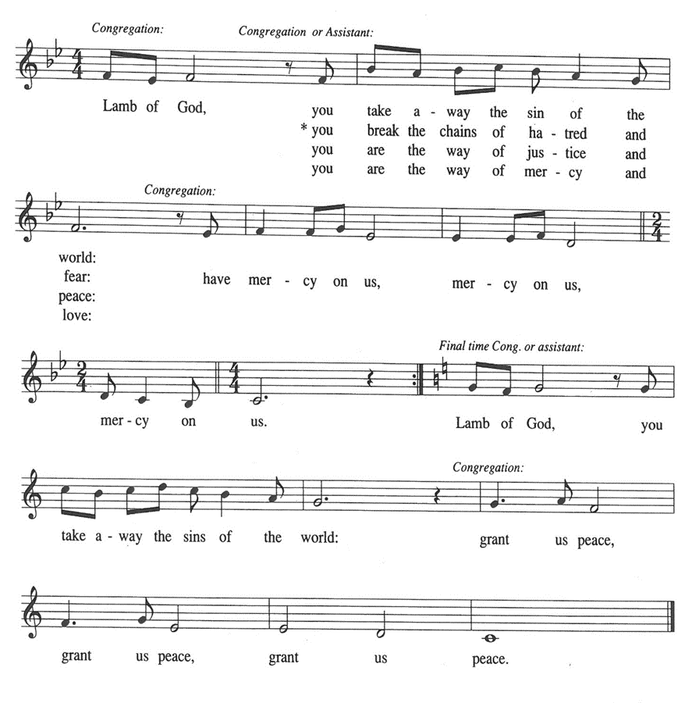

**HYMN DURING DISTRIBUTION 461 *All Who Hunger, Gather Gladly***

**483 *Here is Bread***

***NSB 48 I Am the Bread of Life (Talbot)***

**NSB 54 *I Love You, Lord***

*As you are able please rise*

**THE POST-COMMUNION BLESSING**

P: The Body and Blood of our Lord Jesus Christ strengthen you and keep you in His grace.

**C: Amen.**

**THE POST-COMMUNION PRAYER**

A: Let us pray. Lord Jesus, You have again fed us with the rich Food of Your Body and

Blood. Send us now in the power of Your Spirit to feed those who hunger and thirst

for You. You are the Lord forevermore.

**C: Amen.**

**✠ SENDING ✠**

**THE BENEDICTION**

P: Almighty God: Father, Son, **✠** and Holy Spirit bless you now and forever.

**C: Amen.**

**THE SENDING HYMN 674 *Let Us Talents and Tongues Employ***

**THE DISMISSAL**

A: Go forth with God’s blessing to love and serve the Lord.

**C: Thanks be to God!**

**POSTLUDE *Partita on Let Us Talents and Tongues Employ***

**✠ To God Alone Be Glory✠**

The Meditation is from Richer Fare for the Christian People. Gail Ramshaw, ed. (New

York: Pueblo Publishing Company, 1990) 76.

The Prayers, Introduction to the Lord’s Prayer, and Invitation to the Meal are adapted from

Prayers for Sundays and Seasons. Year A. Peter J. Scagnelli. (Chicago: Liturgy

Training Publications, 1998) 111-112.

The musical setting of the liturgy, “Now the Feast and Celebration” by Marty Haugen, is

used by permission of GIA Publishers, Inc. OneLicense.net License #A-702836.

**ANNOUNCEMENTS**

**Please remember to mail your offering to the Church Office** at 818 Franklin Street, Michigan City, IN 46360**.** Another alternative is to give on-line through Tithe.ly. Please see your closure letter for information on how to set up a Tithe.ly account.

**St. Paul Members are reminded to have** a loved one contact the office if you are hospitalized. Many times, the Pastor doesn’t know someone is in the hospital. If you call and leave a message, please tell us which hospital the patient is at.

**Birthdays: Susan Dolson (8/11)**

**PRAYER CONCERNS:** Jana Thomas, Audrey Beyer, Leonard Cross, Margie Torres, Jayla Jacobi, Barbara Reichert, Jim Gleason, Kim Mitchell.

**OFFICE HOURS:** Libby will be in the office on Mondays, Wednesdays,

and Fridays; volunteers will cover Tuesdays and Thursdays.

   Monday & Wednesday 8:00 a.m. – 5 p.m.

Tuesday & Thursday 9:00 a.m. – 12:00 p.m.

Friday 8:00 a.m. – 12:00 p.m.

**f you are listening to the worship broadcast on the radio and would like to watch the Sunday morning service live stream follow these steps:**

(1) If you have You Tube available on your TV, search for

**St. Paul Lutheran Church Michigan City, IN.**

(2) The direct link on the computer is

https://www.youtube.com/channel/UC5AIPNaKr3QN50984jGOa1g.

    (3) This link is also on the main page of the church’s website in

the church section and will continue to be posted weekly on the St.

Paul Facebook page.

    And it will always be available on the radio broadcast Sunday mornings at 11:00 a.m. on WEFM (95.9), and on the local cable access station #99 for the previous week’s service on Sundays at 4:00 p.m. and the current service on Wednesdays at 7:00 p.m. and Fridays at 8:30 p.m.

**The approved and signed minutes of the May 25, 2023 and the June 22, 2023 Church Council Meetings are on the table at the back of the church in the Narthex. Please take a copy with you as you go.**

**To send e-mail to the church office**, please use the following addresses:

Pastor Mark Reshan: seniorpastor@stpaulmichigancity.com

Church Office Secretary (Libby Pollock): churchsecretary@stpaulmichigancity.com

Church Treasurer (Karen Fleming): finance@stpaulmichigancity.com

**The Good News Newsletter**: If you have an article or anything you want included in **The Good News** please send it to the following e-mail address: splcgoodnews@gmail.com. Pastor Pamela Thiede will be using this e-mail address to assemble **The Good News** each month. The deadline for getting information to Pastor Pamela will be the 20th of each month.

**WORSHIP ATTENDANCE for July 29 and 30, 2023:**

**4:00 p.m. 38**

**9:00 a.m. 58**

**TOTAL 96**

We would like to start monthly missions here at St. Paul. Similar to our “Fill the Shopping Cart!” campaign for May, we’d like to highlight a different mission each month. We are looking for suggestions! If you volunteer somewhere or have a mission that is close to your heart, please let Paul or Lora Brooks know so we can set up a month to support that cause!

Paul: (219) 221-0254; [paulbrooks@gmail.com](mailto:paulbrooks@gmail.com)

Lora: (260) 701-1586; [loralmartin15@gmail.com](mailto:loralmartin15@gmail.com)

**VOLUNTEER OPPORTUNITIES AVAILABLE**

**Franciscan Health in Michigan City** is seeking volunteers to help support their staff who are working towards their Mission to provide health care to those in need. Volunteers donate their time for many reasons, including for the service of God, to stay physically and mentally active, to help their community and to meet new people. Opportunities are available in most areas of the hospital and at its sister sites in both Michigan City and Chesterton, such as the Gift Shop, Welcome Center, Emergency Department, and more. If you have an interest in being a volunteer or have any questions or concerns, please contact Audrey Goress, Volunteer Coordinator, at (219) 877-1421 or by email at [Audrey.goress@franciscanalliance.org](mailto:Audrey.goress@franciscanalliance.org) to help you find a fulfilling assignment that fits your schedule, interests and abilities. Being a volunteer can be an enjoyable and rewarding commitment.

**August Monthly Mission:**

We are in the dog days of summer, so what a perfect time to support the Michiana Humane Society as our monthly mission! A basket will be placed in the Narthex for items to be donated to the shelter. The shelter’s wish list includes:

**Toys –** washable squeaky, Kongs, BullyMake, Nylabone, cat nip

**Treats –** rawhides of all sizes and chewy/soft treats

**Food –** kitten chow, rabbit food, cnned wet food (Pedigree dog food, any kind of cat food), 1st Born Pup formula or kitten formula, gerbil/hamster food, guinea pig food, small bottles/nipples for kittens

**Animal care –** small bottles/nipples for kittens, clay litter, pine shavings, shredded paper **(long cut only)**

**New or gently used items –** slip lead leashes and collars, cages, blankets, linens, towels, wash cloths

**Cleaning supplies –** bleach, laundry detergent, paper towels, tall kitchen trash bags Dawn dish soap, Windex, liquid hand soap/sanitizer, gloves

**Office supplies –** stamps, copy paper, file folders, permanent markers (blue and black, fat tip), dry erase markers, post-it notes, tissues

**We are also planning on donating the proceeds from our concession sales at the**

**boat parade to the Humane Society as well. If you want to donate but can’t do your**

**own shopping, Paul or Lora Brooks would be happy to shop for you!**

**\*\*\*\*\*\*\*\*\*\*\*\*\*\*\*\*\*\*\*\*\*\*\*\*\*\*\*\*\*\*\*\*\*\*\*\*\*\*\*\*\*\*\*\*\*\*\*\*\*\*\*\*\*\*\*\*\*\*\*\*\*\*\*\*\***

**Volunteer Opportunity!**

**Boat Parade Concession Sales**

We are planning on selling cookies, drinks, and popcorn at the boat parade on Saturday, August 5th. Proceeds will benefit our August Mission – the Michiana Humane Society. We are in need of volunteers to help that evening, from 3pm to shortly after the boat parade, which starts at 6pm. If you are able to help, please let Paul or Lora Brooks or Karen Fleming know. Even if you can only help for 30 – 60 minutes, we would appreciate having you!

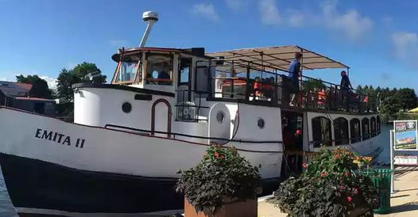

**Special Give-Back Opportunity**

2-hour sunset cruise along the Lake Michigan shoreline

Wednesday, September 6, departing at 6 p.m.

The cost is $35, with the church getting back $10.

To make reservations, go to:

<https://app.bookingcentral.com/book/product/harborcountryadventures?location=5cb18b14-6f6a-46ba-a655-0d19a685fc47&product=152d5966-a46a-43a6-a7f9-c1378641aebf&referer=header&clearcart>

Or call 269– 231-5867.

**NOTE:** If you are uncomfortable paying on-line Paul Brooks is willing to take your money and buy your tickets for you. His number is : 219-221-0254.

**But wait, there’s more . . .**

**On the next page are order forms for purchasing supplies to make Lutheran World Relief Kits which we will be doing together as a congregation this fall. If you have any questions or concerns please contact:**

**Paul Brooks: (219) 221-0254; or at** [**paulbrooks@gmail.com**](mailto:paulbrooks@gmail.com)**.**

**Or Lora Brooks: (260) 701-1586; or loralmartin15@gmail.com.**

**Lutheran World Relief Kits**

We will be purchasing supplies to assemble two kinds of Lutheran World Relief kits together as a congregation this fall. Lutheran World Relief kits are sent to people around the world who are experiencing poverty, disaster, conflict, or more. To make it easier, we are offering everyone an opportunity to sponsor kits. Please indicate how many of each kit you would like to sponsor and return this form with payment to the church office (or in the offering plate). We will take care of purchasing all the supplies. We will hold an assembly day after Sunday worship this fall where we will assemble all the kits together. (No purchase necessary to help us assemble. We will assemble as a team; you will not be responsible for assembling all the kits you purchase yourself.)

**Please make checks payable to St. Paul Lutheran Church.**

**Orders are due Sunday, August 13th, 2023**

**______________# of health kits at $10 each**

(Health kits contain a towel, bar soap, toothbrush, comb, and nail clippers.)

**______________# of school kits at $12 each**

(School kits contain a drawstring backpack, notebooks, rulers, pencils and pens, pencil sharpener, scissors, crayons, and an eraser.)

**Total $______________**

**Lutheran World Relief Kits**

We will be purchasing supplies to assemble two kinds of Lutheran World Relief kits together as a congregation this fall. Lutheran World Relief kits are sent to people around the world who are experiencing poverty, disaster, conflict, or more. To make it easier, we are offering everyone an opportunity to sponsor kits. Please indicate how many of each kit you would like to sponsor and return this form with payment to the church office (or in the offering plate). We will take care of purchasing all the supplies. We will hold an assembly day after Sunday worship this fall where we will assemble all the kits together. (No purchase necessary to help us assemble. We will assemble as a team; you will not be responsible for assembling all the kits you purchase yourself.)

**Please make checks payable to St. Paul Lutheran Church.**

**Orders are due Sunday, August 13th, 2023**

**______________# of health kits at $10 each**

(Health kits contain a towel, bar soap, toothbrush, comb, and nail clippers.)

**______________# of school kits at $12 each**

(School kits contain a drawstring backpack, notebooks, rulers, pencils and pens, pencil sharpener, scissors, crayons, and an eraser.)

**Total $______________**

**ACTIVITIES, EVENTS AND MEETINGS**

**August 2023**

**Sunday,** August 6, 2023 @ 9:00 a.m. Worship Service

Baptism of Adalynn Rose Wavelene Barton

**Wednesday,** August 9, 2023 @ 10:00 a.m. God’s Purls/St. Paul Room

@ 4:00 p.m. Choir Rehearsal

@ 6:00 p.m. Worship & Music Meeting/St. Paul Room

**Saturday,** August 12, 2023 @ 4:00 p.m. Worship Service

**Sunday,** August 13, 2023 @ 9:00 a.m. Worship Service

**Monday,** August 14, 2023 @ 10:30 a.m. Hope Circle/Green Room

**Tuesday,** August 15, 2023 @ 11:00 a.m.—9:00 p.m. **GIVE BACK @ Carlson’s RBS**

@ 4:30 p.m. 150th Anniv. Comm. Mtg./Luther House

@ 7:00 p.m. Estuary/Luther House

**Wednesday,** August 16, 2023 @ 10:00 a.m. God’s Purls/St Paul Room

@ 4:00 p.m. Choir Rehearsal

**Saturday,** August 19, 2023 @ 4:00 p.m. Worship Service

**Sunday,** August 20, 2023 @ 9:00 a.m. Worship Service

**Monday,** August 21, 2023 @ 4:00 p.m. Finance Committee Mtg./Luther House

@ 5:30 p.m. Executive Board Mtg./Luther House

**Wednesday,** August 23, 2023 @ 10:00 a.m. God’s Purls/St. Paul Room

@ 4:00 p.m. Choir Rehearsal

**Thursday,** August 24, 2023 @ 5:30 p.m. Church Council Mtg./Luther House

**Saturday,** August 26, 2023 @ 4:00 p.m. Worship Service

**Sunday,** August 27, 2023 @ 9:00 a.m. Worship Service

**Wednesday,** August 30, 2023 @ 10:00 a.m. God’s Purls/St. Paul Room

@ 4:00 p.m. Choir Rehearsal

**Saturday,** September 2, 2023 @ 4:00 p.m. Worship Service