THE SECOND SUNDAY OF EASTER
April 12, 2026

"Peace be with you," the risen Lord says. But what kind of peace is it? It is peace that walks in the midst of fear. It is peace that counters the terror of a brutal death at the hands of an angry mob. It is peace addressed to fearful hearts huddled together in a locked room, unable to believe that the new day has really dawned.
What kind of peace is it? It is peace signaled by the gesture of extended hands that reveal the marks of crucifixion--wounds that the risen Christ carries into the new age. It is peace spoken in full view of the disciples' faithlessness, their denials, the treachery of betrayal. This peace, accompanied by this gesture, says to these fearful disciples, "I know everything about you. I know how you failed me. I know you better than you know yourselves." And yet, miracle of miracles, this deep knowing is accompanied not by reproach but with peace.
It is not the greeting of a ghost who is half-alive, half-dead. This word of peace is carried unconditionally by the warmth of resurrection breath. But even more, this peace is breathed into the disciples, and into us. It is Jesus' CPR of the soul, undoing former sins, raising us from the dead, calling us into a new life: "Peace! As the Father has sent me, so I send you." This peace calms our fearful hearts, unbolts the doors, and launches us into a new life, sustained by the breath of the Spirit.

Words for Worship

O Lord, I acknowledge and give thanks that you created in me your image so that I may remember, contemplate, and love you. But this image has been so effaced by the abrasion of transgressions, so hidden from sight by the dark billows of sin, that unless you renew and refashion it, it cannot do what it was created to do.

Lord, I do not attempt to comprehend your sublimity, because my intellect is not at all equal to such a task. But I yearn to understand some measure of your truth, which my heart believes and loves. For I do not seek to understand in order to believe, but I believe in order to understand. For I believe even this: that I shall not understand unless I believe.

Anselm

In the Name of Jesus

INTRODUCTION

In today's gospel the risen Christ appears to the disciples and offers them the gift of peace. Even amid doubts and questions, we experience the resurrection in our Sunday gathering around word and meal, and in our everyday lives. Throughout the coming Sundays of Easter the first two readings will be from the Acts of the Apostles and the first letter of Peter. Even as the early Christians proclaimed the resurrection, we rejoice in the new birth and living hope we receive in baptism.

GATHERING

PRE-SERVICE MUSIC We Believe New Song Praise Band
(Kate Miner)

THE EASTER ACCLAMATION

P: Christ is risen! Alleluia!

C: He is risen indeed! Alleluia!

ANNOUNCEMENTS

As you are able please rise

THANKSGIVING FOR BAPTISM

P: In the name of the Father and of the Son and of the Holy Spirit.

C: Amen.

P: Alleluia! Christ is risen.

C: Alleluia! Christ is risen.

P: Just as God’s work of creation never ends,
so the gifts received in Baptism are renewed every day.
Let us give thanks together for the life given in Baptism.

We give You thanks, O God, for the waters of life:
for water to bathe in, water to drink,
for waters to play in and waters that inspire wonder,
for water that gives life to our planet.

C: We give You thanks, O God, for the waters of life.

P: We give You thanks, O God, for the waters of this place:
for water from our tap, for rain and snow,
for water from our rivers and lakes,

C: We give You thanks, O God, for the waters of life.

P: We give You thanks for Your salvation through water:
for delivering Noah and his family through the floodwaters,
for leading Your people Israel through the sea into freedom,
for preserving Your prophet Elijah through the time of drought,
for guiding Your people across the Jordan into a new land,
for quenching the Samaritan woman’s thirst with living water.

C: We give You thanks, O God, for the waters of life.

P: We give You thanks for the life of all the baptized,
and for all who gather here;
for godparents and Baptismal sponsors,
for children and grandchildren,
for our brothers and sisters in Christ
whom we have never seen but to whom we are bound.

C: We give You thanks, O God, for the waters of life.

P: We give You thanks for life in Christ through Your Holy Spirit:
for our entry into Jesus’ death through these waters,
for our new birth into a life of freedom and service,
for our calling to be Your people,
sent our for the life of the world.

C: We give You thanks, blessed and holy Trinity, now and forever. Amen.

GATHERING SONG NSB 72 Refiner’s Fire

THE GREETING AND PRAYER OF THE DAY

P: Alleluia! Christ is risen!

C: Christ is risen indeed! Alleluia!

P: The grace of our Lord Jesus Christ, the love of God, and the communion of the Holy
Spirit be with you all.

C: And also with you.

P: Let us pray. Almighty and eternal God, the strength of those who believe and the hope
of those who doubt, may we, who have not seen, have faith in You and receive the
fullness of Christ's blessing, Who lives and reigns with You and the Holy Spirit, one
God, now and forever.

C: Amen.

The assembly is seated

WORD

FIRST READING Acts 2: 14a, 22-32

After the Holy Spirit came to the apostles on Pentecost, Peter preaches the gospel to the gathered crowd. He tells them that Jesus, who obediently went to his death according to God's plan, was raised from the dead by God. Finally, he appeals to scripture, quoting Psalm 16: 8-11, to show that Jesus is the Messiah: though crucified, the risen Jesus is now enthroned.

Peter, standing with the eleven, raised his voice and addressed the people:
²²"You that are Israelites, listen to what I have to say: Jesus of Nazareth, a man attested to you by God with deeds of power, wonders, and signs that God did through Him among you, as you yourselves know--²³this man, handed over to you according to the definite plan and foreknowledge of God, you crucified and killed by the hands of those
outside the law. ²⁴But God raised Him up, having freed Him from death, because it was impossible for Him to be held in its power. ²⁵For David says concerning Him,
'I saw the Lord always before me,
for He is at my right hand so that I will not be shaken;
²⁶therefore my heart was glad, and my tongue rejoiced;
moreover my flesh will live in hope.
²⁷For you will not abandon my soul to Hades,
or let your Holy One experience corruption.
²⁸You have made known to me the ways of life;
you will make me full of gladness with your presence.'
²⁹"Fellow Israelites, I may say to you confidently of our ancestor David that he both died and was buried, and his tomb is with us to this day. ³⁰Since he was a prophet, he knew that God had sworn with an oath to him that He would put one of his descendants on his throne. ³¹Foreseeing this, David spoke of the resurrection of the Messiah, saying,
'He was not abandoned to Hades,
nor did his flesh experience corruption.'
³²This Jesus God raised up, and of that all of us are witnesses."

A: The Word of the Lord.

C: Thanks be to God.

THE PSALM: Psalm 16 Read responsively

¹Protect me, O God, for I take refuge in You;
I have said to the LORD,
"You are my Lord, my good above all other."

²All my delight is in the godly that are in the land,
upon those who are noble among the people.

³But those who run after other gods
shall have their troubles multiplied.

⁴I will not pour out drink offerings to such gods,
never take their names upon my lips.

⁵O LORD, You are my portion and my cup;
it is You who uphold my lot.

⁶My boundaries enclose a pleasant land;
indeed, I have a rich inheritance.

⁷I will bless the LORD Who gives me counsel;
my heart teaches me night after night.

⁸I have set the LORD always before me;
because God is at my right hand, I shall |not be shaken.

⁹My heart, therefore, is glad, and my spirit rejoices;
my body also shall rest in hope.

¹⁰For You will not abandon me to the grave,
nor let Your holy one see the pit.

¹¹You will show me the path of life;
in Your presence there is fullness of joy,
and in Your right hand are pleasures forevermore.

SECOND READING 1 Peter 1: 3-9

This epistle was written to encourage Christians who were suffering for their faith. It begins by praising God for the resurrection of Jesus, which produces hope, then and now.

Blessed be the God and Father of our Lord Jesus Christ! By His great mercy He has given us a new birth into a living hope through the resurrection of Jesus Christ from the dead, ⁴and into an inheritance that is imperishable, undefiled, and unfading, kept in heaven for you, ⁵who are being protected by the power of God through faith for a salvation ready to be revealed in the last time.
⁶In this you rejoice, even if now for a little while you have had to suffer various trials, ⁷so that the genuineness of your faith--being more precious than gold that, though perishable, is tested by fire--may be found to result in praise and glory and honor when Jesus Christ is revealed.
⁸Although you have not seen Him, you love Him; and even though you do not see Him now, you believe in Him and rejoice with an indescribable and glorious joy, ⁹for you are receiving the outcome of your faith, the salvation of your souls.

The Word of the Lord.

Thanks be to God.

As you are able please rise

THE VERSE
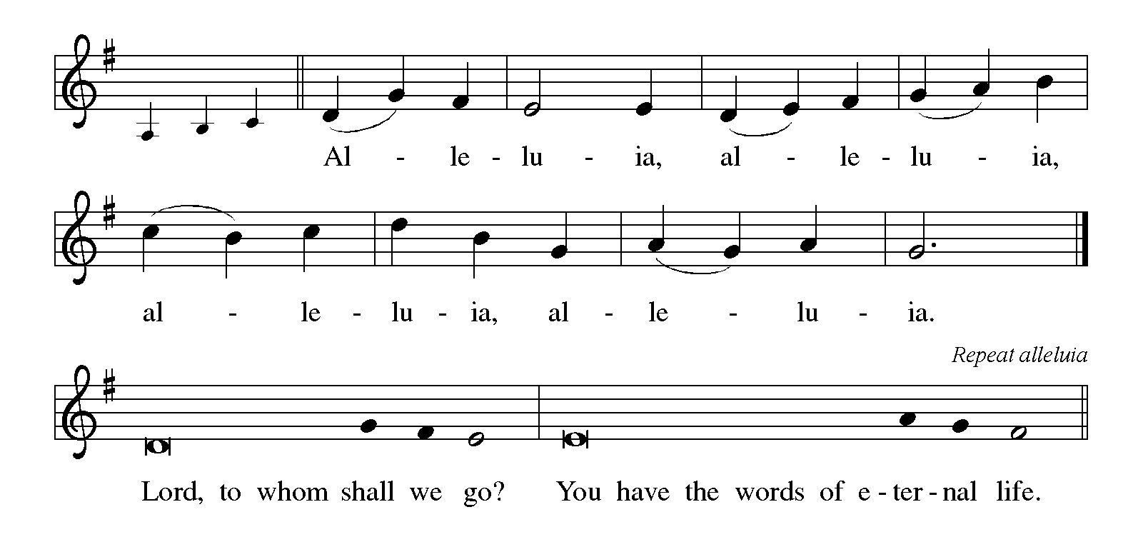

THE HOLY GOSPEL John 20: 19-31

One week after Easter, Christ still comes to those who believe in him; he seeks any who may have missed his offer of peace and life through his resurrection.

P: The Holy Gospel according to St. John, the twentieth chapter.

C: Glory to You, O Lord!

When it was evening on that day, the first day of the week, and the doors of the house where the disciples had met were locked for fear of the Judeans, Jesus came and stood among them and said, "Peace be with you." ²⁰After He said this, He showed them His hands and His side. Then the disciples rejoiced when they saw the Lord.
²¹Jesus said to them again, "Peace be with you. As the Father has sent Me, so I send you." ²²When he had said this, he breathed on them and said to them, "Receive the Holy Spirit. ²³If you forgive the sins of any, they are forgiven them; if you retain the sins of any, they are retained."
²⁴But Thomas (who was called the Twin), one of the twelve, was not with them when Jesus came. ²⁵So the other disciples told him, "We have seen the Lord." But he said to them, "Unless I see the mark of the nails in His hands, and put my finger in the mark of the nails and my hand in His side, I will not believe."
²⁶A week later His disciples were again in the house, and Thomas was with them. Although the doors were shut, Jesus came and stood among them and said, "Peace be with you." ²⁷Then He said to Thomas, "Put your finger here and see My hands. Reach out your hand and put it in My side. Do not doubt but believe."
²⁸Thomas answered him, "My Lord and my God!"²⁹Jesus said to him, "Have you believed because you have seen Me? Blessed are those who have not seen and yet have come to believe."
³⁰Now Jesus did many other signs in the presence of His disciples, which are not written in this book. ³¹But these are written so that you may come to believe that Jesus is the Messiah, the Son of God, and that through believing you may have life in His name.

P: The Gospel of the Lord.

C: Praise to You, O risen Christ!

The assembly is seated

THE SERMON

Silence for reflection follows the sermon

As you are able please rise

THE HYMN OF THE DAY 635 We Walk by Faith

THE NICENE CREED

A: God has made us His people through our Baptism into Christ. Living together in trust
and hope, we confess our faith.

We believe in one God,
the Father, the Almighty,
maker of heaven and earth,
of all that is, seen and unseen.

We believe in one Lord, Jesus Christ,
the only Son of God,
eternally begotten of the Father,
God from God, Light from Light,
true God from true God,
begotten, not made,
of one Being with the Father.
Through Him all things were made.
For us and for our salvation
He came down from heaven;
by the power of the Holy Spirit
He became incarnate from the virgin Mary, and was made man.
For our sake He was crucified under Pontius Pilate;
He suffered death and was buried.
On the third day He rose again
in accordance with the Scriptures;
He ascended into heaven
and is seated at the right hand of the Father.
He will come again in glory to judge the living and the dead,
and His kingdom will have no end.

We believe in the Holy Spirit, the Lord, the giver of life,
Who proceeds from the Father and the Son.
With the Father and the Son He is worshiped and glorified.
He has spoken through the prophets.
We believe in one holy catholic and apostolic Church.
We acknowledge one Baptism for the forgiveness of sins.
We look for the resurrection of the dead,
and the life of the world to come. Amen

THE PRAYER OF THE CHURCH

A: Like Thomas, we are encouraged by the Lord’s presence, and so we offer God our
petitions for the Church, the world, and all those in need.

A: That like Peter, the Church may be courageous and faithful witnesses to the
Resurrection, we pray:

C: Hear us, risen Lord.

A: That the Lord’s gift of peace may be known even where the doors of nations seem
locked by terrorism, violence, and bloodshed, we pray:

C: Hear us, risen Lord.

A: That in this week we might be bearers of Christ’s gift of forgiveness and reconciliation,
we pray:

C: Hear us, risen Lord.

A: That those who are frightened, anxious, doubting, or ill, especially: Jeff Timmrick;
Martha Schroeder; Mark Tannehill; Jan Paholski and Laura Dovey might be
upheld by God in hope and joy, we pray:

C: Hear us, risen Lord.

A: That those celebrating birthdays, especially Karen Kiser; and anniversaries, especially
Jacob and Monica Tannehill might be filled with grace this day and every day, and
grow in grace in the days ahead, we pray:

C: Hear us, risen Lord.

A: That with all the faithful who have gone before us we too may one day come forever
into the presence of the Risen Jesus, our Lord and our God, we pray:

C: Hear us, risen Lord.

P: Loving God, Your Risen Son opened Thomas to faith. By the power of Your Holy
Spirit, open us to the faith of our ancestors so that we too may share the resurrection of
Your Son. We ask this through the same Jesus Christ, our Risen Lord.

C: Amen.

MEAL

THE PEACE

P: The risen Christ stood among the disciples and said, “Peace be with you.”

The peace of the risen Lord be with you always.

C: And also with you.

The assembly is seated

THE OFFERING

THE VOLUNTARY

As you are able please rise

THE OFFERTORY (see p. 9) This Joyful Eastertide

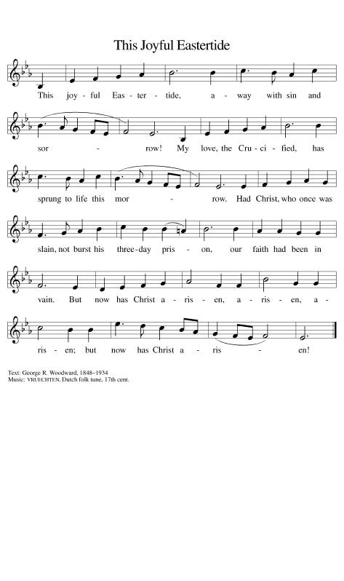

THE OFFERTORY PRAYER

A: Let us pray. Lord our God,

C: You have given us a new birth into a living hope through the resurrection of Your
Son from the dead. We offer our lives back to You with praise and thanks and
adoration. By this holy Sacrament grant us fullness of joy, genuineness of faith,
and peace in Your presence, now and forever. We ask this in the name of Jesus
the Risen Lord. Amen.

THE GREAT THANKSGIVING

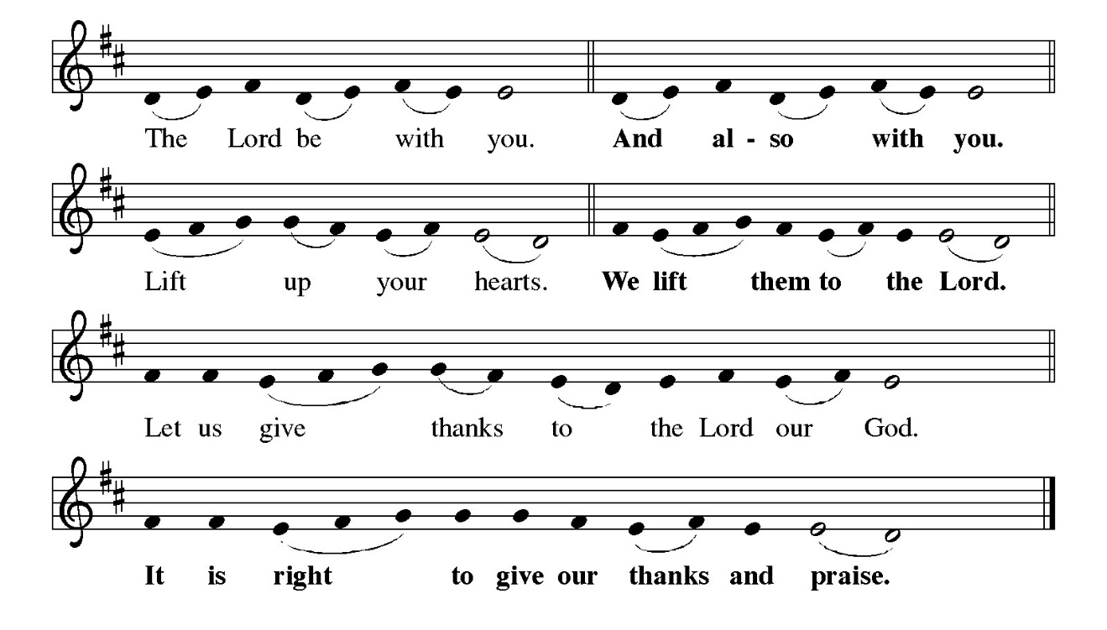
P: It is indeed right, our duty and our joy … and join their unending hymn:

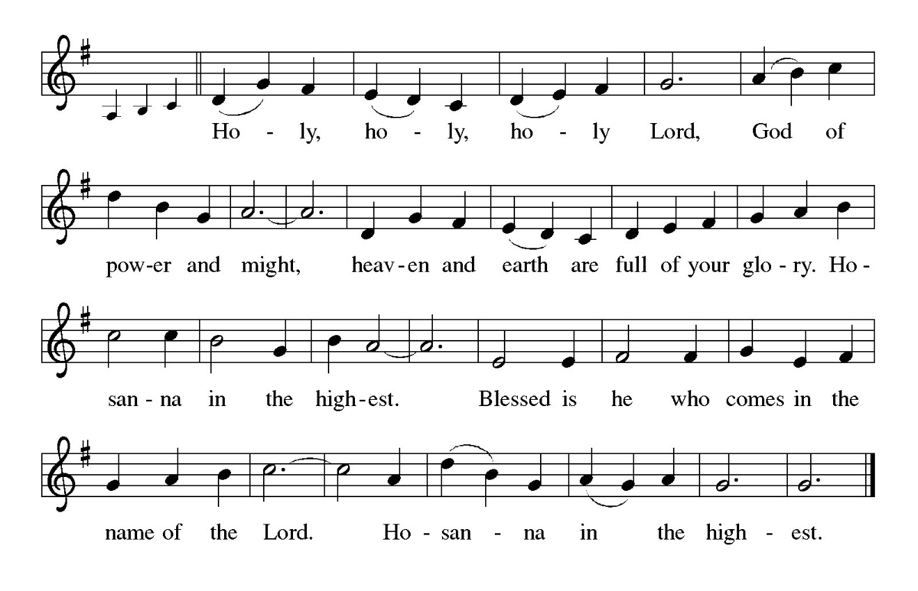
P: Holy, living, and loving God, we praise You for creating the heavens and the earth.
We bless You for bringing Noah and his family through the waters of the flood, for
freeing Your people Israel from the bonds of slavery, and for sending Your
Son to be our Redeemer.

In the night … “Do this for the remembrance of Me.”
As often as we eat … we proclaim the Lord’s death until He comes.

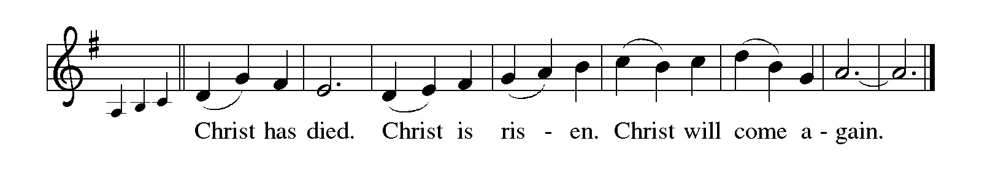

P: Remembering, therefore, His life-giving death and glorious resurrection, we await
Your promised life for all this dying world.
Breathe Your Spirit on us and on this bread and cup:
Carry us in Your arms from death to life, that we may live as Your chosen ones,
clothed in the righteousness of Christ.
Through Him all honor and glory is Yours, Almighty Father, with the Holy Spirit,
in Your holy Church, both now and forever.

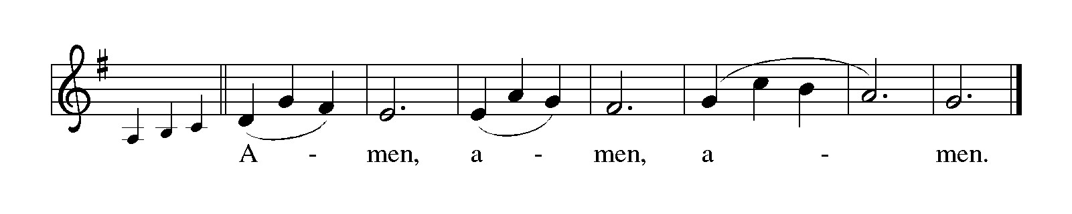

THE LORD’S PRAYER

P: Alleluia! The risen Christ intercedes on our behalf before the throne of God. Let us
therefore join Him in His prayers in the words He taught us:

C: Our Father in heaven, hallowed be Your name.
Your Kingdom come, Your will be done on earth as in heaven.
Give us today our daily bread, and forgive us our sins, as we forgive
those who sin against us.
Save us from the time of trial, and deliver us from evil.
For the Kingdom, the power, and the glory are Yours, now and forever.
Amen.

INVITATION TO THE MEAL

P: Jesus said, I am the true Vine. Abide in Me as I abide in you. Blessed are those who
are called to the Supper of the Lamb. God’s holy gifts for God’s holy people. Come,
for all is now ready.

The assembly is seated

THE DISTRIBUTION Lamb of God (see p. 12)

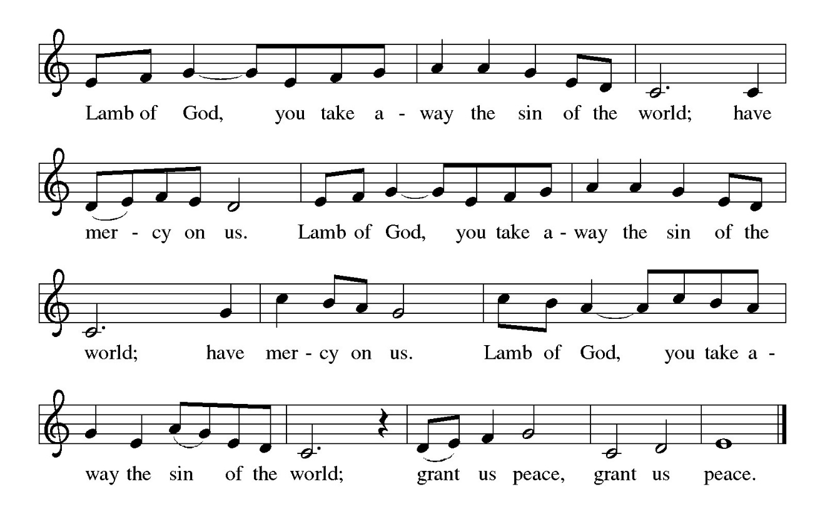
Those wishing to receive the Laying on of Hands, Anointing with Oil, and Prayer for Healing may go to Pastor at the side aisle

HYMN DURING DISTRIBUTION 384 That Easter Day With Joy Was Bright

ELW 715 Christ, Be Our Light

ELW 481 Come to the Table

ELW 482 I Come With Joy

ELW 483 Here is Bread

As you are able please rise

THE POST-COMMUNION BLESSING

P: The Body and Blood of our Lord Jesus Christ strengthen you and keep you in His grace.

C: Amen.

THE POST-COMMUNION PRAYER

A: Let us pray. Risen Lord Jesus, You have again calmed our fears and satisfied our
hunger. Send us now in the power of Your Spirit as signs of Your hope and salvation
for the world. Protect us by Your power in all our trials and testings, and keep us firm
in faith and trust until Your salvation is revealed. You are the Lord forevermore.

C: Amen.
SENDING

THE BENEDICTION

P: Almighty God: Father, Son, and Holy Spirit bless you now and forever.

C: Amen.

SENDING SONG 540 Go Make Disciples

THE DISMISSAL

A: Go in peace. Proclaim the risen Lord. Alleluia! Alleluia!

C: Thanks be to God! Alleluia! Alleluia!

THE POSTLUDE

To God Alone Be Glory

The Meditation is from Words for Worship. Copyright 2001 Augsburg Fortress.

The Greeting, Prayers, Peace, and Dismissal are adapted from Sundays and Seasons.
Copyright 2001 Augsburg Fortress.

The Prayers, Introduction to the Lord’s Prayer, and Invitation to the Meal are adapted
from Prayers for Sundays and Seasons. Year A. Peter J. Scagnelli.
(Chicago: Liturgy Training Publications, 1998) 42-43.

ANNOUNCEMENTS

Please remember to mail your offering to the Church Office at 818 Franklin Street, Michigan City, IN 46360. Another alternative is to give on-line through Tithe.ly. Please see your closure letter for information on how to set up a Tithe.ly account.

St. Paul Members are reminded to have a loved one contact the office if you are hospitalized. Many times, the Pastor doesn’t know someone is in the hospital. If you call and leave a message, please tell us at which hospital the patient is located.

BIRTHDAYS: Karen Kiser (4/16); Diane Sunde (4/19)
ANNIVERSARIES: Jacob & Monica Tannehill (4/16)

PRAYER CONCERNS: John Bennitt; Debbie Martin; Mark Tannehill; Kathy Stein; Jan Paholski; Laura Dovey; Bill Hazelgrove; Al Levenhagen; Carl Wipperman; Major Payne; and Tim Miller.

OFFICE HOURS: Libby will be in the office on Mondays, Wednesdays, and Fridays; volunteers will cover Tuesdays and Thursdays.

Monday & Wednesday 8:00 a.m. – 5 p.m.
Tuesday & Thursday 9:00 a.m. – 12:00 p.m.
Friday 8:00 a.m. – 12:00 p.m.

If you are listening to the worship broadcast on the radio and would like to watch the Sunday morning service live stream follow these steps:

(1) If you have You Tube available on your TV, search for
St. Paul Lutheran Church Michigan City, IN.

(2) The direct link on the computer is https://
www.youtube.com/channel/UC5AIPNaKr3QN50984jGOa1g

(3) This link is also on the main page of the church’s website in
the church section and will continue to be posted weekly on the St.
Paul Facebook page.

And it will always be available on the radio broadcast Sunday mornings at 11:00 a.m.
on WEFM (95.9), and on the local cable access station #99 for the previous week’s
service on Sundays at 4:00 p.m. and the current service on Wednesdays at 7:00 p.m.
and Fridays at 8:30 p.m.

To send e-mail to the church office, please use the following addresses:

Pastor Mark Reshan: seniorpastor@stpaulmichigancity.com

Church Office Secretary (Libby Pollock): churchsecretary@stpaulmichigancity.com

Church Treasurer (Karen Fleming): finance@stpaulmichigancity.com

2026 Church Council:

Pastor - Mark Reshan

President - Donna Knoll

Vice President - Jan Bakken

Secretary - Judy Hunt

Treasurer - Karen Fleming

Members: Sue Koziel; Jim Schraidt; Trish Sprague; Bob Kiser; Barry Anderson; and
Pam Soule

Worship Attendance:

Thursday, April 2, 2026 @ 10:00 a.m. 43 Senior Communion

Friday, April 3, 2026 @ 7:00 p.m. 48 Good Friday

Saturday, April 4, 2026 @ 7:00 p.m. 26 Easter Vigil

Sunday, April 5, 2026 @ 9:00 a.m. 149 The Resurrection/Easter Sunday

TOTAL 266

Copies of the minutes from the February 26, 2026 and March 26, 2026 Church Council meetings are on the back table in the upper Narthex. They were approved by the council via email.

The Good News Newsletter: If you have an article or anything you want included in The Good News please send it to the following e-mail address: splcgoodnews@gmail.com. Pastor Pamela Thiede will be using this e-mail address to assemble The Good News each month. The deadline for getting information to Pastor Pamela will be the 20th of each month.

Next week’s lessons are Acts 2: 14a, 36-41; Psalm 116: 1-4, 12-19; 1 Peter 1: 17-23; Luke 24: 13-35 for those of you who like to study them in advance.

MONTHLY MISSION FOR APRIL 2026
BOYS & GIRLS CLUBS OF LAPORTE COUNTY

The Boys & Girls Clubs of LaPorte County provide a safe space for kids to go after school, during the summer, and while school is operating online, to learn and grow beyond the classroom. Members receive access to homework help, mentoring, sports programs, STEAM enrichment, community service opportunities, and much more. Their programs include the following:

Career Explorations SMART Moves and SMART Decisions
Food Programs Ultimate Journey/STEAM
Game Changers Volunteering
Homework Help/Tutoring/Power Hour

If you would like to support this mission, we will be collecting both supplies and monetary donations. Please make checks payable to St. Paul and mark for the Boys & Girls Clubs and place in the offering. Noisy coin for the month of April will also go to support the Boys & Girls Clubs. The following supplies can be placed in the bin in the upper Narthex:

Felt Dixie Cups
Glue bottles, sticks, or bulk pourable Plain block Legos
Bulk pourable tempura paint Play Doh
Markers & crayons

Construction paper and card stock of all colors; and plain white paper
Paper towels, Kleenex, disinfectant/cleaning wipes
K-8th grade appropriate board and card games
Small “treasure box” type prizes

Thank you for your support of Daisy Lee’s STEM trips for our young students. We raised $476 to help fund this year’s STEM trips! Thank you for your unwavering support for our community each month! Lora

FOR THOSE WHO WOULD LIKE TO KNOW MORE ABOUT THE BOYS & GIRLS CLUBS there are printed handouts on the table in the lower narthex for your reading pleasure!

ACTIVITIES, EVENTS & MEETINGS
APRIL 2026

Wednesday, April 8, 2026 @ 10:00 a.m. God’s Purls/St. Paul Room

@ 11am – Close GIVE BACK @ SWINGBELLY’S

Saturday, April 11, 2026 @ 4:00 p.m. 2 Easter Worship Service/Sanctuary

Sunday, April 12, 2026 @ 9:00 a.m. 2 Easter Worship Service/Sanctuary with
coffee after
Monday, April 13, 2026 @ 1:00 p.m. Hope Circle/Green Room

Wednesday, April 15, 2026 @ 9:15 a.m. Bible Study/Luther House

@ 10:00 a.m. God’s Purls/St. Paul Room

@ 4:30 p.m. Choir Rehearsal/Sanctuary

Saturday, April 18, 2026 @ 4:00 p.m. 3 Easter Worship Service/Sanctuary

Sunday, April 19, 2026 @ 9:00 a.m. 3 Easter Worship Service/Sanctuary
with coffee after
Monday, April 20, 2026 @ 2:00 p.m. Finance Committee Mtg./Luther House
@ 3:00 p.m. Executive Board Mtg./Luther House
Wednesday, April 22, 2026 @ 9:15 a.m. Bible Study/Luther House
@ 10:00 a.m. God’s Purls/St. Paul Room
@ 4:30 p.m. Choir Rehearsal/Sanctuary
Thursday, April 23, 2026 @ 3:00 p.m. Church Council Meeting/St. Paul Room
Saturday, April 25, 2026 @ 4:00 p.m. 4 Easter Worship Service/Sanctuary

Sunday, April 26, 2026 @ 9:00 a.m. 4 Easter Worship Service/Sanctuary with
coffee after
Wednesday, April 29, 2026 @ 9:15 a.m. Bible Study/Luther House
@ 10:00 a.m. God’s Purls/St. Paul Room
@ 4:30 p.m. Choir Rehearsal/Sanctuary

UPDATE ON MAJOR PAYNE

Thank You to the entire congregation for the prayers, cards and gifts, there are too many individuals to name. Major’s condition improves daily. Unfortunately he will be permanently blind in the left eye, there is too much damage to repair. His right eye turned out well. He has several more surgeries ahead, one on his right leg; also his face and his forehead. He has also sustained a short-term memory loss. He is now back at Pine School but can have no recess or gym classes due to the extent of his injuries. He continues to receive physical therapy for all the injuries. From the bottom of our hearts Thanks to each and every one that has been asking. Your prayers have given us a sense of peace.

Sherry & Chuck Payne

Major and the entire family

