**THE ELEVENTH SUNDAY AFTER PENTECOST**

**August 21, 2022**

“Today’s Gospel story is about a woman. In my Bible she is identified as “the bent woman.” How would you like to be immortalized in Scripture that way? ... That was her name, and in her name was her life, her destiny, her whole sad fate. The woman doesn’t have a name, other than the one given to her by the town, a name based on her disability ... She is the crooked woman, the bent woman.

She is encountered by Jesus. And look how Jesus refers to her. He heals her, and that’s wonderful. For the first time in her adult life, she is able to stand up straight, to look straight ahead, to be restored to what we call normalcy. But perhaps just as wonderful is the way Jesus speaks to her, what He says about her.

Jesus calls her, “*a daughter of Abraham ...*” What does that mean? Who was Abraham? Abraham is the great, great grand-daddy of Israel ... God promised to make a great nation out of Abraham, a nation through which all the nations of the earth would be blessed.

She is a daughter of Abraham. She is an heir to the blessings of God. Morever, ... she is called to be a blessing to the whole world ... She, bent over though she is, is part of God’s great salvation of the whole world ...Her life had been caught up in God’s promises to the world. Her life had been renamed, not as a long story of injustice, victimization, and sadness, but as part of the great drama of God’s redemption ...”

“ ... Jesus means to name you. He will not let you acquiesce to the names the world wants to lay upon you. You are daughters, sons of Abraham. Your life is meant to count for something, to take its place in God’s great drama of redemption.

Stand up straight, act like it, go in peace.”

**William Willimon**

**✠ In the Name of Jesus ✠**

**✠ GATHERING ✠**

**INTRODUCTION**

*In today's gospel reading, Jesus criticizes religious people who do not see ethical implications of their beliefs and worship. The first reading offers a pattern of action that honors God's desire for all human beings. Set next to each other, these readings ask the church to think deeply about the credibility of its mission.*

**Bernard, Abbot of Clairvaux, died 1153**

*Bernard, a Cistercian monk, was a man of great spirituality who wrote mystical works and criticized those whom he thought took an overly intellectual approach to the faith. He became an abbot, and wrote several hymns that are still beloved today.*

**PRELUDE *Joyful, Joyful, We Adore Thee*  Mark Thewes**

**ANNOUNCEMENTS**

*As you are able please rise*

**GATHERING HYMN 314 *Arise, Your Light Has Come***

**THE GREETING AND PRAYER OF THE DAY**

P: The grace of our Lord Jesus Christ, the love of God, and the communion of the Holy

Spirit be with you all.

C: **And also with you.**

P: Let us pray. O God, mighty and immortal, You know that as fragile creatures

surrounded by great dangers, we cannot by ourselves stand upright. Give us strength

of mind and body, so that even when we suffer because of human sin, we may rise

victorious through Your Son, Jesus Christ our Lord.

C: **Amen.**

*The assembly is seated*

**✠ WORD ✠**

**FIRST READING Isaiah 58:9b-14**

*The Lord promises those who have returned from exile that where there is justice and mercy the ruins will be rebuilt and light will rise in the darkness.*

9bIf you remove the yoke from among you,

the pointing of the finger, the speaking of evil,

10if you offer your food to the hungry

and satisfy the needs of the afflicted,

then your light shall rise in the darkness

and your gloom be like the noonday.

11The Lord will guide you continually,

and satisfy your needs in parched places,

and make your bones strong;

and you shall be like a watered garden,

like a spring of water,

whose waters never fail.

12Your ancient ruins shall be rebuilt;

you shall raise up the foundations of many generations;

you shall be called the repairer of the breach,

the restorer of streets to live in.

13If you refrain from trampling the sabbath,

from pursuing your own interests on My holy day;

if you call the sabbath a delight

and the holy day of the Lord honorable;

if you honor it, not going your own ways,

serving your own interests, or pursuing your own affairs;

14then you shall take delight in the Lord,

and I will make you ride upon the heights of the earth;

I will feed you with the heritage of your ancestor Jacob,

for the mouth of the Lord has spoken.

The Word of the Lord.

**Thanks be to God.**

**THE PSALM: Psalm 103:1-8** Antiphon by John Paradowski

Cantor sings refrain first, followed immediately by the congregation

and as indicated

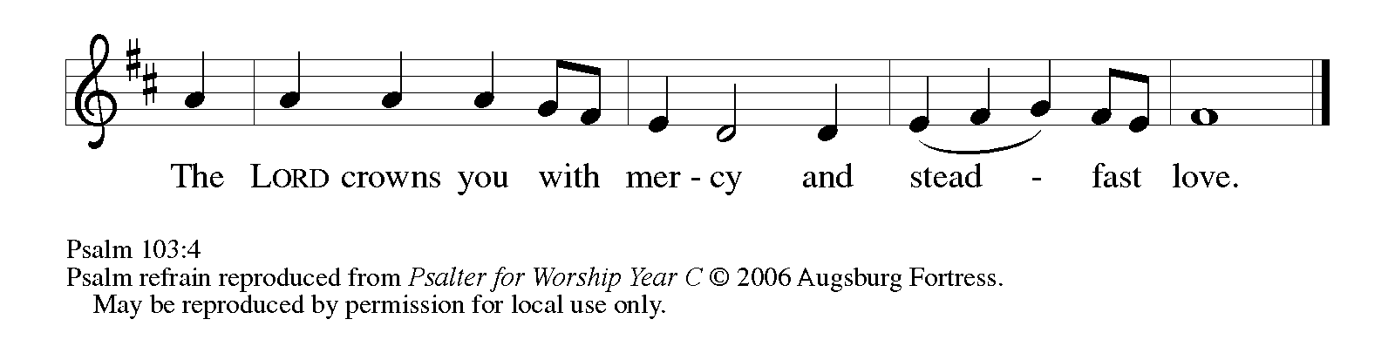

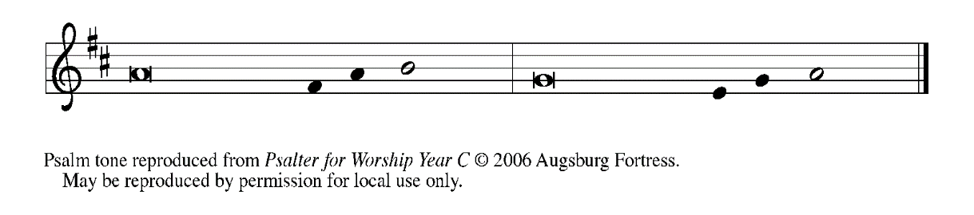

1Bless the LORD, | O my soul,

     and all that is within me, bless God's | holy name.

**2Bless the LORD, | O my soul,**

**and forget not | all God's benefits—**

3Who forgives | all your sins

     and heals all | your diseases;

**4Who redeems your life | from the grave**

**and crowns you with steadfast | love and mercy;   REFRAIN**

5Who satisfies your desires | with good things

     so that your youth is renewed | like an eagle's.

**6O LORD, you provide | vindication**

**and justice for all who | are oppressed.**

7You made known Your | ways to Moses

     and Your works to the chil- | dren of Israel.

**8LORD, You are full of compas- | sion and mercy,**

**slow to anger and abounding in | steadfast love.   REFRAIN**

**SECOND READING Hebrews 12:18-29**

*The writer to the Hebrews presents a striking vision of the eternal dwelling place and the one who welcomes the righteous. There is no fear, only forgiveness through Christ's blood.*

18You have not come to something that can be touched, a blazing fire, and darkness, and gloom, and a tempest, 19and the sound of a trumpet, and a voice whose words made the hearers beg that not another word be spoken to them. 20(For they could not endure the order that was given, "If even an animal touches the mountain, it shall be stoned to death." 21Indeed, so terrifying was the sight that Moses said, "I tremble with fear.")

22But you have come to Mount Zion and to the city of the living God, the heavenly Jerusalem, and to innumerable angels in festal gathering, 23and to the assembly of the firstborn who are enrolled in heaven, and to God the judge of all, and to the spirits of the righteous made perfect, 24and to Jesus, the mediator of a new covenant, and to the sprinkled blood that speaks a better word than the blood of Abel.

25See that you do not refuse the one who is speaking; for if they did not escape when they refused the one who warned them on earth, how much less will we escape if we reject the One Who warns from heaven! 26At that time His voice shook the earth; but now He has promised, "Yet once more I will shake not only the earth but also the heaven."

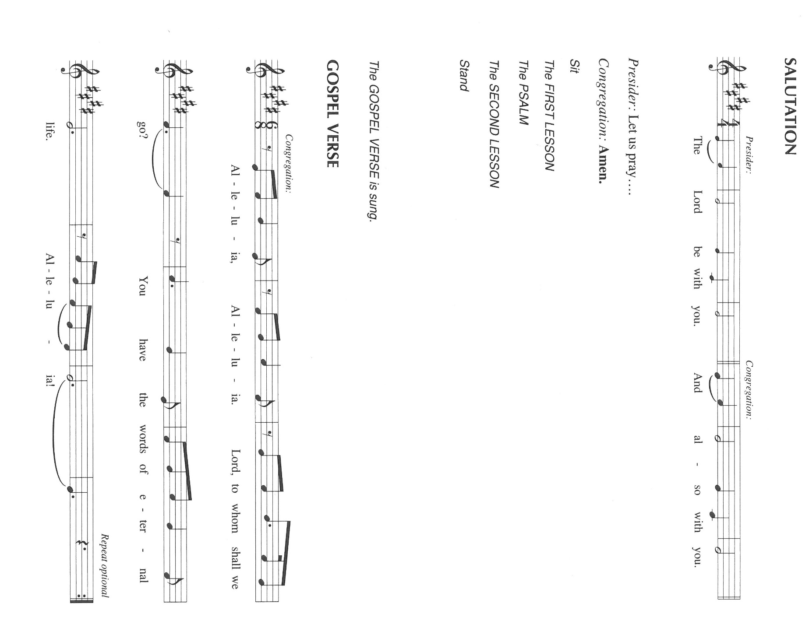27This phrase, "Yet once more," indicates the removal of what is shaken--that is, created things--so that what cannot be shaken may remain. 28Therefore, since we are receiving a kingdom that cannot be shaken, let us give thanks, by which we offer to God an acceptable worship with reverence and awe; 29for indeed our God is a consuming fire.

The Word of the Lord.

**Thanks be to God.**

*As you are able please rise*

**THE VERSE Sung twice**

**THE HOLY GOSPEL Luke 13:10-17**

*After angering the religious leaders by healing a woman on the sabbath, Jesus unmasks their hypocrisy by comparing their practice of releasing livestock on the sabbath to his release of the crippled woman.*

P: The Holy Gospel according to St. Luke, the thirteenth chapter.

C: **Glory to You, O Lord!**

10Now Jesus was teaching in one of the synagogues on the Sabbath. 11And just then there appeared a woman with a spirit that had crippled her for eighteen years. She was bent over and was quite unable to stand up straight. 12When Jesus saw her, He called her over and said, "Woman, you are set free from your ailment." 13When He laid His hands on her, immediately she stood up straight and began praising God.

14But the leader of the synagogue, indignant because Jesus had cured on the Sabbath, kept saying to the crowd, "There are six days on which work ought to be done; come on those days and be cured, and not on the Sabbath day." 15But the Lord answered him and said, "You hypocrites! Does not each of you on the Sabbath untie his ox or his donkey from the manger, and lead it away to give it water? 16And ought not this woman, a daughter of Abraham whom Satan bound for eighteen long years, be set free from this bondage on the Sabbath day?"

17When He said this, all His opponents were put to shame; and the entire crowd was rejoicing at all the wonderful things that He was doing.

P: The Gospel of the Lord.

C: **Praise to You, O Christ!**

*The assembly is seated*

**THE SERMON** Pastor Mark Kloess

*Silence for reflection follows the sermon*

*As you are able please rise*

**THE HYMN OF THE DAY 612 *Healer of Our Every Ill***

**THE APOSTLES’ CREED**

A: God has made us His people through our Baptism into Christ. Living together in trust

and hope, we confess our faith.

C: **I believe in God, the Father almighty,**

**creator of heaven and earth.**

**I believe in Jesus Christ, His only Son, our Lord.**

**He was conceived by the power of the Holy Spirit**

**and born of the virgin Mary.**

**He suffered under Pontius Pilate,**

**was crucified, died, and was buried.**

**He descended into hell.**

**On the third day He rose again.**

**He ascended into heaven,**

**and is seated at the right hand of the Father.**

**He will come again to judge the living and the dead.**

**I believe in the Holy Spirit,**

**the holy catholic Church,**

**the communion of saints,**

**the forgiveness of sins,**

**the resurrection of the body,**

**and the life everlasting. Amen.**

**THE PRAYER OF THE CHURCH**

A: Confident in God’s steadfast love through Jesus Christ and guided by the Holy Spirit,

let us pray for the Church, the world, and all people according to their needs.

A: That the leaders of the Church, especially our Bishops **Elizabeth and Bill**; our Pastors

**Pamela, Mark, Al, Dale, and Mark;** al all missionaries and teachers might through

word and deed lead us to shine the light of Christ into the deep darkness of this world:

Gracious God,

C: **Hear our prayer.**

A: That places and lives laid ruin by famine, poverty, and bloodshed might be restored to

wholeness, vitality, and peace: Gracious God,

C: **Hear our prayer.**

A: That this congregation might be graced with a sensitive and merciful heart for the

hungry, the lonely, and the afflicted: Gracious God,

C: **Hear our prayer.**

A: That the sick, especially . . . would know the healing touch of Jesus: Gracious God,

C: **Hear our prayer.**

A: That those who mourn, especially the family and friends of **Peter Onate,** who died in

the Lord this week, may be comforted by the promise of resurrection to life everlasting

and of being reunited with those they love before the throne of the Lamb: Gracious

God,

C: **Hear our prayer.**

A: That those celebrating birthdays, especially **Betty Yourist** may grow in grace this day

and every day and be filled with grace for the days ahead: Gracious God,

C: H**ear our prayer.**

A: That with all the saints, especially **Bernard, Abbot of Clairvaux,** whom we

commemorate this Day and angels we too will be brought to the city of the living God,

the heavenly Jerusalem: Gracious God,

C: **Hear our prayer.**

P: Gracious God, we call out to You in the power of the Spirit, confident that You hear

the prayers we make in the name of Jesus Who is Lord forever and ever.

C: **Amen.**

**✠ MEAL✠**

**THE PEACE**

P: The peace of the Lord be with you always.

C: **And also with you.**

*The assembly is seated*

**THE OFFERING**

**THE VOLUNTARY *We Are Called*  David Haas**

**(soloist Susan Bagby)**

*As you are able please rise*

**THE OFFERTORY 465 *As the Grains of Wheat***

**THE OFFERTORY PRAYER**

A: Let us pray. Gracious God,

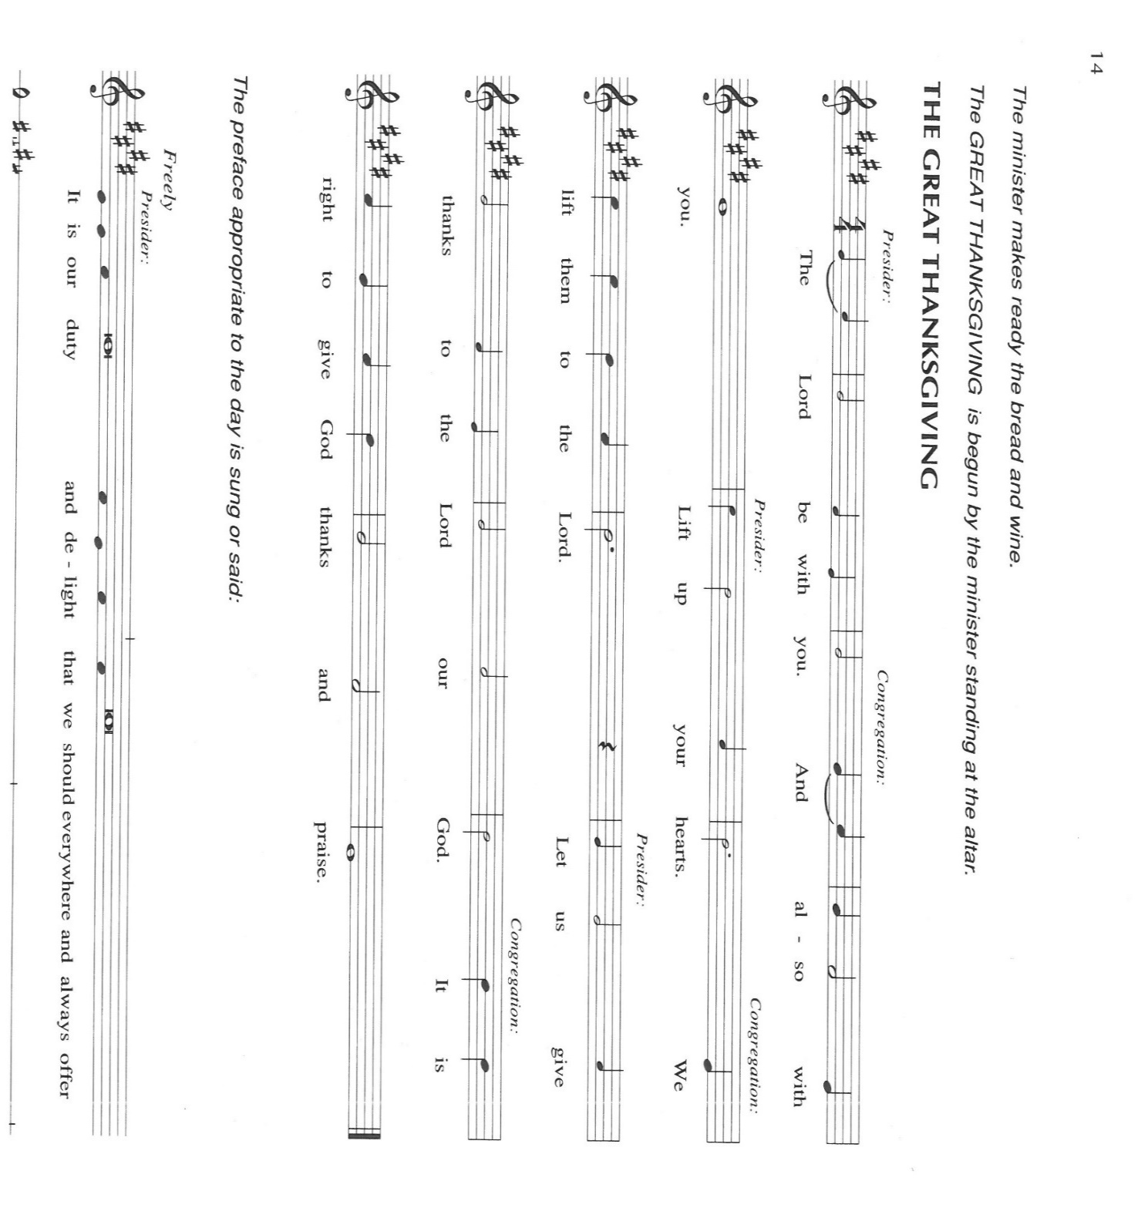

C: **You satisfy us with good things, and crown us with mercy and lovingkindness. In**

**grateful devotion we offer the best of our lives and ourselves to You. Receive these**

**gifts for the sake of Your Son, Jesus Christ, and by this Meal, renew us to make**

**Your loving ways known to all the world. We ask this in the name of Jesus the**

**Lord. Amen.**

**THE GREAT THANKSGIVING**

P: It is our duty and delight … join their unending hymn:

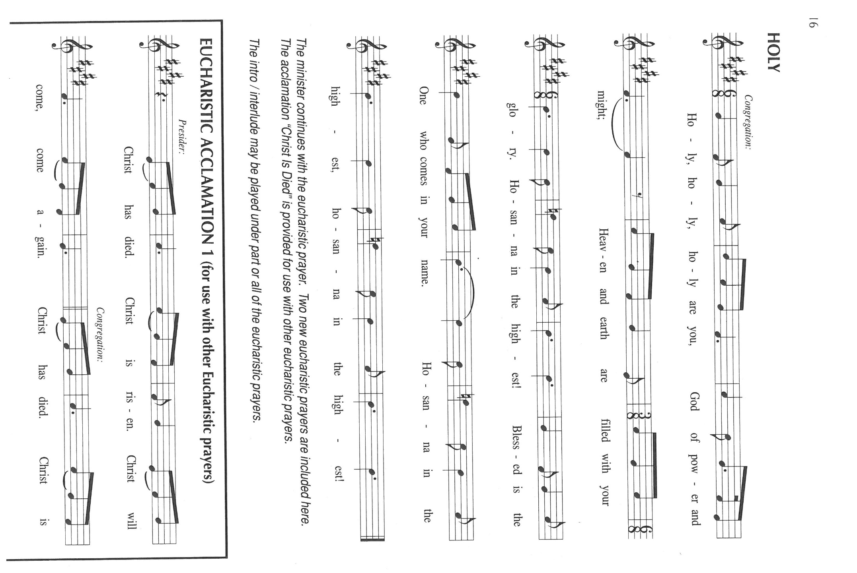

P: The Lord be with you.

C: **And also with you.**

P: Lift up your hearts.

C: **We lift them to the Lord.**

P: Let us give thanks to the Lord our God.

C: **It is right to give Him thanks and praise.**

P: Holy God, our Maker, Redeemer, and Healer,

In the harmonious world of Your creation the plants and animals, the seas and

stars were whole and well in Your praise.

When sin had scarred the world, You sent Your Son to heal our ills and to form us

again into one.

In the night ... “Do this for the remembrance of Me.”

As often as we eat ... we proclaim the Lord’s death until He comes.

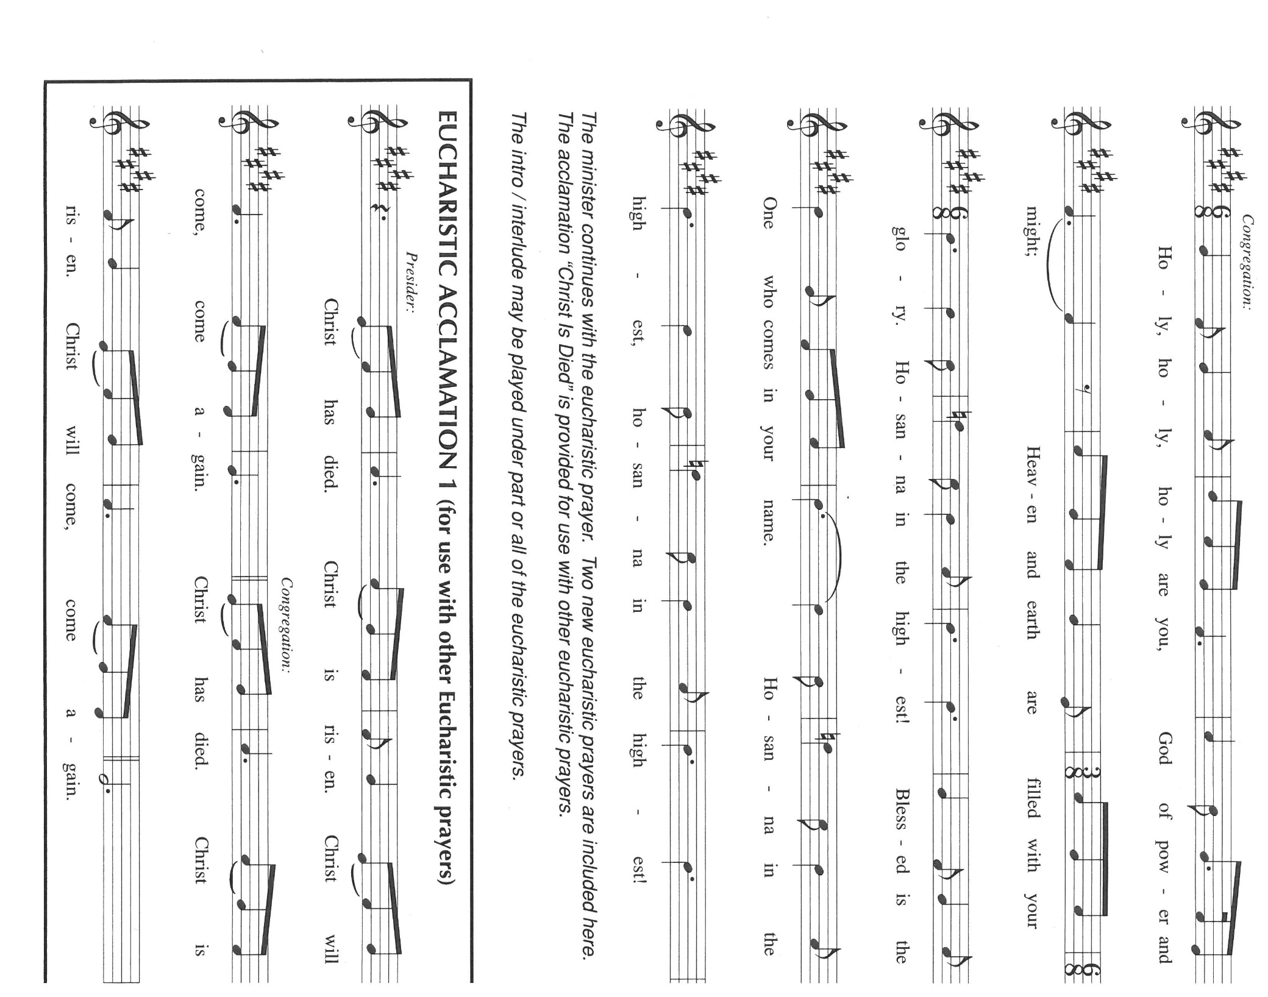

P: Remembering, therefore, His acts of healing, His Body given up, and His victory

over death,

We await that Day when all the peoples of the earth will come to the river to

enjoy the Tree of Life.

Send Your Spirit upon us and this Meal: as grains scattered on the hillside

become one bread,

So let Your Church be gathered from the ends of the earth, that all may be fed

with the Bread of Life, Your Son.

Through Him all honor and glory is Yours, Almighty Father, with the Holy Spirit,

in Your holy Church, both now and forever.

C: **Amen!**

**THE LORD’S PRAYER**

P: Gathered into one by the Spirit, let us pray as Jesus taught us:

C: **Our Father in heaven, hallowed be Your name.**

**Your Kingdom come, Your will be done on earth as it is in heaven.**

**Give us this day our daily bread, and forgive us our sins as we forgive those who**

**sin against us.**

**Save us from the time of trial and deliver us from evil, for the Kingdom and the**

**power and the glory are Yours, now and forever. Amen.**

**INVITATION TO THE MEAL**

P: This is the Lamb of God Who takes away the sin of the world. Blessed are those who

are called to the supper of the Lamb. God’s holy gifts for God’s holy people. Come,

for all is now ready.

*The assembly is seated*

**THE DISTRIBUTION “Lamb of God”**

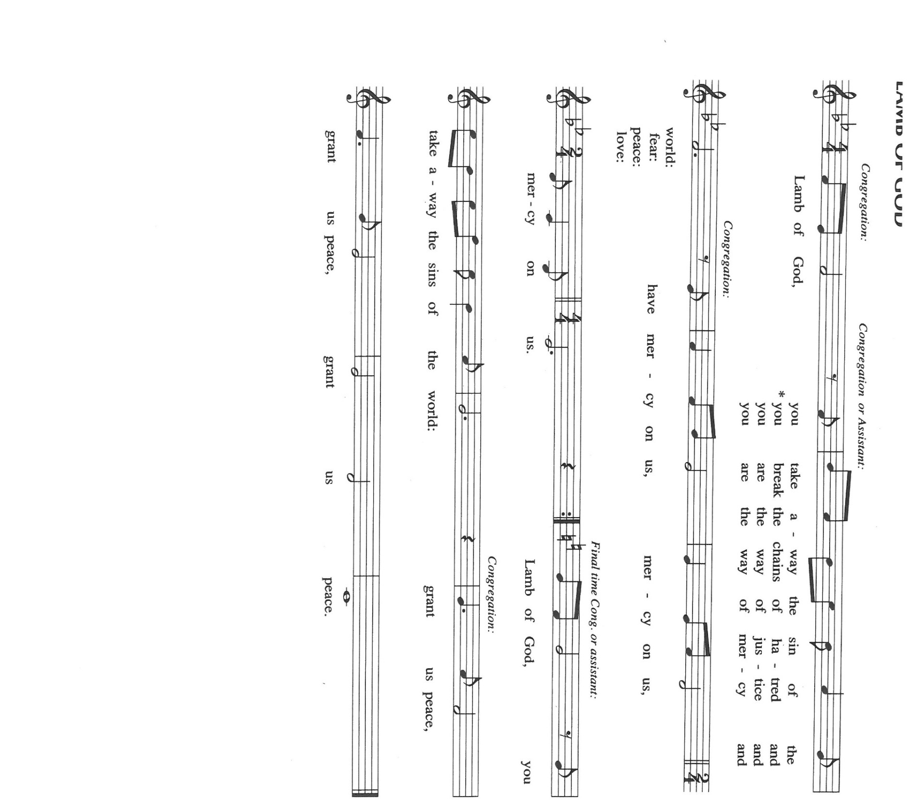

**HYMNS DURING DISTRIBUTION 483 *Here is Bread***

**858 *Praise to the Lord, the Almighty***

*As you are able please rise*

**THE POST-COMMUNION BLESSING**

P: The Body and Blood of our Lord Jesus Christ strengthen you and keep you in His grace.

C: **Amen.**

**THE POST-COMMUNION PRAYER**

A: Let us pray. Gracious God, once again You have satisfied us with the good things of

the Body and Blood of Christ. Renew in us Your mercy and compassion by this Meal,

that the light of Christ might rise in us as a beacon of hope to the hungry and afflicted.

Grant this through Christ our Lord.

C: **Amen.**

**✠ SENDING ✠**

**THE BENEDICTION**

P: Almighty God: Father, Son, ✠ and Holy Spirit bless you now and forever.

C: **Amen.**

**THE SENDING HYMN 537 *On Our Way Rejoicing***

**THE DISMISSAL**

A: Go in peace to bear Christ’s love to all the world.

C: **Thanks be to God!**

**POSTLUDE *The Rejoicing* G. F. Handel**

**✠ To God Alone Be Glory ✠**

The Meditation is from *Words for Worship.* Copyright 1998 Augsburg Fortress.

The musical setting of the liturgy, “Now the Feast and Celebration” by Marty Haugen, is

used by permission of GIA Publishers, Inc. OneLicense.net License #A-702836.

**ANNOUNCEMENTS**

**Please remember to mail your offering to the Church Office** at 818 Franklin Street, Michigan City, IN 46360**.** Another alternative is to give on-line through Tithe.ly. Please see your closure letter for information on how to set up a Tithe.ly account.

**St. Paul Members are reminded to have** a loved one contact the office if you are hospitalized. Many times, the Pastor doesn’t know someone is in the hospital. If you call and leave a message, please tell us which hospital the patient is at.

**Next Sunday’s lessons are Proverbs 25:6-7; Psalm 112; Hebrews 13:1-8, 15-16; Luke 14: 1, 7-14** for those of you who like to study them in advance.

**Birthdays: Betty Yourist (8/22)**

**PRAYER CONCERNS:** Audrey Beyer, Ryan Krueger, Donna Bostater, Maxine Powell, Jim Tomscheck, Eloise Ponder, Mark & Jary Tannehill, Leonard Cross, George Ottersen, Annette Scroggin.

**If you requested someone’s name to be on the prayer list and are aware that they need continued imminent prayer then contact the church office and let us know.** Otherwise we will gradually transfer names to the long-term list.

**OFFICE HOURS:** Libby will be in the office on Mondays, Wednesdays, and Fridays; volunteers will cover Tuesdays and Thursdays.

Monday & Wednesday 8:00 a.m. – 5 p.m.

Tuesday & Thursday 9:00 a.m. – 12:00 p.m.

Friday 8:00 a.m. – 12:00 p.m.

**If you are listening to the worship broadcast on the radio and would like to watch the Sunday morning service live stream follow these steps:**

(1) If you have You.Tube available on your TV, search for

**St. Paul Lutheran Church Michigan City, IN.**

(2) The direct link on the computer is

<https://www.youtube.com/channel/UC5AIPNaKr3QN50984jGOa1g>.

 (3) This link is also on the main page of the church’s website in the church section and will continue to be posted weekly on the St. Paul Facebook page.

And it will always be available on the radio broadcast Sunday mornings at 11:00 a.m. on WEFM (95.9), and on the local cable access station #99 for the previous week’s service on Sundays at 4:00 p.m. and the current service on Wednesdays at 7:00 p.m. and Fridays at 8:30 p.m.

**To send e-mail to the church office**, please use the following addresses:

Pastor Mark Reshan: [seniorpastor@stpaulmichigancity.com](mailto:seniorpastor@stpaulmichigancity.com)

Church Office Secretary (Libby Pollock): [churchsecretary@stpaulmichigancity.com](mailto:churchsecretary@stpaulmichigancity.com)

Church Treasurer (Karen Fleming): [finance@stpaulmichigancity.com](mailto:finance@stpaulmichigancity.com)

**The Good News Newsletter**: If you have an article or anything you want included in **The Good News** please send it to the following e-mail address: splcgoodnews@gmail.com. Pastor Pamela Thiede will be using this e-mail address to assemble **The Good News** each month. The deadline for getting information to Pastor Pamela will be the 20th of each month.

**PLEASE REMEMBER:** the next time you are coming to the church whether it be for one of the worship services or for any other meeting or activity please remember to bring in non-perishable food items to donate to the Salvation Army Food Pantry. There is a

serious need in this community to help especially those whom have little to no access to food and/or shelter. Please open your hearts and continue to be generous in your giving!

**WORSHIP ATTENDANCE for August 13 and 14, 2022**

**4:00 p.m. 30**

**9:00 a.m. 60**

**Total = 90**

**AUGUST 2022 ACTIVITIES, EVENTS & MEETINGS**

**Saturday,** August 13, 2022 at 4:00 p.m. Worship service

**Sunday,** August 14, 2022 at 9:00 a.m. Worship Service

**Wednesday,** August 17, 2022 at 10:00 a.m. God’s Purls/St. Paul Room

**Saturday,** Augst 20, 2022 at 4:00 p.m. Worship Service

**Sunday,** August 21, 2022 at 9:00 a.m. Worship Service

**Monday,** August 22, 2022 at 4:00 p.m. Finance Committee Meeting/Luther House

at 5:30 p.m. Executive Board Meeting/Luther House

**Tuesday,** August 23, 2022 all day and evening **GIVE-BACK AT HOLLY’S**

**Wednesday,** August 24, 2022 at 10:00 a.m. God’s Purls/Green Room/Nursery

**Thursday,** August 25, 2022 at 5:30 p.m. Church Council Meeting/St. Paul Room

**Saturday,** August 27, 2022 at 4:00 p.m. Worship Service

**Sunday,** August 28, 2022 at 9:00 a.m. Worship Service

And please join us afterwards for a Special Coffee Hour. Altar Guild will be providing a

cake to celebrate the baptism of Leah Ann Brooks and Camren Douglas Brooks

St. Paul Lutheran Church has always been a supporter of the less fortunate in our community. We hosted the men’s and women’s shelters for many years. The shelters are now in their own building, but **Interfaith PADS** operates by donations and a few grants.

Well, United Healthcare of LaPorte has granted **PADS** with matching dollar for dollar in donations up to $25,000. This means that for every dollar we donate **PADS** gets another dollar from United Healthcare . . .**PLEASE,** let’s show our continued support by making a donation to **PADS. The mailing address is: Interfaith PADS**

**P.O. Box 38**

**Michigan City, IN 46361**

**We are looking to arrange meals for Mark and Jary Tannehill.** If you are able to help please call or text Jacob Tannehill at 269-405-0926 or Stacie Crozier at 219-877-4351 or let her know when you see her at worship.

***Rally Days – September 10th and 11th***

Rally means to assemble, reassemble and revive.

Plan on joining together to RALLY on Saturday, September 10th after the Saturday worship service (about 5:00pm) for a Pot Luck dinner. The council will provide Grilled Hot Dogs, buns and condiments. Please bring an appetizer, side dish or dessert.

All are welcome to assemble, reassemble if you have been vacationing, and revive our Christian Lutheran journey.

Thank$ for $haring

**Thank you to all** who participated in our GIVE-BACK at Galveston on July 28. We raised $330.00 this time! Not sure, but it might be a record for our GIVE-BACK nights!

This month,we will see you at Holly’s! We’re giving you two coupons so you can invite a friend and give them their own coupon. Remember, the coupon is required for the Give-Back bucks.

