THE TWELFTH SUNDAY AFTER PENTECOST
August 28, 2022

“God treats Jesus--and us--in the same way as the host in the parable: he cares for those who are humiliated and turns away the proud. We can see that fully only in the death and resurrection of Jesus. In (a story) which anyone can understand, today’s (reading) provides the essence of what we might call distinctive Christianity, specifically the way in which God deals with people ...”
“ ... We must not invite the rich to our tables but the poor, because the rich simply repay the compliment by inviting us back: the poor can’t do that. Only then is it evident what being good is.
God seems to have a predilection for those who do not belong to the elite or the religious clan. So Luke weaves a second parable into his story: “When you give a feast, invite the poor, the maimed, the lame and the blind.” But who does that? Nobody--apart from the community of God, the church in its celebration of the eucharist.
That is the only table to which not only friends and relatives are invited but also the cripples, the blind, the maimed and the oppressed. We can come to it in wheelchairs, with a broken and tormented heart; even our enemies may come. Here we already experience a vision of the future in which all those who are humiliated and discriminated against are exalted ... here we come together for the feast, the gathering which the people of the future share together ...”
“ ... The liturgy thus provokes us to act outside the liturgy in accordance with this vision of the coming kingdom of God among us, celebrated here symbolically in anticipation, because we cannot make it reality.
At the same time what we do here in the liturgy subjects what we do outside the liturgy to severe criticism. Despite all our good intentions, outside the liturgy we shall fail in our task ... To recognize this in penitence is already to be open to what is possible through grace, through the work of God in us.
So we have moved from the middle-class table to what the gospel calls the eschatological banquet, where without any failure in communications everyone may sit in the place of honor.”

Edward Schillebeeckx
God Among Us: The Gospel Proclaimed

In the Name of Jesus

GATHERING

INTRODUCTION
Invited and inviting—that is the nature of the church. By God's grace in holy baptism we have a place at the banquet table of the Lord. When, by the power of that same Spirit, humility and mutual love continue among us, the church can be more inviting still.

Augustine, Bishop of Hippo, died 430

Augustine was one of the greatest theologians of the Western church. A native of North Africa, he recovered from a debauched young adulthood through the influence of his mother, Monica, and Bishop Ambrose of Milan. Besides writing influential theological books, he served as bishop of Hippo, in present-day Algeria.

Moses the Black, monk, martyr, died around 400
Converted from life as a thief and a robber to Christianity, Moses was an Ethiopian who became a desert monk at Skete. The change in his heart and life had a profound impact on his native country. He was murdered when Berber bandits attacked his monastery.

PRELUDE A Baptismal Song Robert Hobby
(Flute, Betsy Kohn and Soloist, Lori Zylstra)

ANNOUNCEMENTS

As you are able please rise

BAPTISMAL HYMN Hannah’s Song Robert Hobby
(Flute, Betsy Kohn and Soloist, Lori Zylstra)

THE GREETING AND PRAYER OF THE DAY

P: The grace of our Lord Jesus Christ, the love of God, and the communion of the Holy
Spirit be with you all.

C: And also with you.

The assembly is seated

THE SACRAMENT OF HOLY BAPTISM
Presentation

Candidates for baptism, sponsors, and parents gather with the ministers at the font.

The presiding minister may address the assembly in these or similar words:

In baptism our gracious heavenly Father frees us from sin and death by joining us to the death and resurrection of our Lord Jesus Christ. We are born children of a fallen humanity; by water and the Holy Spirit we are reborn children of God and made members of the church, the body of Christ. Living with Christ and in the communion of saints, we grow in faith, love, and obedience to the will of God.

Sponsors for each candidate, in turn, present the candidates:

I present Leah Ann/Camren Douglas for baptism.

The presiding minister addresses parents or others who bring for baptism children who are not able to answer for themselves:

Called by the Holy Spirit, trusting in the grace and love of God, do you desire to have Leah Ann/Camren Douglas baptized into Christ?

Response:

I do.

The presiding minister continues:
As you bring Leah Ann/Camren Douglas to receive the gift of baptism, you are entrusted with responsibilities:

to live with them among God's faithful people,
bring them to the word of God and the holy supper,
teach them the Lord's Prayer, the Creed, and the Ten Commandments,
place in their hands the holy scriptures,
and nurture them in faith and prayer,
so that they may learn to trust God,
proclaim Christ through word and deed,
care for others and the world God made,
and work for justice and peace.
Do you promise to help Leah Ann/Camren Douglas grow in the Christian faith and life?

Response:

I do.

The presiding minister addresses sponsors:

Sponsors, do you promise to nurture Leah Ann/Camren Douglas in the Christian faith as you are empowered by God's Spirit, and to help them live in the covenant of baptism and in communion with the church?

Response:

I do.

The presiding minister addresses the assembly:

People of God, do you promise to support Leah Ann/Camren Douglas and pray for them in their new life in Christ?

We do.

As you are able please rise

Profession of Faith

The presiding minister addresses candidates for baptism as well as the parents and sponsors of young children. The assembly may join in the responses.

I ask you to profess your faith in Christ Jesus, reject sin, and confess the faith of the church.

Do you renounce the devil and all the forces that defy God?

Parents and sponsors:

I renounce them.

Do you renounce the powers of this world that rebel against God?

Parents and sponsors:

I renounce them.
Do you renounce the ways of sin that draw you from God?

Parents and sponsors:

I renounce them.

The presiding minister addresses the candidates and the assembly.

Do you believe in God the Father?

I believe in God, the Father almighty,
creator of heaven and earth.

Do you believe in Jesus Christ, the Son of God?

I believe in Jesus Christ, His only Son, our Lord.
He was conceived by the power of the Holy Spirit
and born of the virgin Mary.
He suffered under Pontius Pilate,
was crucified, died, and was buried.
He descended into hell.
On the third day He rose again.
He ascended into heaven,
and is seated at the right hand of the Father.
He will come again to judge the living and the dead.

Do you believe in God the Holy Spirit?

I believe in the Holy Spirit,
the holy catholic church,
the communion of saints,
the forgiveness of sins,
the resurrection of the body,
and the life everlasting. Amen.

Thanksgiving at the Font

Water may be poured into the font before or during the thanksgiving. At the font, the presiding minister begins the thanksgiving:

The Lord be with you.

And also with you.

Let us give thanks to the Lord our God.

It is right to give our thanks and praise.

Blessed are You, O God, maker and ruler of all things. Your voice thundered over the waters at creation. You water the mountains and send springs into the valleys to refresh and satisfy all living things.

Through the waters of the flood You carried those in the ark to safety. Through the sea You led Your people Israel from slavery to freedom. In the wilderness You nourished them with water from the rock, and You brought them across the river Jordan to the promised land.

By the baptism of His death and resurrection, Your Son Jesus has carried us to safety and freedom. The floods shall not overwhelm us, and the deep shall not swallow us up, for Christ has brought us over to the land of promise. He sends us to make disciples, baptizing in the name of the Father, and of the Son, and of the Holy Spirit.

Pour out Your Holy Spirit; wash away sin in this cleansing water; clothe the baptized with Christ; and claim Your daughters and sons, no longer slave and free, no longer male and female, but one with all the baptized in Christ Jesus, Who lives and reigns with You in the unity of the Holy Spirit, one God, now and forever.

Amen.

The assembly is seated.

Baptism

The presiding minister baptizes each candidate. The candidate is immersed into the water, or water is poured on the candidate's head, as the presiding minister says:

Leah Ann/Camren Douglas I baptize you in the name of the Father, and of the Son, and of the Holy Spirit.

Amen.

You belong to Christ,
in Whom you have been baptized.

The presiding minister continues:

Let us pray.
We give you thanks, O God that through water and the Holy Spirit you give your daughters and sons new birth, cleanse them from sin, and raise them to eternal life.

Laying both hands on the head of each of the newly baptized, the minister prays for each:

Sustain Leah Ann/Camren Douglas with the gift of Your Holy Spirit: the spirit of wisdom and understanding, the spirit of counsel and might, the spirit of knowledge and the fear of the Lord, the spirit of joy in Your presence, both now and forever.

Amen.

The presiding minister marks the sign of the cross on the forehead of each of the baptized. Oil prepared for this purpose may be used. As the sign of the cross is made, the minister says:

Leah Ann/Camren Douglas, child of God, you have been sealed by the Holy Spirit and marked with the cross of Christ forever.

Amen.

Welcome

A lighted candle may be given to each of the newly baptized (to a sponsor of a young child) as a representative of the congregation says:

Let your light so shine before others
that they may see your good works
and glorify your Father in heaven.

The ministers and the baptismal group face the assembly. A representative of the congregation leads the assembly in the welcome.

Let us welcome the newly baptized.

We welcome you into the body of Christ and into the mission we share:
join us in giving thanks and praise to God
and bearing God's creative and redeeming word to all the world.

THE PRAYER OF THE DAY

P: The Lord be with you.

C: And also with you.

P: Let us pray. O God, You resist those who are proud and give grace to those who are
humble. Give us the humility of Your Son, that we may embody the generosity of Jesus
Christ, our Savior and Lord.

C: Amen.
WORD
FIRST READING Proverbs 25:6-7

The Book of Proverbs is known as wisdom literature. Proverbs presents a view of life that is orderly, simple, and practical. The truth of the advice on humility in the presence of the ruler is self-evident.

⁶Do not put yourself forward in the king's presence
or stand in the place of the great;
⁷for it is better to be told, "Come up here,"
than to be put lower in the presence of a noble.

The Word of the Lord.

Thanks be to God.

THE PSALM: Psalm 112 Antiphon by John Paradowski
Cantor sings refrain first, followed immediately by the congregation
and as indicated

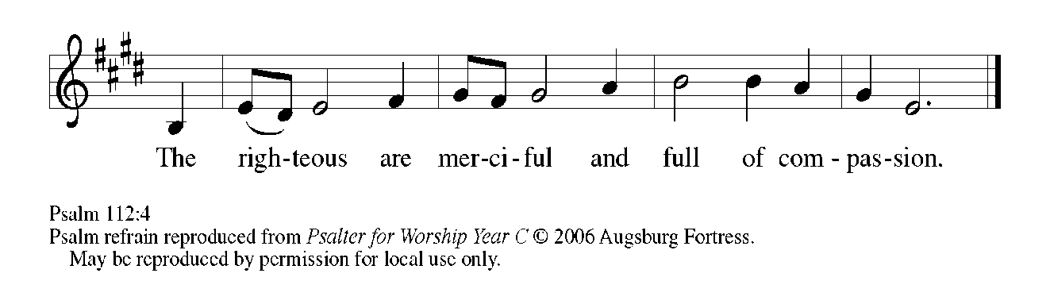

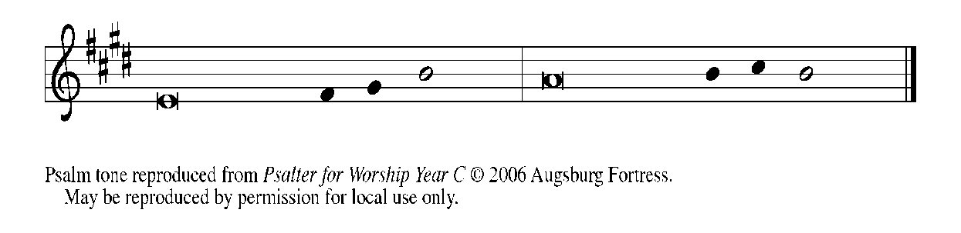

¹Hallelujah! Happy are they who | fear the LORD
and have great delight in | God's commandments!

²Their descendants will be mighty | in the land;
the generation of the upright | will be blessed. REFRAIN

³Wealth and riches will be | in their house,
and their righteousness will | last forever.

⁴Light shines in the darkness | for the upright;
the righteous are merciful and full | of compassion.

⁵It is good for them to be gener- | ous in lending
and to manage their af- | fairs with justice.

⁶For they will nev- | er be shaken;
the righteous will be kept in everlast- | ing remembrance. REFRAIN

⁷They will not be afraid of any | evil rumors;
their heart is steadfast, trusting | in the LORD.

⁸Their heart is established and | will not shrink,
until they see their desire up- | on their enemies.

⁹They have given freely to the poor, and their righteousness stands | fast forever;
they will hold up their | head with honor.

¹⁰The wicked will see it and be angry; they will gnash their teeth and | pine away;
the desires of the wick- | ed will perish. REFRAIN

⁹They have given freely to the poor, and their righteousness stands fast forever;
they will hold up their head with honor.

¹⁰The wicked will see it and be angry; they will gnash their teeth and pine away;
the desires of the wicked will perish.

SECOND READING Hebrews 13:1-8, 15-16

The epistle to the Hebrews is a theological treatise that addresses many issues related to Christian doctrine. At the end of the letter, however, we find a list of exhortations that indicate faith is not only a matter of what we believe, but also of how we live.

¹Let mutual love continue. ²Do not neglect to show hospitality to strangers, for by doing that some have entertained angels without knowing it. ³Remember those who are in prison, as though you were in prison with them; those who are being tortured, as though you yourselves were being tortured. ⁴Let marriage be held in honor by all, and let the marriage bed be kept undefiled; for God will judge fornicators and adulterers. ⁵Keep your lives free from the love of money, and be content with what you have; for He has said, "I will never leave you or forsake you." ⁶So we can say with confidence,
"The Lord is my helper;
I will not be afraid.
What can anyone do to me?"
⁷Remember your leaders, those who spoke the word of God to you; consider the outcome of their way of life, and imitate their faith. ⁸Jesus Christ is the same yesterday and today and forever.
¹⁵Through Him, then, let us continually offer a sacrifice of praise to God, that is, the fruit of lips that confess His name. ¹⁶Do not neglect to do good and to share what you have, for such sacrifices are pleasing to God.

The Word of the Lord.

Thanks be to God.

As you are able please rise

THE VERSE Sung twice

THE HOLY GOSPEL Luke 14:1, 7-14

In Luke's gospel, Jesus often tells parables about meals in order to illustrate God's unexpected grace and lead people to a faithful response. Here, we have two examples of these stories, one extolling humility and the other, inclusivity.

P: The Holy Gospel according to St. Luke, the fourteenth chapter.

C: Glory to You, O Lord!

¹On one occasion when Jesus was going to the house of a leader of the Pharisees to eat a meal on the Sabbath, they were watching Him closely. ⁷When He noticed how the guests chose the places of honor, He told them a parable.
⁸"When you are invited by someone to a wedding banquet, do not sit down at the place of honor, in case someone more distinguished than you has been invited by your host; ⁹and the host who invited both of you may come and say to you, 'Give this person your place,' and then in disgrace you would start to take the lowest place. ¹⁰But when you are invited, go and sit down at the lowest place, so that when your host comes, he may say to you, 'Friend, move up higher'; then you will be honored in the presence of all who sit at the table with you. ¹¹For all who exalt themselves will be humbled, and those who humble themselves will be exalted."
¹²He said also to the one who had invited Him, "When you give a luncheon or a dinner, do not invite your friends or your brothers or your relatives or rich neighbors, in case they may invite you in return, and you would be repaid. ¹³But when you give a banquet, invite the poor, the crippled, the lame, and the blind. ¹⁴And you will be blessed, because they cannot repay you, for you will be repaid at the resurrection of the righteous."

P: The Gospel of the Lord.

C: Praise to You, O Christ!

The assembly is seated

THE SERMON
Silence for reflection follows the sermon

As you are able please rise

THE HYMN OF THE DAY 522 Wash, O God, Our Sons and Daughters

THE PRAYER OF THE CHURCH

A: Let us lift our hearts and voices in behalf of the Church, the world, and all those in need
of our prayers and the healing presence and power of God.

A: That we who serve God in our labor may joyfully give of ourselves without expecting
reward, let us pray to the Lord:

C: Lord, hear our prayer.

A: That in places of violence, war, and unrest, especially in Sri Lanka, Venezuela, Taiwan,
Afghanistan and Ethiopia there might come a genuine and lasting peace, let us pray to
the Lord:

C: Lord, hear our prayer.

A: That Leah Ann and Camren Douglas, newly baptized, may be delivered from the way
of sin and death; filled with the Holy Spirit so that they lack no spiritual gift; and be
strengthened in faith and life so that they may always bear witness to the Lord in word
and action, let us pray to the Lord:

C: Lord, hear our prayer.

A: That our welcome in this assembly of all to the Lord’s Table might reflect the joy of
the great and promised Feast to come, let us pray to the Lord:

C: Lord, hear our prayer.

A: That those who labor might find contentment and fulfillment in their work, and those
who are unemployed or under-employed may be led to fuller opportunities to earn their
livelihood, let us pray to the Lord:

C: Lord, hear our prayer.

A: That those burdened in body, mind, or spirit, especially . . . might be bathed in the
healing power of God, let us pray to the Lord:

C: Lord, hear our prayer.

A: That those celebrating birthdays, especially Jan Paholski may be filled with grace this
day and every day and grow in grace in the days ahead, let us pray to the Lord:

C: Lord, hear our prayer.

A: That those who mourn, especially the families and friends of Norman Egilske and
Carol Weiss, who died in the Lord this week may be comforted by the promise of
resurrection to life everlasting and of being reunited with those they love before the
throne of the Lamb, let us pray to the Lord:

C: Lord, hear our prayer.

A: That with all the saints, especially Augustine, Bishop of Hippo, and Moses the Black,
monk and martyr whom we commemorate this Day we too may walk Jesus’ way of
humble obedience and self-giving love, let us pray to the Lord:

C: Lord, hear our prayer.

P: We beseech You, O God, for Your peacefulness, Your humility, and Your love, both
for ourselves and for our world. Hear and grant our prayers according to Your gracious
and saving will, for the sake of Jesus Christ our Lord.

C: Amen.
MEAL

THE PEACE

P: The peace of the Lord be with you always.

C: And also with you.

The assembly is seated

THE OFFERING

THE VOLUNTARY Seek Ye First Lafferty/Raney

As you are able please stand

THE OFFERTORY 465 As the Grains of Wheat

THE OFFERTORY PRAYER

A: Let us pray. Almighty God,

C: As You give strength and wisdom for our daily work, keep us grounded in Your
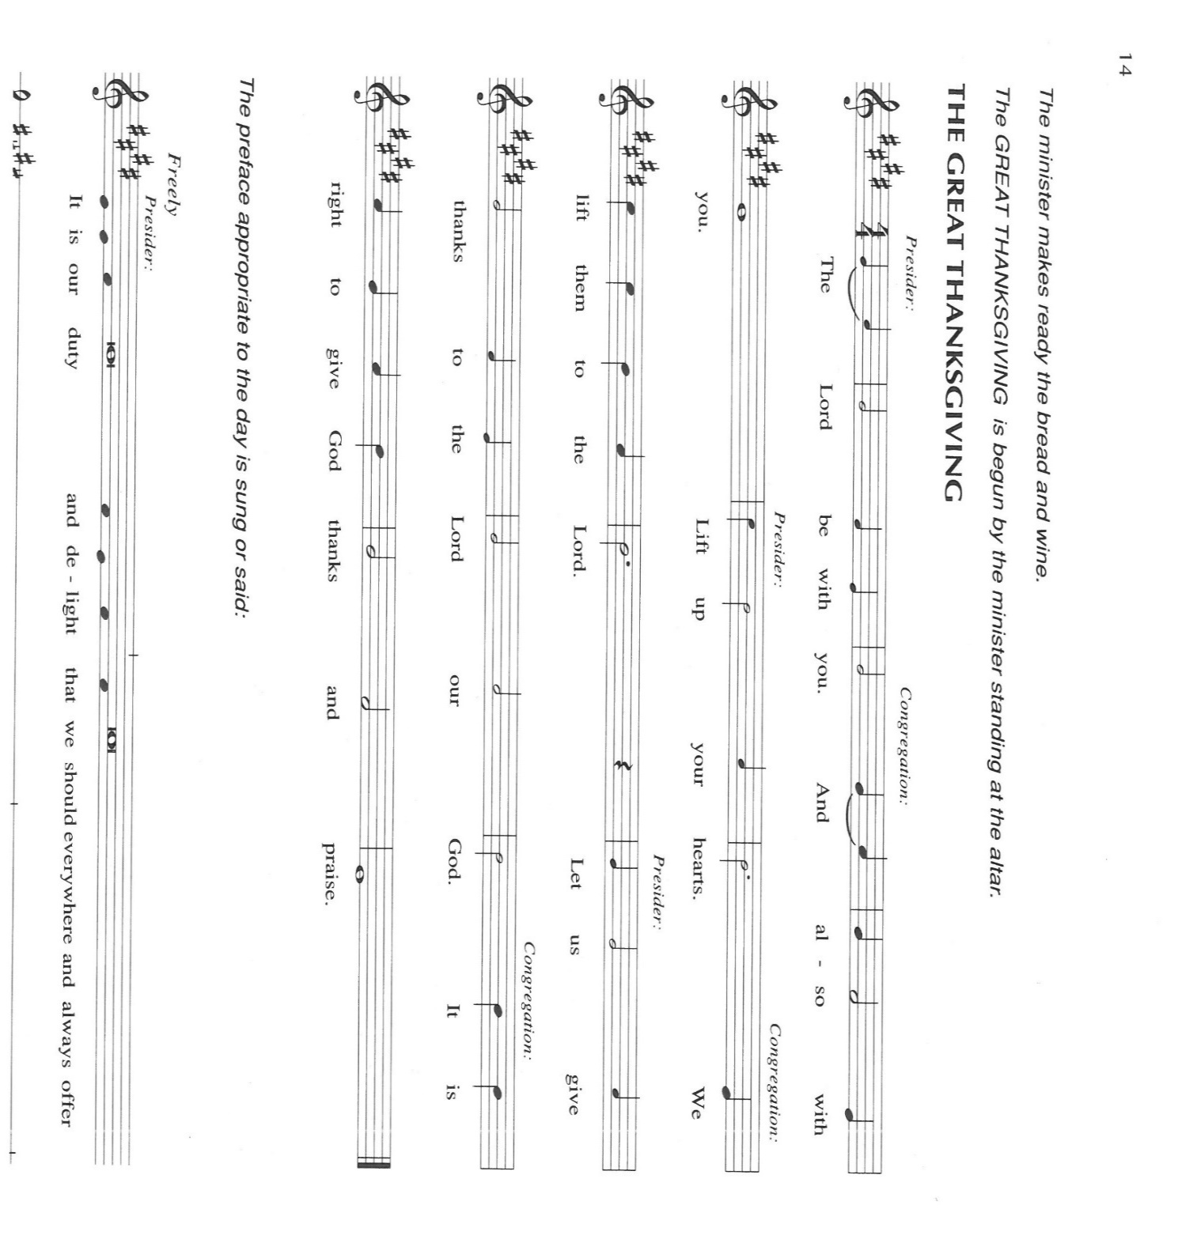
faithful love. Receive these offerings as a sign that we depend wholly on You, and
by this holy Sacrament, fill us with the heart and life of Christ. We ask this in the
name of Jesus the Lord. Amen.

THE GREAT THANKSGIVING

P: It is our duty and delight …and join their unending hymn:

P: Exalted above all is Your name, God of Jacob, for You feed Your people, not only
for today but for eternity with Your good that truly satisfies.
When Your people hungered, You longed to feed them with the finest wheat, and
through the grace of Your servant Joseph turned famine into abundant
provision.
When You brought Your children out of slavery, You filled their mouths with good
things and led them to life in a land of plenty.
In the fullness of time, Your Son gave us a place of honor at the Banquet of salvation,
which is more than we could ever deserve.
Transforming God, as You exalt the humble and humble the exalted, pour Your grace
upon Your Church gathered to remember the dying and rising of Your Son.
Send Your Spirit upon this bread and cup that they may be for us the Body and Blood
of our Lord Jesus Christ,
Who, in the night ... “Do this for the remembrance of Me.”
As often as we eat ... we proclaim the Lord’s death until He comes.

P: Inviting God, as in Your Son You beckon the poor and the crippled and the blind
and the lame,
Visit Your Church where it is poor, and make it reflect the wonder of Your love.
Renew Your people where they are crippled, that Your power may be made perfect
in weakness;
Empower Your children where they are blind, that they may know You more truly;
And uphold Your saints where they are lame, that they may find friends gracious
in support and strength with whom they may never be afraid.
Make Your Church a place of hospitality, that it may entertain angels unawares.
For in Christ You are the same yesterday, today, and forever, and in the power of
Your Spirit we shall never walk alone,
Heavenly Father, radiant in glory.

C: Amen!

THE LORD’S PRAYER

P: Gathered into one by the Spirit, let us pray as Jesus taught us:

C: (Sung) Music is on the front cover of the red hymnal

INVITATION TO THE MEAL

P: This is the Lamb of God Who takes away the sin of the world. Blessed are those who
are called to the supper of the Lamb. God’s holy gifts for God’s holy people. Come,
for all is now ready.

The assembly is seated

THE DISTRIBUTION Lamb of God

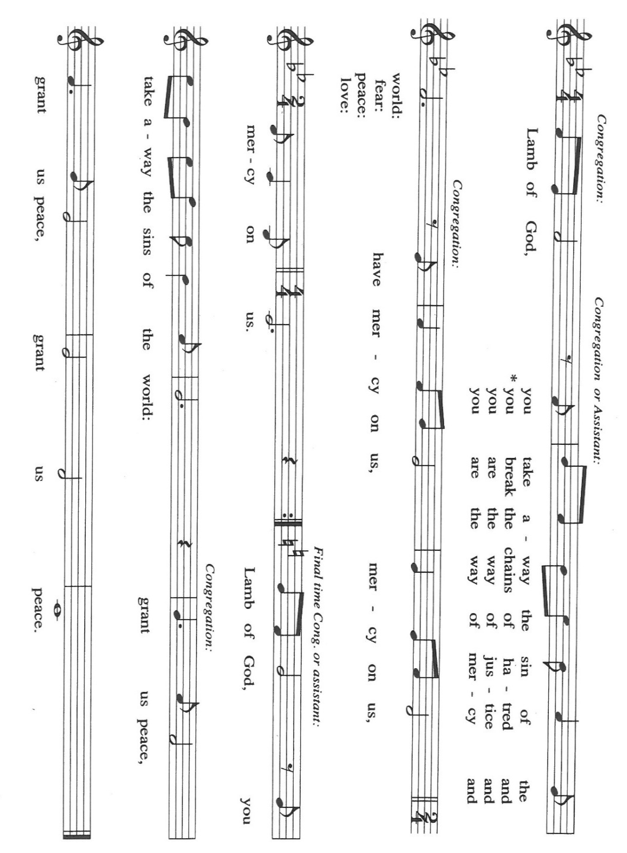
Lamb of God Flute, Betsy Kohn Paris/Raney

HYMNS DURING DISTRIBUTION 462 Now We Join in Celebration
468 Around You, O Lord Jesus
As you are able please rise

THE POST-COMMUNION BLESSING

P: The Body and Blood of our Lord Jesus Christ strengthen you and keep you in His grace.

C: Amen.

THE POST-COMMUNION PRAYER

A: Let us pray. Lord Jesus Christ, once again You have prepared a place of honor for us
at Your Banquet of love. With great joy we celebrate Your obedience to the Father’s
gracious will. Let the Spirit of Your love rule us, that in humility we may embody the
grace of Your Kingdom. You are the Lord forevermore.

C: Amen.
SENDING
THE BENEDICTION

P: Almighty God: Father, Son, and Holy Spirit bless you now and forever.

C: Amen.

THE SENDING HYMN 547 Sent Forth by God’s Blessing

THE DISMISSAL

A: Go in peace to bear Christ’s love to all the world.

C: Thanks be to God!

POSTLUDE Sent Forth by God’s Blessing John A. Behnke

To God Alone Be Glory

The Meditation is from Richer Fare for the Christian People. Gail Ramshaw, ed. (New
York: Pueblo Publishing Company, 1990) 199-200.

The Eucharistic Prayer is adapted from Eucharistic Prayers. Samuel Wells and Abigail
Kocher. (Grand Rapids: Eerdmann’s Publishing Company, 2016) 264-65.

ANNOUNCEMENTS

Please remember to mail your offering to the Church Office at 818 Franklin Street, Michigan City, IN 46360. Another alternative is to give on-line through Tithe.ly. Please see your closure letter for information on how to set up a Tithe.ly account.

St. Paul Members are reminded to have a loved one contact the office if you are hospitalized. Many times, the Pastor doesn’t know someone is in the hospital. If you call and leave a message, please tell us which hospital the patient is at.

Next Sunday’s lessons are Deuteronomy 30: 15-20; Psalm1: Philemon 1-21; Luke 14: 25-33 for those of you who like to study them in advance.

Birthdays: Jan Paholski (9/2)

PRAYER CONCERNS: Audrey Beyer, Ryan Krueger, Donna Bostater, Maxine Powell, Jim Tomscheck, Eloise Ponder, Mark & Jary Tannehill, Leonard Cross, George Ottersen, Annette Scroggin, Helen Hill-Weaver.

If you requested someone’s name to be on the prayer list and are aware that they need continued imminent prayer then contact the church office and let us know. Otherwise we will gradually transfer names to the long-term list.

OFFICE HOURS: Libby will be in the office on Mondays, Wednesdays, and Fridays; volunteers will cover Tuesdays and Thursdays.

Monday & Wednesday 8:00 a.m. – 5 p.m.
Tuesday & Thursday 9:00 a.m. – 12:00 p.m.
Friday 8:00 a.m. – 12:00 p.m.

If you are listening to the worship broadcast on the radio and would like to watch the Sunday morning service live stream follow these steps:

(1) If you have You.Tube available on your TV, search for
St. Paul Lutheran Church Michigan City, IN.

(2) The direct link on the computer is
https://www.youtube.com/channel/UC5AIPNaKr3QN50984jGOa1g.

(3) This link is also on the main page of the church’s website in the church section and will continue to be posted weekly on the St. Paul Facebook page.

And it will always be available on the radio broadcast Sunday mornings at 11:00 a.m. on WEFM (95.9), and on the local cable access station #99 for the previous week’s service on Sundays at 4:00 p.m. and the current service on Wednesdays at 7:00 p.m. and Fridays at 8:30 p.m.
AUGUST 2022 ACTIVITIES, EVENTS & MEETINGS

Saturday, August 27, 2022 at 4:00 p.m. Worship Service

Sunday, August 28, 2022

To send e-mail to the church office, please use the following addresses:

Pastor Mark Reshan: seniorpastor@stpaulmichigancity.com

Church Office Secretary (Libby Pollock): churchsecretary@stpaulmichigancity.com

Church Treasurer (Karen Fleming): finance@stpaulmichigancity.com

The Good News Newsletter: If you have an article or anything you want included in The Good News please send it to the following e-mail address: splcgoodnews@gmail.com. Pastor Pamela Thiede will be using this e-mail address to assemble The Good News each month. The deadline for getting information to Pastor Pamela will be the 20th of each month.

SPECIAL COFFEE HOUR TODAY! This morning the Altar Guild will be providing a cake to celebrate the baptism of Leah Ann Brooks and Camren Douglas Brooks. Please join us in the St. Paul Room after Sunday morning’s service.

WORSHIP ATTENDANCE for August 20 and 21, 2022
4:00 p.m. 32
9:00 a.m. 42
Total = 74

2022 Financial Stewardship

Weekly Church Operating Needs (x 2 weeks): $ 17,961.54
August 13 and 14, and August 20 and 21, 2022
General Fund (including General Memorials): $ 9,108.20
Overage/Shortage: --$ 8,853.34

Restricted Income (not including Memorials)
Supports IK Synod & Church wide Ministries: $404.00
Ministries in our Community/Congregation: $ 50.00
Capital Fund: $ 550.00

We are still looking to arrange meals for Mark and Jary Tannehill. If you are able to help please call or text Jacob Tannehill at 269-405-0926 or Stacie Crozier at 219-877-4351 or let her know when you see her at worship.

Rally Days – September 10th and 11th

Rally means to assemble, reassemble and revive. Plan on joining together to RALLY on Saturday, September 10th after the Saturday worship service (about 5:00pm) for a Pot Luck dinner. The council will provide Grilled Hot Dogs, buns and condiments. Please bring an appetizer, side dish or dessert. All are welcome to assemble, reassemble if you have been vacationing, and revive our Christian Lutheran journey.

PLEASE REMEMBER: the next time you are coming to the church whether it be for one of the worship services or for any other meeting or activity please remember to bring in non-perishable food items to donate to the Salvation Army Food Pantry. There is a
serious need in this community to help especially those whom have little to no access to food and/or shelter. Please open your hearts and continue to be generous in your giving!

The 2022 Church Directory is finished! They are available in the Narthex at the back of the church and there are extra ones in the Church Office. If you have any questions, comments or concerns please feel free to call or email Libby in the Church Office.

St. Paul Lutheran Church has always been a supporter of the less fortunate in our community. We hosted the men’s and women’s shelters for many years. The shelters are now in their own building, but Interfaith PADS operates by donations and a few grants.
Well, United Healthcare of LaPorte has granted PADS with matching dollar for dollar in donations up to $25,000. This means that for every dollar we donate PADS gets another dollar from United Healthcare . . .PLEASE, let’s show our continued support by making a donation to PADS. The mailing address is: Interfaith PADS
P.O. Box 38
Michigan City, IN 46361

SEPTEMBER 2022 ACTIVITIES, EVENTS & MEETINGS

Saturday, September 3, 2022 at 4:00 p.m. Worship Service

Sunday, September 4, 2022 at 9:00 a.m. Worship Service

Wednesday, September 7, 2022 at 10:00 a.m. God’s Purls/St. Paul Room

Saturday, September10, 2022 at 4:00 p.m. RALLY DAY Worship Service
at 5:00 p.m. Pot Luck Dinner/St. Paul Room

