
May, 2025
MARK: MY WORDS

One of the conventional “cardinal rules” of the church is: don’t talk about politics or money. Any political viewpoints that are expressed through preaching, teaching, or written expression are likely to be opposed by at least a small percentage of the congregation, thereby creation division and potential conflict.
Likewise, somehow the attitude was created that talking about how members use their financial resources was inviolately private. Even when formal stewardship campaigns were undertaken only once a year for perhaps a few weeks there was the inevitable complaint, “All you do is talk about money.” That statement often came from those who attended infrequently and contributed to the work of the congregation even less so.
You probably have noticed that we have not undertaken a stewardship effort for a good number of years. There are two main reasons for that. First, no matter what approach we took there was little, if any, change in what people pledged and contributed. After a few years of month-long campaigns complete with letters and sermons and Bible studies, people told us to dispense with all of that and “just tell us what we need to give.” So we did—and there was no change either in pledge amounts or what was actually given.
Within the first few years of my ministry, we even engaged a professional fundraiser to lead our program. We spent thousands of dollars for fees and materials, and at first it seemed to pay off. The amount pledged was 10% higher than we received the year before. But when actual figures were analyzed, it was discovered that there had been no real increase at all.
Second, a vast majority of our members are on fixed incomes and simply cannot commit to giving more financially. They may want to do so, but the funds and resources just are not there. Talking about increasing giving only made many feel guilty or angry. So, we stopped any formal stewardship efforts.
One time of the year, however, it is necessary for us to address our financial situation; and that is at our spring congregational meeting when the proposed budget for the new fiscal year is presented for consideration and ratification. That meeting this year will be on Sunday, May 18, at 10:15, following the morning worship service.
Thanks to the tireless, thorough, and faithful work of our treasurer Karen Fleming and the Finance Committee, we have been able to not only pay our monthly bills but also the many repair costs on the building that we have incurred over the past several years without borrowing any money from the bank. We will hear that we are well holding our own and meeting our responsibilities.
But we must remember that, whether it makes people uncomfortable or not, how we use our financial gifts is a public and not a private matter. It is an essential part of our ministry to this neighborhood and community. Jesus talked about money and its use more than any other topic in His ministry.
All of this is to say that because we utilize our resources in the name of this congregation, we need your presence, your wisdom, and your insight as to how best to use God’s gifts to us. Please plan on attending the meeting. The more agreement that we have, the more we will speak and act with one voice in our continued witness to God’s work in and through us.


POTLUCK MEAL

Following the congregational meeting, we will have a potluck meal. The Council will not be providing the main course this time, so whatever entrees, salads, sides, and desserts we have will come from those who attend. No need to sign up for anything; simply bring a favorite dish to share and enjoy good food and better fellowship following the meeting.


FESTIVAL WORSHIP
Because Easter is so late this year only one major liturgical festival Day falls on the calendar: The Ascension of our Lord (which, as always, falls on a Thursday; this year on May 29, but which we will celebrate on the following Saturday/Sunday, June 1-2). Two others of the six major feast days of the year: The Vigil and Day of Pentecost and The Holy Trinity will be observed in the first weeks of June.
These festivals bring the Fifty Days of Easter to their completion and help us transition into the longest season of the church year, Pentecost. They are some of the most joyous celebrations of the year but also among the most challenging, and we look forward to observing them with special music and uplifting worship.

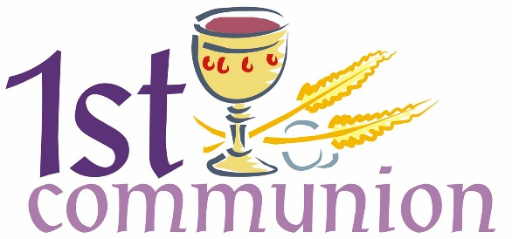

On Easter morning we were honored to welcome the children who completed First Communion instruction to the Lord’s Table for the first time.

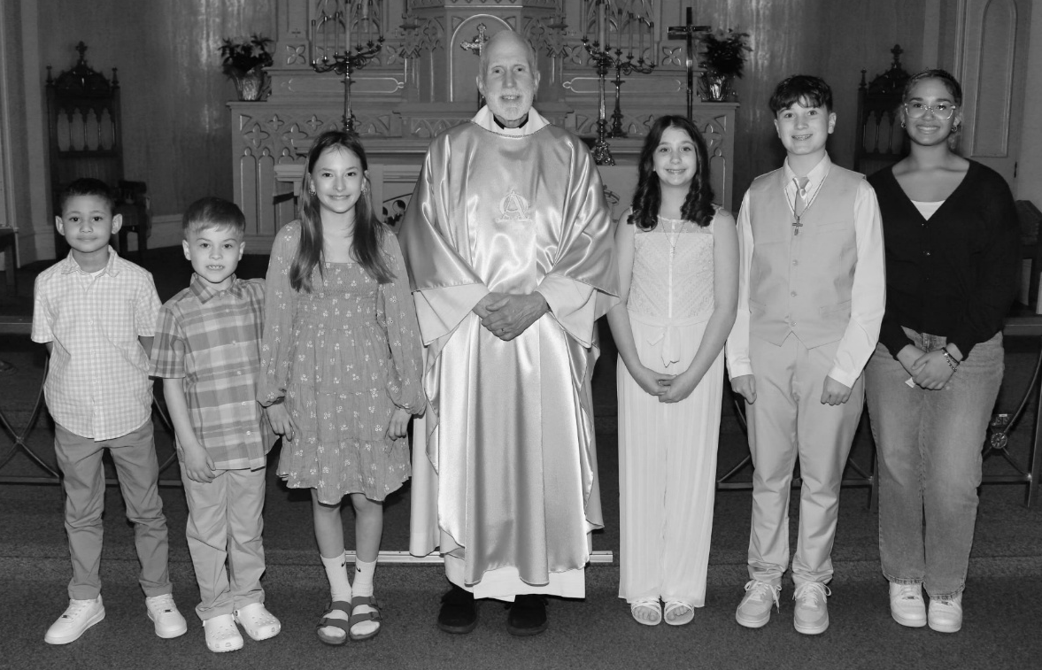
Pictured are (left to right) Camren Brooks, Ben and Molly Robbins, Pastor Reshan, Stella and Carson Riesenberg,and Richer’ea Waltz.



The church office will be closed on Monday, May 26, for the Memorial Day holiday. Regular hours will resume on Tuesday, May 27, at 8:00 a.m.


UPCOMING TRIPS

I will be gone for several days during May connected with our sons’ ending of the school year and summer internships. My son Dan finishes his finals on Thursday, May 8. I will be traveling to Cleveland on Wednesday, May 7, stay overnight, and pick him up and move him back home on the 8th.
As I mentioned in last month’s newsletter, he has been accepted into an internship program in astronomy at the University of Wyoming in Laramie. That program begins on Monday, May 18. Unlike last year with Jacob’s trip to Yakima, WA, I will not be accompanying him. He will be flying out on Saturday the 17th to move into a campus apartment. We will take him to O’Hare that day, so I am arranging for someone to fill in for me in case we run into delays coming back from the airport so I won’t have to worry about being late for worship.
Jacob completes his finals the week of May 27-30. He has to be in Dallas on Monday, June 2, to begin his internship at Texas Instruments. He will be driving there with several classmates who also are interning at the company. As of right now, the plan is for us to drive to Terre Haute on Saturday, May 24, to switch cars with him and let him take our newer family car. This will also give us a chance to see him once more before he leaves for the greater part of the summer. Once again, I will arrange for someone to fill in for me at Saturday worship since we will be gone for most of the day.
If there are any changes to these plans, I will notify the Council and the office. As always, I am reachable by my cell phone at 630-450-1894.


Due to Pastor Pamela’s upcoming Sabbatical, the deadline for the June newsletter will be May 15. The deadline for the July newsletter will return to the 20th of the month (June 20).

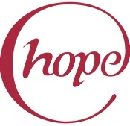

HOPE CIRCLE

Hope Circle at St. Paul Lutheran Church is part of the WELCA (Women of the Evangelical Lutheran Church of America). It meets monthly on the second Monday of each month at 1:00 p.m. at the church. We share and learn using the guidance of the lessons presented in Gather, the magazine published by WELCA.
Annually we have the Sunshine Bag project during the Christmas holiday season. We visit
and honor shut-ins from the congregation with small gifts and treats. We have also shown God’s love by participating in the ELCA Good Gifts program. It was wonderful that our circle could donate money for goats, hens, and roosters for God’s Barnyard.
We would love to have you join us! If you have any questions, please contact Susan Bagby
at (219) 872-7126 or Diane Waltz at (219) 221-7643.

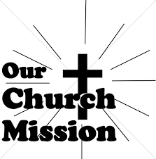

MONTHLY MISSION

Our May Monthly Mission is Camp Sharing Meadows, part of the Share Foundation. Located in LaPorte, Camp Sharing Meadows is an inclusive Christian camp for adults with intellectual and/or developmental disabilities, where a vibrant blend of community, faith, and creative exploration takes center focus. The camp allows individuals with developmental and intellectual disabilities to have fun while learning faith-based values, participating in various activities, and making lifelong friendships. Monetary and check donations can be made out to the church, marked for “Camp Sharing Meadows” in the memo line, and placed in the offering plate. The noisy coin offering will also go to the mission of the month. Thank you for your generosity!

EASTER PLANTS
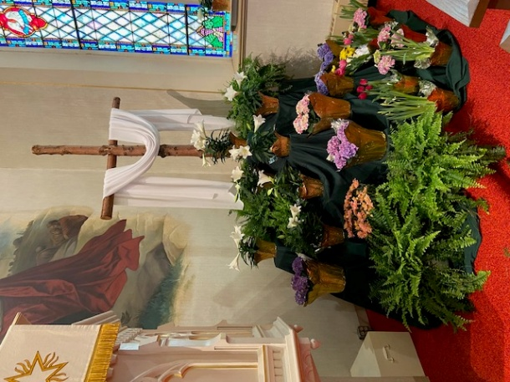
We thank the following for adorning our Easter service with flowers and plants in memory of their loved ones:

In memory of loved ones from Virginia Murray
In memory of loved ones from Bob & Karen Kiser
In memory of my husband, Lee Timm, from Sally Timm
In honor of our family from Tim & Stacie Crozier
In memory of loved ones from Chuck & Sherry Payne
In memory of loved ones from Wayne & Linda Hardesty
In memory of loved ones from Chip & Audrey Claussen
In memory of John Foldenauer from Jason & Carey Howard
In memory of Ronald Johnson from Bev Johnson
In memory of loved ones from David & Nancy Squires
In memory of our father, Ron Johnson, from the Johnson Daughters
In memory of my husband, Roger Milzarek, from Norma Milzarek
In memory of my mother, Audrey Beyer, and my husband, Randy Peters, from Karen Peters
In memory of Fred & Winnie Ziemke and Eleanore & Robert Anderson from Terry & Carole Ziemke
In memory of Elizabeth Haple, Norma and Lawrence Wolgast, Ceann Smith, Villeta Rashka, Teri Rashka, and David Hapke, from Steve & Lauretta Hapke
In memory of our parents, Steve and Erma, and my brother, Allen Kring, from Al & Sue Green
In memory of my husband, George, and Jack and Pearl Latham from Donna Ottersen
In loving memory of our parents, Russell and Ruth Squires, from Janet Bakken and Cindy Poland
In memory of my husband, Henry (Sonny) Robbins, from Sandra Robbins
In loving memory of my husband, Norman Egilske, from Diane Egilske
In loving memory of our father, Henry (Sonny) Robbins, from Mike & Amy Maesch
In memory of my husband, Joseph Koziel, and my parents, Roger and Lucille Storey, from Sue Koziel
In honor of my daughter, Kelly, and my two daughters-in-law, Kristen and Katie, from Sue Koziel
In honor of my brother, Ken Mulder, and my friend, Cheryl, from Judy Mutchler
In loving memory of Otto and Etta Meyer, Allie and Gladys Thomas, Charles Thomas, Sr., Stanley and Gloria Redman, and Josh Jones, from Jana Thomas
In loving memory of my mother, Valerie Waltz, from Richer’ea Garrett
In loving memory of many loved ones from Diane Waltz
In honor of my parents, Jerry and Nancy Stewart, from Melanie Albano
In loving memory of my parents, Joyce and William Manning, from Bethany Manning



IN MEMORY OF MY HUSBAND, ROGER MILZAREK
General Fund from Norma Milzarek

IN MEMORY OF OUR SON, CHAD MILLER
General Fund from Virgil & Patricia Miller

IN MEMORY OF VENIA WENDT
General Fund from Steven & Aleshia Stark

IN MEMORY OF CHARLES PONDER
General Fund from Charles & Sherry Payne, Timothy & Sharon Sanz, Jim Ordziejewski,
Jim & Nancy Stantz, Wayne & Suzann Dolson

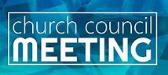

APRIL COUNCIL HIGHLIGHTS

The April Council meeting is scheduled for May 1. Highlights will be included in next month’s newsletter.
As always, full copies of the minutes will be available in the narthex.


May Birthdays May Anniversaries

2 Isabella Robbins 1 Leigh & Beverly Coburn
4 Tim Mellen 2 Charles & Carol Thomas II
Kimberly Payne 5 James & Bernadette Krueger
William Seedorf 6 Chris & Cynthia Scheuchner
5 Rachel Sutor 19 Fred & Judy LaBorn
6 Charles Payne 29 Clay & Kimberly Payne
Brittany Strelesky
7 Marci Petri
8 Mandy Robbins
Abby Haring
9 Lauretta Hapke
11 Audrey Henderson
15 Adaline Gebbink
16 Patricia Miller
17 Melinda Nagle
18 Judy Reshan
20 Donna Collins
21 Hallee Petri
24 Bonnie Ziesmer
25 Marvin Dirks
Pamela Kienitz
Chandler Fisher
26 Emma Robbins
27 Kerry Steinborn
Krysten Fratgillo
30 Sally Timm
31 Audrey Claussen
Pamela Hackett



Long-Term Prayer List

Laura Dovey Russ Fischer Jess Kalvaitis
Christine Kiser Bethany Manning Shirley McCarty
Jan Paholski Grace Romine Danielle Schnell
Martha Schroeder Jeanie Boatman Shepple Joyce Stark
Kathy Stein Mark Tannehill Kathy Thielman
Brian Wiseman

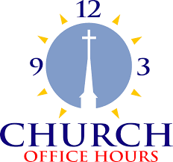

Monday 8:00 a.m. – 5 p.m.
Tuesday 9:00 a.m. – 12:00 noon
Wednesday 8:00 a.m. – 5 p.m.
Thursday 9:00 a.m. – 12 noon
Friday 8:00 a.m. – 12 noon

St. Paul Lutheran Church Staff
Pastor Rev. Mark Reshan
Secretary Libby Pollock
Accompanists Jary Tannehill, Mark Tannehill, Jacob Tannehill
Custodian Mark Kloess

Thank$ for $haring

Last month we raised $150 at the Galveston Give Back. Thanks to all who participated.
This month, we will see you at Swingbelly’s on Wednesday, May 7. Here are two coupons—one for you and one for a friend.

