**THE FOURTEENTH SUNDAY AFTER PENTECOST**

**August 29, 2021**

As our souls prosper, we shall be more and more sensible, not only of the outside, but of the inside. We first battle with the outward man, but as we advance in the divine life, we have nearer views of the chambers of imagery that are in our hearts. And one day after another we shall find more and more abomination there, and consequently we shall see more of the glory of Jesus Christ, the wonders of that Immanuel who daily delivers us from this body of sin and death.

If we grow in the divine life, our heads will grow as well as our hearts, and the Spirit of God leads us out of abominable self, and causes us to flee more and more to that glorious and complete righteousness that Jesus Christ wrought out. The more your souls prosper, the more you will see of the freeness and distinguishing nature of God’s grace, that all is of grace. I mention this, because we ought not to make persons offenders for a word; we should bear with young Christians, and not knock a young child’s brains out because he cannot speak in blank verse.

**George Whitefield**

“…it's not the scribes. Not the Pharisees. Not the law. What Jesus subjects to fiercest criticism in this passage is *the human being*. Joel Marcus notes the concentration of the word *anthrōpos* ("human being" or "person") eleven times in the span of Mark 7:7--23 and says:

"The basic problem Christians should be concerned about, Mark seems to be saying through this striking pileup [of the word *anthrōpos*], is not how or what one should eat but the internal corruption of the *anthrōpos*. It is this malignancy that chokes the life out of tradition, turns it into an enemy of God, contorts it into a way of excusing injustice, and blinds those afflicted by it to their own culpability for the evils that trouble the world…"

“…Jesus' comments propel us to keep *our* evils in the spotlight. Whatever Satan is in Mark's Gospel, it is not the cause of wrongdoing. That job belongs to the human heart. Placing blame on a diabolical entity lurking in the shadows risks diverting attention from our own propensity to rebel and destroy. Truly "evil intentions" dwell, not only within society's notorious figures, but within ourselves and those we love and trust most fervently.

We know enough about the human condition to say that evil is about more than an individual's selfishness or bad decisions. It roams our collective existence, our social, economic, and familial systems. We are at once perpetrators and victims. And our victimization furthers our capacity to perpetrate. "The human heart," or the human will, remains a complex thing. Our kin and culture usually keep us ingrained in patterns of defiling self-destructiveness and idolatry.”

**Matt Skinner**

***✠ In the Name of Jesus✠***

**✠ GATHERING ✠**

**INTRODUCTION**

Jesus protests against human customs being given the weight of divine law, while the essence of God's law is ignored. True uncleanness comes not from external things, but from the intentions of the human heart. Last week Jesus told us "the words that I have spoken to you are spirit and life." Now James says God has given us birth by the word of truth. We, having been washed in the word when we were born in the font, return to it every Sunday to ask God to create in us clean hearts.

**Augustine, Bishop of Hippo, died 430**

*Augustine was one of the greatest theologians of the Western church. A native of North Africa, he recovered from a debauched young adulthood through the influence of his mother, Monica, and Bishop Ambrose of Milan. Besides writing influential theological books, he served as bishop of Hippo, in present-day Algeria.*

**Moses the Black, monk, martyr, died around 400**

*Converted from life as a thief and a robber to Christianity, Moses was an Ethiopian who became a desert monk at Skete. The change in his heart and life had a profound impact on his native country. He was murdered when Berber bandits attacked his monastery.*

**PRE-SERVICE MUSIC Change Me on the Inside Praise Band**

**ANNOUNCEMENTS**

As you are able please rise

**CONFESSION AND ABSOLUTION**

P: In the name of the Father and of ✠the Son and of the Holy Spirit.

C: **Amen.**

P: “So now, Israel, give heed to the statutes and ordinances that I am teaching you to observe, so that you

may live to enter and occupy the land that the LORD ... is giving you.” (Deuteronomy 4:1) Following

God’s ways and commands brings life. Disobedience leads to death. Let us therefore confess before

God and one another our sin, that God may bestow upon us His merciful gift of life.

*Silence for reflection and self-examination is kept*

P: Most merciful God,

C: **We confess that our hearts and lives are sinful and unclean. We have not “observed Your**

**commandments diligently” (Deuteronomy 4:6). We have failed to lead a “blameless life” or**

**always “speak the truth from our heart.” (Psalm 15:2) We have spoken with “guile on our**

**tongue,” and with “contempt for our neighbor.” (15:3) We have not been “quick to listen, slow**

**to speak, and slow to anger.” (James 1:19) We have been “hearers only of the Word” and not**

**“doers” of it. (1:23) We are guilty of “evil intentions” (Mark 7:21) For all our sins, known and**

**unknown, we ask Your forgiveness, O God. Wash us with Your love, O God, and make us clean,**

**that we may “blessed in our doing” of Your perfect law of love.**

P: “Every generous act of giving, with every perfect gift, is from above, coming down from the Father of

lights, with Whom there is no variation of shadow due to change.” (James 1:17) God is always faithful,

and delights in being “generous” with His mercy. This “gift” is for you this Day, for as a called and

ordained minister of the Church of Christ and by His authority, I therefore declare to you the entire

forgiveness of all your sins, in the name of the Father and of ✠the Son and of the Holy Spirit.

C: **Amen.**

**GATHERING SONG 532 *Gather Us In*  page 10**

**THE GREETING AND PRAYER OF THE DAY**

P: The grace of our Lord Jesus Christ, the love of God, and the communion of the Holy Spirit be with

you all.

C: **And also with you.**

P: Let us pray. O God our strength, without You we are weak and wayward creatures. Protect us from

all the dangers that attack us from the outside, and cleanse us from all evil desires that arise from

within ourselves, that we may be preserved through Your Son, Jesus Christ, our Savior and Lord.

C: **Amen.**

*The assembly is seated*

**✠ WORD ✠**

**FIRST READING Deuteronomy 4:1-2, 6-9**

The Israelites believed the law was a divine gift that provided guidelines for living out the covenant. Moses commands the people to obey the law and neither to add to nor subtract from it. The Israelites are also to teach the law to their children and their children’s children.

So now, Israel, give heed to the statutes and ordinances that I am teaching you to observe, so that you may live to enter and occupy the land that the LORD, the God of your ancestors, is giving you. 2You must neither add anything to what I command you nor take away anything from it, but keep the commandments of the LORD your God with which I am charging you.

6You must observe them diligently, for this will show your wisdom and discernment to the peoples, who, when they hear all these statutes, will say, "Surely this great nation is a wise and discerning people!" 7For what other great nation has a god so near to it as the LORD our God is whenever we call to Him? 8And what other great nation has statutes and ordinances as just as this entire law that I am setting before you today?

9But take care and watch yourselves closely, so as neither to forget the things that your eyes have seen nor to let them slip from your mind all the days of your life; make them known to your children and your children's children.

The Word of the Lord.

**Thanks be to God.**

**THE PSALM: Psalm 15** ***Read responsively***

1LORD, who may dwell in Your tabernacle?

     Who may abide upon Your holy hill?

**2Those who lead a blameless life and do what is right,**

**who speak the truth from their heart;**

3they do not slander with the tongue, they do no evil to their friends;

     they do not cast discredit upon a neighbor.

**4In their sight the wicked are rejected,**

**but they honor those who fear the LORD.**

**They have sworn upon their health**

**and do not take back their word.**

5They do not give their money in hope of gain,

nor do they take bribes against the innocent.

     Those who do these things shall never be overthrown.

**SECOND READING James 1:17-27**

The letter of James was intended to provide first-century Christians with instruction in godly behavior. Here, Christians are encouraged to listen carefully and to act on what they hear, especially by caring for those least able to care for themselves.

Every generous act of giving, with every perfect gift, is from above, coming down from the Father of lights, with Whom there is no variation or shadow due to change. 18In fulfillment of His own purpose He gave us birth by the word of truth, so that we would become a kind of first fruits of His creatures.

19You must understand this, my beloved: let everyone be quick to listen, slow to speak, slow to anger; 20for your anger does not produce God's righteousness. 21Therefore rid yourselves of all sordidness and rank growth of wickedness, and welcome with meekness the implanted word that has the power to save your souls.

22But be doers of the word, and not merely hearers who deceive themselves. 23For if any are hearers of the word and not doers, they are like those who look at themselves in a mirror; 24for they look at themselves and, on going away, immediately forget what they were like. 25But those who look into the perfect law, the law of liberty, and persevere, being not hearers who forget but doers who act--they will be blessed in their doing.

26If any think they are religious, and do not bridle their tongues but deceive their hearts, their religion is worthless. 27Religion that is pure and undefiled before God, the Father, is this: to care for orphans and widows in their distress, and to keep oneself unstained by the world.

The Word of the Lord.

**Thanks be to God.**

*The assembly is seated*

**THE VERSE (Sung twice)**

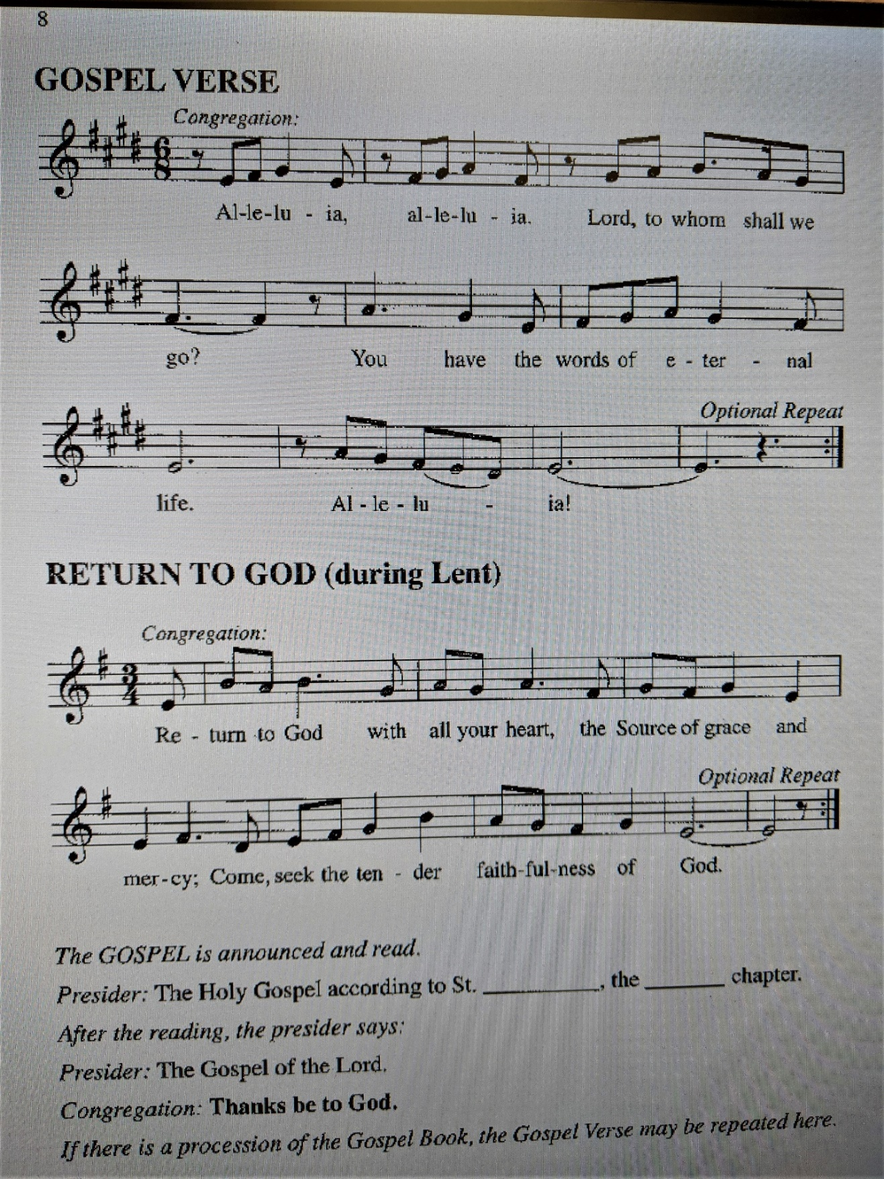

**THE HOLY GOSPEL Mark 7:1-8, 14-15, 21-23**

Mark’s gospel depicts Jesus as challenging traditional ways in which religious people determine what is pure or impure. For Jesus, the observance of religious practices cannot become a substitute for godly words or deeds that spring from a faithful heart.

P: The Holy Gospel according to St. Mark, the seventh chapter.

C: **Glory to You, O Lord!**

Now when the Pharisees and some of the scribes who had come from Jerusalem gathered around Jesus, 2they noticed that some of His disciples were eating with defiled hands, that is, without washing them. 3(For the Pharisees, and all the Judeans, do not eat unless they thoroughly wash their hands, thus observing the tradition of the elders; 4and they do not eat anything from the market unless they wash it; and there are also many other traditions that they observe, the washing of cups, pots, and bronze kettles.) 5So the Pharisees and the scribes asked Him, "Why do Your disciples not live according to the tradition of the elders, but eat with defiled hands?" 6He said to them, "Isaiah prophesied rightly about you hypocrites, as it is written,

'This people honors me with their lips,

but their hearts are far from me;

7in vain do they worship me,

teaching human precepts as doctrines.'

8You abandon the commandment of God and hold to human tradition."

14Then He called the crowd again and said to them, "Listen to Me, all of you, and understand: 15there is nothing outside a person that by going in can defile, but the things that come out are what defile."

21For it is from within, from the human heart, that evil intentions come: fornication, theft, murder, 22adultery, avarice, wickedness, deceit, licentiousness, envy, slander, pride, folly. 23All these evil things come from within, and they defile a person."

P: The Gospel of the Lord.

C: **Praise to You, O Christ!**

*The assembly is seated*

**THE SERMON**

*Silence for reflection follows the sermon*

*As you are please rise*

**HYMN OF THE DAY NSB 72 *Refiner’s Fire*  pages 11-12**

**THE APOSTLES’ CREED**

A: God has made us His people through our Baptism into Christ. Living together in trust and

hope, we confess our faith.

C: **I believe in God, the Father almighty,**

**creator of heaven and earth.**

**I believe in Jesus Christ, His only Son, our Lord.**

**He was conceived by the power of the Holy Spirit**

**and born of the virgin Mary.**

**He suffered under Pontius Pilate**

**was crucified, died, and was buried.**

**He descended into hell.**

**On the third day He rose again.**

**He ascended into heaven,**

**and is seated at the right hand of the Father.**

**He will come again to judge the living and the dead.**

**I believe in the Holy Spirit,**

**the holy catholic Church,**

**the communion of saints,**

**the forgiveness of sins,**

**the resurrection of the body,**

**and the life everlasting. Amen.**

**THE PRAYER OF THE CHURCH**

A: As we await the full harvest of the Spirit, let us offer our prayers to God Who is abundant in every

good gift.

A: That the Church’s structures may promote justice, its laws foster integrity of heart, and its ministry

model compassion, we pray: hear us, O God,

C: **For Your mercy is great.**

A: That political tensions between Greece and Turkey, Belarus and Lithuania; violence and other causes

of chaos, terrorism, and turmoil might be overcome by God’s gift of peace, we pray: hear us, O God,

C: **For Your mercy is great.**

A: That Afghan immigrants might find relief, safety, and welcome as they seek new homes, we pray:

hear us, O God,

C: **For Your mercy is great.**

A: That victims in Haiti of the earthquake and the tropical storm might find relief, abundant assistance,

and hope, we pray: hear us, O God:

C: **For Your mercy is great.**

A: That we in this assembly in this week may be faithful to God’s commands and fruitful in Christ’s own

compassion and mercy, we pray: hear us, O God,

C: **For Your mercy is great.**

A: That the hungry, the unemployed, the homeless, the forgotten, and the sick, especially...may know

God’s generous healing, we pray: hear us, O God,

C: **For Your mercy is great.**

A: That with all the faithful who have gone before us, especially **Augustine, Bishop of Hippo; and**

**Moses the Black, monk, martyr**, whom we commemorate this Day, we might be supported by their

witness until we join them in God’s everlasting Reign, we pray: hear us, O God,

C: **For Your mercy is great.**

P: Teach us to pray, O God, and grant us wisdom in our asking, in the name of Jesus Christ our Lord.

C: **Amen.**

**✠ MEAL✠**

**THE PEACE**

P: The peace of the Lord be with you always.

C: **And also with you.**

*The assembly is seated*

**THE VOLUNTARY *The Heart of Worship*  Praise band**

*As you are able please rise*

**THE OFFERTORY PRAYER**

A: Let us pray. Merciful God,

C: **By Your generous act of giving You bestow upon us every perfect gift for life. In love and**

**thanksgiving we bring You these first fruits of our time, talents, and possessions. Receive them**

**for the sake of Jesus Christ. Grant us grace through this Meal, that Your love may be made**

**perfect in us. We ask this in the name of Jesus the Lord. Amen.**

**THE GREAT THANKSGIVING**

P: The Lord be with you.

C: **And also with you.**

P: Lift up your hearts.

C: **We lift them to the Lord.**

P: Let us give thanks to the Lord our God.

C: **It is right to give Him thanks and praise.**

P: We gladly and joyfully thank and praise You, our Lord and God,

For You created all things from the overflowing of Your goodness and made us Your

beloved in Your covenant of grace.

Out of the long winter of our estrangement You called us to arise and come away with

You, because the springtime of our salvation was at hand.

In fulfillment of Your own purpose You gave us birth by Your Word of truth, so that

we would become the firstfruits of His creatures.

In Your Son Jesus You set us as a seal upon Your heart, and in His cross and resur-

rection You showed that Your love is stronger than death.

Transforming God, You long for us to become holy like You.

Through this gathering of reconciliation and Word of truth and embodiment of peace

You will feed us with Bread for the journey.

In the power of Your Holy Spirit make all who participate in this blessed Meal doers

of Your Word and not hearers only.

By Your same Spirit, bless this food and drink that they may be for us the Body and

Blood of Your Son, Jesus Christ,

Who, in the night ... “Do this for the remembrance of Me.”

As often as we eat this bread ... we proclaim the Lord’s death until He comes.

C: **Christ has died. Christ is risen. Christ will come again.**

P: Gentle God, You call us to be quick to listen and slow to speak.

Embolden all who have no one to listen to them, that in their distress or dismay or

disease they may meet friends, receive justice, and find You.

Give wisdom to any who have something to say, that they may speak Your words,

live Your hope,. and draw others to Your truth.

Bless those who struggle with anger, that their frustration may turn to good work,

and their sense of deep wrong yield a pursuit of righteousness.

Hasten the Day when there will be no more grief or sorrow, but You are all in all,

ever one God, Father, ✠ Son, and Holy Spirit.

C: **Amen!**

**THE LORD’S PRAYER**

P: Let us now pray for our true daily Bread in the words Jesus taught us:

C: **Our Father, Who art in heaven, hallowed be Thy Name.**

**Thy Kingdom come, Thy will be done on earth as it is in heaven.**

**Give us this day our daily bread, and forgive us our trespasses as we forgive those**

**Who trespass against us.**

**And lead us not into temptation, but deliver us from evil.**

**For Thine is the Kingdom, and the power, and the glory, forever and ever. Amen.**

**INVITATION TO THE MEAL**

P: Jesus said, “I am the Bread of Life. If you come to Me, you shall never hunger, and if you believe in

Me, you will never thirst.” God’s holy gifts for God’s holy people. Come, for all is now ready.

*The assembly is seated*

**LAMB OF GOD page 13**

**THE DISTRIBUTION**

**HYMNS DURING DISTRIBUTION 733 *Great is Thy Faithfulness* page 14**

**779 *Amazing Grace* page 15**

**NSB 54 *I Love You, Lord*  page 16**

*As you are able please rise*

**THE POST-COMMUNION BLESSING**

P: The Body and Blood of our Lord Jesus Christ strengthen you and keep you in His grace.

C: **Amen.**

**THE POST-COMMUNION PRAYER**

A: Let us pray. Almighty God, You renew us at Your Table with the Bread of life. Through this holy

Sacrament implant Your Word deep into our hearts and lives, that we may be strengthened in Your

love, and serve You in each other. Grant this through Christ our Lord.

C: **Amen.**

**✠ SENDING ✠**

**THE BENEDICTION**

P: Almighty God: Father, Son, ✠ and Holy Spirit bless you now and forever.

C: **Amen.**

**THE SENDING SONG 674 *Let Us Talents and Tongues Employ*  page 17**

**THE DISMISSAL**

A: Go in peace to bear Christ’s love to the world.

C**: Thanks be to God!**

***✠ To God Alone Be Glory✠***

The Meditations are from *Sundays and Seasons*. Copyright Augsburg Fortress, 1996; and *Working*

*Preacher.* Copyright Luther Seminary, 2021.

The Prayer of the Church is adapted from *Intercessions for the Christian People.* Gail Ramshaw,

ed. (New York: Pueblo Publishing Company, 1988) 125.

The musical setting of the liturgy, “Now the Feast and Celebration” by Marty Haugen, is used by

permission of GIA Publishers, Inc. OneLicense.net License #A-702836.

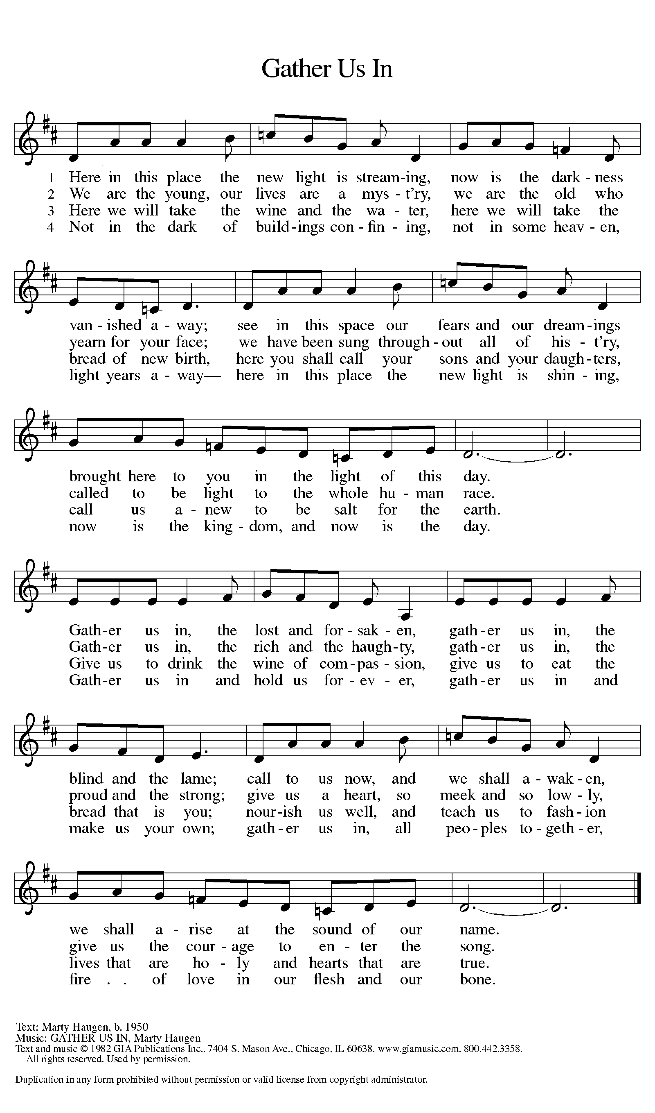

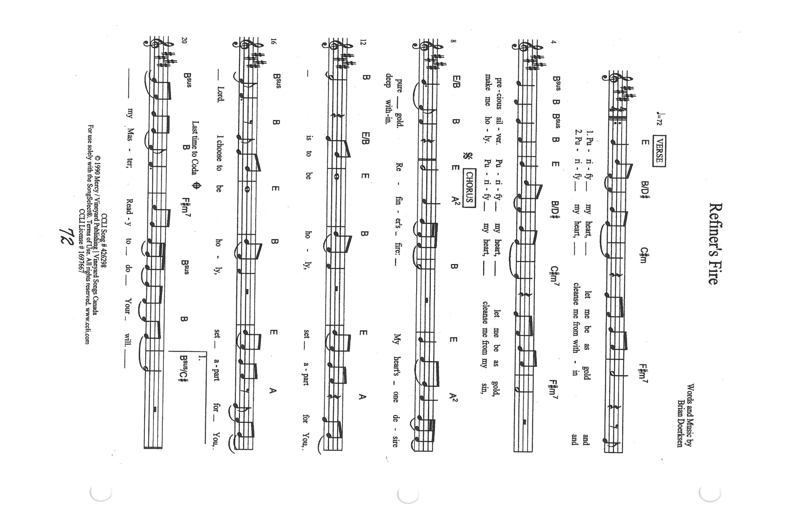

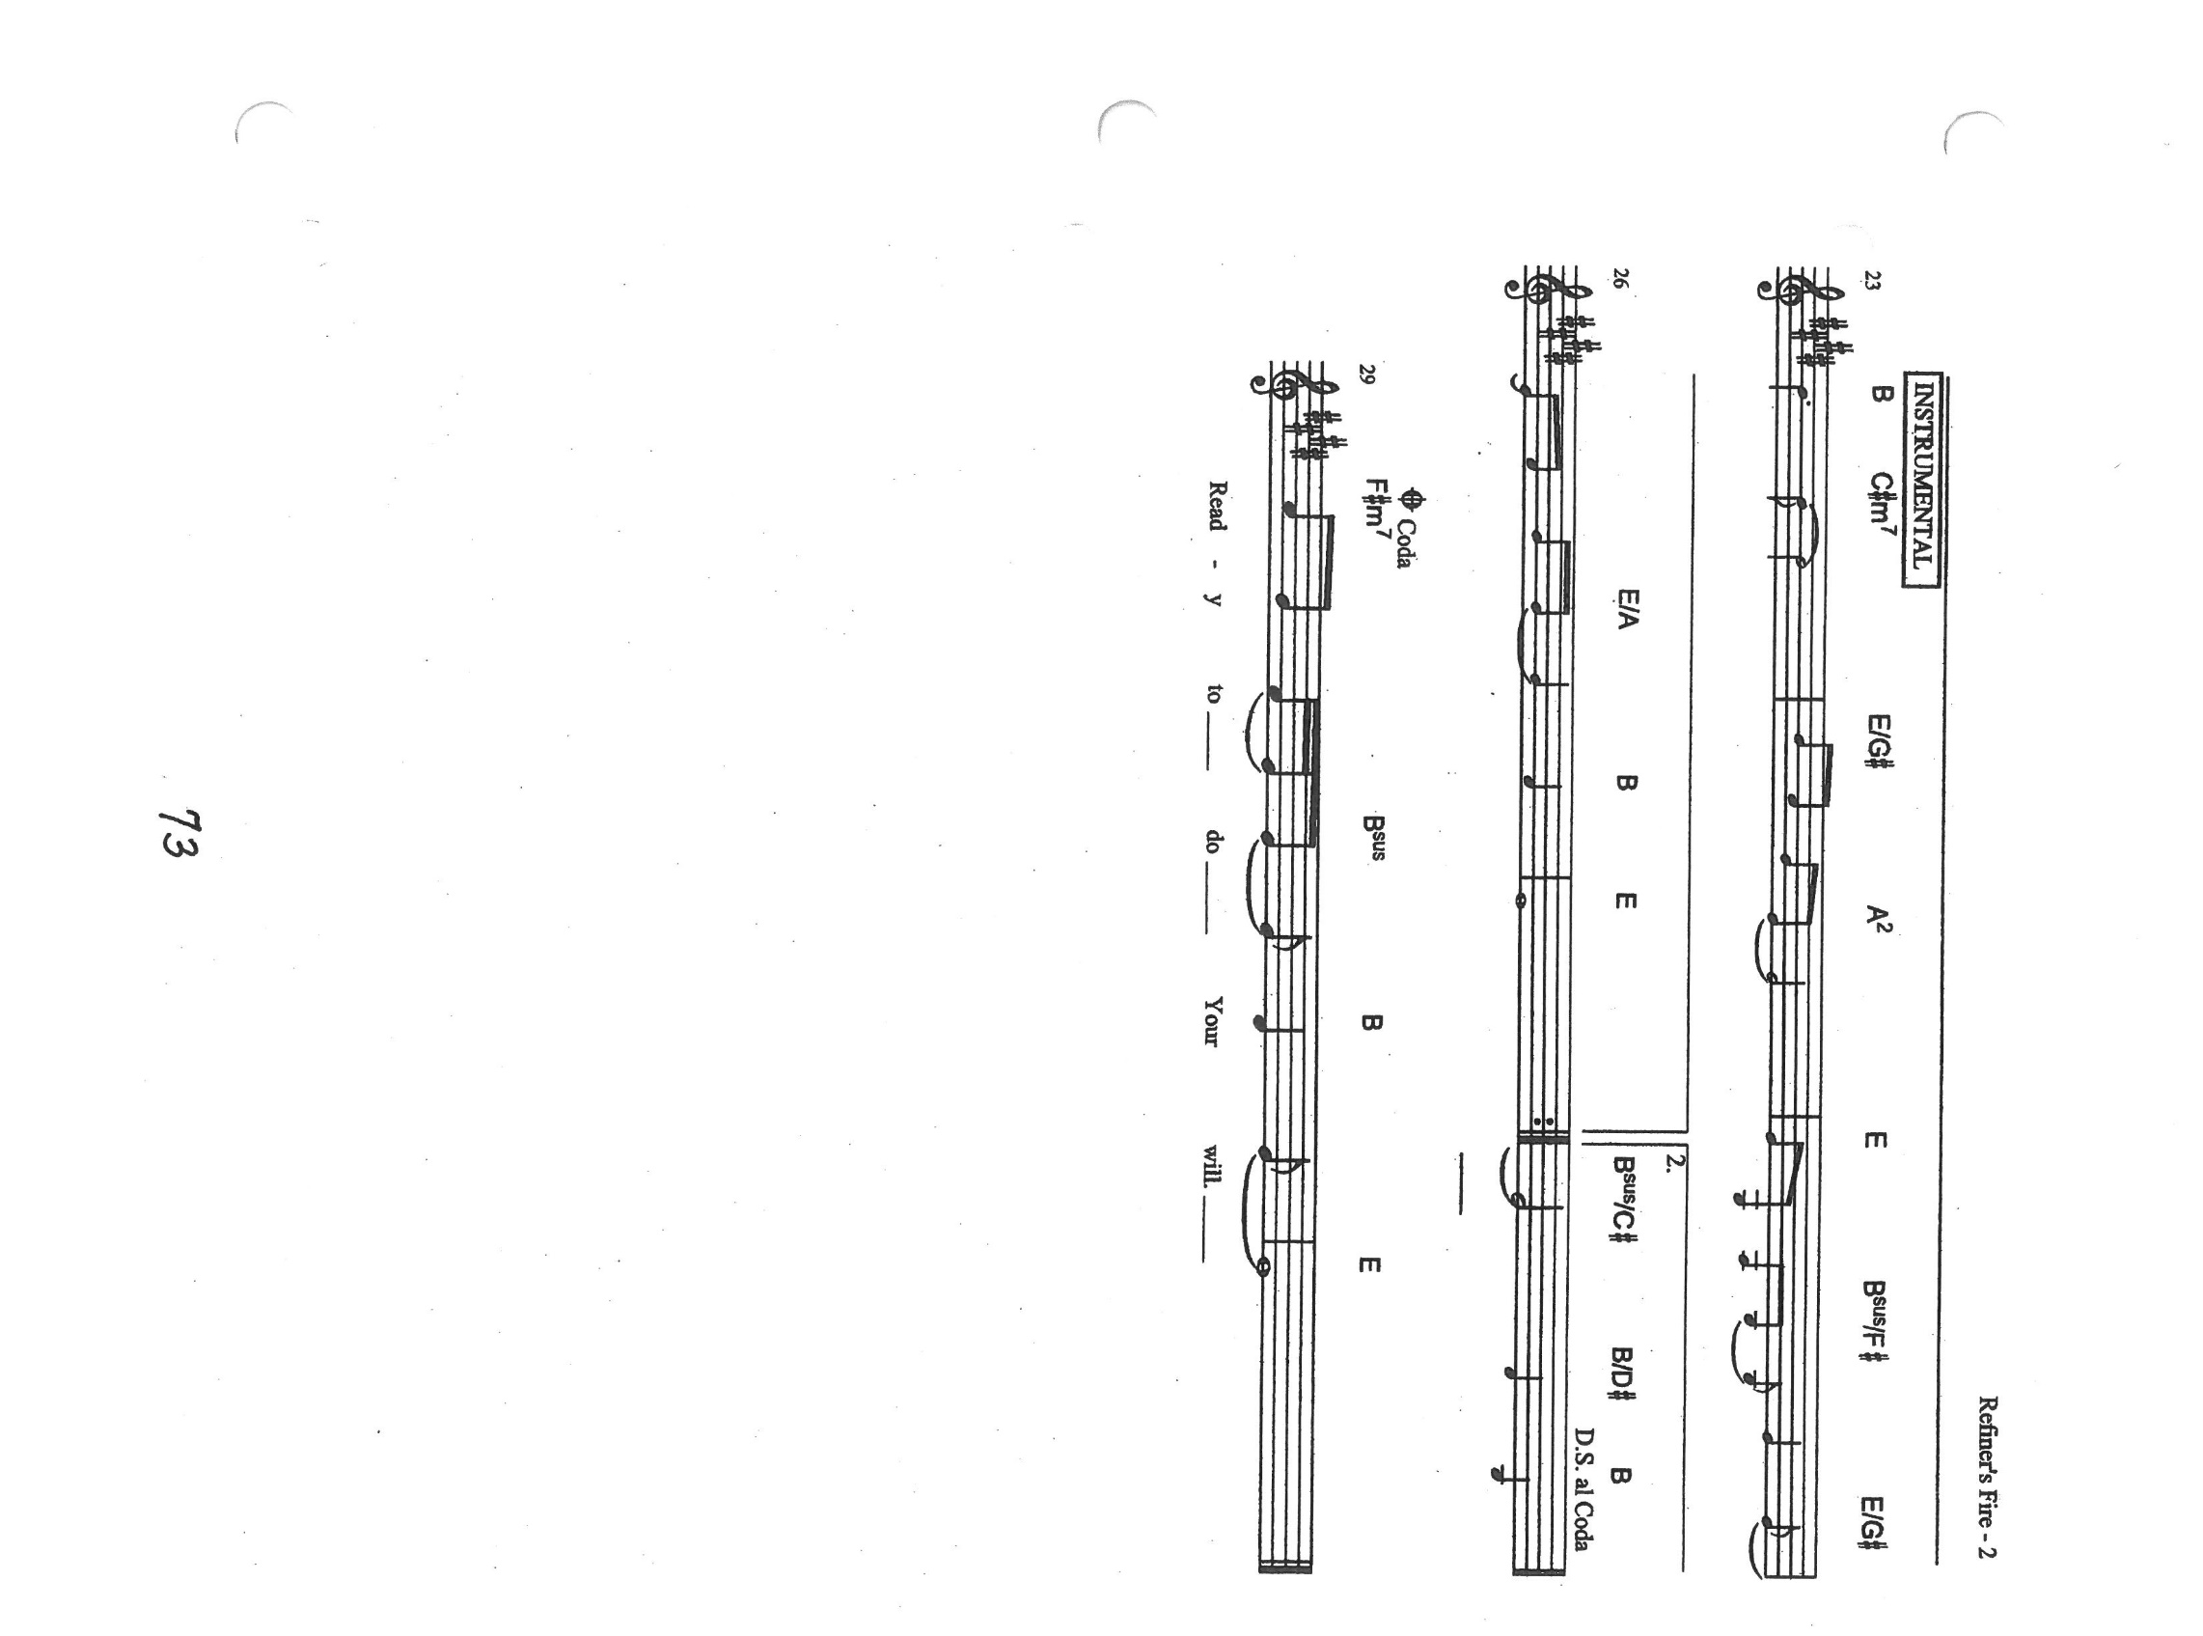

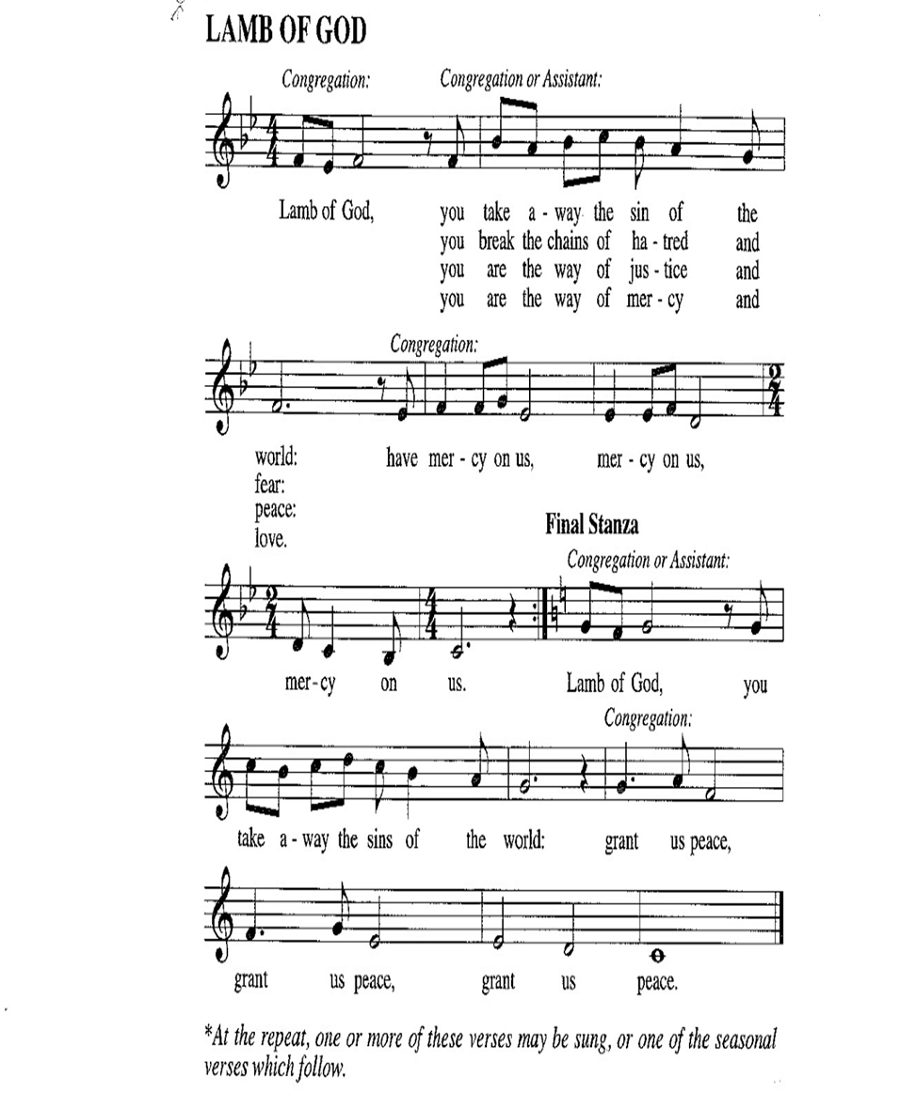

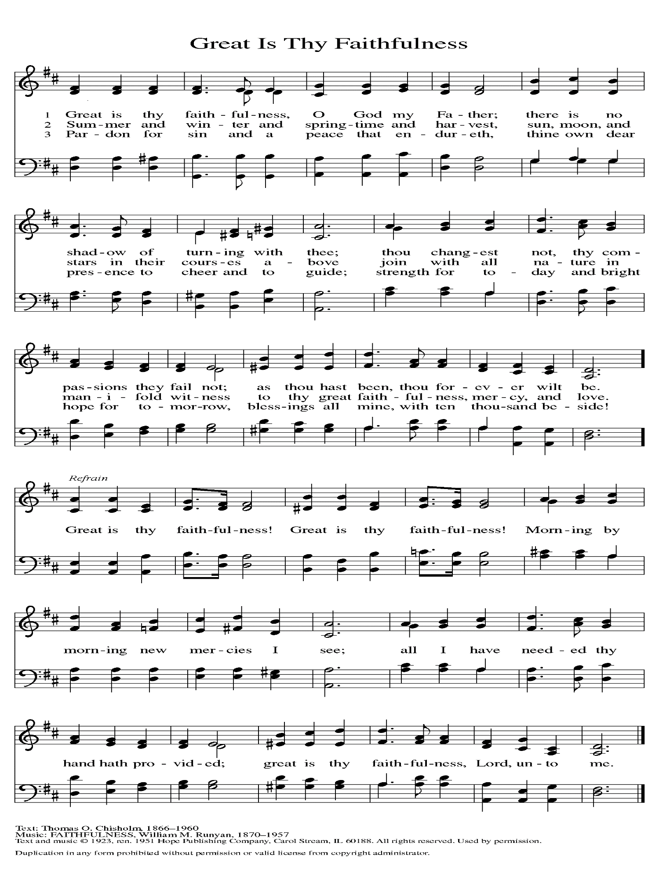

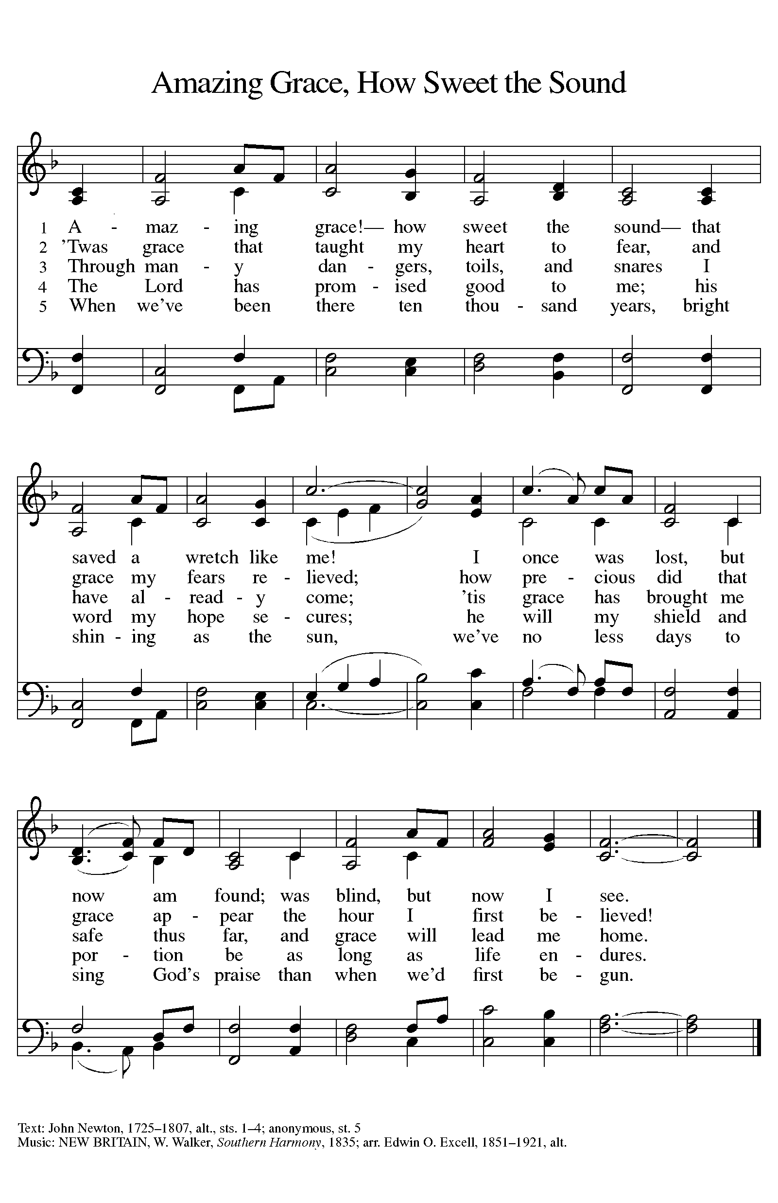

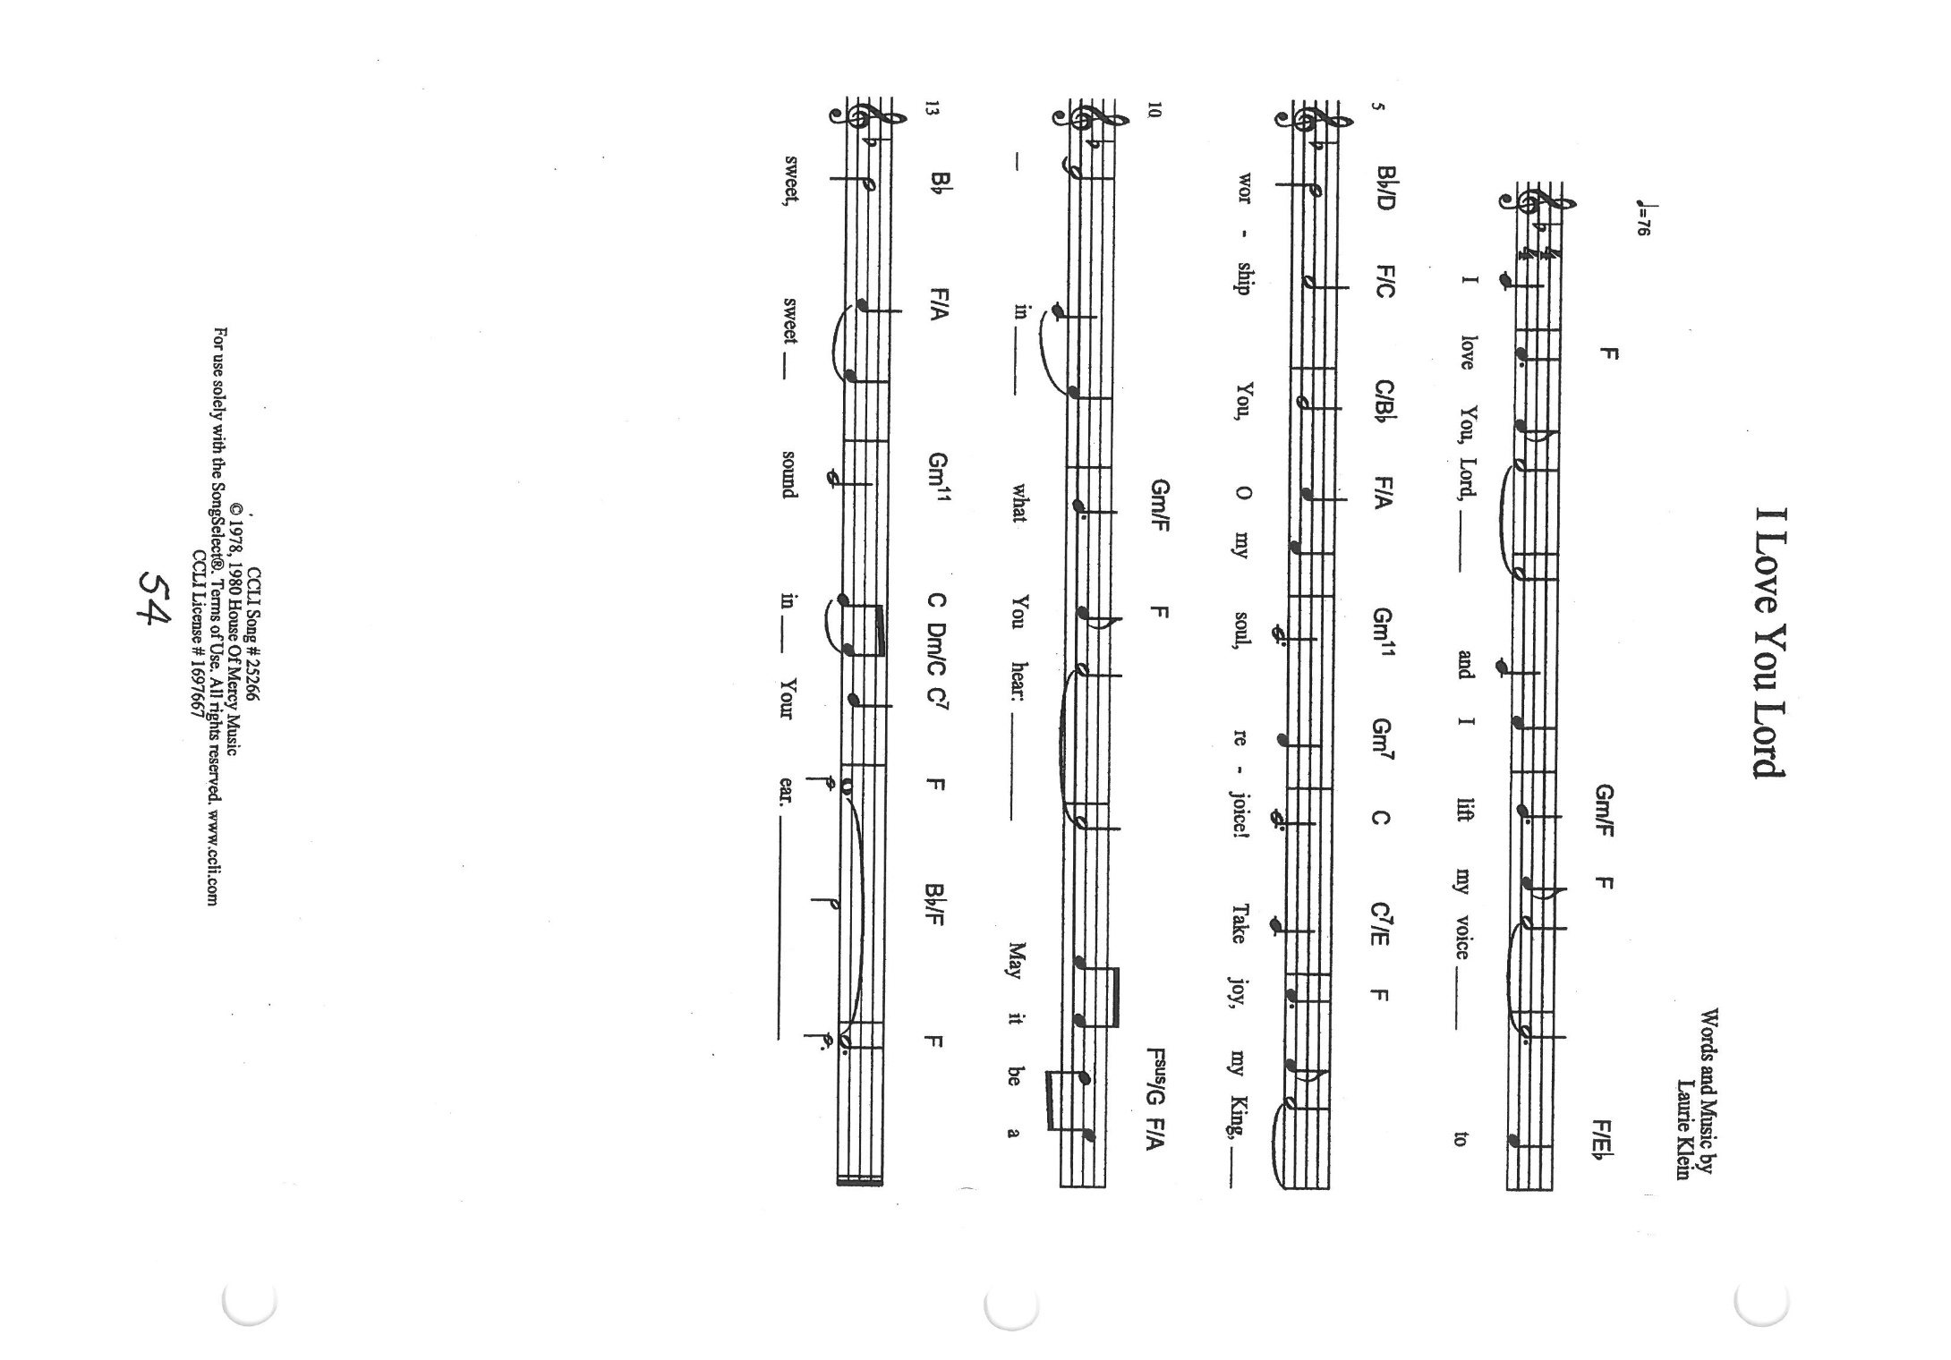

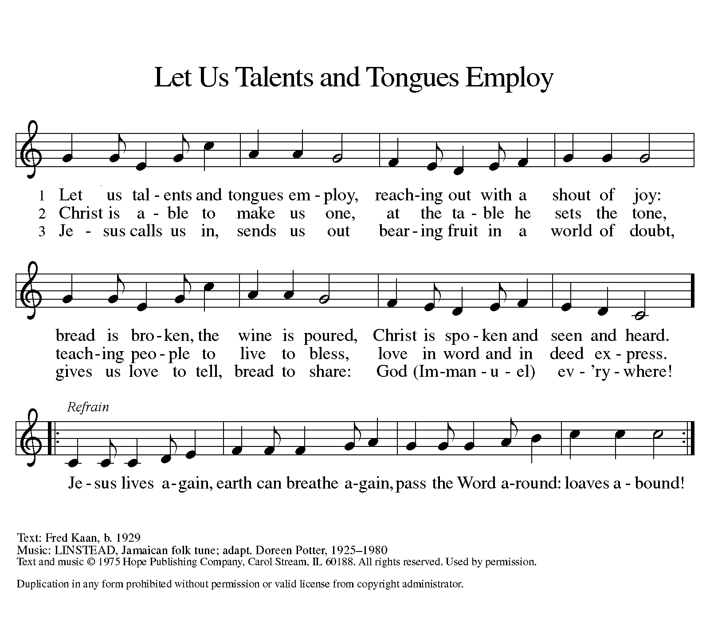

**ANNOUNCEMENTS**

**Please remember to mail your offering to the Church Office** at 818 Franklin Street, Michigan City, IN 46360**.** Another alternative is to give on-line through Tithe.ly. Please see your closure letter for information on how to set up a Tithe.ly account.

**St. Paul Members are reminded to have** a loved one contact the office if you are hospitalized. Many times, the Pastor doesn’t know someone is in the hospital. If you call and leave a message, please tell us which hospital the patient is at.

**Next Sunday’s lessons are Isaiah 35: 4-7a; Psalm146; James 2: 1-10, [11-13] 14-17; Mark 7: 24-37** for those of you who like to study them in advance.

**PRAYER CONCERNS:** Kathy Thielman, Audrey Beyer, George Ottersen, Charles Thomas Sr, Joyce and Bethany Manning, Marla Furness, Christine Kiser, Delores Hackett, Kay Peglow, Lee Timm, Ryan Krueger, Donna Bostater, Diane Gielow, Jeff Jensen, Maxine Powell, Jess Kalvaitis, Pastor Al Lorentzen, Jan Paholski, Laura Dovey, Heidi Happel, Grant Houk, Shane Nevels, Elaine Gehring, Irene Bohnstadt, Joan Coughlin, Jim Tomscheck, Wally & Betty Ratliff, Laura Moore, Cameron Rackard, Erik Tannehill, Ruth Lubs, Ed Gustum and Ken Mulder.

**If you requested someone’s name to be on the prayer list and are aware that they need continued imminent prayer then contact the church office and let us know.** Otherwise we will gradually transfer names to the long-term list.

**OFFICE HOURS:** Libby will be in the office on Mondays, Wednesdays, and Fridays; volunteers will cover Tuesdays and Thursdays.

Monday & Wednesday 8:00 a.m. – 5 p.m.

Tuesday & Thursday 9:00 a.m. – 12:00 p.m.

Friday 8:00 a.m. – 12:00 p.m.

**If you are listening to the worship broadcast on the radio and would like to watch it live stream but you aren’t on Facebook,** follow these four steps:

1) Go to your search engine (Google, Bing, etc.).

2) Search for St. Paul Lutheran Church & School, Michigan City, Indiana

3) Click on the option for St. Paul Lutheran Church & School—Home/Facebook

4) Click on “Videos” in the menu on the left side of the screen.

That should take you to the former videos and there should be one with a little red box that says “LIVE.’ Click on that video to enlarge it.

We will continue to live stream/broadcast the Sunday morning service on our Facebook page, and it will always be available on the radio broadcast Sunday mornings at 11:00 a.m. on WEFM (95.9), and on the local cable access station #99 for the previous week’s service on Sundays at 4:00 p.m. and the current service on Wednesdays at 7:00 p.m. and Fridays at 8:30 p.m.

**To send e-mail to the church office**, please use the following addresses:

 Pastor Mark Reshan: [seniorpastor@stpaulmichigancity.com](mailto:seniorpastor@stpaulmichigancity.com)

 Church Office Secretary (Libby Pollock): [churchsecretary@stpaulmichigancity.com](mailto:churchsecretary@stpaulmichigancity.com)

 Church Treasurer (Karen Fleming) and Bookkeeper (Billie Atchinson):

[finance@stpaulmichigancity.com](mailto:finance@stpaulmichigancity.com).

**The Good News Newsletter**: If you have an article or anything you want included in **The Good News** please send it to the following e-mail address: splcgoodnews@gmail.com. Pastor Pamela Thiede will be using this e-mail address to assemble **The Good News** each month. The deadline for getting information to Pastor Pamela will be the 20th of each month.

**WORSHIP ATTENDANCE for August 21-22, 2021**

**4:00 p.m. 29**

**9:00 a.m. 52**

**Total = 81**

**LAPORTE COUNTY MEALS ON WHEELS needs YOU!** A commitment of **ONE** hour per week can make a difference. Monday through Friday meal delivery is totally dependent on volunteers. Volunteers are needed in Michigan City, LaPorte, Westville, and South County routes NOW. Call 219-872-9117 in Michigan City or 219-369-6483 in LaPorte; or visit www.laportecountymealsonwheels.org or find them on Facebook at LaPorte Co Meals on Wheels.

**IMMEDIATE NEEDS**  **Mondays** **Wednesdays**

Substitute Drivers needed MC route 10 LaPorte/Rolling Prairie route

in MC & LP locations LaPorte Route 4

**Thursdays**

LaPorte Route 2

**2021 Financial Stewardship**

Weekly Church Operating Needs (x 2 weeks): $14,116.36

August 14-15, and August 21-22, 2021

General Fund (including General Memorials): $ 9,032.00

Overage/Shortage: --$ 5,084.36

Restricted Income (not including Memorials)

Supports IK Synod & Churchwide Ministries: $265.00

Ministries in our Community/Congregation: $ 10.00

Capital Fund: $410.00

General Fund $ 20.00

**Crusader Fund $1,735.00**

**September Events and Meetings:**

God’s Purls: Wednesday September 1, 2021 from 10:00am – Noon in the St. Paul Room

Worship Service: Saturday September 4, 2021 at 4:00pm

Worship Service: Sunday September 5, 2021 at 9:00am

Altar Guild: Tuesday September 7, 2021 at 10:00am in the St. Paul Room

September Give Back: Wednesday September 8, 2021 at Hacienda in Michigan City

Worship & Music: Wednesday September 8, 2021 at 6:00pm in the St. Paul Room

Choir Practice: Wednesday September 8, 2021 at 7:00 pm

Worship Service: Saturday September 11, 2021 at 4:00pm

Worship Service: Sunday September 12, 2021 at 9:00am

School Board: Monday September 13, 2021 at 3:30pm in the St. Paul Room

Worship Service: Saturday September 18, 2021 at 4:00pm

Worship Service: Sunday September 19, 2021 at 9:00am

Finance Committee: Monday September 20, 2021 at 4:00pm in the St. Paul Room

Choir Practice: Wednesday September 22, 2021 at 7:00pm

Church Council: Thursday September 23, 2021 at 5:30pm in the St. Paul Room

Worship Service: Saturday September 25, 2021 at 4:00pm

Worship Service: Sunday September 26, 2021 at 9:00am

**Our next Give Back is at Hacienda** in Michigan City on Wednesday September 8, 2021 from open until close of that day. Here are some coupons to start you off. And as always there will be extra coupons in the office until the day of event.

