THE FIRST SUNDAY IN LENT
February 22, 2026

Whether we gaze with longing into the garden or with fear and trembling into the desert, of this we can be sure--God walked there first! And when we who have sinned and despoiled the garden are challenged now to face the desert, we do not face it alone; Jesus has gone there before us to struggle with every demon that has ever plagued a human heart. Face the desert we must if we would reach the garden, but Jesus has gone there before us.

James Healy

The Lord formed these words in my soul: “Therewith is the fiend overcome.” When he said these words, our Lord was referring to his blessed passion. On account of this, I laughed loud and long, which made those who were around me laugh too, and their laughter was a pleasure to me. I understood that we may laugh, comforting ourselves and rejoicing in God that the devil has been overcome.

Julian of Norwich

We have come to the beginning of our Lenten spring, the season to prepare the holy Passover that will bring our catechumens to the saving waters of rebirth, the Passover that will be, for those of us already initiated, a pilgrimage of conversion. Along the way we will be challenged to recognize Christ in the scriptures we read, in those we love and serve, and in those whom we so often neglect to love and serve—for surely Christ is most specially present in them.

Therefore, let us begin the journey!

Our procession is in the spirit of the pilgrimage of the Israelites, our forebears in the faith. We call upon the saints, our holy ancestors, who remind us that we do not journey alone. Let us move forward in joy, keeping our eyes fixed on the goal of our Lenten journey, which is Jerusalem, the holy city of God.

The Penitential Procession for the First Saturday/Sunday in Lent

In the Name of Jesus

INTRODUCTION

Today's gospel tells of Jesus' temptation in the desert. His forty-day fast becomes the basis of our Lenten pilgrimage. In the early church Lent was a time of intense preparation for those to be baptized at the Easter Vigil. This catechetical focus on the meaning of faith is at the heart of our Lenten journey to the baptismal waters of Easter. Hungry for God's mercy, we receive the bread of life to nourish us for the days ahead.

Polycarp, Bishop of Smyrna, martyr, died 156

Because he is said to have been known by John, the author of Revelation, as well as the important early church fathers Irenaeus and Ignatius, Polycarp serves as a vital link in church history. He was burned at the stake at age 86 for refusing to renounce his faith.
GATHERING

PRE-SERVICE MUSIC Eagle’s Wings New Song Praise Band
(Reuben Morgan)

ANNOUNCEMENTS

As you are able please rise

THE INVITATION TO THE PROCESSION

P: In the name of the Father, and of the Son, and of the Holy Spirit.

C: Amen.

P: The grace, mercy, and peace of God be with you all.

C: And also with you.

P: Lent is the church's journey to Easter and the saving waters of rebirth. With the church
throughout the world, we journey with catechumens who are preparing for baptism at
the Easter Vigil. For those of us already baptized, we continue our baptismal journey
of conversion, daily dying to sin that we might walk in newness of life.

Our procession today is in the spirit of the Israelites, as they journeyed through the
wilderness to the promised land. As we begin our Lenten pilgrimage, we join with the
universal church, supported by the saints of all times and places. We journey from
slavery to freedom, from darkness to light, from death to life. Let us go forth in joy, for
the goal of our journey is the new life of the resurrection, which will renew the world,
the church, and our lives.

THE GREAT LITANY 238

The congregation turns toward the cross as it processes around the nave

THE GREETING

P: The grace of our Lord Jesus Christ, the love of God, and the communion of the Holy
Spirit be with you all.

C: And also with you.

THE KYRIE

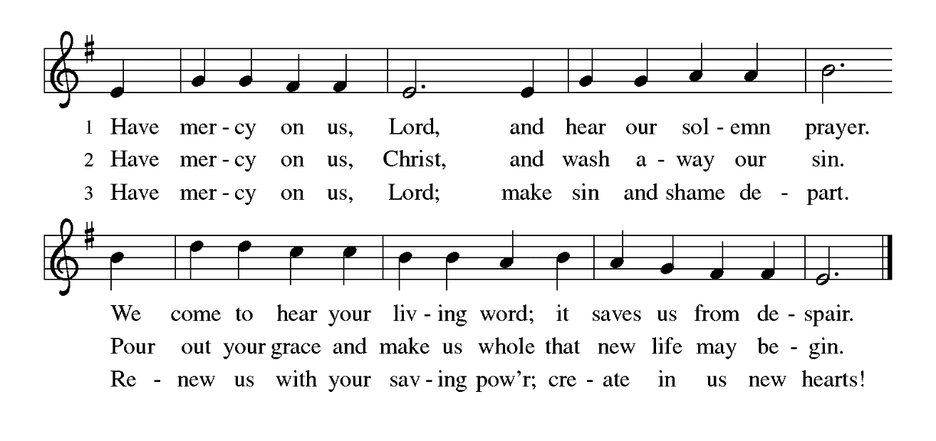
THE PRAYER OF THE DAY

P: The Lord be with you.

C: And also with you.

P: Let us pray. Lord God, our strength, the struggle between good and evil rages within
and around us, and the devil and all the forces that defy You tempt us with empty
promises. Keep us steadfast in Your word, and when we fall, raise us again
and restore us through Your Son, Jesus Christ, our Savior and Lord,
Who lives and reigns with You and the Holy Spirit, one God, now and forever.

C: Amen.

The assembly is seated

WORD

FIRST READING Genesis 2: 15-17; 3: 1-7

Human beings were formed with great care, to be in relationship with the Creator, creation, and one another. This passage recounts the first in a series of stories that depict the nature of human sin--wanting to be like God.

The LORD God took the man and put him in the garden of Eden to till it and keep it. ¹⁶And the LORD God commanded the man, "You may freely eat of every tree of the garden; ¹⁷but of the tree of the knowledge of good and evil you shall not eat, for in the day that you eat of it you shall die."
^{3:1}Now the serpent was more crafty than any other wild animal that the LORD God had made. He said to the woman, "Did God say, 'You shall not eat from any tree in the garden'?" ²The woman said to the serpent, "We may eat of the fruit of the trees in the garden; ³but God said, 'You shall not eat of the fruit of the tree that is in the middle of the garden, nor shall you touch it, or you shall die.' "
⁴But the serpent said to the woman, "You will not die; ⁵for God knows that when you eat of it your eyes will be opened, and you will be like God, knowing good and evil." ⁶So when the woman saw that the tree was good for food, and that it was a delight to the eyes, and that the tree was to be desired to make one wise, she took of its fruit and ate; and she also gave some to her husband, who was with her, and he ate.
⁷Then the eyes of both were opened, and they knew that they were naked; and they sewed fig leaves together and made loincloths for themselves.

The Word of the Lord.

Thanks be to God.

THE PSALM: Psalm 32 Read responsively

¹Happy are they whose transgressions are forgiven,
and whose sin is put away!

²Happy are they to whom the LORD imputes no guilt,
and in whose spirit there is no guile!

³While I held my tongue, my bones withered away
because of my groaning all day long.

⁴For Your hand was heavy upon me day and night;
my moisture was dried up as in the heat of summer.

⁵Then I acknowledged my sin to You, and did not conceal my guilt.
I said, "I will confess my transgressions to the LORD."
Then You forgave me the guilt of my sin.

⁶Therefore all the faithful will make their prayers to You
in time of trouble;
when the great waters overflow, they shall not reach them.

⁷You are my hiding-place; You preserve me from trouble;
You surround me with shouts of deliverance.

⁸"I will instruct you and teach you in the way that you should go;
I will guide you with My eye.

⁹Do not be like horse or mule, which have no understanding;
who must be fitted with bit and bridle,
or else they will not stay near you."

¹⁰Great are the tribulations of the wicked;
but mercy embraces those who trust in the LORD.

¹¹Be glad, you righteous, and rejoice in the LORD;
shout for joy, all who are true of heart.

SECOND READING Romans 5: 12-19

Paul describes the effect of Jesus' obedience as analogous to that of Adam's disobedience. Through Christ, God has reversed the consequences of sin and death to offer the free gift of eternal life.

Just as sin came into the world through one man, and death came through sin, and so death spread to all because all have sinned--¹³sin was indeed in the world before the law, but sin is not reckoned when there is no law. ¹⁴Yet death exercised dominion from Adam to Moses, even over those whose sins were not like the transgression of Adam, who is a type of the one who was to come.
¹⁵But the free gift is not like the trespass. For if the many died through the one man's trespass, much more surely have the grace of God and the free gift in the grace of the one man, Jesus Christ, abounded for the many. ¹⁶And the free gift is not like the effect of the one man's sin. For the judgment following one trespass brought condemnation, but the free gift following many trespasses brings justification.
¹⁷If, because of the one man's trespass, death exercised dominion through that one, much more surely will those who receive the abundance of grace and the free gift of righteousness exercise dominion in life through the one man, Jesus Christ.
¹⁸Therefore just as one man's trespass led to condemnation for all, so one man's act of righteousness leads to justification and life for all. ¹⁹For just as by the one man's disobedience the many were made sinners, so by the one man's obedience the many will be made righteous.

The Word of the Lord.

Thanks be to God.

As you are able please rise

THE VERSE
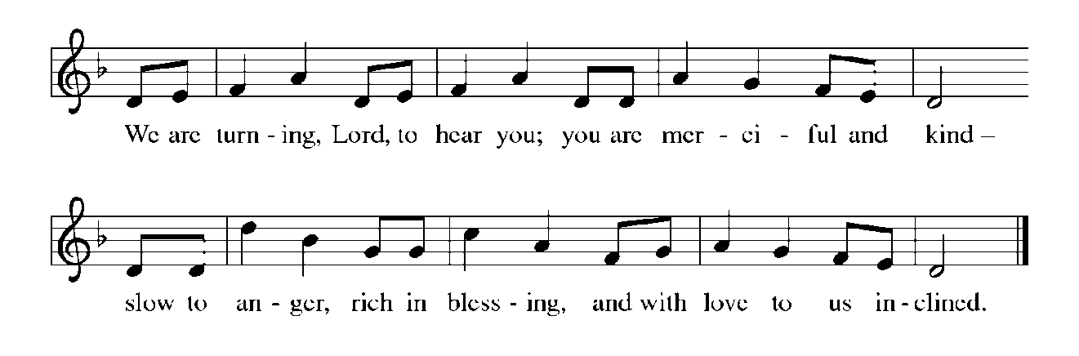
THE HOLY GOSPEL Matthew 4: 1-11

Jesus experiences anew the temptations that Israel faced in the wilderness. As the Son of God, He endures the testing of the evil one.

P: The Holy Gospel according to St. Matthew, the fourth chapter.

C: Glory to You, O Lord!

¹Jesus was led up by the Spirit into the wilderness to be tempted by the devil. ²He fasted forty days and forty nights, and afterwards He was famished. ³The tempter came and said to Him, "If You are the Son of God, command these stones to become loaves of bread." ⁴But He answered, "It is written,
'One does not live by bread alone,
but by every word that comes from the mouth of God.' "
⁵Then the devil took Him to the holy city and placed Him on the pinnacle of the
temple, ⁶saying to Him, "If You are the Son of God, throw Yourself down; for it is written,
'He will command His angels concerning you,'
and 'On their hands they will bear you up,
so that you will not dash your foot against a stone.' "
⁷Jesus said to him, "Again it is written, 'Do not put the Lord your God to the test.' "
⁸Again, the devil took Him to a very high mountain and showed Him all the kingdoms of the world and their splendor; ⁹and he said to Him, "All these I will give You, if you will fall down and worship me."
"And Jesus said to him, 'Begone, Satan, begone, for it is written: You shall worship the Lord your God, and Him alone shall you serve.'"
¹¹Then the devil left Him, and suddenly angels came and waited on Him.

P: The Gospel of the Lord.

C: Praise to You, O Christ!

The assembly is seated

THE SERMON

Silence for reflection follows the sermon

As you are able please rise

THE HYMN OF THE DAY (see p. 7) When We Are Tested
(Stanza 2—Women; Stanza 3—Men)
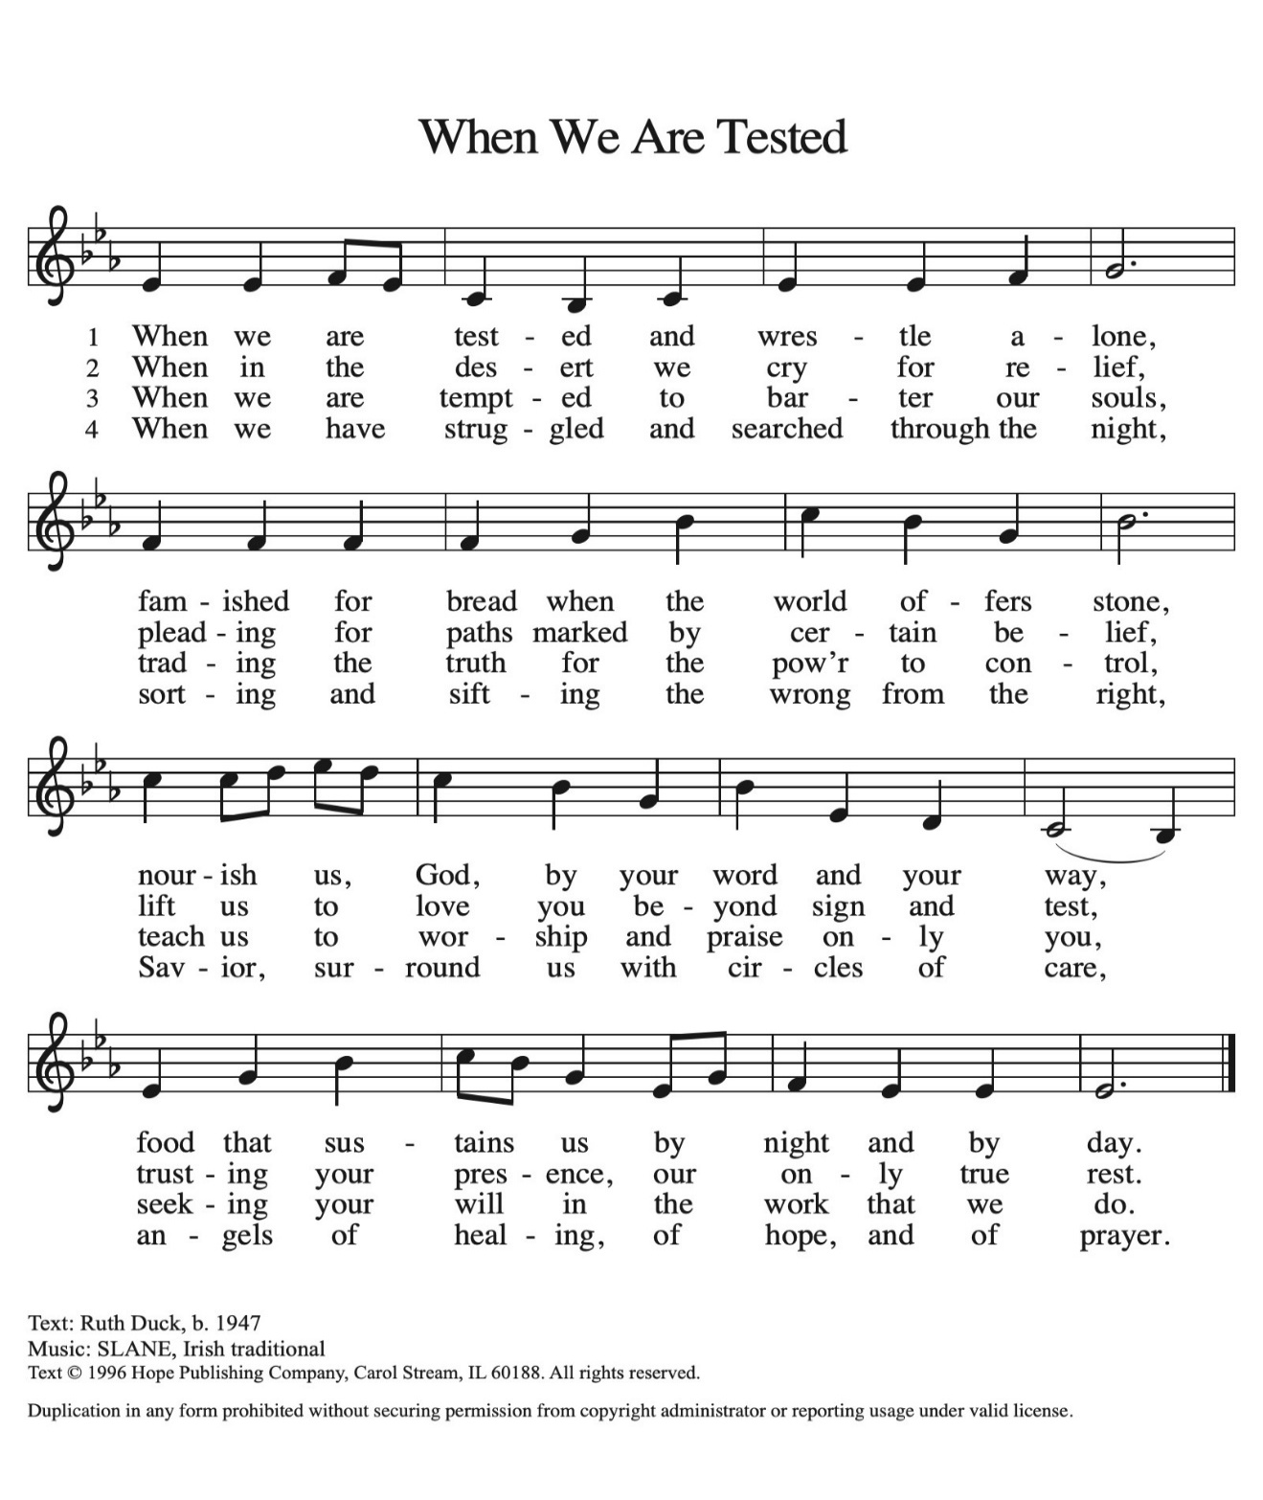

THE NICENE CREED

A: God has made us His people through our Baptism into Christ. Living together in trust
and hope, we confess our faith.

We believe in one God,
the Father, the Almighty,
maker of heaven and earth,
of all that is, seen and unseen.
We believe in one Lord, Jesus Christ,
the only Son of God,
eternally begotten of the Father,
God from God, Light from Light,
true God from true God,
begotten, not made,
of one Being with the Father.
Through Him all things were made.
For us and for our salvation
He came down from heaven;
by the power of the Holy Spirit
He became incarnate from the virgin Mary, and was made man.
For our sake He was crucified under Pontius Pilate;
He suffered death and was buried.
On the third day He rose again
in accordance with the Scriptures;
He ascended into heaven
and is seated at the right hand of the Father.
He will come again in glory to judge the living and the dead,
and His kingdom will have no end.

We believe in the Holy Spirit, the Lord, the giver of life,
Who proceeds from the Father and the Son.
With the Father and the Son He is worshiped and glorified.
He has spoken through the prophets.
We believe in one holy catholic and apostolic Church.
We acknowledge one Baptism for the forgiveness of sins.
We look for the resurrection of the dead,
and the life of the world to come. Amen

THE PRAYER OF THE CHURCH

A: Baptized into the paschal mystery of Jesus and led by the Spirit, let us offer our prayer
to God the Father with confidence and trust.

A: That the Church never seek to dominate or control, but instead conform to Christ’s
humble and faithful service, let us pray to the Lord:

C: Lord, have mercy.

A: That those preparing for Baptism in these days might be drawn into deeper trust in God,
let us pray to the Lord:

C: Lord, have mercy.

A: That this congregation might share our bread with the hungry, lift up the hurting, and
find fulfillment in loving our neighbor, let us pray to the Lord:

C: Lord, have mercy.

A: That those bedeviled by loneliness, grief, homelessness, and illness, especially: Tim
Miller; Kathy Thielman; Major Payne; Martha Schroeder; David Weiss; Joyce
Stark; Sally Timm; Karen Woodruff; Jackie Gaines; Jan Paholski; Laura Dovey;
Carl Wipperman; Shirley Shikany Long; John Bennitt; Catherine Lanigan;
Susan Dolson and Robert Bernth might be borne up by God’s angels, let us pray to
the Lord:

C: Lord, have mercy.

A: That with the faithful departed, especially Polycarp, Bishop of Smyrna, martyr,
whom we commemorate this Day we too may one day be brought from the wilderness
of life into the garden of paradise, let us pray to the Lord:

C: Lord, have mercy.

P: Hear our prayers, O merciful God, as we eagerly await the Day of resurrection and
rebirth, through Your Son, Jesus Christ our Lord.

C: Amen.

MEAL

THE PEACE

P: Through Christ we have been reconciled to God, Who has given us the ministry of
reconciliation. Let us be reconciled with one another.

The peace of the Lord be with you always.

C: And also with you.

The assembly is seated

THE OFFERING

THE VOLUNTARY How Deep the Father’s Love/We Bow Down Medley
(Townend & Grafstrom) New Song Praise Band

As you are able please rise

THE OFFERTORY (see p. 10) Create in Me a Clean Heart

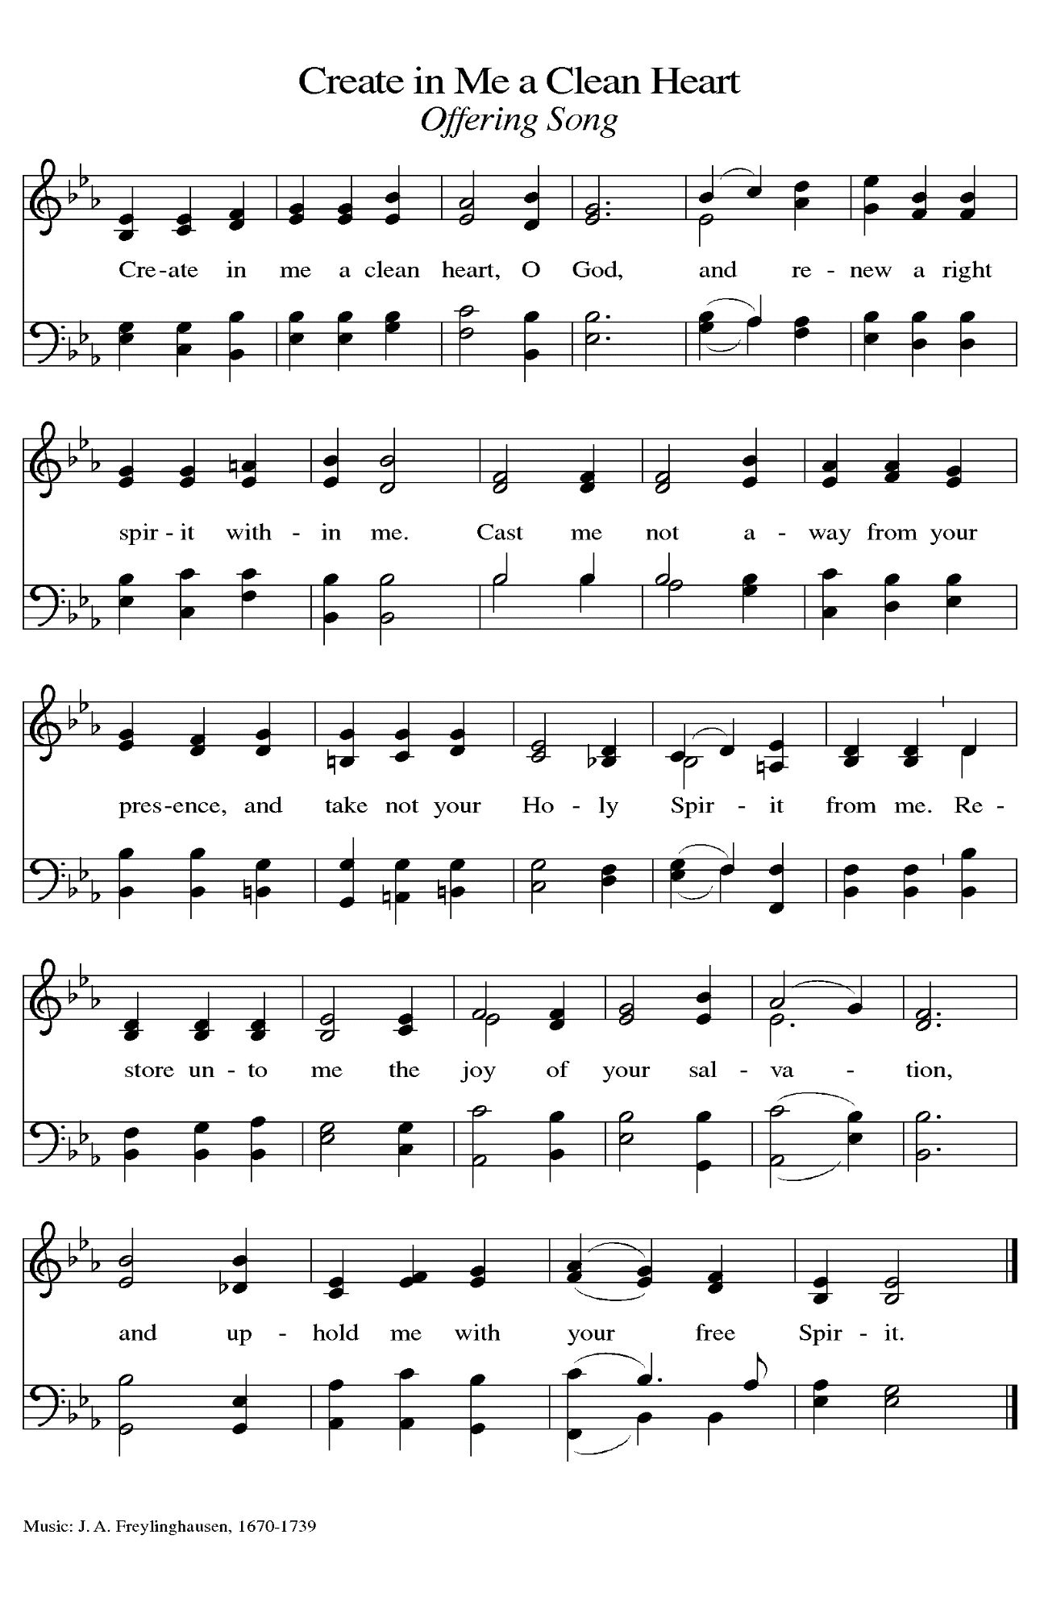
THE OFFERTORY PRAYER

A: Let us pray. God of mercy,

C: You bless us with gifts that sustain our lives; You transform us with the priceless
gift of grace. Receive and use these signs of Your blessings, and may our fasting,
prayer, and works of love be an offering of thanksgiving for all that You have
done for us in Christ our Lord. Amen.

THE GREAT THANKSGIVING

P: The Lord be with you.

C: And also with you.

P: Lift up your hearts.

C: We lift them up to the Lord.

P: Let us give thanks to the Lord our God.

C: It is right to give Him thanks and praise.

P: It is indeed right, our duty, and our joy … join their unending hymn:
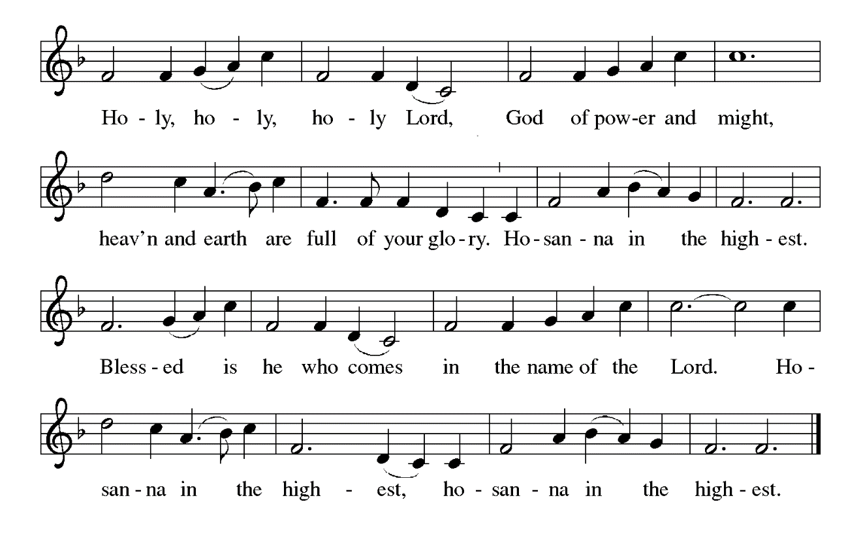

P: Praise and thanks are Yours, Lord God, because You remain faithful through our unfaith
and constant amid our failure.
Adam and Eve could see only scarcity, but You continue to offer us abundance.
Though sin came into the world and poisoned Your good creation, You nonetheless
called the children of Abraham to be Your companions, and in Jesus You faced
the cost of our sin and received its poison into Your own Body, transforming death into life.
Righteous God, in Jesus You were tempted to make stones into bread—but instead in
Him You make us living stones and You make bread become His Body.
Send down Your Holy Spirit, that we may be transformed into Your Body for the life
of Your world, and this bread and cup may become for us our strength and our
stay, the Body and Blood of Your Son Jesus Christ,
Who in the night ... “Do this for the remembrance of Me.”
As often as we eat ... we proclaim the Lord’s death until He comes.

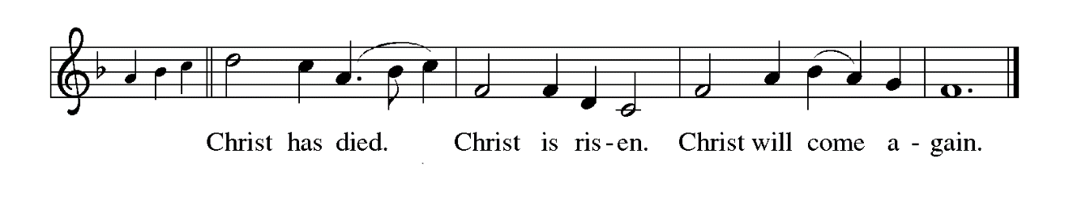P: Justifying God, in Your patience You see the hunger of Your children: send upon us
Your Word that in Your living Bread we may never be hungry again.
In Your mercy You know Your people’s craving for drama and miracle: raise up among
us witnesses to the triumphs of Your grace, that we may see You face to face.
In Your glory You hear Your fragile world’s cries for justice: shape in us the habits of
faithfulness, the disciplines of holiness, and the practices of peace, that we may
find Your justice as we walk with Your Son on the way of the cross,
Until that Day when You surprise us in the joy of resurrection, one God: Father, + Son,
and Holy Spirit,
Full of grace and truth.

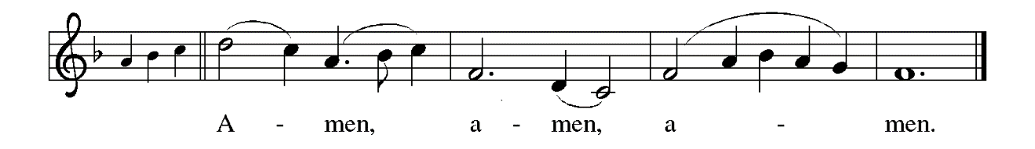

THE LORD’S PRAYER

P: While we were still sinners, Christ died for us, that, with confidence in God’s love for
us, we might dare to pray:

C: (Sung) Music is on the front cover of the red hymnal

INVITATION TO THE MEAL

P: Behold our Savior Christ Jesus, Who abolished death and brought life through the
Gospel. Blessed are those called to the Banquet of the Lamb. God’s holy gifts for
God’s holy people. Come, for all is now ready.

The assembly is seated

THE DISTRIBUTION Lamb of God (see p. 13)

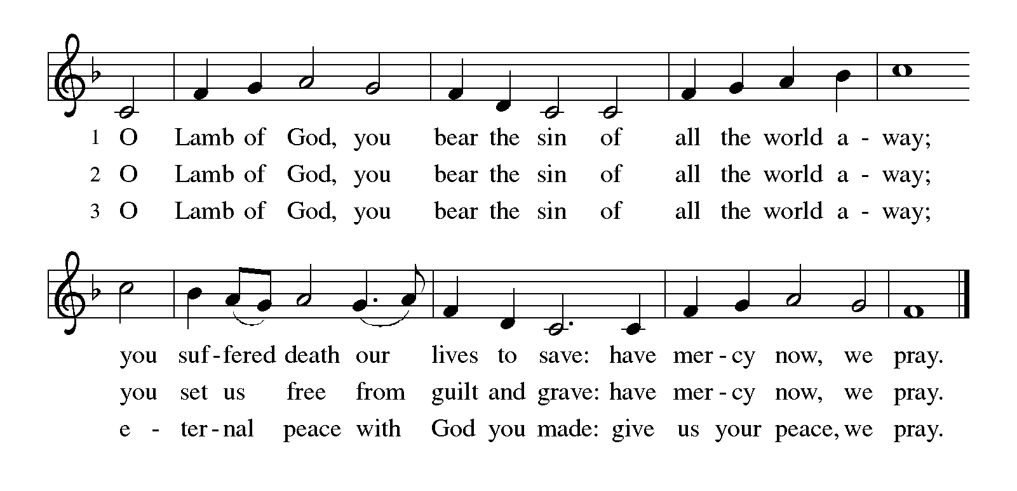
HYMN DURING DISTRIBUTION 618 Guide Me Ever, Great Redeemer
See p. 14 Out in the Wilderness

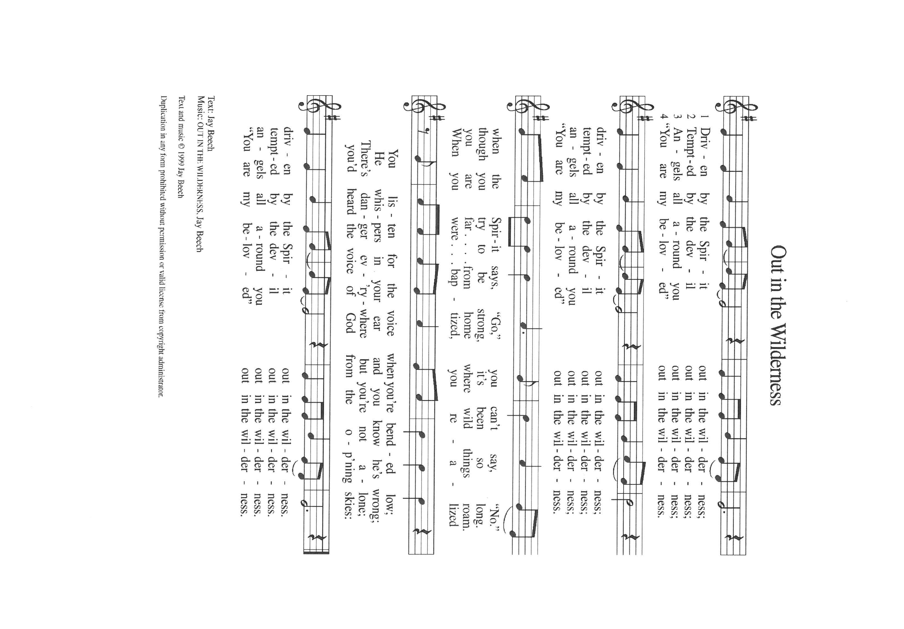

NSB 6 Amazing Love
NSB 104 You Are My Hiding Place

As you are able please rise

THE POST-COMMUNION BLESSING

P: The Body and Blood of our Lord Jesus Christ strengthen you and keep you in His grace.

C: Amen.

THE POST-COMMUNION PRAYER

A: Let us pray. Everlasting God, we have tasted the good Food of Your Table of grace.
Nourished by the life of Your Son, may we live as children of the light, sharing Your
good news; through Jesus Christ our Lord.

C: Amen.

SENDING

THE BENEDICTION

P: Jesus took the form of a servant and was obedient to death, even death on a cross. May
you follow His example and share in the resurrection.

C: Amen.

P: Almighty God: Father, Son, and Holy Spirit bless you now and forever.

C: Amen.

SENDING SONG 504 A Mighty Fortress is Our God

THE DISMISSAL

A: Reconciled to God through Christ, let us go out into the world in peace.

C: Thanks be to God!

THE POSTLUDE

To God Alone Be Glory

The Meditations are from A Lenten Sourcebook: The Forty Days. Book One. J. Robert
Baker, et al., eds. (Chicago: Liturgy Training Publications, 1990) 60; and Sundays and Seasons Online. Copyright 2019 Augsburg Fortress.

The Greeting, Prayers, Peace, Offertory, Post-Communion, and Dismissal are adapted
from Sundays and Seasons. Copyright 2001 Augsburg Fortress.

The Eucharistic Prayer is from With One Voice: Leader’s Edition. (Minneapolis: Augsburg
Fortress, 1995) 68.

The Prayers, Introduction to the Lord’s Prayer, and Invitation to the Meal are adapted from
Prayers for Sundays and Seasons. Year A. Peter J. Scagnelli. (Chicago: Liturgy Training Publications, 1998) 30-31; and, Sundays and Seasons. Copyright 2010 Augsburg Fortress.

ANNOUNCEMENTS

Please remember to mail your offering to the Church Office at 818 Franklin Street, Michigan City, IN 46360. Another alternative is to give on-line through Tithe.ly. Please see your closure letter for information on how to set up a Tithe.ly account.

St. Paul Members are reminded to have a loved one contact the office if you are hospitalized. Many times, the Pastor doesn’t know someone is in the hospital. If you call and leave a message, please tell us at which hospital the patient is located.

PRAYER CONCERNS: Robert Bernth; John Bennitt; Sarah McNabb; Debbie Martin; Mark Tannehill; Kathy Stein; Jan Paholski; Laura Dovey; Bill Hazelgrove;
Al Levenhagen; Carl Wipperman; Major Payne; Carol Hazelgrove; Allen Sydow;
Elizabeth Sanders; Susan Dolson and Tim Miller.

OFFICE HOURS: Libby will be in the office on Mondays, Wednesdays, and Fridays; volunteers will cover Tuesdays and Thursdays.

Monday & Wednesday 8:00 a.m. – 5 p.m.
Tuesday & Thursday 9:00 a.m. – 12:00 p.m.
Friday 8:00 a.m. – 12:00 p.m.

If you are listening to the worship broadcast on the radio and would like to watch the Sunday morning service live stream follow these steps:

(1) If you have You Tube available on your TV, search for
St. Paul Lutheran Church Michigan City, IN.

(2) The direct link on the computer is https://
www.youtube.com/channel/UC5AIPNaKr3QN50984jGOa1g

(3) This link is also on the main page of the church’s website in
the church section and will continue to be posted weekly on the St.
Paul Facebook page.

And it will always be available on the radio broadcast Sunday mornings at 11:00 a.m.
on WEFM (95.9), and on the local cable access station #99 for the previous week’s
service on Sundays at 4:00 p.m. and the current service on Wednesdays at 7:00 p.m.
and Fridays at 8:30 p.m.

To send e-mail to the church office, please use the following addresses:

Pastor Mark Reshan: seniorpastor@stpaulmichigancity.com

Church Office Secretary (Libby Pollock): churchsecretary@stpaulmichigancity.com

Church Treasurer (Karen Fleming): finance@stpaulmichigancity.com

2026 Church Council:

Pastor - Mark Reshan

President - Donna Knoll

Vice President - Jan Bakken

Secretary - Judy Hunt
Treasurer - Karen Fleming

Members: Sue Koziel; Jim Schraidt; Trish Sprague; Bob Kiser; Barry Anderson; and
Pam Soule

Worship Attendance:
Saturday, February 14, 2026 @ 4:00 p.m. 28
Sunday, February 15, 2026 @ 9:00 a.m. 64
TOTAL 92

Copies of the minutes from the December 18, 2025 Church Council meeting are on the back table in the upper Narthex. It was approved by the council via email.

The Good News Newsletter: If you have an article or anything you want included in The Good News please send it to the following e-mail address: splcgoodnews@gmail.com. Pastor Pamela Thiede will be using this e-mail address to assemble The Good News each month. The deadline for getting information to Pastor Pamela will be the 20th of each month.

Next week’s lessons are Genesis 12: 1-4a; Psalm 121; Romans 4: 1-5, 13-17 and John 3: 1-17 for those of you who like to study them in advance.

FEBRUARY 2026 MISSION OF THE MONTH is the Makerspace at the Michigan City Public Library.
The Makerspace is a place where young people can tinker, design, craft, create and explore. It includes a variety of equipment and projects for guided exploration and hands-on learning in the STEAM areas (science, technology, engineering, arts, and math). Some of the items currently available are art supplies (markers, crayons, colored pencils, glue sticks), etch-a-sketch, rubiks cube, building toys, and 3D printers. Lots of youth visit makerspace and many of the art supplies could use a refill. We will be collecting art supplies, or other STEAM supplies. Please place your supplies in the bin in the outer narthex. If you wish to make a monetary donation, please make checks out to the church marked for the makerspace and place in the offering plate. Thank you for your generous donations to our community!

SNOW EMERGENCY LIST
This is a reminder of where to turn to learn if worship has been canceled because of inclement weather conditions. There are two ways to learn about the status of the service.
First, you may turn to our church and school Facebook page: https://www.facebook.com/stpaulmichigancity/ for updated announcements. Or, perhaps most quickly and easily, you may call the church office number (219-874-7293) and press the “#” key and you will hear a recording about our “open/closed” status.

2026 Financial Stewardship

Weekly Church Operating Needs (x 2 weeks)
February 7-8, 2026 and February 14-15, 2026 $ 12,141.00

General Fund (including General Memorials): $ 16,975.00

Overage/Shortage: + $ 4,843.00

Restricted Income (not including Memorials)
Supports IK Synod & Church wide Ministries: $ 171.00

Ministries in our Community/Congregation: $ 75.00

Capital Fund: $ 307.00

Memorials
General Fund: $ 20.00

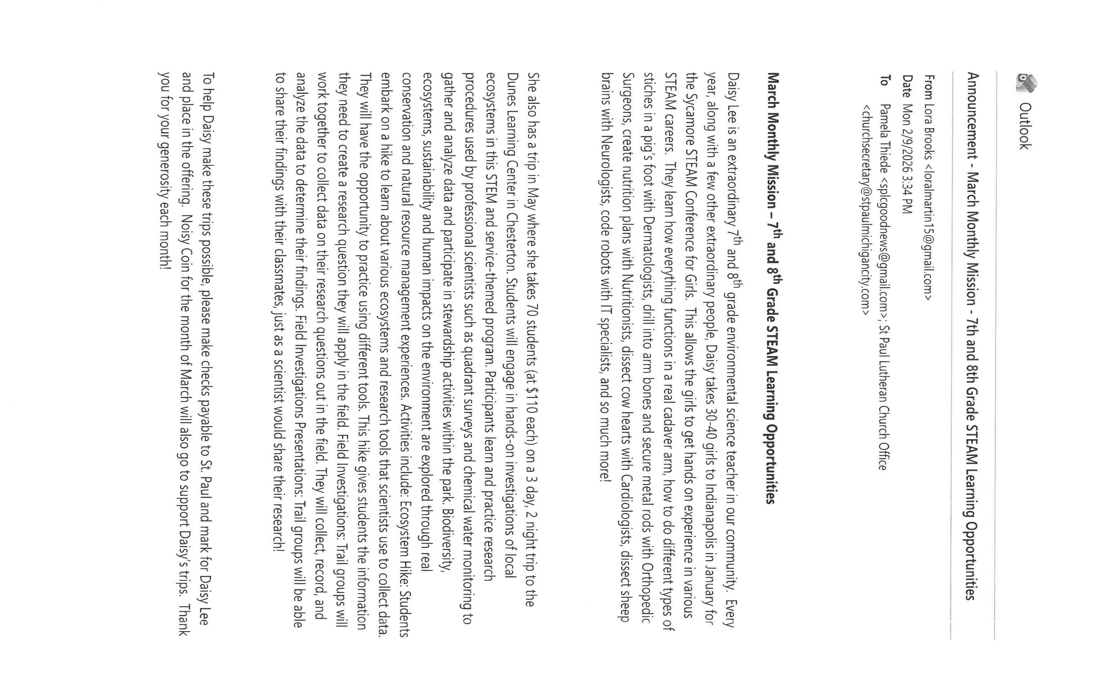

ACTIVITIES, EVENTS & MEETINGS
FEBRUARY 2026

Wednesday, February 18, 2026 @ 10:00 a.m. Ash Wednesday Worship Service
@ 7:00 p.m. Ash Wednesday Worship Service
Saturday, February 21, 2026 @ 4:00 p.m. 1st Lent Worship Service/Sanctuary

Sunday, February 22, 2026 @ 9:00 a.m. 1st Lent Worship Service/Sanctuary with Coffee after
Monday, February 23, 2026 @ 2:00 p.m. Finance Comm. Mtg./Luther House
@ 3:00 p.m. Executive Board Meeting/ Luther House
Tuesday, February 24, 2026 @ 4:00 p.m. 150th Anniv. Comm. Mtg./Luther House
Wednesday, February 25, 2026 @ 9:15 a.m. Bible Study/Luther House
@ 10:00 a.m. God’s Purls/St. Paul Room
@ 6:00 p.m. midweek Lenten Service/Sanctuary
Thursday, February 26, 2026 @ 3:00 p.m. Church Council Meeting/St. Paul Room
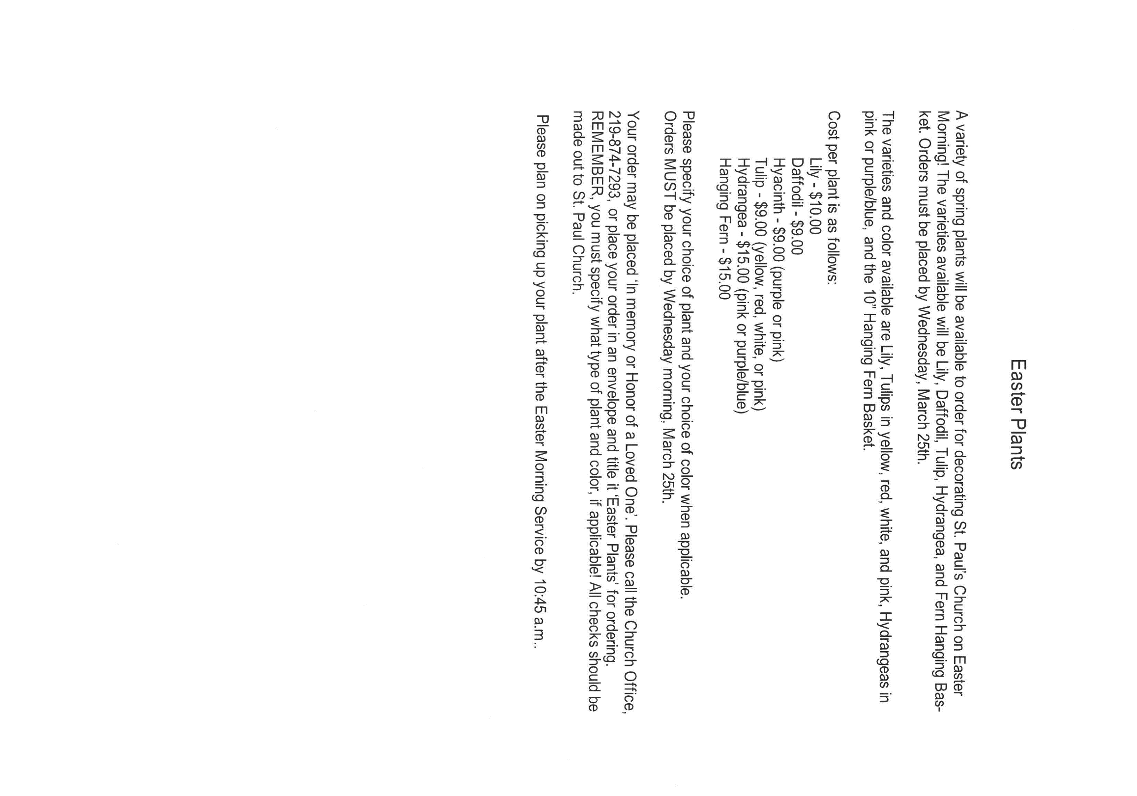
Saturday, February 28, 2026 @ 4:00 p.m. 2nd Lent Worship Service/Sanctuary

Thank$ for $haring
Thank you to all who participate in our Give-Back opportunities each month where we earn $$ to add to our Mission of the Month donations from our congregation to those in our community who need our help!
On Tuesday, March 10, 2026 we’re meeting at Holly’s Restaurant And Pub for our GIVE BACK from 11am—close. Here are two coupons—one for you and one for a friend.

