THE FIFTEENTH SUNDAY AFTER PENTECOST
September 18, 2022

The amazing thing about this story is the rich man’s reaction to the scheme (of the manager). He doesn’t get made, as we would expect of him. Instead, he actually commends the manager for his shrewdness, as much as to say, “Well, I’ve got to hand it to you. You really know how to take care of yourself!”
Now you and I know, of course, that such a thing would never happen—no boss is going to be happy with a dishonest employee … So what is this story doing in the New Testament anyway …”
Jesus told it because it is a very good picture of you and me. Not that we are cheaters or social parasites living off of our friends … Jesus told this parable because it portrays how shrewd we are. We know how to get along in the world, don’t we? We know how to turn things to our advantage …
But our Lord puts an ironic twist on the end of this little story in the New Testament. “Make friends for yourselves” he says, “by means of unrighteous mammon”—that is, make friends for yourselves with your money, or your shrewdness, or your ability to get along in the world—“so that when it fails they may receive you into the eternal habitations.”
And you see, that is just the point—that none of those things that we are good at doing put us right with God or win for us his abundant and eternal life. We are very shrewd and able people, but we are not shrewd enough to realize that this is not all there is to human life.”

Elizabeth Achtemeier
“On Being Wise in This Generation”

Jesus commends the steward for taking an interest in the future. He foresees his future, and provides for it. Now, it seems that for many Christians, the chief concern has been to get to heaven after death. Too often a preoccupation for that aspect of the future creates an indifference to human values while on earth.
But the future about which we are to think does not begin at some distant time after the resurrection of the dead. It begins now. It is the task of the church in every age to look at present practices and policies and to ask, “How will these affect tomorrow and the next day?”
If the consequences are grim, then it is the task of the church to call for reassessment and reversal—or to use the biblical word, repentance. When we are baptized, when we receive the eucharist, the future comes into our midst, and we are summoned to care about it earnestly, to protect it fervently.

Laurence Hull Stookey

In the Name of Jesus

GATHERING

INTRODUCTION
As we are invited today to consider what it means to be managers (rather than owners) of all that we have, it is crucial to recall that we are bought with a price. “Christ Jesus, himself human …gave himself a ransom for all.” Apart from the generosity of God we have nothing—we are nothing. By God’s gracious favor we have everything we need.
Dag Hammarskjöld, renewer of society, died 1961

A Swedish diplomat, Hammarskjöld served as the second Secretary General of the United Nations until his death in a plane crash while trying to negotiate peace in present-day Zambia. His journal, published as Markings, revealed the depth of his Christian faith.

PRELUDE Trumpet Tune Marko Hakanpaa

ANNOUNCEMENTS

As you are able please rise

GATHERING HYMN 448 This Is the Spirit’s Entry Now

THE GREETING

P: The grace of our Lord Jesus Christ, the love of God, and the communion of the Holy
Spirit be with you all.

C: And also with you.

The assembly is seated

THE SACRAMENT OF HOLY BAPTISM
Presentation

Candidates for baptism, sponsors, and parents gather with the ministers at the font.

The presiding minister may address the assembly in these or similar words:

In baptism our gracious heavenly Father frees us from sin and death by joining us to the death and resurrection of our Lord Jesus Christ. We are born children of a fallen humanity; by water and the Holy Spirit we are reborn children of God and made members of the church, the body of Christ. Living with Christ and in the communion of saints, we grow in faith, love, and obedience to the will of God.

Sponsors for each candidate, in turn, present the candidates:

I present Harlow Rae for baptism.

The presiding minister addresses parents or others who bring for baptism children who are not able to answer for themselves:

Called by the Holy Spirit, trusting in the grace and love of God, do you desire to have Harlow Rae baptized into Christ?

Response:

I do.

The presiding minister continues:

As you bring Harlow Rae to receive the gift of baptism, you are entrusted with responsibilities:

to live with her among God's faithful people,
bring her to the word of God and the holy supper,
teach her the Lord's Prayer, the Creed, and the Ten Commandments,
place in her hands the holy scriptures,
and nurture her in faith and prayer,
so that she may learn to trust God,
proclaim Christ through word and deed,
care for others and the world God made,
and work for justice and peace.
Do you promise to help Harlow Rae grow in the Christian faith and life?

Response:

I do.

The presiding minister addresses sponsors:

Sponsors, do you promise to nurture Harlow Rae in the Christian faith as you are empowered by God's Spirit, and to help her live in the covenant of baptism and in communion with the church?

Response:

I do.

The presiding minister addresses the assembly:

People of God, do you promise to support Harlow Rae and pray for her in her new life in Christ?

We do.

As you are able please rise

Profession of Faith

The presiding minister addresses candidates for baptism as well as the parents and sponsors of young children. The assembly may join in the responses.

I ask you to profess your faith in Christ Jesus, reject sin, and confess the faith of the church.

Do you renounce the devil and all the forces that defy God?

Parents and sponsors:

I renounce them.

Do you renounce the powers of this world that rebel against God?

Parents and sponsors:

I renounce them.

Do you renounce the ways of sin that draw you from God?

Parents and sponsors:

I renounce them.
The presiding minister addresses the candidates and the assembly.

Do you believe in God the Father?

I believe in God, the Father almighty,
creator of heaven and earth.

Do you believe in Jesus Christ, the Son of God?

I believe in Jesus Christ, His only Son, our Lord.
He was conceived by the power of the Holy Spirit
and born of the virgin Mary.
He suffered under Pontius Pilate,
was crucified, died, and was buried.
He descended into hell.
On the third day He rose again.
He ascended into heaven,
and is seated at the right hand of the Father.
He will come again to judge the living and the dead.

Do you believe in God the Holy Spirit?

I believe in the Holy Spirit,
the holy catholic church,
the communion of saints,
the forgiveness of sins,
the resurrection of the body,
and the life everlasting. Amen.

Thanksgiving at the Font

Water may be poured into the font before or during the thanksgiving. At the font, the presiding minister begins the thanksgiving:

The Lord be with you.

And also with you.

Let us give thanks to the Lord our God.

It is right to give our thanks and praise.

Blessed are You, O God, maker and ruler of all things. Your voice thundered over the waters at creation. You water the mountains and send springs into the valleys to refresh and satisfy all living things.

Through the waters of the flood You carried those in the ark to safety. Through the sea You led Your people Israel from slavery to freedom. In the wilderness You nourished them with water from the rock, and You brought them across the river Jordan to the promised land.

By the baptism of His death and resurrection, Your Son Jesus has carried us to safety and freedom. The floods shall not overwhelm us, and the deep shall not swallow us up, for Christ has brought us over to the land of promise. He sends us to make disciples, baptizing in the name of the Father, and of the Son, and of the Holy Spirit.
Pour out Your Holy Spirit; wash away sin in this cleansing water; clothe the baptized with Christ; and claim Your daughters and sons, no longer slave and free, no longer male and female, but one with all the baptized in Christ Jesus, Who lives and reigns with You in the unity of the Holy Spirit, one God, now and forever.

Amen.

The assembly is seated.

Baptism

The presiding minister baptizes each candidate. The candidate is immersed into the water, or water is poured on the candidate's head, as the presiding minister says:

Harlow Rae I baptize you in the name of the Father, and of the Son, and of the Holy Spirit.

Amen.

You belong to Christ,
in Whom you have been baptized.

The presiding minister continues:

Let us pray.
We give you thanks, O God that through water and the Holy Spirit you give your daughters and sons new birth, cleanse them from sin, and raise them to eternal life.

Laying both hands on the head of each of the newly baptized, the minister prays for each:

Sustain Harlow Rae with the gift of Your Holy Spirit: the spirit of wisdom and understanding, the spirit of counsel and might, the spirit of knowledge and the fear of the Lord, the spirit of joy in Your presence, both now and forever.

Amen.

The presiding minister marks the sign of the cross on the forehead of each of the baptized. Oil prepared for this purpose may be used. As the sign of the cross is made, the minister says:

Harlow Rae, child of God, you have been sealed by the Holy Spirit and marked with the cross of Christ forever.

Amen.

Welcome

A lighted candle may be given to each of the newly baptized (to a sponsor of a young child) as a representative of the congregation says:

Let your light so shine before others
that they may see your good works
and glorify your Father in heaven.

The ministers and the baptismal group face the assembly. A representative of the congregation leads the assembly in the welcome.

Let us welcome the newly baptized.

We welcome you into the body of Christ and into the mission we share:
join us in giving thanks and praise to God
and bearing God's creative and redeeming word to all the world.

THE PRAYER OF THE DAY

P: The Lord be with you.

C: And also with you.

P: Let us pray. God among us, we gather in the name of Your Son to learn love for one
another. Keep our feet from evil paths. Turn our minds to Your wisdom and our hearts
to the grace revealed in Your Son, Jesus Christ, our Savior and Lord.

C: Amen.

The assembly is seated
WORD

FIRST READING Amos 8:4-7
Amos was called by God to prophesy in the Northern Kingdom of Israel. Peace and prosperity in Israel led to corrupt business practices and oppression of the poor. The prophet declares that God will not tolerate such a situation,

⁴Hear this, you that trample on the needy,
and bring to ruin the poor of the land,
⁵saying, “When will the new moon be over
so that we may sell grain;
and the sabbath,
so that we may offer wheat for sale?
We will make the ephah small and the shekel great,
and practice deceit with false balances,
⁶buying the poor for silver
and the needy for a pair of sandals,
and selling the sweepings of the wheat.”
⁷The Lord has sworn by the pride of Jacob:
Surely I will never forget any of their deeds.

The Word of the Lord.

Thanks be to God.

THE PSALM: Psalm 113 Antiphon by Dorothy Christopherson
Refrain is sung first by the choir and then repeated immediately
by the congregation and as indicated

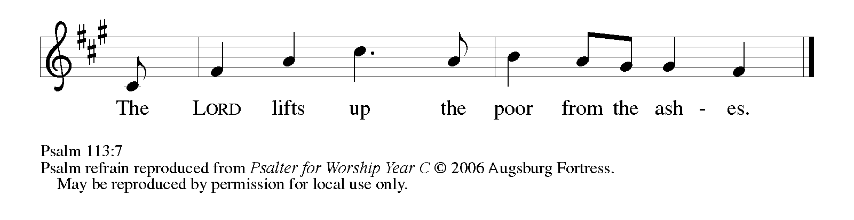
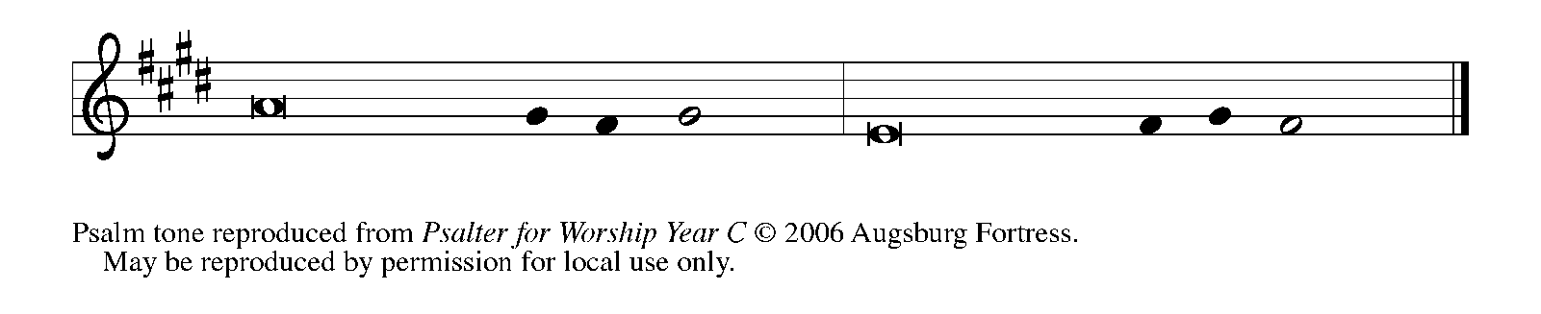

¹Hallelujah! Give praise, you servants | of the Lord;
praise the name | of the Lord.
²Let the name of the | Lord be blessed,
from this time forth for- | evermore.
³From the rising of the sun to its | going down
let the name of the | Lord be praised.

⁴The Lord is high a- | bove all nations;
God’s glory a- | bove the heavens. REFRAIN
⁵Who is like the | Lord our God,
Who sits en-| throned on high,
⁶but stoops | to behold
the heavens | and the earth?
⁷The Lord takes up the weak out | of the dust
and lifts up the poor | from the ashes,
⁸enthroning them | with the rulers,
with the rulers | of the people.

⁹The Lord makes the woman of a | childless house
to be a joyful mother of children.| Hallelujah! REFRAIN

SECOND READING 1 Timothy 2:1-7
The Pastoral Epistles offer insight into how early Christians understood many practical matters, such as church administration and worship. The church’s focused prayer for others is an expression of the single-minded passion God has toward us in Jesus.

¹First of all, then, I urge that supplications, prayers, intercessions, and thanksgivings be
made for everyone,
²for kings and all who are in high positions, so that we may lead a quiet and
peaceable life in all godliness and dignity.
³This is right and is acceptable in the sight of God our Savior,
⁴Who desires everyone to be saved and to come to the knowledge of the truth.
⁵For there is one God; there is also one mediator between God and humankind,
Christ Jesus, Himself human,
⁶Who gave himself a ransom for all
—this was attested at the right time.
⁷For this I was appointed a herald and an apostle (I am telling the truth, I am not lying),
a teacher of the Gentiles in faith and truth.

The Word of the Lord.

Thanks be to God.

As you are able please rise

THE VERSE

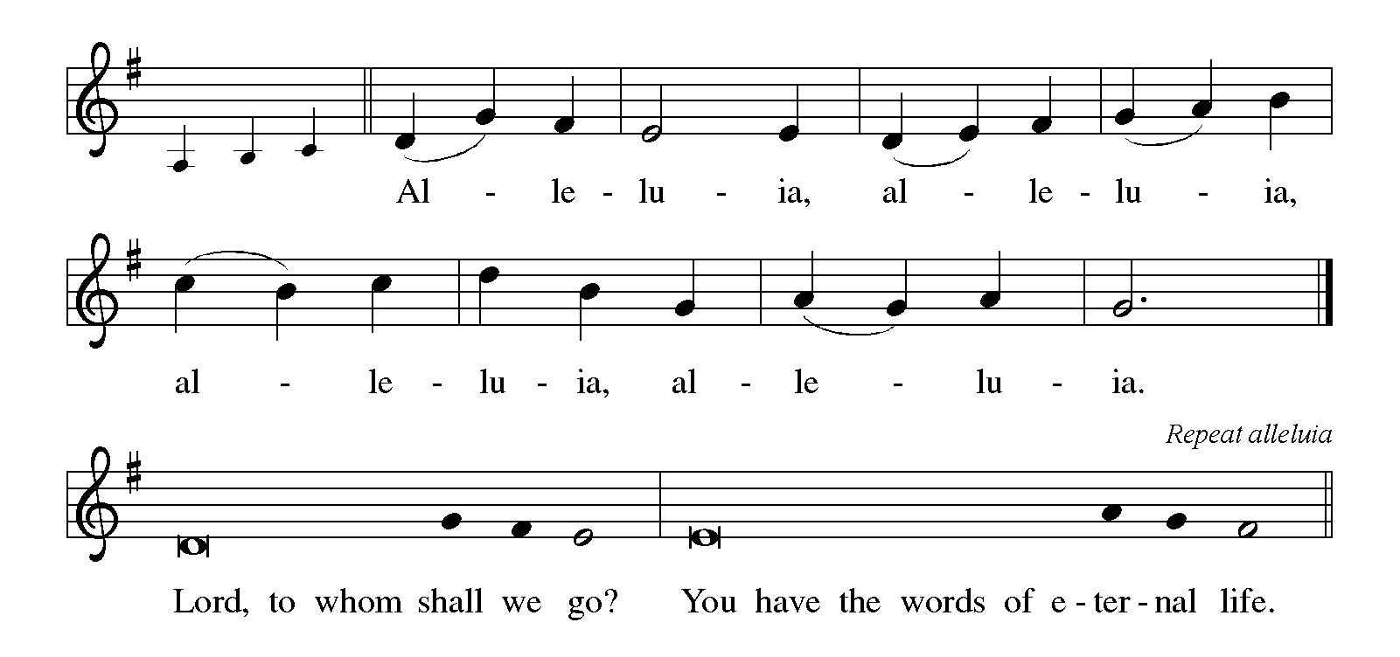

THE HOLY GOSPEL Luke 16:1-13
Jesus tells the curious story of a dishonest man who cheats his employer and then is commended by him for having acted so shrewdly. Jesus wonders why his own followers are less creative and diligent in their stewardship given that they are managers of a far more valuable household.

P: The Holy Gospel according to St. Luke, the sixteenth chapter.

C: Glory to You, O Lord!

¹Then Jesus said to the disciples, “There was a rich man who had a manager, and
charges were brought to him that this man was squandering his property.
²So he summoned him and said to him, ‘What is this that I hear about you?
Give me an accounting of your management, because you cannot be my
manager any longer.’
³Then the manager said to himself, ‘What will I do, now that my master is
taking the position away from me? I am not strong enough to dig, and
I am ashamed to beg.
⁴I have decided what to do so that, when I am dismissed as manager,
people may welcome me into their homes.’
⁵So, summoning his master’s debtors one by one, he asked the first, ‘How much
do you owe my master?’
⁶He answered, ‘A hundred jugs of olive oil.’ He said to him, ‘Take your bill,
sit down quickly, and make it fifty.’
⁷Then he asked another, ‘And how much do you owe?’ He replied, ‘A hundred
containers of wheat.’ He said to him, ‘Take your bill and make it eighty.’
⁸And his master commended the dishonest manager because he had acted shrewdly;
for the children of this age are more shrewd in dealing with their own
generation than are the children of light.
⁹And I tell you, make friends for yourselves by means of dishonest wealth so
that when it is gone, they may welcome you into the eternal homes.
¹⁰“Whoever is faithful in a very little is faithful also in much; and whoever is
dishonest in a very little is dishonest also in much.
¹¹If then you have not been faithful with the dishonest wealth, who will entrust to
you the true riches?
¹²And if you have not been faithful with what belongs to another, who will give
you what is your own?
¹³No slave can serve two masters; for a slave will either hate the one and love
the other, or be devoted to the one and despise the other. You cannot
serve God and wealth.”

P: The Gospel of the Lord.

C: Praise to You, O Christ!

The assembly is seated

THE SERMON
Silence for reflection follows the sermon
As you are able please rise

THE HYMN OF THE DAY 710 Let Streams of Living Justice

The assembly is seated

THE INSTALLATION OF MUSICIANS

The musicians to be installed come forward

John Remmel Senior Organist
Lori Zylstra Director of Music
The Senior Choir
Jary Tannehill Director, New Song Praise Band
Mark Tannehill Member, New Song Praise Band
Jacob Tannehill Member, New Song Praise Band
Stacie Crozier Member, New Song Praise Band
P: Our Lord, Who came among us as a servant, calls us to faith and life of loving service
to our neighbor. You stand among us as those called to a particular service, a gift from
God to inspire us to love and good works.

A reading from Romans: Just as each of our bodies has several parts and each part has
a separate function, so all of us, in union with Christ, form one body, and as parts of it
we belong to each other. Our gifts differ according to the grace given us. If your gift
is prophecy, then use it as your faith suggests; if administration, then use it for
administration; if teaching, then use it for teaching. Let the preachers deliver sermons,
the almsgivers give freely, the officials be diligent, and those who do works of mercy
do them cheerfully.

P: Will you assume this ministry in the confidence that it comes from God?

R: I will, and I ask God to help me.

P: Will you carry out this ministry in accordance with the teachings and practice of the
Lutheran Church?

R: I will, and I ask God to help me.

P: Will you be diligent in your study of the Holy Scriptures and faithful in your use of the
means of grace and in prayer?

R: I will, and I ask God to help me.

P: Will you trust in God’s care, seek to grow in love for those you serve, strive for
excellence in your skills, and adorn the Gospel with a godly life?

R: I will, and I ask God to help me.

P: Almighty God, Who has given you the will to do these things, graciously give you the
strength and compassion to perform them.

C: Amen.

P: I install you as musicians of St. Paul Lutheran Church in the name of the Father and of
+ the Son and of the Holy Spirit.

C: Amen.

P: Let us pray. O God of majesty, Whom saints and angels delight to worship: Be present
with Your servants who seek through Your gift of music to perfect our praises and to
proclaim Your Word with power. Through their ministries grant us new awareness of
Your beauty and grace, and make us all worthy at last to join the praises of the hosts of
heaven; through Your Son, Jesus Christ our Lord.

C: Amen.

P: Almighty God, our heavenly Father, guide, bless, and keep you, that you may be faithful
to the ministry to which you have been called.

C: Amen.

THE PRAYER OF THE CHURCH
A: God is just; God is one. But we are often fragmented and consumed by many wants.
Let us gather our needs now and offer them confidently and simply to God with hope
and joy.

A: That the Church and its leaders, especially our bishops Elizabeth and Bill; our pastors
Pamela and Al, Mark, Dale and Mark, that they may be wise, tireless, and faithful
in their preaching and living of the Good News, we pray to the Lord:

C: Lord, hear our prayer.

A: That Harlow Rae, newly baptized, may be delivered from the way of sin and death;
filled with the Holy Spirit so that she lacks no spiritual gift; and be strengthened in faith
and life so that she may always bear witness to the Lord in word and action, we pray to
the Lord:

C: Lord, hear our prayer.

A: That the leaders of world powers may be just and honorable in dealing with those they
are called to serve, and that there might be peace, a reduction of arms, and an end to
war and terrorism, we pray to the Lord:

C: Lord, hear our prayer.

A: That all Christians may hold their goods and money lightly and use them for the sake
of God’s good purposes in the world, we pray to the Lord:

C: Lord, hear our prayer.

A: That employers and employees may act honestly in their workplaces and treat one
another with dignity, we pray to the Lord:

C: Lord, hear our prayer.

A: That this congregation might respond to the needs of the poor and hungry of this
community and serve the common good, we pray to the Lord:

C: Lord, hear our prayer.

A: That the lonely, the heartbroken, the hopeless and despairing, and the sick, especially
Bernadette Krueger; Lee Timm; Audrey Beyer; Bethany Manning; Dolores
Hackett; Erik Tannehill; Jean Thomas and Alan Martin might be lifted up by God
into health, hope, joy, and healing, we pray to the Lord:

C: Lord, hear our prayer.

A: That those celebrating birthdays, especially Kay Peglow and Helen Wiese; and
anniversaries, especially Don and Elizabeth Thompson may be filled with grace this
day and every day, and grow in grace in the days ahead, we pray to the Lord:

C: Lord, hear our prayer.

A: That with the faithful who have gone before us, especially Dag Hammarskjold,
renewer of society, whom we commemorate this Day, we may join the heavenly host
in blessing God’s name forever, we pray to the Lord:

C: Lord, hear our prayer.

P: Just God, one God, we live in this world and look for the world to come. Teach us for
what to ask; give us all we need. Make us life-givers with You as Your build Your
Kingdom here, in the name of Jesus the Lord.

C: Amen.
MEAL

THE PEACE

P: The peace of the Lord be with you always.

C: And also with you.

The assembly is seated

THE OFFERING

THE VOLUNTARY Take Now My Voice Douglas Nolan

As you are able please rise

THE OFFERTORY 531 (Stanzas 1, 3) The Trumpets Sound, the Angels Sing

THE OFFERTORY PRAYER

A: Let us pray. God of power,

C: The glory of Your works fills us with wonder and awe. Accept our offering this
day, and help us to live in peace and harmony with one another and to be wise
stewards of all Your abundant gifts. We ask this in the name of Jesus the Lord.
Amen.

THE GREAT THANKSGIVING
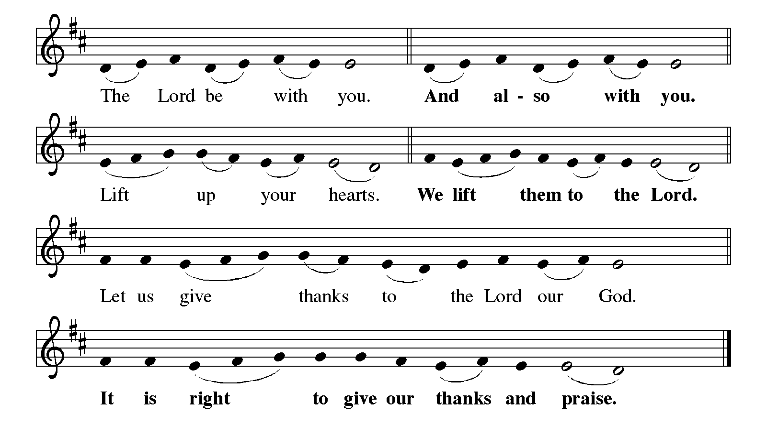
P: It is indeed right, our duty and our joy … join their unending hymn:

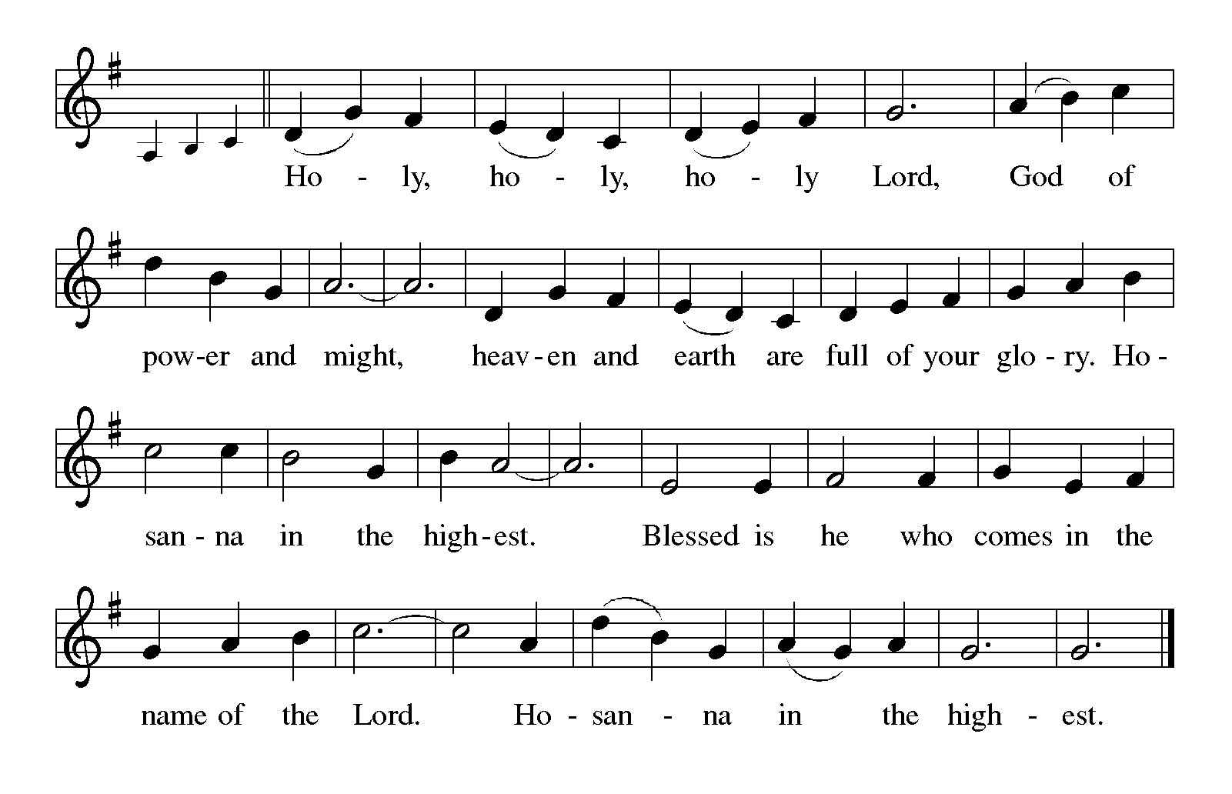
P: Holy God, one God, Savior of the world, we bless and praise Your name.
There is no one like You; You are enthroned above heaven and earth.
Yet in great love You stoop to give us life and hope.
You chose Israel, Your beloved, to be a sign of blessing to all nations.
Through her disobedience and faithlessness, Your love remained sure.

At the last, You showed Yourself faithful in Your Son, Jesus Christ.
He is our Mediator, in Whom is salvation and truth.
In the night … “Do this for the remembrance of Me.”
As often as we eat … we proclaim the Lord’s death until He comes.

P: With this bread and cup we remember the life our Lord offered for us.
He became sin for us sinners, His life a ransom to save us from death.
Just as He died for all, so will all find life in Him when He returns in glory to
complete Your Reign of love.
Send now Your Holy Spirit on us and these Your gifts of bread and wine.
That we and all who share the Lord’s Body and Blood may shrewdly serve You in
our neighbor until they, with us, are welcomed into Your eternal home.
To You, O God: Father, Son, and Holy Spirit, be all honor and glory, in Your holy
Church, in heaven and on earth, now and forever.
THE LORD’S PRAYER

P: Gathered into one by the Spirit, let us pray as Jesus taught us:

C: Our Father, Who art in heaven, hallowed be Thy Name. Thy Kingdom come. Thy
will be done on earth as it is in heaven. Give us this day our daily bread, and
forgive us our trespasses as we forgive those who trespass against us. And lead us
not into temptation, but deliver us from evil. For Thine is the Kingdom, and the
power, and the glory, forever and ever. Amen.

INVITATION TO THE MEAL

P: Holy things for holy people.

C: One is holy, One is Lord, Jesus Christ, to the glory of God.

P: Come, taste and see that the Lord is good.

The assembly is seated

THE DISTRIBUTION

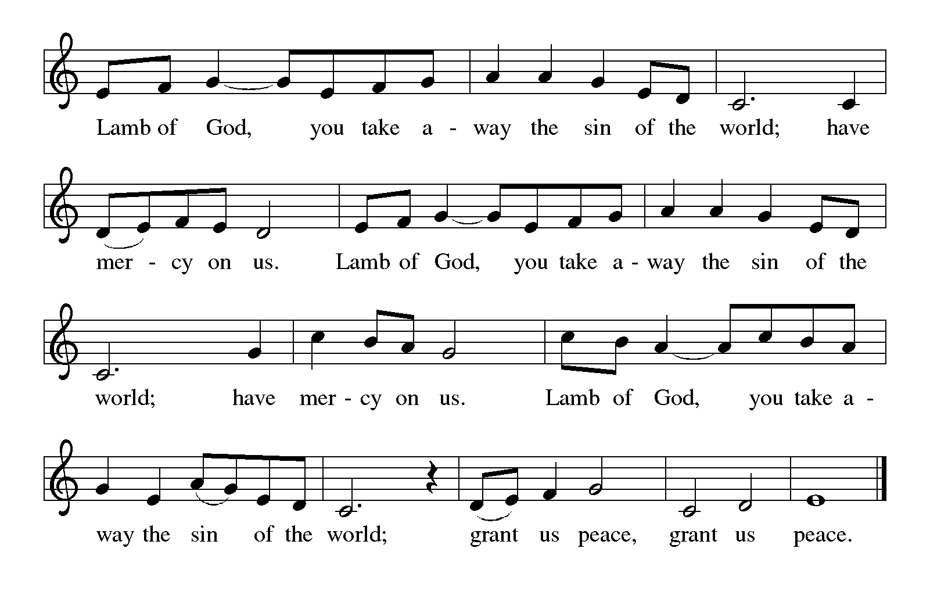
HYMNS DURING DISTRIBUTION 793 Be Thou My Vision
678 God, Whose Giving Knows No Ending

As you are able please rise

THE POST-COMMUNION PRAYER

A: Let us pray. Lord God, strengthened by this Meal, send us as Your heralds to bring
Your saving will to all people. Make us bold and joyful in our service, until all are
gathered at Your heavenly Feast of joy. Grant this through Christ our Lord.

C: Amen.

SENDING

THE BENEDICTION

P: Almighty God: Father, Son, and Holy Spirit bless you now and forever.

C: Amen.

SENDING HYMN 717 Let Justice Flow Like Streams

THE DISMISSAL

A: Go in peace to bear Christ’s love to all the world.

C: Thanks be to God!

POSTLUDE Voluntary on Thaxted Albert L. Travis

To God Alone Be Glory

The Meditation is from Richer Fare for the Christian People. Gail Ramshaw, ed. (New
York: Pueblo Publishing Company, 1990) 202-203.

The Prayers are adapted from Intercessions for the Christian People. Gail Ramshaw, ed.
(New York: Pueblo Publishing Company, 1988) 234.

The Offertory Prayer is from The Book of Alternate Services of the Anglican Church of
Candad. (Toronto: Anglican Book Centre, 1985) 382.

ANNOUNCEMENTS

Please remember to mail your offering to the Church Office at 818 Franklin Street, Michigan City, IN 46360. Another alternative is to give on-line through Tithe.ly. Please see your closure letter for information on how to set up a Tithe.ly account.

St. Paul Members are reminded to have a loved one contact the office if you are hospitalized. Many times, the Pastor doesn’t know someone is in the hospital. If you call and leave a message, please tell us which hospital the patient is at.

Next Sunday’s lessons are Amos 6: 1a, 4-7; Psalm 146: 1 Timothy 6:6-19; Luke 16: 19-31 for those of you who like to study them in advance.

Birthdays: Kay Peglow (9/19); Helen Wiese (9/22)
Anniversaries: Don & Beth Thompson (9/19)

PRAYER CONCERNS: Audrey Beyer, Ryan Krueger, Donna Bostater, Maxine Powell, Jim Tomscheck, Eloise Ponder, Mark & Jary Tannehill, Leonard Cross, George Ottersen, Annette Scroggin, Helen Hill-Weaver, Bernadette Krueger and Alan Martin.

If you requested someone’s name to be on the prayer list and are aware that they need continued imminent prayer then contact the church office and let us know. Otherwise we will gradually transfer names to the long-term list.

OFFICE HOURS: Libby will be in the office on Mondays, Wednesdays, and Fridays; volunteers will cover Tuesdays and Thursdays.

Monday & Wednesday 8:00 a.m. – 5 p.m.
Tuesday & Thursday 9:00 a.m. – 12:00 p.m.
Friday 8:00 a.m. – 12:00 p.m.

If you are listening to the worship broadcast on the radio and would like to watch the Sunday morning service live stream follow these steps:

(1) If you have You.Tube available on your TV, search for
St. Paul Lutheran Church Michigan City, IN.

(2) The direct link on the computer is
https://www.youtube.com/channel/UC5AIPNaKr3QN50984jGOa1g.

(3) This link is also on the main page of the church’s website in the church section and will continue to be posted weekly on the St. Paul Facebook page.

And it will always be available on the radio broadcast Sunday mornings at 11:00 a.m. on WEFM (95.9), and on the local cable access station #99 for the previous week’s service on Sundays at 4:00 p.m. and the current service on Wednesdays at 7:00 p.m. and Fridays at 8:30 p.m.

To send e-mail to the church office, please use the following addresses:

Pastor Mark Reshan: seniorpastor@stpaulmichigancity.com

Church Office Secretary (Libby Pollock): churchsecretary@stpaulmichigancity.com

Church Treasurer (Karen Fleming): finance@stpaulmichigancity.com

The Good News Newsletter: If you have an article or anything you want included in The Good News please send it to the following e-mail address: splcgoodnews@gmail.com. Pastor Pamela Thiede will be using this e-mail address to assemble The Good News each month. The deadline for getting information to Pastor Pamela will be the 20th of each month.

WORSHIP ATTENDANCE for September 10 and 11, 2022
4:00 p.m. 35
9:00 a.m. 39
Total = 74

THANK YOU for the lovely reception and for joining us in celebration of Leah and Cam’s baptism! The love and support showered on Leah and Cam made the day even more special!
Paul, Lora, Leah, Amanda and Cam Brooks

We are still looking to arrange meals for Mark and Jary Tannehill. If you are able to help please call or text Jacob Tannehill at 269-405-0926 or Stacie Crozier at 219-877-4351 or let her know when you see her at worship.

SEPTEMBER 2022 ACTIVITIES, EVENTS & MEETINGS

Saturday, September 3, 2022 at 4:00 p.m. Worship Service

Sunday, September 4, 2022 at 9:00 a.m. Worship Service

Wednesday, September 7, 2022 at 9:45 a.m. Bible Study/Luther House
at 10:00 a.m. God’s Purls/St. Paul Room

Saturday, September10, 2022 at 4:00 p.m. RALLY DAY Worship Service
at 5:00 p.m. Pot Luck Dinner/St. Paul Room

Sunday, September 11, 2022 at 9:00 a.m. RALLY DAY Worship Service

Monday, September 12, 2022 at 12:30 p.m. Harmony Circle/Green Room/Nursery

at 3:30 p.m. School Board Meeting/Luther House

Tuesday, September 13, 2022 at 9:30 a.m. Charity Circle/Green Room/Nursery
at 7:00 p.m. Meetup/Discussion Group called “Estuary”
at Luther House

Wednesday, September 14, 2022 at 9:45 a.m. Bible Study/Luther House

at 10:00 a.m. God’s Purls/St. Paul Room

at 6:00 p.m. Worship & Music Meeting/St. Paul Room

at 7:00 p.m. Choir Rehearsal

Saturday, September 17, 2022 at 4:00 p.m. Worship Service

Sunday, September 18, 2022 at 9:00 a.m. Worship Service

Monday, September 19, 2022 at 4:00 p.m. Finance Committee Meeting/Luther House

at 5:30 p.m. Executive Board Meeting/Luther House

Wednesday, September 21, 2022 at 9:45 a.m. Bible Study/Luther House

at 10:00 a.m. God’s Purls/St. Paul Room

Thursday, September 22, 2022 at 5:00 p.m. 150th Anniversary Planning

at 5:30 p.m. Church Council Meeting/St. Paul Room

Saturday, September 24, 2022 at 4:00 p.m. Worship Service

Sunday, September 25, 2022 at 9:00 a.m. Worship Service

Wednesday, September 28, 2022 9:45 a.m. Bible Study/Luther House

10:00 a.m. God’s Purls/St. Paul Room

Open – Close GIVE-BACK AT HACIENDA

Saturday, October 1, 2022 at 4:00 p.m. Worship Service

Sunday, October 2, 2022 at 9:00 a.m. Worship Service

Thank$ for $haring
Thanks to all who have participated in our recent give-back nights. The July give-back at Galvaston raised $330; the August give-back at Holly’s raised $224.

This month,we will see you at Hacienda! We’re giving you two coupons so you can invite a friend and give them their own coupon. Remember, the coupon is required for the Give-Back bucks.

