THE FIFTEENTH SUNDAY AFTER PENTECOST
September 5, 2021

That Christians pray for recovery of their sick and proclaim to them God’s healing will is itself too natural to require justification. The New Testament, moreover, sets sickness and recovery in a specific context. Bodily disaster, as the one unavoidable reminder of death, is understood as a central fact and a betraying signal of creation’s bondage to evil. Jesus’ proclamation of the imminence of God’s victory, a proclamation so urgent as itself already to liberate from evil, therefore became visible especially as healing (Mark 5-6)…Thus Jesus’ healings were very precisely sacraments of the coming kingdom …
…Surely what we find, for our situation, in the New Testament is permission to do what we anyway want to do: pray for the recovery of our sick and assure them of the efficacy of such prayer, and do both in the specific context of the church’s mission against creation’s bondage, in which illness is more than misfortune and healing is a sign of the gospel’s future triumph.
To such prayer and assurance the New Testament attaches the promise of healing, in that total sense which encompasses physical recovery as its visible aspect.

Robert W. Jenson

“…I'm convinced the woman does exemplify faith. In doing so, she makes us consider what "faith" even means. Notice, especially, her persistent efforts (refusing to go away until she gets what she came for), her hopeful insight (refusing to believe even a tiny speck of grace isn't out of reach and knowing just a scrap can make the difference for her), and -- in the end -- her trusting acceptance (her willingness to take Jesus at his word and journey home alone to confirm her daughter's healing).
Who says things like desperation and tenacity aren't the same thing as faith, when that desperation and tenacity are brought to Jesus? In Mark, "faith" is hardly about getting Jesus' name or titles right, nailing the right confession, or articulating proper doctrine. It's about clinging to Jesus and expecting him to heal, to restore, to save. It's about demanding he do what he says he came to do.
Look for the Syrophoenician woman in the back row of church this Sunday. Maybe she's the one whose reputation discourages her from getting involved or the one who slips out during the last hymn to avoid having to mix with the churchy "insiders." But she keeps coming back, fiercely convinced that if anything you preach week-in and week-out is true, then it's got to be true for her, too.
Like Jacob (Genesis 32:26), she's not letting go until she gets her blessing.
Let her faith compel all of us to recognize new implications in a truly abundant gospel.”

Matt Skinner
In the Name of Jesus

INTRODUCTION

In today's gospel Jesus heals a deaf and mute man using the word ephphatha, which means "be opened." The author of James exhorts the community of faith to guard against favoritism among its members. In baptism we have died to any distinctions that would separate us from each other. Likewise, in the eucharist each one receives the free gift of Christ equally and without discrimination. Through word and sacrament God opens our minds and hearts to the healing and liberating gospel of Christ.

GATHERING

PRELUDE Praise to the Lord, the Almighty Paul Manz

ANNOUNCEMENTS

As you are able please rise

CONFESSION AND ABSOLUTION

P: In the name of the Father and of the Son and of the Holy Spirit.

C: Amen.

P: “Happy are they who have the God of Jacob for their help, whose hope is in the LORD their
God ...” (Psalm 146:4) Confessing our sins, let us turn to our God for help, hope, and
forgiveness in our time of need.

Silence for self-examination and reflection is kept

P: Most merciful God,

C: We confess that we have sinned against You in thought, word, and deed. We have not
loved You with our whole heart nor our neighbors as ourselves. (James 2:8) We have
not always shown mercy to those in need. (2:13) We have ignored the cries of the poor,
those treated with injustice, and the hungry. (2:6) We are partial to those with power
and who can help us. Often our “faith” lacks “works.” (2:14) For the sake of Your Son,
Jesus Christ, have mercy on us. Free us for faithful living toward You and loving service
toward our neighbor.

P: “Say to those of a fearful heart, ‘Be strong, do not fear! Here is your God ... He will come to
save you.” (Isaiah 35:4) God indeed comes with a Word of salvation and hope: as a called and
ordained minister of the Church of Christ, and by His authority, I therefore declare to you the
entire forgiveness of all your sins, in the name of the Father and of the Son and of the Holy
Spirit.

C: Amen.

GATHERING HYMN 858 Praise to the Lord, the Almighty page 9

THE GREETING AND PRAYER OF THE DAY

P: The grace of our Lord Jesus Christ, the love of God, and the communion of the Holy Spirit be
with you all.

C: And also with you.

P: Let us pray. Gracious God, throughout the ages You transform sickness into health and death
into life. Open us to the power of Your presence, and make us as a people ready to proclaim
Your promises to the whole world, through Jesus Christ, our Healer and Lord.

C: Amen.

The assembly is seated

WORD

FIRST READING Isaiah 35:4-7a

These verses arise as a word of hope to the exiles in Babylon. Chapter 34 portrays God's vengeance on Edom, Israel's age-old enemy, which makes the path from Babylon to Zion safe for the exiles' return. This chapter concludes with a description of the highway home, the holy way of God's people, blossoming with God's glory.

Say to those who are of a fearful heart,
"Be strong, do not fear!
Here is your God.
He will come with vengeance,
with terrible recompense.
He will come and save you."
⁵Then the eyes of the blind shall be opened,
and the ears of the deaf unstopped;
⁶then the lame shall leap like a deer,
and the tongue of the speechless sing for joy.
For waters shall break forth in the wilderness,
and streams in the desert;
^{7a}the burning sand shall become a pool,
and the thirsty ground springs of water.

The Word of the Lord.

Thanks be to God.

THE PSALM: Psalm 146 Read responsively

¹Hallelujah!
Praise the LORD, O my soul!

²I will praise the LORD as long as I live;
I will sing praises to my God while I have my being.

³Put not your trust in rulers,
in mortals in whom there is no help.

⁴When they breathe their last, they return to earth,
and in that day their thoughts perish.

⁵Happy are they who have the God of Jacob for their help,
whose hope is in the LORD their God;

⁶Who made heaven and earth, the seas, and all that is in them;
Who keeps promises forever;

⁷Who gives justice to those who are oppressed,
and food to those who hunger.
The LORD sets the captive free.

⁸The LORD opens the eyes of the blind;
the LORD lifts up those who are bowed down;
the LORD loves the righteous.

⁹The LORD cares for the stranger;
the LORD sustains the orphan and widow,
but frustrates the way of the wicked.

¹⁰The LORD shall reign forever,
your God, O Zion, throughout all generations. Hallelujah!

SECOND READING James 2:1-17

The epistle of James is written to Christians who may have misunderstood the teaching that salvation comes by faith rather than by doing good works. James insists that true faith shows itself in action.

My brothers and sisters, do you with your acts of favoritism really believe in our glorious Lord Jesus Christ? ²For if a person with gold rings and in fine clothes comes into your assembly, and if a poor person in dirty clothes also comes in, ³and if you take notice of the one wearing the fine clothes and say, "Have a seat here, please," while to the one who is poor you say, "Stand there," or, "Sit at my feet," ⁴have you not made distinctions among yourselves, and become judges with evil thoughts? ⁵Listen, my beloved brothers and sisters. Has not God chosen the poor in the world to be rich in faith and to be heirs of the kingdom that He has promised to those who love Him? ⁶But you have dishonored the poor. Is it not the rich who oppress you? Is it not they who drag you into court? ⁷Is it not they who blaspheme the excellent name that was invoked over you?
⁸You do well if you really fulfill the royal law according to the scripture, "You shall love your neighbor as yourself." ⁹But if you show partiality, you commit sin and are convicted by the law as transgressors. ¹⁰For whoever keeps the whole law but fails in one point has become accountable for all of it. ¹¹For the One Who said, "You shall not commit adultery," also said, "You shall not murder." Now if you do not commit adultery but if you murder, you have become a transgressor of the law. ¹²So speak and so act as those who are to be judged by the law of liberty. ¹³For judgment will be without mercy to anyone who has shown no mercy; mercy triumphs over judgment.
¹⁴What good is it, my brothers and sisters, if you say you have faith but do not have works? Can faith save you? ¹⁵If a brother or sister is naked and lacks daily food, ¹⁶and one of you says to them, "Go in peace; keep warm and eat your fill," and yet you do not supply their bodily needs, what is the good of that? ¹⁷So faith by itself, if it has no works, is dead.

The Word of the Lord.

Thanks be to God.

As you are able please rise

THE VERSE (Sung twice)

THE HOLY GOSPEL Mark 7:24-37

In Mark’s Gospel, encounters with woman usually signify turning points in Jesus’ ministry. Here, a conversation with a Syrophoenician woman marks the beginning of His mission to the Gentiles.

P: The Holy Gospel according to St. Mark, the seventh chapter.

C: Glory to You, O Lord!

Jesus set out and went away to the region of Tyre. He entered a house and did not want anyone to know He was there. Yet He could not escape notice, ²⁵but a woman whose little daughter had an unclean spirit immediately heard about Him, and she came and bowed down at His feet. ²⁶Now the woman was a Gentile, of Syrophoenician origin. She begged Him to cast the demon out of her daughter.
²⁷He said to her, "Let the children be fed first, for it is not fair to take the children's food and throw it to the dogs." ²⁸But she answered Him, "Sir, even the dogs under the table eat the children's crumbs." ²⁹Then He said to her, "For saying that, you may go--the demon has left your daughter." ³⁰So she went home, found the child lying on the bed, and the demon gone.
³¹Then He returned from the region of Tyre, and went by way of Sidon towards the Sea of Galilee, in the region of the Decapolis. ³²They brought to Him a deaf man who had an impediment in his speech; and they begged Him to lay His hand on him. ³³He took him aside in private, away from the crowd, and put His fingers into his ears, and He spat and touched his tongue.
³⁴Then looking up to heaven, He sighed and said to him, "Ephphatha," that is, "Be opened." ³⁵And immediately his ears were opened, his tongue was released, and he spoke plainly. ³⁶Then Jesus ordered them to tell no one; but the more He ordered them, the more zealously they proclaimed it. ³⁷They were astounded beyond measure, saying, "He has done everything well; He even makes the deaf to hear and the mute to speak."

P: The Gospel of the Lord.

C: Praise to You, O Christ!

The assembly is seated

THE SERMON
Silence for reflection follows the sermon

As you are able please rise

HYMN OF THE DAY NSB 67 Nothing But the Blood page 10

THE APOSTLES’ CREED

A: God has made us His people through our Baptism into Christ. Living together in trust and
hope, we confess our faith.

C: I believe in God, the Father almighty,
creator of heaven and earth.
I believe in Jesus Christ, His only Son, our Lord.
He was conceived by the power of the Holy Spirit
and born of the virgin Mary.
He suffered under Pontius Pilate
was crucified, died, and was buried.
He descended into hell.
On the third day He rose again.
He ascended into heaven,
and is seated at the right hand of the Father.
He will come again to judge the living and the dead.
I believe in the Holy Spirit,
the holy catholic Church,
the communion of saints,
the forgiveness of sins,
the resurrection of the body,
and the life everlasting. Amen.

THE PRAYER OF THE CHURCH

A: God calls us today to be open to the Word and to one another. Seeking the wisdom of God’s
ways, let us pray for the Church, the world, and all those need.

A: That the Church may faithfully bring God’s Word of life and hope to all in silence, darkness,
and despair, let us pray to the Lord:

C: Lord, have mercy.

A: That those who work for peace in war-torn countries and places of bloodshed, especially Syria,
Yemen, Nigeria, and Afghanistan may be strong in their wisdom and resolve, let us pray to the
Lord:

C: Lord, have mercy.

A: That the victims of Hurricane Ida in Louisiana and Mississippi and the wild fires in California,
Oregon and other western states might receive relief, endurance, strength and hope as they
recover from the damage to their homes, communities, and lives, let us pray to the Lord:

C: Lord, have mercy.

A: That those in the healing professions who search for cures and those who attend to the sick
might be strengthened for their tasks, let us pray to the Lord:

C: Lord, have mercy.

A: That the sick and shut-in, especially … may find comfort and healing, let us pray to the Lord:

C: Lord, have mercy.

A: That those celebrating birthdays, especially Joan Coughlin; Verne Lee; and Joan Seifert;
and anniversaries, especially Paul and Lora Brooks may grow in grace this day and every
day and be filled with grace for the days ahead, let us pray to the Lord:

C: Lord, have mercy.

A: That with all those who have gone before us we may one day share in God’s everlasting glory,
let us pray to the Lord:

C: Lord, have mercy.

P: Receive our prayers, O God, and strengthen us in our desire to speak Your truth and serve our
sisters and brothers in love; through Jesus Christ our Lord.

C: Amen.

THE LORD’S PRAYER

P: Because in Christ we have received the Spirit of adoption, as daughters and sons of God we
dare to pray:

C: Our Father in heaven, hallowed be Your name. Your Kingdom come. Your will be
done on earth as in heaven. Give us this day our daily bread. Forgive us our sins as we
forgive those who sin against us. Save us from the time of trial and deliver us from evil.
For the Kingdom, the power, and the glory are Yours, now and forever. Amen.

SENDING

THE BENEDICTION

P: Almighty God: Father, Son, and Holy Spirit bless you now and forever.

C: Amen.

THE SENDING SONG NSB 42 Great is the Lord page 11

THE DISMISSAL

A: Go in peace to bear Christ’s love to the world.

C: Thanks be to God!

To God Alone Be Glory

The Meditations are from Christian Dogmatics. Volume 2. Carl Braaten and Robert Jenson, eds.
(Philadelphia: Fortress Press, 1984) 376-377; and Working Preacher. Copyright 2021
Luther Seminary.

The Prayer of the Church is adapted from Intercessions for the Christian People. Gail Ramshaw,
ed. (New York: Pueblo Publishing Company, 1988) 125.

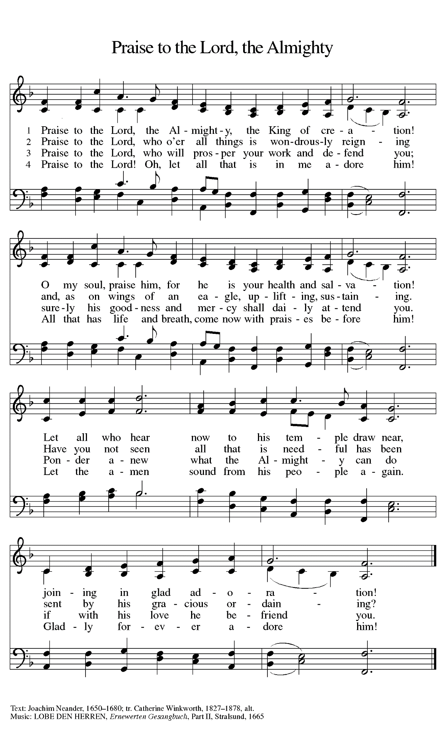
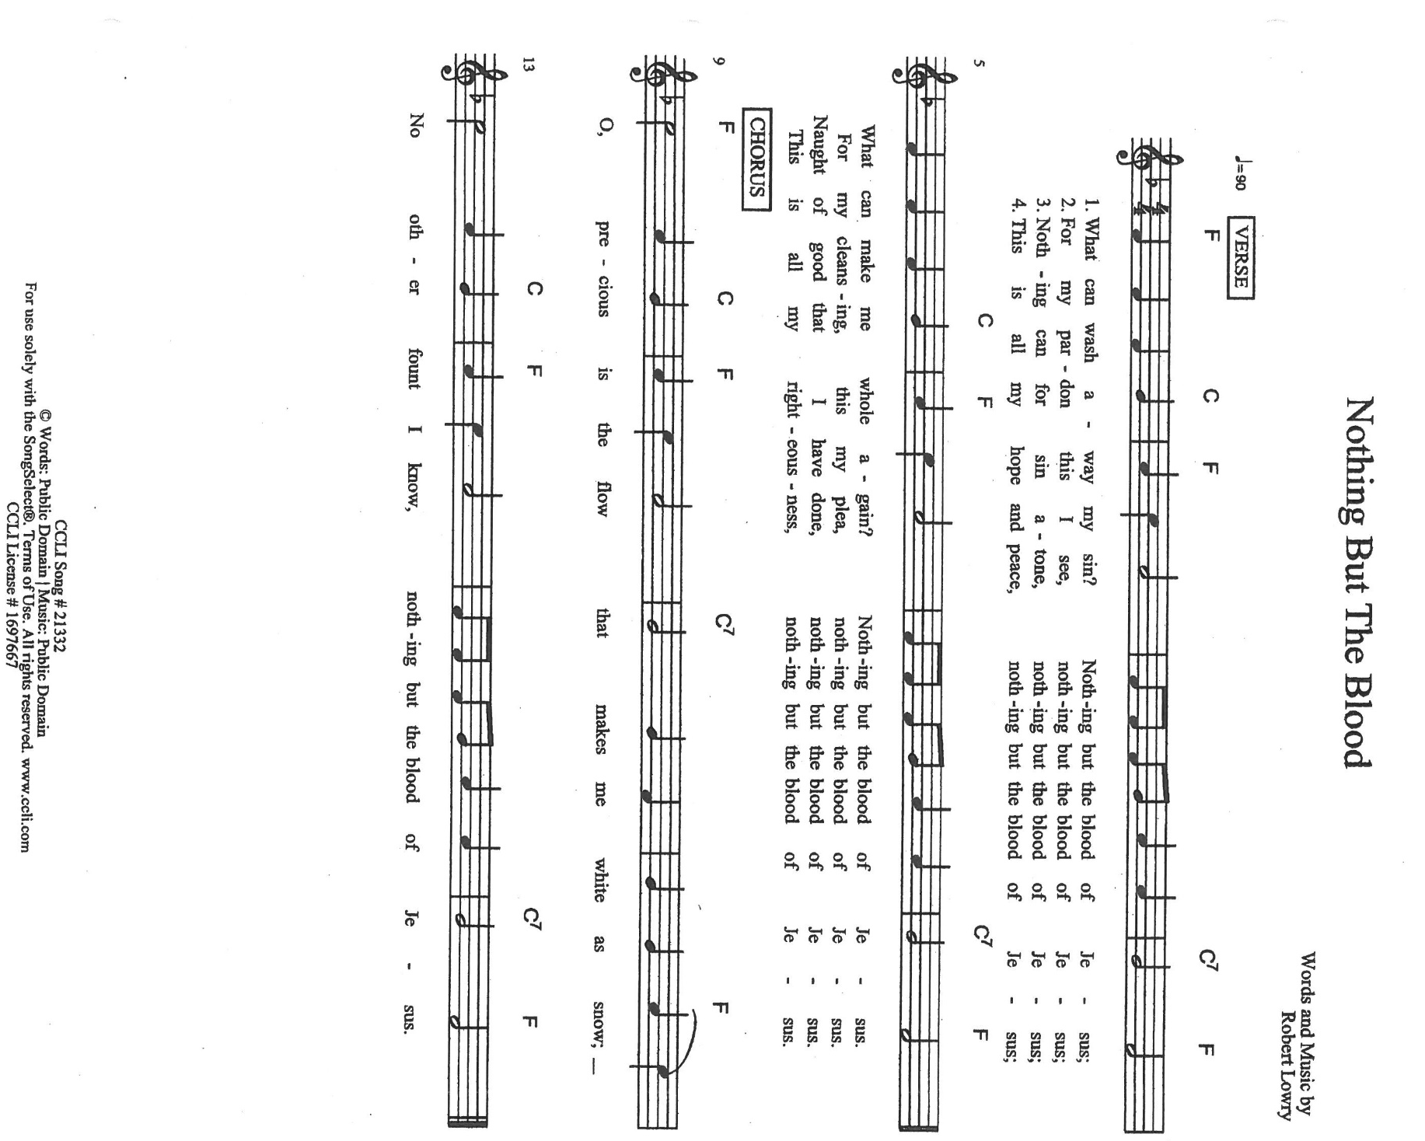

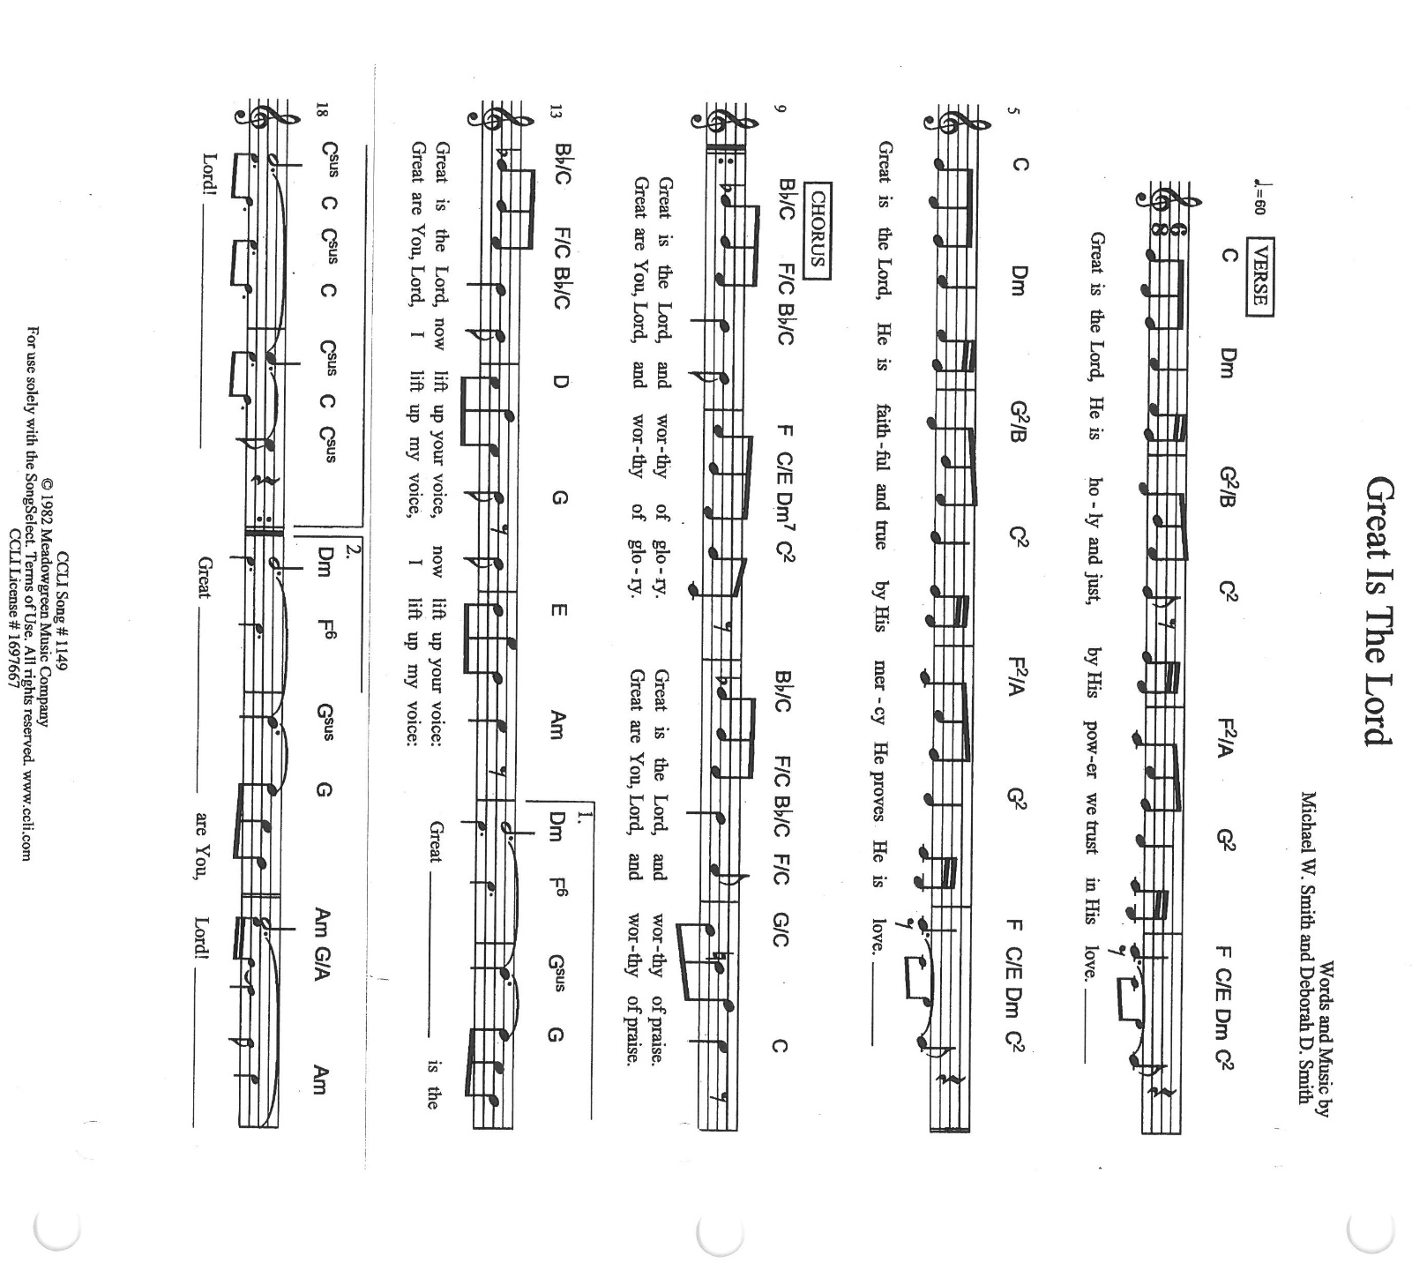

ANNOUNCEMENTS

Please remember to mail your offering to the Church Office at 818 Franklin Street, Michigan City, IN 46360. Another alternative is to give on-line through Tithe.ly. Please see your closure letter for information on how to set up a Tithe.ly account.

St. Paul Members are reminded to have a loved one contact the office if you are hospitalized. Many times, the Pastor doesn’t know someone is in the hospital. If you call and leave a message, please tell us which hospital the patient is at.

Next Sunday’s lessons are Isaiah 50: 4-9a; Psalm116: 1-9; James 3: 1-12; Mark 8: 27-38 for those of you who like to study them in advance.

BIRTHDAYS: Jean Coughlin (9/7); Verne Lee (9/7); Joan Seifert (9/8)
ANNIVERSARIES: Paul & Laura Brooks (9/6)

PRAYER CONCERNS: Kathy Thielman, Audrey Beyer, George Ottersen, Charles Thomas Sr, Joyce and Bethany Manning, Marla Furness, Christine Kiser, Delores Hackett, Kay Peglow, Lee Timm, Ryan Krueger, Donna Bostater, Diane Gielow, Jeff Jensen, Maxine Powell, Jess Kalvaitis, Pastor Al Lorentzen, Jan Paholski, Laura Dovey, Heidi Happel, Grant Houk, Shane Nevels, Elaine Gehring, Irene Bohnstadt, Joan Coughlin, Jim Tomscheck, Wally & Betty Ratliff, Laura Moore, Cameron Rackard, Erik Tannehill, Ruth Lubs, Ed Gustum and Ken Mulder.

If you requested someone’s name to be on the prayer list and are aware that they need continued imminent prayer then contact the church office and let us know. Otherwise we will gradually transfer names to the long-term list.

OFFICE HOURS: Libby will be in the office on Mondays, Wednesdays, and Fridays; volunteers will cover Tuesdays and Thursdays.
Monday & Wednesday 8:00 a.m. – 5 p.m.
Tuesday & Thursday 9:00 a.m. – 12:00 p.m.
Friday 8:00 a.m. – 12:00 p.m.
If you are listening to the worship broadcast on the radio and would like to watch it live stream but you aren’t on Facebook, follow these four steps:

1) Go to your search engine (Google, Bing, etc.).
2) Search for St. Paul Lutheran Church & School, Michigan City, Indiana
3) Click on the option for St. Paul Lutheran Church & School—Home/Facebook
4) Click on “Videos” in the menu on the left side of the screen.

That should take you to the former videos and there should be one with a little red box that says “LIVE.’ Click on that video to enlarge it.

We will continue to live stream/broadcast the Sunday morning service on our Facebook page, and it will always be available on the radio broadcast Sunday mornings at 11:00 a.m. on WEFM (95.9), and on the local cable access station #99 for the previous week’s service on Sundays at 4:00 p.m. and the current service on Wednesdays at 7:00 p.m. and Fridays at 8:30 p.m.

To send e-mail to the church office, please use the following addresses:
Pastor Mark Reshan: seniorpastor@stpaulmichigancity.com
Church Office Secretary (Libby Pollock): churchsecretary@stpaulmichigancity.com
Church Treasurer (Karen Fleming) and Bookkeeper (Billie Atchinson):
finance@stpaulmichigancity.com.

The Good News Newsletter: If you have an article or anything you want included in The Good News please send it to the following e-mail address: splcgoodnews@gmail.com. Pastor Pamela Thiede will be using this e-mail address to assemble The Good News each month. The deadline for getting information to Pastor Pamela will be the 20th of each month.

WORSHIP ATTENDANCE for August 28-29, 2021
4:00 p.m. 31
9:00 a.m. 49
Total = 80

LAPORTE COUNTY MEALS ON WHEELS needs YOU! A commitment of ONE hour per week can make a difference. Monday through Friday meal delivery is totally dependent on volunteers. Volunteers are needed in Michigan City, LaPorte, Westville, and South County routes NOW. Call 219-872-9117 in Michigan City or 219-369-6483 in LaPorte; or visit
www.laportecountymealsonwheels.org or find them on Facebook at LaPorte Co Meals on Wheels.

IMMEDIATE NEEDS Mondays Wednesdays

Substitute Drivers needed MC route 10 LaPorte/Rolling Prairie route
in MC & LP locations LaPorte Route 4

Thursdays
LaPorte Route 2

September Events and Meetings:

God’s Purls: Wednesday September 1, 2021 from 10:00am – Noon in the St. Paul Room
Worship Service: Saturday September 4, 2021 at 4:00pm

Worship Service: Sunday September 5, 2021 at 9:00am
September Give Back: Wednesday September 8, 2021 at Hacienda in Michigan City
Worship & Music: Wednesday September 8, 2021 at 6:00pm in the St. Paul Room
Choir Practice: Wednesday September 8, 2021 at 7:00 pm
Worship Service: Saturday September 11, 2021 at 4:00pm

Worship Service: Sunday September 12, 2021 at 9:00am
School Board: Monday September 13, 2021 at 3:30pm in the St. Paul Room
Worship Service: Saturday September 18, 2021 at 4:00pm

Worship Service: Sunday September 19, 2021 at 9:00am
Finance Committee: Monday September 20, 2021 at 4:00pm in the St. Paul Room
Choir Practice: Wednesday September 22, 2021 at 7:00pm
Church Council: Thursday September 23, 2021 at 5:30pm in the St. Paul Room
Worship Service: Saturday September 25, 2021 at 4:00pm

Worship Service: Sunday September 26, 2021 at 9:00am

Thank you to all who participated in the August Give Back Night at Galveston Steakhouse which brought in $250.00. We appreciate all who could make it!

Our next Give Back is at Hacienda in Michigan City on Wednesday September 8, 2021 from open until close of that day. Here are some coupons to start you off. And as always there will be extra coupons in the office until the day of event.

