**THE SIXTEENTH SUNDAY AFTER PENTECOST**

**September 12, 2021**

Christ speaks the truth when he makes a connection between the work of the cross and the denial of self. Peter speaks for all of us when he expresses his horror of the cross. We flee from the unspeakable gospel, we hide from the cross, and we escape to our many words about it, to our preachings of concern, liberation, and inclusivity.

We run to the enhancement of ourselves in the weary world of verbal religion, upon which the Christ invokes an injunction of silence. The unspeakable word flows out of silence. And it is out of silence that the unspeakable gospel flows. We have been sealed by the Holy Spirit and marked with the cross of Christ forever. The silent cross-word is anchored in our baptism. In baptism it is etched unto us as God leads us through death to life.

**Franklin A. Wilson**

“…No wonder Jesus recognizes in Peter’s rebuke the voice of the tempter and a spokesperson for the thinking of this world, not the realm that Jesus would soon rule from his peculiar throne. Jesus was about the head to Jerusalem, which his people wanted more than anything to become the capital of the world and the navel of the universe. What awaited him in Jerusalem would lead to a different sort of rule and capital than that. Which means Peter must get behind Jesus. There he would learn cross-bearing, otherwise known as heaven’s plan for taking over.

Peter wasn’t so much worried about Jesus as he was about himself, however, and the same goes for us. Even before the reminder that he belongs *behind* Jesus, not out ahead of him implementing a new administration’s empirical strategies, Peter knew deep down that Jesus led and he followed. But Jesus seemed headed straight into danger, pain, and death and would surely take Peter down with him. Sure enough, Jesus confirms that suspicion by the time this day’s conversation ends. If you want to come along, you must take up your cross and learn to give life away, not hoard it, hide it, and save it like some gift we can’t bear to share lest we end up with none for ourselves…”

“…What is cross-bearing for us? We easily enough think of the cross we bear for Christ in this world as the load of things in our own lives which are hurtful and unpleasant, like our financial woes, poor health, psychological depressions and stresses, insensitive spouses, or ungrateful children.

Christ’s cross, however, wasn’t some inevitable burden of his own that he chose to bear faithfully instead of shirking. No, he carried and endured one he did not have to bear. He chose to take it up for the sake of others. Hence, true cross-bearers in this world don’t so much bear the inevitable burden of their own poverty or want, but as people with plenty they choose to share the plight of the poor and hungry by doing something about it.

True cross-bearers may not have dread diseases such as AIDS but risk their own good health so as to take up the burden of the infected by risking whatever proximity it takes to help and comfort them. A cross-bearer is a family member with every good reason to write off that brother, sister, child or spouse who has made life miserable, but who instead chooses steps that might lead to reconciliation or bring true peace and wholeness to the family. Cross-bearers needn’t have anything to do with messy political situations in the world’s trouble spots or far away, but nevertheless risk reputations, careers, and even life itself.

Jesus bids Peter, and us, “Come die with me …”

**Frederick Niedner, Jr.**

***✠ In the Name of Jesus✠***

**INTRODUCTION**

*Three weeks ago we heard John’s gospel’s version of Peter’s confession of faith. This week we hear Mark’s version, when Peter says, “You are the Messiah.” In John, the stumbling block is Jesus’ invitation to eat his flesh, given for the life of the world. In Mark too the scandal has to do with Jesus’ words about his own coming death, and here Peter himself stumbles over Jesus’ words. But Jesus is anointed (the meaning of “messiah”) in Mark only on the way to the cross (14:3); so we are anointed in baptism with the sign of the cross.*

**John Chrysostom, Bishop of Constantinople, died 407**

*John was a priest in Antioch and an outstanding preacher. His eloquence earned him the nickname "Chrysostom" ("golden mouth"). Appointed bishop of Constantinople, seat of the empire, he criticized corruption in the court. As a result, he was exiled by the empress.*

**✠ GATHERING ✠**

**PRE-SERVICE MUSIC *Breathe* Praise Band**

**ANNOUNCEMENTS**

*As you are able please rise*

**GATHERING SONG NSB 70 *Open Our Eyes* PraiseBand page 9**

**(sing twice)**

**THE GREETING AND PRAYER OF THE DAY**

P: The grace of our Lord Jesus Christ, the love of God, and the communion of the Holy

Spirit be with you all.

C: **And also with you.**

P: Let us pray. O God, through suffering and rejection You bring forth our salvation.

Grant that for the sake of the Gospel we may turn from the lure of evil, take up our

cross, and follow Your Son, Jesus Christ, our Savior and Lord.

C: **Amen.**

*The assembly is seated*

**CHOIR ANTHEM  *Take Now My Voice* St. Paul Senior Choir**

**✠ WORD ✠**

**FIRST READING Isaiah 50:4-9a**

*The image of the servant of the Lord is one of the notable motifs in the book of Isaiah. Today’s reading describes the mission of the servant, whom early Christians associated with Jesus. Like Jesus, the servant does not strike back at his detractors but trusts in God’s steadfast love.*

4 The Lord God has given me

     the tongue of a teacher,

   that I may know how to sustain

     the weary with a word.

   Morning by morning He wakens—

     wakens my ear

     to listen as those who are taught.

5 The Lord God has opened my ear,

     and I was not rebellious,

     I did not turn backward.

6 I gave my back to those who struck me,

     and my cheeks to those who pulled out the beard;

   I did not hide my face

     from insult and spitting.

7 The Lord God helps me;

     therefore I have not been disgraced;

   therefore I have set my face like flint,

     and I know that I shall not be put to shame;

8 He Who vindicates me is near.

   Who will contend with me?

     Let us stand up together.

   Who are my adversaries?

     Let them confront me.

9a It is the Lord God Who helps me;

     who will declare me guilty?

A: The Word of the Lord.

C: **Thanks be God.**

**THE PSALM: Psalm 116:1-8 Read responsively**

1 I love the Lord, Who has heard my voice,

     and listened to my supplication,

2 **for the Lord has given ear to me**

**whenever I called.**

3 The cords of death entangled me; the anguish of the grave came upon me;

     I came to grief and sorrow.

4**Then I called upon the name of the Lord:**

**“O Lord, I pray You, save my life.”**

5 Gracious is the Lord and righteous;

     our God is full of compassion.

6 **The Lord watches over the innocent;**

**I was brought low, and God saved me.**

7 Turn again to your rest, O my soul.

     for the Lord has dealt well with you.

8 **For you have rescued my life from death,**

**my eyes from tears, and my feet from stumbling;**

9 I will walk in the presence of the Lord

     in the land of the living.

**SECOND READING James 3:1-12**

*This text uses various images to illustrate how damaging and hurtful the way we speak to and about others can be. Not only are we to control our speech, but what we say and how we say it is to reflect our faith.*

1 Not many of you should become teachers, my brothers and sisters, for you know that we who teach will be judged with greater strictness. 2 For all of us make many mistakes. Anyone who makes no mistakes in speaking is perfect, able to keep the whole body in check with a bridle. 3 If we put bits into the mouths of horses to make them obey us, we guide their whole bodies.

4 Or look at ships: though they are so large that it takes strong winds to drive them, yet they are guided by a very small rudder wherever the will of the pilot directs. 5So also the tongue is a small member, yet it boasts of great exploits.

How great a forest is set ablaze by a small fire! 6 And the tongue is a fire. The tongue is placed among our members as a world of iniquity; it stains the whole body, sets on fire the cycle of nature, and is itself set on fire by hell. 7 For every species of beast and bird, of reptile and sea creature, can be tamed and has been tamed by the human species, 8 but no one can tame the tongue—a restless evil, full of deadly poison.

9 With it we bless the Lord and Father, and with it we curse those who are made in the likeness of God. 10 From the same mouth come blessing and cursing. My brothers and sisters, this ought not to be so. 11 Does a spring pour forth from the same opening both fresh and brackish water? 12 Can a fig tree, my brothers and sisters, yield olives, or a grapevine figs? No more can salt water yield fresh.

A: The Word of the Lord.

C: **Thanks be to God.**

*As you are able please rise*

**THE VERSE page 5**

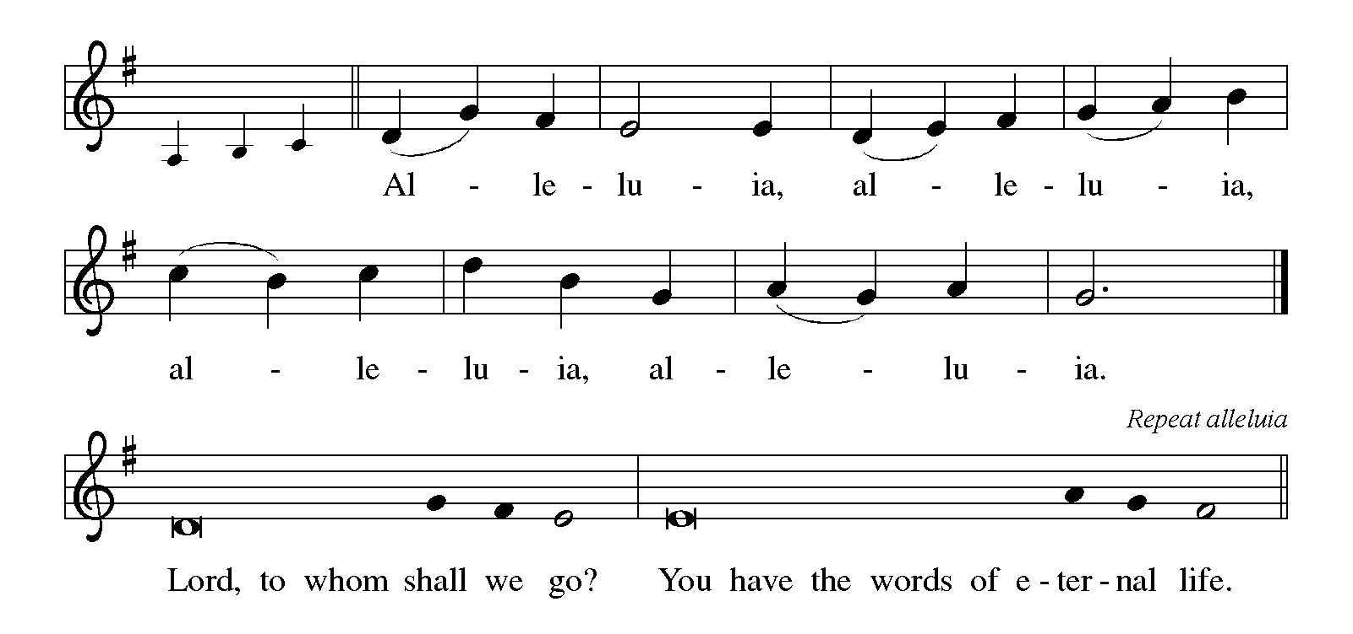

**THE HOLY GOSPEL Mark 8:27-35**

*This story provides the turning point in Mark’s gospel. Peter is the first human being in the narrative to acknowledge Jesus as the Messiah, but he cannot accept that as the Messiah Jesus will have to suffer. Moreover, Jesus issues a strong challenge to all by connecting discipleship and the cross.*

P: The Holy Gospel according to St. Mark, the eighth chapter.

C: **Glory to You, O Lord!**

27Jesus went on with His disciples to the villages of Caesarea Philippi; and on the way He asked His disciples, “Who do people say that I am?” 28 And they answered Him, “John the Baptist; and others, Elijah; and still others, one of the prophets.” 29 He asked them, “But who do you say that I am?” Peter answered Him, “You are the Messiah.” 30 And He sternly ordered them not to tell anyone about Him.

31 Then He began to teach them that the Son of Man must undergo great suffering, and be rejected by the elders, the chief priests, and the scribes, and be killed, and after three days rise again. 32 He said all this quite openly. And Peter took Him aside and began to rebuke Him. 33 But turning and looking at His disciples, He rebuked Peter and said, “Get behind Me, Satan! For you are setting your mind not on divine things but on human things.”

34 He called the crowd with His disciples, and said to them, “If any want to become My followers, let them deny themselves and take up their cross and follow Me. 35 For those who want to save their life will lose it, and those who lose their life for My sake, and for the sake of the gospel, will save it.

36 For what will it profit them to gain the whole world and forfeit their life? 37 Indeed, what can they give in return for their life? 38Those who are ashamed of Me and of My words in this adulterous and sinful generation, of them the Son of Man will also be ashamed when He comes in the glory of His Father with the holy angels.”

P: The Gospel of the Lord.

C: **Praise to You, O Christ!**

*The assembly is seated*

**THE SERMON**  **The Rev. Dr. Frederick Niedner**

*Silence for reflection follows the sermon*

*As you are able please rise*

**THE HYMN OF THE DAY 798 *Will You Come and Follow Me*  page 10**

**THE APOSTLES’ CREED**

A: God has made us His people through our Baptism into Christ. Living together in trust

and hope, we confess our faith.

C: **I believe in God, the Father almighty,**

**creator of heaven and earth.**

**I believe in Jesus Christ, His only Son, our Lord.**

**He was conceived by the power of the Holy Spirit**

**and born of the virgin Mary.**

**He suffered under Pontius Pilate**

**was crucified, died, and was buried.**

**He descended into hell.**

**On the third day He rose again.**

**He ascended into heaven,**

**and is seated at the right hand of the Father.**

**He will come again to judge the living and the dead.**

**I believe in the Holy Spirit,**

**the holy catholic Church,**

**the communion of saints,**

**the forgiveness of sins,**

**the resurrection of the body,**

**and the life everlasting. Amen.**

**THE PRAYER OF THE CHURCH**

A: Jesus calls us to give up our lives for others. That we may have the faith and trust to

live as Jesus did, let us pray for the Church, the world, and all those in need.

A: That all who confess Jesus as Lord and Messiah may take up the cross and follow Jesus

by sacrificing themselves for the sake of the Gospel, let us pray to the Lord:

C: **Lord, hear our prayer.**

A: That those in Louisiana, Mississippi, New York and New Jersey devastated by

Hurricane Ida; those in Haiti recovering from the earthquake and Ida; and those towns

and homes in California ravaged by wildfires would find ready help from relief

agencies, comfort in their grief, and strength and hope as they rebuild their lives and

homes, let us pray to the Lord:

C: **Lord, hear our prayer.**

A: That on this 20th anniversary weekend of the terrorist attacks on the World Trade Center

and the Pentagon those who yet seek to spread chaos and destruction would be defeated

through the power of God’s mighty Spirit of peace, let us pray to the Lord:

C: **Lord, hear our prayer.**

A: That those who experience society’s rejection and persecution because of race, creed,

or gender may be vindicated by the God of justice Who hears their cry, let us pray to

the Lord:

C **Lord, hear our prayer.**

A: That this community’s profession of faith in Jesus the Messiah may take flesh in

practical works of charity for those in need to lighten their burdens, let us pray to the

Lord:

C: **Lord, hear our prayer.**

A: That those who lack food and clothing, the homeless, the addicted, the unemployed,

and the sick, especially … may be helped, healed, and restored by God’s deep

compassion, let us pray to the Lord:

C: **Lord, hear our prayer.**

A: That those celebrating birthdays, especially **Bob Pheanis and Kay Peglow;** and

anniversaries, especially **Al and Sue Green,** **Pamela and Richard Henderson and**

**Don and Beth Thompson** may grow in grace this day and every day and be filled with

grace for the days ahead, let us pray to the Lord:

C: **Lord, hear our prayer.**

A: That those who mourn, especially the family and friends of **Ryan Cross,** first grade

student at our school and brother of second grade teacher Tonya Moore, who died in

the Lord this week, may be comforted by our loving Father Who lost His own Son to

death, and by the promise of resurrection to life everlasting and being reunited with

those they love before the throne of the Lamb, let us pray to the Lord:

C: **Lord, hear our prayer.**

A: That with the faithful departed, especially **John Chrysostom, Bishop of**

**Constantinople,** whom we commemorate this Day, whose lives on earth were spent in

service to Christ, we may follow Jesus to the everlasting life He promises, let us pray

to the Lord:

C: **Lord, hear our prayer.**

P: Hear our prayers, O merciful God, and accept our praises. May the Gospel of Your

cross give its abundant life to all the world, through Jesus Christ, Your Son and our

Lord.

C: **Amen.**

**THE PEACE**

P: The peace of the Lord be with you always.

C: **And also with you.**

**THE LORD’S PRAYER**

P: Because in Christ we have received the Spirit of adoption, as daughters and sons of God

we dare to pray:

C: **Our Father, Who art in heaven, hallowed be Thy Name.**

**Thy Kingdom come, Thy will be done on earth as it is in heaven.**

**Give us this day our daily bread, and forgive us our trespasses as we forgive those**

**Who trespass against us.**

**And lead us not into temptation, but deliver us from evil.**

**For Thine is the Kingdom, and the power, and the glory, forever and ever. Amen.**

**✠ SENDING ✠**

**THE BENEDICTION**

P: Almighty God: Father, Son, ✠ and Holy Spirit bless you now and forever.

C: **Amen.**

**THE SENDING HYMN 733 *Great is Thy Faithfulness*  page 11**

**THE DISMISSAL**

A: Go in peace to bear Christ’s love to the world.

C: **Thanks be to God!**

**POSTLUDE *Trumpet Tune*  Marko Hakanpaa**

***✠ To God Alone Be Glory✠***

The Meditation is from *Sundays and Seasons Online.* Copyright Augsburg Fortress 2015;

and The Liturgical Institute, 2003.

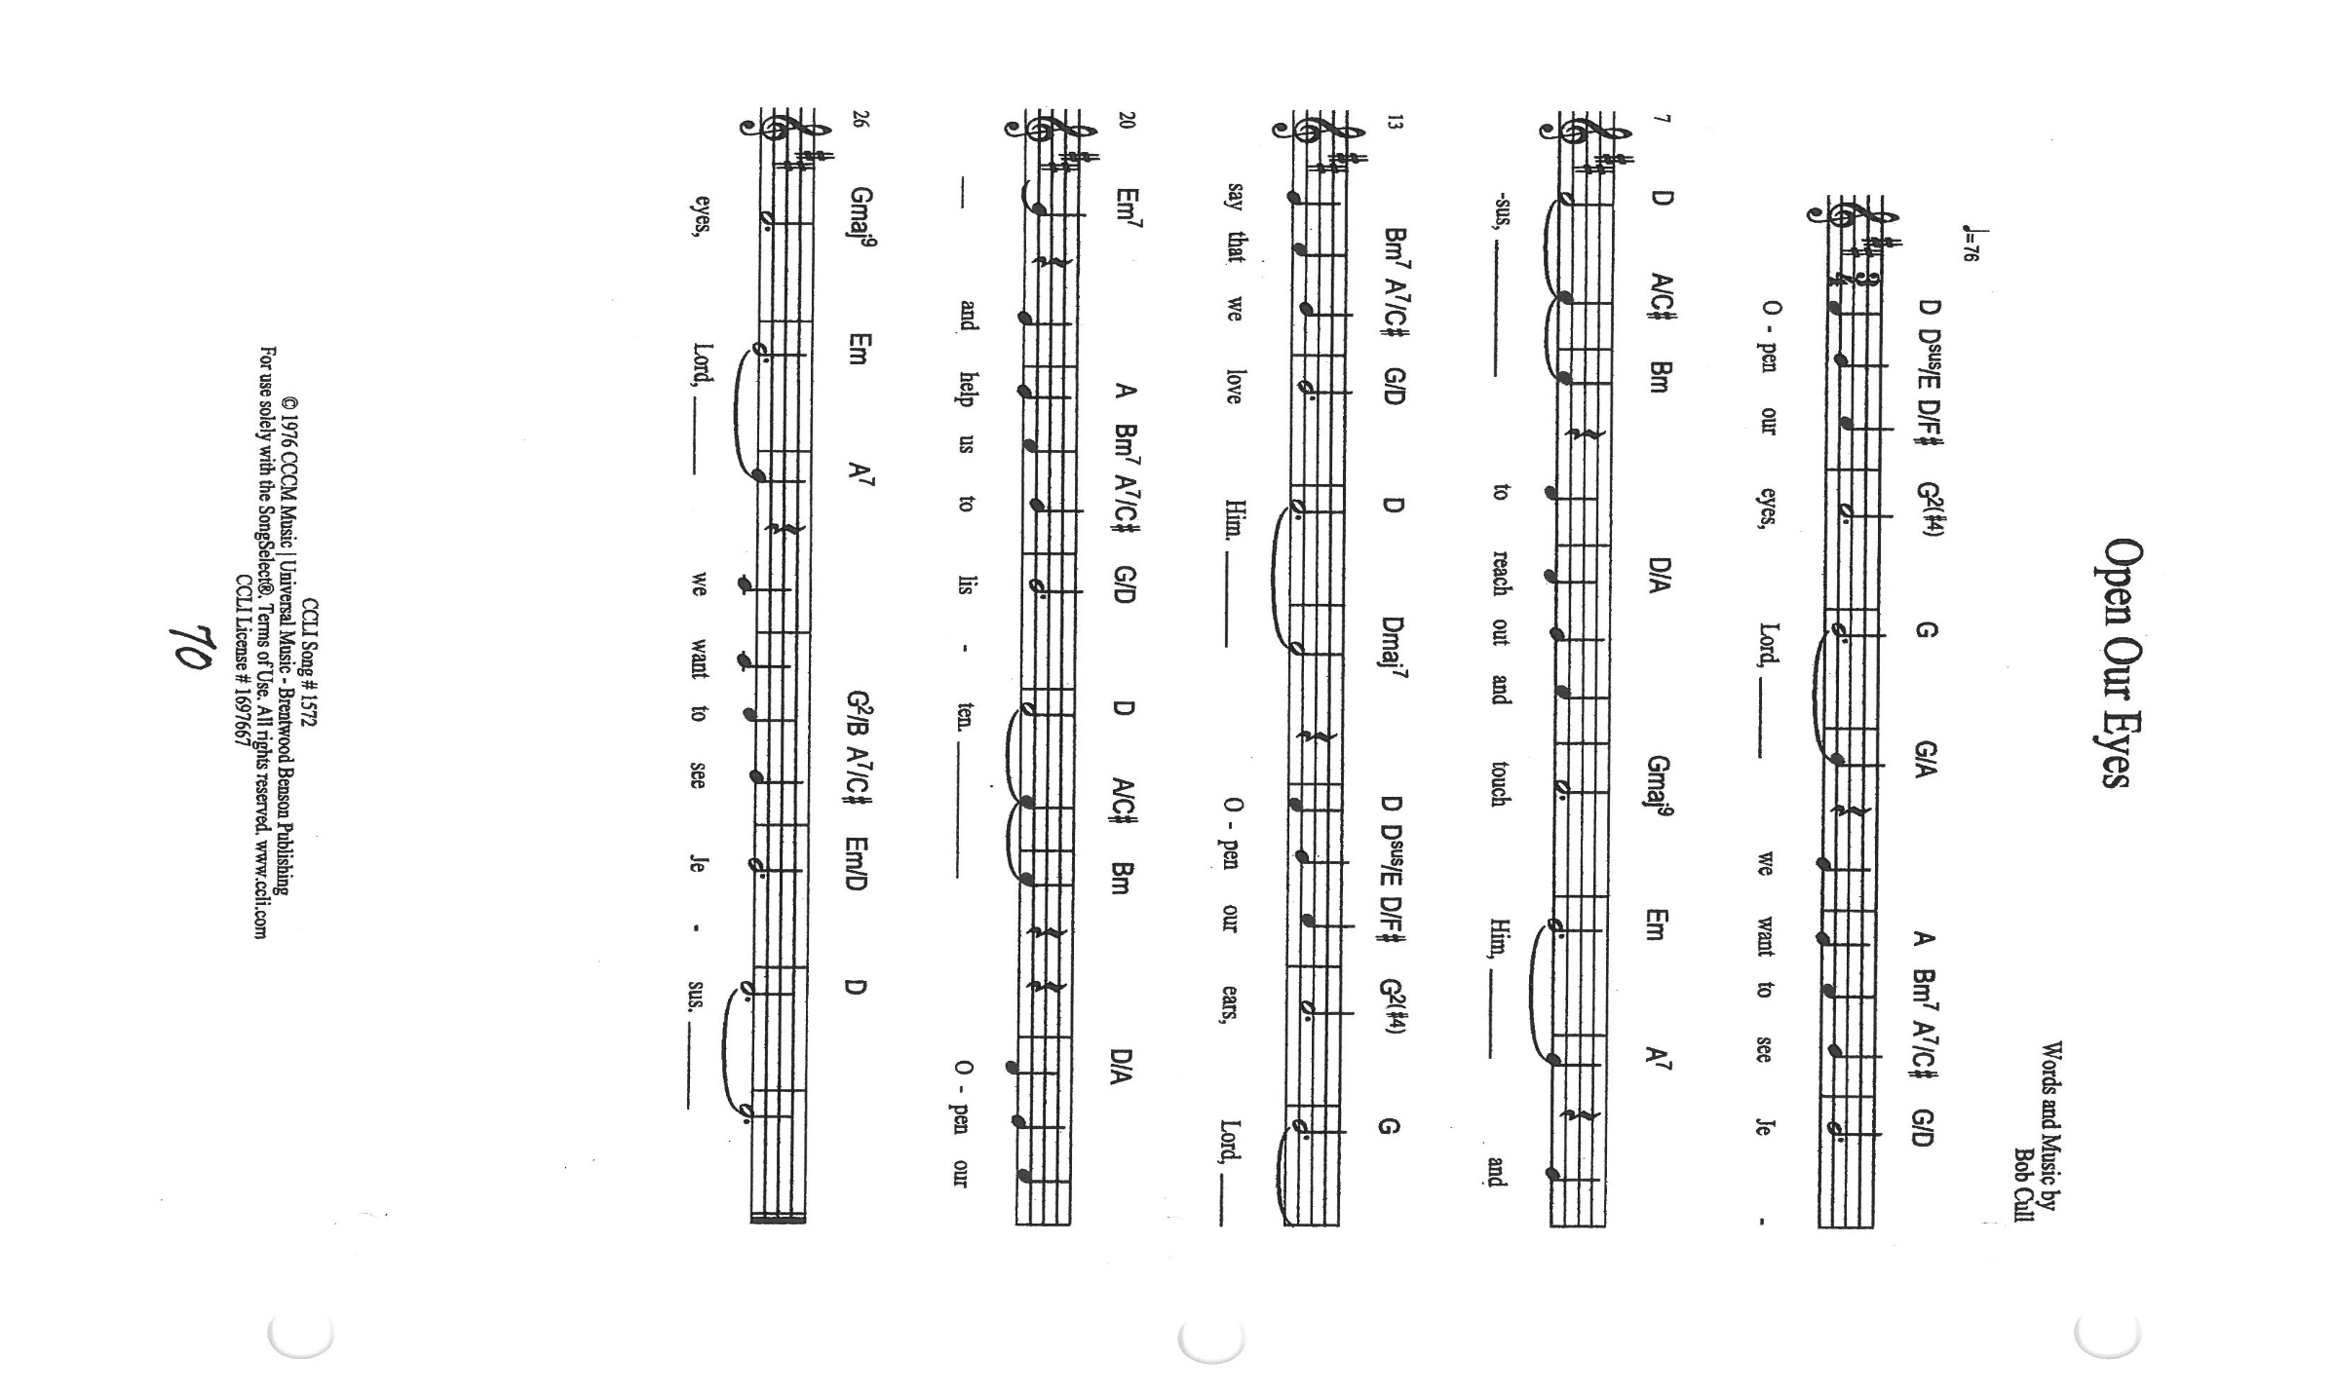

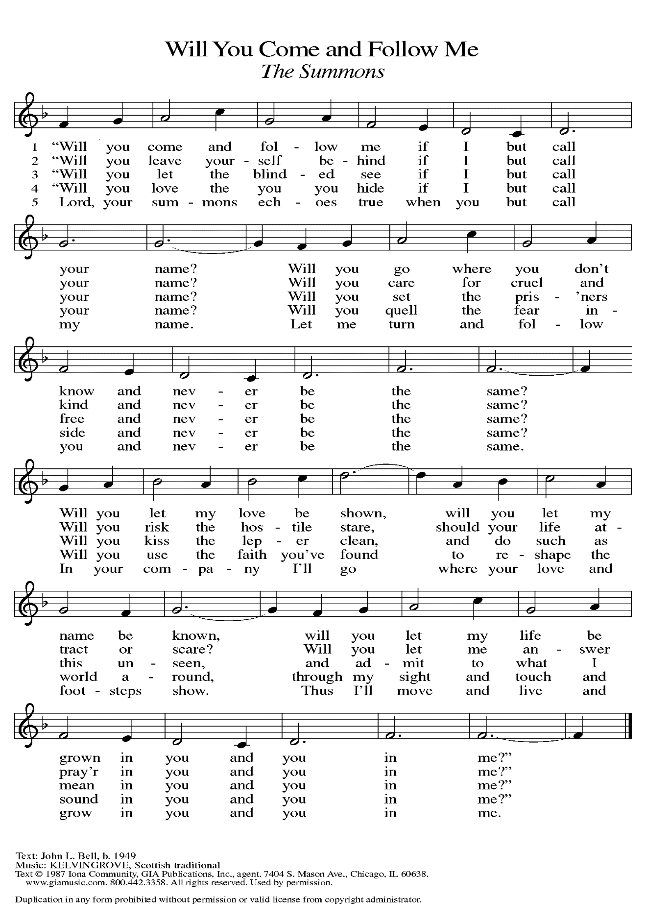

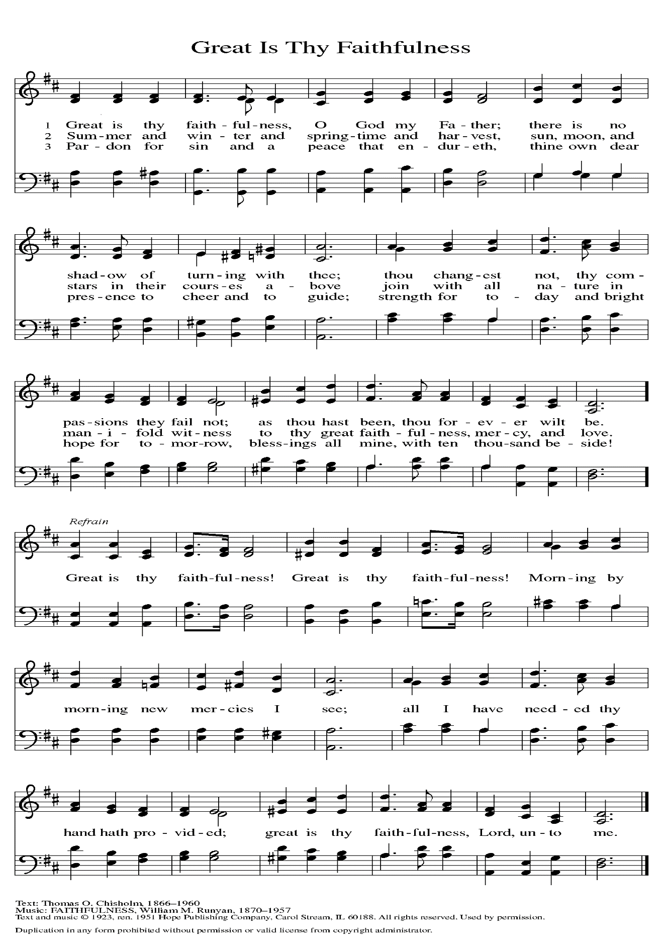

**ANNOUNCEMENTS**

**One of our first-grade students, Ryan Cross from our school** died tragically in an accident over Labor Day weekend. He was also the younger brother of our second-grade teacher, Ms. Taylor Moore. We are setting up a fund to assist the family in this time of great sorrow and need. You may contribute either by cash or check. Please make checks out to St. Paul Lutheran Church and designate it as a memorial to the Moore family. If you are donating cash please also identify your gift for this memorial fund. Thank you for your compassion and generosity.

**Special Thanks to Pastor Tim Diemer and The Rev. Dr. Frederick Niedner, Jr.** for filling in for Pastor Reshan this weekend and leading worship for us.

**Please remember to mail your offering to the Church Office** at 818 Franklin Street, Michigan City, IN 46360**.** Another alternative is to give on-line through Tithe.ly. Please see your closure letter for information on how to set up a Tithe.ly account.

**St. Paul Members are reminded to have** a loved one contact the office if you are hospitalized. Many times, the Pastor doesn’t know someone is in the hospital. If you call and leave a message, please tell us which hospital the patient is at.

**Next Sunday’s lessons are Jeremiah 11: 18-20; Psalm 54; James 3: 13-4: 3, 7-8a; Mark 9: 30-37** for those of you who like to study them in advance.

**BIRTHDAYS: Robert Pheanis (9/14); Kay Peglow (9/19)**

**ANNIVERSARIES: Al & Sue Green (9/15); Pamela & Richard Henderson (9/15); Don & Elizabeth Thompson (9/19)**

**PRAYER CONCERNS:** Kathy Thielman, Audrey Beyer, George Ottersen, Charles Thomas Sr, Joyce and Bethany Manning, Marla Furness, Christine Kiser, Delores Hackett, Kay Peglow, Lee Timm, Ryan Krueger, Donna Bostater, Diane Gielow, Jeff Jensen, Maxine Powell, Jess Kalvaitis, Pastor Al Lorentzen, Jan Paholski, Laura Dovey, Heidi Happel, Grant Houk, Shane Nevels, Irene Bohnstadt, Joan Coughlin, Jim Tomscheck, Wally & Betty Ratliff, Laura Moore, Cameron Rackard, Erik Tannehill, Ruth Lubs, Ed Gustum and Ken Mulder.

**If you requested someone’s name to be on the prayer list and are aware that they need continued imminent prayer then contact the church office and let us know.** Otherwise we will gradually transfer names to the long-term list.

**OFFICE HOURS:** Libby will be in the office on Mondays, Wednesdays, and Fridays; volunteers will cover Tuesdays and Thursdays.

Monday & Wednesday 8:00 a.m. – 5 p.m.

Tuesday & Thursday 9:00 a.m. – 12:00 p.m.

Friday 8:00 a.m. – 12:00 p.m.

**If you are listening to the worship broadcast on the radio and would like to watch it live stream but you aren’t on Facebook,** follow these four steps:

1) Go to your search engine (Google, Bing, etc.).

2) Search for St. Paul Lutheran Church & School, Michigan City, Indiana

3) Click on the option for St. Paul Lutheran Church & School—Home/Facebook

4) Click on “Videos” in the menu on the left side of the screen.

That should take you to the former videos and there should be one with a little red box that says “LIVE.’ Click on that video to enlarge it.

We will continue to live stream/broadcast the Sunday morning service on our Facebook page, and it will always be available on the radio broadcast Sunday mornings at 11:00 a.m. on WEFM (95.9), and on the local cable access station #99 for the previous week’s service on Sundays at 4:00 p.m. and the current service on Wednesdays at 7:00 p.m. and Fridays at 8:30 p.m.

**To send e-mail to the church office**, please use the following addresses:

 Pastor Mark Reshan: [seniorpastor@stpaulmichigancity.com](mailto:seniorpastor@stpaulmichigancity.com)

 Church Office Secretary (Libby Pollock): [churchsecretary@stpaulmichigancity.com](mailto:churchsecretary@stpaulmichigancity.com)

 Church Treasurer (Karen Fleming) and Bookkeeper (Billie Atchinson):

[finance@stpaulmichigancity.com](mailto:finance@stpaulmichigancity.com).

**The Good News Newsletter**: If you have an article or anything you want included in **The Good News** please send it to the following e-mail address: splcgoodnews@gmail.com. Pastor Pamela Thiede will be using this e-mail address to assemble **The Good News** each month. The deadline for getting information to Pastor Pamela will be the 20th of each month.

**WORSHIP ATTENDANCE for September 4-5, 2021**

**4:00 p.m. 23**

**9:00 a.m. 46**

**Total = 69**

**2021 Financial Stewardship**

Weekly Church Operating Needs (x 2 weeks): $14,116.36

August 14-15, and August 21-22, 2021

General Fund (including General Memorials): $ 6,710.50

Overage/Shortage: --$ 7,405.86

Restricted Income (not including Memorials)

Supports IK Synod & Churchwide Ministries: $247.00

Ministries in our Community/Congregation: $ 60.00

Capital Fund: $452.50

General Fund $ 10.00

**Crusader Fund $ 275.00**

**September Events and Meetings:**

Worship Service: Saturday September 11, 2021 at 4:00pm

Worship Service: Sunday September 12, 2021 at 9:00am

School Board: Monday September 13, 2021 at 3:30pm in the St. Paul Room

Worship Service: Saturday September 18, 2021 at 4:00pm

Worship Service: Sunday September 19, 2021 at 9:00am

Finance Committee: Monday September 20, 2021 at 4:00pm in the St. Paul Room

Choir Practice: Wednesday September 22, 2021 at 7:00pm

Church Council: Thursday September 23, 2021 at 5:30pm in the St. Paul Room

Worship Service: Saturday September 25, 2021 at 4:00pm

Worship Service: Sunday September 26, 2021 at 9:00am

**BENEFIT FOR ERIK TANNEHILL**

On Saturday, September 25, from 10:00 a.m.-2:00 p.m., together with the members of First Presbyterian Church and First United Methodist Church, we will hold a benefit for our own Erik Tannehill. Erik continues to oversee the Soup Kitchen ministry, currently operating out of First United Methodist. Because of some health issues and a recent hospitalization, his own income stream from his catering business and the operation of his Melt Restaurant in La Porte has been interrupted.

We would like to raise some money to help him and his family, so this benefit has been put together. **To simplify the bookkeeping for the event if you would like to contribute to the fund please make the check out to Erik directly.** It will be held in the parking lot of First United Methodist and will include a car show, entertainment from the Hoosier Star program, and the sale of food and refreshments. Sloppy Joes will be provided by The Stadium Inn, we will sell hot dogs and chips, and there will be other food selections and desserts for sale.

Parking will be held in our lot since First United Methodist’s will be filled with the car show. As we did for the Taste of Michigan City and the Boat Parade and races, we will charge $5 for parking with the proceeds going to the fund for Erik.

Volunteers are needed for our parking; help with preparing and selling the food items; and setting up and taking down tables, chairs, and other equipment. To help, contact the church office

at 219-874-7293.