**THE SIXTEENTH SUNDAY AFTER PENTECOST**

**September 8, 2024**

That Christians pray for recovery of their sick and proclaim to them God’s healing will is itself too natural to require justification. The New Testament, moreover, sets sickness and recovery in a specific context. Bodily disaster, as the one unavoidable reminder of death, is understood as a central fact and a betraying signal of creation’s bondage to evil. Jesus’ proclamation of the imminence of God’s victory, a proclamation so urgent as itself already to liberate from evil, therefore became visible especially as healing (Mark 5-6)…Thus Jesus’ healings were very precisely *sacraments* of the coming kingdom …

…Surely what we find, for our situation, in the New Testament is *permission* to do what we anyway want to do: pray for the recovery of our sick and assure them of the efficacy of such prayer, and do both in the specific context of the church’s mission against creation’s bondage, in which illness is more than misfortune and healing is a sign of the gospel’s future triumph.

To such prayer and assurance the New Testament attaches the promise of healing, in that total sense which encompasses physical recovery as its visible aspect.

**Robert W. Jenson**

**✠ *In the Name of Jesus* ✠**

**INTRODUCTION**

*In today's gospel Jesus heals a deaf and mute man using the word ephphatha, which means "be opened." The author of James exhorts the community of faith to guard against favoritism among its members. In baptism we have died to any distinctions that would separate us from each other. Likewise, in the eucharist each one receives the free gift of Christ equally and without discrimination. Through word and sacrament God opens our minds and hearts to the healing and liberating gospel of Christ.*

*Today is the commemoration of* **Peter Claver,** *priest and missionary to Columbia, who died in 1654. He served in what is now Colombia by teaching and caring for the slaves brought there for labor. They arrived in ships where they had been confined in dehumanizing conditions. He supplied them with medicine, food and clothing. He learned their dialects and taught them Christianity.*

**✠ GATHERING ✠**

**PRE-SERVICE MUSIC Praise Adonai St. Paul Praise Band**

**(Paul Baloche)**

**ANNOUNCEMENTS**

As you are able please rise

**CONFESSION AND ABSOLUTION**

P: In the name of the Father and of  **✠** the Son and of the Holy Spirit.

**C: Amen.**

P: “Happy are they who have the God of Jacob for their help, whose hope is in the LORD their

God ...” (Psalm 146: 4) Confessing our sins, let us turn to our God for help, hope, and

forgiveness in our time of need.

*Silence for self-examination and reflection is kept*

P: Most merciful God,

**C: We confess that we have sinned against You in thought, word, and deed. We have not**

**loved You with our whole heart nor our neighbors as ourselves. (James 2: 8) We have**

**not always shown mercy to those in need. (2: 13) We have ignored the cries of the poor,**

**those treated with injustice, and the hungry. (2: 6) We are partial to those with power**

**and who can help us. Often our “faith” lacks “works.” (2: 14) For the sake of Your Son,**

**Jesus Christ, have mercy on us. Free us for faithful living toward You and loving service**

**toward our neighbor.**

P: “Say to those of a fearful heart, ‘Be strong, do not fear! Here is your God ... He will come to

save you.” (Isaiah 35: 4) God indeed comes with a Word of salvation and hope: as a called

and ordained minister of the Church of Christ, and by His authority, I therefore declare to you

the entire forgiveness of all your sins, in the name of the Father and of **✠** the Son and of the

Holy Spirit.

**C: Amen.**

**GATHERING SONG NSB 45 *He Who Began a Good Work in You***

**THE GREETING AND PRAYER OF THE DAY**

P: The grace of our Lord Jesus Christ, the love of God, and the communion of the Holy Spirit be

with you all.

**C: And also with you.**

P: Let us pray. Gracious God, throughout the ages You transform sickness into health and death

into life. Open us to the power of Your presence, and make us as a people ready to proclaim

Your promises to the whole world, through Jesus Christ, our Healer and Lord.

**C: Amen.**

*The assembly is seated*

**✠ WORD ✠**

**FIRST READING Isaiah 35: 4-7a**

*These verses arise as a word of hope to the exiles in Babylon. Chapter 34 portrays God's vengeance on Edom, Israel's age-old enemy, which makes the path from Babylon to Zion safe for the exiles' return. This chapter concludes with a description of the highway home, the holy way of God's people, blossoming with God's glory.*

Say to those who are of a fearful heart,

"Be strong, do not fear!

Here is your God.

He will come with vengeance,

with terrible recompense.

He will come and save you."

5Then the eyes of the blind shall be opened,

and the ears of the deaf unstopped;

6then the lame shall leap like a deer,

and the tongue of the speechless sing for joy.

For waters shall break forth in the wilderness,

and streams in the desert;

7athe burning sand shall become a pool,

and the thirsty ground springs of water.

The Word of the Lord.

**Thanks be to God.**

**THE PSALM: Psalm 146** **Read responsively**

1Hallelujah!

     Praise the LORD, O my soul!

**2I will praise the LORD as long as I live;**

**I will sing praises to my God while I have my being.**

3Put not your trust in rulers,

     in mortals in whom there is no help.

**4When they breathe their last, they return to earth,**

**and in that day their thoughts perish.**

5Happy are they who have the God of Jacob for their help,

     whose hope is in the LORD their God;

**6Who made heaven and earth, the seas, and all that is in them;**

**Who keeps promises forever;**

7Who gives justice to those who are oppressed,

and food to those who hunger.

     The LORD sets the captive free.

**8The LORD opens the eyes of the blind;**

**the LORD lifts up those who are bowed down;**

**the LORD loves the righteous.**

9The LORD cares for the stranger;

     the LORD sustains the orphan and widow,

     but frustrates the way of the wicked.

**10The LORD shall reign forever,**

**your God, O Zion, throughout all generations. Hallelujah!**

**SECOND READING James 2: 1-17**

*The epistle of James is written to Christians who may have misunderstood the teaching that salvation comes by faith rather than by doing good works. James insists that true faith shows itself in action.*

My brothers and sisters, do you with your acts of favoritism really believe in our glorious Lord Jesus Christ? 2For if a person with gold rings and in fine clothes comes into your assembly, and if a poor person in dirty clothes also comes in, 3and if you take notice of the one wearing the fine clothes and say, "Have a seat here, please," while to the one who is poor you say, "Stand there," or, "Sit at my feet," 4have you not made distinctions among yourselves, and become judges with evil thoughts? 5Listen, my beloved brothers and sisters. Has not God chosen the poor in the world to be rich in faith and to be heirs of the kingdom that He has promised to those who love Him? 6But you have dishonored the poor. Is it not the rich who oppress you? Is it not they who drag you into court? 7Is it not they who blaspheme the excellent name that was invoked over you?

8You do well if you really fulfill the royal law according to the scripture, "You shall love your neighbor as yourself." 9But if you show partiality, you commit sin and are convicted by the law as transgressors. 10For whoever keeps the whole law but fails in one point has become accountable for all of it. 11For the One Who said, "You shall not commit adultery," also said, "You shall not murder." Now if you do not commit adultery but if you murder, you have become a transgressor of the law. 12So speak and so act as those who are to be judged by the law of liberty. 13For judgment will be without mercy to anyone who has shown no mercy; mercy triumphs over judgment.

14What good is it, my brothers and sisters, if you say you have faith but do not have works? Can faith save you? 15If a brother or sister is naked and lacks daily food, 16and one of you says to them, "Go in peace; keep warm and eat your fill," and yet you do not supply their bodily needs, what is the good of that? 17So faith by itself, if it has no works, is dead.

The Word of the Lord.

**Thanks be to God.**

*As you are able please rise*

**THE VERSE**

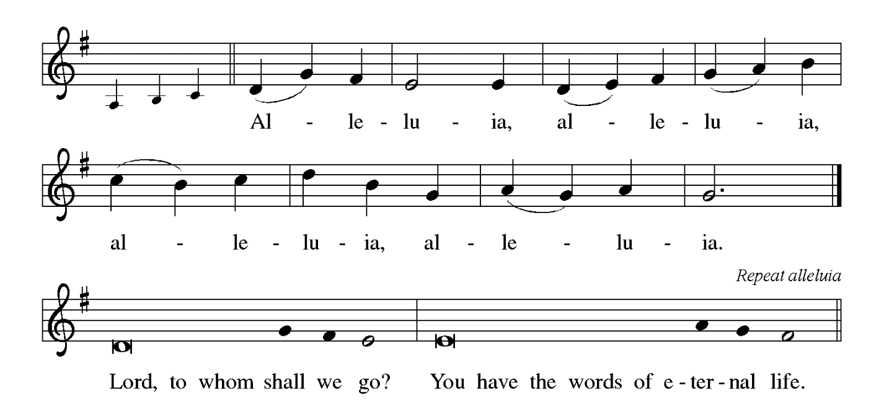

**THE HOLY GOSPEL Mark 7: 24-37**

*In Mark’s Gospel, encounters with woman usually signify turning points in Jesus’ ministry. Here, a conversation with a Syrophoenician woman marks the beginning of His mission to the Gentiles.*

P: The Holy Gospel according to St. Mark, the seventh chapter.

**C: Glory to You, O Lord!**

Jesus set out and went away to the region of Tyre. He entered a house and did not want anyone to know He was there. Yet He could not escape notice, 25but a woman whose little daughter had an unclean spirit immediately heard about Him, and she came and bowed down at His feet. 26Now the woman was a Gentile, of Syrophoenician origin. She begged Him to cast the demon out of her daughter.

27He said to her, "Let the children be fed first, for it is not fair to take the children's food and throw it to the dogs." 28But she answered Him, "Sir, even the dogs under the table eat the children's crumbs." 29Then He said to her, "For saying that, you may go--the demon has left your daughter." 30So she went home, found the child lying on the bed, and the demon gone.

31Then He returned from the region of Tyre, and went by way of Sidon towards the Sea of Galilee, in the region of the Decapolis. 32They brought to Him a deaf man who had an impediment in his speech; and they begged Him to lay His hand on him. 33He took him aside in private, away from the crowd, and put His fingers into his ears, and He spat and touched his tongue.

34Then looking up to heaven, He sighed and said to him, "Ephphatha," that is, "Be opened." 35And immediately his ears were opened, his tongue was released, and he spoke plainly. 36Then Jesus ordered them to tell no one; but the more He ordered them, the more zealously they proclaimed it. 37They were astounded beyond measure, saying, "He has done everything well; He even makes the deaf to hear and the mute to speak."

P: The Gospel of the Lord.

**C: Praise to You, O Christ!**

*The assembly is seated*

**THE SERMON** *Silence for reflection follows the sermon*

*As you are able please rise*

**HYMN OF THE DAY 612 *Healer of Our Every Ill***

**THE APOSTLES’ CREED**

A: God has made us His people through our Baptism into Christ. Living together in trust and

hope, we confess our faith.

**C:** **I believe in God, the Father almighty,**

**creator of heaven and earth.**

**I believe in Jesus Christ, His only Son, our Lord.**

**He was conceived by the power of the Holy Spirit**

**and born of the virgin Mary.**

**He suffered under Pontius Pilate**

**was crucified, died, and was buried.**

**He descended into hell.**

**On the third day He rose again.**

**He ascended into heaven,**

**and is seated at the right hand of the Father.**

**He will come again to judge the living and the dead.**

**I believe in the Holy Spirit,**

**the holy catholic Church,**

**the communion of saints,**

**the forgiveness of sins,**

**the resurrection of the body,**

**and the life everlasting. Amen.**

**THE PRAYER OF THE CHURCH**

A: God calls us today to be open to the Word and to one another. Seeking the wisdom of God’s

ways, let us pray for the Church, the world, and all those in need.

A: That the Church may faithfully bring God’s Word of life and hope to all in silence, darkness,

and despair, let us pray to the Lord:

**C: Lord, have mercy.**

A: That those who work for peace in war-torn countries and places of bloodshed, especially Syria,

Yemen, Myanmar, and Indonesia may be strong in their wisdom and resolve, let us pray to the

Lord:

**C: Lord, have mercy.**

A: That those in the healing professions who search for cures and those who attend to the sick

might be strengthened for their tasks, let us pray to the Lord:

**C: Lord, have mercy.**

A: That the sick and shut-in, especially: **Mark Tannehill; Ken Baker; Venia Wendt; Russ**

**Fischer; Christine Kiser; Debbie Martin; Kathy Stein; and Cathy Martin** may find

comfort and healing, let us pray to the Lord:

**C: Lord, have mercy.**

A: That those celebrating birthdays, especially **Joan Seifert and Bob Pheanis;** and anniversaries,

especially **Al and Sue Green** may grow in grace this day and every day and be filled with

grace for the days ahead, let us pray to the Lord:

**C: Lord, have mercy.**

A: That with all those who have gone before us in the faith, especially **Peter Claver, priest and**

**missionary to Colombia,** whom we commemorate this Day we may one day share in God’s

everlasting glory, let us pray to the Lord:

**C: Lord, have mercy.**

P: Receive our prayers, O God, and strengthen us in our desire to speak Your truth and serve our

sisters and brothers in love; through Jesus Christ our Lord.

**C: Amen.**

**✠ MEAL ✠**

**THE PEACE**

P: The peace of the Lord be with you always.

**C: And also with you.**

*The assembly is seated*

**THE VOLUNTARY *God Will Make a Way* St. Paul Praise Band**

**(Don Moen)**

**THE OFFERING**

*As you are able please rise*

**THE PRESENTATION OF GIFTS 531 *The Trumpet Sounds, the Angels Sing***

**(stanzas 1, 3)**

**THE OFFERTORY PRAYER**

A: Let us pray. Great and holy God.

**C: You have set before us the Food of life, the Body and Blood of Your Son, Jesus Christ.**

**In grateful response, we bring You these gifts of our labor and love. By this holy**

**Sacrament, may we be opened to Your power and grace. We ask this in the name of**

**Jesus the Lord. Amen.**

**THE GREAT THANKSGIVING**

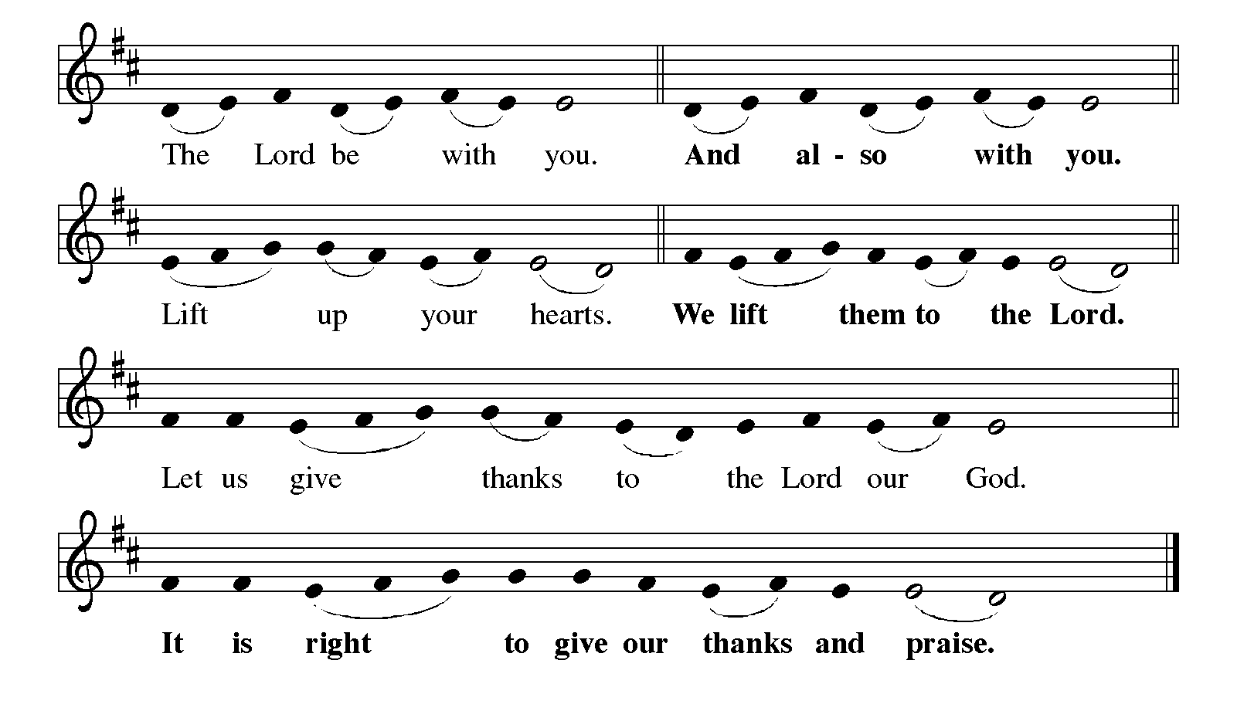

P: It is our duty and delight … and join their unending hymn:

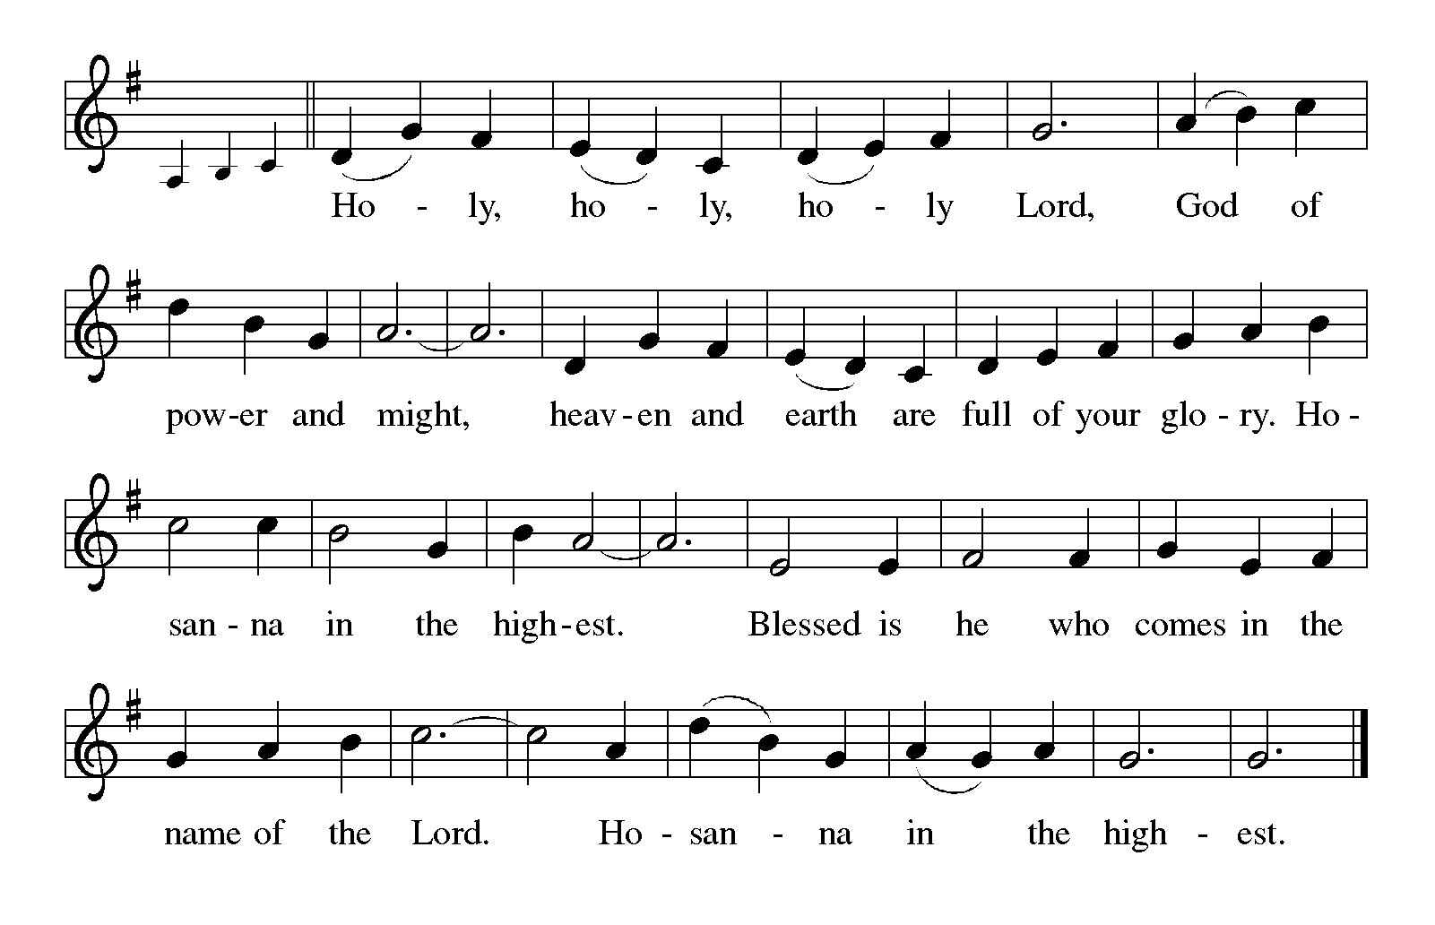

P: Holy God, we lift our hearts to thank You, because You open our ears to hear Your voice

and release our tongue to sing Your praise.

You created the earth as a place of encounter between You and Your creatures.

You called Your people from slavery and wilderness to covenant and abundant life.

You gave Your children manna to share, and from the crumbs that fell from their table

You made a banquet to welcome all nations to the joy of Your companionship.

You made the Body of Your crucified and risen Son the altar of Your mercy and of our

redemption.

Life-giving God, You share Your bread with the poor, and You make this banquet the place

where in the power of Your Spirit we are united as one Body in Your Son.

Make this Meal a moment of reconciliation between You and Your people, and let those who

share in it be ambassadors of reconciliation within Your wounded world.

Send Your Holy Spirit upon this bread and cup, that they may be for us the Body and Blood

of Your Son, Jesus Christ,

Who, in the night ... “Do this for the remembrance of Me.”

As often as we eat this bread ... we proclaim the Lord’s death until He comes.

**C: Christ has died. Christ is risen. Christ will come again.**

P: God of the afflicted, You have chosen the poor in the world to be rich in faith and to be

heirs of the kingdom that You have promised to those who love You.

Make Your Church rich as You are rich, in compassion and mercy, in wisdom and grace;

and make Your people poor as You are poor, in sharing the calamity of those

who endure injustice and knowing the pain of all who live with the world’s anger.

Take away the mask of poverty, that all may see with joy the riches of those the world

calls poor, and remove the mask of wealth, that all may see with love the poverty

of those the world calls rich.

Hasten the Day when Your gentle mercy triumphs over the world’s harsh judgement, and

all find a place at the Feast of Your Kingdom, ever one God:

Father, **✠** Son, and Holy Spirit.

**C: Amen.**

**THE LORD’S PRAYER**

P: Because in Christ we have received the Spirit of adoption, as daughters and sons of God we

dare to pray:

**C: Our Father, Who art in heaven, hallowed be Thy Name.**

**Thy Kingdom come, Thy will be done on earth as it is in heaven.**

**Give us this day our daily bread, and forgive us our trespasses as we forgive those**

**Who trespass against us.**

**And lead us not into temptation, but deliver us from evil.**

**For Thine is the Kingdom, and the power, and the glory, forever and ever. Amen.**

**INVITATION TO THE MEAL**

P: This is the Lamb of God Who takes away the sin of the world. Blessed are those who are called

to the Supper of the Lamb. God’s holy gifts for God’s holy people. Come, for all is now ready.

*The assembly is seated*

**THE DISTRIBUTION**

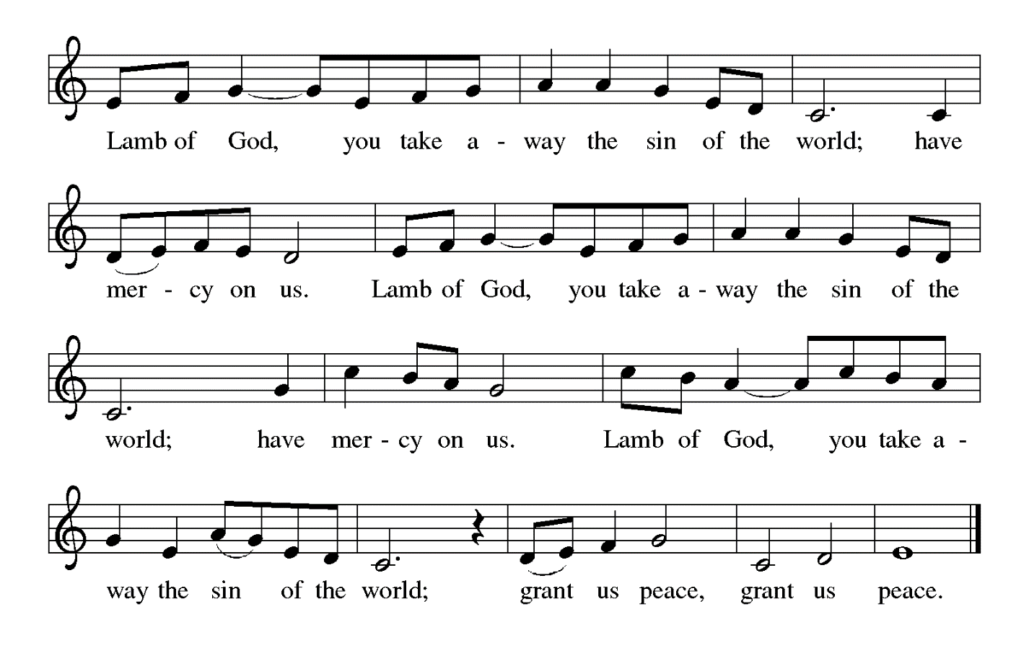

Those wishing to receive the Laying on of Hands, Anointing with Oil, and Prayer for

Healing may go to Pastor at each side aisle

**HYMN DURING DISTRIBUTION 843 *Praise the One Who Breaks the Darkness***

**ELW 733 *Great is Thy Faithfulness***

**ELW 574 *Here I Am, Lord***

**NSB 37 *Give Thanks***

*As you are able please rise*

**THE POST-COMMUNION BLESSING**

P: The Body and Blood of our Lord Jesus Christ strengthen you and keep you in His grace.

**C: Amen.**

**THE POST-COMMUNION PRAYER**

A: Let us pray. Lord God, Your Word and Sacrament give us food and life. May we who have

shared in holy things have our eyes opened, our ears unstopped, and our tongues released to

speak and do fruits of love to Your honor and glory. Grant this through Christ our Lord.

**C: Amen.**

**✠ SENDING ✠**

**THE BENEDICTION**

P: Almighty God: Father, Son, and ✠ Holy Spirit bless you now and forever.

**C: Amen.**

**THE SENDING HYMN 886 *Oh, For a Thousand Tongues to Sing***

**THE DISMISSAL**

A: Go in peace to bear Christ’s love to the world.

**C: Thanks be to God!**

**POSTLUDE**

**✠  *To God Alone Be Glory* ✠**

The Meditation is from *Christian Dogmatics.* Volume 2. Carl Braaten and Robert Jenson, eds.

(Philadelphia: Fortress Press, 1984) 376-377.

The Prayer of the Church is adapted from *Intercessions for the Christian People.* Gail Ramshaw,

ed. (New York: Pueblo Publishing Company, 1988) 125.

**ANNOUNCEMENTS**

**Please remember to mail your offering to the Church Office** at 818 Franklin Street, Michigan City, IN 46360**.** Another alternative is to give on-line through Tithe.ly. Please see your closure letter for information on how to set up a Tithe.ly account.

**St. Paul Members are reminded to have** a loved one contact the office if you are hospitalized. Many times, the Pastor doesn’t know someone is in the hospital. If you call and leave a message, please tell us which hospital the patient is at.

**Birthdays: Joan Seifert (9/8); Robert Pheanis (9/14)**

**Anniversaries: Al & Sue Green (9/15)**

**PRAYER CONCERNS:** Ivye Benson, Donna Storey, Shirley McCarty, Joan Seifert, Nolan Wilson, Debbie Martin, Mark Tannehill, Brian Wiseman, Kathy Stein, Danielle

Schnell; Venia Wendt, Jan Paholski and Laura Dovey.

**OFFICE HOURS:** Libby will be in the office on Mondays, Wednesdays,

and Fridays; volunteers will cover Tuesdays and Thursdays.

  Monday & Wednesday 8:00 a.m. – 5 p.m.

Tuesday & Thursday 9:00 a.m. – 12:00 p.m.

Friday 8:00 a.m. – 12:00 p.m.

**If you are listening to the worship broadcast on the radio and would like to watch the Sunday morning service live stream follow these steps:**

(1) If you have You Tube available on your TV, search for

**St. Paul Lutheran Church Michigan City, IN.**

(2) The direct link on the computer is

https://www.youtube.com/channel/UC5AIPNaKr3QN50984jGOa1g.

   (3) This link is also on the main page of the church’s website in

the church section and will continue to be posted weekly on the St.

Paul Facebook page.

And it will always be available on the radio broadcast Sunday mornings at 11:00 a.m.

on WEFM (95.9), and on the local cable access station #99 for the previous week’s

service on Sundays at 4:00 p.m. and the current service on Wednesdays at 7:00 p.m.

And Fridays at 8:30 p.m.

**Next Sunday’s lessons are Isaiah 50: 4-9a; Psalm 116: 1-9; James 3: 1-12 and Mark 8: 27-38** for those of you who like to study them in advance.

**To send e-mail to the church office**, please use the following addresses:

Pastor Mark Reshan: seniorpastor@stpaulmichigancity.com

Church Office Secretary (Libby Pollock): churchsecretary@stpaulmichigancity.com

Church Treasurer (Karen Fleming): finance@stpaulmichigancity.com

**The Good News Newsletter**: If you have an article or anything you want included in **The Good News** please send it to the following e-mail address: splcgoodnews@gmail.com. Pastor Pamela Thiede will be using this e-mail address to assemble **The Good News** each month. The deadline for getting information to Pastor Pamela will be the 20th of each month.

**Worship Attendance:**

**Saturday, August 31, 2024 @ 4:00 p.m. 21**

**Sunday, September 1, 2024 @ 9:00 a.m. 68**

**TOTAL 89**

**VOLUNTEER OPPORTUNITY**

The church office is in need of a volunteer who could relieve the Tuesday and Thursday

volunteers on occasion. If you are willing to volunteer please contact Janet Bakken at

**(219) 242-3449.**

**FROM THE CHURCH COUNCIL**

The Council will begin considering local 501C organizations who will benefit from the half of the school sale money that was set aside.  If you have a local 501C organization that you would like for the Council to consider, we need that suggestion in writing.  You can email it to church[secretary@stpaulmichigancity.com](mailto:secretary@stpaulmichigancity.com) or send it by U.S. mail.  The Council will not consider any suggestions that are not in writing.

Janet Bakken

Council President

**CALLING ALL SINGERS! NEW MEMBERS WELCOME!**

**St. Paul Choir will begin the 2024-2025 season after Labor Day, with its first rehearsal set for Monday, September 9, 2024 at 10:30 a.m. in the sanctuary. We’ll begin singing at the September 15 service and sing about three Sundays per month. If you love to sing, please consider joining us – no special training is necessary. For more information, contact Stacie Crozier at (219) 877-4351**

**or** [**staciejcro@gmail.com**](mailto:staciejcro@gmail.com)**.**



**September Monthly Mission:**

**Our September monthly mission is the Christian Appalachian Project.** This Organization was started by a Catholic priest assigned to pastor a large portion of east-central Kentucky. Through his outreach he witnessed tremendous poverty in Appalachia. With the help of others he provided food, clothing and other essentials to neighbors in need. His small outreach grew into the Christian Appalachian Project in 1964 and now serves more than 1 million people a year in all 13 states of the Appalachian region. In this region the poverty rate is 28%, food insecurity is 19.7%, and 46% of homes are severely deteriorating. 88.5% of donations go directly to families in need, providing food, clothing, home repair, elderly services and other essentials. Please consider helping our neighbors in Appalachia by donating to this month’s mission. Checks can be made out to St. Paul and marked for the Christian Appalachian Project and placed in the offering plate. Noisy coin contributions will also go to the mission of the month. Thank you for your giving hearts!

**SHOE DRIVE WITH ST. LUKE LUTHERAN CHURCH**

Our congregation is teaming up with St. Luke Lutheran Church to help with their shoe drive. Please bring any used shoes, boots or sandals to church with you and place them in the box in the outer narthex. They will then be delivered to St. Luke’s. These shoes will be sent to underdeveloped countries and used to help start businesses for micro-entrepreneurs. Clean your closets and get rid of the clutter!

**Copies of the minutes** from the May 22, 2024 Church Council Meeting and the

July 25, 2024 Church Council meeting are on the back table in the upper Narthex. They were approved by the council via email. There was no Council Meeting in June 2024.

**2024 Financial Stewardship**

Weekly Church Operating Needs (x 2 weeks): $ 11,327.50

August 24-25; August 31—September 1, 2024

General Fund (including General Memorials): $ 7,174.00

Overage/Shortage: —- $ 4,153.50

Restricted Income (not including Memorials)

Supports IK Synod & Church wide Ministries: $ 320.00

Ministries in our Community/Congregation: $ 380.00

Capital Fund: $ 320.00

**ACTIVITIES, EVENTS & MEETINGS**

**SEPTEMBER 2024**

**Sunday,** September 8, 2024 @ 9:00 a.m. 16th Pentecost Worship Service

**Monday,** September 9, 2024 @ 10:30 a.m. Choir Rehearsal/Sanctuary

@ 1:00 p.m. Hope Circle/Green Room

**Tuesday,** September 10, 2024 @ 7:00 p.m. Estuary/Luther House

**Wednesday,** September 11, 2024 @ 9:00 a.m. Worship & Music Mtg/Luther House

@10:00 a.m. God’s Purls/St. Paul Room

**Thursday,** September 12, 2024 **@ 4:00 p.m. – 10:00 p.m. GIVE BACK**

**@ GALVESTON**

**Saturday,** September 14, 2024 @ 4:00 p.m. 17th Pentecost Worship Service

**Sunday,** September 15, 2024 @ 9:00 a.m. 17th Pentecost Worship Service

**Monday,** September 16, 2024 @ 10:30 a.m. Choir Rehearsal/Sanctuary

**Wednesday,** September 18, 2024 @ 9:00 a.m. Bible Study/Luther House

@10:00 a.m. God’s Purls/St. Paul Room

**Saturday,** September 21, 2024 @ 4:00 p.m. 18th Pentecost Worship Service

**Sunday,** September 22, 2024 @ 9:00 a.m. 18th Pentecost Worship Service

**Monday,** September 23, 2024 @ 10:30 a.m. Choir Rehearsal/Sanctuary

@ 2:00 p.m. Finance Committee Mtg/Luther House

@ 3:00 p.m. Executive Board Meeting/Luther House

**Wednesday,** September 25, 2024 @ 9:00 a.m. Bible Study/Luther House

@ 10:00 a.m. God’s Purls/St. Paul Room

**Thursday,** September 26, 2024 @ 5:30 p.m. Church Council Mtg/St. Paul Room

**Saturday,** September 28, 2024 @ 4:00 p.m. 19th Pentecost Worship Service

**Sunday,** September 29, 2024 @ 9:00 a.m. 19th Pentecost Worship Service

Thank$ for $haring

This month, we will see you at Galveston on Thursday, September 12! Here are two coupons: one for you and one for a friend.

**FYI:**

**On September 16th work will begin on converting Franklin Street back in to a two way street. We are not yet sure if access to the church’s parking lot will be affected, nor do we know how long it will take this project to be completed. We will update whenever possible as we know more. Please allow plenty of time for you to arrive for your activities and worship services.**