**THE SIXTEENTH SUNDAY AFTER PENTECOST**

**September 17, 2023**

**“**To forgive somebody is to say one way or another, "You have done something unspeakable, and by all rights I should call it quits between us. Both my pride and my principles demand no less. However, although I make no guarantees that I will be able to forget what you've done, and though we may both carry the scars for life, I refuse to let it stand between us. I still want you for my friend."

To accept forgiveness means to admit that you've done something unspeakable that needs to be forgiven, and thus both parties must swallow the same thing: their pride.

This seems to explain what Jesus means when he says to God, "Forgive us our trespasses as we forgive those who trespass against us." Jesus is not saying that God's forgiveness is conditional upon our forgiving others. In the first place, forgiveness that's conditional isn't really forgiveness at all, just fair warning; and in the second place, our unforgivingness is among those things about us that we need to have God forgive us most. What Jesus apparently is saying is that the pride that keeps us from forgiving is the same pride that keeps us from accepting forgiveness, and will God please help us do something about it.

When somebody you've wronged forgives you, you're spared the dull and self-diminishing throb of a guilty conscience.

When you forgive somebody who has wronged you, you're spared the dismal corrosion of bitterness and wounded pride.

For both parties, forgiveness means the freedom again to be at peace inside their own skins and to be glad in each other's presence.”

**Frederick Buechner**

***Wishful Thinking***

**✠ In the Name of Jesus ✠**

**INTRODUCTION**

*In today's gospel reading, Jesus invites us to forgive one another. His invitation, however, is not an optional activity for Christians. It is the heart of the gospel and the distinctive character of Christian life. Out of love for us in our weakness and sin, God forgives us, heals us, and strengthens us to be a forgiving people. The sign of the cross invites us to the ministry of reconciliation in word and sacrament. The cross, marked on our foreheads at baptism and traced over our bodies at the funeral liturgy, assures us of Christ's victory over death and the promise of eternal life.*

**Cyprian, Bishop of Carthage, martyr, died around 258**

*Cyprian served as a bishop during a time of great persecution of Christians. He insisted on receiving back those who had left the faith under duress. He also provided medical care during a severe epidemic.*

**Hildegard, Abbess of Bingen, died 1179**

*A mystic who was widely influential within the church, Hildegard advised and reproved kings and popes, wrote poems and hymns, and produced treatises in medicine, theology, and natural history. She was also a musician and artist.*

**✠ GATHERING ✠**

**CALL TO WORSHIP: *“In The Morning, O Lord”***

**BELLS**

**PRELUDE: *“Awake, O Sleeper, Rise From Death (“Azmon”)” Manz***

**ANNOUNCEMENTS**

*As you are able please rise*

**CONFESSION AND ABSOLUTION**

P: In the name of the Father and of **✠** the Son and of the Holy Spirit.

**C: Amen.**

P: “The LORD is full of compassion and mercy, slow to anger and of great kindness ... He has

not dealt with us according to our sins, nor rewarded us according to our wickedness.” (Psalm

103:8,10). Relying upon God’s kindness, we are free to confess our sins, knowing that God

will deal with us with abundant mercy, care, and forgiveness.

*Silence for self-examination and reflection is kept*

P: Most merciful God,

**C: We confess that we have sinned against You in thought, word, and deed. We are guilty**

**of passing judgment on others and despising those with whom we disagree. (Romans**

**14:10) We have been quick to anger and slow to forgive. We have been grudging in our**

**pardon and impatient with those who are in our debt. (Matthew 18:30) We have**

**received mercy from You, but withheld mercy from others. For the sake of Your Son,**

**Jesus Christ, have mercy now on us. Free us from our anger and pride, that we may live**

**to You and for You in peace and joy.**

P: “For as the heavens are high above the earth, so is (God’s) mercy great upon those who fear

Him. As far as the east is from the west, so far has He removed our sins from us.” (Psalm

103:12-13) God’s mercy is great for you this day, for as a called and ordained minister of the

Church of Christ, and by His authority, I therefore declare to you the entire forgiveness of all

your sins, in the name of the Father and of + the Son and of the Holy Spirit.

**C: Amen.**

**GATHERING HYMN 452 *Awake, O Sleeper, Rise from Death***

**THE GREETING AND PRAYER OF THE DAY**

P: The grace of our Lord Jesus Christ, the love of God, and the communion of

the Holy Spirit be with you all.

**C: And also with you.**

P: Let us pray. O Lord God, merciful Judge, You are the inexhaustible Fountain of forgiveness.

Replace our hearts of stone with hearts that love and adore You, that we may delight in doing

Your will, through Jesus Christ, our Savior and Lord.

**C: Amen.**

*The assembly is seated*

**✠ WORD ✠**

**FIRST READING Genesis 50: 15-21**

*The story of Joseph is a wisdom story. In it, Joseph plays the role of a wise man. Portrayed in a situation of oppression, he provides an important model of how the wise should act.*

Realizing that their father was dead, Joseph's brothers said, "What if Joseph still bears a grudge against us and pays us back in full for all the wrong that we did to him?" 16So they approached Joseph, saying, "Your father gave this instruction before he died, 17"Say to Joseph: I beg you, forgive the crime of your brothers and the wrong they did in harming you.' Now therefore please forgive the crime of the servants of the God of your father."

Joseph wept when they spoke to him. 18Then his brothers also wept, fell down before him, and said, "We are here as your slaves." 19But Joseph said to them, "Do not be afraid! Am I in the place of God? 20Even though you intended to do harm to me, God intended it for good, in order to preserve a numerous people, as he is doing today. 21So have no fear; I myself will provide for you and your little ones." In this way he reassured them, speaking kindly to them.

A: The Word of the Lord.

**C: Thanks be to God.**

**THE PSALM: Psalm 108:8-13** Antiphon by Daniel Kallman

Choir sings refrain first, followed immediately by the congregation

and as indicated

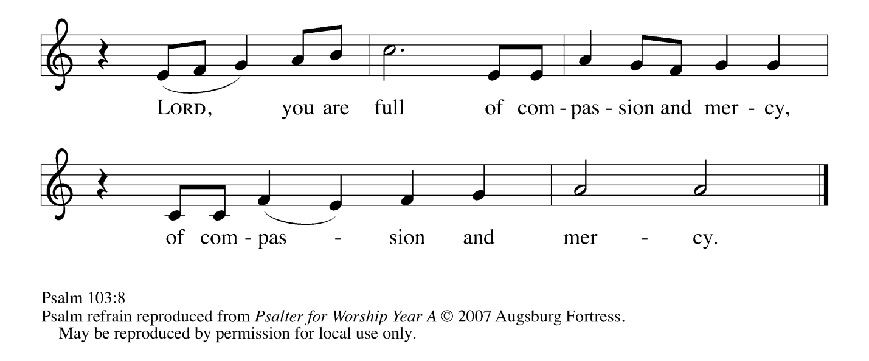

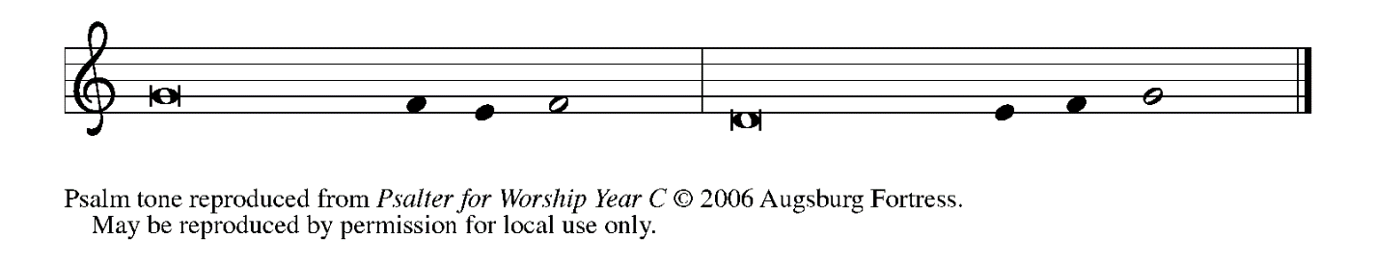

**8Lord, You are full of compas- | sion and mercy,  
  slow to anger and abounding in | steadfast love;**

**9You will not al- | ways accuse us,  
  nor will You keep Your an- | ger forever. REFRAIN**

**10You have not dealt with us according | to our sins,  
  nor repaid us according to | our iniquities.**

**11For as the heavens are high a- | bove the earth,  
  so great is Your steadfast love for | those who fear You.**

**12As far as the east is | from the west,  
  so far have You removed our transgres- | sions from us.**

**13As a father has compassion | for his children,  
  so You have compassion for those who fear | You, O Lord.  REFRAIN**

**SECOND READING Romans 14: 1-12**

*The Christians in Rome came from a diversity of cultural backgrounds: some Jewish, some Gentile. Here Paul urges them to respect one another's opinions on various religious matters, even though he himself believes that some of the ideas are held by people weak in faith.*

Welcome those who are weak in faith, but not for the purpose of quarreling over opinions. 2Some believe in eating anything, while the weak eat only vegetables. 3Those who eat must not despise those who abstain, and those who abstain must not pass judgment on those who eat; for God has welcomed them. 4Who are you to pass judgment on servants of another? It is before their own lord that they stand or fall. And they will be upheld, for the Lord is able to make them stand.

5Some judge one day to be better than another, while others judge all days to be alike. Let all be fully convinced in their own minds. 6Those who observe the day, observe it in honor of the Lord. Also those who eat, eat in honor of the Lord, since they give thanks to God; while those who abstain, abstain in honor of the Lord and give thanks to God.

7We do not live to ourselves, and we do not die to ourselves. 8If we live, we live to the Lord, and if we die, we die to the Lord; so then, whether we live or whether we die, we are the Lord's. 9For to this end Christ died and lived again, so that he might be Lord of both the dead and the living.

10Why do you pass judgment on your brother or sister? Or you, why do you despise your brother or sister? For we will all stand before the judgment seat of God. 11For it is written,

"As I live, says the Lord, every knee shall bow to me,

and every tongue shall give praise to God."

12So then, each of us will be accountable to God.

A: The Word of the Lord.

**C: Thanks be to God.**

*As you are able please rise*

**THE VERSE** Sung twice

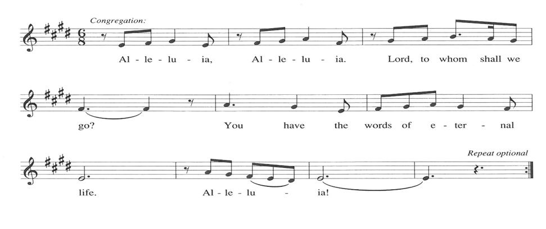

**THE HOLY GOSPEL Matthew 18: 21-35**

*Jesus has been instructing his disciples about confronting other people who live in ways that are sinful. Now, Peter's question about forgiveness elicits a parable that clarifies this issue. Although the community of faith should challenge sinners to repent, it should also proclaim a forgiveness that reflects the bountiful mercy of God.*

P: The Holy Gospel according to St. Matthew, the eighteenth chapter.

**C: Glory to You, O Lord!**

Peter came and said to [Jesus,] "Lord, if another member of the church sins against me, how often should I forgive? As many as seven times?" 22Jesus said to him, "Not seven times, but, I tell you, seventy-seven times.

23"For this reason the kingdom of heaven may be compared to a king who wished to settle accounts with his slaves. 24When he began the reckoning, one who owed him ten thousand talents was brought to him; 25and, as he could not pay, his lord ordered him to be sold, together with his wife and children and all his possessions, and payment to be made.

26So the slave fell on his knees before him, saying, 'Have patience with me, and I will pay you everything.' 27And out of pity for him, the lord of that slave released him and forgave him the debt. 28But that same slave, as he went out, came upon one of his fellow slaves who owed him a hundred denarii; and seizing him by the throat, he said, 'Pay what you owe.' 29Then his fellow slave fell down and pleaded with him, 'Have patience with me, and I will pay you.'

30But he refused; then he went and threw him into prison until he would pay the debt. 31When his fellow slaves saw what had happened, they were greatly distressed, and they went and reported to their lord all that had taken place. 32Then his lord summoned him and said to him, 'You wicked slave! I forgave you all that debt because you pleaded with me. 33Should you not have had mercy on your fellow slave, as I had mercy on you?' 34And in anger his lord handed him over to be tortured until he would pay his entire debt. 35So my heavenly Father will also do to every one of you, if you do not forgive your brother or sister from your heart."

P: The Gospel of the Lord.

**C: Praise to You, O Christ!**

*The assembly is seated*

**THE SERMON**

*Silence for reflection follows the sermon*

*As you are able please rise*

**THE HYMN OF THE DAY 605 *Forgive Our Sins as We Forgive***

**THE APOSTLES’ CREED**

A: God has made us His people through our Baptism into Christ. Living together in trust and hope, we confess our faith.

**C: I believe in God, the Father almighty,**

**creator of heaven and earth.**

**I believe in Jesus Christ, His only Son, our Lord.**

**He was conceived by the power of the Holy Spirit**

**and born of the virgin Mary.**

**He suffered under Pontius Pilate,**

**was crucified, died, and was buried.**

**He descended into hell.**

**On the third day He rose again.**

**He ascended into heaven,**

**and is seated at the right hand of the Father.**

**He will come again to judge the living and the dead.**

**I believe in the Holy Spirit,**

**the holy catholic Church,**

**the communion of saints,**

**the forgiveness of sins,**

**the resurrection of the body,**

**and the life everlasting. Amen**

**THE PRAYER OF THE CHURCH**

A: Remembering the covenant the Most High has made with us, let us pray in the name of the

Lord Jesus to Whom we belong for the Church and the world.

A: That the Church, the community of saints and sinners, might be a sign of God’s steadfast love

and forgiveness in our broken and separated world, let us pray to the Lord:

**C: Lord, have mercy.**

A: That our bishops, **Elizabeth and Bill;** our pastors **Dale, Mark, Al, Pamela, and Mark;** and

all the baptized may in life and speech faithfully bear witness to the rich compassion and

kindness of God, let us pray to the Lord:

**C: Lord, have mercy.**

A: That the Spirit might overcome places of hatred, bitterness, vengeance, warfare, bloodshed,

and violence, especially in Ukraine, Eritrea, Gabon, and Sudan with forgiveness and

reconciliation, let us pray to the Lord:

**C: Lord, have mercy.**

A: That the survivors of Hurricane Idelia might be strengthened and comforted in their grief and

despair as they work to rebuild their lives, let us pray to the Lord:

**C: Lord, have mercy.**

A: That those burdened by worry, poverty, hunger, or illness, especially **…** might be crowned

with the healing lovingkindness of God, let us pray to the Lord:

**C: Lord, have mercy.**

A: That those celebrating birthdays, especially **Kay Peglow and Helen Wiese;** and anni-

versaries, especially **Don and Beth Thompson,** may be filled with grace this day and

every day and grow in grace in the days ahead, let us pray to the Lord:

**C: Lord, have mercy.**

A: That with all the saints who have revealed God’s abundant mercy and limitless forgiveness,

especially **Cyprian, Bishop of Carthage, martyr; and Hildegard of Bingen, Abbess,** whom

commemorate this Day we may in all ways live to the Lord, let us pray to the Lord:

**C: Lord, have mercy.**

P: Lord God, Your Son made Himself least among us, bore our sins upon the cross, and delivered

us from death by His own suffering and dying. Forgive us our sins, by which we have added

to the world’s pain, and make us instruments of peace and reconciliation; through the same

Jesus Christ our Lord.

**C: Amen.**

**✠ MEAL ✠**

**THE PEACE**

P: The peace of the Lord be with you always.

**C: And also with you.**

*The assembly is seated*

**THE OFFERING**

**THE VOLUNTARY**

*As you are able please rise*

**THE PRESENTATION OF THE GIFTS 465 *As the Grains of Wheat***

**THE OFFERTORY PRAYER**

A: Let us pray. God of mercy,

**C: You gather us again around Your Table to give thanks and eat in Your honor. Accept**

**the gifts we offer, and may we who are reconciled at this Meal bring wholeness to our**

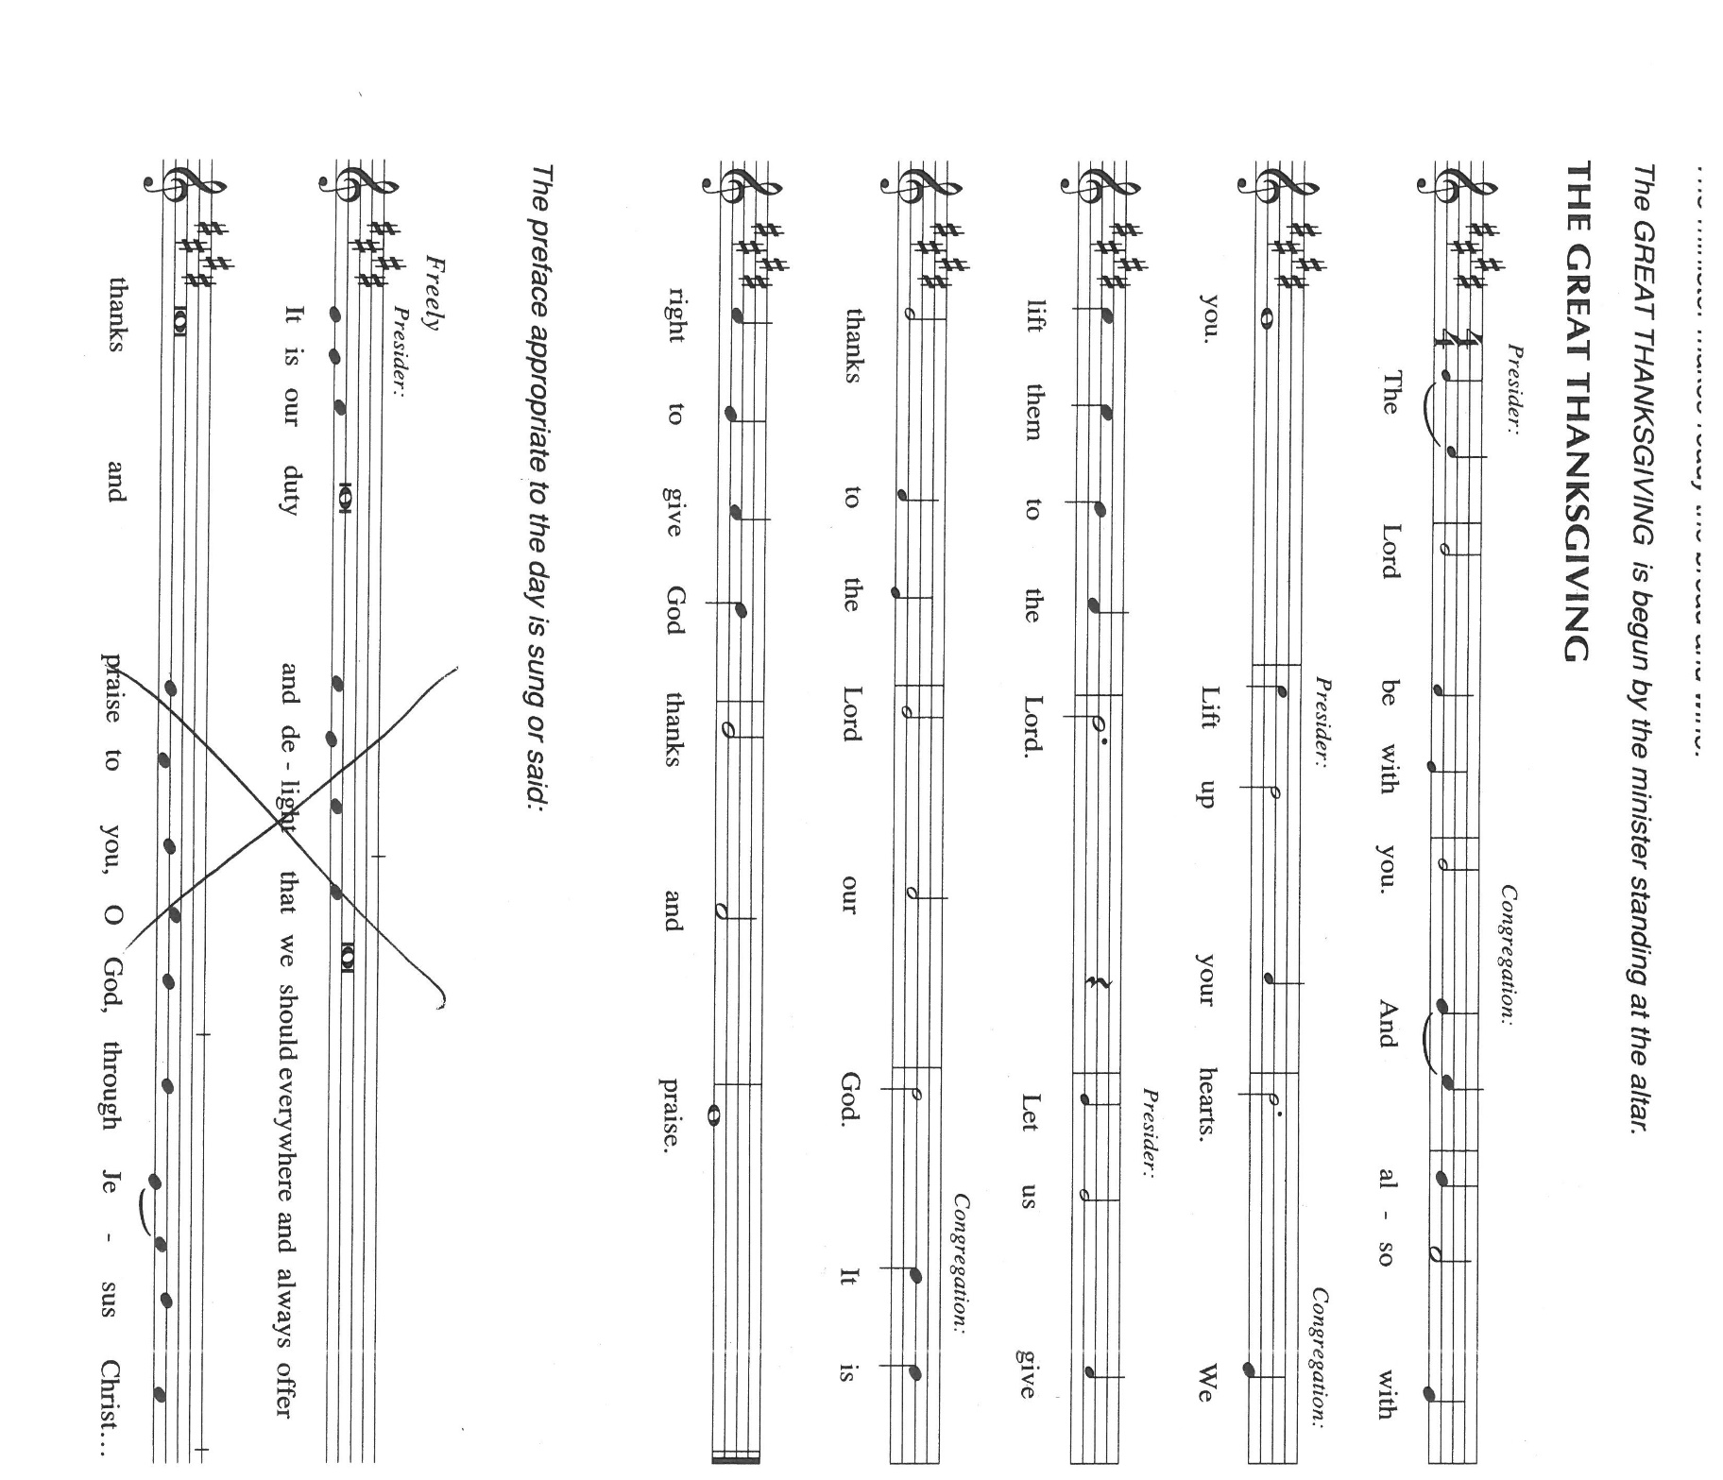 **broken world. We ask this in the name of Jesus the Lord. Amen.**

**THE GREAT THANKSGIVING**

P: It is our duty and delight … join their unending hymn:

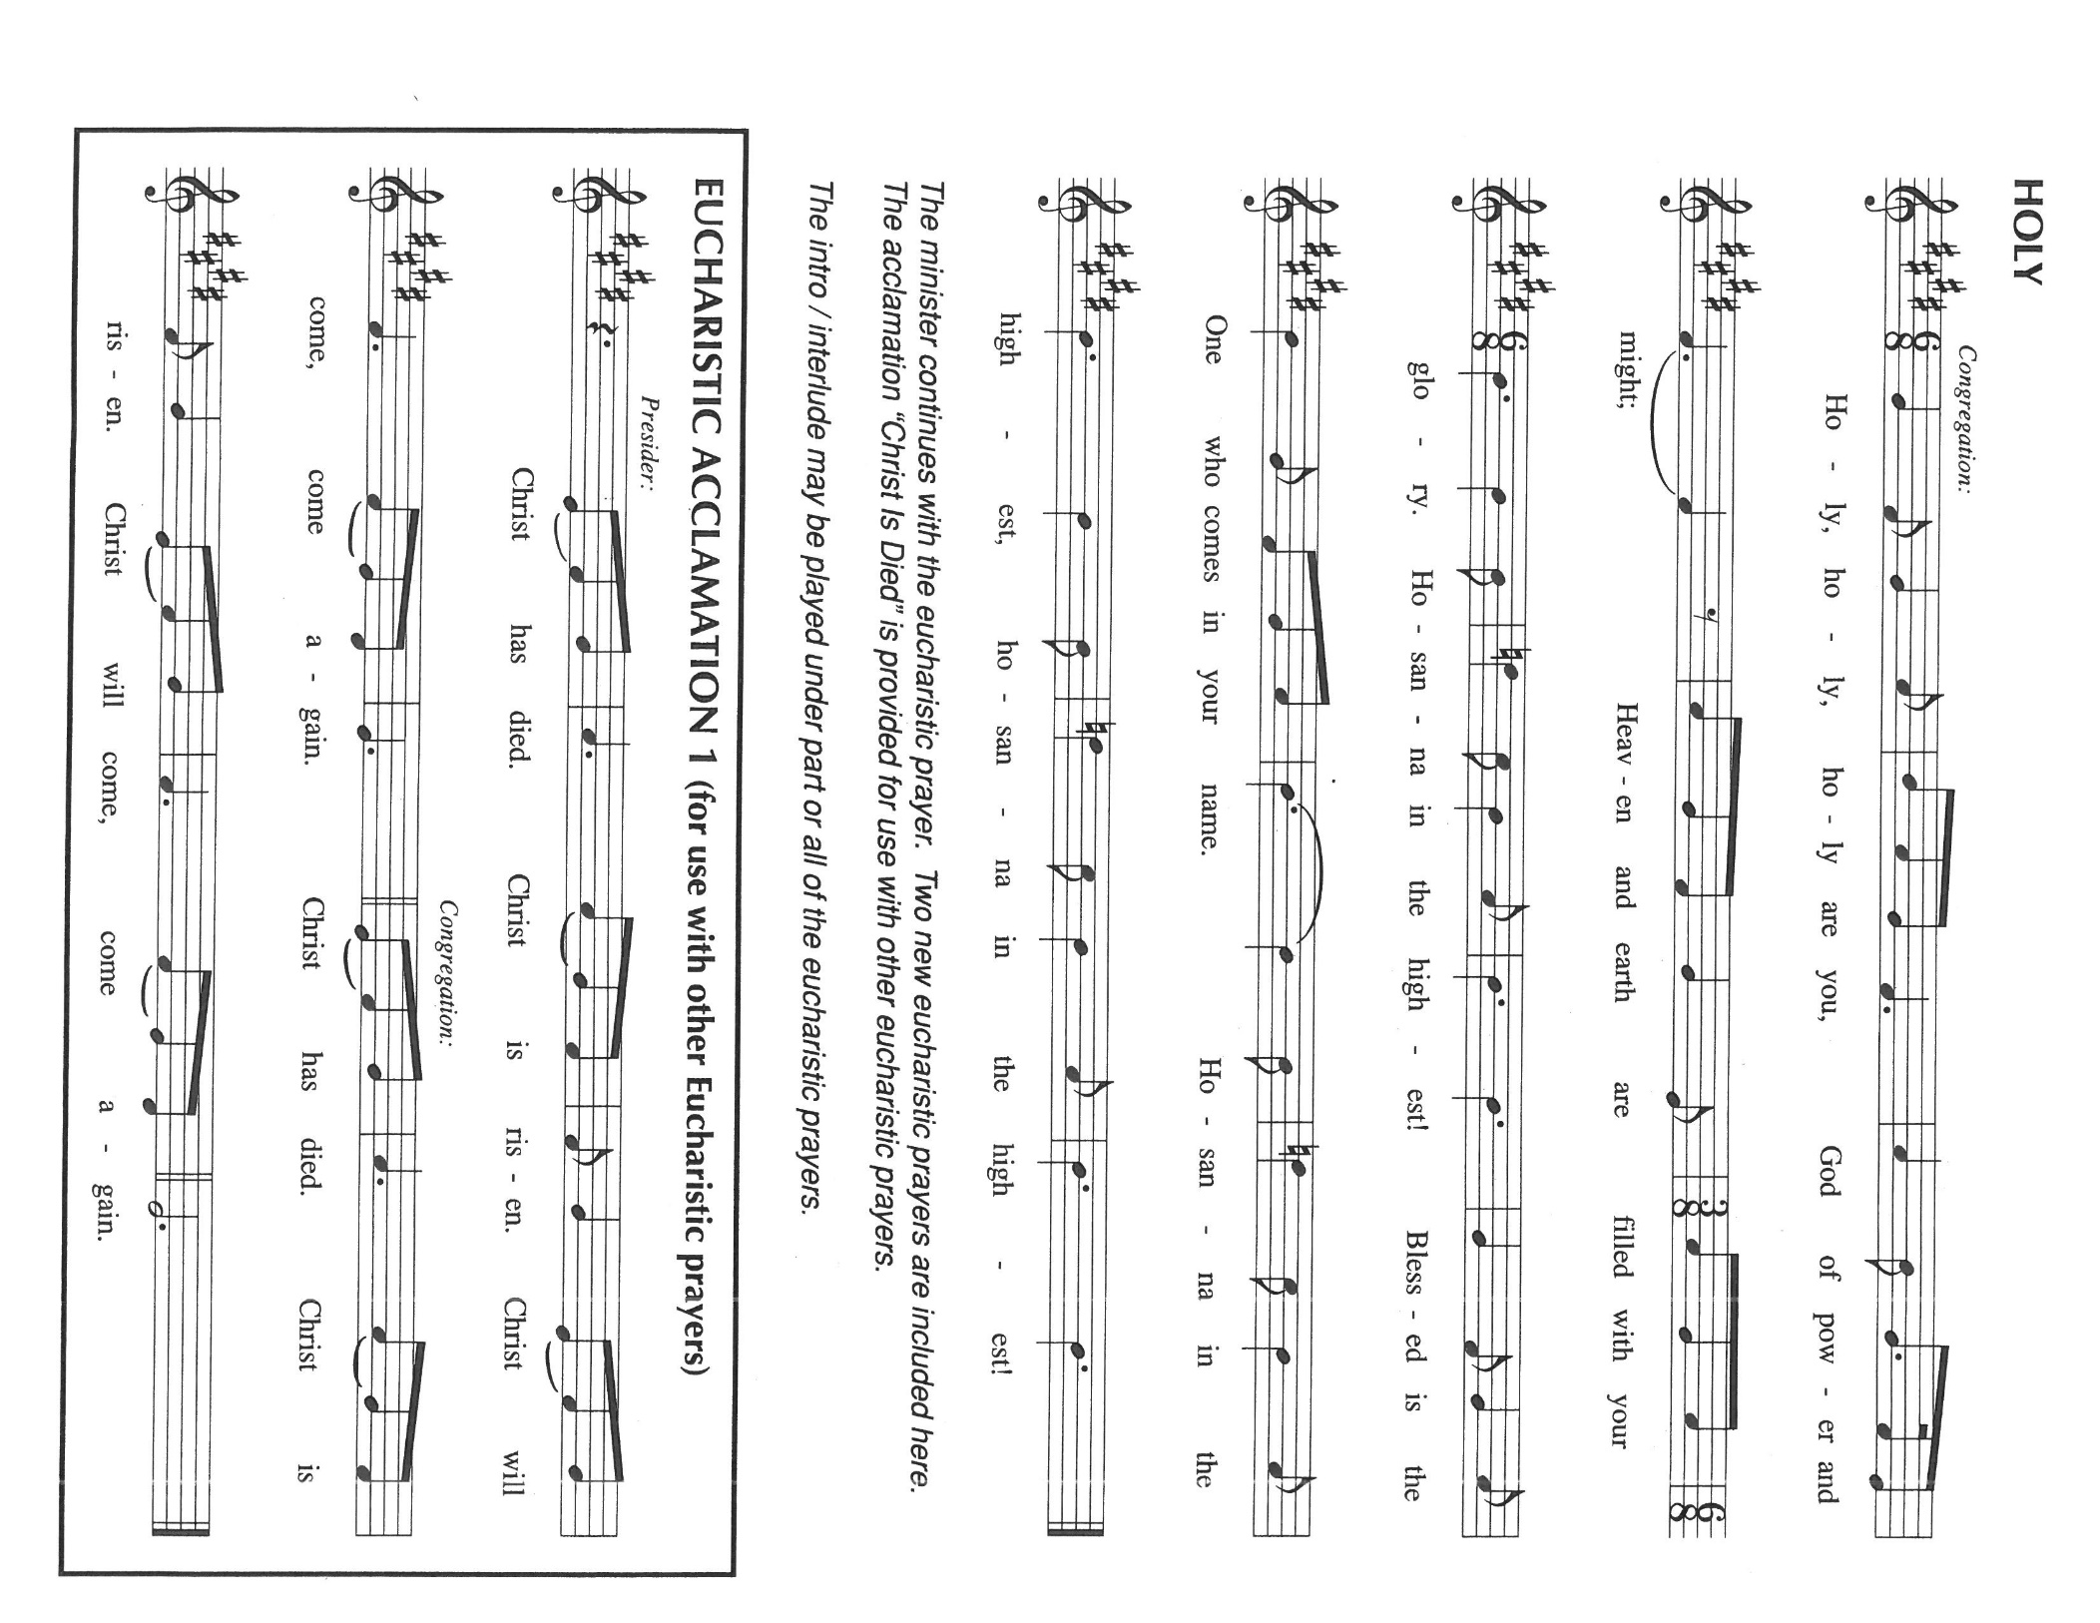

P: Blessed are You, O Lord our God, Creator of heaven and earth, for You are

full of compassion and mercy.

You tenderly care for us, and satisfy us with good things.

You made Your ways known to Moses, and Your works to Israel.

Through famine and slavery, defeat and exile, You intended good, and brought life out of death

that they might be Your life to all the world.

At the last Your life was revealed in Your only-begotten Son, Jesus Christ.

Whether we live or whether we die, we belong to Him.

In the night ... “Do this for the remembrance of Me.”

As often as we eat ... we proclaim the Lord’s death until He comes.

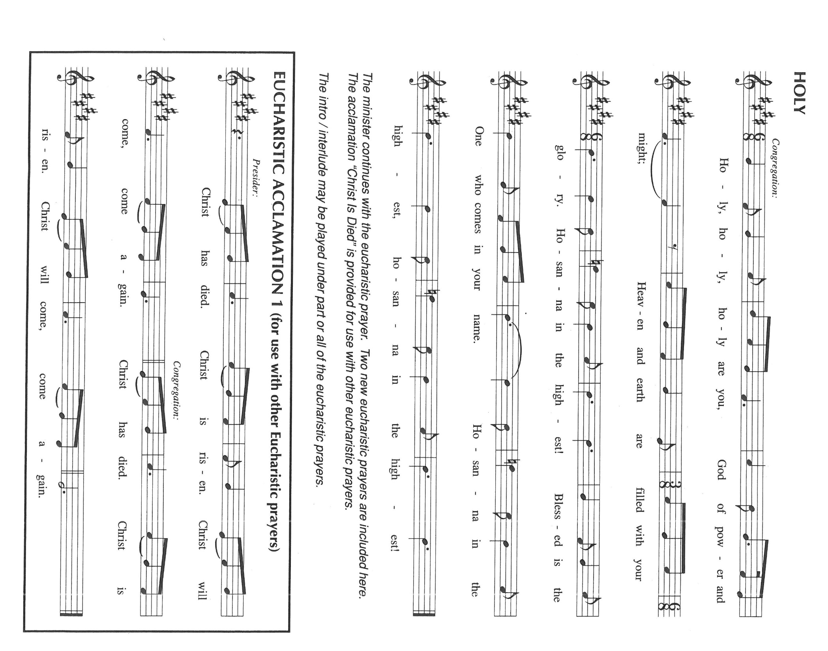

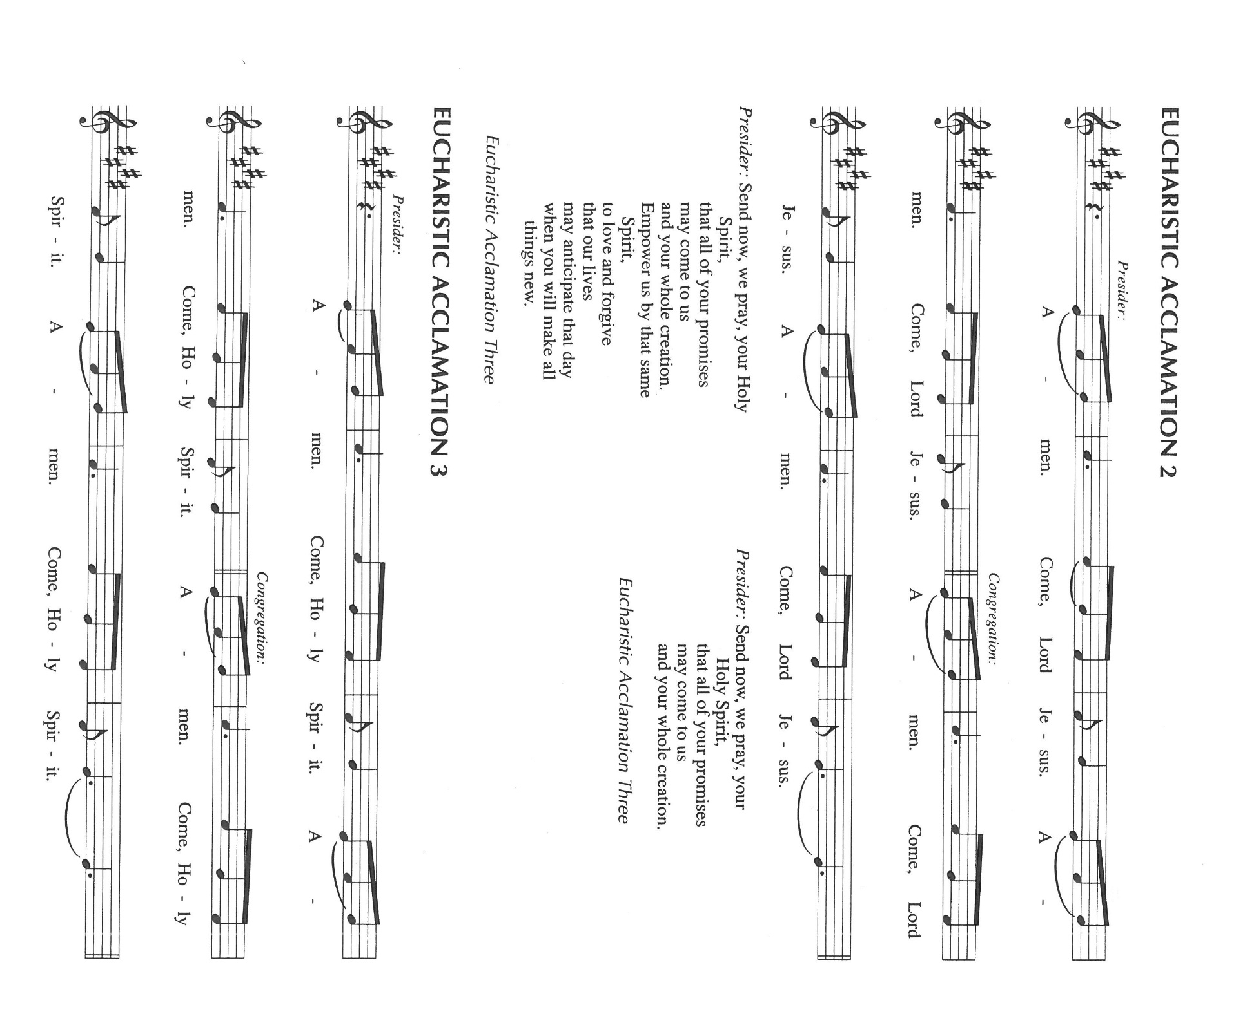

P: With this bread and cup we remember the life our Lord offered for us: He healed the sick, fed

the hungry, and forgave sinners.

He died and rose that He might be Lord of both the living and the dead.

Remembering His command to love one another, His life and death, and His glorious

resurrection and ascension, we pray for His coming again even as we cry:

As we await His return in glory, when every knee shall bow, we ask You:

Send now Your Holy Spirit on us and these Your gifts of bread and wine, that as we eat in

honor of the Lord,

We may be as forgiving as we have been forgiven, until all the world is reconciled and made

one in Your love.

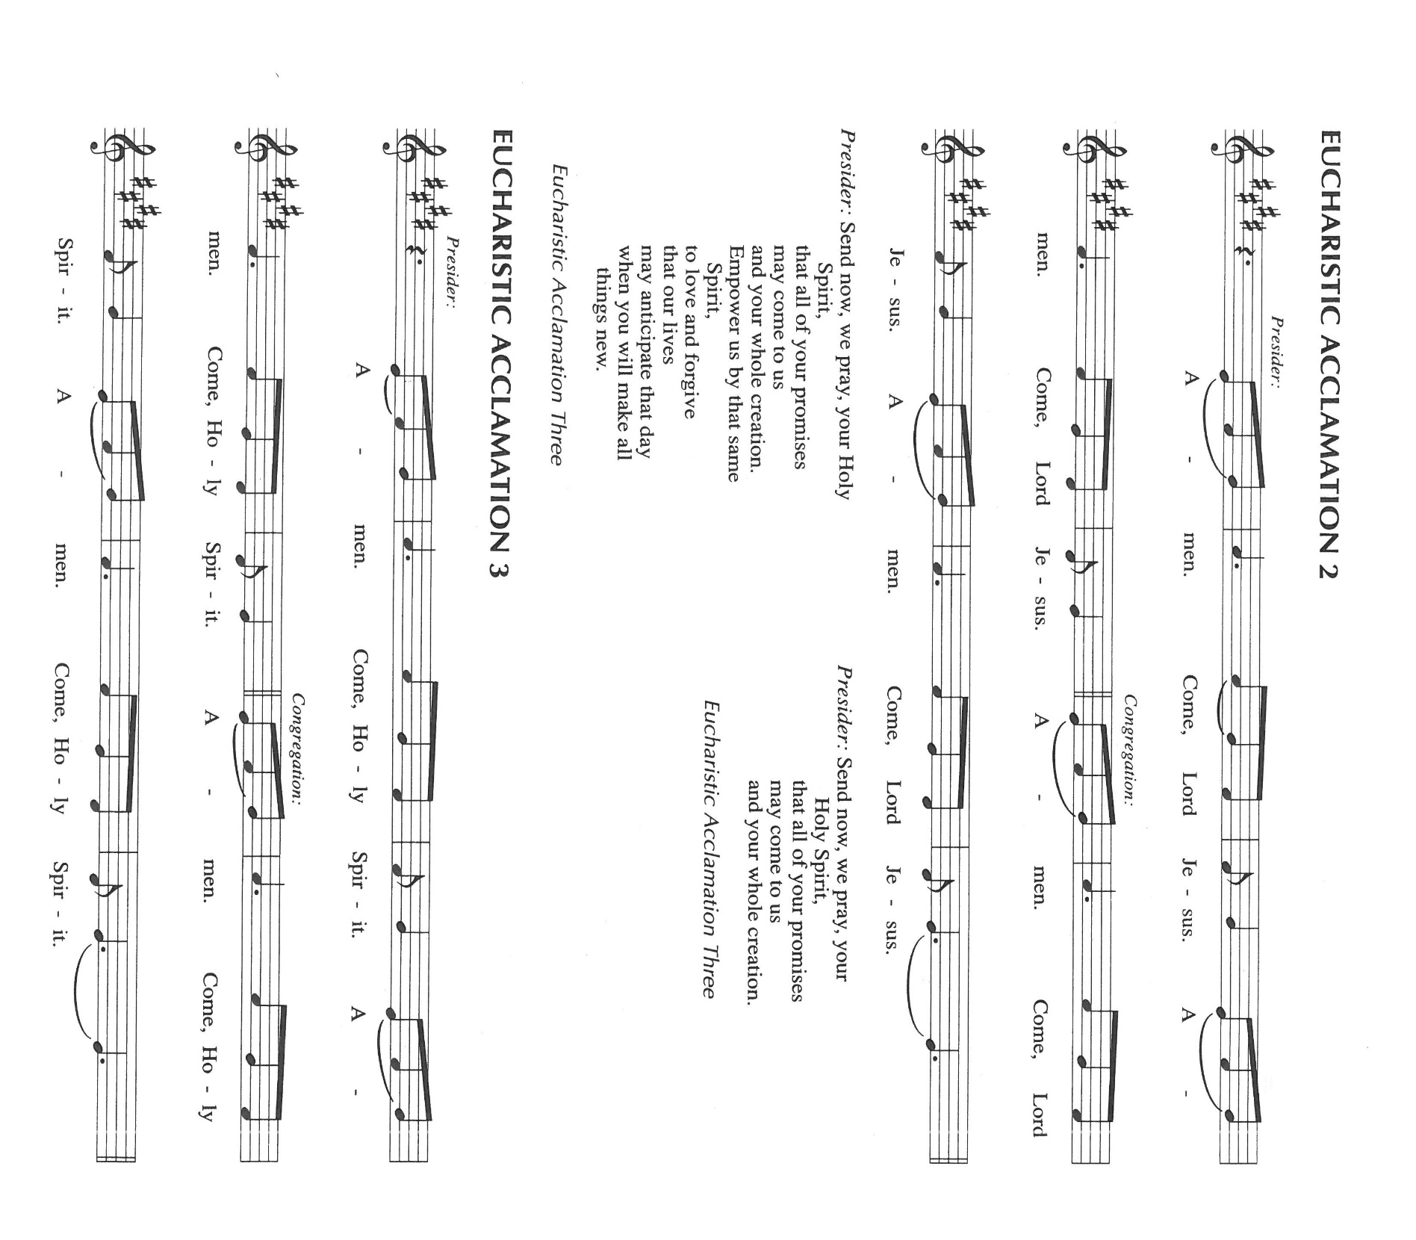

To You, O God: Father, Son, and Holy Spirit, be all honor and glory, in Your holy Church, in

heaven and on earth, now and forever.

**C: Amen!**

**THE LORD’S PRAYER**

P: With trust in God Whose providence nourishes and sustains us, let us now pray as Jesus taught

us:

**C: Our Father, Who art in heaven, hallowed be Thy name.**

**Thy Kingdom come, Thy will be done on earth as it is in heaven.**

**Give us this day our daily bread, and forgive us our trespasses, as we forgive those**

**who trespass against us.**

**And lead us not into temptation, but deliver us from evil.**

**For Thine is the Kingdom, and the power, and the glory, forever and ever. Amen.**

**INVITATION TO THE MEAL**

P: Behold the living Bread come down from heaven. Those who eat of it will never die. Behold

the cup of eternal life. Those who drink of it will life forever. God’s holy gifts for God’s holy

people. Come, for all is now ready.

*The assembly is seated*

**LAMB OF GOD**

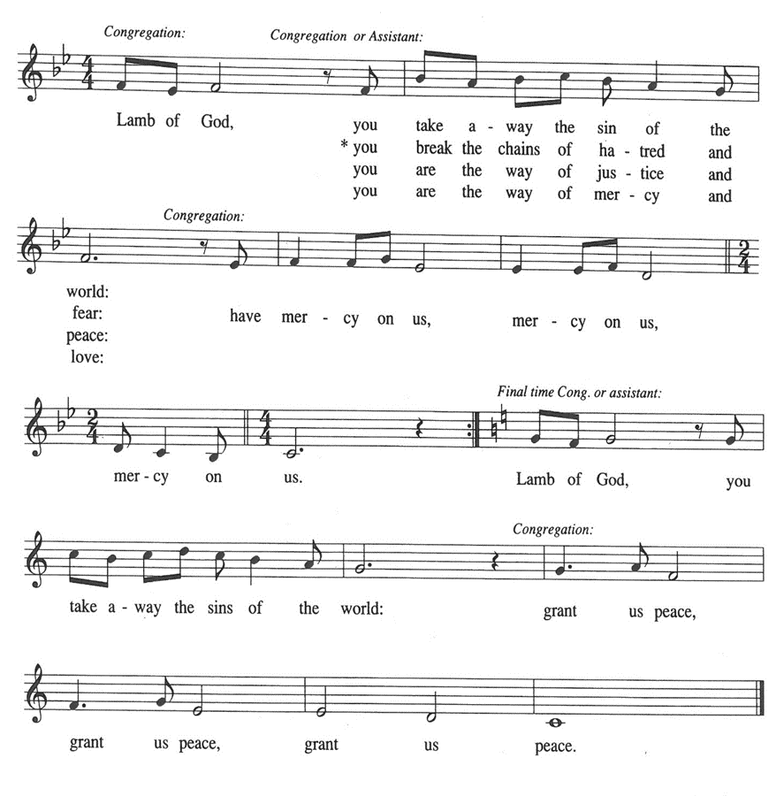

**CHOIR: *I Am the Bread of Life***  **Talbot**

**HYMN DURING DISTRIBUTION 479 *We Come to the Hungry Feast***

*As you are able please rise*

**THE POST-COMMUNION BLESSING**

P: The Body and Blood of our Lord Jesus Christ strengthen you and keep you in His grace.

**C: Amen.**

**THE POST-COMMUNION PRAYER**

A: Let us pray. God of peace, in this Eucharist we have been reconciled to You and to our

neighbors. May we who have been nourished by holy things always have the courage to

forgive. Grant this through Christ our Lord.

**C: Amen.**

**✠ SENDING✠**

**THE BENEDICTION**

P: Almighty God: Father, Son **✠** and Holy Spirit bless you now and forever.

**C: Amen.**

**SENDING HYMN 544 *Praise the Lord, Rise Up Rejoicing***

**THE DISMISSAL**

A: Go in peace to love and serve the Lord.

**C: Thanks be to God!**

**THE POSTLUDE: *“Sent Forth By God’s Blessing”*****Bente**

**✠ To God Alone Be Glory✠**

The Meditation is from *Wishful Thinking.* Frederick Buechner. (New York: Harper and Row

Publishing House, 1979) 78.

The Prayers, Introduction to the Lord’s Prayer, and Invitation to the Meal are adapted from *Prayers*

*For Sundays and Seasons. Year A.* Peter J. Scagnelli. (Chicago: Liturgy Training

Publications, 1998) 118-119.

The musical setting of the liturgy, “Now the Feast and Celebration” by Marty Haugen, is used

by permission of GIA Publishers, Inc. OneLicense.net License #A-702836.

**ANNOUNCEMENTS**

**Please remember to mail your offering to the Church Office** at 818 Franklin Street, Michigan City, IN 46360**.** Another alternative is to give on-line through Tithe.ly. Please see your closure letter for information on how to set up a Tithe.ly account.

**St. Paul Members are reminded to have** a loved one contact the office if you are hospitalized. Many times, the Pastor doesn’t know someone is in the hospital. If you call and leave a message, please tell us which hospital the patient is at.

**Next Sunday’s lessons are Ezekiel 2:8--3:11; Psalm 119: 33-40; Ephesians 2: 4-10; Matthew 9: 9-13** for those of you who like to study them in advance.

**Birthdays: Kay Peglow (9/19); Helen Wiese (9/22)**

**Anniversaries: Don & Beth Thompson (9/19)**

**PRAYER CONCERNS:** Laura Mellen, Jana Thomas, Leonard Cross, Margie Torres, Jayla Jacobi, Barbara Reichert, Jim Gleason, Kim Mitchell, and Ken Wilson.

**OFFICE HOURS:** Libby will be in the office on Mondays, Wednesdays,

and Fridays; volunteers will cover Tuesdays and Thursdays.

   Monday & Wednesday 8:00 a.m. – 5 p.m.

Tuesday & Thursday 9:00 a.m. – 12:00 p.m.

Friday 8:00 a.m. – 12:00 p.m.

**If you are listening to the worship broadcast on the radio and would like to watch the Sunday morning service live stream follow these steps:**

(1) If you have You Tube available on your TV, search for

**St. Paul Lutheran Church Michigan City, IN.**

(2) The direct link on the computer is

<https://www.youtube.com/channel/UC5AIPNaKr3QN50984jGOa1g>.

    (3) This link is also on the main page of the church’s website in

the church section and will continue to be posted weekly on the St.

Paul Facebook page.

    And it will always be available on the radio broadcast Sunday mornings at 11:00 a.m. on WEFM (95.9), and on the local cable access station #99 for the previous week’s service on Sundays at 4:00 p.m. and the current service on Wednesdays at 7:00 p.m. and Fridays at 8:30 p.m.

**The approved and signed minutes of the July 27, 2023 Church Council Meetings are on the table at the back of the church in the Narthex. Please take a copy with you as you go.**

**To send e-mail to the church office**, please use the following addresses:

Pastor Mark Reshan: seniorpastor@stpaulmichigancity.com

 Church Office Secretary (Libby Pollock): churchsecretary@stpaulmichigancity.com

Church Treasurer (Karen Fleming): [finance@stpaulmichigancity.com](mailto:finance@stpaulmichigancity.com)

**The Good News Newsletter**: If you have an article or anything you want included in **The Good News** please send it to the following e-mail address: splcgoodnews@gmail.com. Pastor Pamela Thiede will be using this e-mail address to assemble **The Good News** each month. The deadline for getting information to PastorPamela will be the 20th of each month.

**WORSHIP ATTENDANCE for September 9 and 10, 2023:**

**4:00 p.m. 32**

**9:00 a.m. 47**

**TOTAL 79**

We would like to start monthly missions here at St. Paul. Similar to our “Fill the Shopping Cart!” campaign for May, we’d like to highlight a different mission each month. We are looking for suggestions! If you volunteer somewhere or have a mission that is close to your heart, please let Paul or Lora Brooks know so we can set up a month to support that cause! Paul: (219) 221-0254; [paulbrooks@gmail.com](mailto:paulbrooks@gmail.com) Lora: (260) 701-1586; [loralmartin15@gmail.com](mailto:loralmartin15@gmail.com)

**LUTHERAN WORLD RELIEF KIT PACKING**

We will be packing the Lutheran World Relief kits on Saturday, September 30th, in the St. Paul Room starting at 1:00 p.m. Light refreshments will be provided. Due to back to school sales, we were able to stretch our money even farther, and will be packing 100 school kits and 108 health kits. All are welcome, young or old, whether you purchased kits or not, we will have a job for you and need plenty of help!

**Do you have a Keurig coffee machine that you aren’t using?** The Keurig machine that was donated to the church office several years ago is no longer working. The office staff, volunteers and visitors would be very grateful for your donation!

**SEPTEMBER’S MONTHLY MISSION ANNOUNCEMENT**

**September’s monthly mission** will be ELCA’s Lutheran Disaster Response for the Maui wildfire. The Maui wildfire caused billionsof dollars in damage and burned nearly 3,000 structures. It created an immediate housing shortage around Lahaina and raised concerns about long-term displacement. The donations received will go directly to Maui to support Maui victims. Please place your donations in the offering plates marked for September’s Mission/US Wildfires. Checks can be made out to St. Paul. Thank you for your support!

**VOLUNTEER OPPORTUNITIES AVAILABLE**

**Franciscan Health in Michigan City** is seeking volunteers to help support their staff who are working towards their Mission to provide health care to those in need. Volunteers donate their time for many reasons, including for the service of God, to stay physically and mentally active, to help their community and to meet new people. Opportunities are available in most areas of the hospital and at its sister sites in both Michigan City and Chesterton, such as the Gift Shop, Welcome Center, Emergency Department, and more. If you have an interest in being a volunteer or have any questions or concerns, please contact Audrey Goress, Volunteer Coordinator, at (219) 877-1421 or by email at [Audrey.goress@franciscanalliance.org](mailto:Audrey.goress@franciscanalliance.org) to help you find a fulfilling assignment that fits your schedule, interests and abilities. Being a volunteer can be an enjoyable and rewarding commitment.

**2023 Financial Stewardship**

Weekly Church Operating Needs (x 2 weeks): $ 13,850.00

August 26 and 27, September 2 and 3, 2023

General Fund (including General Memorials): $ 6,297.00

Overage/Shortage: — $ 7,553.00

Restricted Income (not including Memorials)

Supports IK Synod & Church wide Ministries: $ 207.00

Ministries in our Community/Congregation: $ 10.00

Capital Fund: $ 185.00

Memorials

General Fund $ 125.00

Altar Guild $ 50.00

**ACTIVITIES, EVENTS & MEETINGS**

**SEPTEMBER 2023**

**Sunday,** September 10, 2023 @ 9:15 a.m. Worship Service

**Monday,** September 11, 2023 @ 1:00 p.m. Hope Circle/Green Room

**Tuesday,** September 12, 2023 @ 4:30 p.m. Anniv. Comm. Mtg./Luther House

@ 7:00 p.m. Estuary/Luther House

**Wednesday,** September 13, 2023 @ 9:15 a.m. Bible Study/Luther House

@10:00 a.m. God’s Purls/St. Paul Room

@3:00p.m. Worship & Music Mtg./St. Paul Room

@4:00 p.m. Choir Rehearsal

**Thursday,** September 14, 2023 from 4:00 p.m. –10:00 p.m. **GIVE BACK @**

**GALVESTON STEAK HOUSE**

**Saturday,** September 16, 2023 @ 4:00 p.m. Worship Service

**Sunday,** September 17, 2023 @ 9:00 a.m. Worship Service

**Wednesday,**  September 20, 2023 @ 9:15 a.m. Bible Study/Luther House

@ 10:00 a.m. God’s Purls/St Paul Room

@ 4:00 p.m. Choir Rehearsal

**Saturday,**  September 23, 2023 @ 4:00 p.m. Worship Service

**Sunday,** September 24, 2023 @ 9:00 a.m. Worship Service

**Monday,** September 25, 2023 @ 4:00 p.m. Finance Comm. Mtg./Luther House

@ 5:00 p.m. Executive Board Mtg./Luther House

**Wednesday,** September 27, 2023 @ 9:15 a.m. Bible Sudy/Luther House

@ 10:00 a.m. God’s Purls/ St. Paul Room

@ 4:00 p.m. Choir Rehearsal

**Thursday,** September 28, 2023 @5:30 p.m. Church Council Mtg/St. Paul Room

**Saturday,** September 30, 2023 @ 1:00 p.m.—3:00 p.m. Lutheran World Relief Kit Packing

@4:00 p.m. Worship Service

**RINGERS WANTED!**

A Reformation Festival Handbell Choir is being formed for Reformation Sunday, October 29, 2023. Novices, beginners and experienced ringers are welcome and encouraged. The musical selection will be veery simple and playable by first-time ringers. If you are interested or want more information, please attend the brief “Handbell Roundup” meeting immediately after Church, Sunday, October 1, in the narthex. Date and time for the three 45 minute practices will be set at the roundup.

For more information please contact Pastor Tom Fischer via email at:(pastorgolf@mail.com) or phone (248) 495-3723 by October 1, 2023.