THE SEVENTEENTH SUNDAY AFTER PENTECOST
September 19, 2021

Who was this child? From where had she come? The text moves swiftly from passion prediction through teachings about servanthood to receiving a child in Jesus’ name. It is a movement from death through confronted ambition to a new insight into what it means to be a follower of Christ. Jesus speaks of servanthood, of becoming last and servant of all. The disciples may be blind with guilt, but we observe the teaching clearly, reinforced by our memory of Jesus’ basin and towel on the night before his death.
In taking the child, Jesus incarnates his teaching. Jesus lays aside his own status in reaching out to a child, a symbol of the marginalized within any community. In his reception of the child Jesus models the openness, vulnerability and humility to which we are invited.

Stephen M. Larson

“… And so, as it turns out, the definition of greatness is indeed a question of faith, a Christological question, a theological question. A question that the faithful are asked to consider. Were this not the case, I think anyway, Mark would have left it out. That Mark included this interchange that this is a critical point for followers of Christ actually to follow, gives me pause.
Mark is pointing to something important, something essential, about believing in Jesus. Because God becoming human, the incarnation, upended every assumption of greatness that the world deemed as definitive. Because God becoming human decided that greatness is not about separation but solidarity, not about better than but relationship. Not about self-adulation but empowerment and encouragement of the other.
Greatness is determined by weakness and vulnerability. By service and sacrifice. By humility and honor. By truthfulness and faithfulness. We are called to preach this kind of greatness, we are called to embody this kind of greatness, so that the world can witness the true meaning of greatness born out of love.”

Karoline Lewis
In the Name of Jesus

INTRODUCTION

Today we hear James warn against selfish ambition, while the disciples quarrel over which one of them is the greatest. Jesus tells them the way to be great is to serve. Then, to make it concrete, he puts in front of them an actual flesh-and-blood child. We are called to welcome the particular children God puts in front of us, to make room for them in daily interaction, and to give them a place of honor in the assembly.

Dag Hammarskjöld, renewer of society, died 1961

A Swedish diplomat, Hammarskjöld served as the second Secretary General of the United Nations until his death in a plane crash while trying to negotiate peace in present-day Zambia. His journal, published as Markings, revealed the depth of his Christian faith.

Nelson Wesley Trout, bishop, died 1996

A native of Ohio, Trout served parishes in several parts of the United States before being elected bishop of the South Pacific District of the American Lutheran Church, the first African American Lutheran to serve in such a capacity.

GATHERING

PRELUDE Lord, Whose Love in Humble Service Wilbur Held

ANNOUNCEMENTS

As you are able please rise

CONFESSION AND ABSOLUTION

P: In the name of the Father and of the Son and of the Holy Spirit.

C: Amen.

P: “Where there is envy and selfish ambition, there will also be disorder and wickedness of every
kind. But the wisdom from above is first pure, then peaceable, gentle, willing to yield, full of
mercy and good fruits ... and a harvest of righteousness is sown in peace for those who make
peace.” (James 3:16-18) Let us confess our ways of “envy and selfish ambition” that, turning
from our sin, we may receive God’s own promise of righteousness, mercy, and peace.

Silence for self-examination and reflection is kept

P: Most merciful God,

C: We confess that we have sinned against You in thought, word, and deed. We have not
acted wisely and with understanding. We have sought value for our lives through placing
ourselves ahead of others. (Mark 9:34) Instead of being “willing to yield,” we are quick
to take and possess. (James 3:17) We want to be “first,” but always at the expense of
others. (Mark 9:34) We want to be served rather than serve. We covet “greatness,” but
associate it with status and power instead of humility and compassion. In Your boundless
mercy from above, O God, forgive our self-centeredness. Grant us Your peace, that our
“ways” may be guided by Your wisdom, “gentle,” and full of “mercy and good fruits.”

P: “Draw near to God and He will draw near to you.” (James 4:8) God has indeed come close to
meet you in your repentance. He brings a Word of forgiveness, life, and hope: for as a called
and ordained minister of the Church of Christ, and by His authority, I declare to you the entire
forgiveness of all your sins, in the name of the Father and of the Son and of the Holy Spirit.

C: Amen.

GATHERING HYMN 588 There’s a Wideness in God’s Mercy page 9

GREETING AND PRAYER OF THE DAY

P: The grace of our Lord Jesus Christ, the love of God, and the communion of the Holy Spirit be
with you all.

C: And also with you.

P: Let us pray. O God, our teacher and guide, You draw us to Yourself and welcome us as beloved
children. Help us to lay aside all envy and selfish ambition, that we may walk in Your ways
of wisdom and understanding as servants of Your Son, Jesus Christ, our Savior and Lord.

C: Amen.

The assembly is seated

WORD

FIRST READING Jeremiah 11:18-20

Today's reading tells of the suffering of a just man, the prophet Jeremiah, who announced God's message of impending doom only to receive opposition. The common idea of the just sufferer seems to have influenced the early Christians as they sought to understand the sufferings and death of Jesus.

It was the LORD Who made it known to me, and I knew;
then You showed me their evil deeds.
¹⁹But I was like a gentle lamb
led to the slaughter.
And I did not know it was against me
that they devised schemes, saying,
"Let us destroy the tree with its fruit,
let us cut him off from the land of the living,
so that his name will no longer be remembered!"
²⁰But You, O LORD of hosts, Who judge righteously,
Who try the heart and the mind,
let me see Your retribution upon them,
for to You I have committed my cause.

The Word of the Lord.

Thanks be to God.

THE PSALM: Psalm 54 Read responsively

Save me, O God, by Your name;
in Your might, defend my cause.

²Hear my prayer, O God;
give ear to the words of my mouth.

³For the arrogant have risen up against me,
and the ruthless have sought my life,
those who have no regard for God.

⁴Behold, God is my helper;
it is the Lord Who sustains my life.

⁵Render evil to those who spy on me;
in Your faithfulness, destroy them.

⁶I will offer You a freewill sacrifice
and praise Your name, O LORD, for it is good.

⁷For You have rescued me from every trouble,
and my eye has seen the ruin of my foes.

SECOND READING James 3:13--4:3, 7-8a

James contrasts the wisdom from above, with all its good characteristics, with the desire to "have things," which leads to conflicts and disputes in the community. Meaning in life does not come from cravings for possessions or pleasure, which only breed competition.

Who is wise and understanding among you? Show by your good life that your works are done with gentleness born of wisdom. ¹⁴But if you have bitter envy and selfish ambition in your hearts, do not be boastful and false to the truth. ¹⁵Such wisdom does not come down from above, but is earthly, unspiritual, devilish.
¹⁶For where there is envy and selfish ambition, there will also be disorder and wickedness of every kind. ¹⁷But the wisdom from above is first pure, then peaceable, gentle, willing to yield, full of mercy and good fruits, without a trace of partiality or hypocrisy. ¹⁸And a harvest of righteousness is sown in peace for those who make peace.
^{4:1}Those conflicts and disputes among you, where do they come from? Do they not come from your cravings that are at war within you? ²You want something and do not have it; so you commit murder. And you covet something and cannot obtain it; so you engage in disputes and conflicts. You do not have, because you do not ask.
³You ask and do not receive, because you ask wrongly, in order to spend what you get on your pleasures. ⁷Submit yourselves therefore to God. Resist the devil, and he will flee from you. ⁸Draw near to God, and He will draw near to you.

The Word of the Lord.

Thanks be to God.

As you are able please rise

THE VERSE page 5

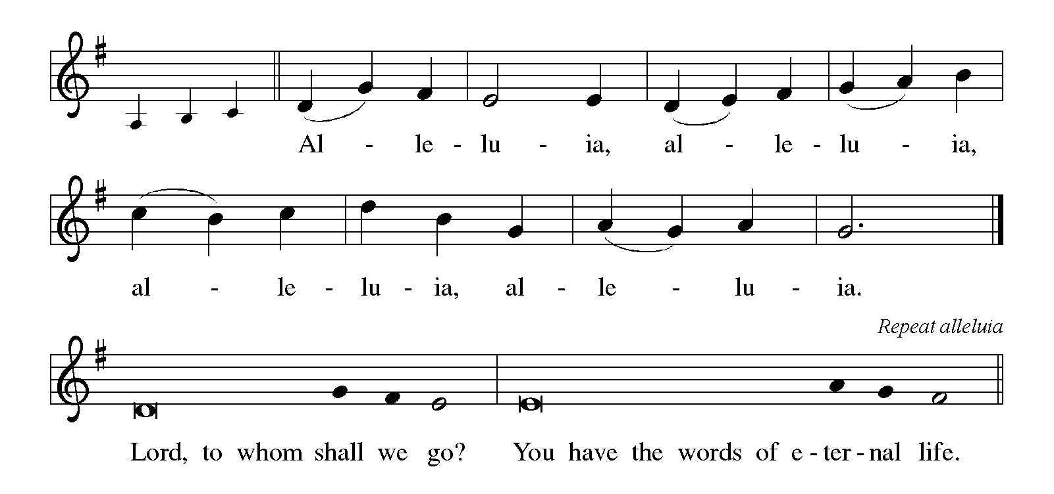

THE HOLY GOSPEL Mark 9:30-37

Jesus’ teaching and action in this text are directed to the church whenever it is seduced by the world’s definition of greatness: prestige, power, influence, and money. The antidote to such a concern for greatness is servanthood.

P: The Holy Gospel according to St. Mark, the ninth chapter.

C: Glory to You, O Lord!

Jesus and the disciples went on and passed through Galilee. He did not want anyone to know it; ³¹for He was teaching His disciples, saying to them, "The Son of Man is to be betrayed into human hands, and they will kill Him, and three days after being killed, He will rise again." ³²But they did not understand what He was saying and were afraid to ask Him.
³³Then they came to Capernaum; and when He was in the house He asked them, "What were you arguing about on the way?" ³⁴But they were silent, for on the way they had argued with one another who was the greatest. ³⁵He sat down, called the twelve, and said to them, "Whoever wants to be first must be last of all and servant of all."
³⁶Then He took a little child and put it among them; and taking it in His arms, He said to them, ³⁷"Whoever welcomes one such child in My name welcomes Me, and whoever welcomes Me welcomes not Me but the One Who sent Me."

P: The Gospel of the Lord.

C: Praise to You, O Christ!

The assembly is seated

THE SERMON
Silence for reflection follows the sermon

As you are able please rise

THE HYMN OF THE DAY NSB 84 The Potter’s Hand pages 10-11

THE APOSTLES’ CREED

A: God has made us His people through our Baptism into Christ. Living together in trust and
hope, we confess our faith.

C: I believe in God, the Father almighty,
creator of heaven and earth.
I believe in Jesus Christ, His only Son, our Lord.
He was conceived by the power of the Holy Spirit
and born of the virgin Mary.
He suffered under Pontius Pilate
was crucified, died, and was buried.
He descended into hell.
On the third day He rose again.
He ascended into heaven,
and is seated at the right hand of the Father.
He will come again to judge the living and the dead.
I believe in the Holy Spirit,
the holy catholic Church,
the communion of saints,
the forgiveness of sins,
the resurrection of the body,
and the life everlasting. Amen.

THE PRAYER OF THE CHURCH

A: Christ embraced humanity, sharing God’s love with the poor, the oppressed, and the weak.
May our lives reflect that same concern as we turn to God with our needs for the Church and
all the world.

A: That the Church may be unified in its praise and witness to Christ, let us pray to the Lord:

C: Lord, have mercy.

A: That the world created by God, divided by anger and hatred, bloodshed and violence, especially
in Ukraine; Afghanistan; Guinea, and Syria might know the power of God’s peace, let us pray
to the Lord:

C: Lord, have mercy.

A: That this and every Christian congregation might nurture every member--male and female,
young and old, married and single, let us pray to the Lord:

C: Lord, have mercy.

A: That husbands and wives may cultivate the image of God in one another, and families support
one another and serve those in need, let us pray to the Lord:

C: Lord, have mercy.

A: That those who have experienced broken relationships, and those who stand in need of physical
healing, especially ... may know God’s help and hope, let us pray to the Lord:

C: Lord, have mercy.

A: That those celebrating birthdays, especially Kay Peglow; Helen Wiese; and Fred Weiss;
and anniversaries, especially Don and Beth Thompson may be filled with grace this day and
every day and grow in grace in the days ahead, let us pray to the Lord:

C: Lord, have mercy.

A: That with the saints and martyrs of the Church, especially Dag Hammarskjöld, renewer of
society; and Nelson Trout, bishop, whom we commemorate this Day we may testify to Christ
until we share in His glory and honor, let us pray to the Lord:

C: Lord, have mercy.

P: Gracious and merciful God, Your faithfulness is timeless. Grant that our lives might reflect
that same faithfulness which Jesus, Your Son, shared with us, in Whose name we pray.

C: Amen.

THE PEACE

P: The peace of the Lord be with you always.

C: And also with you.

THE LORD'S PRAYER

P: As disciples who follow Jesus on the way to the Kingdom, we pray in childlike trust as He
taught us:

C: Our Father in heaven, hallowed be Your name. Your Kingdom come. Your will be
done on earth as in heaven. Give us this day our daily bread. Forgive us our sins as we
forgive those who sin against us. Save us from the time of trial and deliver us from evil.
For the Kingdom, the power, and the glory are Yours, now and forever. Amen.

SENDING
THE BENEDICTION

P: Almighty God: Father, Son, and Holy Spirit bless you now and forever.

C: Amen.

SENDING SONG 538 The Lord Now Sends Us Forth page 12

THE DISMISSAL

A: Go in peace to bear Christ's love to the world.

C: Thanks be to God!

To God Alone Be Glory

The Meditation is from Sundays and Seasons Online. Copyright 2015 Augsburg Fortress.

The Prayer of the Church is adapted from Intercessions for the Christian People. Gail Ramshaw,
ed. (New York: Pueblo Publishing Company, 1988) 126.

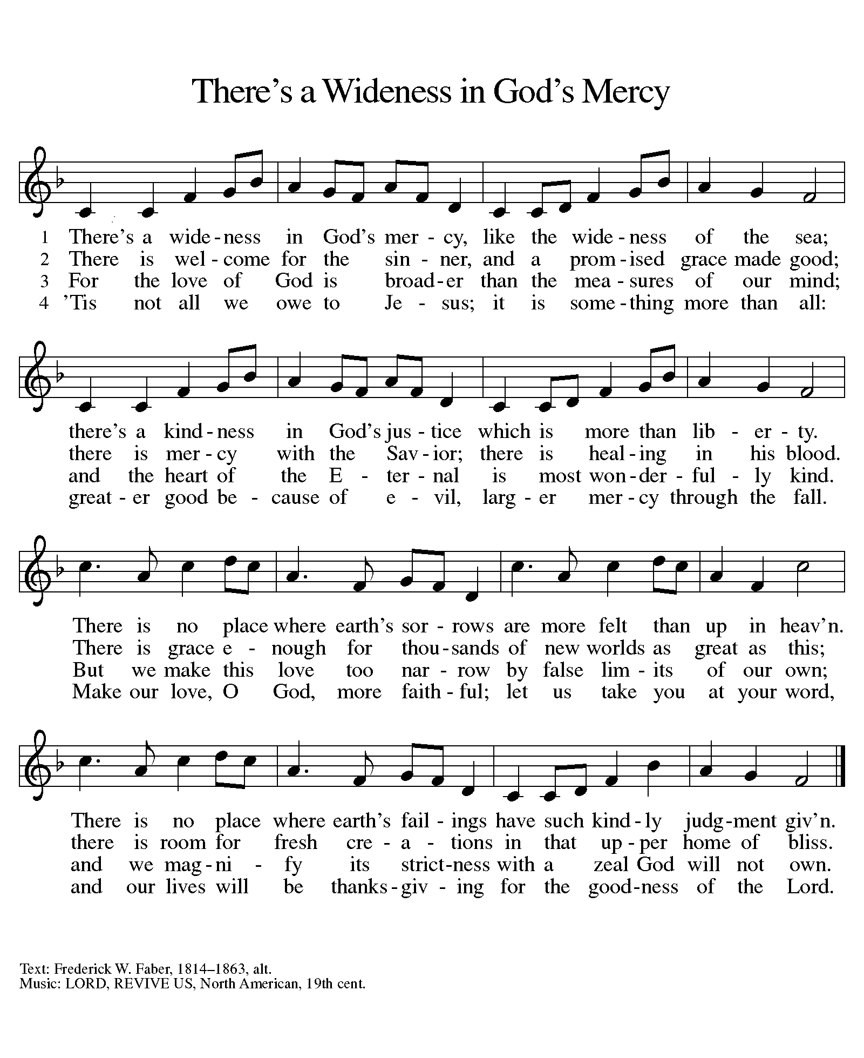

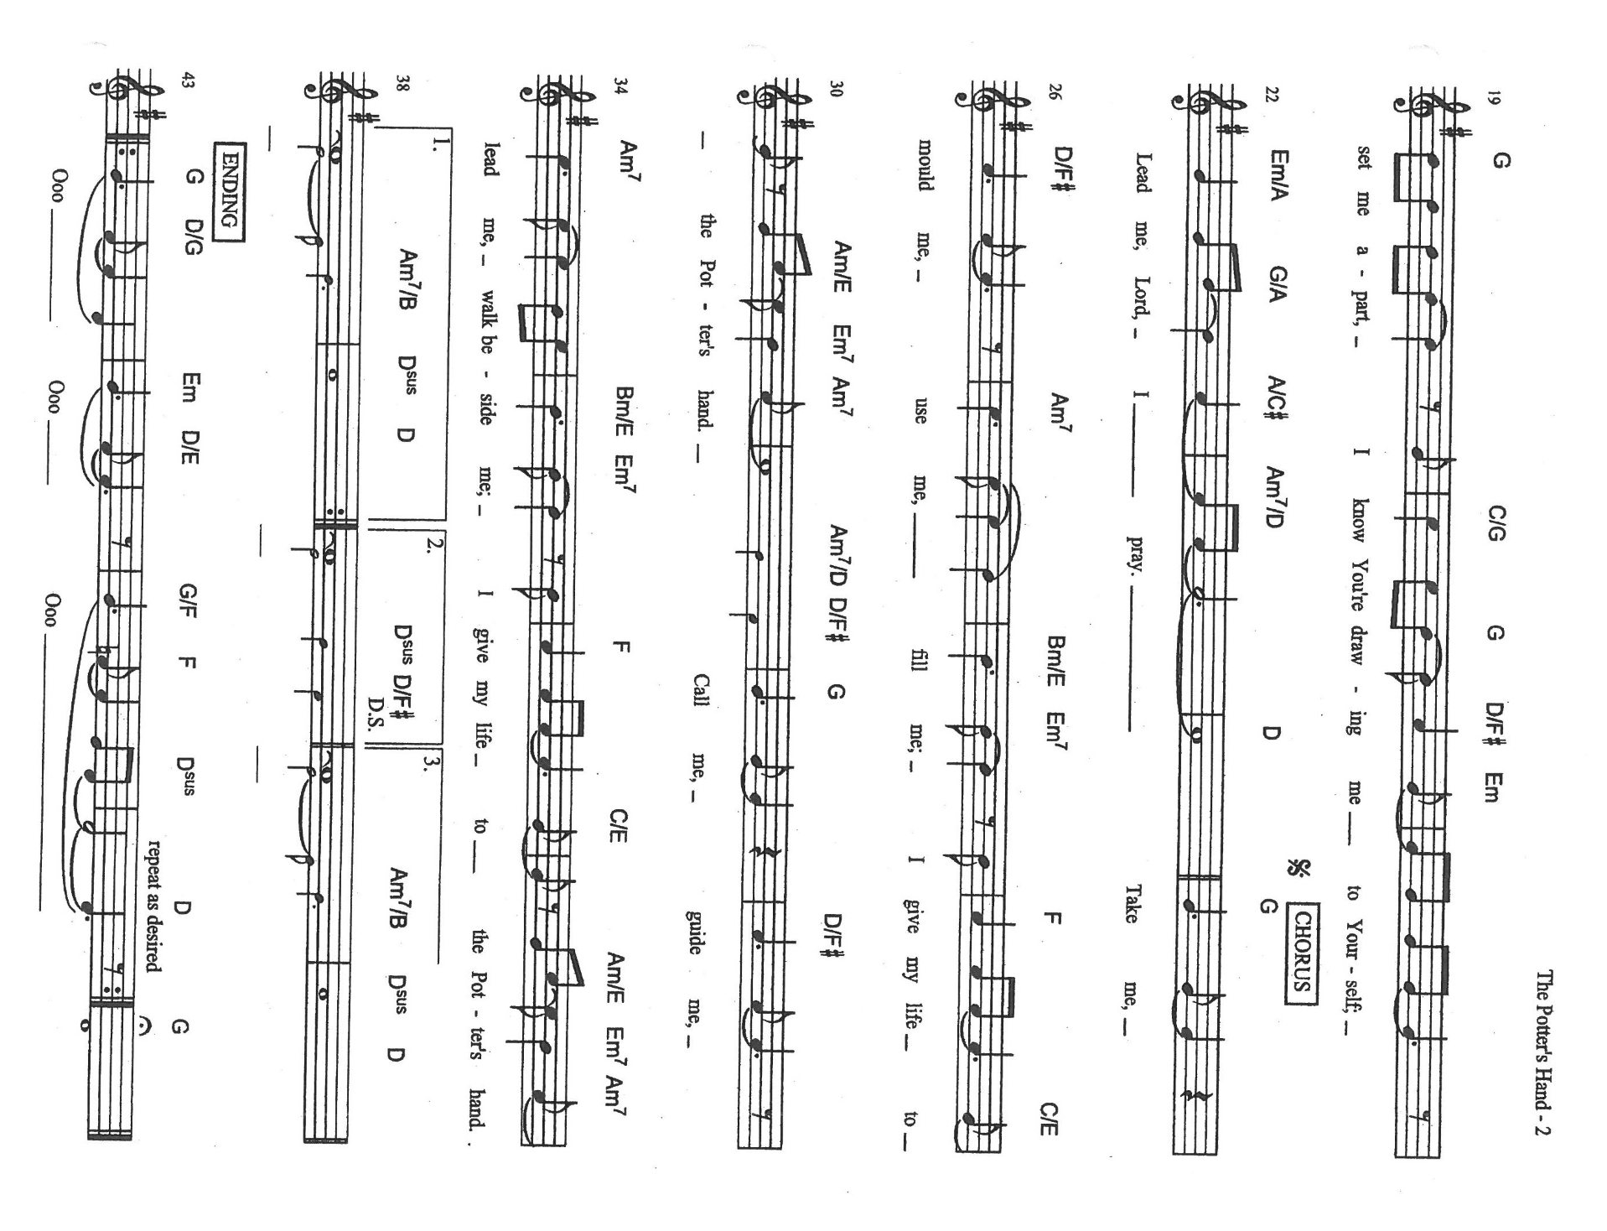
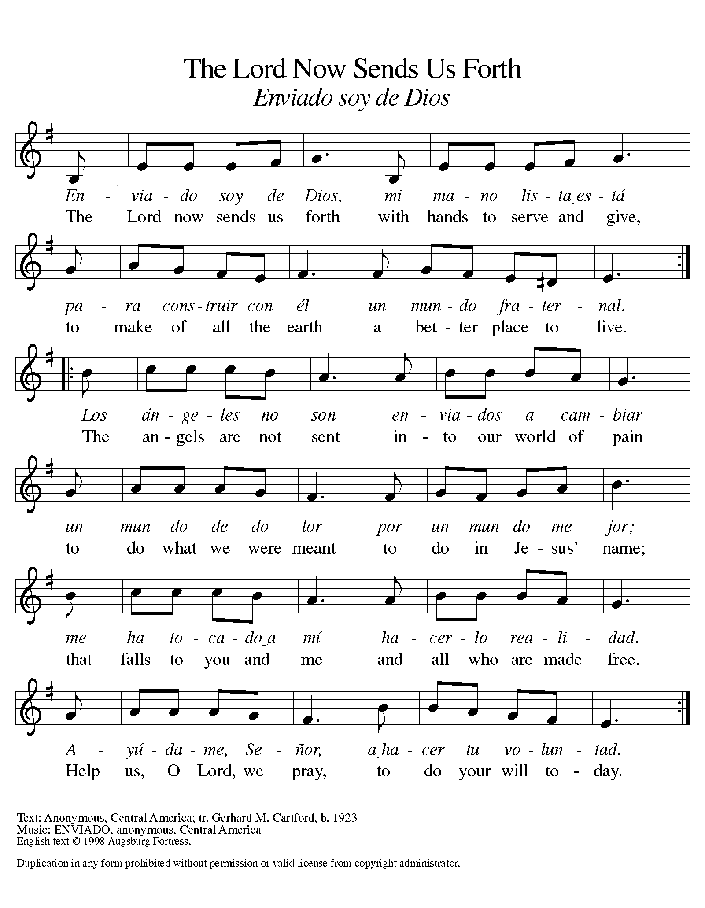

ANNOUNCEMENTS

Please remember to mail your offering to the Church Office at 818 Franklin Street, Michigan City, IN 46360. Another alternative is to give on-line through Tithe.ly. Please see your closure letter for information on how to set up a Tithe.ly account.

St. Paul Members are reminded to have a loved one contact the office if you are hospitalized. Many times, the Pastor doesn’t know someone is in the hospital. If you call and leave a message, please tell us which hospital the patient is at.

Next Sunday’s lessons are Numbers 11: 4-6, 10-16, 24-29; Psalm 19: 7-14; James 5: 13-20; Mark 9: 38-50 for those of you who like to study them in advance.

BIRTHDAYS: Kay Peglow (9/19); Helen Wiese (9/22); Fred Weiss (9/26)
ANNIVERSARIES: Don & Elizabeth Thompson (9/19)

PRAYER CONCERNS: Kathy Thielman, Audrey Beyer, George Ottersen, Charles Thomas Sr, Joyce and Bethany Manning, Marla Furness, Christine Kiser, Delores Hackett, Kay Peglow, Lee Timm, Ryan Krueger, Donna Bostater, Diane Gielow, Jeff Jensen, Maxine Powell, Jess Kalvaitis, Pastor Al Lorentzen, Jan Paholski, Laura Dovey, Heidi Happel, Shane Nevels, Irene Bohnstadt, Joan Coughlin, Jim Tomscheck, Wally & Betty Ratliff, Laura Moore, Cameron Rackard, Erik Tannehill, Ruth Lubs, Ed Gustum and Ken Mulder.

If you requested someone’s name to be on the prayer list and are aware that they need continued imminent prayer then contact the church office and let us know. Otherwise we will gradually transfer names to the long-term list.

OFFICE HOURS: Libby will be in the office on Mondays, Wednesdays, and Fridays; volunteers will cover Tuesdays and Thursdays.
Monday & Wednesday 8:00 a.m. – 5 p.m.
Tuesday & Thursday 9:00 a.m. – 12:00 p.m.
Friday 8:00 a.m. – 12:00 p.m.
If you are listening to the worship broadcast on the radio and would like to watch it live stream but you aren’t on Facebook, follow these four steps:

1) Go to your search engine (Google, Bing, etc.).
2) Search for St. Paul Lutheran Church & School, Michigan City, Indiana
3) Click on the option for St. Paul Lutheran Church & School—Home/Facebook
4) Click on “Videos” in the menu on the left side of the screen.

That should take you to the former videos and there should be one with a little red box that says “LIVE.’ Click on that video to enlarge it.

We will continue to live stream/broadcast the Sunday morning service on our Facebook page, and it will always be available on the radio broadcast Sunday mornings at 11:00 a.m. on WEFM (95.9), and on the local cable access station #99 for the previous week’s service on Sundays at 4:00 p.m. and the current service on Wednesdays at 7:00 p.m. and Fridays at 8:30 p.m.

To send e-mail to the church office, please use the following addresses:
Pastor Mark Reshan: seniorpastor@stpaulmichigancity.com
Church Office Secretary (Libby Pollock): churchsecretary@stpaulmichigancity.com
Church Treasurer (Karen Fleming) and Bookkeeper (Billie Atchinson):
finance@stpaulmichigancity.com.

The Good News Newsletter: If you have an article or anything you want included in The Good News please send it to the following e-mail address: splcgoodnews@gmail.com. Pastor Pamela Thiede will be using this e-mail address to assemble The Good News each month. The deadline for getting information to Pastor Pamela will be the 20th of each month.

WORSHIP ATTENDANCE for September 11-12, 2021
4:00 p.m. 24
9:00 a.m. 41
Total = 65

September Events and Meetings:

Worship Service: Saturday September 18, 2021 at 4:00pm

Worship Service: Sunday September 19, 2021 at 9:00am
Finance Committee: Monday September 20, 2021 at 4:00pm in the St. Paul Room
Bible Study: Wednesday September 22, 2021at 10:00am in Luther House
Choir Practice: Wednesday September 22, 2021 at 7:00pm
Church Council: Thursday September 23, 2021 at 5:30pm in the St. Paul Room
Worship Service: Saturday September 25, 2021 at 4:00pm

Worship Service: Sunday September 26, 2021 at 9:00am

One of our first-grade students, Ryan Cross from our school died tragically in an accident over Labor Day weekend. He was also the younger brother of our second-grade teacher, Ms. Taylor Moore. We are setting up a fund to assist the family in this time of great sorrow and need. You may contribute either by cash or check. Please make checks out to St. Paul Lutheran Church and designate it as a memorial to the Moore family. If you are donating cash please also identify your gift for this memorial fund. Thank you for your compassion and generosity.

A reminder that the benefit for Erik Tannehill is this Saturday, September 25 from 10:00 a.m.-2:00 p.m. in the church parking lot of First United Methodist on 7th and Pine Streets. In conjunction with First United and First Presbyterian we will be serving food and refreshments and enjoying a car show and entertainment from Hoosier Star. We are in need of the following volunteers: parking lot attendants in our lot; 4-5 people who can help direct the parking of the show cars who can also serve as “runners” during the show (please arrive by 9:00 a.m. at First United); and helpers afterwards to take down tables, tents, chairs, etc. We want to make this a great success for Erik so please find some time to help and stop by to share your well wishes and generous donations to his fund.

