**THE SEVENTEENTH SUNDAY AFTER PENTECOST**

**October 2, 2022**

Would you know that Christ is the seed? He is the grain of mustard seed, in that the narrative of the Lord’s passion is most bitter and most grievous, most bitter unto tears, most grievous unto our repentance. He sows the grain of mustard and so sows the kingdom of heaven. Not only is Christ the seed, but the least of all the seeds, because he came not in power, not in wealth, not in the wisdom of this world. But suddenly he unfolds as a tree the soaring eminence of his might.

**Ambrose, Bishop of Milan**

**Fourth century**

When Jesus' followers ask for faith, what do we want? Some might desire that faith brings a certain kind of certainty, perhaps even superiority. Faith, then, becomes an accomplishment. Some seek a mystical experience, a faith that works like a drug and helps us get through life's ordinary challenges. Some aspire to faith as an antidote to struggle. With enough faith, the televangelists tell us, we can conquer doubt, illness, even economic hardship.In this light, mustard seed faith and modest discipleship may be just what we need. By God's grace, discipleship requires not unshakable confidence or spectacular accomplishments. Luke's Jesus indeed makes extraordinary demands of his disciples, yet sometimes discipleship requires ordinary and daily practices of fidelity and service.

**Greg Carey**

Faith is putting one foot in front of the other and walking toward a future we do see yet but trust God is fashioning. Faith is heading out the door each day looking for opportunities to be God’s partner and co-worker in the world. Faith is imagining that the various challenges put in front of us -- whether solving a problem at work or forgiving someone who wronged us -- are actually opportunities that invite us to grow as disciples and witness to God’s presence and goodness in the world.

**David Lose**

**✠ GATHERING ✠**

**✠ In the Name of Jesus ✠**

**INTRODUCTION**

A little faith goes a long way is our Lord’s point in the gospel. A mustard seed’s-worth has miraculous potential. The patience, tenacity, and endurance required for the life of faith are the blessings received in water and the word (holy baptism), bread and wine (holy communion), the word read and proclaimed in this assembly. Anticipate them. Receive them with thanksgiving.

**Jerome, translator, teacher, died 420**

*Jerome was a biblical scholar and translator, but rather than translating the original Hebrew and Greek scriptures into classical Latin, he worked in the commonly-spoken Latin of the day, creating a version called the Vulgate.*

**✠ GATHERING ✠**

**PRELUDE *Lord Jesus Christ, Be Present Now*  Johann Walther**

**ANNOUNCEMENTS**

*As you are able please rise*

**CONFESSION AND ABSOLUTION**

P: In the name of the Father and of ✠ the Son and of the Holy Spirit.

C: **Amen.**

P: “Commit your way to the LORD and put your trust in Him … be still before the LORD

and wait patiently for Him.” (Psalm 37: 5,7) Recognizing our need for God’s mercy,

in silence let us confess our sin, trusting in God’s promise of reconciliation and

forgiveness.

*Silence for meditation and self-examination is kept*

P: Most merciful God,

C: **We confess that we are sinners in need of Your forgiveness. Like the prophet we**

**too despair in the face of the world’s troubles (Habakkuk 1:1-4). We doubt Your**

**goodness (1:3). We lack Your love, compassion, and mercy. For our lack of trust,**

**forgive us, O Lord. Send Your Spirit upon us, and rekindle the gift of grace You**

**have given us (2 Timothy 1:6), that we may serve You as we ought with joy and**

**hope.**

P: “Take delight in the LORD, and He shall give you your heart’s desire.” (Psalm 37:4)

God grants the gift you seek this day: for as a called and ordained minister of the

Church of Christ, and by His authority, I therefore declare to you the entire forgiveness

of all your sins, in the name of the Father and of ✠ the Son and of the Holy Spirit.

C: **Amen.**

**GATHERING HYMN 527 *Lord Jesus Christ, Be Present Now***

**THE GREETING AND PRAYER OF THE DAY**

P: The grace of our Lord Jesus Christ, the love of God, and the communion of the Holy

Spirit be with you all.

C: **And also with you.**

P: Let us pray. Benevolent, merciful God: When we are empty, fill us. When we are weak

in faith, strengthen us. When we are cold in love, warm us, that with fervor we may

love our neighbors and serve them for the sake of Your Son, Jesus Christ, our Savior

and Lord.

C: **Amen.**

*The assembly is seated*

**✠ WORD ✠**

**FIRST READING Habakkuk 1:1-4; 2:1-4**

Injustice and violence in the time leading up to the Babylonian exile move this prophet to lament: How can a good and all-powerful God see evil in the world and seemingly remain indifferent? God answers by proclaiming that the wicked will perish, but the righteous will live by faith.

**Chapter 1**

The oracle that the prophet Habakkuk saw.  
2O LORD, how long shall I cry for help,  
and You will not listen?  
Or cry to you "Violence!"  
and You will not save?  
3Why do You make me see wrongdoing  
and look at trouble?  
Destruction and violence are before me;  
strife and contention arise.  
4So the law becomes slack  
and justice never prevails.  
The wicked surround the righteous —   
therefore judgment comes forth perverted.

**Chapter 2**

I will stand at my watchpost,

and station myself on the rampart;

I will keep watch to see what he will say to me,

and what he will answer concerning my complaint.

2Then the LORD answered me and said:

Write the vision;

make it plain on tablets,

so that a runner may read it.

3For there is still a vision for the appointed time;

it speaks of the end, and does not lie.

If it seems to tarry, wait for it;

it will surely come, it will not delay.

4Look at the proud!

Their spirit is not right in them,

but the righteous live by their faith.

The Word of the Lord.

**Thanks be to God.**

**THE PSALM: Psalm 37:1-10** **Read responsively**

1Do not be provoked by evildoers;

     do not be jealous of those who do wrong.

**2For they shall soon wither like the grass,**

**and like the green grass fade away.**

3Put your trust in the LORD and do good;

     dwell in the land and find safe pasture.

**4Take delight in the LORD,**

**Who shall give you your heart's desire.**

5Commit your way to the LORD; put your trust in the LORD,

     and see what God will do.

**6The LORD will make your vindication as clear as the light**

**and the justice of your case like the noonday sun.**

7Be still before the LORD and wait patiently.

     Do not be provoked by the one who prospers, the one who succeeds in evil schemes.

**8Refrain from anger, leave rage alone;**

**do not be provoked; it leads only to evil.**

9For evildoers shall be cut off,

     but those who hope in the LORD shall possess the land.

**SECOND READING 2 Timothy 1:1-14**

This message written from Paul to Timothy is a personal message of encouragement. In the face of hardship and persecution, Timothy is reminded that his faith is a gift of God. He is encouraged to exercise that faith with the help of the Holy Spirit.

Paul, an apostle of Christ Jesus by the will of God, for the sake of the promise of life that is in Christ Jesus, 2To Timothy, my beloved child: Grace, mercy, and peace from God the Father and Christ Jesus our Lord.

3I am grateful to God — Whom I worship with a clear conscience, as my ancestors did — when I remember you constantly in my prayers night and day. 4Recalling your tears, I long to see you so that I may be filled with joy. 5I am reminded of your sincere faith, a faith that lived first in your grandmother Lois and your mother Eunice and now, I am sure, lives in you. 6For this reason I remind you to rekindle the gift of God that is within you through the laying on of my hands; 7for God did not give us a spirit of cowardice, but rather a spirit of power and of love and of self-discipline.

8Do not be ashamed, then, of the testimony about our Lord or of me His prisoner, but join with me in suffering for the gospel, relying on the power of God, 9Who saved us and called us with a holy calling, not according to our works but according to His own purpose and grace.

This grace was given to us in Christ Jesus before the ages began, 10but it has now been revealed through the appearing of our Savior Christ Jesus, Who abolished death and brought life and immortality to light through the gospel. 11For this gospel I was appointed a herald and an apostle and a teacher, 12and for this reason I suffer as I do.

But I am not ashamed, for I know the One in Whom I have put my trust, and I am sure that He is able to guard until that day what I have entrusted to Him. 13Hold to the standard of sound teaching that you have heard from me, in the faith and love that are in Christ Jesus. 14Guard the good treasure entrusted to you, with the help of the Holy Spirit living in us.

The Word of the Lord.

**Thanks be to God.**

*As you are able please rise*

**THE VERSE**

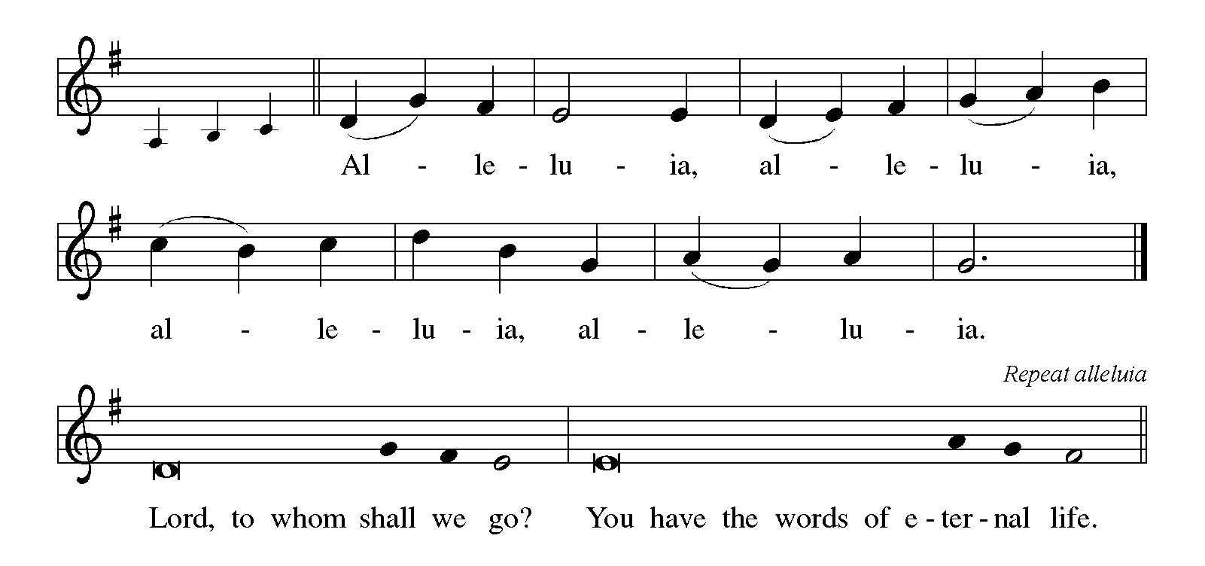

**THE HOLY GOSPEL Luke 17:5-10**

On the way to Jerusalem, Jesus instructs his followers about the power of faith and the duties of discipleship. He calls his disciples to adopt the attitude of servants whose actions are responses to their identity rather than works seeking reward.

P: The Holy Gospel according to St. Luke, the seventeenth chapter.

C: **Glory to You, O Lord!**

5The apostles said to the Lord, "Increase our faith!" 6The Lord replied, "If you had faith the size of a mustard seed, you could say to this mulberry tree, 'Be uprooted and planted in the sea,' and it would obey you.

7Who among you would say to your slave who has just come in from plowing or tending sheep in the field, 'Come here at once and take your place at the table'? 8Would you not rather say to him, 'Prepare supper for me, put on your apron and serve me while I eat and drink; later you may eat and drink'? 9Do you thank the slave for doing what was commanded? 10So you also, when you have done all that you were ordered to do, say, 'We are worthless slaves; we have done only what we ought to have done!'"

P: The Gospel of the Lord.

C: **Praise to You, O Christ!**

*The assembly is seated*

**THE SERMON**

*Silence for reflection follows the sermon*

*As you are able please rise*

**THE HYMN OF THE DAY 796 *How Firm a Foundation***

**THE APOSTLES’ CREED**

A: God has made us His people through our Baptism into Christ. Living together in trust

and faith, we confess our faith.

C: **I believe in God, the Father almighty,**

**creator of heaven and earth.**

**I believe in Jesus Christ, His only Son, our Lord.**

**He was conceived by the power of the Holy Spirit**

**and born of the virgin Mary.**

**He suffered under Pontius Pilate,**

**was crucified, died, and was buried.**

**He descended into hell.**

**On the third day He rose again.**

**He ascended into heaven,**

**and is seated at the right hand of the Father.**

**He will come again to judge the living and the dead.**

**I believe in the Holy Spirit,**

**the holy catholic Church,**

**the communion of saints,**

**the forgiveness of sins,**

**the resurrection of the body,**

**and the life everlasting. Amen.**

**THE PRAYER OF THE CHURCH**

A: With confidence in God’s abundant grace, let us pray for the Church, the world, and all

who cry out for mercy.

A: We yearn, O God, for understanding and faith in these difficult days. Give us the

patience to let things happen in Your time and way and not in our own. Lord, in Your

mercy,

C: **Hear our prayer.**

A: You have entrusted Your Church, O God, with the gift of Your Word. Fill us with

Your Spirit of power and love and self-discipline as we live it and proclaim it. Lord,

in Your mercy,

C: **Hear our prayer.**

A: You promise, O God, that evildoers and their schemes will wither and fade like the

grass. Turn the hearts of all who plot hatred and violence, that we may know safety

and peace. Lord, in Your mercy,

C: **Hear our prayer.**

A: We seek, O God, to be more faithful servants in this community. Increase our

compassion, our generosity of gifts and talents, our selflessness in service. Lord, in

Your mercy,

C: **Hear our prayer.**

A: We ask, O God, that Zachary Petri and Katie Schoof, joined together as husband and

wife in Christ may grow in holy love for You, one another, and for the world. Lord, in

Your mercy,

C: **Hear our prayer.**

A: We plead, O God, for healing for the sick, especially . . . Lord, in Your mercy,

C: **Hear our prayer.**

A: We bless You, O God, for those celebrating birthdays, especially **Dan McNabb;** and

anniversaries, especially **Jim and Sue Tomsheck**. Grant them to grow in grace this

day and be filled with grace for the days ahead: Lord, in Your mercy,

C: **Hear our prayer.**

A: We thank You, O God, for all who have led the way of faith. Make us obedient servants

until the day we join the faithful in Your Kingdom. Lord, in Your mercy,

C: **Hear our prayer.**

P: Give us strength to pray and not lose heart, O God. Hasten the coming of Your Reign

made known in the death and resurrection of Jesus Who is Lord, now and forever.

C: **Amen.**

**✠ MEAL ✠**

**THE PEACE**

P: The peace of the Lord be with you always.

C: **And also with you.**

*The assembly is seated*

**OFFERING**

**VOLUNTARY *Beautiful Savior*  John A. Behnke**

*As you are able please rise*

**THE OFFERTORY 531 (Stanzas 1, 3) *The Trumpets Sound, the Angels Sing***

**THE OFFERTORY PRAYER**

A: Let us pray. God of truth,

C: **Receive all we offer You this day. By this Meal, increase our faith, and make us**

**worthy servants, strong to follow in the way of Jesus the Lord. Amen.**

**THE GREAT THANKSGIVING**

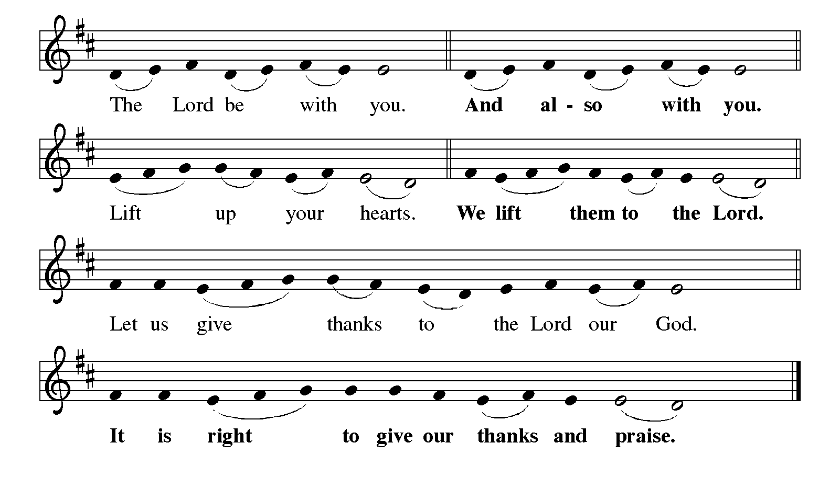

P: It is indeed right, our duty, and our joy … join their unending hymn:

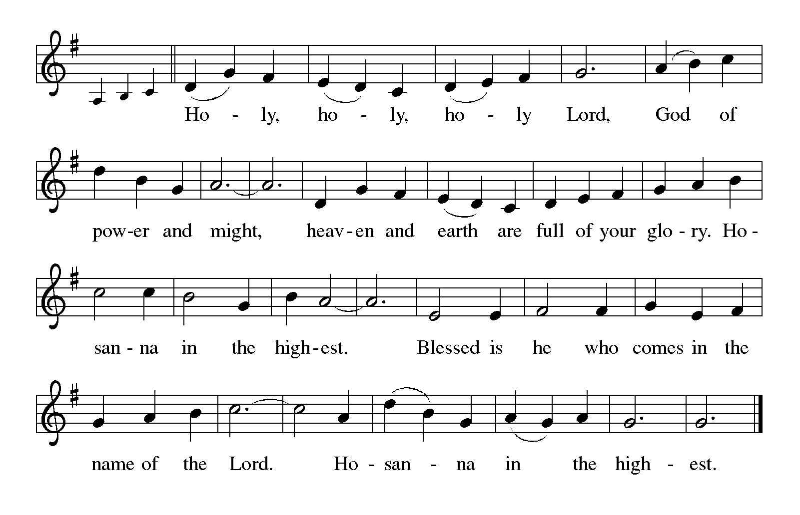

P: It is our duty and our joy to thank You, Lord God, our hope and our foundation,

because You made this sunrise of wonder and You established the heavens

in bright array.

With great joy, You called a people and set them free.

Finally in Your Son Jesus You came among Your people and let loose the power of

Your Spirit.

In Jesus’ death and resurrection You transformed our meanness and cruelty into

Your unfailing joy and grace.

Exhilarating God, in Jesus You have given us the architect of our salvation, and in

this Meal You show Your willingness to be broken and poured out to win

us back to You.

Send down Your Holy Spirit, that Your people may be made holy by Your grace, and

these gifts of bread and wine may be for us the Body and Blood of Your

Son, Jesus Christ,

Who, in the night … “Do this for the remembrance of Me.”

As often as we eat … we proclaim the Lord’s death until He comes.

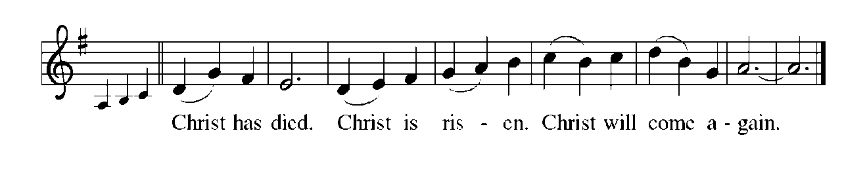

P: Generous God, as You fill us with the Bread of Life, renew our hope that not only

we but all Your people may never be hungry again.

Make us heralds and apostles and teachers, that we may know Your power to save,

be called to spread Your grace and mercy, and build one another up in the

ways of right and faithful living and peace;

That our tradition may be renewed in trust, deepened in suffering, and resolute amid

shame, until we see You face to face, and Your justice shines throughout

the earth, and all people rise to enjoy Your glory,

Ever one God, Father ✠ Son, and Holy Spirit.

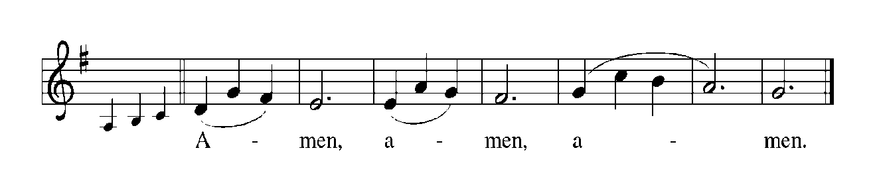

**THE LORD’S PRAYER**

P: Gathered into one by the Holy Spirit, let us pray as Jesus taught us:

C: **Our Father in heaven, hallowed be Your name. Your Kingdom come. Your will**

**be done on earth as it is in heaven. Give us this day our daily bread, and forgive**

**us our sins as we forgive those who sin against us. Save us from the time of trial**

**and deliver us from evil. For the Kingdom, the power, and the glory are Yours,**

**now and forever. Amen.**

**INVITATION TO THE MEAL**

P: This is the Lamb of God Who takes away the sin of the world. Happy are they who are

called to His Table. God’s holy gifts for God’s holy people. Come, for all is now

ready.

*The assembly is seated*

**THE DISTRIBUTION**

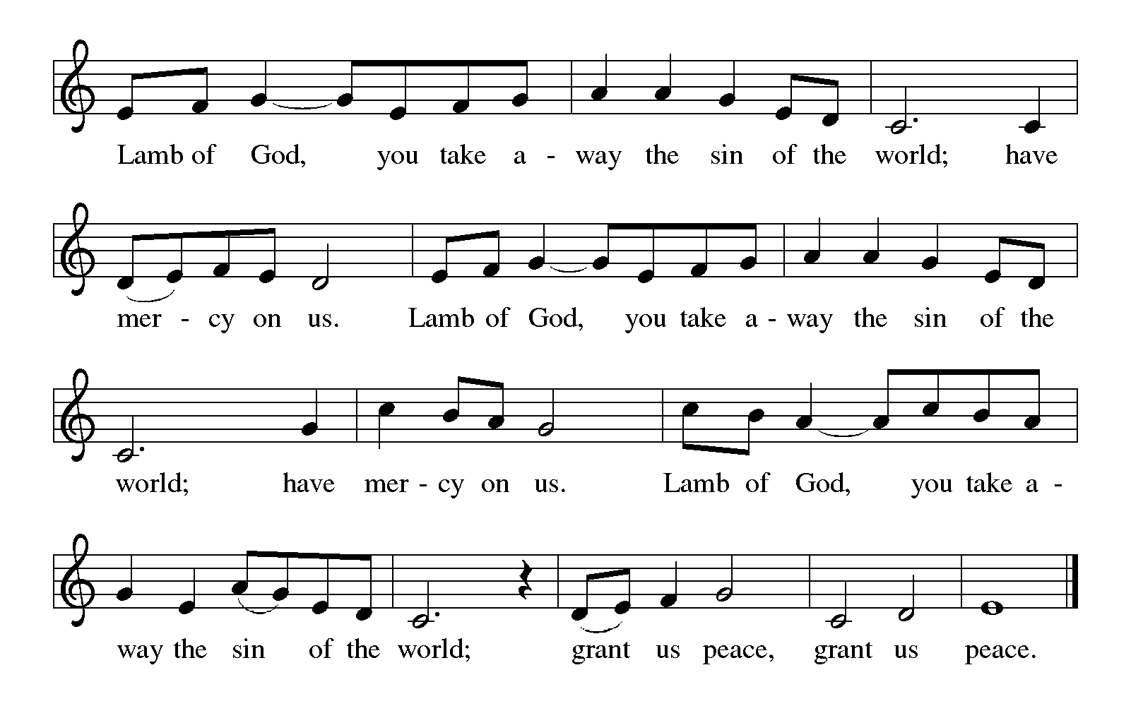

**HYMN DURING DISTRIBUTION 759 *My Faith Looks Up to Thee***

**635 *We Walk by Faith***

*As you are able please rise*

**THE POST-COMMUNION BLESSING**

P: The Body and Blood of our Lord Jesus Christ strengthen you and keep you in His grace.

C: **Amen.**

**THE POST-COMMUNION PRAYER**

A: Let us pray. Lord Jesus Christ, by faith we have tasted the life-giving Food of Your

Kingdom. Strengthen us by this Feast, and help us to produce the fruits of faith that

bring joy to You and Your life to the world. You are the Lord forevermore.

C: **Amen.**

**✠ SENDING ✠**

**THE BENEDICTION**

P: Almighty God: Father, Son, ✠ and Holy Spirit bless you now and forever.

C: **Amen.**

**THE SENDING HYMN 545 *Lord, Dismiss Us With Your Blessing***

**THE DISMISSAL**

A: Go in peace to bear Christ’s love to all the world.

C: **Thanks be to God!**

**POSTLUDE *March in B flat* J. Haydn**

**✠ To God Alone Be Glory ✠**

The Meditations are from *Sundays and Seasons Online.* Copyright 2019 Augsburg

Fortress; and *Pulpit Resource.* William Willimon, ed. Vol. 26, No. 4 ((Inver

Heights, MN: Logos Productions, 1998) 3.

The Prayers are adapted from *Intercessions for the Christian People.* Gail Ramshaw, ed.

(New York: Pueblo Publishing Company, 1988) 196.

The Eucharistic Prayer is adapted from *Eucharistic Prayers.* Samuel Wells and Abigail

Kocher. (Grand Rapids: Eerdmann’s Publishing Company, 2016) 296-97.

**ANNOUNCEMENTS**

**Please remember to mail your offering to the Church Office** at 818 Franklin Street, Michigan City, IN 46360**.** Another alternative is to give on-line through Tithe.ly. Please see your closure letter for information on how to set up a Tithe.ly account.

**St. Paul Members are reminded to have** a loved one contact the office if you are hospitalized. Many times, the Pastor doesn’t know someone is in the hospital. If you call and leave a message, please tell us which hospital the patient is at.

**Next Sunday’s lessons are II Kings 5: 1-3, 7-15c; Psalm 111; 2 Timothy 2: 8-15 and Luke 17: 11-19** for those of you who like to study them in advance.

**Birthdays: Dan McNabb (10/7)**

**Anniversaries: James & Susan Thomsheck (10/4)**

**PRAYER CONCERNS:** Audrey Beyer, Ryan Krueger, Donna Bostater, Maxine

Powell, Jim Tomscheck, Eloise Ponder, Mark & Jary Tannehill, Leonard Cross, George Ottersen, Annette Scroggin, Helen Hill-Weaver, Bernadette Krueger, Patti Henoch and Valerie Waltz.

**If you requested someone’s name to be on the prayer list and are aware that they need continued imminent prayer then contact the church office and let us know.** Otherwise we will gradually transfer names to the long-term list.

**OFFICE HOURS:** Libby will be in the office on Mondays, Wednesdays, and Fridays; volunteers will cover Tuesdays and Thursdays.

Monday & Wednesday 8:00 a.m. – 5 p.m.

Tuesday & Thursday 9:00 a.m. – 12:00 p.m.

Friday 8:00 a.m. – 12:00 p.m.

**If you are listening to the worship broadcast on the radio and would like to watch the Sunday morning service live stream follow these steps:**

(1) If you have You.Tube available on your TV, search for

**St. Paul Lutheran Church Michigan City, IN.**

(2) The direct link on the computer is

<https://www.youtube.com/channel/UC5AIPNaKr3QN50984jGOa1g>.

 (3) This link is also on the main page of the church’s website in the church section and will continue to be posted weekly on the St. Paul Facebook page.

And it will always be available on the radio broadcast Sunday mornings at 11:00 a.m. on WEFM (95.9), and on the local cable access station #99 for the previous week’s service on Sundays at 4:00 p.m. and the current service on Wednesdays at 7:00 p.m. and Fridays at 8:30 p.m.

**To send e-mail to the church office**, please use the following addresses:

Pastor Mark Reshan: [seniorpastor@stpaulmichigancity.com](mailto:seniorpastor@stpaulmichigancity.com)

Church Office Secretary (Libby Pollock): [churchsecretary@stpaulmichigancity.com](mailto:churchsecretary@stpaulmichigancity.com)

Church Treasurer (Karen Fleming): [finance@stpaulmichigancity.com](mailto:finance@stpaulmichigancity.com)

**The Good News Newsletter**: If you have an article or anything you want included in **The Good News** please send it to the following e-mail address: splcgoodnews@gmail.com. Pastor Pamela Thiede will be using this e-mail address to assemble **The Good News** each month. The deadline for getting information to Pastor Pamela will be the 20th of each month.

**WORSHIP ATTENDANCE for September 24 and 25, 2022**

**4:00 p.m. 41**

**9:00 a.m. 31**

**Total = 72**

**OCTOBER 2022 ACTIVITIES, EVENTS & SERVICES**

**Saturday,** October 1, 2022at 4:00 p.m. Worship Service

**Sunday,** October 2, 2022 at 9:00 a.m. Worship Service

**Wednesday,** October 5, 2022 at 9:45 a.m. Bible Study/Luther House

at 10:00 a.m. God’s Purls/ St. Paul Room

**Saturday,** October 8, 2022 at 4:00 p.m. Worship Service

**Sunday,** October 9, 2022 at 9:00 a.m. Worship Service

**Monday,** October 10, 2022 at 12:30 p.m.Harmony Circle/St. Paul Room

at 3:30 p.m. School Board Mtg./Luther House

**Tuesday,** October 11, 2022 at 9:30 a.m. Charity Circle/St. Paul Room

at 7:00 p.m. Estuary/Luther House

**Wednesday,** October 12, 2022 at 9:45 a.m. Bible Study/Luther House

at 10:00 a.m. God’s Purls/St. Paul Room

at 6:00 p.m. Worship & Music Comm. Mtg./St. Paul Room

at 7:00 p.m. Choir Rehearsal

**Saturday,** October 15, 2022 at 4:00 p.m.Worship Service

**Sunday,** October 16, 2022 at 9:00 a.m. Worship Service

**Monday,** October 17, 2022 at 4:00 p.m. Finance Committee Mtg./Luther House

at 5:30 p.m. Executive Board Mtg./Luther House

**Wednesday,** October 19, 2022 at 9:45 a.m. Bible Study /Luther House

at 10:00 a.m. God’s Purls/St. Paul Room

**Saturday,** October 22, 2022 at 4:00 p.m. Worship Service

**Sunday,** October 23, 2022 at 9:00 a.m. Worship Service

**Wednesday,** October 26, 2022 at 9:45 a.m. Bible Study/Luther House

at 10:00 a.m. God’s Purls/St. Paul Room

**Thursday,** October 27, 2022 from 4:p.m. -- 10:00 p.m. (Close)

at 5:00 p.m.150th Anniv. Planning Comm. Mtg.

at 5:30 p.m. Church Council Mtg./St. Paul Room

**Saturday,** October 29, 2022at 4:00 p.m. Worship Service

**Sunday,** October 30, 2022 at 9:00 a.m. Worship Service