THE EIGHTEENTH SUNDAY AFTER PENTECOST
September 26, 2021

Do you want to honor Christ’s body? Then do not scorn him in his nakedness, nor honor him here in the church with silken garments while neglecting him outside where he is cold and naked. Of what use is it to weigh down Christ’s table with golden cups, when he himself is dying of hunger? First, fill him when he is hungry; then use the means you have left to adorn his table. Will you have a golden cup made, but not give a cup of water? Do not, therefore, adorn the church and ignore your afflicted brother, for he is the most precious temple of all.

John Chrysostom

“…Remember last week when he held that toddler in his arms? Our story picks up there and we have no indication that Jesus has set aside the child.
John speaks up for the first of two times in Mark’s gospel. On both occasions, John addresses Jesus as “teacher” and immediately demonstrates that he has not followed Jesus’ teaching. The second occasion will be when Jesus predicts his upcoming passion for the third time, and John together with his brother will turn away from the prediction again to pursue their own greatness.
That second John-speech shares many traits with the one assigned for today. In the first part of the story (which we heard last week), Jesus is holding the toddler in his arms and exhorting his disciples to attend to them if they wish to pursuit greatness. John interrupts him -- “teacher” -- without any sign that he has heard this and steers the conversation away from hospitality and compassion …”
“…Jesus is bringing the attention of the disciples back to his teaching about the child whom he still holds in his arms. He told them of the importance of welcoming the little ones; now he warns of what will happen if they act hostilely toward the same …”
“…When seen in the narrative flow, this text warns of missing Jesus’ call to care for the little ones. Inattention to the little ones imperils one’s life eternally. Children are portrayed as those who practice that key marker of discipleship: they trust or believe in Jesus (verse 42). When Jesus held the toddler in their midst Christ declared the child a sacrament of God’s presence and his own: ‘Whoever welcomes one such child in my name welcomes me, and whoever welcomes me welcomes not me but the one who sent me’ (Mark 9:37).
This story warns us to pay attention to the children who give us access to the presence of God. We are to do all within our power to protect and care for them within the community of faith and without. Sometimes we do damage to them actively. But just as often we, like John, simply lose track of those whom Jesus has put in the center of community. We become distracted by competition or our own status. Jesus calls us to be a community of peace where trusting children are cherished.”

Robert Jones

In the Name of Jesus

INTRODUCTION

Someone is casting out demons in Jesus’ name who isn’t part of Jesus’ own circle, and the disciples want him stopped. They appeal to Jesus, as Joshua did to Moses about the elders who prophesied without official authorization. Like Moses, Jesus refuses to see this as a threat. Jesus welcomes good being done in his name, even when it is not under his control. The circle we form around Jesus’ word must be able to value good being done in ways we wouldn’t do it, by people we can’t keep tabs on.

Michael and All Angels

Michael the archangel, captain of the heavenly hosts, is remembered on this day along with the other angels and archangels. The word "angel" means messenger, and in Judaism, Christianity, and Islam, these beings have a fully spiritual nature and no physical body.

GATHERING

PRE-SERVICE MUSIC Come, Now is the Time to Worship New Song Praise Band

PRELUDE When in Our Music God is Glorified Robert A. Hobby

ANNOUNCEMENTS

As you are able please rise

CONFESSION AND ABSOLUTION

P: In the name of the Father and of the Son and of the Holy Spirit.

C: Amen.

P: “Who can detect one’s own offenses? Cleanse me from my secret faults. Above all,
keep Your servant from presumptuous sins; let them not get dominion over me; then
shall I be whole and sound, and innocent of a great offense.” (Psalm 19:12-13) God
sees and knows the “secrets” of our hearts. That our sins may not “get dominion” over
us let us therefore confess them before God and one another, that by His great mercy
He might again make us “whole and sound.”

Silence for self-examination and reflection is kept

P: Most merciful God,

C: We confess that we have sinned against You and one another in thought, word,
and deed. We have burdened You with our complaining about what we do not
have instead of being thankful for what You have so generously gifted us
(Numbers 11:4-11). We have not desired Your teachings and ways above all else
(Psalm 19:10). The “words of our mouths and meditations of our hearts” have not
always been “acceptable” in Your sight (19:14). We have failed to pray with faith
(James 5:15) nor confessed our sins (5: 16). We have “wandered from Your truth.”
(5:19) For the sake of Your Son, Jesus Christ, forgive us and have mercy upon us.
Return us from “wandering,” that our “multitude of sins” may be “covered” and
we might be restored to faithful and fruitful service to You.

P: In Jesus God has gone to “hell” (Mark 9: 47) and the grave in order to “bring us sinners
back” (James 5:20) to God and that we might “enter the kingdom” (Mark 9: 47). For
Jesus’ sake God does “cleanse you from all your faults,” known and “secret” (Psalm
19: 12), for as a called and ordained minister of the Church of Christ, and by His
authority, I declare to you the entire forgiveness of all your sins, in the name of the
Father, and of the Son and of the Holy Spirit.

C: Amen.

GATHERING HYMN NSB 16 Blessed Be Your Name pages 11-12

GREETING AND PRAYER OF THE DAY

P: The grace of our Lord Jesus Christ, the love of God, and the communion of the Holy
Spirit be with you all.

C: And also with you.

P: Let us pray. Generous God, Your Son gave His life that we might come to peace with
You. Give us a share of Your Spirit, and in all we do empower us to bear the name of
Jesus Christ, our Savior and Lord.

C: Amen.

The assembly is seated

WORD

FIRST READING Numbers 11: 4-6, 10-16, 24-29

What constitutes legitimate need and legitimate leadership is the focus of this reading. God
provides manna in the wilderness, yet the people crave meat. What is truly needful? God
bestows the spirit on seventy elders, yet two men not designated as leaders prophesy in the power of God’s spirit. What constitutes real leadersip?

⁴The rabble among them had a strong craving; and the Israelites also wept again, and said, “If only we had meat to eat! ⁵We remember the fish we used to eat in Egypt for nothing, the cucumbers, the melons, the leeks, the onions, and the garlic; ⁶but now our strength is dried up, and there is nothing at all but this manna to look at.”
¹⁰Moses heard the people weeping throughout their families, all at the entrances of their tents. Then the Lord became very angry, and Moses was displeased. ¹¹So Moses said to the Lord, “Why have You treated Your servant so badly? Why have I not found favor in Your sight, that You lay the burden of all this people on me? ¹²Did I conceive all this people? Did I give birth to them, that You should say to me, ‘Carry them in your bosom, as a nurse carries a sucking child, to the land that You promised on oath to their ancestors’?
¹³Where am I to get meat to give to all this people? For they come weeping to me and say, ‘Give us meat to eat!’ ¹⁴I am not able to carry all this people alone, for they are too heavy for me. ¹⁵If this is the way You are going to treat me, put me to death at once—if I have found favor in Your sight—and do not let me see my misery.”
¹⁶So the Lord said to Moses, “Gather for Me seventy of the elders of Israel, whom you know to be the elders of the people and officers over them; bring them to the tent of meeting, and have them take their place there with you.”
²⁴So Moses went out and told the people the words of the Lord; and he gathered seventy elders of the people, and placed them all around the tent. ²⁵Then the Lord came down in the cloud and spoke to him, and took some of the spirit that was on him and put it on the seventy elders; and when the spirit rested upon them, they prophesied. But they did not do so again.
²⁶Two men remained in the camp, one named Eldad, and the other named Medad, and the spirit rested on them; they were among those registered, but they had not gone out to the tent, and so they prophesied in the camp. ²⁷And a young man ran and told Moses, “Eldad and Medad are prophesying in the camp.” ²⁸And Joshua son of Nun, the assistant of Moses, one of his chosen men, said, “My lord Moses, stop them!” ²⁹But Moses said to him, “Are you jealous for my sake? Would that all the Lord‘s people were prophets, and that the Lord would put his spirit on them!”
The Word of the Lord.

Thanks be to God.

THE PSALM: Psalm 19:7-14 Read responsively

⁷The teaching of the Lord is perfect and revives the soul;
the testimony of the Lord is sure and gives wisdom to the simple.

⁸The statutes of the Lord are just and rejoice the heart;
the commandment of the Lord is clear and gives light to the eyes.

⁹The fear of the Lord is clean and endures forever;
the judgments of the Lord are true and righteous altogether.

¹⁰More to be desired are they than gold, more than much fine gold,
sweeter far than honey, than honey in the comb.

¹¹By them also is Your servant enlightened,
and in keeping them there is great reward.

¹²Who can detect one’s own offenses?
Cleanse me from my secret faults.

¹³Above all, keep Your servant from presumptuous sins; let them not get dominion
over me; then shall I be whole and sound, and innocent of a great offense.

¹⁴Let the words of my mouth and the meditation of my heart be acceptable in
Your sight, O Lord, my strength and my redeemer.

SECOND READING James 5:13-20

Marks of the Christian community include praying for those who are sick and in need, celebrating with those in good health, restoring those who have strayed, confessing sins to one another, and offering forgiveness to each other.

¹³Are any among you suffering? They should pray. Are any cheerful? They should sing songs of praise. ¹⁴Are any among you sick? They should call for the elders of the church and have them pray over them, anointing them with oil in the name of the Lord. ¹⁵The prayer of faith will save the sick, and the Lord will raise them up; and anyone who has committed sins will be forgiven.
¹⁶Therefore confess your sins to one another, and pray for one another, so that you may be healed. The prayer of the righteous is powerful and effective. ¹⁷Elijah was a human being like us, and he prayed fervently that it might not rain, and for three years and six months it did not rain on the earth. ¹⁸Then he prayed again, and the heaven gave rain and the earth yielded its harvest.
¹⁹My brothers and sisters, if anyone among you wanders from the truth and is brought back by another, ²⁰you should know that whoever brings back a sinner from wandering will save the sinner’s soul from death and will cover a multitude of sins.

The Word of the Lord.

Thanks be to God.

CHOIR ANTHEM Give Me Jesus St. Paul Senior Choir

As you are able please rise

THE VERSE

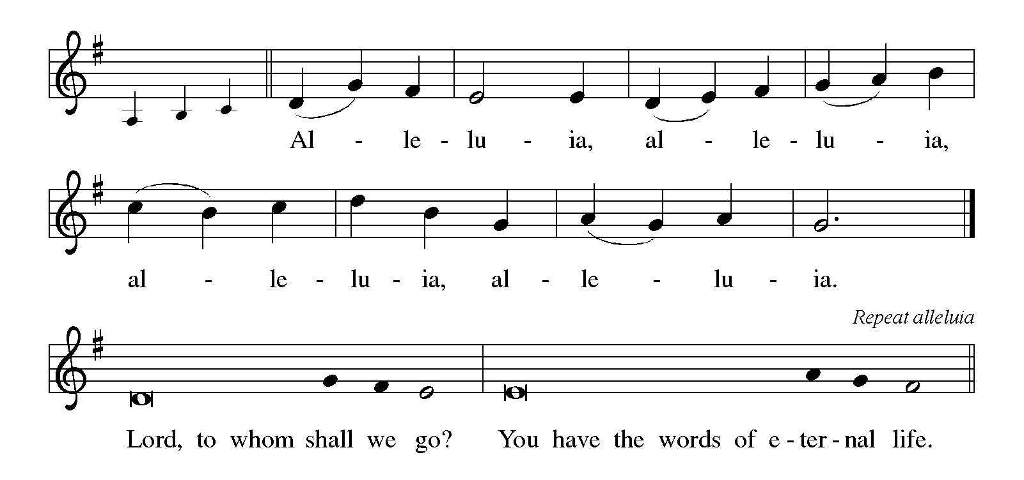

THE HOLY GOSPEL Mark 9:38-50

On the way to Jerusalem, Jesus teaches his disciples about ministry that involves service and sacrifice. His disciples are slow to realize that these words apply to them as well as to others.

P: The Holy Gospel according to St. Mark, the ninth chapter.

C: Glory to You, O Lord!

³⁸John said to [Jesus,] “Teacher, we saw someone casting out demons in Your name, and we tried to stop him, because he was not following us.” ³⁹But Jesus said, “Do not stop him; for no one who does a deed of power in My name will be able soon afterward to speak evil of Me. ⁴⁰Whoever is not against us is for us. ⁴¹For truly I tell you, whoever gives you a cup of water to drink because you bear the name of Christ will by no means lose the reward.
⁴²“If any of you put a stumbling block before one of these little ones who believe in Me, it would be better for you if a great millstone were hung around your neck and you were thrown into the sea. ⁴³If your hand causes you to stumble, cut it off; it is better for you to enter life maimed than to have two hands and to go to hell, to the unquenchable fire.
⁴⁵And if your foot causes you to stumble, cut it off; it is better for you to enter life lame than to have two feet and to be thrown into hell. ⁴⁷And if your eye causes you to stumble, tear it out; it is better for you to enter the kingdom of God with one eye than to have two eyes and to be thrown into hell, ⁴⁸where their worm never dies, and the fire is never quenched.
⁴⁹“For everyone will be salted with fire. ⁵⁰Salt is good; but if salt has lost its saltiness, how can you season it? Have salt in yourselves, and be at peace with one another.”
P: The Gospel of the Lord.

C: Praise to You, O Christ!

The assembly is seated

THE SERMON
Silence for reflection follows the sermon

As you are able please rise

THE HYMN OF THE DAY NSB 18 Bring Forth the Kingdom page 13

THE APOSTLES’ CREED

A: God has made us His people through our Baptism into Christ. Living together in trust
and hope, we confess our faith.

C: I believe in God, the Father almighty,
creator of heaven and earth.
I believe in Jesus Christ, His only Son, our Lord.

He was conceived by the power of the Holy Spirit
and born of the virgin Mary.
He suffered under Pontius Pilate
was crucified, died, and was buried.
He descended into hell.
On the third day He rose again.
He ascended into heaven,
and is seated at the right hand of the Father.
He will come again to judge the living and the dead.

I believe in the Holy Spirit,
the holy catholic Church,
the communion of saints,
the forgiveness of sins,
the resurrection of the body,
and the life everlasting. Amen.

The assembly is seated

THE INSTALLATION OF MUSICIANS

The musicians to be installed come forward

John Remmel Senior Organist
Lori Zylstra Director of Music
The Choir
Jary Tannehill Director, New Song Praise Band
Charlie Marks Member, New Song Praise Band
Mark Tannehill Member, New Song Praise Band
Stacie Crozier Member, New Song Praise Band
Sue Koziel Member, New Song Praise Band

P: Our Lord, Who came among us as a servant, calls us to faith and life of loving service
to our neighbor. You stand among us as those called to a particular service, a gift from
God to inspire us to love and good works.

A reading from Romans: Just as each of our bodies has several parts and each part has
a separate function, so all of us, in union with Christ, form one body, and as parts of it
we belong to each other. Our gifts differ according to the grace given us. If your gift
is prophecy, then use it as your faith suggests; if administration, then use it for
administration; if teaching, then use it for teaching. Let the preachers deliver sermons,
the almsgivers give freely, the officials be diligent, and those who do works of mercy
do them cheerfully.

P: Will you assume this ministry in the confidence that it comes from God?

R: I will, and I ask God to help me.

P: Will you carry out this ministry in accordance with the teachings and practice of the
Lutheran Church?

R: I will, and I ask God to help me.

P: Will you be diligent in your study of the Holy Scriptures and faithful in your use of the
means of grace and in prayer?

R: I will, and I ask God to help me.

P: Will you trust in God’s care, seek to grow in love for those you serve, strive for
excellence in your skills, and adorn the Gospel with a godly life?

R: I will, and I ask God to help me.

P: Almighty God, Who has given you the will to do these things, graciously give you the
strength and compassion to perform them.

C: Amen.

As you are able please rise

THE PRAYER OF THE CHURCH

A: Christ calls us to a life of peace and humility. Let us pray for strength to live this
baptized life as we intercede for the Church, the world, and all those in need.

A: That the Church may rejoice at every sign of the Spirit’s presence and recognize as
fellow-disciples all who call on the name of Jesus, let us pray to the Lord:

C: Lord, hear our prayer.

A: That stumbling blocks placed in the path toward peace, especially in Tunisia, Syria,
Afghanistan, and other places of violence may give way to mutual trust and
reconciliation, let us pray to the Lord:

C: Lord, hear our prayer.

A: That our musicians and all those who lead worship may inspire us to wholly dedicate
our lives to the Lord in prayer, praise, and service to one another, let us pray to the
Lord:

C: Lord, hear our prayer.

A: That all children, especially refugees, immigrant children separated from their families;
the enslaved, the abused, and exploited may know the freedom to grow with self-
confidence, hope, and joy, let us pray to the Lord:

C: Lord, hear our prayer.

A: That the oppressed, the imprisoned, the hungry, the homeless, the addicted, and the
sick, especially … may raised up in the name of the Lord to health, strength, and
wholeness, let us pray to the Lord:

C: Lord, hear our prayer.

A: That those celebrating birthdays, especially Fred Weiss, Joyce Manning and
anniversaries, especially Bob and Carrie Ziesmer may be filled with grace this day
and every day and grow in grace in the days ahead, let us pray to the Lord:

C: Lord, hear our prayer.

A: That with those who have gone before us in the faith and served Christ in others we
may enter the Kingdom and join Michael and All Angels, whom we commemorate
this Day in everlasting joy and hope, let us pray to the Lord:

C: Lord, hear our prayer.

P: We are thirsty, O merciful God; give us a cup of water to drink. Hear our prayers and
answer our cries of need for the sake of Your Son, Jesus Christ our Lord.

C: Amen.

THE PEACE

P: The peace of the Lord be with you always.

C: And also with you.

THE LORD'S PRAYER
P: As disciples who follow Jesus on the way to the Kingdom, we pray in childlike trust as
He taught us:

C: (Sung) Music on the front cover of the red hymnal page 10

SENDING

THE BENEDICTION

P: Almighty God: Father, Son, and Holy Spirit bless you now and forever.

C: Amen.

SENDING HYMN 865 Praise, My Soul, the King of Heaven page 14

THE DISMISSAL

A: Go in peace to bear Christ's love to the world.

C: Thanks be to God!

POSTLUDE Maestoso (from Sonata II) Felix Mendelssohn

To God Alone Be Glory

The Meditations are from Sundays and Seasons Online. Copyright 2015 Augsburg
Fortress; and Working Preacher. Copyright Luther Seminary 2021.

The Prayers are adapted from Prayers for Sundays and Seasons. Year B. (Chicago: Liturgy
Training Publications, 1990) 137.

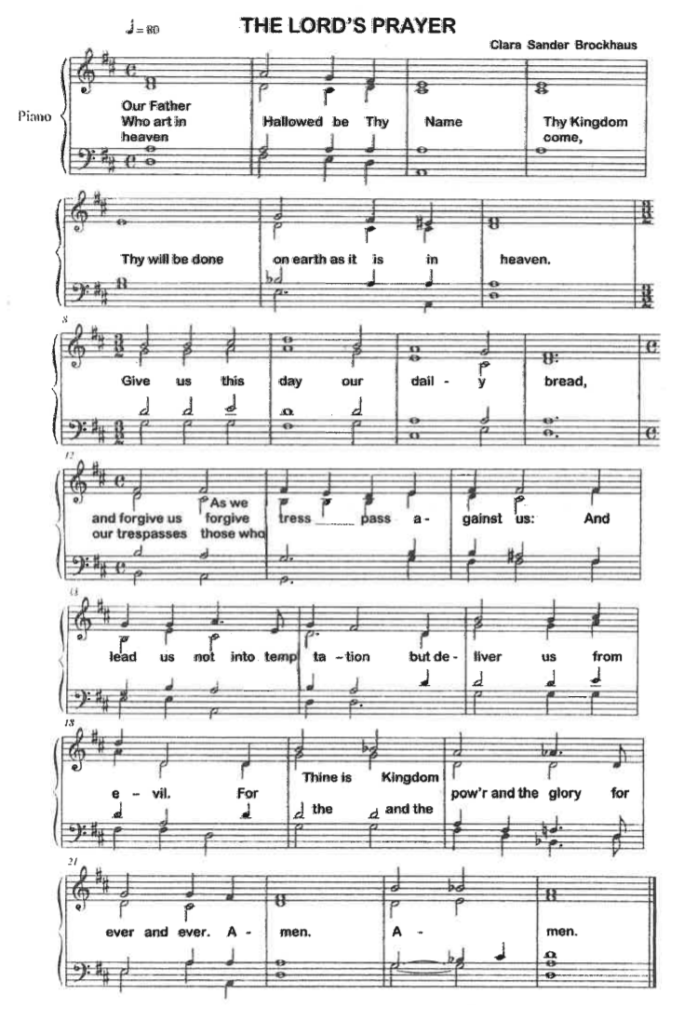
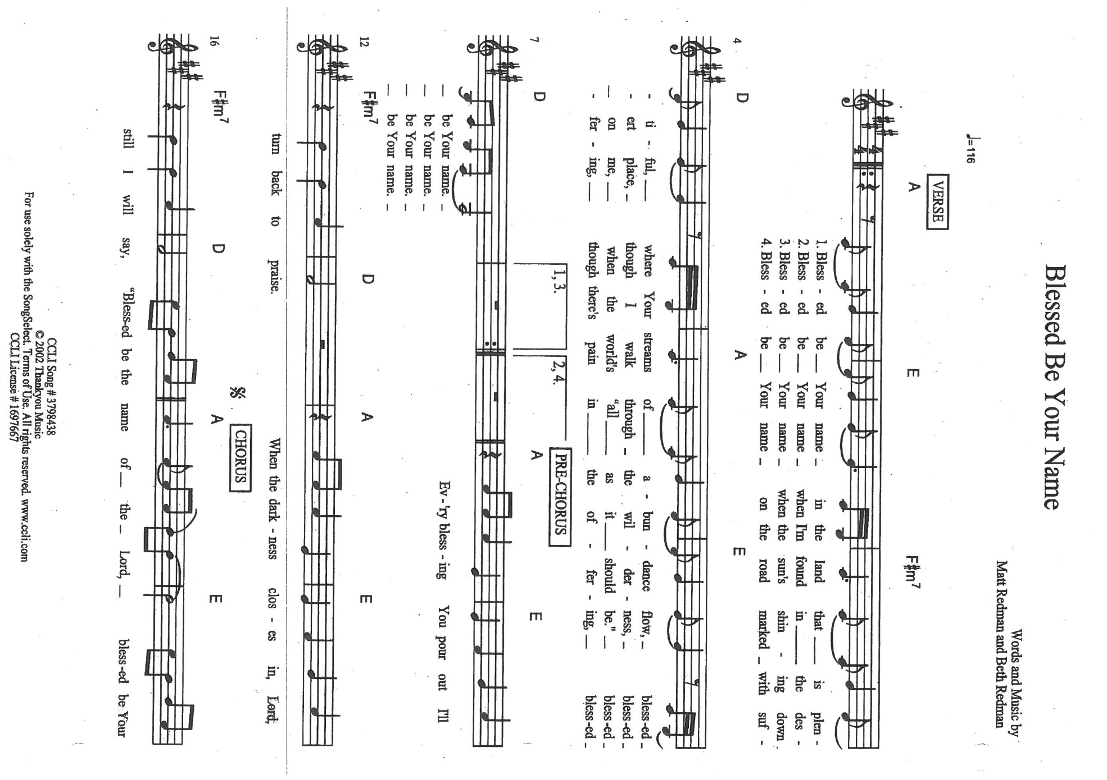
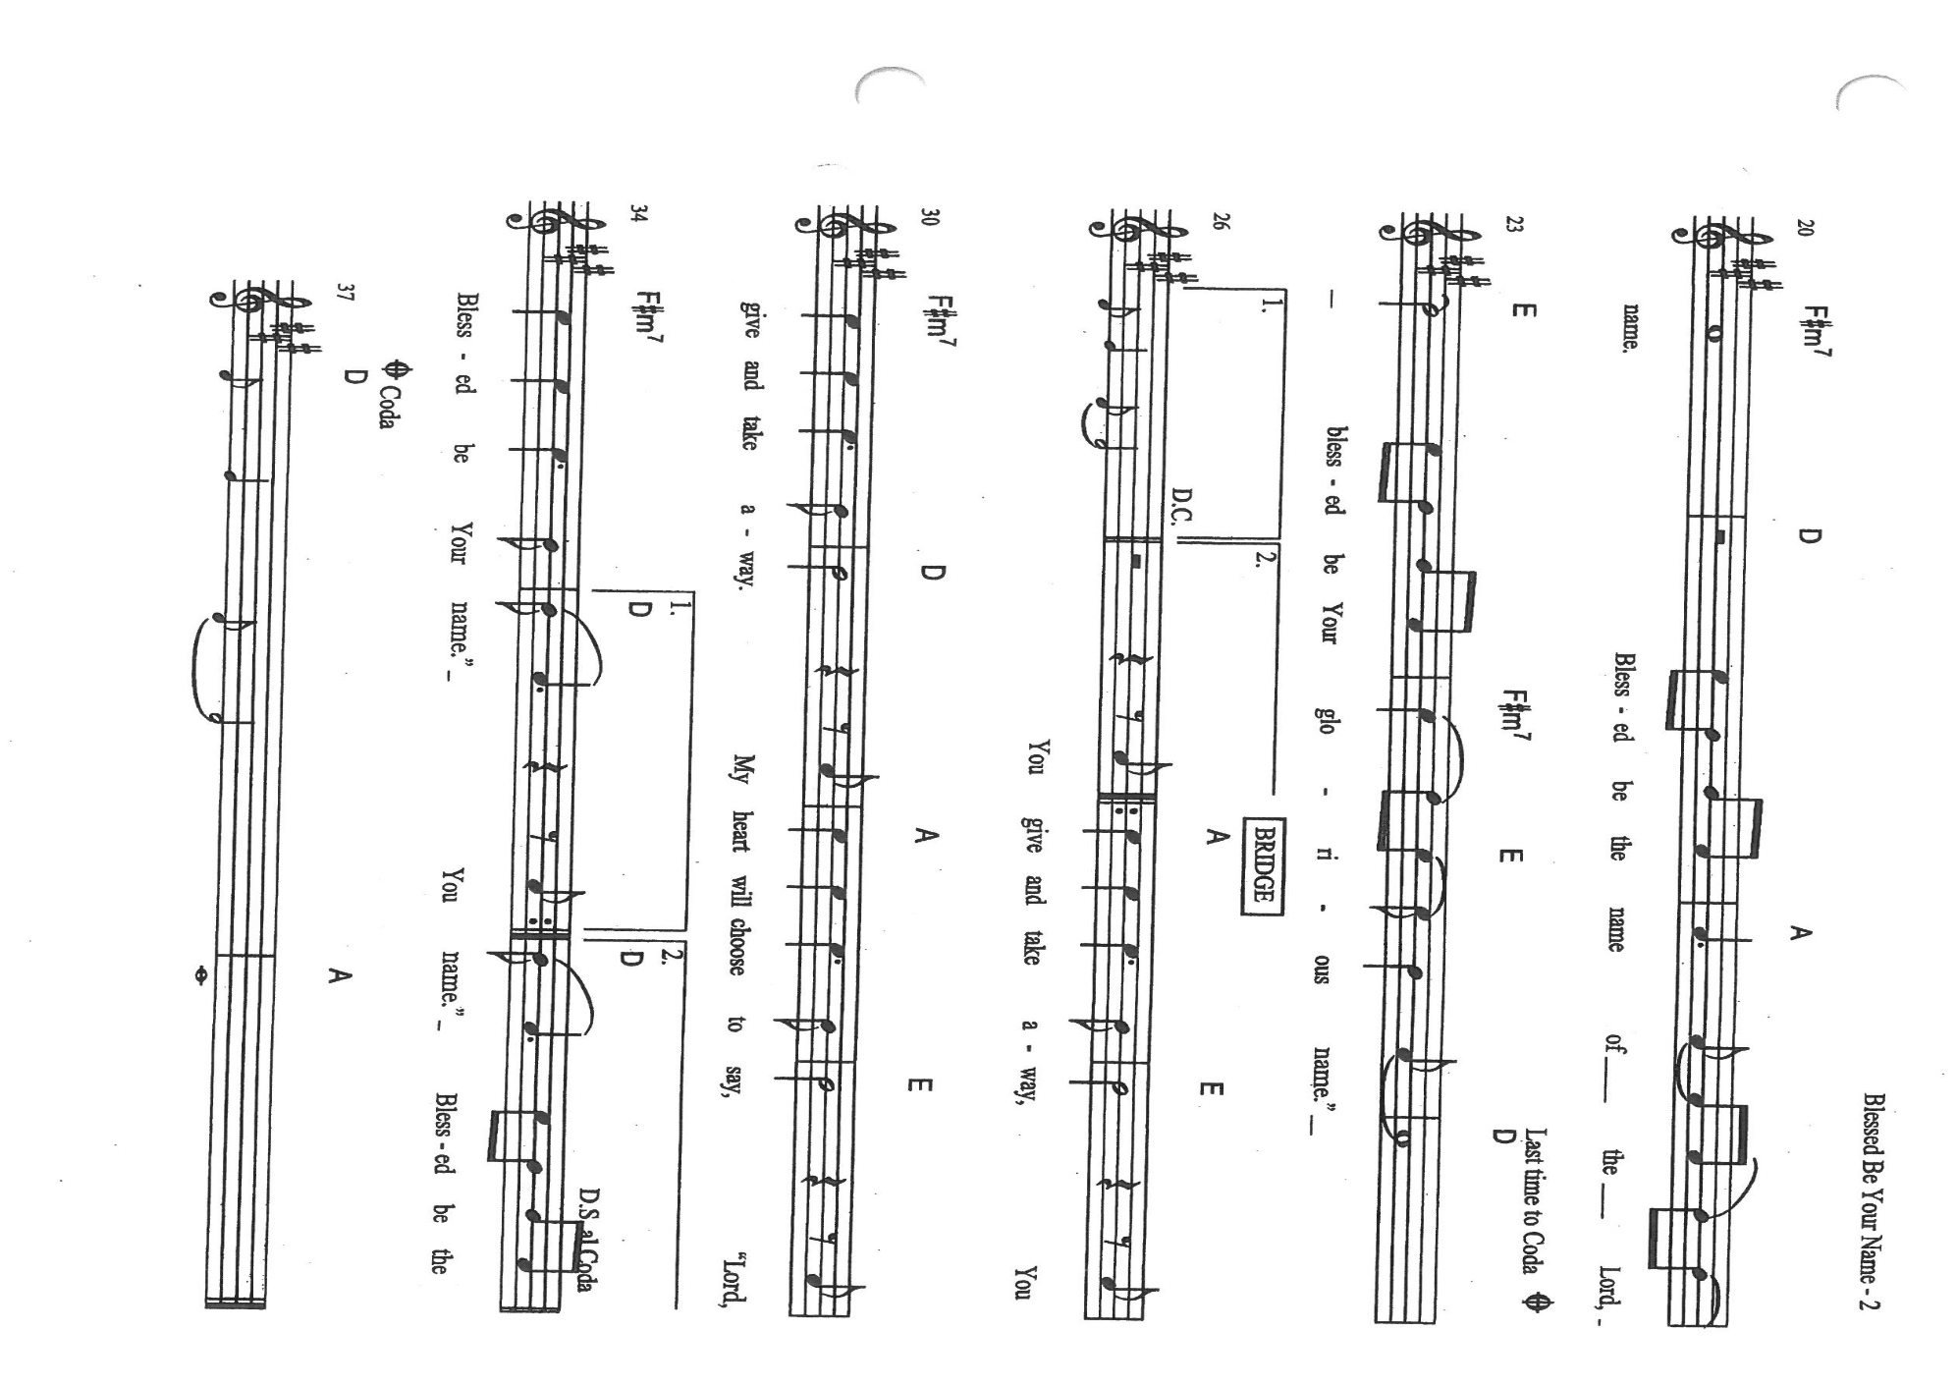
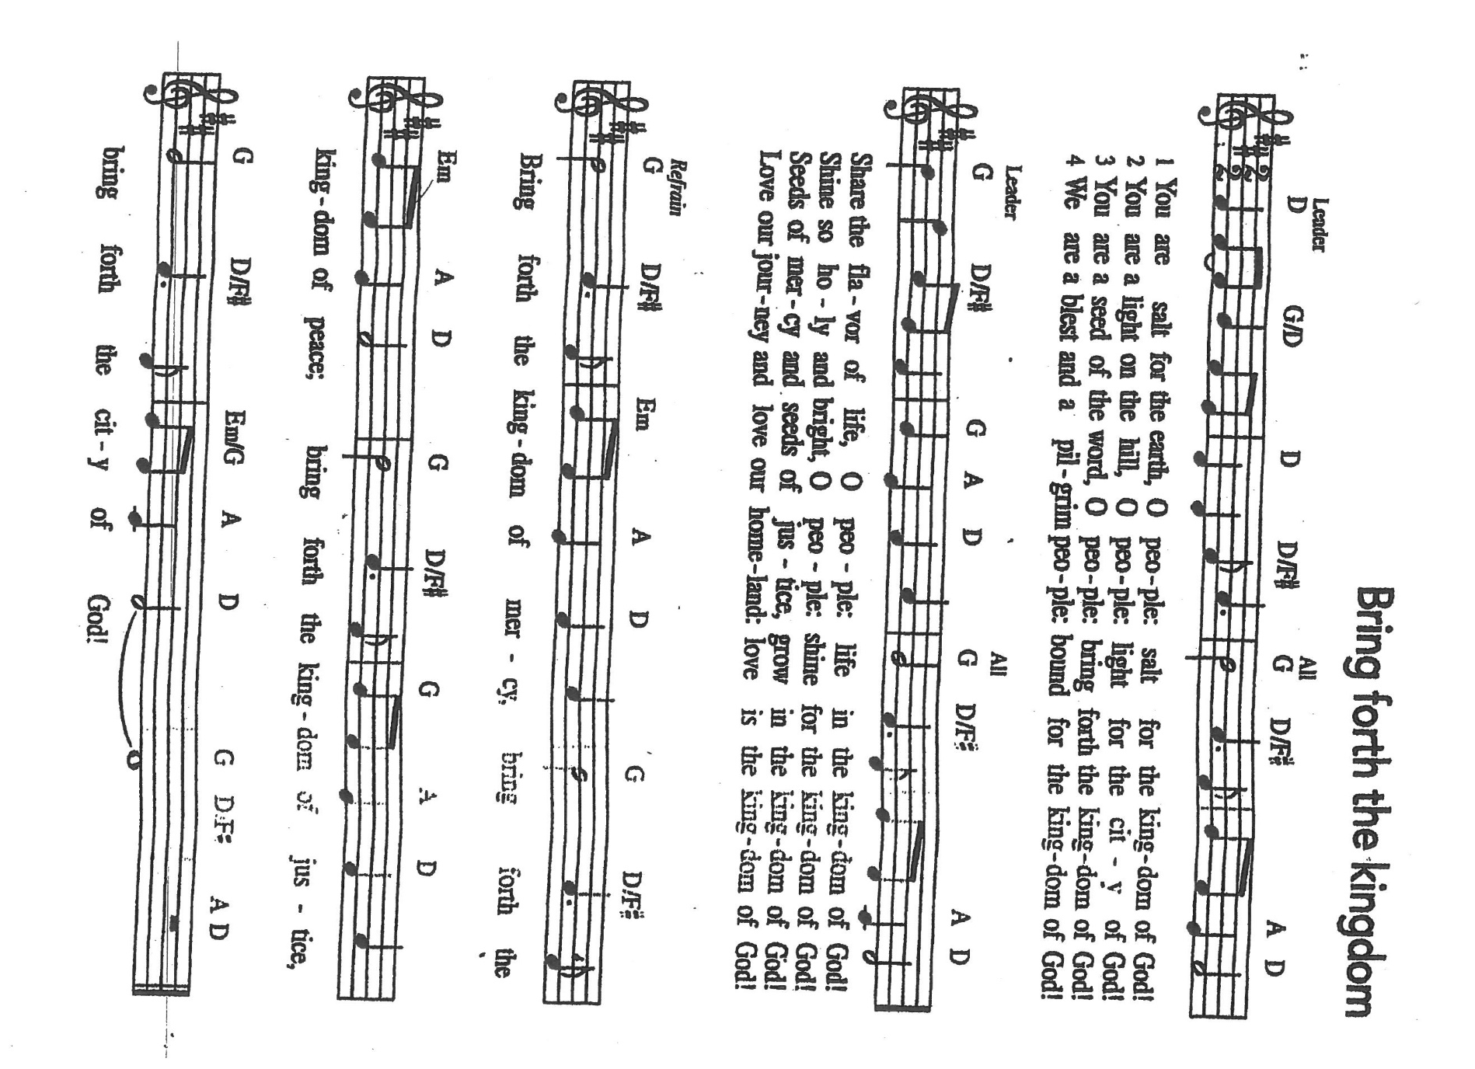

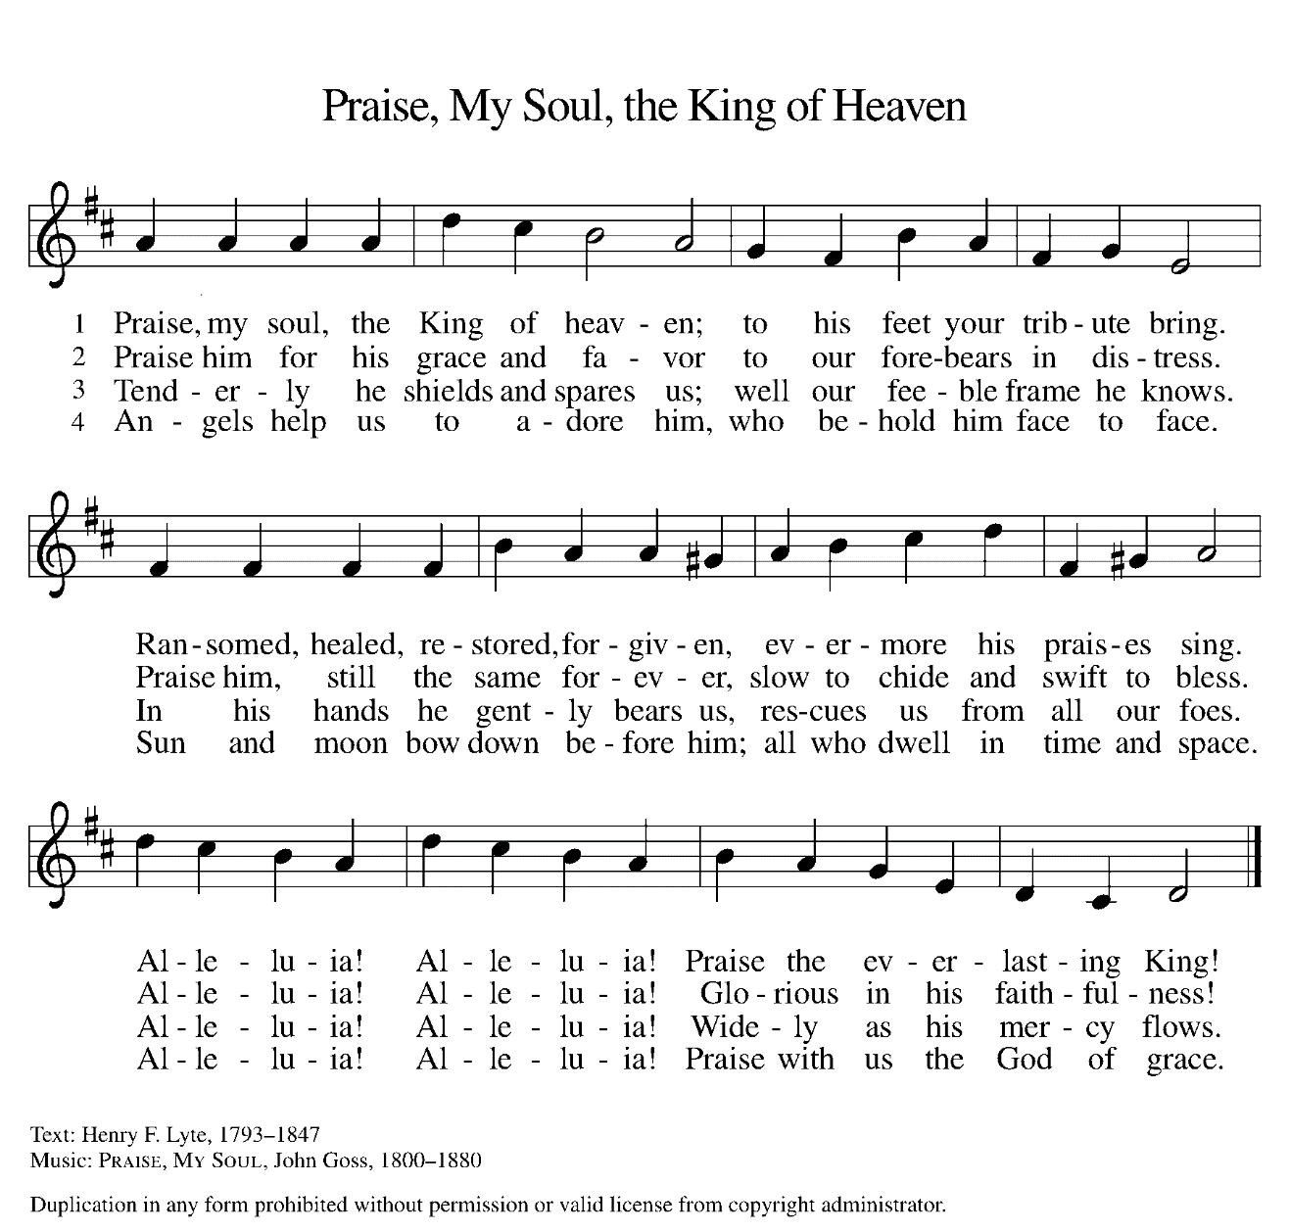

ANNOUNCEMENTS

Please remember to mail your offering to the Church Office at 818 Franklin Street, Michigan City, IN 46360. Another alternative is to give on-line through Tithe.ly. Please see your closure letter for information on how to set up a Tithe.ly account.

St. Paul Members are reminded to have a loved one contact the office if you are hospitalized. Many times, the Pastor doesn’t know someone is in the hospital. If you call and leave a message, please tell us which hospital the patient is at.

Next Sunday’s lessons are Genesis 2: 18-24; Psalm 8; Hebrews 1: 1-4, 2: 5-12; Mark 10: 2-16 for those of you who like to study them in advance.

BIRTHDAYS: Fred Weiss (9/26); Joyce Manning (9/30
ANNIVERSARIES: Robert & Carrie Ziesmer (9/30)

PRAYER CONCERNS: Kathy Thielman, Audrey Beyer, George Ottersen, Charles Thomas Sr, Joyce and Bethany Manning, Marla Furness, Christine Kiser, Delores Hackett, Kay Peglow, Lee Timm, Ryan Krueger, Donna Bostater, Diane Gielow, Jeff Jensen, Maxine Powell, Jess Kalvaitis, Pastor Al Lorentzen, Jan Paholski, Laura Dovey, Heidi Happel, Shane Nevels, Irene Bohnstadt, Joan Coughlin, Jim Tomscheck, Wally & Betty Ratliff, Laura Moore, Cameron Rackard, Erik Tannehill, Ruth Lubs, Ed Gustum and Ken Mulder.

If you requested someone’s name to be on the prayer list and are aware that they need continued imminent prayer then contact the church office and let us know. Otherwise we will gradually transfer names to the long-term list.

OFFICE HOURS: Libby will be in the office on Mondays, Wednesdays, and Fridays; volunteers will cover Tuesdays and Thursdays.
Monday & Wednesday 8:00 a.m. – 5 p.m.
Tuesday & Thursday 9:00 a.m. – 12:00 p.m.
Friday 8:00 a.m. – 12:00 p.m.
If you are listening to the worship broadcast on the radio and would like to watch it live stream but you aren’t on Facebook, follow these four steps:

1) Go to your search engine (Google, Bing, etc.).
2) Search for St. Paul Lutheran Church & School, Michigan City, Indiana
3) Click on the option for St. Paul Lutheran Church & School—Home/Facebook
4) Click on “Videos” in the menu on the left side of the screen.

That should take you to the former videos and there should be one with a little red box that says “LIVE.’ Click on that video to enlarge it.

We will continue to live stream/broadcast the Sunday morning service on our Facebook page, and it will always be available on the radio broadcast Sunday mornings at 11:00 a.m. on WEFM (95.9), and on the local cable access station #99 for the previous week’s service on Sundays at 4:00 p.m. and the current service on Wednesdays at 7:00 p.m. and Fridays at 8:30 p.m.
To send e-mail to the church office, please use the following addresses:
Pastor Mark Reshan: seniorpastor@stpaulmichigancity.com
Church Office Secretary (Libby Pollock): churchsecretary@stpaulmichigancity.com
Church Treasurer (Karen Fleming) and Bookkeeper (Billie Atchinson):
finance@stpaulmichigancity.com.

The Good News Newsletter: If you have an article or anything you want included in The Good News please send it to the following e-mail address: splcgoodnews@gmail.com. Pastor Pamela Thiede will be using this e-mail address to assemble The Good News each month. The deadline for getting information to Pastor Pamela will be the 20th of each month.

WORSHIP ATTENDANCE for September 18-19, 2021
4:00 p.m. 25
9:00 a.m. 38
Total = 63

September Events and Meetings:
Worship Service: Saturday September 25, 2021 at 4:00pm

Worship Service: Sunday September 26, 2021 at 9:00am

2021 Financial Stewardship
Weekly Church Operating Needs (x 2 weeks): $14,116.36
September 11—12, and September 18--19, 2021
General Fund (including General Memorials): $ 9094.50
Overage/Shortage: --$ 5,021.86

Restricted Income (not including Memorials)
Supports IK Synod & Churchwide Ministries: $377.00
Ministries in our Community/Congregation: $646.00
Capital Fund: $452.50

Total initial donation to the Moore Family
for funeral expenses for Ryan Cross: $646.00

Next Give Back night will be on Tuesday, October 5, 2021 at Holly’s in Michigan City. There will be coupons in the bulletins and in the church office for those who wish to participate!

