THE BAPTISM OF OUR LORD
The First Sunday after the Epiphany
January11, 2026

The Spirit came down from on high and hallowed the waters by brooding over them. In the baptism of John, the Spirit passed by the rest and abode on the one (Jesus); but now the Spirit has descended and abides upon all that are born of the water. Out of all that John baptized, on only one did the Spirit dwell, but now the Spirit has flown and come down in order to dwell on the many; and as each one after another comes up from the water, they are loved and abide in God.

Ephrem the Syrian

Obedience (to the will of God as seen in Jesus’ submission to Baptism to “fulfill all righteousness”) is not as burdensome as it seems at first blush. We are doing nothing more than falling head over heels in love with the everlasting Lover of our souls.

Richard Foster

Why are your waters troubled, O Jordan, and why do you turn backward, not proceeding forward according to your natural flow? The Jordan answers, saying, ‘I cannot bear a consuming fire. Thus do I marvel and tremble at your exceeding condescension; for I am not accustomed to wash the pure. I have not learned to purify the sinless, but to purify impure vessels’ ... Let us believers thus cry unto him, saying, O God that has appeared for our salvation, glory to you.

From the Eastern liturgy for the
Feast of the Divine Epiphany

In the Name of Jesus

INTRODUCTION

In the waters of the Jordan, Jesus is revealed as the beloved Son of God. Through this great epiphany, Jesus fulfills all righteousness and becomes the servant of God who will bring forth justice and be a light to the nations. In the waters of baptism we too are washed by the Word, anointed by the Spirit, and named God's beloved children. Our baptismal mission is to proclaim good news to all who are oppressed or in need of God's healing.

GATHERING
PRELUDE

ANNOUNCEMENTS

As you are able please rise

REMEMBERING OUR BAPTISM

P: In one and the same instant you died and were born again.

C: “Do you not know that all of us who were baptized into Christ Jesus were baptized
into His death?” (Romans 6: 3)

P: The Bible tells us that there is “a time to be born and a time to die.” (Ecclesiastes 3: 2).
For you, however, it was the reverse: first you died, and then you were born again.

C: “We were buried therefore with Christ through Baptism into death so that as
Christ was raised from the dead through the glory of the Father, we too might live
a new life.” (Romans 6: 4)

P: Daily--in the morning, when you rise, and in the evening, when you go to bed—
remember that you have died and been reborn through your Baptism. Make the sign
of the holy cross and say:

C: In the name of the Father and of the Son and of the Holy Spirit. Amen.

PROCESSIONAL HYMN 311 Hail to the Lord’s Anointed

The congregation faces the cross as it enters

THE GREETING AND PRAYER OF THE DAY

P: To the Church of God in this place, to those who are called to be saints, to all those who
call upon the name of our Lord Jesus Christ:

The grace of our Lord Jesus Christ, the love of God, and the communion of the Holy
Spirit be with you all.

C: And also with you.

P: Let us pray. O God our Father, at the baptism of Jesus You proclaimed Him Your
beloved Son and anointed Him with the Holy Spirit. Make all who are baptized into
Christ faithful to their calling to be Your daughters and sons, and empower us all with
Your Spirit, through Jesus Christ, our Savior and Lord, Who lives and reigns with You
and the Holy Spirit, one God, now and forever.

C: Amen.

The assembly is seated

WORD

FIRST READING Isaiah 42: 1-9

The Lord's transformation of something old (something expected) into something new is a major theme of Isaiah 40-55. Today's reading begins with the familiar language of the Lord bringing justice (or "the true way") through a chosen one. What is new is how the Lord brings that about: the servant is not a triumphant warrior, but is one who works quietly and patiently.

Here is my servant, whom I uphold,
my chosen, in whom my soul delights;
I have put my spirit upon him;
he will bring forth justice to the nations.
²He will not cry or lift up his voice,
or make it heard in the street;
³a bruised reed he will not break,
and a dimly burning wick he will not quench;
he will faithfully bring forth justice.
⁴He will not grow faint or be crushed
until he has established justice in the earth;
and the coastlands wait for his teaching.
⁵Thus says God, the LORD,
who created the heavens and stretched them out,
who spread out the earth and what comes from it,
who gives breath to the people upon it
and spirit to those who walk in it:
⁶I am the LORD, I have called you in righteousness,
I have taken you by the hand and kept you;
I have given you as a covenant to the people,
a light to the nations,
⁷to open the eyes that are blind,
to bring out the prisoners from the dungeon,
from the prison those who sit in darkness.
⁸I am the LORD, that is my name;
my glory I give to no other,
nor my praise to idols.
⁹See, the former things have come to pass,
and new things I now declare;
before they spring forth,
I tell you of them.

The Word of the Lord.

Thanks be to God.

From Martin Luther’s Small Catechism

A: What is Baptism?

C: Baptism is not just plain water. Instead, it is water used according to God’s
command and connected with God’s Word.

A: What then is that Word of God?

C: Where our Lord Jesus Christ says in Matthew, “Go therefore and make disciples
of all nations, baptizing them in the name of the Father and of the Son and of the
Holy Spirit.”

THE PSALM: Psalm 29 Antiphon by Robert Hobby
Choir sings refrain first, followed immediately by the congregation
and as indicated
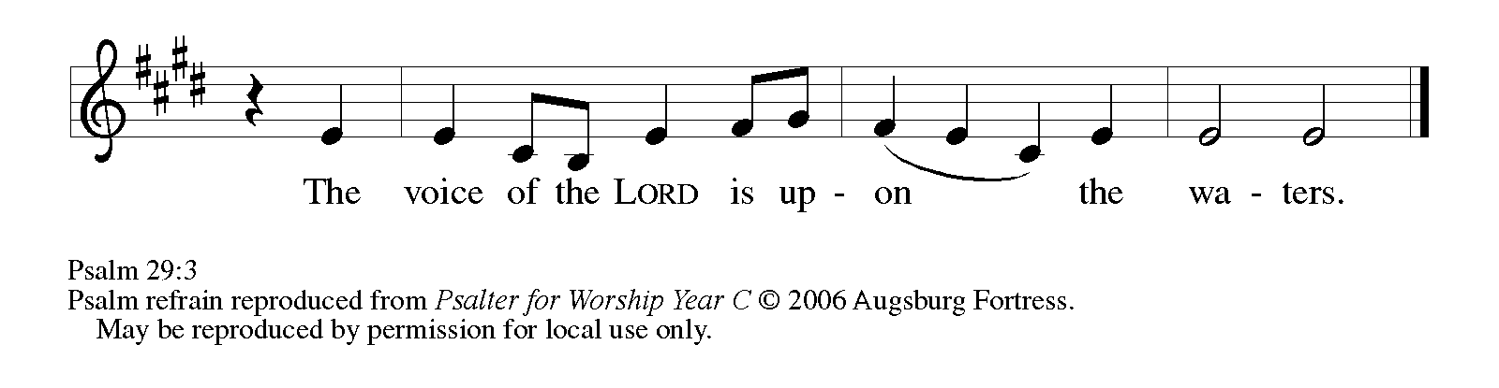
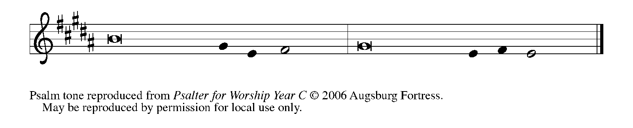
Ascribe to the | LORD, you gods,
ascribe to the LORD glo- | ry and strength.

²Ascribe to the LORD the glory | due God's name;
worship the LORD in the beau- | ty of holiness.

³The voice of the LORD is upon the waters; the God of | glory thunders;
the LORD is upon the | mighty waters.

⁴The voice of the LORD is a pow- | erful voice;
the voice of the LORD is a | voice of splendor. REFRAIN

⁵The voice of the LORD breaks the | cedar trees;
the LORD breaks the ce- | dars of Lebanon;

⁶the LORD makes Lebanon skip | like a calf,
and Mount Hermon like a | young wild ox.

⁷The voice | of the LORD
bursts forth in | lightning flashes.

⁸The voice of the LORD | shakes the wilderness;
the LORD shakes the wilder- | ness of Kadesh. REFRAIN

⁹The voice of the LORD makes the oak trees writhe
and strips the | forests bare.
And in the temple of the LORD all are | crying, "Glory!"

¹⁰The LORD sits enthroned a- | bove the flood;
the LORD sits enthroned as king for- | evermore.

¹¹O LORD, give strength | to Your people;
give them, O LORD, the bless- | ings of peace. REFRAIN

SECOND READING Acts 10: 34-43

Peter's sermon to the Roman centurion Cornelius tells how the message of God's inclusive salvation came to expression in the ministry of Jesus following John's baptism.

Peter began to speak to Cornelius and his household: "I truly understand that God shows no partiality, ³⁵but in every nation anyone who fears Him and does what is right is acceptable to Him. ³⁶You know the message He sent to the people of Israel, preaching peace by Jesus Christ - He is Lord of all.
³⁷That message spread throughout Judea, beginning in Galilee after the baptism that John announced: ³⁸how God anointed Jesus of Nazareth with the Holy Spirit and with power; how He went about doing good and healing all who were oppressed by the devil, for God was with Him. ³⁹We are witnesses to all that He did both in Judea and in Jerusalem. They put Him to death by hanging Him on a tree; ⁴⁰but God raised Him on the third day and allowed Him to appear, ⁴¹not to all the people but to us who were chosen by God as witnesses, and who ate and drank with Him after He rose from the dead.
⁴²He commanded us to preach to the people and to testify that He is the One ordained by God as judge of the living and the dead. ⁴³All the prophets testify about Him that everyone who believes in Him receives forgiveness of sins through His name."

The Word of the Lord.

Thanks be to God.

A: How can water do such great things?

C: Clearly the water does not do it, but the Word of God, which is with, in, and
among the water, and faith, which trusts this Word of God in the water. For
without the Word of God the water is plain water and not a baptism, but with the
Word of God it is a baptism, that is, a grace-filled water of life and a “bath of the
new birth in the Holy Spirit.”

As you are able please rise

THE VERSE
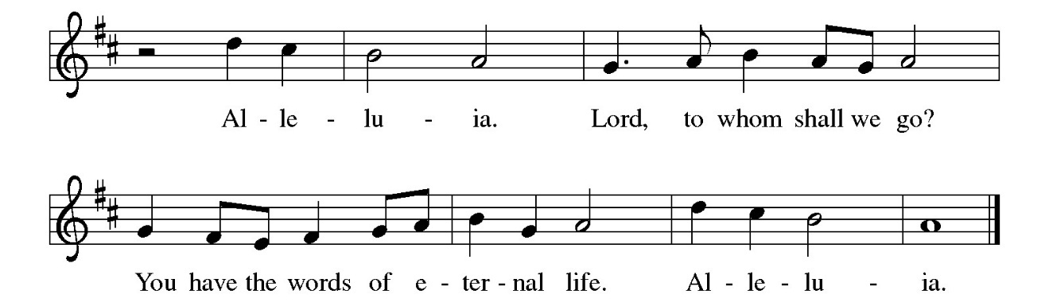

THE HOLY GOSPEL Matthew 3: 13-17

Before Jesus begins his ministry, he is baptized by John, touched by the Spirit, and identified publicly as God's child.

P: The Holy Gospel according to St. Matthew, the third chapter.

C: Glory to You, O Lord!

Jesus came from Galilee to John at the Jordan, to be baptized by him. ¹⁴John would have prevented him, saying, "I need to be baptized by You, and do You come to me?" ¹⁵But Jesus answered him, "Let it be so now; for it is proper for us in this way to fulfill all righteousness." Then he consented.
¹⁶And when Jesus had been baptized, just as He came up from the water, suddenly the heavens were opened to Him and He saw the Spirit of God descending like a dove and alighting on Him. ¹⁷And a voice from heaven said, "This is My Son, the Beloved, with Whom I am well pleased."

P: The Gospel of the Lord.

C: Praise to You, O Christ!

A: What then is the significance of such baptism with water?

C: It signifies that daily the old person in us with all our sins and evil desires is to be
drowned through sorrow for sin and repentance, and that daily a new person is to
come forth and rise up to live before God in righteousness and purity forever.

The assembly is seated

THE SERMON

Silence for reflection follows the sermon

As you are able please rise

THE HYMN OF THE DAY423 Shall We Gather at the River

The assembly is seated

THE AFFIRMATION OF BAPTISM

PRESENTATION

Presentation

P: Dear friends, we give thanks to God for the gift of Baptism as we present ourselves
before God this day to affirm our Baptism into Christ.

Prayer

P: Let us pray. Merciful God, we thank You that You have made us Your own by water
and the Word in Baptism. You have called us to Yourself, enlightened us with the gifts
of Your Spirit, and nourished us in the community of faith. Uphold Your servants as
we affirm the gifts and promises of Baptism, and unite the hearts of all whom You have
brought to new birth through this holy sacrament. We ask this in the name of Christ.

C: Amen.

PROFESSION

Renunciation of Evil

P: As you affirm your Baptism, I ask you to reject sin, profess your faith in Christ, and
confess the faith of the Church.

P: Do you renounce the devil and all the forces that defy God?

C: I renounce them.

P: Do you renounce the powers of this world that rebel against God?

C: I renounce them.

P: Do you renounce the ways of sin that draw you from God?

C: I renounce them.

Profession of Faith

P: With the whole Church, let us confess our faith.
Do you believe in God the Father?

C: I believe in God, the Father almighty, creator of heaven and earth.

P: Do you believe in Jesus Christ, the Son of God?

C: I believe in Jesus Christ, his only Son, our Lord.
He was conceived by the power of the Holy Spirit
and born of the virgin Mary.
He suffered under Pontius Pilate,
was crucified, died, and was buried.
He descended into hell.
On the third day he rose again.
He ascended into heaven,
and is seated at the right hand of the Father.
He will come again to judge the living and the dead.

P: Do you believe in God the Holy Spirit?

C: I believe in the Holy Spirit,
the holy catholic Church,
the communion of saints,
the forgiveness of sins,
the resurrection of the body,
and the life everlasting. Amen.

Commitment

P: You have made public profession of your faith. Do you intend to continue in the
covenant God made with you in holy Baptism:
to live among God’s faithful people,
to hear the Word of God and share in the Lord’s Supper,
to proclaim the good news of God in Christ through word and deed,
to serve all people, following the example of Jesus,
and to strive for justice and peace in all the earth?

C: I do, and I ask God to help and guide me.

BLESSING

Prayer of Blessing

P: Let us pray. We give You thanks, O God, that through water and the Holy Spirit You
give us new birth, wash us from sin, and raise us to eternal life. Stir up in each of us
the gift of Your Holy Spirit: the spirit of wisdom and understanding, the spirit of
counsel and might, the spirit of knowledge and fear of the Lord, the spirit of joy in Your
presence, both now and forever.

C: Amen.

ACCLAMATION

Baptismal Remembrance

P: When we were joined to Christ in the waters of Baptism, we were clothed with God’s
mercy and forgiveness. Together let us remember our Baptism.

P: Blessed are You, O God of grace. From age to age You made water a sign of Your
presence among us. In the beginning Your Spirit brooded over the waters and You
created the world by Your Word, calling forth life in which You took delight.

You led Israel safely through the Red Sea into the land of promise, and in the waters of
the Jordan, You proclaimed Jesus Your beloved one. By water and the Spirit You
adopted us as Your daughters and sons, making us heirs of the promise and servants of
God.

Through this water remind us of our Baptism. Shower us with Your Spirit, that Your
forgiveness, grace, and love may be renewed in our lives. To You be given honor and
praise through Jesus Christ our Lord in the unity of the Holy Spirit, now and forever.

C: Amen.

The acclamation continues with a hymn, during which the assembly
remembers their Baptism through water sprinkled from the font

HYMN DURING THE SPRINKLING 456 Baptized in Water

P: Almighty God, Who has given us a new birth by water and the Holy Spirit, and bestowed
on us the forgiveness of sins, keep us in eternal life through the grace of Jesus Christ
our Lord.

C: Amen.

RECEPTION OF NEW MEMBERS

P: These persons, Angela Cook and Frank Chavez have come to us from other
congregations and desire to transfer their membership into our community of faith.

As their names are read the new members come forward
A representative of the congregation welcomes them

A: We welcome you as members of Christ Lutheran Church to join with us in worshiping
God, hearing His Word and sharing in His Supper, proclaiming the Good News of God
in Christ through word and deed, serving all people, and striving for justice and peace
in all the earth.

As you are able please rise

THE PRAYER OF THE CHURCH

A: Let us pray for those who are affirming their Baptism, and for all the baptized
everywhere.

That they may be redeemed from all evil and rescued from the way of sin and death:
Lord, in Your mercy,

C: hear our prayer.

A: That the Holy Spirit may open their hearts to Your grace and truth: Lord, in Your
mercy,

C: hear our prayer.

A: That they may be kept in the faith and communion of Your holy Church: Lord, in Your
mercy,

C: hear our prayer.

A: That they may be sent into the world in witness to Your love: Lord, in Your mercy,

C: hear our prayer.

A: That they may be brought to the fullness of Your peace and glory: Lord in Your mercy,

C: hear our prayer.

A: That the Spirit may relentlessly drive leaders and nations toward reconciliation, peace,
and the establishment of God’s justice: Lord, in Your mercy,

C: hear our prayer.

A: That those weakened by illness, especially: Major Payne; Robert Bernth; Carl
Wipperman; Chuck Payne; Martha Schroeder; Joyce Stark; Jackie Gaines;
David Weiss; Fred Weiss; Shirley Shikany Long; Shirley Freels; John Bennitt;
Catherine Lanigan; Tim Miller; Roy Romine and Lucas Bradshaw may receive
God’s strength and blessing of peace: Lord, in Your mercy,

C: hear our prayer.

A: That our new members: Angela and Frank may with their gifts enrich our mission
and ministry to their neighborhood and community: Lord, in Your mercy,

C: hear our prayer.

A: That those celebrating birthdays, especially Mike Knoll; and anniversaries, especial-
ly Brad and Kelly Neulieb may grow in grace this day and every day and be filled
with grace for the days ahead: Lord, in Your mercy,

C: Hear our prayer.

A: That the light of all the saints may guide us also to be instruments of healing and peace:
Lord, in Your mercy,

C: hear our prayer.

P: Into Your hands, O Lord, we commend all for whom we pray, trusting in Your mercy,
through Your Son, Jesus Christ our Lord.

C: Amen.

MEAL

THE PEACE

P: In the waters of the font, God has made us one with Christ Who is our life, our hope,
and our salvation.

The peace of the Lord be with you always.

C: And also with you.

The assembly is seated

THE OFFERING

THE VOLUNTARY Living Water St. Paul Senior Choir (E. Crocker)

As you are able please rise

THE PRESENTATION OF GIFTS (see p. 11) Let the Vineyards Be Fruitful

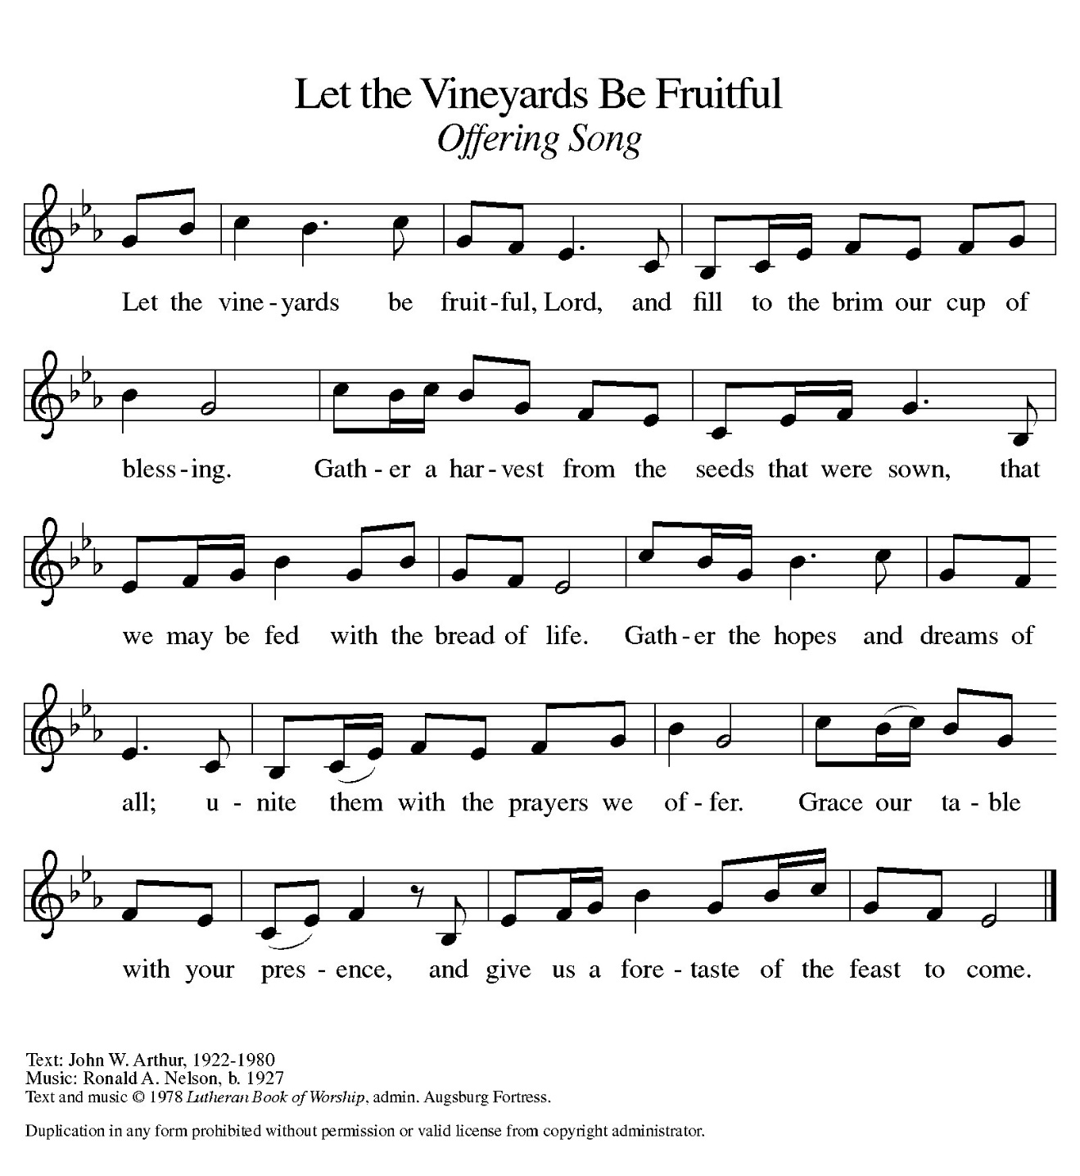
THE OFFERTORY PRAYER

A: Let us pray. God of glory,

C: We celebrate the revelation of Jesus as Your beloved Son Who makes all creation
new. Accept all we offer You this day, and through this holy Sacrament, make us
new in Him, Jesus Christ our Lord. Amen.

THE GREAT THANKSGIVING

P:PP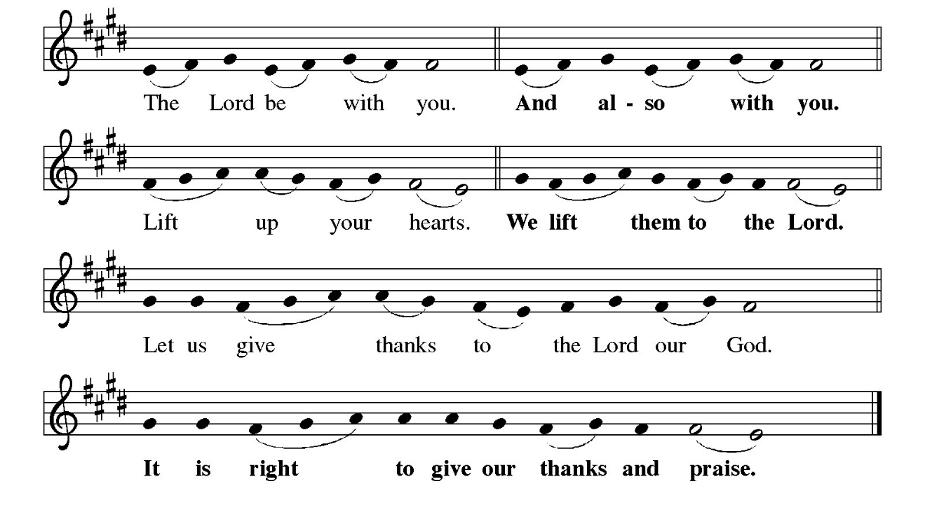
P: It is indeed right and salutary …and join their unending hymn:
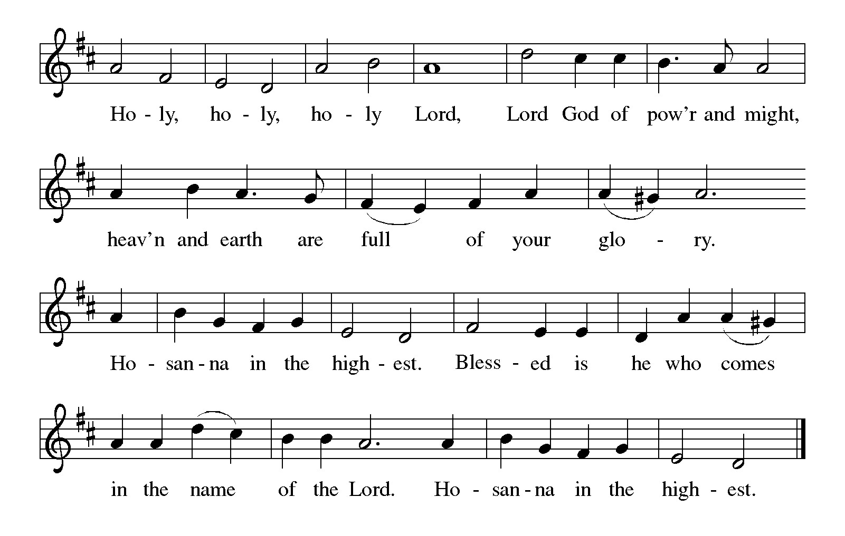
P: God of hope, in Your Holy Spirit You hovered over the face of the waters at creation,
and in Your pillar of fire You led Your people to liberation across the Red Sea.
Through the waters You brought Your people into the life and land of promise.

In Your Son’s Baptism at the Jordan we see Your creative and liberating purpose at
work amid our human flaws and failures, and we hear anew with hope the
promise of Your voice.
In our own Baptism You number us among Your saints, created and redeemed for
Your glory.
Through Baptism You bury us in death with Christ yet raise us to new life with Him
forever.
Blessing God, Who sent down Your Holy Spirit like a dove upon Your Beloved,
send Your Spirit among us now to make us holy by Your grace.
By the power of that same Spirit, make these gifts of bread and wine be for us the
Body and Blood of Your Son Jesus,
Who, in the night … “Do this for the remembrance of Me.”
As often as we eat … we proclaim the Lord’s death until He comes.
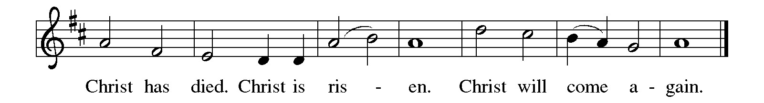
P: Father of glory, You have opened Your heaven and come among us.
Be close to those who ache for Your liberating power in the midst of trials and seek
Your open heaven.
Visit all who need the healing, forgiving, peacemaking, and restoring touch of Your
Spirit and look for Your Kingdom to come.
Bless all who long to be called beloved, by sibling or parent or spouse or friend or child,
and any who are searching for the love that only You can bring,
Until all stand in Your presence, and sing Your name, and are enfolded in Your
embrace,
Father, Son, and Holy Spirit, ever one God.
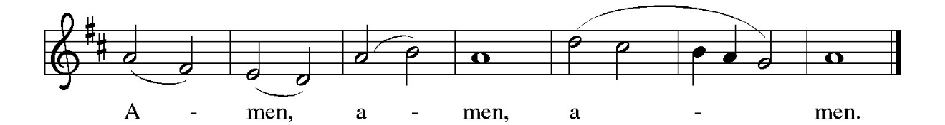
THE LORD’S PRAYER

P: Because in Christ we have received the Spirit of adoption, as daughters and sons of
God, we dare to pray:

C: Our Father, Who art in heaven, hallowed be Thy Name. Thy Kingdom come.
Thy will be done on earth as it is in heaven. Give us this day our daily bread, and
forgive us our sins as we forgive those who sin against us. And lead us not into
temptation, and deliver us from evil, for Thine is the Kingdom, and the power,
and glory, forever and ever. Amen.

INVITATION TO THE MEAL

P: Behold the true Light of the world, the Beloved of God, anointed by the Spirit. Blessed
are those who are called to the Supper of the Lamb. God’s holy gifts for God’s holy
people. Come, for all is now ready.

The assembly is seated

THE DISTRIBUTION Lamb of God

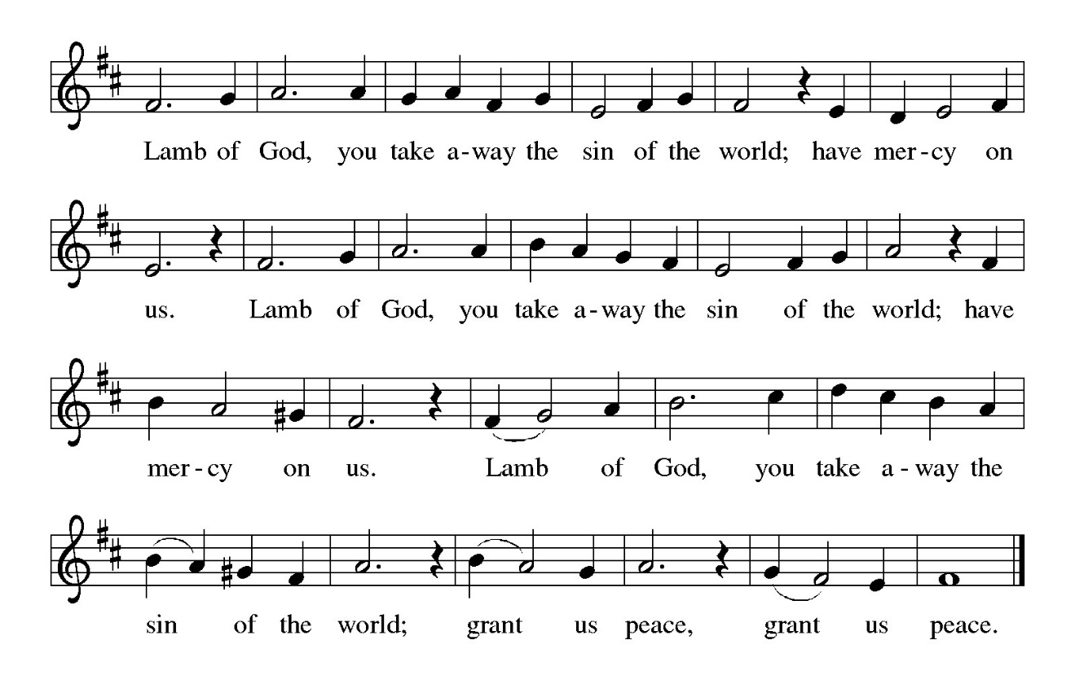
Those wishing to receive the Laying on of Hands, Prayer, and Anointing
with Oil may go to Pastor at the side aisle

HYMN DURING DISTRIBUTION 396 Spirit of Gentleness
ELW 510 Word of God, Come Down on Earth
ELW 459 Wade in the Water
ELW 881 Let All Things Now Living
NSB 66 Make Me A Servant

As you are able please rise

THE POST-COMMUNION BLESSING

P: The Body and Blood of our Lord Jesus Christ strengthen you and keep you in His grace.

C: Amen.

THE POST-COMMUNION PRAYER

A: Let us pray. Almighty God, in Baptism You called us in righteousness to be Your
servants. Grant that all who have beheld the glory of Your Son in this holy Sacrament
may be kept in His grace as we bring Your justice to all our broken world. Grant this
through Christ our Lord.

C: Amen.

SENDING

THE BENEDICTION

P: Almighty God: Father, Son, and Holy Spirit bless you now and forever.

C: Amen.

SENDING SONG 543 Go, My Children, With My Blessing

THE DISMISSAL

A: You are servants of God; you are light to the nations.

Go in peace. Serve the Lord.

C: Thanks be to God!

POSTLUDE

To God Alone Be Glory

The Meditations are from New Proclamation. Marshall D. Johnson, ed. (Minneapolis:
Augsburg Fortress, 2001) 91-91; and Pulpit Resource. William Willimon, ed. (Inver Heights, MN: Logos Productions, Inc. 1998) 10.

The Prayers, Introduction to the Lord’s Prayer, and Invitation to the Meal are adapted from
Prayers for Sundays and Seasons. Year A. Peter J. Scagnelli. (Chicago: Liturgy
Training Publications, 1998) 24-25.

ANNOUNCEMENTS

Please remember to mail your offering to the Church Office at 818 Franklin Street, Michigan City, IN 46360. Another alternative is to give on-line through Tithe.ly. Please see your closure letter for information on how to set up a Tithe.ly account.

St. Paul Members are reminded to have a loved one contact the office if you are hospitalized. Many times, the Pastor doesn’t know someone is in the hospital. If you call and leave a message, please tell us at which hospital the patient is located.

BIRTHDAYS: Mike Knoll (1/10)
ANNIVERSARIES: Kelly & Brad Neulieb (1/12)

PRAYER CONCERNS: Robert Bernth; Barry Anderson; John Bennitt; Sarah McNabb; Debbie Martin; Mark Tannehill; Kathy Stein; Jan Paholski; Laura Dovey; Grace Romine; Bill Hazelgrove; Al Levenhagen; Carl Wipperman; Major Payne; Carol Hazelgrove; Allen Sydow; Elizabeth Sanders ; Roy Romine and Tim Miller.

OFFICE HOURS: Libby will be in the office on Mondays, Wednesdays, and Fridays; volunteers will cover Tuesdays and Thursdays.

Monday & Wednesday 8:00 a.m. – 5 p.m.
Tuesday & Thursday 9:00 a.m. – 12:00 p.m.
Friday 8:00 a.m. – 12:00 p.m.

If you are listening to the worship broadcast on the radio and would like to watch the Sunday morning service live stream follow these steps:

(1) If you have You Tube available on your TV, search for
St. Paul Lutheran Church Michigan City, IN.

(2) The direct link on the computer is https://
www.youtube.com/channel/UC5AIPNaKr3QN50984jGOa1g

(3) This link is also on the main page of the church’s website in
the church section and will continue to be posted weekly on the St.
Paul Facebook page.

And it will always be available on the radio broadcast Sunday mornings at 11:00 a.m.
on WEFM (95.9), and on the local cable access station #99 for the previous week’s
service on Sundays at 4:00 p.m. and the current service on Wednesdays at 7:00 p.m.
and Fridays at 8:30 p.m.

To send e-mail to the church office, please use the following addresses:

Pastor Mark Reshan: seniorpastor@stpaulmichigancity.com

Church Office Secretary (Libby Pollock): churchsecretary@stpaulmichigancity.com

Church Treasurer (Karen Fleming): finance@stpaulmichigancity.com

2026 Church Council:

Pastor - Mark Reshan

President - Donna Knoll

Vice President - Jan Bakken

Secretary -Judy Hunt

Treasurer -Karen Fleming

Members: Sue Koziel; Jim Schraidt; Trish Sprague; Bob Kiser; Barry Anderson; and
Pam Soule

Worship Attendance:
Saturday, January 3, 2026 @ 4:00 p.m. 30
Sunday, January 4, 2026 @ 9:00 a.m. 53
TOTAL 83

Copies of the minutes from the December 18, 2025 Church Council meeting are on the back table in the upper Narthex. It was approved by the council via email.

The Good News Newsletter: If you have an article or anything you want included in The Good News please send it to the following e-mail address: splcgoodnews@gmail.com. Pastor Pamela Thiede will be using this e-mail address to assemble The Good News each month. The deadline for getting information to Pastor Pamela will be the 20th of each month.

Sunday’s lessons are Isaiah 49: 1-7; Psalm 40: 1-11; I Corinthians 1: 1-9; and
John 1: 29-42 for those of you who like to study them in advance.

2026 Financial Stewardship

Weekly Church Operating Needs (x 2 weeks)
December 27-28, 2025; and January 3-4, 2026: $ 12, 912.00

General Fund (including General Memorials): $ 11,968.00

Overage/Shortage: — $ 944.00

Restricted Income (not including Memorials)
Supports IK Synod & Church wide Ministries: $ 120.00

Ministries in our Community/Congregation: $ 50.00

Capital Fund: $ 215.00

Memorials
General Fund: $ 100.00

**2025 Donation Statements**

Donation statements are being sent out this week. Statements will not be sent through the regular mail due to the high cost of postage. If you have an email address on record in the church office you will receive your statement via email. If you don’t find it in your regular email please check your “junk” mail.
For those who do not have email your statement will be placed in your hanging file folder in the upper narthex at the back of the church. If you don’t find a statement in your hanging file or in your email then call the church office and let us know so we can make sure you get your statement.
Please review your statement and if you have any questions or concerns or have a correction that needs to be made call the church office at (219) 874-7293 and let Libby, the church secretary, or the Treasurer, Karen Fleming, know.

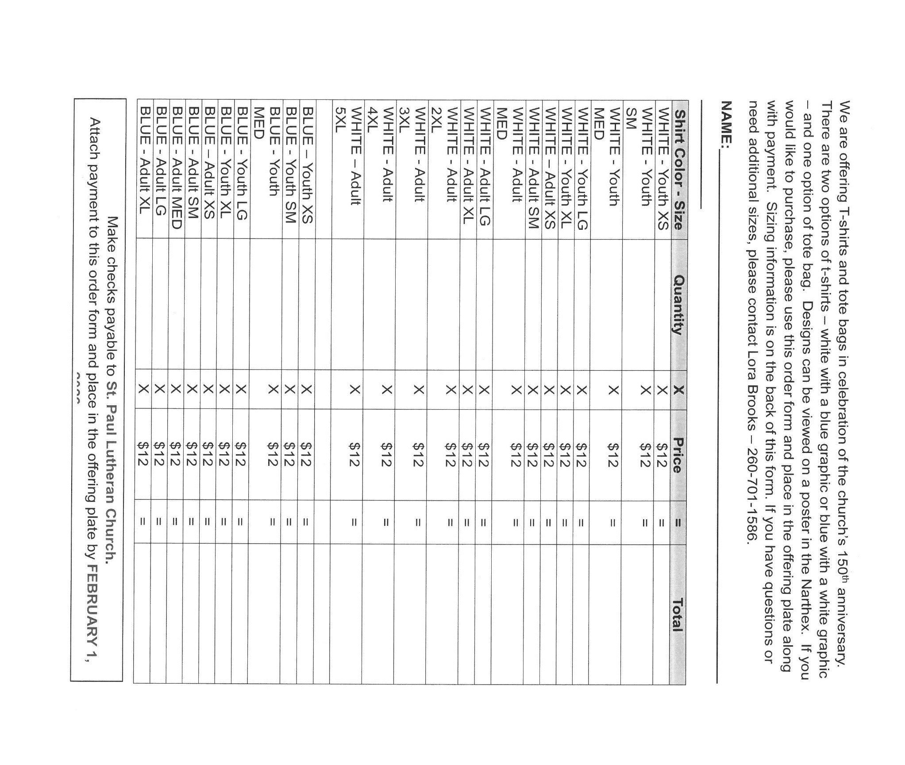

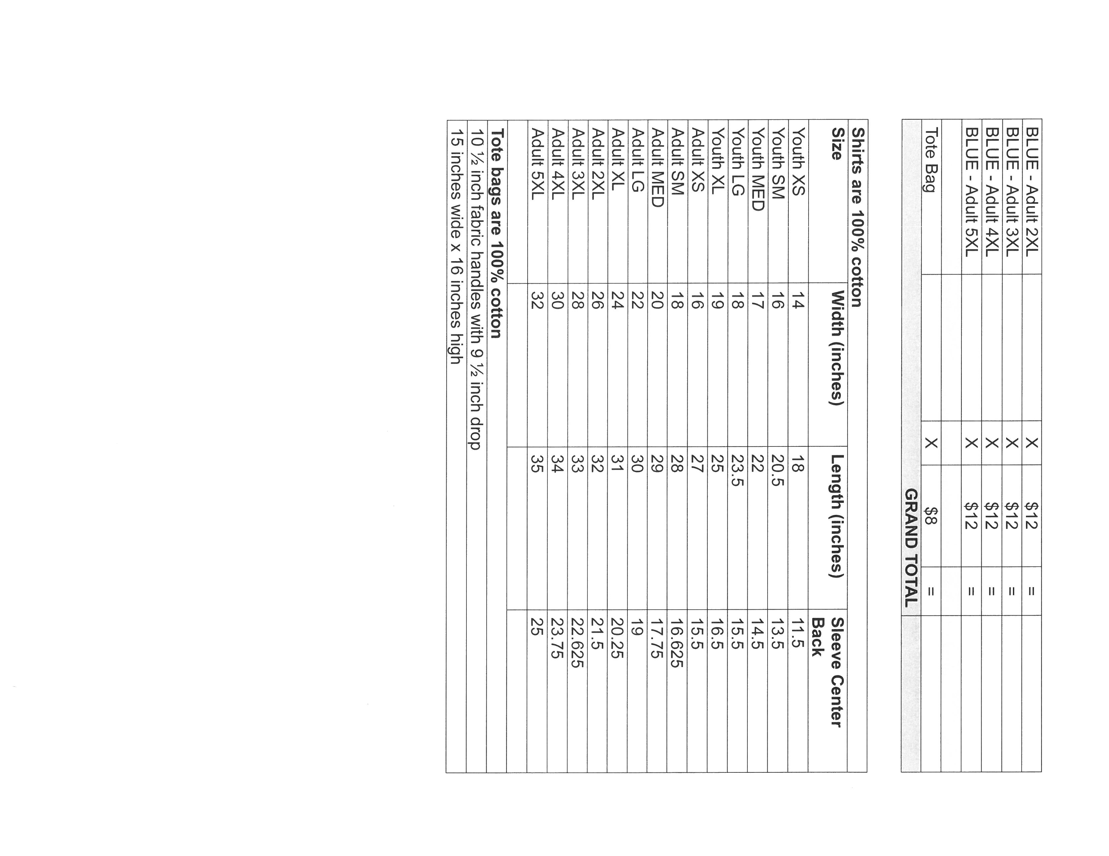

ACTIVITIES, EVENTS & MEETINGS
January 2026

Saturday, January 10, 2026 @ 4:00 p.m. Baptism of Our Lord Worship Service/

Sunday, January 11, 2026 @ 9:00 a.m. Baptism of our Lord Worship Service/ Sanctuary with Coffee after/St. Paul Room

Monday, January 12, 2026 @ 1:00 p.m. Hope Circle/Green Room

Wednesday, January 14, 2026 @ 9:15 a.m. Bible Study/Luther House

@10:00 a.m. God’s Purls/St. Paul Room

@3:30 p.m. Worship & Music Mtg./Luther House

@ 4:30 p.m. Choir Rehearsal/Sanctuary

Thursday, January 15, 2026 @ 4:00 p.m. 150th Anniv. Comm./Luther Hose

Saturday, January 17, 2026 @ 4:00 p.m. 2 Epiphany Worship Service/Sanctuary

Sunday, January 18, 2026 @ 9:00 a.m. 2 Epiphany Worship Service/Sanctuary with Coffee after/St. Paul Room

Monday, January 19, 2026 @ 2:00 p.m. Finance Comm. Mtg./Luther House

@ 3:00 p.m. Executive Board Mtg./Lither House

Wednesday, January 21, 2026 @ 9:15 a.m. Bible Study/Luther House

@ 10:00 a.m. God’s Purls/St. Paul Room

@ 4:30 p.m. Choir Rehearsal

Thursday, January 22, 2026 @ 3:00 p.m. Church Council Mtg./St. Paul Room

Saturday, January 24, 2026 @ 4:00 p.m. 3 Epiphany Worship Service/Sanctuary

Sunday, January 25, 2026 @ 9:00 a.m. 3 Epiphany Worship Service/ Sanctuary with Coffee after/St. Paul Room

Wednesday, January 28, 2026 @ 9:15 a.m. Bible Study/Luther House

@10:00 a.m. God’s Purls/St. Paul Room

@ 4:30 p.m. Choir Rehearsal/Sanctuary

Saturday, January 31, 2026 @ 4:00 p.m. 4 Epiphany Worship Service/Sanctuary

