**THE FESTIVAL OF ST. MICHAEL AND ALL ANGELS**

**The Sixteenth Sunday after Pentecost**

**September 28, 2025**

Christianity, following Judaism (and followed in turn by Islam), speaks of an order of heavenly messengers, the angels, created by God to do His bidding and differing from humans by having a fully spiritual nature and no physical body. They are mentioned by Jesus as watching over children (Matthew 18: 10) and rejoicing over penitent sinners (Luke 15: 10), and there are numerous references to them in the Scripture. Michael the archangel is mentioned in the books of Daniel (10: 13ff; 12: 1)), Jude (9), and Revelation (12: 7-9), as well as in apocryphal literature. Michael is the only angel assigned a liturgical observance before the ninth century.

The cult of Michael originated in Phrygia, where he was venerated as a healer. Hot springs were dedicated to him in Greece and Asia. Beginning in the fourth century churches were dedicated to him, and his popularity spread to the West. He is said to have made an appearance on Mt. Garganus on the southwest coast of Italy in the fifth or sixth century during an invasion by the Goths. This apparition was traditionally commemorated on May 5.

Michael, whose name is popularly thought to mean, ‘Who is like God?’ is usually shown in art as youthful, strong, and clad in armor. He has been regarded as the helper of Christian armies and protector of individual Christians against the devil, especially at the hour of death.

**Philip Pfatteicher**

***Festivals and Commemorations***

Forget the vain pursuit of halo and harp. Enough of those larger than life, militant seraphim who support our propensity for war. Put aside the hierarchical, patriarchal imagery. Angels have something important to teach us about ourselves and God.

Angels remind us that our material world is influenced by the world of the spirit, and that we are intrinsically capable of inhabiting both worlds with equal ease. Humanity may rank a little lower than the angels because we are flesh as well as spirit, yet through Jesus who is God's own Word made flesh, we can rise above the angels to share in the very life of God.

Look closely, and you will see that angels reveal God's secrets, guard and protect the vulnerable, are witness to miracles, are called to unending praise. Today we celebrate not only their achievements, but also that potential in ourselves to be and do the same.

**Miriam Therese Winter, SCMM**

**✠ In the Name of Jesus ✠**

**INTRODUCTION**

*Angels visited Abraham at Mamre; the angel Gabriel announced to Mary that she would be the mother of Jesus; a great company of angels sang at Jesus’ birth. Michael the archangel, captain of the heavenly hosts and protector of Christians, is remembered on this day with all the angels of God.*

**Michael and All Angels**

*Michael the archangel, captain of the heavenly hosts, is remembered on this day along with the other angels and archangels. The word "angel" means messenger, and in Judaism, Christianity, and Islam, these beings have a fully spiritual nature and no physical body.*

**✠ GATHERING ✠**

**PRE-SERVICE MUSIC *Eagles Wings* New Song Praise Band**

**(Reuben Morgen)**

**ANNOUNCEMENTS**

*As you are able please rise*

**DIALOGUE OF THE ANGELS**

P: Bless the Lord, all you multitude of angels.

**C: Bless the Lord, O inhabitants of earth.**

P: God sends forth His angels for divine service:

**C: To serve those who are to inherit salvation.**

P: The Lord commands His angels concerning you:

**C: To watch and guard you in all your ways.**

P: When the Son of Man comes with the clouds:

**C: He will order His angels to gather the elect.**

P: Then around the throne we shall all gather:

**C: And sing with all the heavenly host: “Holy, Holy, Holy, Lord!”**

**THE GATHERING SONG NSB 96 *We Are An Offering***

**THE GREETING AND PRAYER OF THE DAY**

P: “Bless the LORD, all you His hosts, you ministers of His who do His will.

**C: Bless His holy name!” (Psalm 103: 21)**

P: The grace of our Lord Jesus Christ, the love of God, and the communion of the Holy

Spirit be with you all.

**C: And also with you.**

P: Let us pray. Everlasting God, You have ordained and constituted in a wonderful order

the ministries of angels and mortals. Mercifully grant that, as Your holy angels always

serve and worship You in heaven, so by Your appointment they may help and defend

us here on earth; through Your Son, Jesus Christ our Lord, Who lives and reigns with

You and the Holy Spirit, one God, now and forever.

**C: Amen.**

*The assembly is seated*

**✠ WORD ✠**

**FIRST READING Daniel 10: 10-14, 12: 1-3**

*Daniel trembles in the presence of an angel. That angels tells the prophet about the good and terrible future when the dead will be resurrected and the archangel Michael will usher in the deliverance of the nation.*

A hand touched me and roused me to my hands and knees. 11He said to me, “Daniel, greatly beloved, pay attention to the words that I am going to speak to you. Stand on your feet, for I have now been sent to you.” So while he was speaking this word to me, I stood up trembling.

12He said to me, “Do not fear, Daniel, for from the first day that you set your mind to gain understanding and to humble yourself before your God, your words have been heard, and I have come because of your words. 13But the prince of the kingdom of Persia opposed me twenty-one days. So Michael, one of the chief princes, came to help me, and I left him there with the prince of the kingdom of Persia, 14and have come to help you understand what is to happen to your people at the end of days. For there is a further vision for those days.

12L1At that time Michael, the great prince, the protector of your people, shall arise. There shall be a time of anguish, such as has never occurred since nations first came into existence. But at that time your people shall be delivered, everyone who is found written in the book.

2Many of those who sleep in the dust of the earth shall awake, some to everlasting life, and some to shame and everlasting contempt. 3Those who are wise shall shine like the brightness of the sky, and those who lead many to righteousness, like the stars forever and ever.”

The Word of the Lord.

**Thanks be to God.**

**THE PSALM: Psalm 103 :1-5, 20-22** Antiphon by Anne Krentz Organ

Choir sings refrain first, followed immediately by the congregation

and as indicated

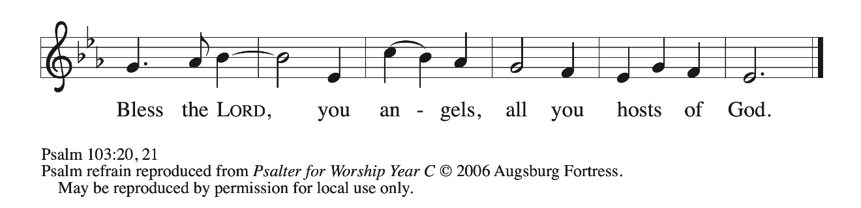

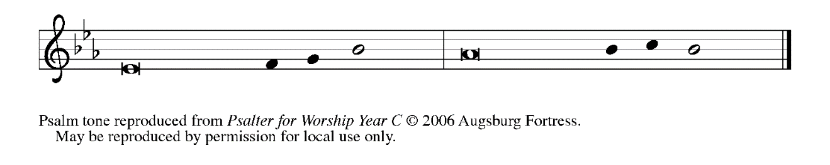

1Bless the Lord, **|** O my soul,

and all that is within me, bless God’s **|** holy name.

**2Bless the Lord, | O my soul,**

**and forget not | all God’s benefits—**

3Who forgives **|** all your sins

and heals all **|** your diseases;

**4Who redeems your life | from the grave**

**and crowns you with steadfast | love and mercy;**

5Who satisfies your desires **|** with good things

so that your youth is renewed **|** like an eagle’s.

**20Bless the Lord, you angels, you mighty ones who | do God’s bidding,**

**who obey the voice | of God’s word. REFRAIN**

21Bless the Lord, all you **|** hosts of God,

you servants who **|** do God’s will.

**22Bless the Lord, all you works of God, in all places | where God rules;**

**bless the Lord, | O my soul. REFRAIN**

**SECOND READING Revelation 12: 7-12**

*Armed with the power of God, Michael and the angels of God fight those armed with the power of evil, the devil and the devil’s angels. The “blood of the Lamb,” our crucified Lord Jesus, gives Michael the power to force the devil from a place in heaven.*

War broke out in heaven; Michael and his angels fought against the dragon. The dragon and his angels fought back, 8but they were defeated, and there was no longer any place for them in heaven. 9The great dragon was thrown down, that ancient serpent, who is called the Devil and Satan, the deceiver of the whole world—he was thrown down to the earth, and his angels were thrown down with him.

10Then I heard a loud voice in heaven, proclaiming, “Now have come the salvation and the power and the kingdom of our God and the authority of His Messiah, for the accuser of our comrades has been thrown down, who accuses them day and night before our God.

11But they have conquered him by the blood of the Lamb and by the word of their testimony, for they did not cling to life even in the face of death. 12Rejoice then, you heavens and those who dwell in them! But woe to the earth and the sea, for the devil has come down to you with great wrath, because he knows that his time is short!

The Word of the Lord.

**Thanks be to God.**

*As you are able please rise*

**THE VERSE**

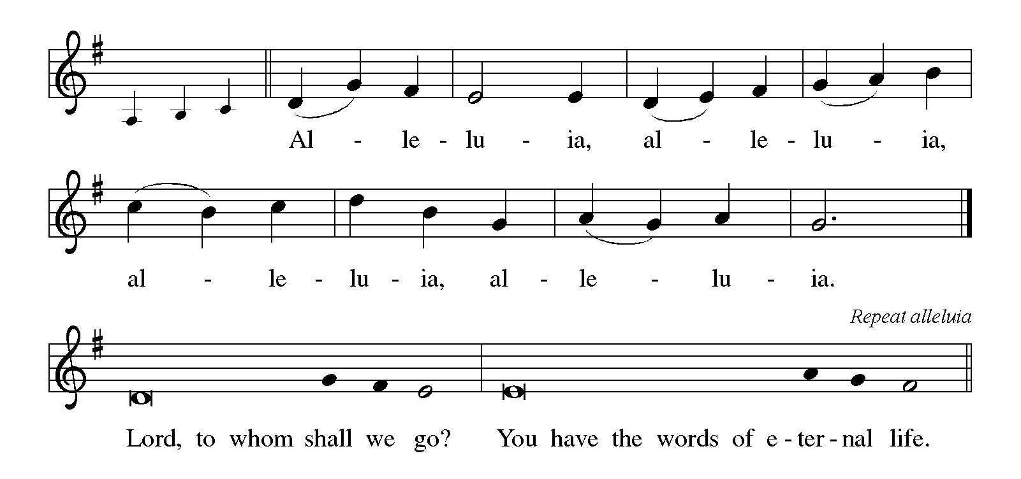

**THE HOLY GOSPEL Luke 10: 17-20**

*The missionary church (“the seventy-two”) is given magnificent power. Greater than this gift of power over the enemy, however, is the gift of salvation: their names are written in heaven.*

P: The Holy Gospel according to St. Luke, the tenth chapter.

**C: Glory to You, O Lord!**

The seventy-two returned with joy, saying, “Lord, in Your name even the demons submit to us!” 18He said to them, “I watched Satan fall from heaven like a flash of lightening. 19See, I have given you authority to tread on snakes and scorpions, and over all the power of the enemy; and nothing will hurt you. 20Nevertheless, do not rejoice at this, that the spirits submit to you, but rejoice that your names are written in heaven.”

The Gospel of the Lord.

**Praise to You, O Christ!**

*The assembly is seated*

**THE SERMON**

*Silence for reflection follows the sermon*

*As you are able please rise*

**THE HYMN OF THE DAY 864 *Praise My Soul, the God of Heaven***

Stanza 2—Women; Stanza 3--Men

**THE NICENE CREED**

A: God has made us His people through our Baptism into Christ. Living together in trust

and hope, we confess our faith.

**We believe in one God,**

**the Father, the Almighty,**

**Maker of heaven and earth,**

**of all that is, seen and unseen.**

**We believe in one Lord, Jesus Christ,**

**the only Son of God,**

**eternally begotten of the Father,**

**God from God, Light from Light,**

**true God from true God,**

**begotten, not made,**

**of one Being with the Father.**

**Through Him all things were made.**

**For us and for our salvation**

**He came down from heaven;**

**by the power of the Holy Spirit**

**He became incarnate from the virgin Mary, and was made man.**

**For our sake He was crucified under Pontius Pilate;**

**He suffered death and was buried.**

**On the third day He rose again**

**in accordance with the Scriptures;**

**He ascended into heaven**

**and is seated at the right hand of the Father.**

**He will come again in glory to judge the living and the dead,**

**and His kingdom will have no end.**

**We believe in the Holy Spirit, the Lord, the giver of life,**

**Who proceeds from the Father and the Son.**

**With the Father and the Son He is worshiped and glorified.**

**He has spoken through the prophets.**

**We believe in one holy catholic and apostolic Church.**

**We acknowledge one Baptism for the forgiveness of sins.**

**We look for the resurrection of the dead,**

**and the life of the world to come. Amen**

**THE PRAYER OF THE CHURCH**

A: Drawing near to the throne of the living God, where countless angels gather in

thunderous praise, let us intercede through Jesus our Mediator for the Church, the

world, and those in any need.

A: Almighty God, we thank You for the wonder of Your creation and the variety of orders

within it. We thank You for Your servants, the angels, whom You send to us on our

behalf. Above all we thank You for Your Son, enthroned above the cherubim, for the

salvation He won by His blood. Gracious God,

**C: Hear our prayer.**

A: As You sent angels in dreams to visit Jacob and Joseph with messages of Your will,

help us also to know Your will for our lives and lead us to do it. Gracious God,

**C: Hear our prayer.**

A: As the angel of the Lord stood between the people of Israel and the Egyptians at the

Red Sea, so stand between us and our enemies, and lend us Your guard and protection.

Gracious God,

**C: Hear our prayer.**

A: As the angel went before the Israelites to lead them through the wilderness into the

Promised Land, so send an angel before us that we might follow Your right pathway

into Your promised Kingdom. Gracious God,

**C: Hear our prayer.**

A: Make us as welcoming of strangers as Abraham and Sarah, who received and

entertained angels unawares. Gracious God,

**C: Hear our prayer.**

A: Send holy Michael, the archangel, great defender of the faithful, to be our defender in

times of trouble and temptation. Gracious God,

**C: Hear our prayer.**

A: Send Your archangel Gabriel, holy bearer of glad tidings, to bring us Your Word and

to help us to understand and do it. Gracious God,

**C: Hear our prayer.**

A: Send Your archangel Raphael, great healer of Your people, to bring wholeness,

strength, and health to all who suffer diseases and distresses, especially: **Fred Weiss;**

**David Weiss; Martha Schroeder; Robert Bernth; Al Levenhagen; Shirley Freels;**

**Kathy Thielman; Kevin Thiede; Roger and Margaret Miller; Debbie Martin;**

**Larry Litchford; Joyce Stark; Jan Paholski; Laura Dovey; Lucas Bradshaw;**

**John Bennitt; and Bill Hazelgrove.** Gracious God,

**C: Hear our prayer.**

A: Enrich those celebrating anniversaries, especially **Jim and Sue Tomscheck** that they

may be filled with grace this day and every day and grow in grace in the days ahead.

Gracious God,

**C: Hear our prayer.**

A: And at the last, send forth Your trumpeting angels to waken us from our sleep and take

us, with all the faithful who have gone before us to Your heavenly Kingdom. Gracious

God,

**C: Hear our prayer.**

P: Holy God, mighty Lord, King of the universe, in Your goodness and by Your grace,

You show favor to Your people by giving us Your Son, our Lord Jesus Christ, and by

sending Your holy angels to minister to us as they ministered to Him in the wilderness.

For all this, we thank You. Hear our prayers, so that we might praise Your holy name

with one voice with all the host of heaven; through Jesus Christ, our Savior and Lord,

Who lives and reigns with You and the Holy Spirit, one God, forever and ever.

**C: Amen!**

**✠ MEAL ✠**

**THE PEACE**

P: The peace of the Lord be with you always.

**C: And also with you.**

*The assembly is seated*

**THE OFFERING**

**THE VOLUNTARY Choir** ***Great is the Lord***  **St. Paul Senior Choir**

(M.W. Smith & D. Smith; arr. E. Lojeski)

*As you are able please rise*

**THE PRESENTATION OF THE GIFTS 531 *The Trumpets Sound, the Angels Sing***

**(**Stanzas 1,3)

**THE OFFERTORY PRAYER**

A: Let us pray. Lord God,

**C: By the ministries of Your angels receive our praise and thanksgiving. Accept these**

**gifts we gratefully offer. May our lives we set before You testify to Your victory**

**over evil through Your Son, Jesus Christ our Lord. Amen.**

**THE GREAT THANKSGIVING**

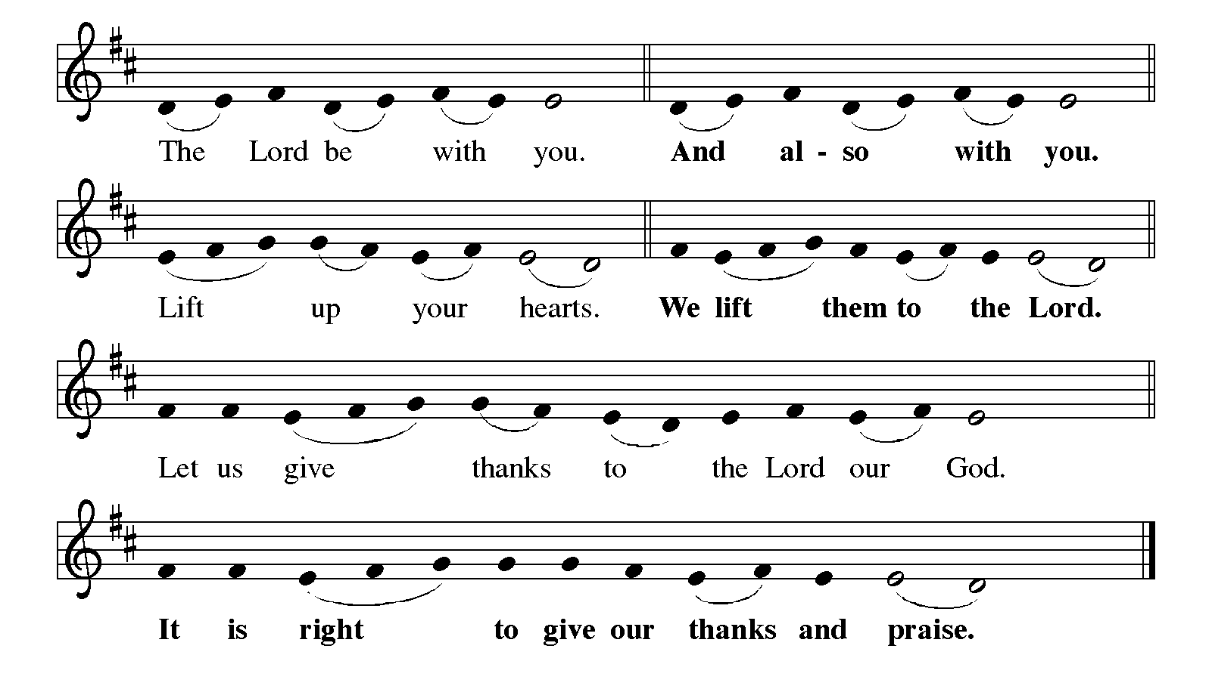

P: It is our duty and delight … and join their unending hymn:

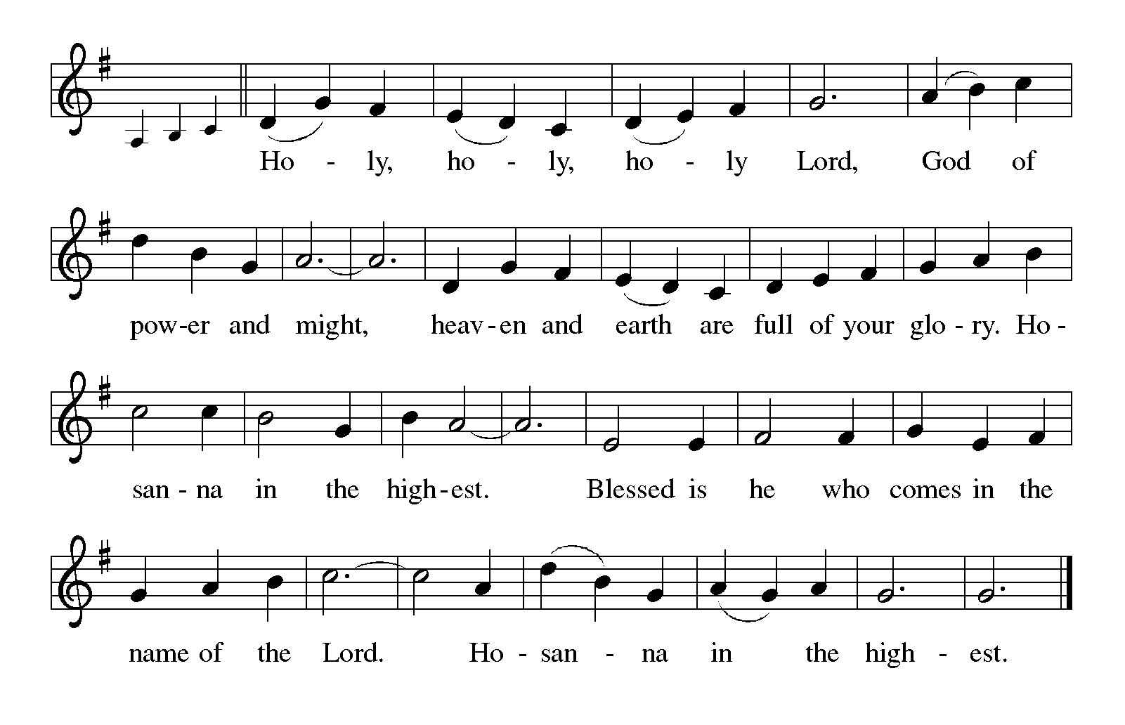

P: Blessed are You, O Lord our God, King of the universe. All creation worships You,

and all creatures, visible and invisible, adore You.

You have set Your throne in the heavens, and You rule over all the earth.

You chose Israel to be Your own, and through judges and prophets, kings and angels

You rescued them from danger and defeat to keep Your covenant alive and Your promise of blessing true.

At the last in love You sent Your only-begotten Son, Jesus Christ.

By the blood of His cross He has made peace and won for You a holy victory.

In the night … “Do this in remembrance of Me.”

As often as we eat … we proclaim the Lord’s death until He comes.

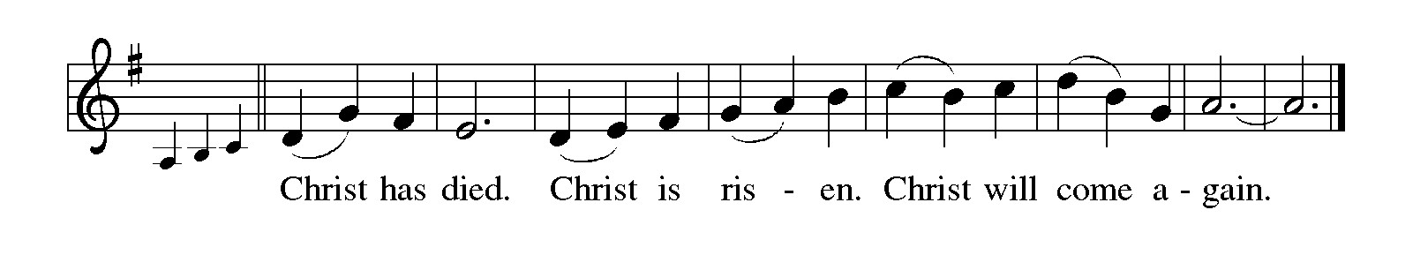P: With this bread and cup, O God, we remember that by His life, death, and rising the

Lord Jesus crushed evil, sin, and death forever.

He ascended to Your right hand, and promised to return in triumph to share with us

Your final Feast of victory.

Send now Your Holy Spirit on us and these Your gifts of bread and wine, that we and

all who share the Lord’s Body and Blood

May be bold in our testimony that Jesus yet conquers evil, and, supported by the angels,

remain faithful to Christ until He comes in glory.

To You, O God: Father, Son, and Holy Spirit, be all honor and glory, in Your holy

Church, in heaven and on earth, now and forever.

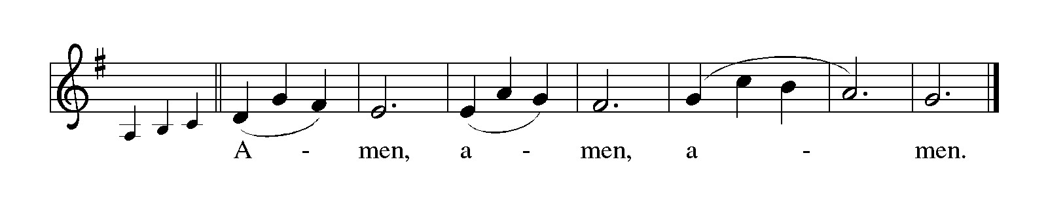

**THE LORD’S PRAYER**

P: Gathered into one by the Holy Spirit. let pray as Jesus taught us:

**C: (Sung) Music is on the front cover of the red hymnal**

**INVITATION TO THE MEAL**

P: This is the Lamb of God Who takes away the sin of the world. Blessed are those who

are called to the Supper of the Lamb. God’s holy gifts for God’s holy people. Come,

for all is now ready.

*The assembly is seated*

**THE DISTRIBUTION**

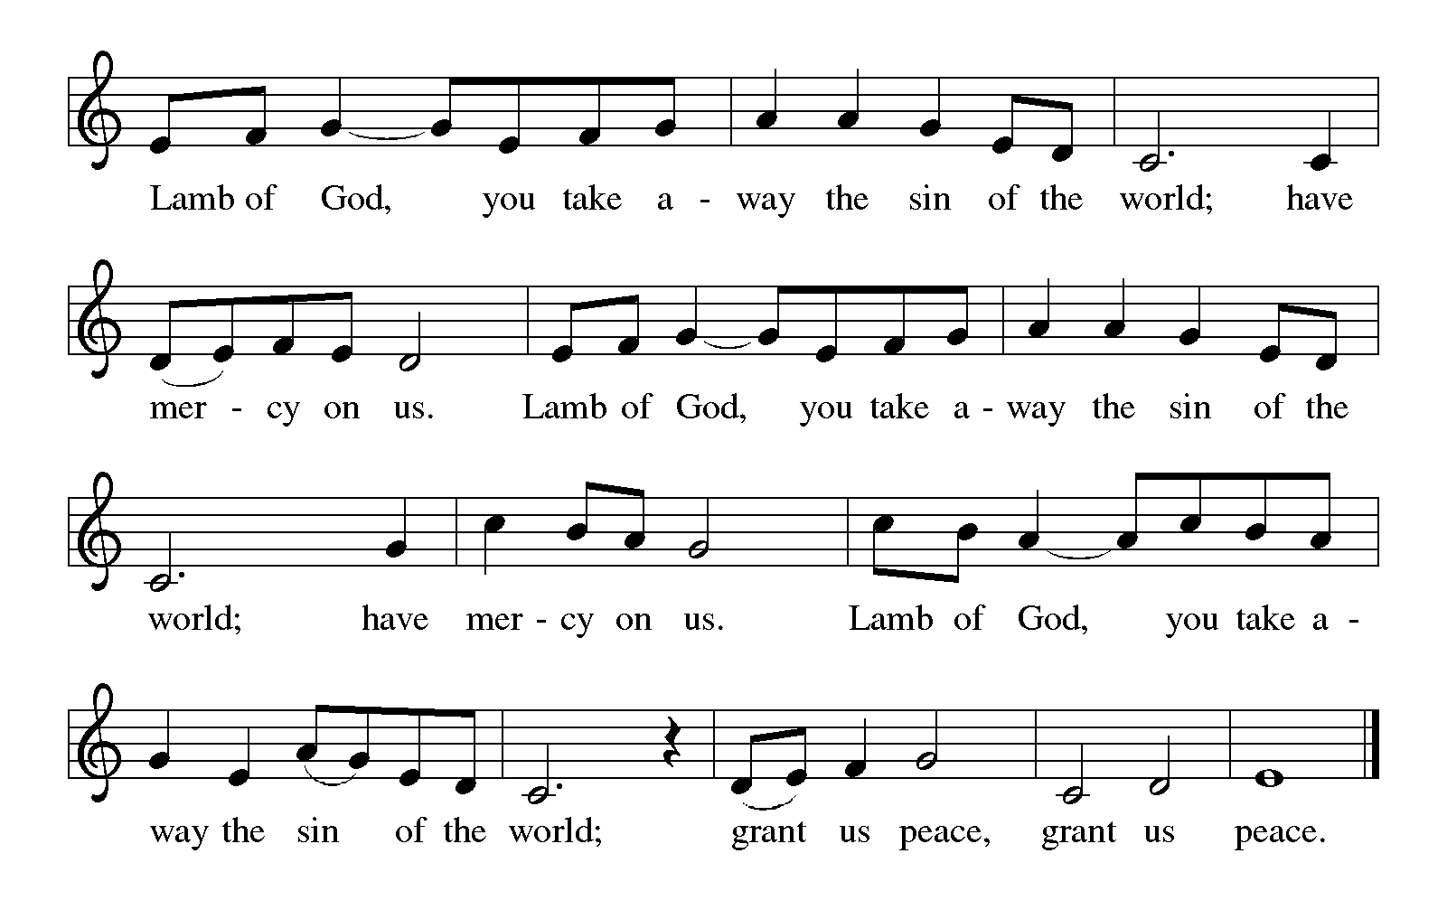

**HYMN DURING DISTRIBUTION 434 *Jesus Shall Reign***

**NSB 16 *Blessed Be Your Name***

**NSB 40 *God of the Poor***

**NSB 67 *Nothing But the Blood***

*As you are able please rise*

**THE POST-COMMUNION BLESSING**

P: The Body and Blood of our Lord Jesus Christ strengthen you and keep you in His grace.

**C: Amen.**

**THE POST-COMMUNION PRAYER**

A: Let us pray. Almighty God, hear the prayers of those whom You renew with the Bread

of Life. Made strong by the courage it gives, and under the watchful care of the angels,

keep us in fellowship with them until at the last we may attain to Your everlasting

glory. Grant this through Christ our Lord.

**C: Amen.**

**✠ SENDING ✠**

**THE BENEDICTION**

P: May the God of heaven and earth shower His grace and favor upon you.

**C: Amen.**

P: May He always send His holy angels to minister to you in your times of need.

**C: Amen.**

P: May you stand with the saints and all the angels of heaven before Christ’s eternal throne.

**C: Amen.**

P: May almighty God: Father, Son, and **✠** Holy Spirit bless you now and forever.

**C: Amen.**

**THE SENDING HYMN 414 *Holy God, We Praise Your Name***

The congregation faces the cross as it leaves

**THE DISMISSAL**

A: Go in peace. Remember the poor.

**C: Thanks be to God!**

**POSTLUDE**

**✠ To God Alone Be Glory ✠**

The Introduction to the Day of St. Michael and All Angels is from *Festivals and*

*Commemorations.* Philip Pfatteicher. (Minneapolis: Augsburg Publishing House,

1984) 368.

The Meditation is from *Sundays and Seasons Online.* Copyright 2013 Augsburg Fortress

Publishing.

The Dialog of the Angels and the Prayers are adapted from Thomas Weitzel, *Liturgy of the*

*Angels* for St. Michael and All Angels.

**ANNOUNCEMENTS**

**Please remember to mail your offering to the Church Office** at 818 Franklin Street, Michigan City, IN 46360**.** Another alternative is to give on-line through Tithe.ly. Please see your closure letter for information on how to set up a Tithe.ly account.

**St. Paul Members are reminded to have** a loved one contact the office if you are hospitalized. Many times, the Pastor doesn’t know someone is in the hospital. If you call and leave a message, please tell us at which hospital the patient is located.

**ANNIVERSARIES: James & Susan Tomsheck (10/4)**

**PRAYER CONCERNS:** Bev Coburn; Barry Anderson; John Bennitt; Judy

Gustum; Larry Litchford; Sarah McNabb; Jeanie Boatman Shepple; Debbie Martin; Mark Tannehill; Kathy Stein; Jan Paholski; Laura Dovey; Grace Romine; Roger and Margaret Miller; Bill Hazelgrove; Kerry Steinborn; Robert Bernth; Craig Hunt; and Al Levenhagen.

**OFFICE HOURS:** Libby will be in the office on Mondays, Wednesdays, and Fridays; volunteers will cover Tuesdays and Thursdays.

  Monday & Wednesday 8:00 a.m. – 5 p.m.

Tuesday & Thursday 9:00 a.m. – 12:00 p.m.

Friday 8:00 a.m. – 12:00 p.m.

**If you are listening to the worship broadcast on the radio and would like to watch the Sunday morning service live stream follow these steps:**

(1) If you have You Tube available on your TV, search for

**St. Paul Lutheran Church Michigan City, IN.**

(2) The direct link on the computer is [https://](https://www.youtube.com/channel/UC5AIPNaKr3QN50984jGOa1g)

[www.youtube.com/channel/UC5AIPNaKr3QN50984jGOa1g](https://www.youtube.com/channel/UC5AIPNaKr3QN50984jGOa1g).

   (3) This link is also on the main page of the church’s website in

the church section and will continue to be posted weekly on the St.

Paul Facebook page.

And it will always be available on the radio broadcast Sunday mornings at 11:00 a.m.

on WEFM (95.9), and on the local cable access station #99 for the previous week’s

service on Sundays at 4:00 p.m. and the current service on Wednesdays at 7:00 p.m.

and Fridays at 8:30 p.m.

**Sunday’s lessons are Habakkuk 1: 1-4; 2: 1-4; Psalm 37: 1-9; 2 Timothy 1: 1-14; and Luke 17: 5-10** for those of you who like to study them in advance.

**To send e-mail to the church office**, please use the following addresses:

Pastor Mark Reshan: seniorpastor@stpaulmichigancity.com

Church Office Secretary (Libby Pollock): churchsecretary@stpaulmichigancity.com

Church Treasurer (Karen Fleming): finance@stpaulmichigancity.com

**2025 Church Council:**

Mark Reshan - Pastor

 Janet Bakken – President

 Donna Knoll – Vice President

 Judy Hunt – Secretary

 Karen Fleming – Treasurer

 Members: Paul Brooks, Diane Egilske, Sue Koziel, Judy Mutchler,

Jim Schraidt, Trish Sprague

**Worship Attendance:**

**Saturday , September 20, 2025 @ 4:00 p.m. 26**

**Sunday, September 21, 2025 @ 9:00 a.m. 56**

**TOTAL 82**

**Copies of the minutes from the June 26, 2025 and the August 28, 2025 Church Council meetings are on the back table in the upper Narthex. They were approved by the council via email. There was no Council meeting in July 2025.**

**The Good News Newsletter**: If you have an article or anything you want included in **The Good News** please send it to the following e-mail address: splcgoodnews@gmail.com. Pastor Pamela Thiede will be using this e-mail address to assemble **The Good News** each month. The deadline for getting information to Pastor Pamela will be the 20th of each month.

**THANKS!**

Our Property Manager would like to thank Chuck Payne, David Squires, and Tim Crozier for scraping and painting the outside trim on the Luther House this week. Their hard work is greatly appreciated! Bob Kiser

**September 2025 Mission of the Month**

The Mission of the Month for September 2025: ZERO Prostate Cancer

September is Prostate Cancer Awareness Month. Prostate cancer will affect about one in seven men in their lifetime and about 35,000 men will die from prostate cancer this year. Fortunately, if detected early, prostate cancer can be successfully treated, and new treatments are becoming available to extend the lives of men with advanced disease. ZERO is the largest prostate cancer support, education and advocacy organization in the United States. It offers free support and education services to prostate cancer patients, and advocates for research funding and improved prostate cancer treatment. Jim Schraidt is a fifteen-year prostate cancer survivor and a member of the Board of Directors of ZERO. He leads a monthly ZERO-sponsored support group that meets in Chicago with simultaneous virtual access. Jim is happy to answer questions about prostate cancer and ZERO, and more information can be found at <https://zerocancer.org>.

Checks can be written to St. Paul and can be marked for ZERO and placed in the offering plate.

Noisy coin offering will also support the mission of the month.

**OCTOBER MONTHLY MISSION:**

October’s monthly mission is Franciscan Health Woodland Cancer Care Center patients. The center is located on 400 North and provides the convenience of one location for a full spectrum of cancer services. We will be collecting care kits as well as money for this mission. There are paper lunch .bags available in the Narthex. Please take as many bags as you want to fill with items to make a care kit for someone going through cancer treatments. Examples of items would be warm socks, hats, gloves, lotion, chapstick, hard candy, gum, snacks, hand sanitizer, small journals, books, activity books, small puzzles, or other activities to do while having treatment (which can take several hours). Please bring your completed care kits back by **Sunday, November 2nd** and place them in the bin in the Narthex. If you’d rather donate financially, they have a fund that goes toward local patients where they provide different things such as gas cards, or gift cards. Money can be placed in the offering plate and marked for the Cancer Center. Noisy coin for the month of October will also go toward the monthly mission. Thank you for your unwavering support each month!

**LWR Kit Packing: We will be gathering in the St. Paul Room (church basement) on Saturday, October 11th at 2:30 p.m. to pack the school and personal care kits for Lutheran World Relief.** We have 100 school kits and 100 personal care kits to pack. More hands make light work and the packing goes pretty quickly. Fellowship and refreshments to follow. No purchase or experience necessary. All ages are welcome. If you aren’t comfortable packing, come observe and join us for fellowship after! The kits will be delivered to Christ Lutheran Church in Valparaiso the following weekend, where they will be sent to an LWR warehouse in either Minnesota or Maryland. From there, they will be sent any where in the world where disaster has struck and need is great. This year so far kits have been sent to Texas after the flash floods in July, North Carolina after Hurricane Helene, and Democratic Republic of Congo due to war and unrest.

**ACTIVITIES, EVENTS & MEETINGS**

**SEPTEMBER 2025**

**Sunday,** September 21, 2025 @9:00 a.m. Pent 15 (Day of St. Matthew) Worship with coffee after/St. Paul Room

**Monday,** September 22, 2025 @ 2:00 p.m. Finance Comm. Mtg./Luther House

@3:00 p.m. Executive Board Mtg./Luther House

**Tuesday,** September 23, 2025 @ 4:00 p.m. 150th Anniv. Comm. Mtg./Luther House

**Wednesday,** September 24, 2025 @ 9:15 a.m. Bible Study/Luther House

@ 10:00 a.m. God’s Purls/St. Paul Room

@ 4:30 p.m. Choir Rehearsal/Sanctuary

**Thursday,** September 25, 2025 @ 5:30 p.m. Church Council Mtg./St. Paul Room

**Saturday,** September 27, 2025 @ 4:00 p.m. Pent 16 (Day of St. Michael &All The Angels) Worship Service/Sanctuary

**Sunday,** September 28, 2025 @ 9:00 a.m. Pent 16 (Day of St. Michael &All The Angels) Worship with coffee after/St. Paul Room

**ACTIVITIES, EVENTS & MEETINGS**

**OCTOBER 2025**

**Wednesday,** October 1, 2025 @ 9:15 a.m. Bible Study/Luther House

@ 10:00 a.m. God’s Purls/St. Paul Room

@ 4:30p.m. Choir Rehearsal/Sanctuary

**Thursday,** October 2, 2025 Faith Circle

**From 4:00 p.m.-10:00 p.m. GIVE BACK @ Galveston Steak House**

**Saturday,** October 4, 2025 @ 4:00 p.m. 17th Pent Worship Service/Sanctuary

**Sunday,** October 5, 2025 @ 9:00 a.m. 17th Pent Worship/Sanctuary with coffee after

**Wednesday,** October 8, 2025 @ 9:15 a.m. Bible Study/Luther House

@ 10:00 a.m. God’s Purls/St. Paul Room

@ 3:30 p.m. Worship & Music Comm. Mtg./Luther House

@4:30 p.m. Choir Rehearsal/Sanctuary

**Saturday,** October 11, 2025 @ 2:30 p.m. Packing LWR Kits/St. Paul Room

@4:00 p.m. 18th Pent Worship Service/Sanctuary

**Sunday,** October 12, 2025 @ 9:00 a.m. 18th Pent Worship Service/Sanctuary with coffee after

**Monday,** October 13, 2025 @ 1:00 p.m. Hope Circle/Green Room

**Tuesday,** October 14, 2025 @ 7:00 p.m. Estuary/Luther House

**Wednesday,** October 15, 2025 @ 9:15 a.m. Bible Study/Luther House

@10:00 a.m. God’s Purls/St. Paul Room

@ 4:30 p.m. Choir Rehearsal/Sanctuary

**Thursday,** October 16, 2025 @ 6:00 p.m. **Card Making with Donna**/St. Paul Room

**Saturday,** October 18, 2025 @ 4:00 p.m. 19th Pent Worship Service/Sanctuary

**Sunday,** October 19, 2025 @ 9:00 a.m. 19th Pent Worship/Sanctuary with coffee after

**Monday,** October 20, 2025 @ 2:00 p.m. Finance Comm. Mtg./Luther House

@ 3:00 p.m. Executive Board Mtg./Luther House

**Wednesday,** October 22, 2025 @ 9:15 a.m. Bible Study/Luther House

@ 10:00 a.m. God’s Purls/St. Paul Room

@ 4:30 p.m. Choir Rehearsal/Sanctuary

**Thursday,** October 23, 2025 @ 5:30 p.m. Church Council Meeting/St. Paul Room

**Saturday,** October 25, 2025 @ 4:00 p.m. 20th Pent/**Reformation** Worship/Sanctuary

**Sunday,** October 26, 2025 @ 9:00 a.m. 20th Pent/**Reformation Sunday** Worship

Service/Sanctuary with Coffee after/St. Paul Room

**Wednesday,** October 29. 2025 @ 9:15 a.m. Bible Study/Luther House

@10:00 a.m. God’s Purls/St. Paul Room

@4:30 p.m. Choir Rehearsal/Sanctuary

Thank$ for $haring

Thanks to all who participate in the Give Back opportunities! We raised $240 at our Give Back night on September 9th at Holly’s Restaurant & Pub. Our next Give Back will be at Galveston Steak House on Thursday, October 2, 2025 from 4pm—10pm.  Here are two coupons—one for you and one for a friend.



