THE SECOND SUNDAY OF ADVENT
December 10, 2023

The way to freedom runs through the wilderness. Hence the first message is that the people must prepare a way, more accurately a street, straight through the wilderness. From Babylonian hymns and from archaeological evidence we know that the high street in Babylon was rather like the Champs Elysees in Paris, leading to the Arc de Triumph.
Isaiah wants such a highway for the Lord, running through the wilderness and leading to the temple in Jerusalem, which was to be rebuilt. However, God’s glory is not revealed in splendid cavalcades on great streets or in processions with imposing effigies, but only in everyday history, and above all in the event of the liberation of his people from slavery, through the difficult journey through the wilderness, back to the freedom of Zion.
That, Isaiah says, is the way in which God’s glory is made manifest and revealed to all. That is where God’s jealous honor is to be found: in the exaltation of the insignificant, the poor and the lowly, those who are oppressed.

Edward Schillebeeckx

The advent mystery is the beginning of the end of all in us that is not yet Christ.

Thomas Merton

In an age which offers a variety of escapes from the human condition, Christians are more than ever a sign of contradiction. They continue to believe that the search for God must begin with the acceptance of the human. They believe this because it is in the stable of inhumanity that God has come in search of us.

In the human experience of Jesus, God became available to us as the depth of human life. Thus, a Christian believes that the experience of ultimate meaning comes not from a leap out of the human condition but a journey through its dark waters.

John Heagle

In the Name of Jesus

GATHERING

INTRODUCTION

John called people to repent, to clear the decks, to completely reorder their lives so that nothing would get in the way of the Lord's coming. The reading from Isaiah gives the context for this radical call: the assurance of forgiveness that encourages us to repent; the promise that the coming one will be gentle with the little ones. Isaiah calls us all to be heralds with John, to lift up our voices fearlessly and say, "See, your God is coming!" We say it to one another in worship, in order to say it with our lives in a world in need of justice and peace.

PRELUDE

ANNOUNCEMENTS

As you are able please rise

CONFESSION AND ABSOLUTION

P: In the name of the Father and of the Son and of the Holy Spirit.

C: Amen.

P: “Comfort, O comfort My people, says your God. Speak tenderly to Jerusalem, and cry
to her that she has served her term, that her penalty is paid, that she has received from
the LORD’s hand double for all her sins.” (Isaiah 40: 1-2) The prophet promises that
the Day of the Lord’s coming will be marked by gentleness, tenderness, and
forgiveness. God will make a holy way to us to gather us to Himself. Let us confess the
“rough places” of our lives, that God might meet us with mercy and hope.

Silence for self-examination and reflection is kept

P: Most merciful God,

C: We confess that we have not been faithful Advent people. We have despaired of
Your promise to come again. We have confused Your patience with slowness and
indifference. (2 Peter 3: 9) Our repentance has been insincere. (Mark 1: 4) We
have failed to prepare Your way by living lives of holiness and godliness. (1: 3)
For these and all the ways we have sinned against You, O God, forgive us. Show
us Your mercy, O Lord, and grant us Your salvation, that we may know Your life,
and rejoice in Your goodness.

P: “You have forgiven the iniquity of Your people, (O LORD), and blotted out all their
sins. I will listen to what the LORD God is saying, for He is speaking peace to His
faithful people, and to those who turn their hearts to Him.” (Psalm 85: 7-8) God speaks
peace to you this Day in a Word that stands forever: as a called and ordained minister
of the church of Christ, and by His authority, I therefore declare to you the entire
forgiveness of all your sins, in the name of the Father and of the Son and of the Holy
Spirit.

C: Amen.

P: Show us Your mercy, O Lord:

C: And grant us Your salvation!

GATHERING HYMN 264 Prepare the Royal Highway

THE GREETING AND PRAYER OF THE DAY

P: Christ comes to lighten our darkness.

C: Come, Lord Jesus.

P: The grace of our Lord Jesus Christ, the love of God, and the communion of the Holy
Spirit be with you all.
C: And also with you.

P: Let us pray. Stir up our hearts, Lord God, to prepare the way of Your only Son. By His
coming strengthen us to serve You with purified lives; through Jesus Christ, our Savior
and Lord, Who lives and reigns with You and the Holy Spirit, one God, now and
forever.

C: Amen.

The assembly is seated

WORD

THE LIGHTING OF THE ADVENT LOG

THE HYMN DURING THE LIGHTING 266 All Earth is Hopeful Stanzas 1, 2

P: Let us pray. Blessed are You, O Lord our God, Ruler of the universe. John the Baptist
calls all people to prepare the Lord's way for the kingdom of heaven is near. Bless us
as we light the candles on this log. Baptize us with the fire of Your Spirit, that we may
be a light shining in the darkness welcoming others as Christ has welcomed us, for He
is our light and our salvation. Blessed be God forever.

C: Amen.

Choir Bring Us Hope St. Paul Senior Choir
(Ruth Elaine Schram)

FIRST READING Isaiah 40: 1-11

In grand, flowing, poetic lines, the prophet known as Second Isaiah announces that the exile of God's people in Babylon is over. The Lord will deliver Israel in an exodus more magnificent than the exodus from Egypt. This word can be trusted, because the only enduring reality in life is the word of the Lord.

Comfort, O comfort My people,
says your God.
²Speak tenderly to Jerusalem,
and cry to her
that she has served her term,
that her penalty is paid,
that she has received from the LORD's hand
double for all her sins.
³A voice cries out:
"In the wilderness prepare the way of the LORD,
make straight in the desert a highway for our God.
⁴Every valley shall be lifted up,
and every mountain and hill be made low;
the uneven ground shall become level,
and the rough places a plain.
⁵Then the glory of the LORD shall be revealed,
and all people shall see it together,
for the mouth of the LORD has spoken."
⁶A voice says, "Cry out!"
And I said, "What shall I cry?"
All people are grass,
their constancy is like the flower of the field.
⁷The grass withers, the flower fades,
when the breath of the LORD blows upon it;
surely the people are grass.
⁸The grass withers, the flower fades;
but the word of our God will stand forever.
⁹Get you up to a high mountain,
O Zion, herald of good tidings;
lift up your voice with strength,
O Jerusalem, herald of good tidings,
lift it up, do not fear;
say to the cities of Judah,
"Here is your God!"
¹⁰See, the Lord God comes with might,
and His arm rules for him;
His reward is with Him,
and His recompense before Him.
¹¹He will feed His flock like a shepherd;
He will gather the lambs in His arms,
and carry them in His bosom,
and gently lead the mother sheep.

The Word of the Lord.

Thanks be to God.

THE PSALM: Psalm 85: 1-2, 8-13 Read responsively

¹You have been gracious to Your land, O LORD;
You have restored the good fortune of Jacob.

²You have forgiven the iniquity of Your people
and blotted out all their sins.

⁸I will listen to what the LORD God is saying;
for You speak peace to Your faithful people
and to those who turn their hearts to You.

⁹Truly, Your salvation is very near to those who fear You,
that Your glory may dwell in our land.

¹⁰Steadfast love and faithfulness have met together;
righteousness and peace have kissed each other.
¹¹Faithfulness shall spring up from the earth,
and righteousness shall look down from heaven.

¹²The LORD will indeed grant prosperity,
and our land will yield its increase.

¹³Righteousness shall go before the LORD
and shall prepare for God a pathway.
SECOND READING 2 Peter 3: 8-15a
The Second Letter of Peter is written to Christians who believed that Jesus would return very soon and were perplexed by this seeming delay. The author reminds the readers that the certainty of God's promise is more important than the timing.
Do not ignore this one fact, beloved, that with the Lord one day is like a thousand years, and a thousand years are like one day. ⁹The Lord is not slow about His promise, as some think of slowness, but is patient with you, not wanting any to perish, but all to come to repentance. ¹⁰But the day of the Lord will come like a thief, and then the heavens will pass away with a loud noise, and the elements will be dissolved with fire, and the earth and everything that is done on it will be disclosed.
¹¹Since all these things are to be dissolved in this way, what sort of persons ought you to be in leading lives of holiness and godliness, ¹²waiting for and hastening the coming of the day of God, because of which the heavens will be set ablaze and dissolved, and the elements will melt with fire? ¹³But, in accordance with his promise, we wait for new heavens and a new earth, where righteousness is at home.
¹⁴Therefore, beloved, while you are waiting for these things, strive to be found by Him at peace, without spot or blemish; ¹⁵and regard the patience of our Lord as salvation.

The Word of the Lord.

Thanks be to God.

As you are able please rise

THE VERSE

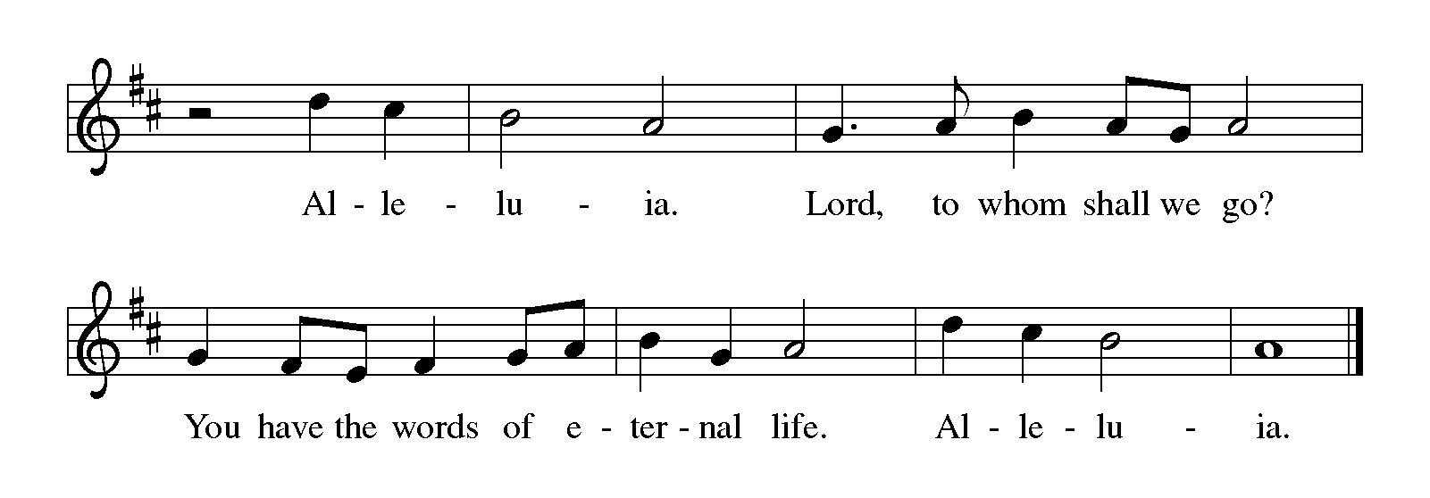
THE HOLY GOSPEL Mark 1: 1-8

The gospel of Mark does not begin with a story of Jesus’ birth but with the voice of one crying out in the wilderness: Prepare the way of the Lord.

P: The Holy Gospel according to St. Mark, the first chapter.

C: Glory to You, O Lord!

The beginning of the good news of Jesus Christ, the Son of God.
²As it is written in the prophet Isaiah,
"See, I am sending my messenger ahead of you,
who will prepare your way;
³the voice of one crying out in the wilderness:
'Prepare the way of the Lord,
make His paths straight,' "
⁴John the baptizer appeared in the wilderness, proclaiming a baptism of repentance for the forgiveness of sins. ⁵And people from the whole Judean countryside and all the people of Jerusalem were going out to him, and were baptized by him in the river Jordan, confessing their sins.
⁶Now John was clothed with camel's hair, with a leather belt around his waist, and he ate locusts and wild honey. ⁷He proclaimed, "The One Who is more powerful than I is coming after me; I am not worthy to stoop down and untie the thong of His sandals. ⁸I have baptized you with water; but He will baptize you with the Holy Spirit.”

P: The Gospel of the Lord.

C: Praise to You, O Christ!

The assembly is seated

THE SERMON
Silence for reflection follows the sermon

As you are able please rise

THE HYMN OF THE DAY NSB 72 Refiner’s Fire

THE NICENE CREED

A: God has made us His people through our Baptism into Christ. Living together in trust
and hope, we confess our faith.

We believe in one God,
the Father, the Almighty,
Maker of heaven and earth,
of all that is, seen and unseen.

We believe in one Lord, Jesus Christ,
the only Son of God,
eternally begotten of the Father,
God from God, Light from Light,
true God from true God,
begotten, not made,
of one Being with the Father.
Through Him all things were made.
For us and for our salvation
He came down from heaven;
by the power of the Holy Spirit
He became incarnate from the virgin Mary, and was made man.
For our sake He was crucified under Pontius Pilate;
He suffered death and was buried.
On the third day He rose again
in accordance with the Scriptures;
He ascended into heaven
and is seated at the right hand of the Father.
He will come again in glory to judge the living and the dead,
and His kingdom will have no end.

We believe in the Holy Spirit, the Lord, the giver of life,
Who proceeds from the Father and the Son.
With the Father and the Son He is worshiped and glorified.
He has spoken through the prophets.
We believe in one holy catholic and apostolic Church.
We acknowledge one Baptism for the forgiveness of sins.
We look for the resurrection of the dead,
and the life of the world to come. Amen

THE PRAYER OF THE CHURCH

A: In joy at the nearness of the Christ, let us offer our prayers to God for the Church, the
world, and all those in need.

A: That the Church may faithfully and boldly herald the glad tidings of God’s advent to
gather and comfort all people, we pray to the Lord:

C: Stir up Your power, O Lord, and come.

A: That the power of God’s holy presence might clear a path through the rubble of broken
hearts and lives to make of our world and all of us a new creation, we pray to the Lord:

C: Stir up Your power, O Lord, and come.

A: That the God of Isaiah and John the Baptist might continue to raise up prophets in our
midst who call us to new life and new ways, we pray to the Lord:

C: Stir up Your power, O Lord, and come.

A: That in a world where we expect only violence, terrorism, and bloodshed, God might
come with power and might to bring hope, peace, and justice, we pray to the Lord:
C: Stir up Your power, O Lord, and come.

A: That this congregation might, by leading lives of holiness and godliness, wait for the
day of God and hasten its coming, we pray to the Lord:

C: Stir up Your power, O Lord, and come.

A: That those troubled by their sins, those facing surgery and recovering from it, the lonely,
the despairing, and the sick, especially . . . might be tenderly comforted by God, we
pray to the Lord:

C: Stir up Your power, O Lord, and come.

A: That those celebrating birthdays, especially Karen Steinborn; and Carol Radke
might grow in grace this day and every day and be filled with grace for the days ahead,
we pray to the Lord:

C: Stir up Your power, O Lord, and come.

P: Recall us to our Baptism, O Lord, and hear our cries for ourselves and for the whole
world, which we offer in deep hope and fierce trust, through Your Son, Jesus Christ
our Lord.

C: Amen.
MEAL

THE PEACE

P: The peace of the Lord be with you always.

C: And also with you.

The assembly is seated

THE OFFERING

THE VOLUNTARY Did You Hear the Mountains Tremble? The Praise Band
(Martin Smith)

As you are able please rise

THE PRESENTATION OF GIFTS 257 Oh, Come, Oh, Come, Emmanuel Stanza 1

THE OFFERTORY PRAYER

A: Let us pray. Gracious God,

C: As You promised, You grant us prosperity. We are rich with Your blessings of
time, talents, and treasures. Through them we offer You our very lives. Receive
them and bless them for the sake of Your Son, Jesus Christ. By this Sacrament
comfort us with Your love that we may proclaim Your advent with joy. We ask
this in the name of Jesus the Lord. Amen.

THE GREAT THANKSGIVING

P: The Lord be with you.

C: And also with you.

P: Lift up your hearts.

C: We lift them up to the Lord.

P: Let us give thanks to the Lord our God.

C: It is right to give Him thanks and praise.

P: Constant God, with You a thousand years are like one day.
We thank and praise You because You have not been slow about Your promise
but have patiently waited that all might come to repentance.
In John the Baptist You sent a herald who embodied the prophecies of Your chosen
people and announced the coming of Your Son Jesus Christ.
Through Baptism You offer us the forgiveness of sins, and after the water of cleansing
You clothe us anew in Your Spirit.
You invite us into the heritage of Your prophets and the destiny of Your saints.
In Your Son’s death You lay down Your life for us, and in raising Him from the
tomb You inaugurate Your eternal Kingdom of peace.
Holy God, You call Your people to wait for and hasten the Day of Your coming.
We long to open wide the gates and spread apart the everlasting doors that You, our
King of glory, may enter among us, and we may say, “Here is our God.”
Fulfill our hopes and send now Your gracious Spirit on Your people and on these
gifts of bread and wine, that they may be for us the Body and Blood of our
Lord Jesus Christ,
Who, in the night ... “Do this for the remembrance of Me.”
As often as we eat ... proclaim the Lord’s death until He comes.

C: Christ has died. Christ is risen. Christ will come again.

P: Gentle God, You feed Your flock like a shepherd and gather Your lambs into
Your arms.
Speak tenderly to all who linger under the shadow of exile, imprisonment, exclusion,
or rejection.
Give Your children the joy of knowing that they have served their term, that their
penalty is paid, that they shall receive back from Your hand double for all
they have ached to lose.
Where Your people are isolated on a mountain top, cry to them that their mountain
will be laid low;
Where they are in the valley of despair, whisper to them that they shall be exalted.
God of our weary years, God of our silent tears, hasten the coming of our new
Day begun, when we shall see the wonder of Your tender face,
Where the grass never withers and the flower never fades because You are all in all,
Father, Son, and Holy Spirit.

C: Amen!
THE LORD’S PRAYER

P: Let us pray for the coming of the Kingdom as Jesus taught us:

C: Our Father in heaven, hallowed be Your name.
Your Kingdom come, Your will be done on earth as in heaven.
Give us today our daily bread, and forgive us our sins, as we forgive
those who sin against us.
Save us from the time of trial, and deliver us from evil.
For the Kingdom, the power, and the glory are Yours, now and forever.
Amen.

INVITATION TO THE MEAL

P: Behold the Lord Whose advent we await, Who will come with glory on the Day of
judgment. Blessed are those who are called to the Banquet of the Lamb. God’s holy
gifts for God’s holy people. Come, for all is now ready.

The assembly is seated

THE DISTRIBUTION

Those wishing to receive the Laying on of Hands, Anointing with Oil, and
Prayer for Healing may go to Pastor at each side aisle

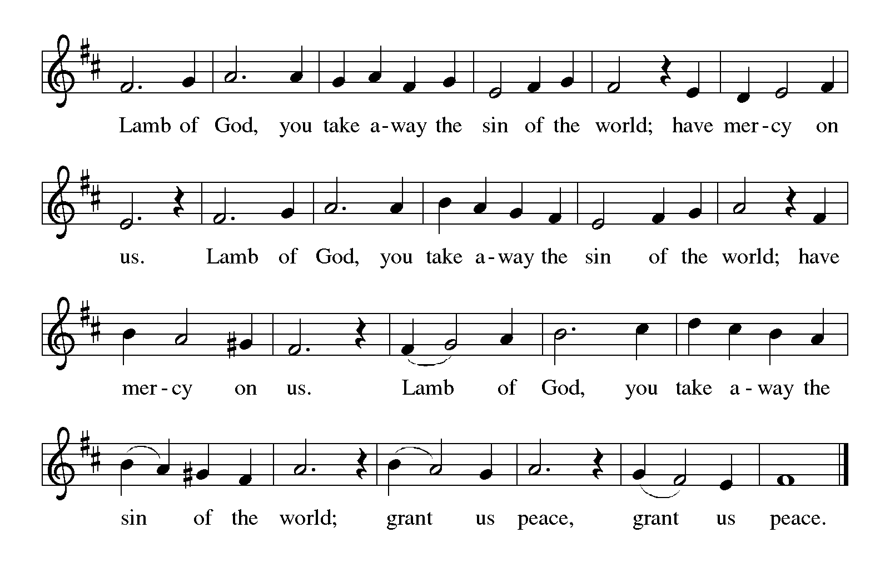

HYMN DURING DISTRIBUTION 256 Comfort, Comfort, Now My People
NSB 88 There Is A Redeemer
NSB 61 Kyrie Eleison
ELW 451 Waterlife
As you are able please rise

THE POST-COMMUNION BLESSING

P: The Body and Blood of our Lord Jesus Christ strengthen you and keep you in His grace.

C: Amen.

THE POST-COMMUNION PRAYER

A: Let us pray. Lord Jesus, like a faithful Shepherd You have again fed us with the rich
Food of Your Body and Blood. Strengthen us through this Meal, that in all we do and
say, we may prepare Your way to our waiting world. You are the Lord forevermore.

C: Amen.
SENDING

THE BENEDICTION

P: God is faithful, and will strengthen you to the End, as you wait for the revealing of our
Lord Jesus Christ. Almighty God: Father, Son, and Holy Spirit bless you now and
forever.

C: Amen.

THE SENDING HYMN 249 On Jordan’s Banks the Baptist’s Cry

THE DISMISSAL

A: Go in peace. Prepare the way of the Lord.

C: Thanks be to God!

POSTLUDE

To God Alone Be Glory

The Meditation is from Sundays and Seasons Online. Copyright 2017 Augsburg Fortress.

The Prayers are adapted from Sundays and Seasons. Copyright 1999 Augsburg Fortress.

ANNOUNCEMENTS

Please remember to mail your offering to the Church Office at 818 Franklin Street, Michigan City, IN 46360. Another alternative is to give on-line through Tithe.ly. Please see your closure letter for information on how to set up a Tithe.ly account.

St. Paul Members are reminded to have a loved one contact the office if you are hospitalized. Many times, the Pastor doesn’t know someone is in the hospital. If you call and leave a message, please tell us which hospital the patient is at.

Next Sunday’s lessons are Isaiah 61: 1-4, 8-11; Psalm 126; IThessalonians 5: 16-24; John 1: 6-8, 19-28 for those of you who like to study them in advance.

Birthdays: Karen Steinborn (12/14); Carol Radke (12/ 17)

PRAYER CONCERNS: Jana Thomas, Leonard Cross, Margie Torres, Jayla Jacobi, Barbara Reichert, Jim Gleason, Kim Mitchell, Ronwynn Jones, Chris Jones, Ken Rosenbaum, Mark Tannehill; Janice White; Joan Seifert; Virginia Murray, Kay Kleinschmidt,and Brian Wiseman.

OFFICE HOURS: Libby will be in the office on Mondays, Wednesdays,
and Fridays; volunteers will cover Tuesdays and Thursdays.

Monday & Wednesday 8:00 a.m. – 5 p.m.
Tuesday & Thursday 9:00 a.m. – 12:00 p.m.
Friday 8:00 a.m. – 12:00 p.m.

If you are listening to the worship broadcast on the radio and would like to watch the Sunday morning service live stream follow these steps:

(1) If you have You Tube available on your TV, search for
St. Paul Lutheran Church Michigan City, IN.

(2) The direct link on the computer is
https://www.youtube.com/channel/UC5AIPNaKr3QN50984jGOa1g.

(3) This link is also on the main page of the church’s website in
the church section and will continue to be posted weekly on the St.
Paul Facebook page.

And it will always be available on the radio broadcast Sunday mornings at 11:00 a.m.
on WEFM (95.9), and on the local cable access station #99 for the previous week’s
service on Sundays at 4:00 p.m. and the current service on Wednesdays at 7:00 p.m. and
Fridays at 8:30 p.m.

The approved and signed minutes of the September 28, 2023 Church Council Meeting are on the table at the back of the church in the Narthex. Please take a copy with you as you go.

To send e-mail to the church office, please use the following addresses:

Pastor Mark Reshan: seniorpastor@stpaulmichigancity.com

Church Office Secretary (Libby Pollock): churchsecretary@stpaulmichigancity.com

Church Treasurer (Karen Fleming): finance@stpaulmichigancity.com

The Good News Newsletter: If you have an article or anything you want included in The Good News please send it to the following e-mail address: splcgoodnews@gmail.com. Pastor Pamela Thiede will be using this e-mail address to assemble The Good News each month. The deadline for getting information to PastorPamela will be the 20th of each month.

WORSHIP ATTENDANCE for December 2 and 3, 2023:
4:00 p.m. 33
9:00 a.m. 66
TOTAL 99

LOOKING FOR IDEAS

We’d like to continue to highlight a different mission each month. We are looking for suggestions! If you volunteer somewhere or have a mission that is close to your heart, please let Paul or Lora Brooks know so we can set up a month to support that cause! Paul: (219) 221-0254, paulbrooks@gmail.com; or Lora: (260) 701-1586, loralmartin15@gmail.com.

December Local Monthly Mission:

December’s local mission is available a little early due to the holidays. An Angel Tree has been placed in the Narthex with angel tags. Each tag is for a gift for a child within our community who is in need and otherwise may not receive a gift for Christmas this year. If you wish to participate, please take a tag and shop for the item listed. Attach the tag to the gift and return it under the tree UNWRAPPED by December 10th. If you’d like to contribute but cannot do the shopping yourself, please let Paul or Lora Brooks know and we would be happy to shop for you. Thanks for your help in bringing joy this Christmas season to the kids within our community!

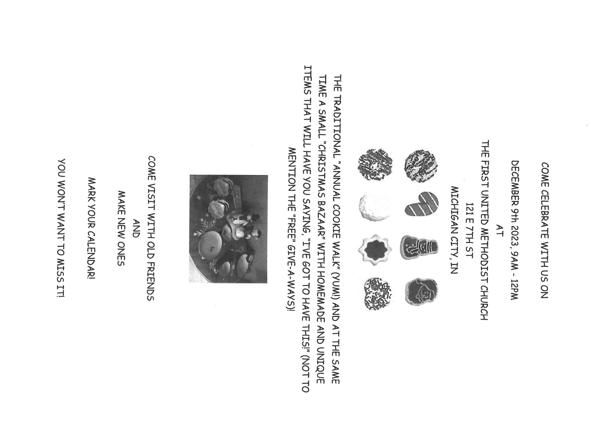

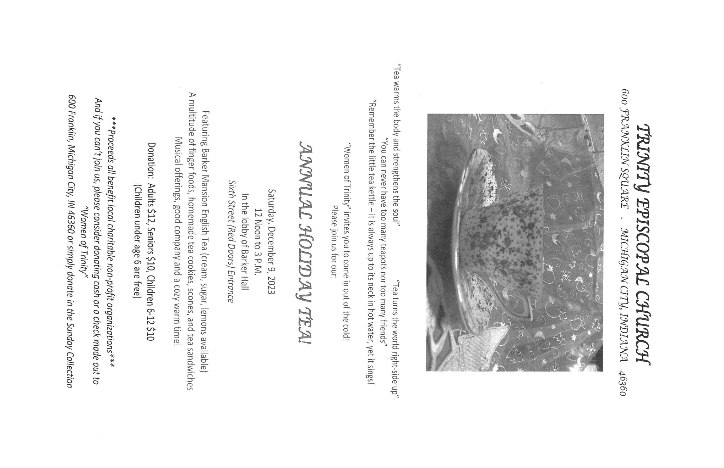

ADVENT/CHRISTMAS WORSHIP

It has long been a tradition to hold a “Quiet/Senior Communion” service in Advent and Lent. Originally intended as a special service for those who were homebound or in nursing or assisted living facilities to attend worship, in recent years it has expanded to include all (not just “seniors”) who wish to gather for a meaningful spoken service and good food and fellowship afterward. This years’ service will take place on Wednesday, December 20, at 9:00 a.m. instead of 10:00 a.m. as in the past. An invitation letter will go out in early December, but all are welcome. Mark the date and new time on your calendar, and we hope to see you on the 20th.

Saturday, December 23 Holy Communion, 4:00 p.m.
The Fourth Saturday of Advent

Sunday, December 24 Holy Communion, 9:00 a.m.
The Fourth Sunday of Advent

Sunday, December 24 Holy Communion, 6:00 p.m.
Christmas Eve

Monday, December 25 Holy Communion, 9:00 a.m.
Christmas Day
Please note the time change

Saturday, December 30 Holy Communion/Lessons and
The First Saturday After Christmas Carols 4:00 p.m.

Sunday, December 31 Holy Communion/Lessons and
The First Sunday After Christmas Carols 9:00 a.m.

ACTIVITIES, EVENTS & MEETINGS
DECEMBER 2023

Saturday, December 2, 2023 @ 4:00 p.m. Worship Service

Sunday, December 3, 2023 @ 9:00 a.m. Worship Service

Tuesday, December 5, 2023 @ 4:00 p.m. Bell Choir Rehearsal

Wednesday, December 6, 2023 @ 9:15 a.m. Bible Study/Luther House

@ 10:00 a.m. God’s Purls/St Paul Room

@ 4:00 p.m. Choir Rehearsal

Thursday, December 7, 2023 @ ? Faith Circle

Saturday, December 9, 2023 @ 4:00 p.m. Worship Service

Sunday, December 10, 2023 @ 9:00 a.m. Worship service

Monday, December 11, 2023 @ 9:00 a.m. Hope Circle/Sunshine Baskets/SPRoom

Tuesday, December 12, 2023 @ all day and eve. GIVE BACK @ Holly’s

@ 4:00 p.m. Bell Choir Rehearsal

@ 7:00 p.m. Estuary/Luther House

Wednesday, December 13, 2023 @ 9:15 a.m. Bible Study/Luther House

@ 10:00 a.m. God’s Purls/St. Paul Room

@ 3:00p.m. Worship & Music Comm. Mtg./Luther House

@4:00 p.m. Choir Rehearsal

Saturday, December 16, 2023 @ 4:00 p.m. Worship Service

Sunday, December 17, 2023 @ 9:00 a.m. Worship Service

Tuesday, December 18, 2023 @ 4:00 p.m. Bell Choir Rehearsal

Wednesday, December 20, 2023 @ 9:00 a.m. Quiet/Senior Communion Service
with refreshments & fellowship immediately after
in St. Paul Room

@ 4:00 p.m. Choir Rehearsal

Saturday, December 23, 2023 @ 4:00 p.m. Worship Service/The Fourth Saturday of Advent
Sunday, December 24 Holy Communion, 9:00 a.m.
The Fourth Sunday of Advent

Sunday, December 24 Holy Communion, 6:00 p.m.
Christmas Eve

Monday, December 25 Holy Communion, 9:00 a.m.
Christmas Day Please note the time change

Thursday, December 28 5:30 p.m. Church Council Mtg.

Saturday, December 30 Holy Communion/Lessons and
The First Saturday After Christmas Carols 4:00 p.m.

Sunday, December 31 Holy Communion/Lessons and
The First Sunday After Christmas Carols 9:00 a.m.

Thank$ for $haring
This month, we will see you at Holly’s on Tuesday, December 12! Here are two coupons: one for you and one for a friend.

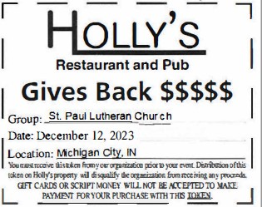

CHRISTMAS JOY LIGHTS FESTIVAL AT FRIENDSHIP BOTANICAL
GARDENS
The staff & volunteers at Friendship Botanic Gardens are planning for our Christmas Joy Lights Festival. We are hoping to find some event volunteers, singers and musicians to participate as Christmas Carolers and Musicians. We plan to host 300-600 guests per night on December 15th, 16th and 17th (at different time slots between 4p.m. and 7p.m.) for a special Holiday-themed Community Event. We will have stations celebrating the magic of Christmas throughout The Gardens. Please feel free to contact Margaret O’Donnell at: (219) 238-6550 if you or someone you know is interested in participating or to reply that we have no one able to help out at this time. Thanks so much!

