**THE SECOND SUNDAY AFTER CHRISTMAS**

**The Festival of the Name of Jesus**

**January 2, 2022**

“In 153 B.C., January 1, the beginning of the month immediately following the winter solstice, was accepted by the Roman Empire as the beginning of the year. Previously, March 1 had been observed as New Year’s Day; later, in the sixth century A.D., March 25, the Annunciation, was adopted throughout Christendom as the beginning of the year. In 1582 Pope Gregory XIII reformed the calendar and restored the beginning of the year to January 1. It was not accepted in England and America until 1752.

In the pagan world, New Year’s Day was a time of widespread license. For some centuries, therefore, the Church gave no liturgical notice to the day whatever ...When the Church noted the day at all, it was kept as a day of fasting and penitence, church attendance being seen as an antidote to participation in pagan revels ...”

“ ...In the seventh century, however, probably under Pope Boniface IX (615), January 1 was made a church holiday, simply called “The Octave (eighth day) of the Lord” in imitation of the eighth day of Easter and of the Epiphany. Since the celebration of the new year could not be suppressed, the Church did as it has often done and transformed the pagan holiday into a church festival ...”

“...The celebration of the Circumcision of Jesus began about the middle of the sixth century in Gaul ...In the Middle Ages, the day also came to be associated with devotion to the Holy Name of Jesus, since the brief Gospel reading (Luke 2:21) reported both the circumcision and the giving of the name ...”

**Philip Pfatteicher**

***Festivals and Commemorations***

**INTRODUCTION**

*The observance of the octave (eighth day) of Christmas has roots in the sixth century. Until the recent past, Lutheran calendars called this day* “The Circumcision and Name of Jesus.” The emphasis on circumcision is the older emphasis. Every Jewish boy was circumcised and formally named on the eighth day of his life. Already in his youth, Jesus bears the mark of a covenant that he makes new through the shedding of his blood, now and on the cross. That covenant, like Jesus’ name, is a gift that marks the children of God. Baptized into Christ, the church begins a new year in Jesus’ *name.*

**The Name of Jesus**

*By Jewish law, every baby boy was circumcised and named on the eighth day of life, so on the eighth day of Christmas the church celebrates this event in Jesus' life. The keeping of the covenant as well as Jesus' name are signs of God's salvation given to us through him.*

**Johann Konrad Wilhelm Loehe, renewer of the church, died 1872**

*A nineteenth-century German Lutheran pastor, Loehe worked to enliven the church with the eucharist at its center, from which would flow evangelism and social ministry. He sent pastors to North America, Australia, New Guinea, Brazil, and the Ukraine.*

**✠ In the Name of Jesus✠**

**✠ GATHERING✠**

**PRE-SERVICE MUSIC *The Heart of Worship*  Praise Band**

**ANNOUNCEMENTS**

*As you are able please rise*

**THE GATHERING SONG 531 *The Trumpets Sound, the Angels Sing* page 10**

**A CHRISTMAS DIALOGUE**

P: The people who walked in darkness have seen a great light.

C: **The light shines in the darkness, and the darkness has not overcome it.**

P: Those who dwelt in a land of deep darkness, on them light has shined.

C: **We have beheld Christ’s glory, glory as of the only Son from the Father.**

P: For to us a child is born, to us a Son is given.

C: **In Him was life, and the life was the life of all people.**

P: Out of the mouths of infants and children, Your majesty is praised above the heavens.

C: **O Lord, our Lord, who exalted is your name in all the earth.**

P: The grace of our Lord Jesus Christ, the love of God, and the communion of the Holy

Spirit be with you all.

C: **And also with you.**

**THE PRAYER OF THE DAY**

P: Let us pray. Eternal Father, You gave Your incarnate Son the holy name of Jesus to be

a sign of our salvation. Plant in every heart the love of the Savior of the world, Jesus

Christ, our Savior and Lord, Who lives and reigns with You and the Holy Spirit, one

God, now and forever.

C: **Amen.**

*The assembly is seated*

**✠ WORD ✠**

**FIRST READING Numbers 6:22-27**

*God commanded Aaron to say these words, known as the Aaronic benediction, in blessing the people of Israel. We too are marked with God’s name and God’s blessing as we are sent from our assemblies into the world.*

22The LORD spoke to Moses, saying: 23Speak to Aaron and his sons, saying, Thus you

shall bless the Israelites: You shall say to them,

24The LORD bless you and keep you;

25the LORD make His face to shine upon you, and be gracious to you;

26the LORD lift up His countenance upon you, and give you peace.

27So they shall put My name on the Israelites, and I will bless them.

The Word of the Lord.

**Thanks be to God.**

**THE PSALM: Psalm 8** **Read responsively**

1O LORD our Lord,

     how majestic is Your name in all the earth!—

**2You Whose glory is chanted above the heavens**

**out of the mouths of infants and children;**

**You have set up a fortress against Your enemies,**

**to silence the foe and avenger.**

3When I consider Your heavens, the work of Your fingers,

     the moon and the stars You have set in their courses,

**4what are mere mortals that You should be mindful of them,**

**human beings that You should care for them?**

5Yet You have made them little less than divine;

     with glory and honor You crown them.

**6You have made them rule over the works of Your hands;**

**You have put all things under their feet:**

7all flocks and cattle,

     even the wild beasts of the field,

**8the birds of the air, the fish of the sea,**

**and whatever passes along the paths of the sea.**

9O LORD our Lord,

     how majestic is Your name in all the earth!

**SECOND READING Galatians 4:4-7**

*Paul proclaims the ultimate significance of the nativity: Jesus was born the Son of God so that, because of him, we all may be God's children.*

4But when the fullness of time had come, God sent His Son, born of a woman, born under

the law,

5in order to redeem those who were under the law, so that we might receive adoption as

children.

6And because you are children, God has sent the Spirit of His Son into our hearts, crying,

"Abba! Father!"

7So you are no longer a slave but a child, and if a child then also an heir, through God.

The Word of the Lord.

**Thanks be to God.**

*As you are able please rise*

**THE VERSE 886 *Oh, For a Thousand Tongues to Sing*  page 11** (Stanzas 1-3)

**THE HOLY GOSPEL Luke 2:15-21**

*Eight days after his birth, Jesus is circumcised according to Jewish law and given the name announced by the angel before his conception.*

P: The Holy Gospel according to St. Luke, the second chapter.

C: **Glory to You, O Lord!**

15When the angels had left them and gone into heaven, the shepherds said to one another,

"Let us go now to Bethlehem and see this thing that has taken place, which the Lord

has made known to us."

16So they went with haste and found Mary and Joseph, and the child lying in the manger.

17When they saw this, they made known what had been told them about this child;

18and all who heard it were amazed at what the shepherds told them.

19But Mary treasured all these words and pondered them in her heart.

20The shepherds returned, glorifying and praising God for all they had heard and seen, as

it had been told them.

21After eight days had passed, it was time to circumcise the child; and He was called Jesus,

the name given by the angel before he was conceived in the womb.

P: The Gospel of the Lord.

C: **Praise to You, O Christ!**

**THE HYMN 886 *Oh, For a Thousand Tongues to Sing*  page 11** (Stanzas 4-6)

*The assembly is seated*

**THE SERMON**

*Silence for reflection follows the sermon*

*As you are able please rise*

**THE HYMN OF THE DAY 620 *How Sweet the Name of Jesus Sounds*  page 12**

**THE NICENE CREED**

A: God has made us His people through our Baptism into Christ. Living together in trust

and hope, we confess our faith.

**We believe in one God,**

**the Father, the Almighty,**

**maker of heaven and earth,**

**of all that is, seen and unseen.**

**We believe in one Lord, Jesus Christ,**

**the only Son of God,**

**eternally begotten of the Father,**

**God from God, Light from Light,**

**true God from true God,**

**begotten, not made,**

**of one Being with the Father.**

**Through Him all things were made.**

**For us and for our salvation**

**He came down from heaven;**

**by the power of the Holy Spirit**

**He became incarnate from the virgin Mary, and was made**

**man.**

**For our sake He was crucified under Pontius Pilate;**

**He suffered death and was buried.**

**On the third day He rose again**

**in accordance with the Scriptures;**

**He ascended into heaven**

**and is seated at the right hand of the Father.**

**He will come again in glory to judge the living and the dead,**

**and His kingdom will have no end.**

**We believe in the Holy Spirit, the Lord, the giver of life,**

**Who proceeds from the Father and the Son.**

**With the Father and the Son He is worshiped and glorified.**

**He has spoken through the prophets.**

**We believe in one holy catholic and apostolic Church.**

**We acknowledge one Baptism for the forgiveness of sins.**

**We look for the resurrection of the dead,**

**and the life of the world to come. Amen**

**THE PRAYER OF THE CHURCH**

A: Glorifying and praising God for the Good News we have heard and seen, let us offer

intercession in the name of Jesus for the Church, the world, and all in need.

A: That God’s face may shine upon the Church as we proclaim the saving name of Jesus,

until every tongue confesses Him as Lord to the glory of God: God of our salvation,

C: **Hear our prayer.**

A: That God’s face may shine upon the nations of the world, that in this New Year

governments and leaders may more justly work for peace and the well-being of all:

God of our salvation,

C: **Hear our prayer.**

A: That God’s face may shine upon this congregation, that in this New Year our faith may

be strengthened and our minds and lives more closely conformed to Christ: God of our

salvation,

C: **Hear our prayer.**

A: That God’s face may shine upon those in need: the poor, the unemployed, the addicted,

the homeless, the dying, and the sick, especially: . . .that the light of His face

may fill them with peace: God of our salvation,

C: **Hear our prayer.**

A: That those celebrating birthdays, especially **Mary Peters; Jo Ann Kring; and Susan**

**Bagby** may be filled with grace this day and every day and grow in grace in the days

ahead: God of our salvation,

C: **Hear our prayer.**

A: That with the saints of every age we too may reflect Your grace and blessing until Your

face is turned to us for all eternity: God of our salvation,

C: **Hear our prayer.**

P: As shepherds were astonished by Your marvels, O God, so too do we stand in awe of

Your goodness. Be merciful to us today in our need that we may learn to be Your

compassion in the world. We ask this in the name of Jesus.

C: **Amen.**

**✠ MEAL✠**

**THE PEACE**

P: Unto us a Child is born; unto us a Son is given.

And His name is Prince of peace.

The peace of Christ be with you always.

**And also with you.**

***The assembly is seated***

**THE VOLUNTARY *Someone Else Living in You* Praise Band**

*As you are able please rise*

**THE OFFERTORY PRAYER**

A: Let us pray. Gracious God,

C: **The name of Jesus brings salvation to the world. In all we offer You this Day, may**

**we honor Him, and through this eating and drinking, may our lives and minds be**

**conformed to His. We ask this in the name of Jesus the Lord. Amen.**

**THE GREAT THANKSGIVING**

P: The Lord be with you.

C: **And also with you.**

P: Lift up your hearts.

C: **We lift them up to the Lord.**

P: Let us give thanks to the Lord our God.

C: **It is right to give Him thanks and praise.**

P: Father, we thank You with our lips and in our lives, that having created us and all things

through Your Word You welcome and prayer and praise.

For the goodness of creation and the glory to which You call us by our redemption, we

praise You.

For the law and prophets, calling us to obedience, and warning us against disobedience,

we praise You.

Above all, we offer You praise and thanksgiving over this bread and cup because in

Jesus Christ You have joined Yourself to us, uniting heaven and earth.

We remember Jesus’ birth into our humanity, His baptism for our sin, His compassion

for our suffering, His intimacy with our frailty, His rebuke of our pride, His

bearing of the cross, and His rising from the dead.

According therefore to His command and promise of presence we now thankfully

remember that in the night ... “Do this for the remembrance of Me.”

As often as we eat ... we proclaim the Lord’s death until He comes.

C: **Christ has died. Christ is risen. Christ will come again.**

P: We ask You, Father: pour out Your Holy Spirit on us and these Your gifts of bread and

wine.

May we, marked again with His holy Name be one with Christ, one with each other,

and one in His ministry of blessing to all the world.

May our communion with Him Who was, Who is, and Who is to come be a sign of His

eternal rule over all the world until every knee bows and every tongue

confesses Him as Lord.

This sacrifice of praise and thanksgiving we offer You, gracious God, in the name of

Jesus, in the unity of the Holy Spirit, one God, to ages of ages.

C: **Amen!**

**THE LORD’S PRAYER**

P: The Word became flesh and dwelled among us, that as children of God we might dare to pray:

C: **Our Father, Who art in heaven, hallowed be Thy Name. Thy Kingdom come. Thy**

**will be done on earth as it is in heaven. Give us this day our daily bread, and**

**forgive us our trespasses as we forgive those who trespass against us. And lead us**

**not into temptation, but deliver us from evil, for Thine is the Kingdom, and the**

**power, and glory, forever and ever. Amen.**

**INVITATION TO THE MEAL**

P: Behold the Light of the world, begotten of the Father’s glory, of Whose fullness and

grace we have all received. Blessed are those who are called to the Supper of the Lamb.

Come, for all is now ready.

*The assembly is seated*

**THE DISTRIBUTION**

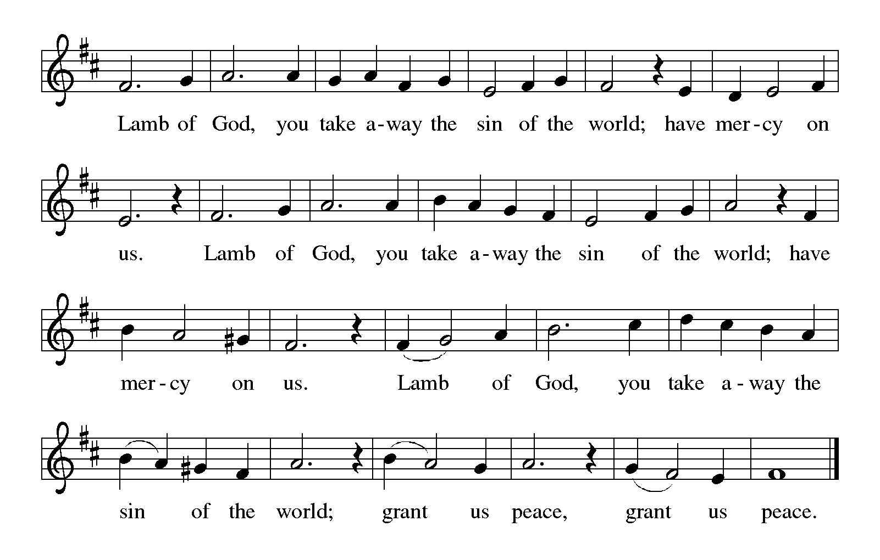

**HYMN DURING DISTRIBUTION 820 *O Savior, Precious Savior*  page 13**

**296 *What Child is This*  page 14**

**NSB 59 *Jesus, Name Above All Names*  page 15**

*As you are able please rise*

**THE POST-COMMUNION BLESSING**

P: The Body and Blood of our Lord Jesus Christ strengthen you and keep you in His grace.

C: **Amen.**

**✠ SENDING ✠**

**THE BENEDICTION**

P: The Lord bless you and keep you.

The Lord make His face shine upon you and be gracious to you.

The Lord look upon you with favor and give you peace.

C: **Amen.**

**THE SENDING HYMN 299 *Cold December Flies Away*  page 16**

**THE DISMISSAL**

A: You are called to belong to Jesus Christ. Go in grace and peace to exalt his name in all

the earth. Alleluia, Alleluia!

C: **Thanks be to God!  Alleluia!  Alleluia!**

**POSTLUDE *Oh, for a Thousand Tongues*  Robert Hobby**

**✠ To God Alone Be Glory✠**

The Meditation is from *Festivals and Commemorations.* Philip Pfatteicher. (Minneapolis:

Augsburg Press, 1980) 167.

The Offertory and Post-Communion Prayers are adapted from *The Book of Alternative*

*Services of the Anglican Church of Canada.* (Toronto: Anglican Book Centre,

191985) 278-79.

The Prayers are adapted from *Sundays and Seasons.com* (Augsburg Fortress Press) 2005

and *Prayers for Sundays and Seasons. Year B.* Peter J. Scagnelli. (Chicago:

Liturgy Training Publications, 1992) 21.

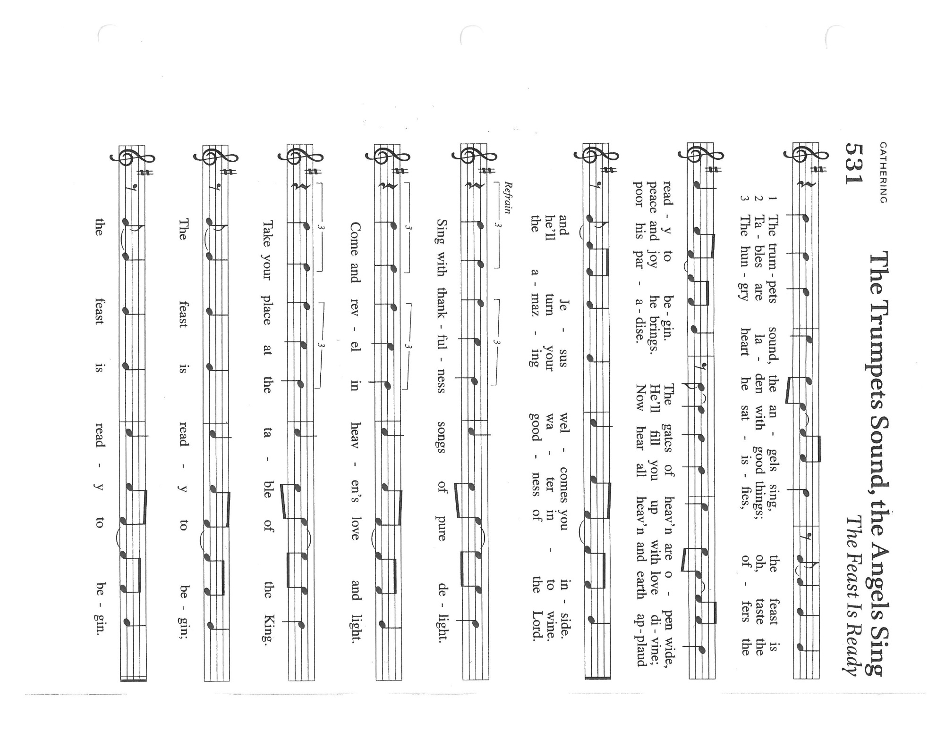

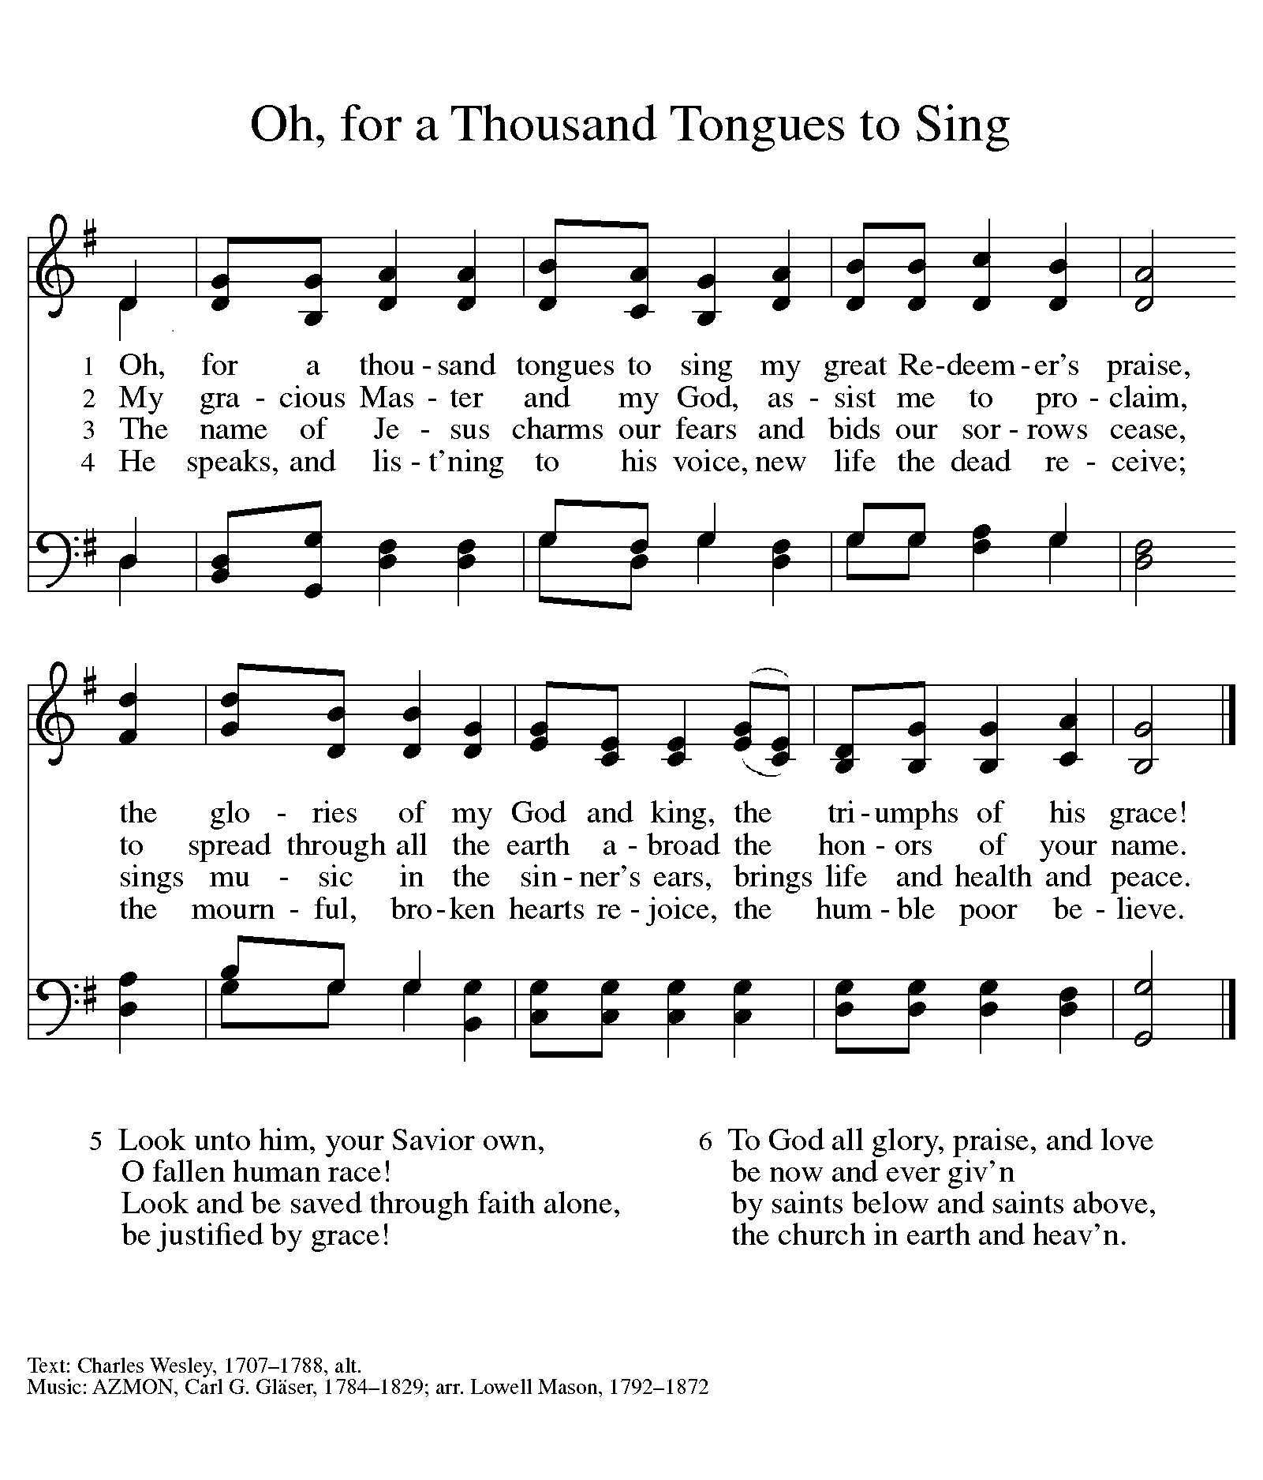

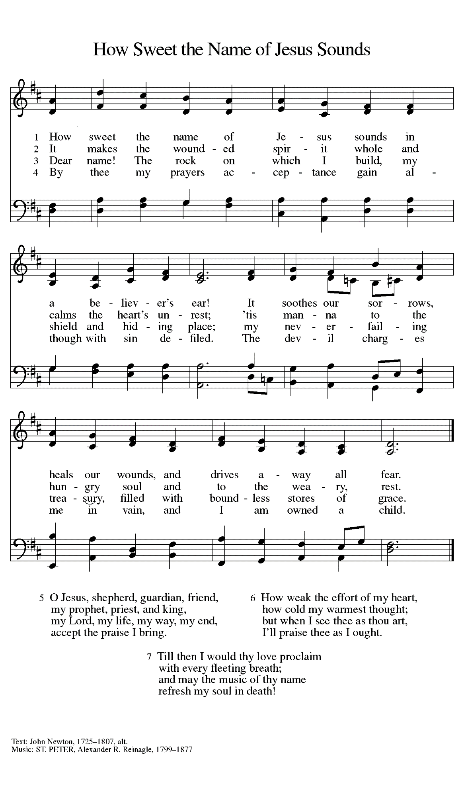

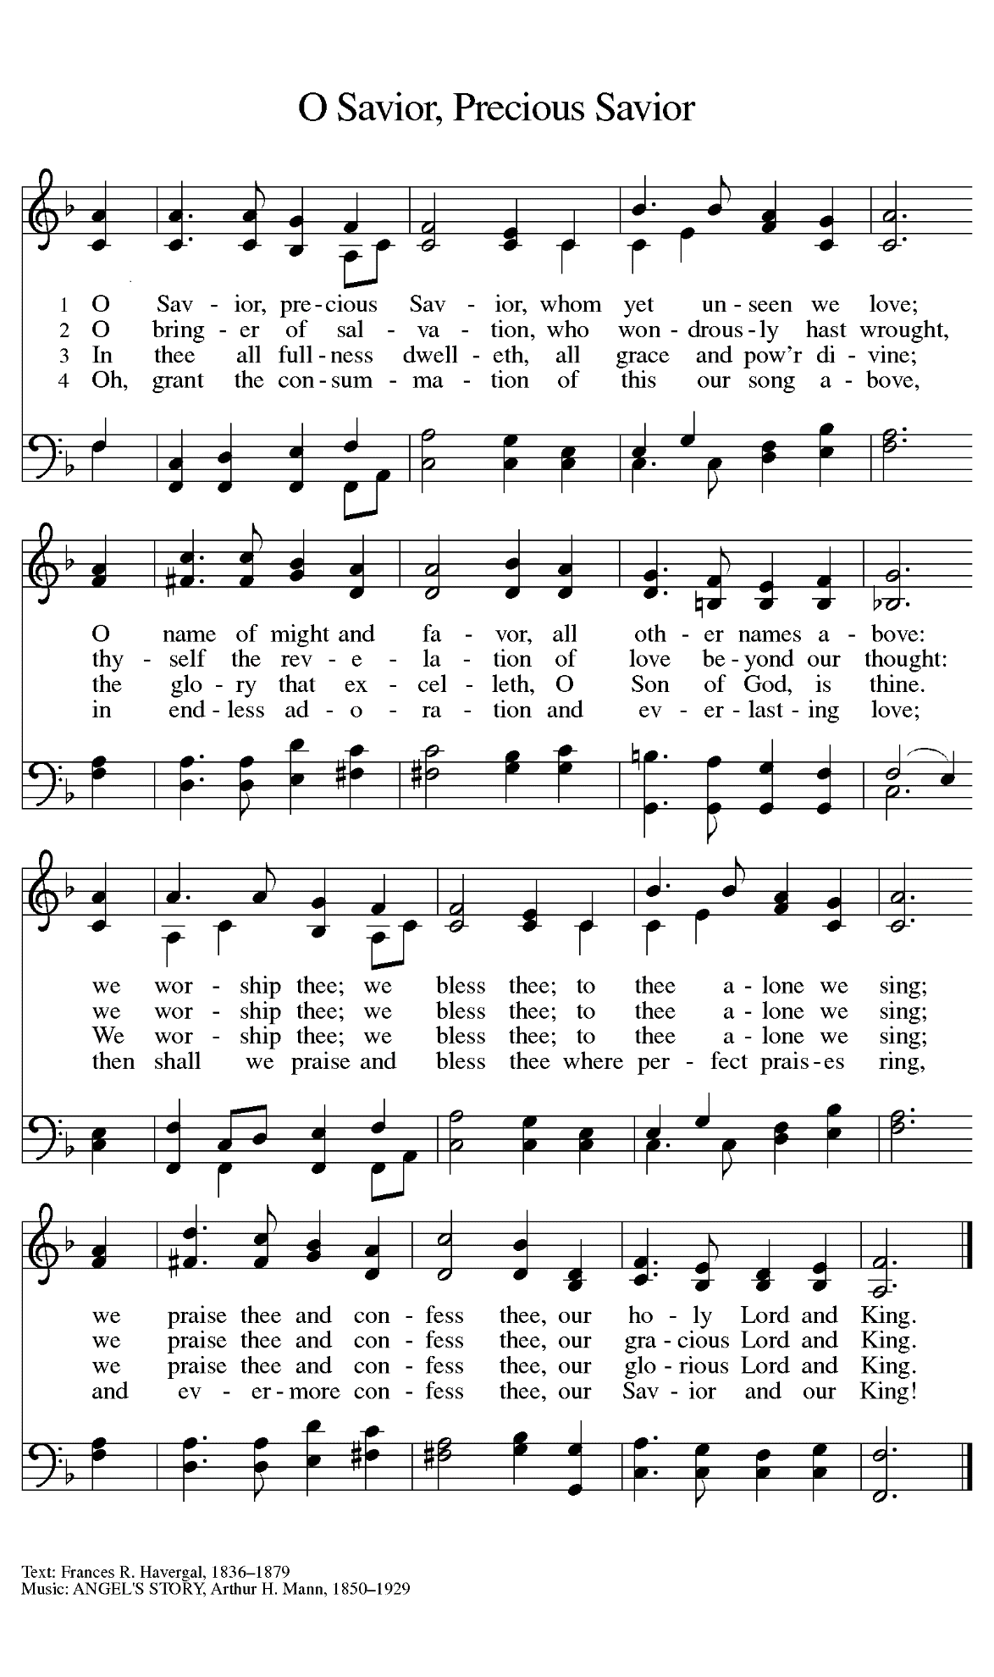

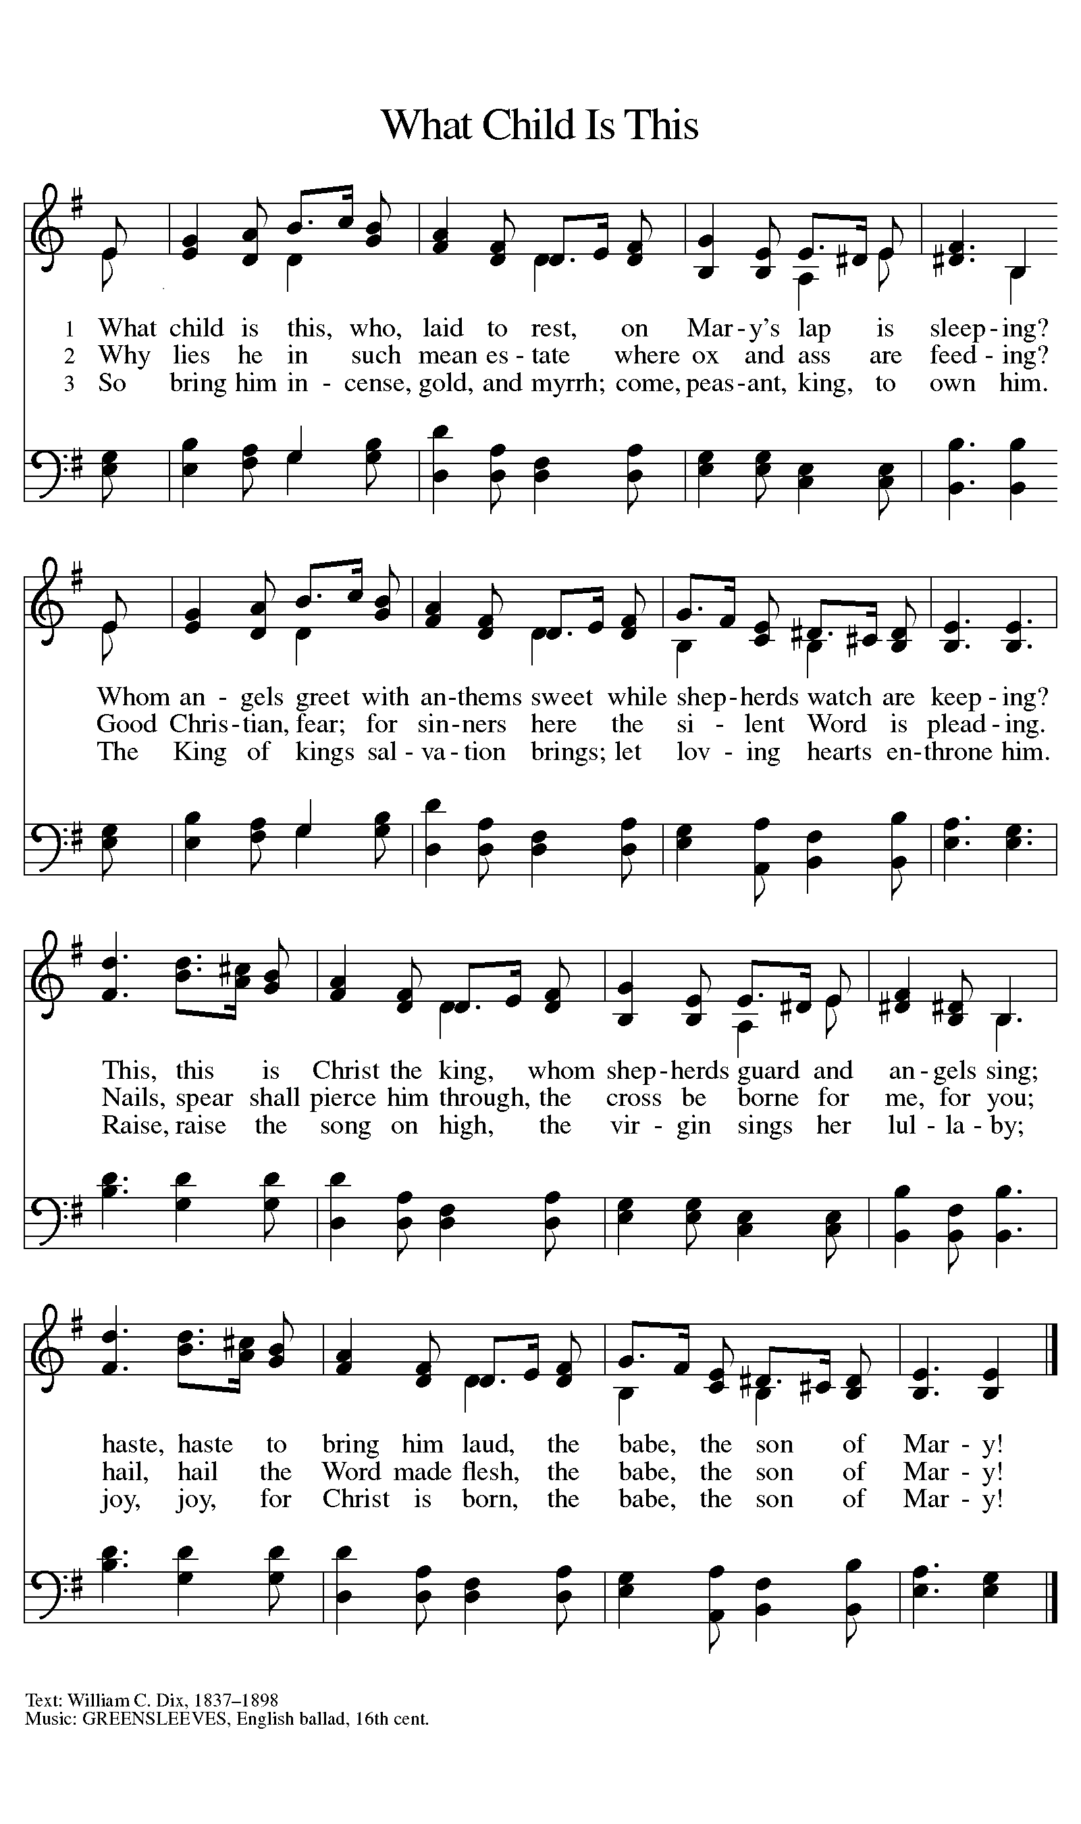

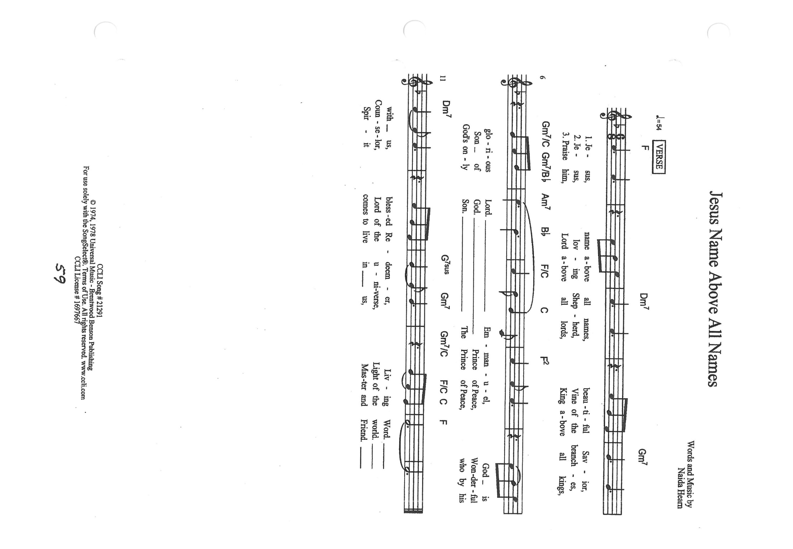

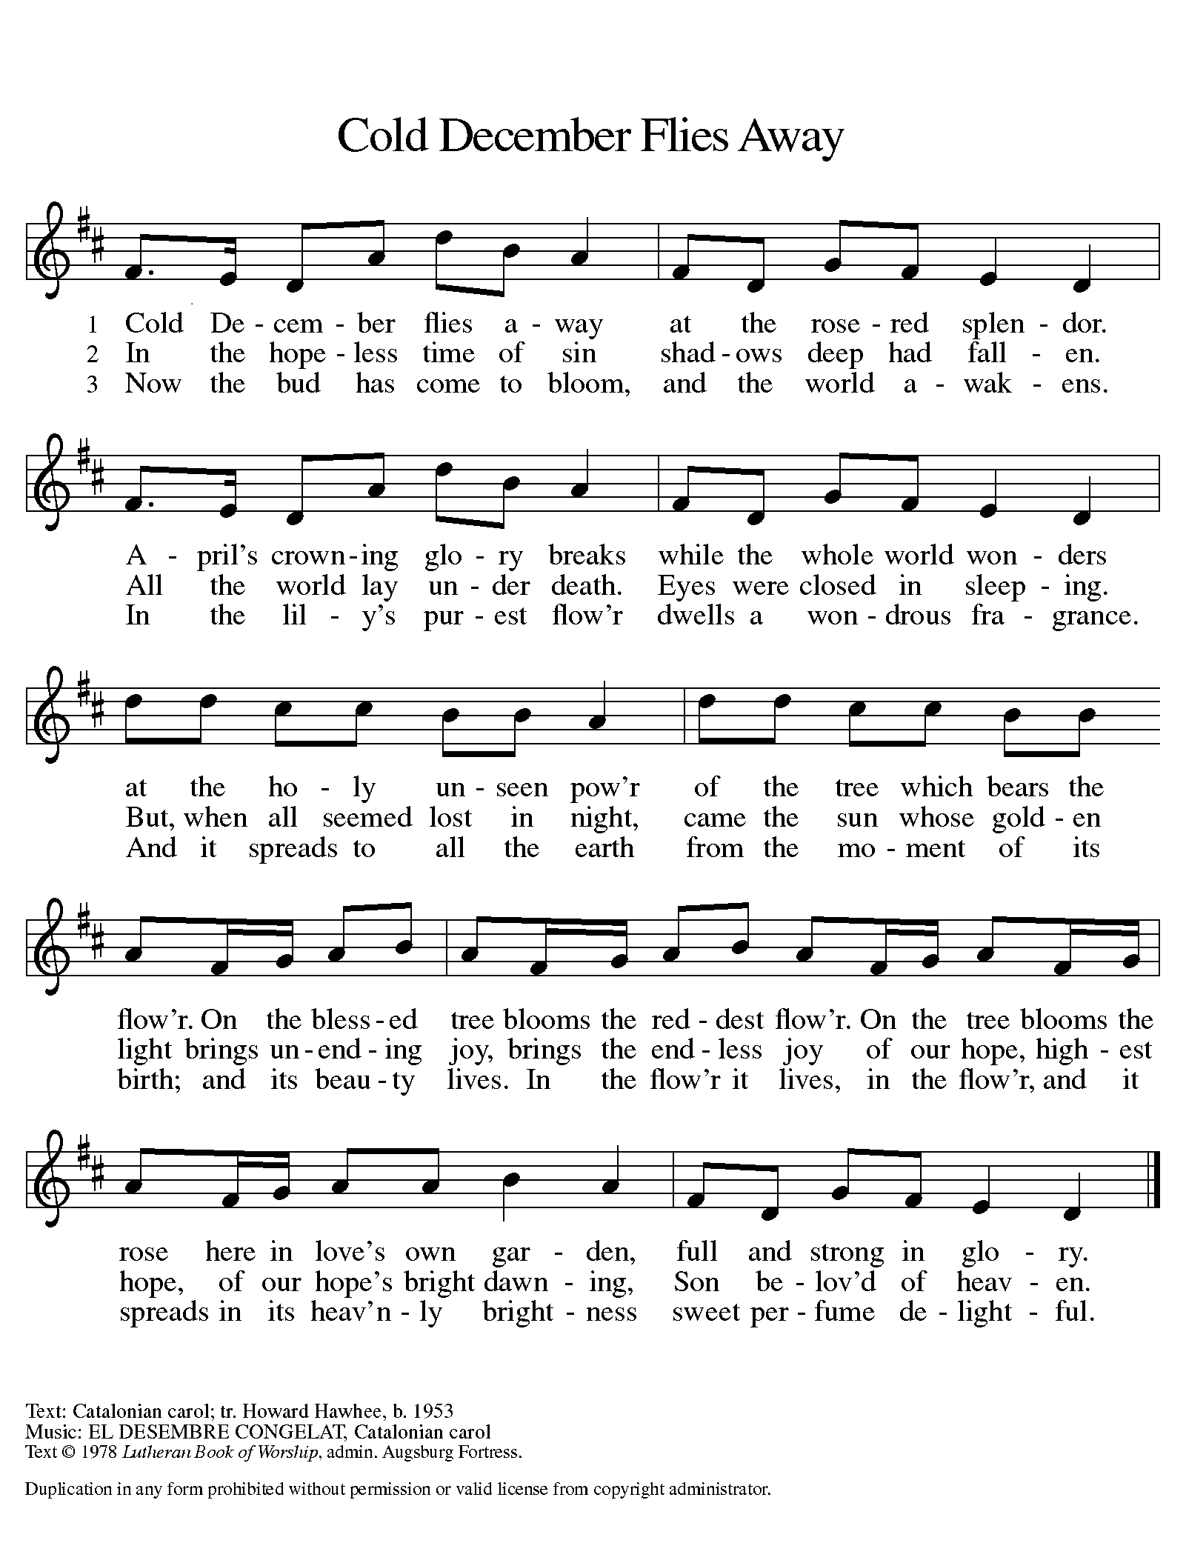

**POINSETTIAS 2021**

Jim & Bernadette Krueger 3 plants. One in honor of Ryan Krueger and Anna Raul; one in memory of Ed & Mary Losiniecki; and one in memory of Jan & Robert Krueger

Mary Knaup 3 plants. One in memory of Victor Herbert; one in memory of Kathryn Herbert; and one in memory of Dennis Knaup

Rich & Karen Fleming 2 plants. One in memory of Karen’s mother Mary Knapp and one in memory of Norma Fleming

Beverly Johnson 2 plants in honor of family

Paul & Lora Brooks 1 plant in memory of

Dan Reef and Maggie Brooks

Diane Gielow 1 plant in memory of loved ones

Melinda Nagle 2 plants. One plant in memory of her parents, Randall & Lois Miller and one in honor of her new grandson, Miles Andres

Pamela Thiede 1 plant in memory of her parents

Rynold & Evelyn Thiede

Richard Thielman 3 plants. One in loving memory of Lori Hall; one in loving memory of Norman & Marcella O’Donnell; and one in loving memory of Donald & Desolyn Thielman

Nancy Mauman and family 3 plants. One in loving memory of

her husband, John Mauman; one in loving memory of her parents, Dorothy & Wally Liebig; and one in loving memory of loved ones

Richard & Pamela Henderson 3 plants. One in memory of her Mom, Suzanne Cains; one in memory of his Father, Gary Henderson; and one in honor of their daughters,

Madeline and Audrey

Mike and Marge Bockover 3 plants in memory of loved ones

Susan Koziel 2 plants. One in memory of loved ones; and one in honor of her children and grandchildren

Don & Beth Thompson 2 plants. One in memory of Palmer and Ruth Thompson and loved ones; and one in memory of Suzanne Cains and in honor of Richard Cains

Gail Leffew 1 plant in memory of Paul Leffew

Sandy Robbins 1 plant in memory of Sonny (Henry) Robbins

Bob and Karen Kiser 1 plant in memory of loved ones

Maxine Powell 2 plants. One in memory of Clint Powell and one in memory of Connie Hollis

Virginia Murray 1 plant in memory of loved ones

Carol & Fred Weiss 2 plants. 1 plant in memory of their son Donald; and 1 plant in memory of Fred’s sister Suzanne Cains

Janet Bakken 2 plants in memory of loved ones and in honor of family and friends

Susan Bagby 1 plant in memory of her parents Raymond and Hazel Reiter

Brenda Biggs 2 plants. One in memory of Sue Biggs wife of Roland, and one in memory of her mother, Sue Biggs and grandmother to her nieces and nephews Sue Biggs

Bill & Carol Geleske 1 plant in memory of Clarence & Leona Lange and 1 in memory of

Robert & Shirley Lange Timm

Tim & Laura Mellen 1 plant

Larry & Judy Litchford 2 plants. 1 in honor of all those in the military; and 1 in honor of all police officers

Chip &Audrey Claussen 2 plants; 1 in memory of her parents, Ollie & Josephine Olson and brother, Richard Olson; and 1 in memory of his parents, Edward & Solveig Claussen

Jason & Carey Howard 2 plants. 1 in memory of her Dad, John Foldenauer; and 1 in memory of his Mom, Christine Leslie

The family of Richard Cains 6 plants in loving memory of Wife, Mother, Grandmother, Suzanne Cains

Carol Radke 1 plant in memory of Al Radke

**ANNOUNCEMENTS**

**Please remember to mail your offering to the Church Office** at 818 Franklin Street, Michigan City, IN 46360**.** Another alternative is to give on-line through Tithe.ly. Please see your closure letter for information on how to set up a Tithe.ly account.

**St. Paul Members are reminded to have** a loved one contact the office if you are hospitalized. Many times, the Pastor doesn’t know someone is in the hospital. If you call and leave a message, please tell us which hospital the patient is at.

**Birthdays: Mary Peters (1/06); JoAnn Kring (1/06); Susan Bagby (1/09)**

**PRAYER CONCERNS:** Kathy Thielman, Audrey Beyer, Bethany Manning, Marla Furness, Kay Peglow, Lee Timm, Ryan Krueger, Donna Bostater, Diane Gielow, Jeff Jensen, Maxine Powell, Jess Kalvaitis, Pastor Al Lorentzen, Jan Paholski, Laura Dovey, Heidi Happel, Shane Nevels, Irene Bohnstadt, Joan Coughlin, Jim Tomscheck, Wally & Betty Ratliff, Laura Moore, Cameron Rackard, Erik Tannehill, Ed Gustum, Ken Mulder, Ashton Steele, Christian Martinez, Nancy Wisser, Ryan Sirk, Tyler Brown, Jary Tannehill, Jim Gleason, Carl Loetz, Knox Shepherd, Patsy Humbers, Ed Riddle and Blythe Topa.

**If you requested someone’s name to be on the prayer list and are aware that they need continued imminent prayer then contact the church office and let us know.** Otherwise we will gradually transfer names to the long-term list.

**OFFICE HOURS:** Libby will be in the office on Mondays, Wednesdays, and Fridays; volunteers will cover Tuesdays and Thursdays.

Monday & Wednesday 8:00 a.m. – 5 p.m.

Tuesday & Thursday 9:00 a.m. – 12:00 p.m.

Friday 8:00 a.m. – 12:00 p.m.

**If you are listening to the worship broadcast on the radio and would like to watch the Sunday morning service live stream follow these steps:**

1. If you have You.Tube available on your TV, search for

**St. Paul Lutheran Church Michigan City, IN.**

(2) The direct link on the computer is

https://www.youtube.com/channel/UC5AIPNaKr3QN50984jGOa1g.

(3) This link is also on the main page of the church’s website in the church section and will continue to be posted weekly on the St. Paul Facebook page.

And it will always be available on the radio broadcast Sunday mornings at 11:00 a.m. on WEFM (95.9), and on the local cable access station #99 for the previous week’s service on Sundays at 4:00 p.m. and the current service on Wednesdays at 7:00 p.m. and Fridays at 8:30 p.m.

**To send e-mail to the church office**, please use the following addresses:

 Pastor Mark Reshan: seniorpastor@stpaulmichigancity.com

 Church Office Secretary (Libby Pollock): churchsecretary@stpaulmichigancity.com

 Church Treasurer (Karen Fleming) and Bookkeeper (Billie Atchinson):

finance@stpaulmichigancity.com.

**The Good News Newsletter**: If you have an article or anything you want included in **The Good News** please send it to the following e-mail address: splcgoodnews@gmail.com. Pastor Pamela Thiede will be using this e-mail address to assemble **The Good News** each month. The deadline for getting information to Pastor Pamela will be the 20th of each month.

**WORSHIP ATTENDANCE for December 24, 25 and 26, 2021**

**6:00 p.m. 111**

**10:00 a.m. 33**

**9:00 a.m. 29**

**Total= 173**

**The Community Soup Kitchen serving out of First United Methodist is in need of volunteers.** Sunday through Tuesday is always need, as is occasionally Wednesdays and Thursdays. Hours are 9:30 a.m. to 1:15 p.m. and it is not necessary to stay the entire time. There is also a need for volunteers to be available to help pick up deliveries from the Food Bank when they arrive. If you are able to help please contact their church office at 872-7200.

**Thank You!**Maxine Powell sends her thanks for the many birthday and Christmas wishes and cards. She wishes a Merry Christmas and Happy holidays to everyone!

**2021 Financial Stewardship**

Weekly Church Operating Needs (x 2 weeks): $14,116.36

December 18 and 19, 25 and 26, 2021

General Fund (including General Memorials): $10,294.80

Overage/Shortage: --$ 3,821.56

Restricted Income (not including Memorials)

Supports IK Synod & Churchwide Ministries: $ 85.00

Ministries in our Community/Congregation: ----

Capital Fund: $ 345.00

General Fund: $2,905.00

Capital Fund $ 50.00

**“Giving Tuesday”** which is a global day of giving happened on Tuesday, November 30, 2021. St. Paul Church received $4,220.00 from Facebook/Meta on that dayand of thatamount $715.00 was matched by Facebook/Meta. Thank You to all who participated!

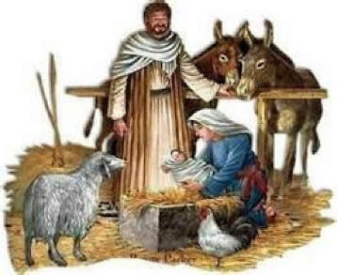

**ADVENT/CHRISTMAS DECORATIONS**

Once again, we would like to recognize and thank those who so selflessly gave of their time and energy to put up the beautiful decorations that adorned our worship space during Advent and Christmas. As always please make sure that you offer your deep thanks for all their hard work.

Christmas Tree Bob and Karen Kiser; Bill Seedorf; Larry and Judy Litchford; Wayne and Suzann Dolson; Casey and Brad Neulieb

Advent Log Virginia Murray

Poinsettia plants Virginia Murray; Sue Koziel

Large wooden cross Janet Bakken; Sue Koziel; Karen Steinborn

Garland (outer narthex and Communion railings) Karen Steinborn; Sue Koziel

Window treatments (nave and outside) Mary Knaup

Upper narthex nativity scene and creche Pastor Mark Kloess; Jary Tannehill;

Stacie Crozier