THE SECOND SUNDAY AFTER THE EPIPHANY
January 16, 2022

Many of Christ’s miracles, although at first obscure, have become clearer in the course of time. Then, those who saw the event from the very beginning narrated what had taken place: Jesus then made wine from water. But now, as well as then, Jesus continues to change our weak and unstable wills into that which is better.
For there are, I affirm, people who differ in nothing from water: they are cold, weak, and never stand firm. Let us bring those who are so afflicted to the Lord, that he may change their will to the quality of wine: that they no longer simply flow away, but that they be steadfast, and that they become to themselves and to others a source of comfort.

John Chrysostom

A man who once calculated the amount of water turned to wine (in John 2:1-11) presented his estimate to St. Jerome and asked if the guests at Cana had drunk all that wine. Jerome responded and said, “No, we are still drinking of it.”

Sundays and Seasons
In the Name of Jesus

INTRODUCTION

The Sundays after Epiphany continue to celebrate the revelation of the glory of God to us as it was made known to the magi and to those on Jordan's banks at the baptism of Jesus—today using wedding imagery. Our God rejoices over God's people "as the bridegroom rejoices over the bride." By the power of the Spirit there are gifts galore for everyone. In Christ Jesus the best wine is saved for last. Taste and see.

Martin Luther King Jr., renewer of society, martyr, died 1968

An American prophet of justice among races and nations, King was an eloquent preacher, a leader of the nonviolent resistance to race-segregated society, and recipient of the Nobel Peace Prize in 1964. Born on this date, he was assassinated on April 4, 1968.

GATHERING

PRE-SERVICE MUSIC Beautiful Savior (All My Days) Praise Band

ANNOUNCEMENTS

As you are able please rise

CONFESSION AND ABSOLUTION

P: In the name of the Father and of the Son and of the Holy Spirit.

C: Amen.

P: God of the Epiphany, God of brightness and light, we confess to You that we walk in
darkness and close our eyes to the signs of Your presence among us.

C: Forgive us, Lord, and open our eyes.

P: When we turn from You to talk in our own ways,

C: Forgive us, Lord, and open our eyes.

P: When we turn from the needs of the poor, the hungry, the suffering, and all who are
stifled by the darkness:

C: Forgive us, Lord, and open our eyes.

P: When we seek to control Your glory and power for our own purposes:

C: Forgive us, Lord, and open our eyes.

P: When we fail to see Your Church as the body of many gifts, and fail to use those gifts
for the common good of all:

C: Forgive us, Lord, and open our eyes. Open our eyes to the depth of Your love and
desire for us, revealed finally in the cross of Your Son, Jesus Christ. Do not keep
silent, O God. Speak again Your Word, that we may know You have named us
Yours, and so in loving faith may serve and please You.

P: Because of Jesus Christ, you have been given a new name: “My delight is in you.”
(Isaiah 62:3) God earnestly desires you to hear and trust that promise. Therefore, as a
called and ordained minister of the Church of Christ, and by His authority, I declare to
you the entire forgiveness of all your sins, in the name of the Father and of the Son
and of the Holy Spirit.

C: Amen.

GATHERING SONG NSB 78-79 Shout to the North page 10-11

THE GREETING AND PRAYER OF THE DAY

P: Arise; shine; for your light has come. The grace of our Lord Jesus Christ, the love of
God, and the communion of the Holy Spirit be with you all.

C: And also with you.

P: Let us pray. Lord God, Source of every blessing, You showed forth Your glory and led
many to faith by the works of Your Son, Who brought gladness and salvation to His
people. Transform us by the Spirit of His love, that we may find our life together in
Him, Jesus Christ, our Savior and Lord.

C: Amen.

The assembly is seated

WORD

FIRST READING Isaiah 62:1-5

The people’s return to their homeland after the exile was not the glorious event announced earlier by the prophet. Nevertheless, the writer of today’s reading declares hope. The close connection between a name and its bearer appears as the restored Jerusalem receives a new name. The marriage metaphor used of God and Jerusalem indicates the joy of communal life with God.

For Zion’s sake I will not keep silent,
and for Jerusalem’s sake I will not rest,
until her vindication shines out like the dawn,
and her salvation like a burning torch.
The nations shall see your vindication,
and all the kings your glory;
and you shall be called by a new name
that the mouth of the LORD will give.
You shall be a crown of beauty in the hand of the LORD,
and a royal diadem in the hand of your God.
You shall no more be termed Forsaken,
and your land shall not more be termed Desolate;
but you shall be caked My Delight Is in Her,
and your land Married;
for the LORD delights in you,
and your land shall be married.
For as a young man marries a young woman,
so shall your builder marry you,
and as the bridegroom rejoices over the bride,
so shall your God rejoice over you.

The Word of the Lord.

Thanks be to God.

THE PSALM: Psalm 36:5-10 Read responsively

⁵Your love, O LORD, reaches to the heavens,
and Your faithfulness to the clouds.

⁶Your righteousness is like the strong mountains, Your justice like the great deep;
You save humankind and animals, O LORD.

⁷How priceless is Your love, O God!
All people take refuge under the shadow of Your wings.

⁸They feast upon the abundance of Your house;
You give them drink from the river of Your delights.

⁹For with You is the well of life,
and in Your light we see light.

¹⁰Continue Your lovingkindness to those who know You,
and Your favor to those who are true of heart.

SECOND READING 1 Corinthians 12:1-11

Paul’s words concerning spiritual gifts are written to the Christians in Corinth, where self-promotion and boasting have made the exercise of those gifts divisive.

Now concerning spiritual gifts, brothers and sisters, I do not want you to be uninformed. You know that when you were pagans, you were enticed and led astray to idols that could not speak. Therefore I want you to understand that no one speaking by the Spirit of God ever says, “Let Jesus be cursed!” and no one can say “Jesus is Lord” except by the Holy Spirit.
Now there are varieties of gifts, but the same Spirit; and there are varieties of services, but the same Lord; and there are varieties of activities, but it is the same God who activates all of them in every one. To each is given the manifestation of the Spirit for the common good.
To one is given through the Spirit the utterance of wisdom, and to another the utterance of knowledge according to the same Spirit, to another faith by the same Spirit, to another gifts of healing by the one Spirit, to another the working of miracles, to another prophecy, to another the discernment of gifts, to another various kinds of tongues, to another the interpretation of tongues. All these are activated by one and the same Spirit, who allots to each one individually just as the Spirit chooses.

The Word of the Lord.

Thanks be to God.

As you are able please rise

THE VERSE

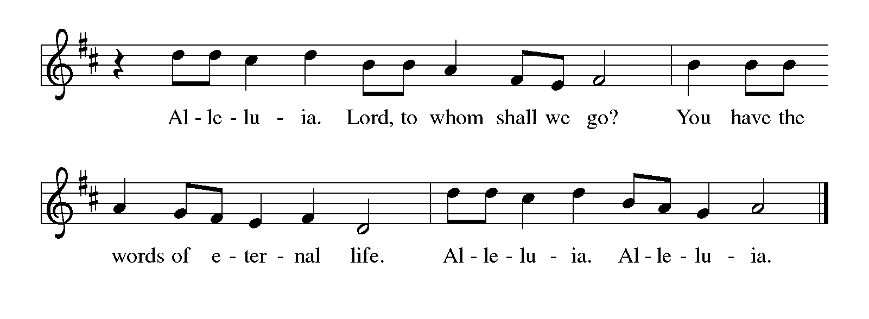
THE HOLY GOSPEL John 2:1-11

John’s Gospel describes Jesus’ first miracle as an epiphany, a “sign” that reveals God’s presence and power in and through Jesus.

P: The Holy Gospel according to St. John, the second chapter.

C: Glory to You, O Lord!

On the third day there was a wedding in Cana of Galilee, and the mother of Jesus was there. Jesus and His disciples had also been invited to the wedding. When the wine gave out, the mother of Jesus said to Him, “They have no wine.” And Jesus said to her, “Woman, what concern is that to you and to Me? My hour has not yet come.” His mother said to the servants, “Do whatever He tells you.”
Now standing there were six stone water jars for the Judean rites of purification, each holding twenty or thirty gallons. Jesus said to them, “Fill the jars with water.” And they filled them up to the brim. He said to them, “Now draw some out, and take it to the chief steward.” So they took it.
When the steward tasted the water that had become wine, and did not know where it came from (though the servants who had drawn the water knew), the steward called the bridegroom and said to him, “Everyone serves the good wine first, and then the inferior wine after the guests have become drunk. But you have kept the good wine until now.” Jesus did this, the first of His signs, in Cana of Galilee, and revealed His glory; and his disciples believed in Him.

P: The Gospel of the Lord.

C: Praise to You, O Christ!

The assembly is seated

THE SERMON
Silence for reflection follows the sermon

As you are able please rise

THE HYMN OF THE DAY 312 Jesus, Come! For We Invite You page 12

THE APOSTLES’ CREED

A: God has made us His people through our Baptism into Christ. Living together in trust
and hope we confess our faith.

C: I believe in God, the Father almighty,
creator of heaven and earth.
I believe in Jesus Christ, His only Son, our Lord.
He was conceived by the power of the Holy Spirit
and born of the virgin Mary.
He suffered under Pontius Pilate
was crucified, died, and was buried.
He descended into hell.
On the third day He rose again.
He ascended into heaven,
and is seated at the right hand of the Father.
He will come again to judge the living and the dead.

I believe in the Holy Spirit,
the holy catholic church,
the communion of saints,
the forgiveness of sins,
the resurrection of the body,
and the life everlasting. Amen.

THE PRAYER OF THE CHURCH

A: As God’s chosen and priestly people, let us pray for the people of the earth upon whom
the light of Christ shines with grace and mercy.

A: That the Church might be like a burning torch, bearing the light of Christ so all nations
might be drawn to You, we pray: O gracious Lord,

C: Hear our prayer.

A: That, weary of violence, countries ravaged by ethnic conflict, hatred, and warfare,
especially Syria, Afghanistan, Yemen, Congo, and Venezuela may find peace, begin to
rebuild their homes, lives, and communities, their spirit no longer desolate, we pray: O
gracious Lord,

C: Hear our prayer.

A: That we in this community may recognize and use the gifts we have received from the
Spirit for the common good of all we are called to serve, we pray: O gracious Lord,

C: Hear our prayer.

A: That the chronically ill, the despairing or lonely, the grieving, and the sick, especially:
. . . might find refuge in the shadow of your wings and there find peace and healing, we
pray: O gracious Lord,

C: Hear our prayer.

A: That with faithful heralds of the Gospel, especially Martin Luther King, Jr., renewer
of society, martyr, whom we commemorate this Day, we too may one day feast upon
the abundance of God’s house, we pray: O gracious Lord,

C: Hear our prayer.

P: Holy God, love of the human family and helper of all in need, hear the prayers we offer
in faith, and strengthen us in love. Cast the radiance of your mercy over the creation
you have made in the image of your Son, Jesus Christ our Lord

C: Amen.

MEAL

THE PEACE

P: The peace of the Lord be with you always.

C: And also with you.

The assembly is seated

THE VOLUNTARY Shines the Light St. Paul Senior Choir

As you are able please rise

THE OFFERTORY PRAYER

A: Let us pray. Living God,

C: In the abundance of Your mercy You give us physical and spiritual gifts. Receive
these offerings we bring with our praise and thanksgiving. Through this Meal,
activate in us the power of Your Spirit, that we may use Your gifts to live as signs
of Your glory and love. We ask this in the name of Jesus the Lord. Amen.

THE GREAT THANKSGIVING

P: The Lord be with you.

C: And also with you.

P: Lift up your hearts.

C: We lift them up to the Lord.

P: Let us give thanks to the Lord our God.

C: It is right to give Him thanks and praise.

P: Redeeming God, we cannot keep silent, because Your vindication of Your people
shines out like the dawn, and Your salvation is like a burning torch.
You renew the nature of creation by the grace of Your saving power.
Though Your children wander far from Your ways, You call us a crown of beauty and
a royal diadem in Your hand.
In the death of Your Son we showed You the depth of our estrangement; but in His
resurrection and ascension and coming of Your Spirit You showed us the
height and depth of Your love.
Gracious God, in Your Holy Spirit You empower us with gifts of wisdom and
knowledge and faith and healing and miracles and prophecy and revelation
and discernment.
Send that Spirit upon us now, that Your world may see Your divinity through our
humanity.
Sanctify this bread of humility and wine of joy that they may be for us the Body and
Blood of Your Son, Jesus Christ,
Who, in the night … “Do this for the remembrance of Me.”
As often as we eat … we proclaim the Lord’s death until He comes.

C: Christ has died. Christ is risen. Christ will come again.

P: God of justice and mercy, as at Cana the wine was good, bless Your whole creation.
As at Cana the wine ran short, be close to all who know their need of You.
As at Cana the wine ran out, assist those living in the midst of death, and dying in the
midst of life.
As at Cana You saved the best till last, flood this earth with the wine of Your
Kingdom, that justice may roll down like a river, and righteousness like a
never-failing stream,
Until we see You face to face, and recognize our diverse faces in the face of Your
Son,
Through Whom, and with Whom, and in Whom, in the unity of the Holy Spirit, all
honor and glory are Yours, Almighty Father, now and forever.

C: Amen!

THE LORD’S PRAYER

P: Because in Christ we have received the Spirit of adoption, as daughters and sons of
God, we dare to pray:
C: Our Father, Who art in heaven, hallowed be Thy Name. Thy Kingdom come, Thy
will be done on earth as it is in heaven. Give us this day our daily bread, and
forgive us our trespasses as we forgive those who trespass against us. And lead us
not into temptation but deliver us from evil. For Thine is the Kingdom, and the
power, and the glory, forever and ever. Amen.

INVITATION TO THE MEAL

P: Behold the true Light of the world, the Beloved of God, anointed by the Spirit. Blessed
are those who are called to the Supper of the Lamb. God’s holy gifts for God’s holy
people. Come, for all is now ready.

The assembly is seated

THE DISTRIBUTION

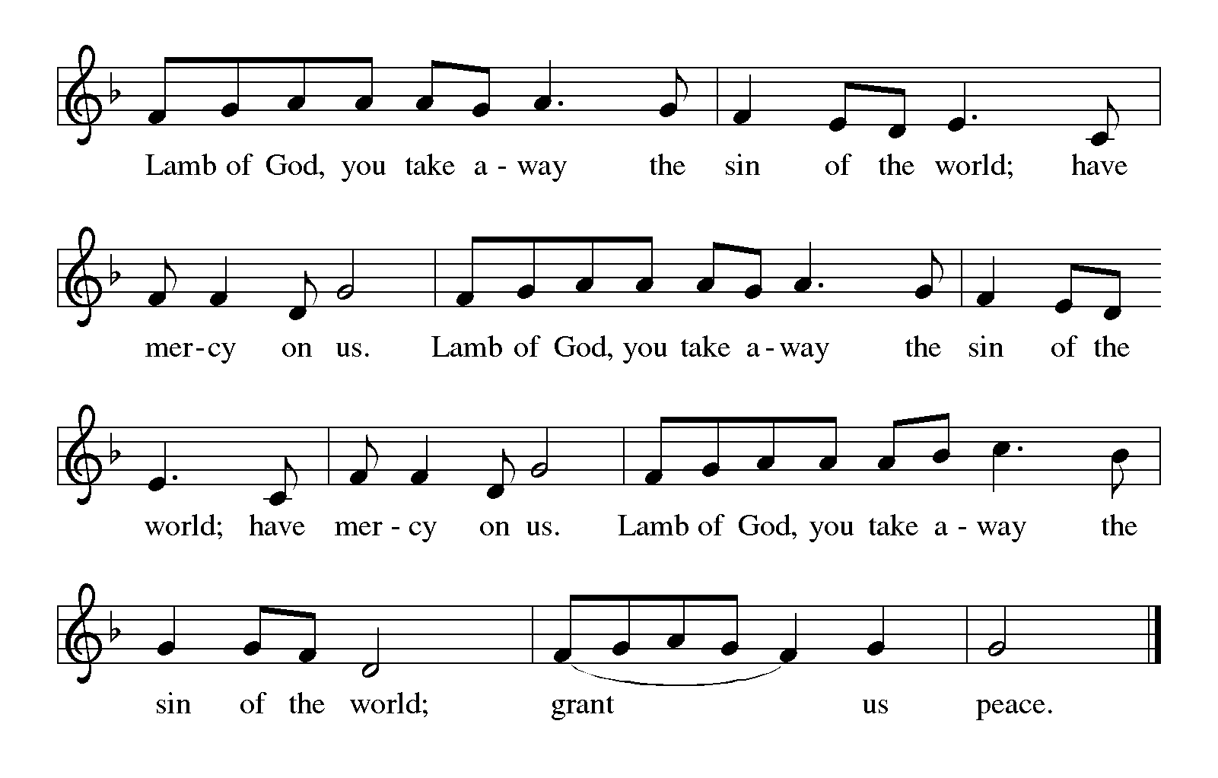
HYMN DURING DISTRIBUTION 487 What Feast of Love page 13
NSB 92-93 Trading My Sorrows page 14-15
NSB 104 You Are My Hiding Place page 16

As you are able please rise

THE POST COMMUNION BLESSING

P: The Body and Blood of our Lord Jesus Christ strengthen you and keep you in His
grace.

C: Amen.

THE POST-COMMUNION PRAYER

A: Let us pray. God of glory, You nourish us with Bread from heaven, Your Son, Jesus
Christ our Lord. Enliven in us the gifts of Your Holy Spirit, that through us Your light
may shine in all the world. Grant this through Christ our Lord.

C: Amen.
SENDING

THE BENEDICTION

P: Almighty God: Father, Son, and Holy Spirit bless you now and forever.

C: Amen.

SENDING HYMN 879 For the Beauty of the Earth page 17

THE DISMISSAL

A: You are servants of God; you are light to the nations.
Go in peace. Serve the Lord.

C: Thanks be to God!

POSTLUDE Stories of Jesus Jerry Westenkuehler

To God Alone Be Glory

The Meditation is from Sundays and Seasons. Copyright 1997 Augsburg Fortress.

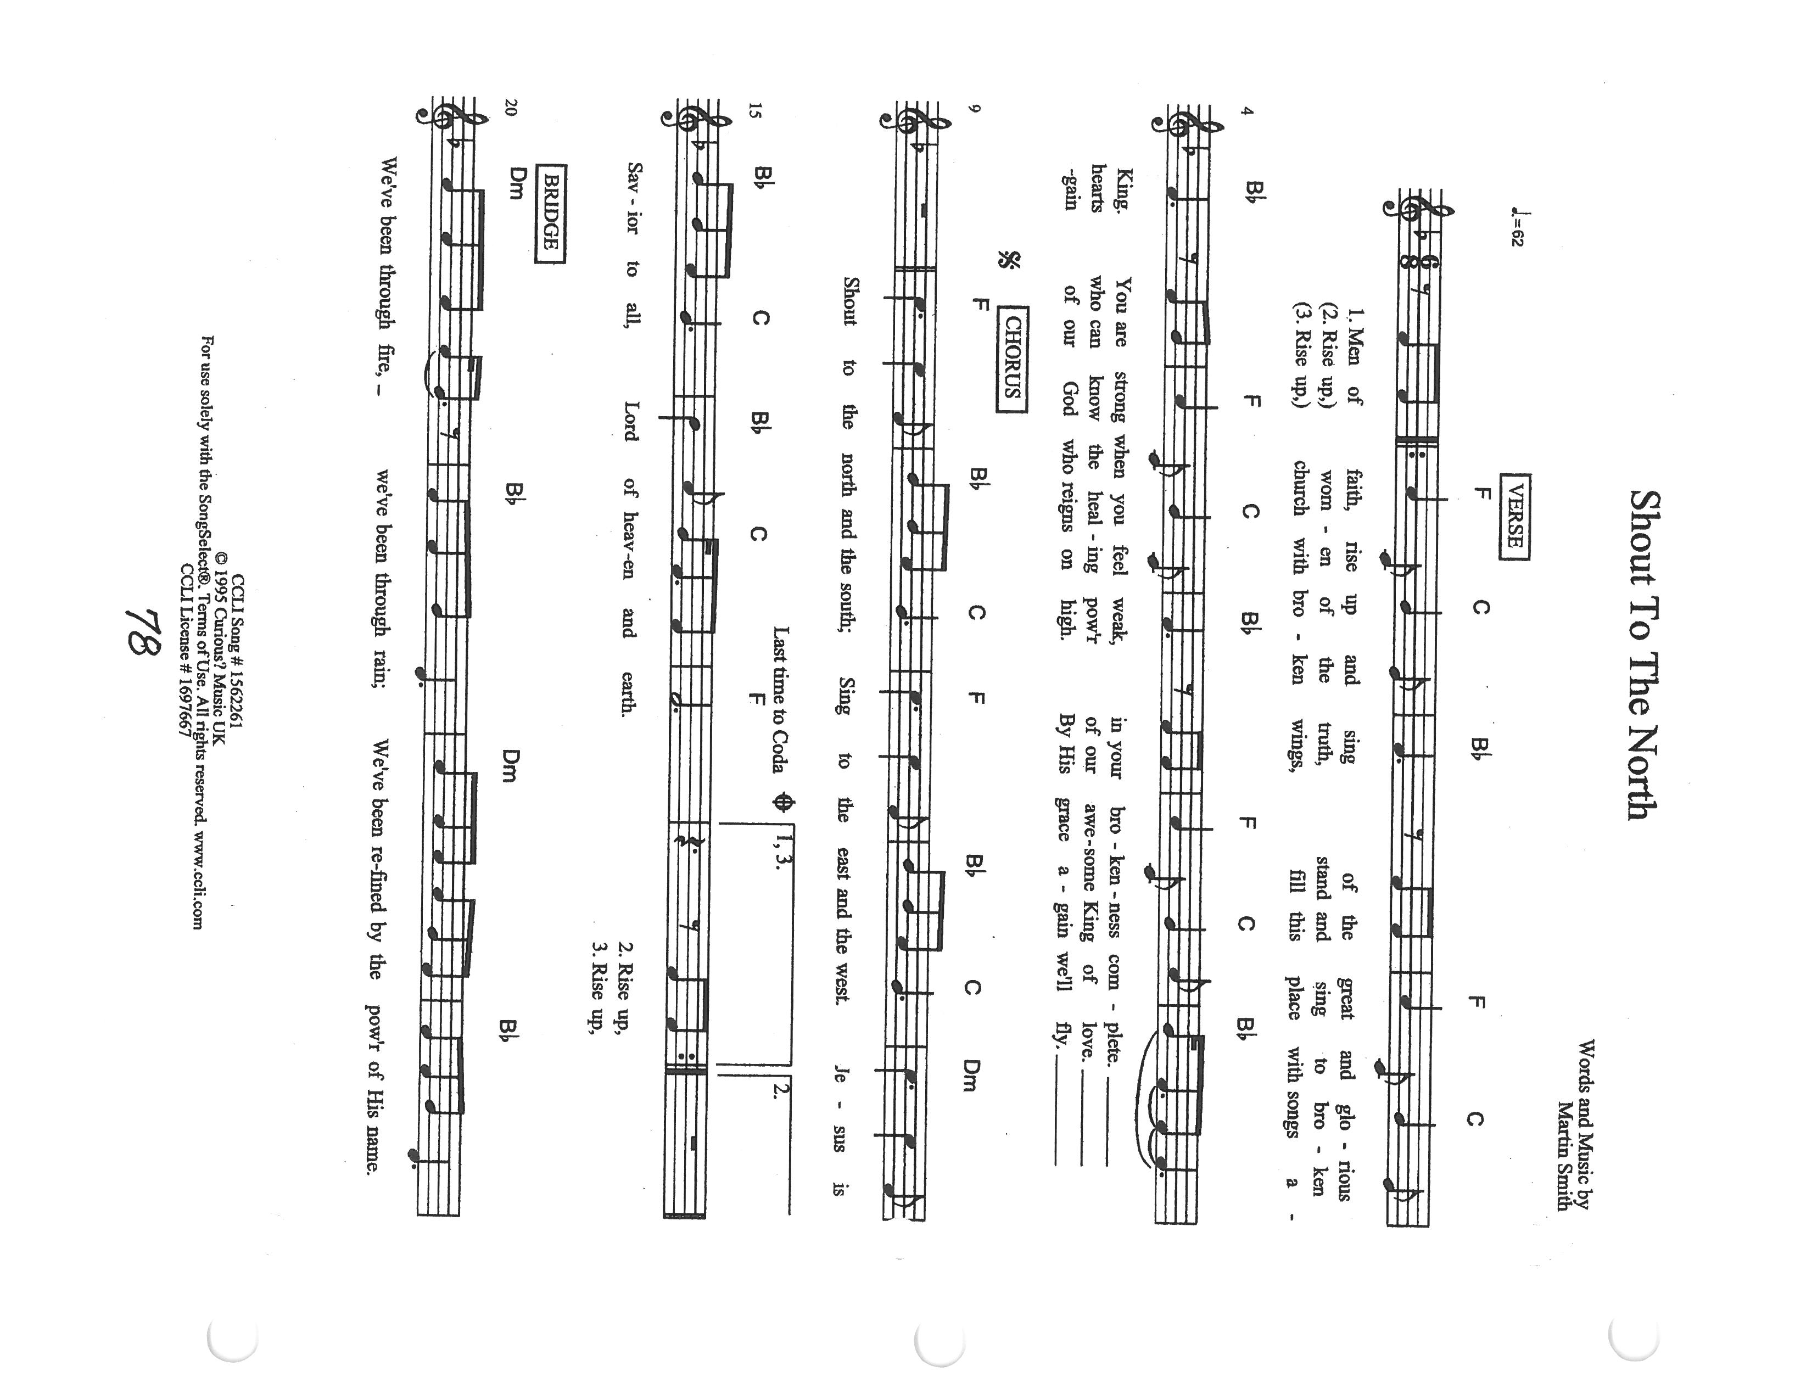
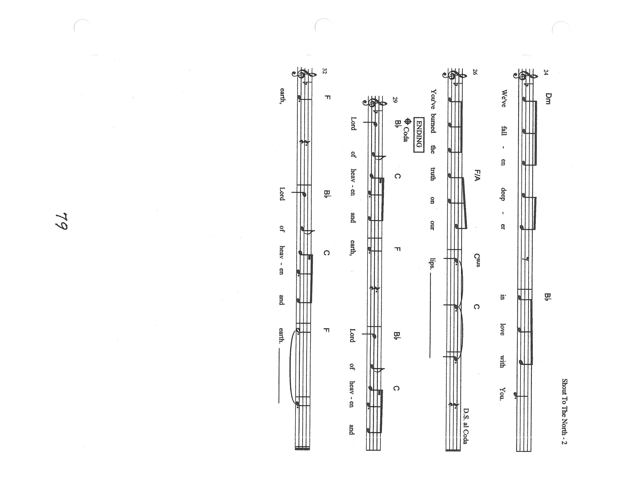
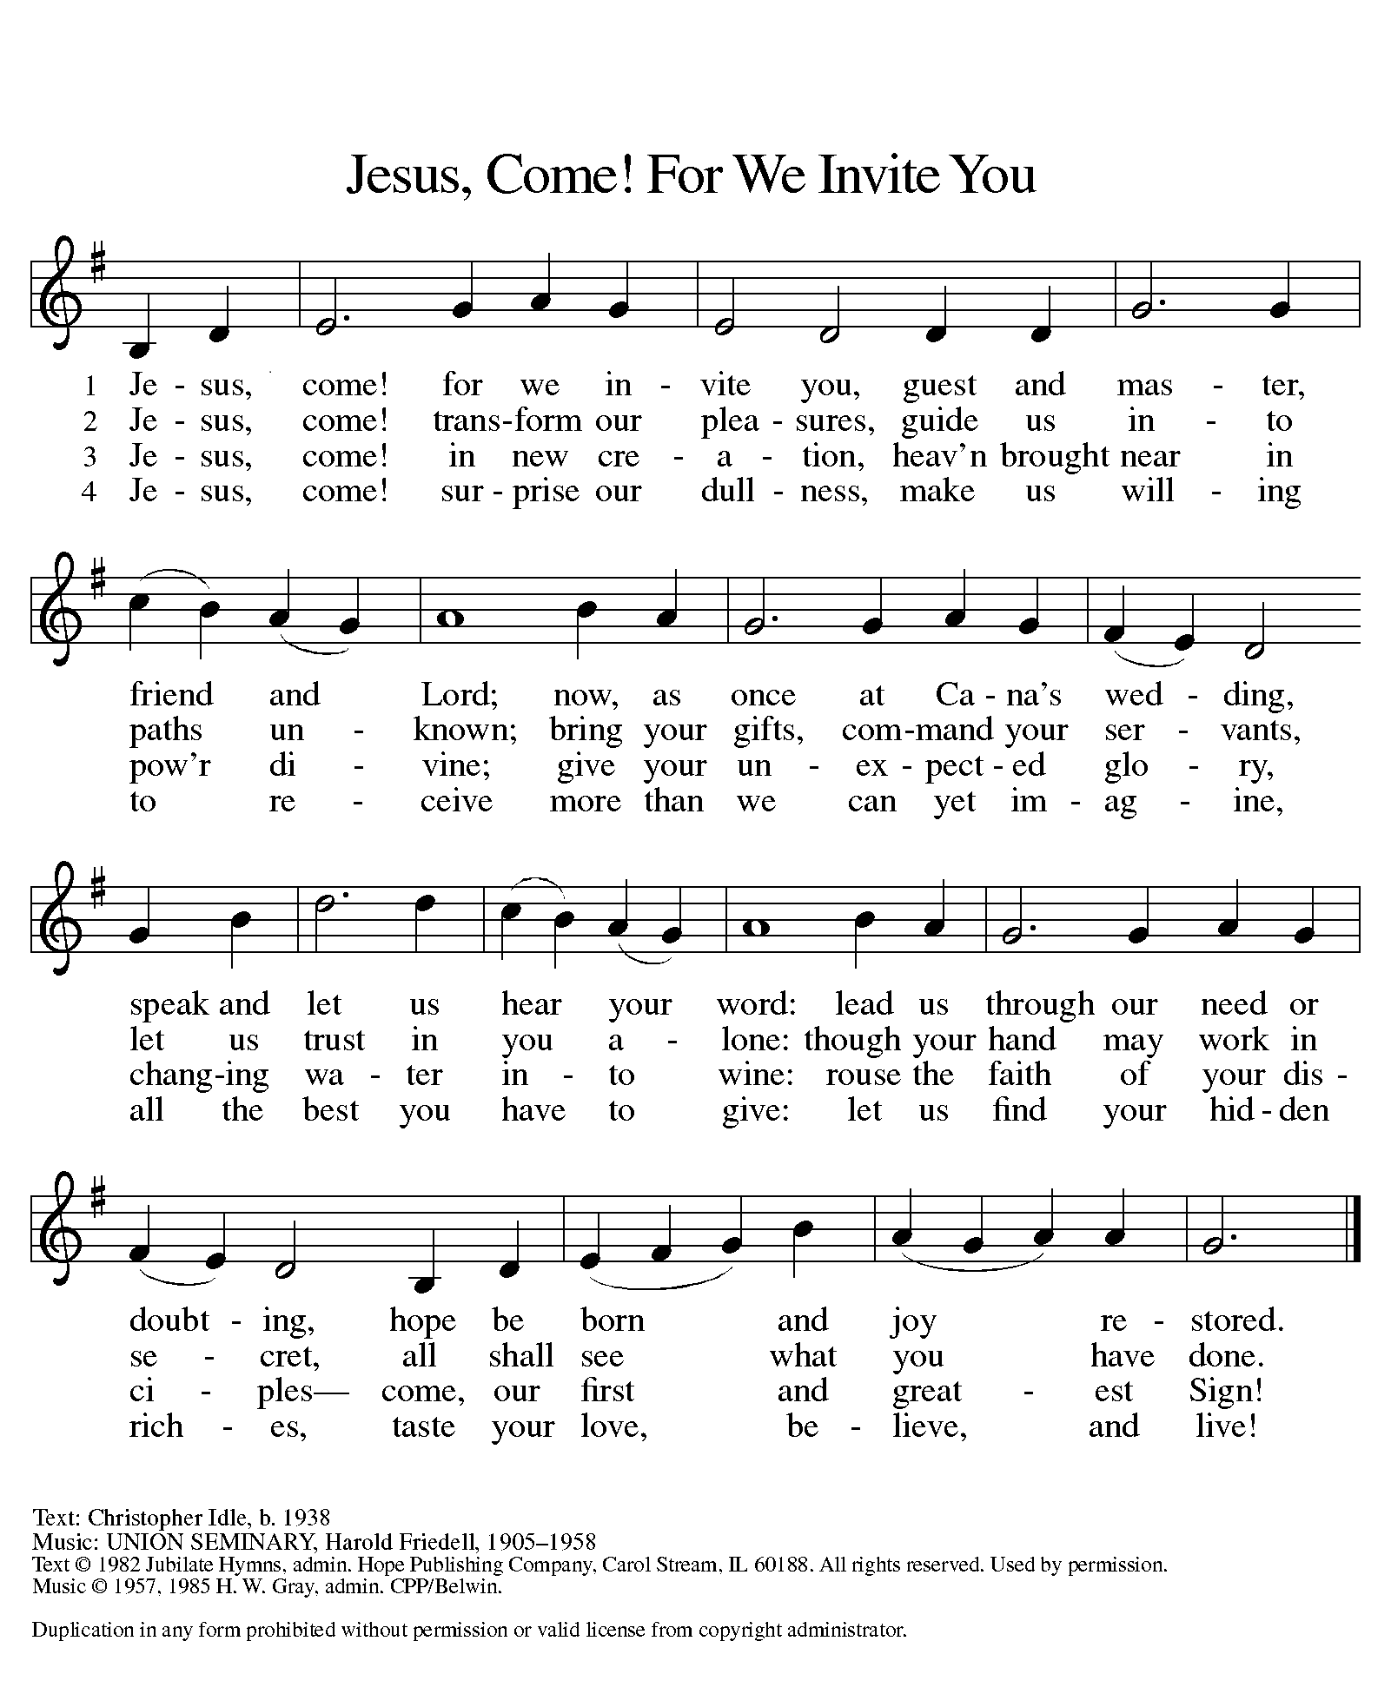

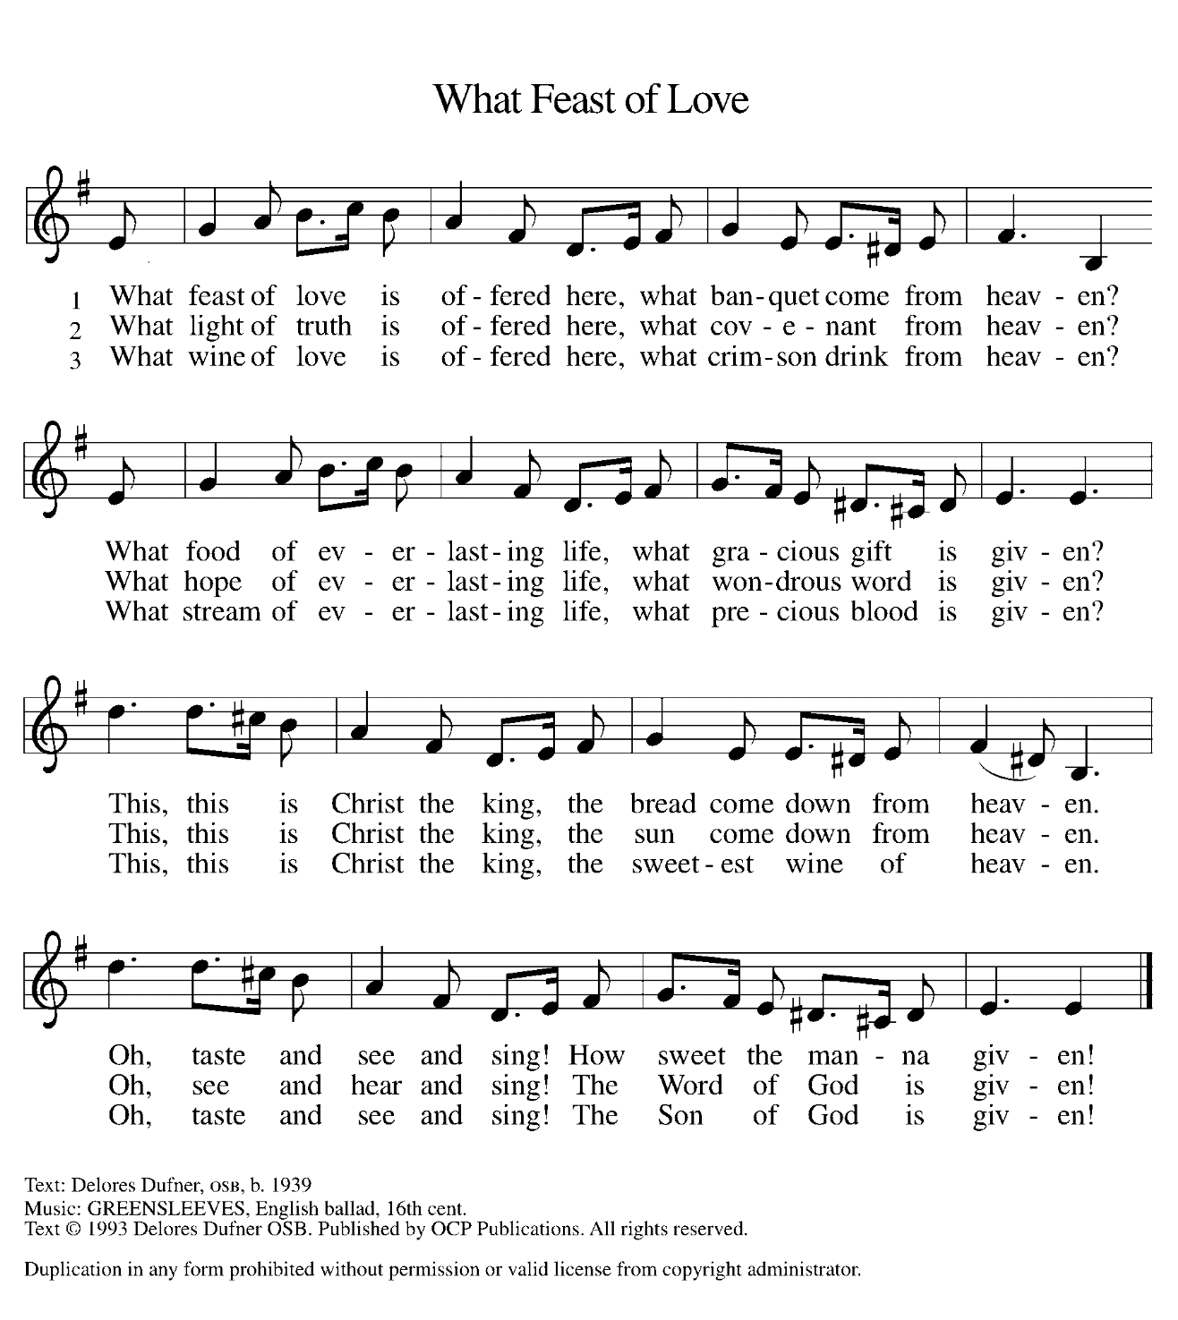

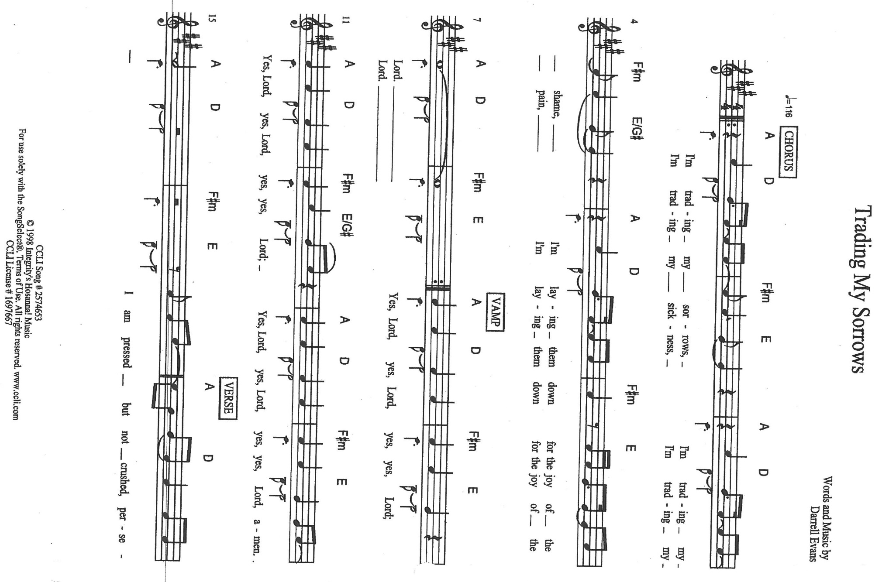
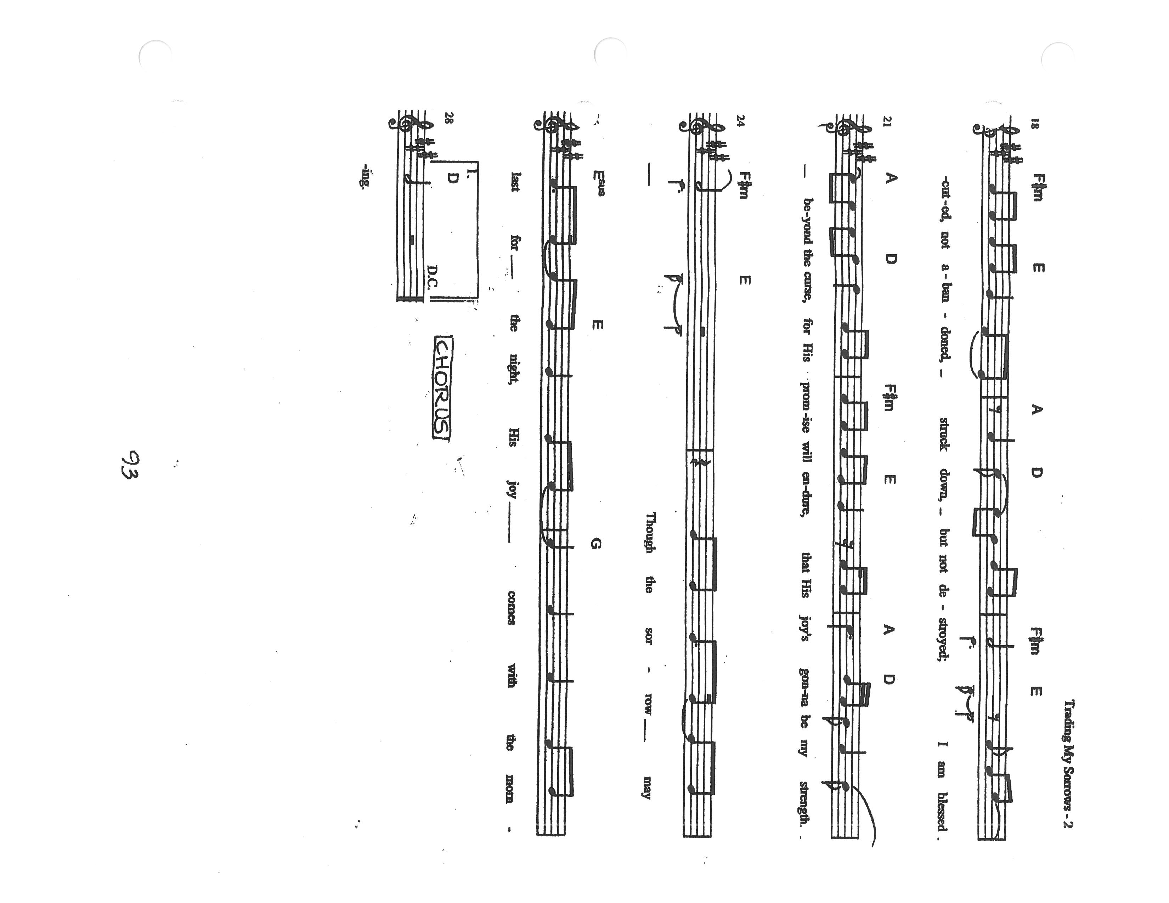
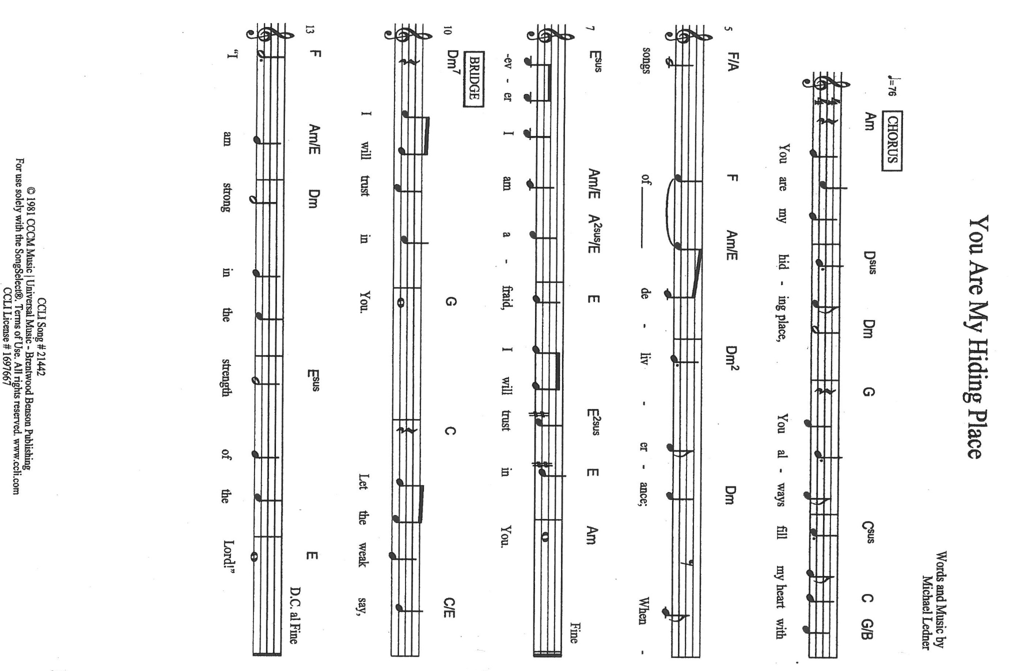
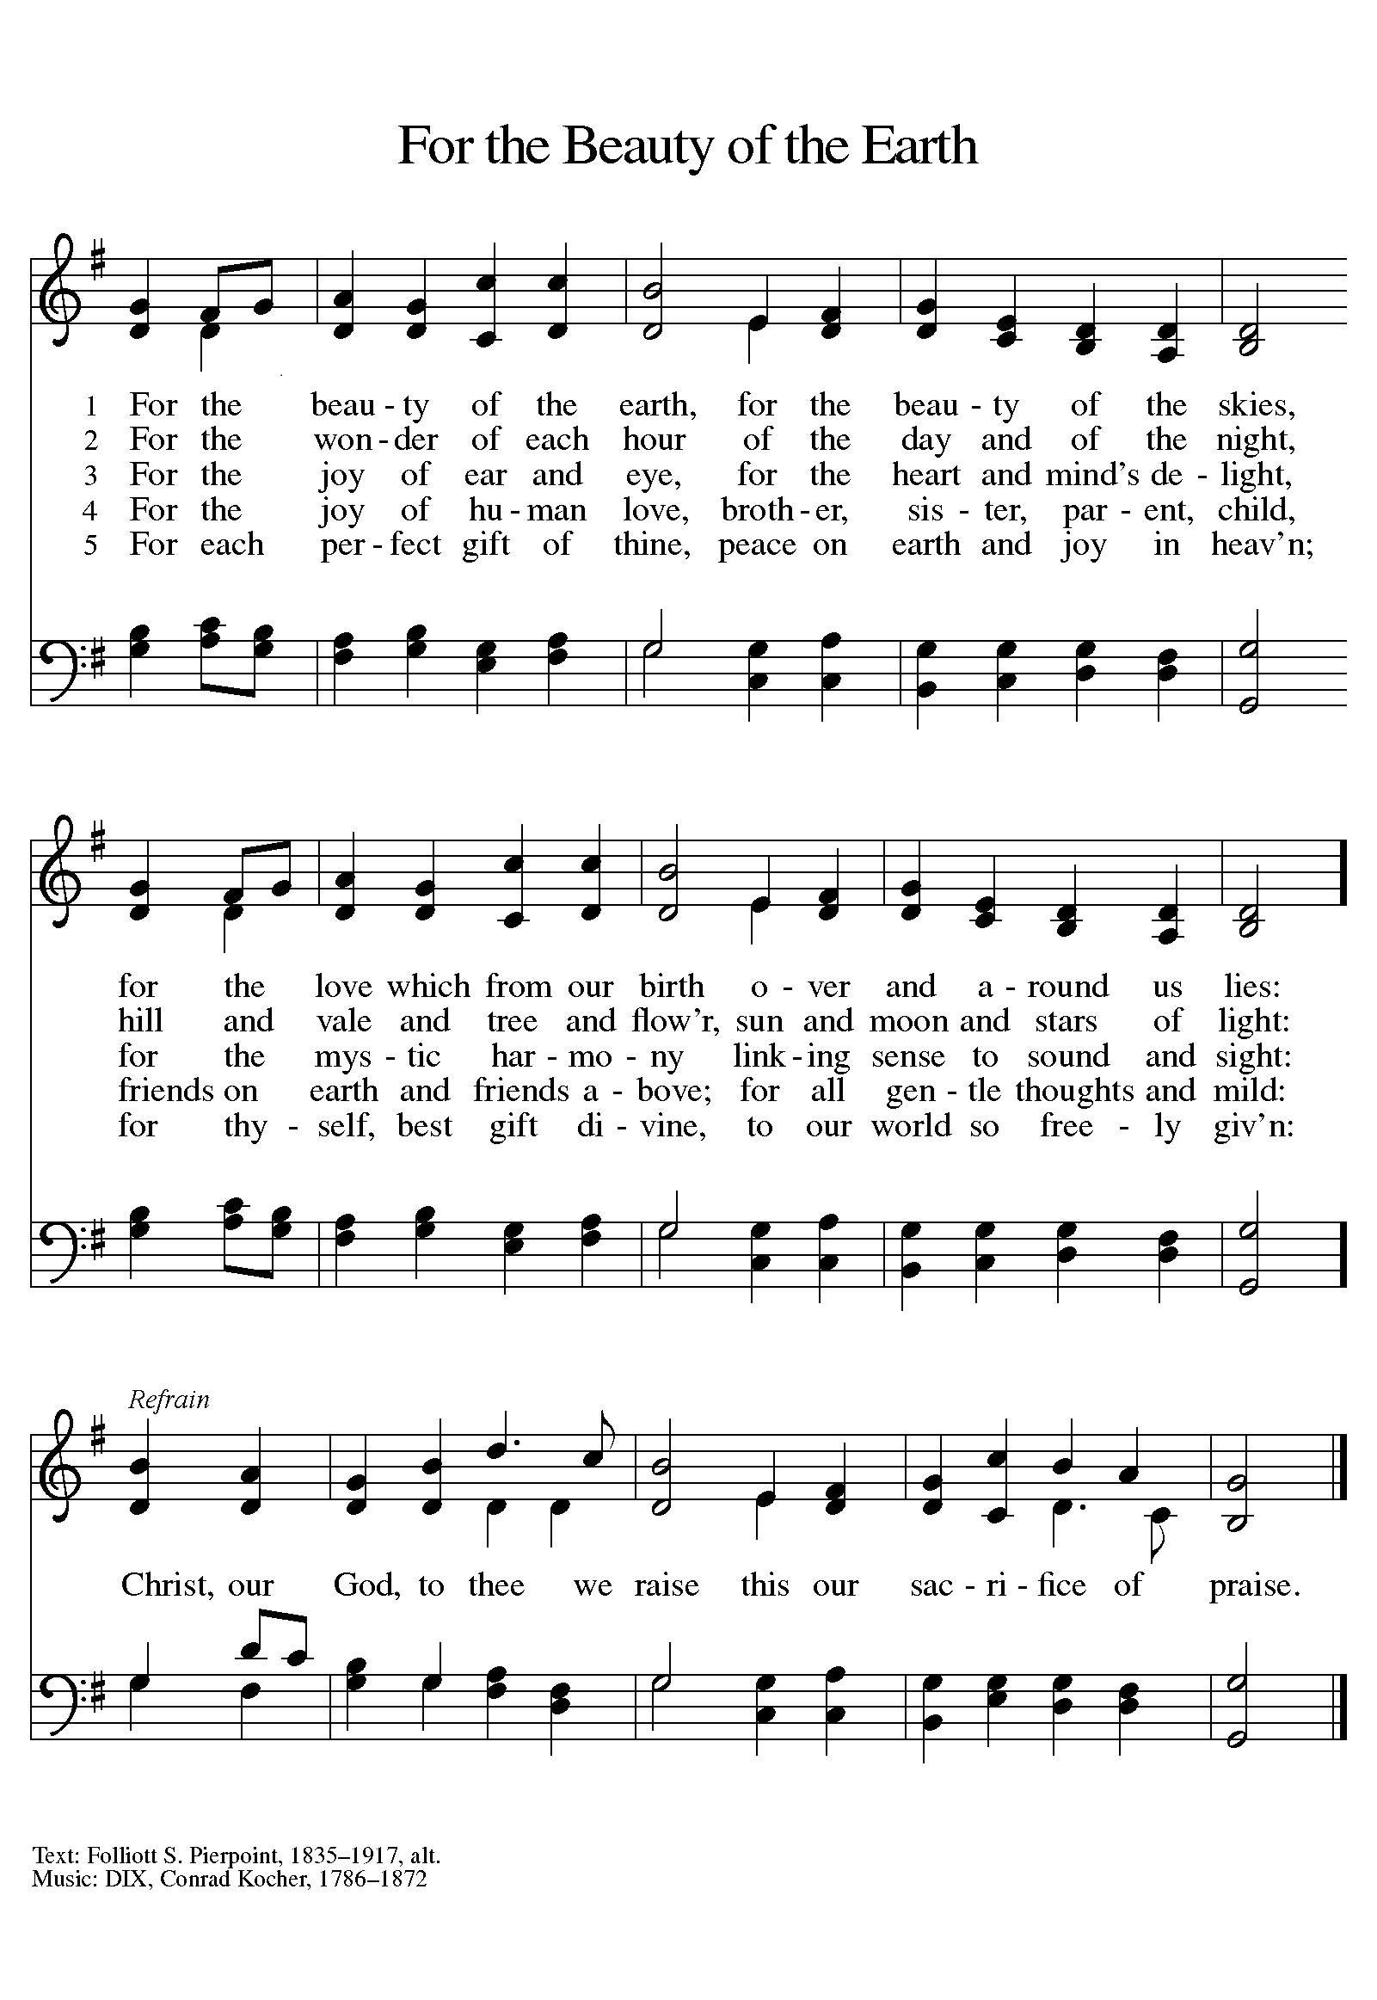

ANNOUNCEMENTS

Please remember to mail your offering to the Church Office at 818 Franklin Street, Michigan City, IN 46360. Another alternative is to give on-line through Tithe.ly. Please see your closure letter for information on how to set up a Tithe.ly account.

St. Paul Members are reminded to have a loved one contact the office if you are hospitalized. Many times, the Pastor doesn’t know someone is in the hospital. If you call and leave a message, please tell us which hospital the patient is at.

Next Sunday’s lessons are Nehemiah 8: 1-3, 5-6, 8-10; Psalm 19; I Corinthians 12: 12-31a; Luke 4: 14-21 for those of you who like to study them in advance.

PRAYER CONCERNS: Kathy Thielman, Audrey Beyer, Bethany Manning, Marla Furness, Ryan Krueger, Donna Bostater, Maxine Powell, Jess Kalvaitis, Jan Paholski, Laura Dovey, Heidi Happel, Shane Nevels, Joan Coughlin, Jim Tomscheck, Jary Tannehill, Ed Gustum, Ken Mulder, Ashton Steele, Christian Martinez, Nancy Wisser, Ryan Sirk, Carl Loetz, Patsy Humbers, Ed Riddle and Blythe Topa.

If you requested someone’s name to be on the prayer list and are aware that they need continued imminent prayer then contact the church office and let us know. Otherwise we will gradually transfer names to the long-term list.

OFFICE HOURS: Libby will be in the office on Mondays, Wednesdays, and Fridays; volunteers will cover Tuesdays and Thursdays.

Monday & Wednesday 8:00 a.m. – 5 p.m.
Tuesday & Thursday 9:00 a.m. – 12:00 p.m.
Friday 8:00 a.m. – 12:00 p.m.

If you are listening to the worship broadcast on the radio and would like to watch the Sunday morning service live stream follow these steps:

- If you have You.Tube available on your TV, search for
St. Paul Lutheran Church Michigan City, IN.

(2) The direct link on the computer is
https://www.youtube.com/channel/UC5AIPNaKr3QN50984jGOa1g.

(3) This link is also on the main page of the church’s website in the church section and will continue to be posted weekly on the St. Paul Facebook page.

And it will always be available on the radio broadcast Sunday mornings at 11:00 a.m. on WEFM (95.9), and on the local cable access station #99 for the previous week’s service on Sundays at 4:00 p.m. and the current service on Wednesdays at 7:00 p.m. and Fridays at 8:30 p.m.

To send e-mail to the church office, please use the following addresses:
Pastor Mark Reshan: seniorpastor@stpaulmichigancity.com
Church Office Secretary (Libby Pollock): churchsecretary@stpaulmichigancity.com
Church Treasurer (Karen Fleming) and Bookkeeper (Billie Atchinson):
finance@stpaulmichigancity.com.

The Good News Newsletter: If you have an article or anything you want included in The Good News please send it to the following e-mail address: splcgoodnews@gmail.com. Pastor Pamela Thiede will be using this e-mail address to assemble The Good News each month. The deadline for getting information to Pastor Pamela will be the 20th of each month.

WORSHIP ATTENDANCE for January 8 and 9, 2022
4:00 p.m. 21
9:00 a.m. 42
Total= 63

The Community Soup Kitchen serving out of First United Methodist is in need of volunteers. Sunday through Tuesday is always need, as is occasionally Wednesdays and Thursdays. Hours are 9:30 a.m. to 1:15 p.m. and it is not necessary to stay the entire time. There is also a need for volunteers to be available to help pick up deliveries from the Food Bank when they arrive. If you are able to help please contact their church office at 872-7200.

For information regarding worship closure due to inclement weather or COVID concerns please utilize one of these resources:

- If the decision is made early enough in the week to cancel worship an email will be sent to those on the church email list
- You may tune to WEFM 95.9 for an announcement during their broadcast
- The church and school Facebook page (St Paul Lutheran Church & School - Michigan City, IN | Facebook) will post an announcement
- You may dial the church office number (219-874-7293) and when the automated menu begins press the # button for a recorded announcement

Between these sources we hope to keep everyone informed as to the status of our worship services.

JANUARY MEETINGS AND ACTIVITIES

Worship Service: Saturday, January 15, 2022 at 4:00pm

Worship Service: Sunday, January 16, 2022 at 9:00am
Finance Committee Meeting: Monday, January 17, 2022 at 4:00pm/St. Paul Room
Executive Board Meeting: Monday, January 17, 2022at 5:30pm/Luther House
Wednesday Bible Study: January 19, 2022 at 9:45am/Luther House
God’s Purls: Wednesday, January 19, 2022 at 10:00am/St. Paul Room
Church Council Meeting: Thursday, January 20, 2022 at 5:30pm/St. Paul Room
Worship Service: Saturday, January 22, 2022 at 4:00pm

Worship Service: Sunday, Jauary 23, 2022 at 9:00am
Wednesday Bible Study: January 26, 2022 at 9:45am/Luther House
God’s Purls: Wednesday, January 26, 2022 at 10:00am/St. Paul Room
GIVE-BACK AT Galveston Steakhouse: Thursday, January 27, 2022 at 4pm—10pm
Worship Service: Saturday, January 29, 2022 at 4:00pm

Worship Service: Sunday, January 30, 2022 at 9:00am

2022 Financial Stewardship

Weekly Church Operating Needs (x 2 weeks): $14,116.36
January 1 and 2, 8 and 9, 2022
General Fund (including General Memorials): $ 7,953.20
Overage/Shortage: --$ 6,163.16

Restricted Income (not including Memorials)
Supports IK Synod & Churchwide Ministries: $ 283.00
Ministries in our Community/Congregation: ----
Capital Fund: $ 630.00

General Fund: $1,660.00

GIVE-BACK AT Galveston Steakhouse

We received $158.00 from our Give-Back night at Holly’s on December 14, 2021. Thanks to all who participated.
This month,we will see you at Galveston! We’re giving you two coupons so you can invite a friend and give them their own coupon. Remember, the coupon is required for the Give-Back bucks.

