**THE SECOND SUNDAY IN LENT**

**March 5, 2023**

**9:00 a.m.**

You can enter the kingdom of God only by being born anew. Nicodemus' question (How can anyone be born after having grown old? Can one enter a second time into the mother's womb?) shows a double misunderstanding. Like the Samaritan woman who asks for the never-failing water, he takes what Jesus is saying literally. But he also misunderstands by thinking that being born is something we can manage or achieve.

Nicodemus is a religious leader, a theologian, and he wants to know how to meet the requirements. Jesus is describing the "way in" as a process that is not susceptible to definition or control. A baby doesn't have control in the process of being born. And neither do we in an even more un-pin-downable event: we are to be born of the wind. Jesus uses a pun here, because "spirit" and "wind" are the same word in Greek. The wind/spirit blows wherever it wishes. You cannot tell where it comes from or where it is going. It eludes all our attempts to get a fix on it.

It is tempting for us to hear this story and think, We know what it means to be born from water and the Spirit, and we've done it. We are baptized. We have a lock on it. But here is a reality that won't be locked down, a new life we can't control. It is one of the reasons why we need to come back to our baptism continually, as we do especially in Lent, letting the rebirth happen to us in ways we can't control, with outcomes we can't predict. All we can be sure of is that this new, eternal life is a gift of God's love, a whirlwind that brings no destruction, but that rearranges the world in order to make it whole.

**Words for Worship**

Exult with joy in Christ. For now the saving warmth of the eternal font invites you. Now your mother adopts you to make you her child. Thanks to your faith, the wave of rebirth has already begotten you. Run, then, forward to the mother who experiences no pains of labor, although she cannot count the number of those to whom she gives birth. Happily you are going to drink the new milk together. Fly to the fountain, to the sweet womb of your mother.

**Zeno of Verona**

[Zeno of Verona, in *Baptism: Ancient Liturgies and Patristic Texts*, ed. A Hamman OFM (Staten Island, NY: Alba, 1967), 64-66.]

***✠******In the Name of Jesus ✠***

**INTRODUCTION**

During Lent we journey with all those around the world who will be baptized at the Easter Vigil. In today's gospel Jesus tells Nicodemus that he must be born of water and Spirit. At the font we are given a new birth as daughters and sons of God. As God made a covenant with Abraham, in baptism God promises to raise us up with Christ to new life. From worship we are sent forth to proclaim God's love for all the world.

**Perpetua and Felicity and companions, martyrs at Carthage, died 202**

*Vibia Perpetua was a noblewoman, and Felicity her slave, who were catechumens at Carthage, northern Africa. They, with four other catechumens, had defied the Roman emperor who had forbidden conversions to Christianity, and were put to death in the amphitheater.*

**✠ GATHERING ✠**

**PRELUDE *Come, Follow Me*  Max Reger**

**ANNOUNCEMENTS**

*As you are able please rise*

**CONFESSION AND ABSOLUTION**

P: In the name of the Father and of **✠** the Son and of the Holy Spirit.

**C: Amen.**

P: “God did not send the Son into the world to condemn the world, but in order that the

world might be saved through Him.” (John 3:17) In Lent we are called to return to the

Lord with all our heart, for God wishes us to be reconciled to Him and one another.

Therefore, let us confess our sins and seek the life and salvation God freely offers in

Christ.

*Silence for self-examination and reflection is kept*

P: Most merciful God,

**C: You sent Your Son, Jesus Christ to save the lost and offer eternal life to all who**

**believe in Him. (John 3:16) We confess that we have strayed from You and turned**

**aside from Your way. We have been afraid to risk going with You as You search**

**for the lost and those in darkness. You have called us to new ventures of faith but**

**we have chosen what is known and secure. (Genesis 12:1) On this forty-day**

**journey, cleanse us of our fear. Grant us the courage to follow into Your future**

**of life and blessing. Forgive us our sins, O God, that with Christ we too may reveal**

**Your suffering love and proclaim His death for the life of all the world.**

P: Almighty God have mercy on you, forgive you all your sins through our Lord Jesus

Christ, strengthen you in all goodness, and by the power of the Holy Spirit keep you in

everlasting life.

**C: Amen.**

**GATHERING HYMN 448 *This is the Spirit’s Entry Now***

**THE GREETING**

P: The grace of our Lord Jesus Christ, the love of God, and the communion of the Holy

Spirit be with you all.

**C: And also with you.**

**THE KYRIE**

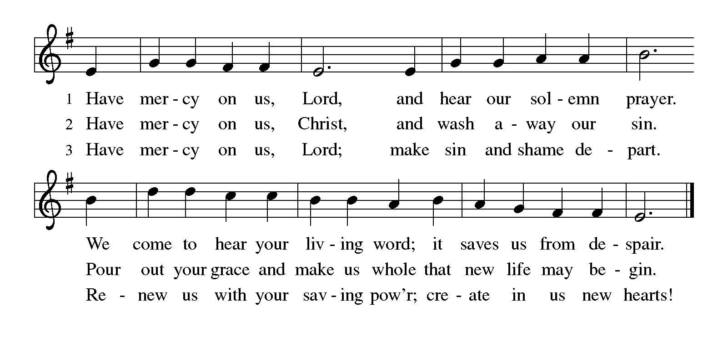

**THE PRAYER OF THE DAY**

P: The Lord be with you.

**C: And also with you.**

P: Let us pray. O God, our leader and guide, in the waters of Baptism You bring us to

new birth to live as Your children. Strengthen our faith in Your promises, that by

Your Spirit we may lift up Your life to all the world through Your Son, Jesus Christ,

our Savior and Lord, Who lives and reigns with You and the Holy Spirit, one God,

now and forever.

**C: Amen.**

*The assembly is seated*

**✠ WORD ✠**

**FIRST READING Genesis 12: 1-4**

*Genesis 1-11, often called the "primeval history," provides the background for today's reading. The repeated pattern of human rebellion and God's response ends with the Tower of Babel incident (11:1-9). In today's reading, God begins the relationship with humanity anew, starting with the person of Abram.*

The LORD said to Abram, "Go from your country and your kindred and your father's house to the land that I will show you. 2I will make of you a great nation, and I will bless you, and make your name great, so that you will be a blessing. 3I will bless those who bless you, and the one who curses you I will curse; and in you all the families of the earth shall be blessed."

4So Abram went, as the LORD had told him.

The Word of the Lord.

**Thanks be to God.**

**THE PSALM: Psalm 121** Antiphon by Mark Sheppherd

Choir sings refrain first, followed immediately by the congregation

and as indicated

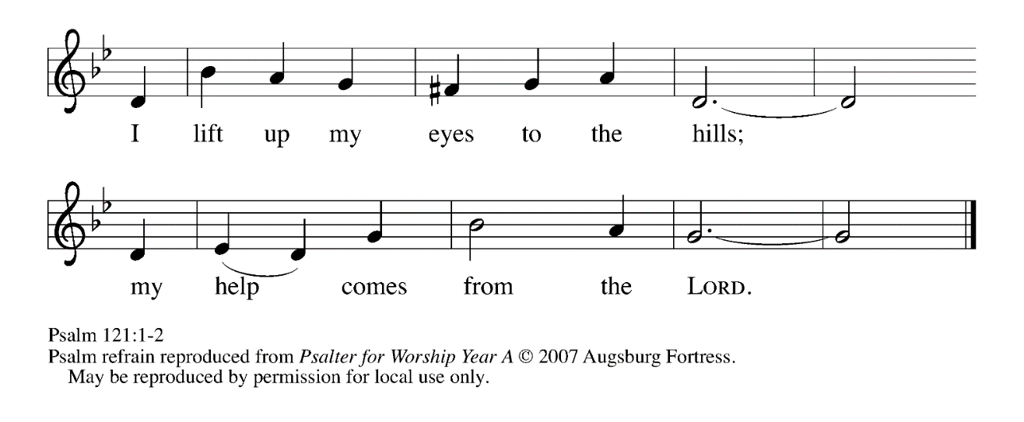

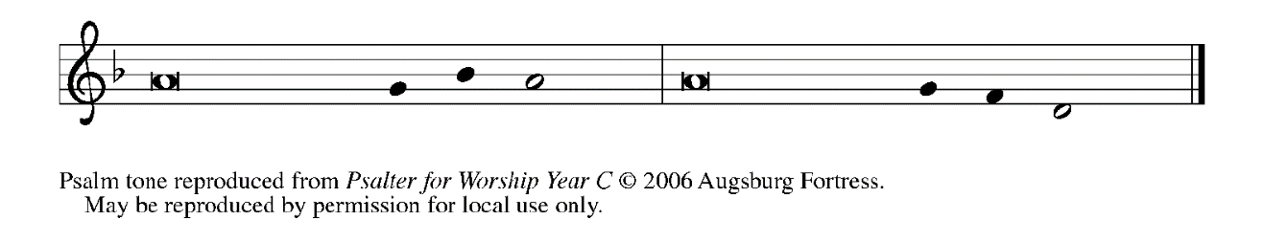

1I lift up my eyes | to the hills;

     from where is my | help to come?

**2My help comes | from the LORD,**

**the maker of heav- | en and earth.**

3The LORD will not let your | foot be moved

     nor will the One Who watches over you | fall asleep.

**4Behold, the keep- | er of Israel**

**will neither slum- | ber nor sleep;   REFRAIN**

5the LORD watches | over you;

     the LORD is your shade at | your right hand;

**6the sun will not strike | you by day,**

**nor the | moon by night.**

7The LORD will preserve you | from all evil

     and will | keep your life.

**8The LORD will watch over your going out and your | coming in,**

**from this time forth for- | evermore.   REFRAIN**

**SECOND READING Romans 4:1-5, 13-17**

*Paul has taught that Jews and Gentiles alike are made right with God through faith. Abraham and his trust in God’s promises made him “the father of many nations.”*

What are we to say was gained by Abraham, our ancestor according to the flesh? 2For if Abraham was justified by works, he has something to boast about, but not before God. 3For what does the scripture say? "Abraham believed God, and it was reckoned to him as righteousness." 4Now to one who works, wages are not reckoned as a gift but as something due. 5But to one who without works trusts Him Who justifies the ungodly, such faith is reckoned as righteousness.

13For the promise that he would inherit the world did not come to Abraham or to his descendants through the law but through the righteousness of faith. 14If it is the adherents of the law who are to be the heirs, faith is null and the promise is void. 15For the law brings wrath; but where there is no law, neither is there violation.

16For this reason it depends on faith, in order that the promise may rest on grace and be guaranteed to all his descendants, not only to the adherents of the law but also to those who share the faith of Abraham (for he is the father of all of us, 17as it is written, "I have made you the father of many nations")--in the presence of the God in Whom he believed, Who gives life to the dead and calls into existence the things that do not exist.

The Word of the Lord.

**Thanks be to God.**

*As you are able please rise*

**THE VERSE**

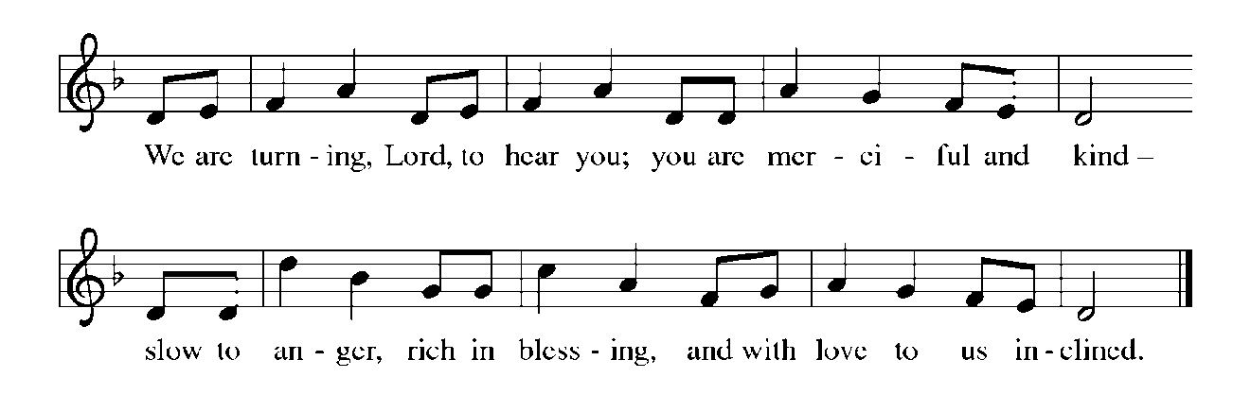

**THE HOLY GOSPEL John 3:1-17**

*Nicodemus learns from Jesus that the Father’s love He brings for the world is received as a gift through water and the Spirit.*

P: The Holy Gospel according to St. John, the third chapter.

**C: Glory to You, O Lord!**

Now there was a Pharisee named Nicodemus, a leader of the Judeans. 2He came to Jesus by night and said to Him, "Rabbi, we know that You are a teacher Who has come from God; for no one can do these signs that You do apart from the presence of God."

3Jesus answered him, "Very truly, I tell you, no one can see the kingdom of God without being born from above." 4Nicodemus said to Him, "How can anyone be born after having grown old? Can one enter a second time into the mother's womb and be born?" 5Jesus answered, "Very truly, I tell you, no one can enter the kingdom of God without being born of water and Spirit.

6What is born of the flesh is flesh, and what is born of the Spirit is spirit. 7Do not be astonished that I said to you, 'You must be born from above.' 8The wind blows where it chooses, and you hear the sound of it, but you do not know where it comes from or where it goes. So it is with everyone who is born of the Spirit." 9Nicodemus said to him, "How can these things be?" 10Jesus answered him, "Are you a teacher of Israel, and yet you do not understand these things?

11"Very truly, I tell you, we speak of what we know and testify to what we have seen; yet you do not receive our testimony. 12If I have told you about earthly things and you do not believe, how can you believe if I tell you about heavenly things?

13No one has ascended into heaven except the One Who descended from heaven, the Son of Man. 14And just as Moses lifted up the serpent in the wilderness, so must the Son of Man be lifted up, 15that whoever believes in Him may have eternal life.

16"For God so loved the world that He gave His only Son, so that everyone who believes in Him may not perish but may have eternal life.

17"Indeed, God did not send the Son into the world to condemn the world, but in order that the world might be saved through Him."

P: The Gospel of the Lord.

**C: Praise to You, O Christ!**

*The assembly is seated*

**THE SERMON**

*Silence for reflection follows the sermon*

*As you are able please rise*

**THE HYMN OF THE DAY 323 *God Loved the World***

**THE NICENE CREED**

A: God has made us His people through our Baptism into Christ. Living together in trust

and hope, we confess our faith.

**We believe in one God,**

**the Father, the Almighty,**

**maker of heaven and earth,**

**of all that is, seen and unseen.**

**We believe in one Lord, Jesus Christ,**

**the only Son of God,**

**eternally begotten of the Father,**

**God from God, Light from Light,**

**true God from true God,**

**begotten, not made,**

**of one Being with the Father.**

**Through Him all things were made.**

**For us and for our salvation**

**He came down from heaven;**

**by the power of the Holy Spirit**

**He became incarnate from the virgin Mary, and was made man.**

**For our sake He was crucified under Pontius Pilate;**

**He suffered death and was buried.**

**On the third day He rose again**

**in accordance with the Scriptures;**

**He ascended into heaven**

**and is seated at the right hand of the Father.**

**He will come again in glory to judge the living and the dead,**

**and His kingdom will have no end.**

**We believe in the Holy Spirit, the Lord, the giver of life,**

**Who proceeds from the Father and the Son.**

**With the Father and the Son He is worshiped and glorified.**

**He has spoken through the prophets.**

**We believe in one holy catholic and apostolic Church.**

**We acknowledge one Baptism for the forgiveness of sins.**

**We look for the resurrection of the dead,**

**and the life of the world to come. Amen.**

**THE PRAYER OF THE CHURCH**

A: Let us ask God to bless all families of the earth in the name of Jesus, the Beloved Son

in Whom God is well pleased.

A: That all who lead and teach in the Church would guide God’s people ever more fully

into Christ’s way of forgiveness, reconciliation, and peace, let us pray to the Lord:

**C: Lord, have mercy.**

A: That in Peru, Brazil, Ukraine and other places of turmoil there might be an end to

violence and the Spirit’s gift of peace and stability, let us pray to the Lord:

**C: Lord, have mercy.**

A: That those seeking Baptism might receive the blessings of God, let us pray to the Lord:

**C: Lord, have mercy.**

A: That this congregation might follow in faithful service wherever the Spirit leads, let us

pray to the Lord:

**C: Lord, have mercy.**

A: That the hungry, the homeless, the unemployed, and the sick, especially . . . might find

help and healing from the Lord, let us pray to the Lord:

**C: Lord, have mercy.**

A: That those celebrating birthdays, especially **Gail Leffew** might grow in grace this day

and every day and be filled with grace for the days ahead, let us pray to the Lord:

**C: Lord, have mercy.**

A: That with all the saints, especially **Perpetua and Felicity and companions, martyrs,**

whom we commemorate this Day we may enter God’s eternal life, let us pray to the

Lord:

**C: Lord, have mercy.**

P: God of Abraham and Sarah, we give You thanks for the signs of Your radiant presence

in the faith of our forebears. Transfigure us by the gift of faith for our life’s journey,

until we behold Your glorious beauty face to face, through Jesus Christ our Lord.

**C: Amen.**

**✠ MEAL ✠**

**THE PEACE**

P: The peace of the Lord be with you always.

**C: And also with you.**

*The assembly is seated*

**THE OFFERING**

**THE VOLUNTARY *In This Very Room*  Ron & Carol Harris**

*As you are able please rise*

**THE OFFERTORY**

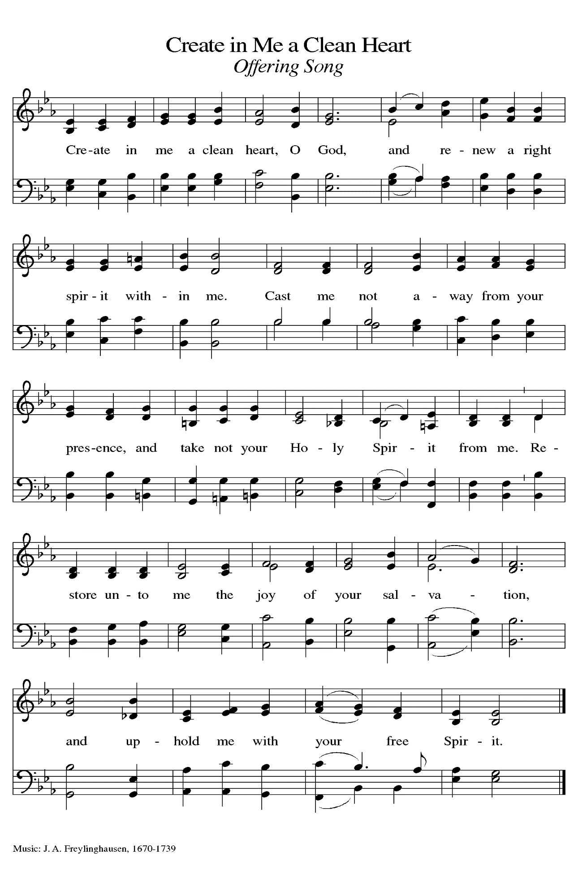

**THE OFFERTORY PRAYER**

A: Let us pray. God of mercy,

**C: As Jesus was lifted up on the cross for our salvation, so we lift these gifts before**

**You with joy and thanksgiving. By our eating and drinking of this holy**

**Sacrament, draw us up into Your eternal life. We ask this in the name of Jesus**

**the Lord. Amen.**

**THE GREAT THANKSGIVING**

P: The Lord be with you.

**C: And also with you.**

P: Lift up your hearts.

**C: We lift them up to the Lord.**

P: Let us give thanks to the Lord our God.

**C: It is right to give Him thanks and praise.**

P: It is indeed right, our duty, and our joy … join their unending hymn:

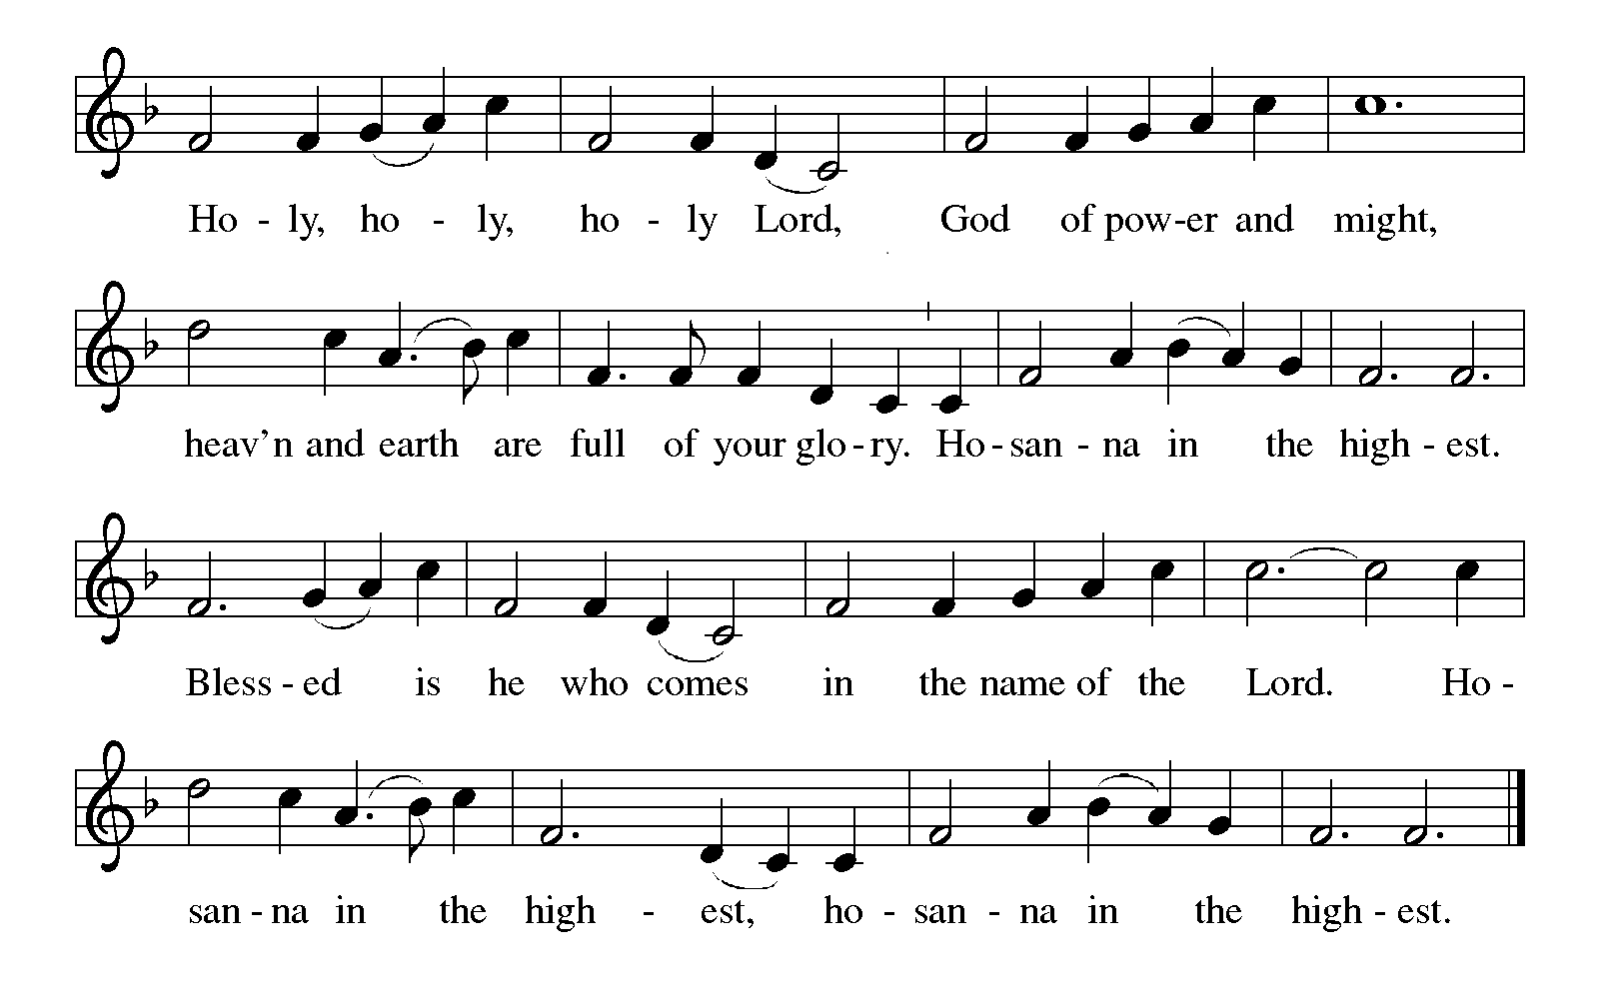

P: Blessings and thanks belong to You, promising God.

You make the sands of the desert and the stars of the sky, and in Abraham and Sarah

You called a people to be a great nation in whom all families of the earth

would find a blessing.

In Jesus You raised up a new Abraham to be a blessing to all the people.

In His death and resurrection, sin died and eternal life was born.

Faithful God, in Jesus You fulfilled all righteousness.

In Him You turn our duty into joy, and our sorrow into dancing.

You give us new birth through water and the Spirit.

Send down Your Holy Spirit now, that Your people may become a blessing to You and

all the world, and that the bread of sustenance and the wine of celebration may

become for us the Body and Blood of Your Son, Jesus Christ,

Who, in the night … “Do this for the remembrance of Me.”

As often as we eat … we proclaim the Lord’s death until He comes.

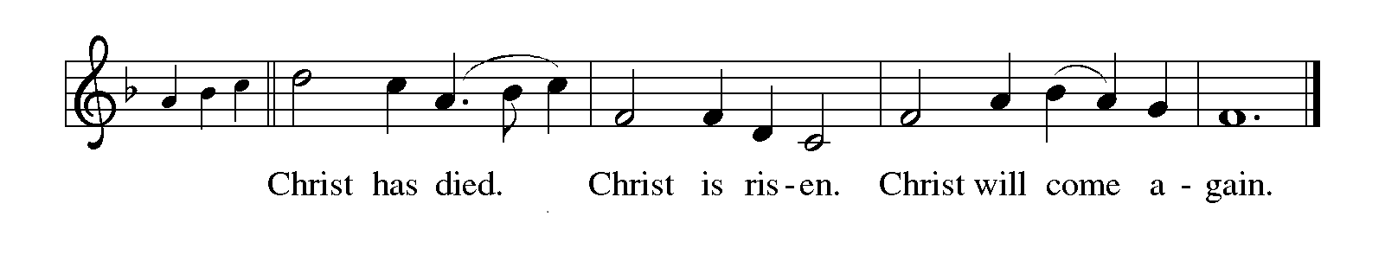

P: Generous God, You loved the world so much that You gave Your only Son; look now

upon the places where Your people are perishing, where they are being

condemned, where they are being born under the shadow of disease and

destruction and despair.

Infuse Your Church with Spirit and truth, walk with Your beloved ancestors of

Abraham and Sarah as they seek security, companionship, and freedom in

Your world,

And fill all Your saints with the hope of eternal life, that all may come to praise Your

name, and every grain of sand and star in the sky be stirred with the wonders

of Your grace,

Ever one God: Father, **✠** Son, and Holy Spirit, now and forever.

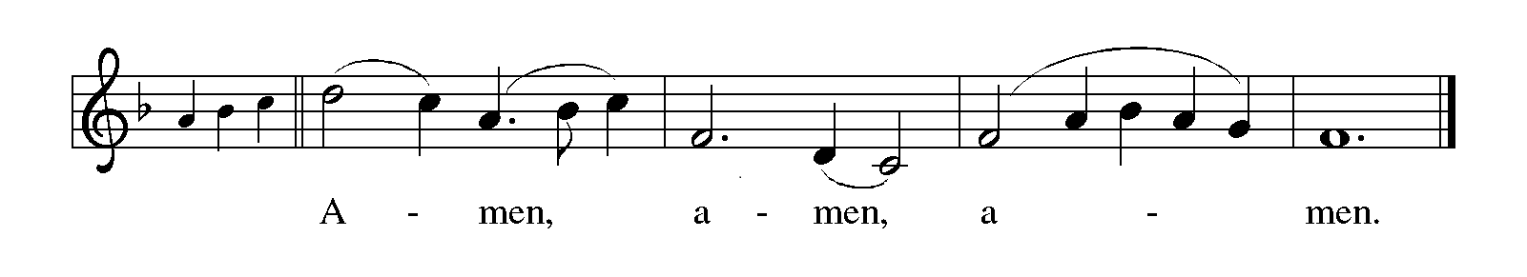

**THE LORD’S PRAYER**

P: While we were still sinners, Christ died for us, that, with confidence in God’s love for

us, we might dare to pray:

**C: Our Father, Who art in heaven, hallowed be Thy Name. Thy Kingdom come, Thy**

**will be done on earth as it is in heaven. Give us this day our daily bread, and**

**forgive us our trespasses as we forgive those who trespass against us. And lead us**

**not into temptation but deliver us from evil. For Thine is the Kingdom, and the**

**power, and the glory, forever and ever. Amen.**

**INVITATION TO THE MEAL**

P: Behold our Savior Christ Jesus, Who abolished death and brought life through the

Gospel. Blessed are those called to the Banquet of the Lamb. God’s holy gifts for

God’s holy people. Come, for all is now ready.

*The assembly is seated*

**THE DISTRIBUTION**

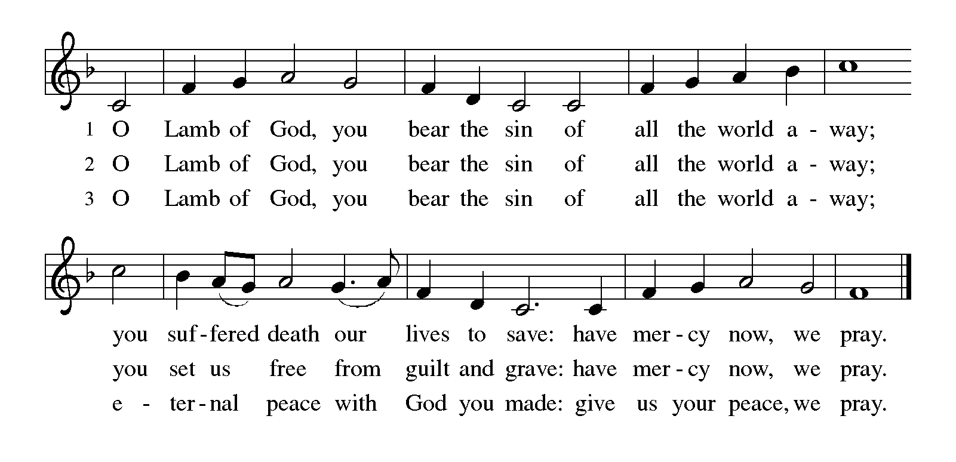

**HYMN DURING DISTRIBUTION 796 *How Firm a Foundation***

**759 *My Faith Looks Up to Thee***

*As you are able please rise*

**THE POST-COMMUNION BLESSING**

P: The Body and Blood of our Lord Jesus Christ strengthen you and keep you in His grace.

**C: Amen.**

**THE POST-COMMUNION PRAYER**

A: Let us pray. Lord Jesus, in this Meal we have again seen You lifted up in all Your life-

giving glory. Grant us a share of Your eternal life now, that with hope and joy we may

journey with You both now and into the life to come. You are the Lord forevermore.

**C: Amen.**

**✠ SENDING ✠**

**THE BENEDICTION**

P: Jesus took the form of a servant and was obedient to death, even death on a cross. May

you follow His example and share in the resurrection.

**C: Amen.**

P: Almighty God: Father, Son, ✠ and Holy Spirit bless you now and forever.

**C: Amen.**

**SENDING HYMN 660 *Lift High the Cross***

**THE DISMISSAL**

A: Reconciled to God through Christ, let us go out into the world in peace.

**C: Thanks be to God!**

**POSTLUDE *Rejoice in the Lord*  Mansfield**

***✠ To God Alone Be Glory ✠***

The Meditation is from *Words for Worship.* Copyright 1999 Augsburg Fortress.

The Greeting, Prayers, Peace, Offertory, Post-Communion, and Dismissal are adapted

from *Sundays and Seasons.* Copyright 2001 Augsburg Fortress.

The Prayers, Introduction to the Lord’s Prayer, and Invitation to the Meal are adapted from

*Prayers for Sundays and Seasons. Year A.* Peter J. Scagnelli. (Chicago: Liturgy

Training Publications, 1998) 32-33.

The Eucharistic Prayer is adapted from *Eucharistic Prayers.* Samuel Wells and Abigail

Kocher. (Grand Rapids: Eerdmann’s Publishing Company, 2016) 126-27.

**ANNOUNCEMENTS**

**Please remember to mail your offering to the Church Office** at 818 Franklin Street, Michigan City, IN 46360**.** Another alternative is to give on-line through Tithe.ly. Please see your closure letter for information on how to set up a Tithe.ly account.

**St. Paul Members are reminded to have** a loved one contact the office if you are

hospitalized. Many times, the Pastor doesn’t know someone is in the hospital. If you call and leave a message, please tell us which hospital the patient is at.

**Next Saturday’s lessons are: Exodus 17: 1-7; Psalm 95; Romans 5: 1-11; and John 4: 5-42** for those of you who like to study them in advance.

**Birthdays: Gail Leffew (3/06)**

**PRAYER CONCERNS:** Audrey Beyer, Donna Bostater, Maxine Powell, Jim Tomscheck, Eloise Ponder, Mark & Jary Tannehill, Leonard Cross, Margie Torres, Jayla Jacobi and Barbara Reichert.

**OFFICE HOURS:** Libby will be in the office on Mondays, Wednesdays, and Fridays; volunteers will cover Tuesdays and Thursdays.

Monday & Wednesday 8:00 a.m. – 5 p.m.

Tuesday & Thursday 9:00 a.m. – 12:00 p.m.

Friday 8:00 a.m. – 12:00 p.m.

**If you are listening to the worship broadcast on the radio and would like to watch the Sunday morning service live stream follow these steps:**

(1) If you have You.Tube available on your TV, search for

**St. Paul Lutheran Church Michigan City, IN.**

(2) The direct link on the computer is

https://www.youtube.com/channel/UC5AIPNaKr3QN50984jGOa1g.

(3) This link is also on the main page of the church’s website in the church sec-

tion and will continue to be posted weekly on the St. Paul Facebook page.

And it will always be available on the radio broadcast Sunday mornings at 11:00 a.m. on WEFM (95.9), and on the local cable access station #99 for the previous week’s service on Sundays at 4:00 p.m. and the current service on Wednesdays at 7:00 p.m. and Fridays at 8:30 p.m.

**To send e-mail to the church office**, please use the following addresses:

Pastor Mark Reshan: seniorpastor@stpaulmichigancity.com

Church Office Secretary (Libby Pollock): churchsecretary@stpaulmichigancity.com

Church Treasurer (Karen Fleming): finance@stpaulmichigancity.com

**The Good News Newsletter**: If you have an article or anything you want included in **The Good News** please send it to the following e-mail address: splcgoodnews@gmail.com. Pastor Pamela Thiede will be using this e-mail address to assemble **The Good News** each month. The deadline for getting information to Pastor

Pamela will be the 20th of each month.

**WORSHIP ATTENDANCE for February 22, 2023**

**10:00 a.m. 27**

**7:00 p.m. 31**

**TOTAL 58**

**WORSHIP ATTENDANCE for February 25 and 26, 2023**

**4:00 p.m. 29**

**9:00 a.m. 47**

**TOTAL 76 TOTAL = 134**

**Warren Schacht has generously offered to convert audio tapes and cassettes to CD’s and VHS tapes to DVDs** at no charge! He is currently converting our church audio tapes/cassettes and has extended the offer to anyone who is interested in updating their material. You may call him directly at: 219-448-1444 or email him at: [w.schacht230@comcast.net](mailto:w.schacht230@comcast.net). Thank you, Warren!

**In an effort to save money on postage**: yearly donation statements have been emailed to those members who have email. Any members without email will find your statements in your hanging file folder in the Narthex. If you are unable to attend church please let the church office know so we can send your statement through the regular mail.

**The approved minutes of the December 20, 2022 and the January 26, 2023 Church Council meetings are on the table at the back of the church in the Narthex.**

**ACTIVITIES, EVENTS & MEETINGS**

**MARCH 2023**

**Wednesday,** March 1, 2023 @ 9:45 a.m. Bible Study/Luther House

@ 10:00 a.m. God’s Purls/St. Paul Room

@ 6:00 p.m. Holden Evening Prayer Worship

@ 6:30 p.m. Choir Rehearsal

**Thursday,** March 2, 2023 @ 9:30 a.m. Faith Circle (Questions call Nancy Squires at

1-219-210-8502)

**Saturday,** March 4, 2023 @ 4:00 p.m. Worship Service

**Sunday,** March 5, 2023 @ 9:00 a.m. Worship Service

**Wednesday,** March 8, 2023 @ 9:45 a.m. Bible Study/Luther House

@ 10:00 a.m. God’s Purls/St. Paul Room

@ 6:00 p.m. Holden Evening Prayer Worship

@ 6:30 p.m. Choir Rehearsal

**Saturday,** March 11, 2023 @ 4:00 p.m. Worship Service

**Sunday,** March 12, 2023 @ 9:00 a.m. Worship Service

**Monday,** March 13, 2023 @ 12:30 p.m. Harmony Circle/Green Room (Nursery)

**Tuesday,** Marc h 14, 2023 @ 9:30 a.m. Charity Circle/Green Room (Nursery)

@ 11:00 a.m. – close Swingbelly’s GIVE-BACK

@ 3:30 P.M. School Board Meeting/Luther House

@ 7:00 p.m. Estuary/Luther House

**Wednesday,** March 15, 2023 @ 9:45 a.m. Bible Study/Luther House

@ 10:00 a.m. God’s Purls/St. Paul Room

@ 6:00 p.m. Holden Evening Prayer Worship

@6:30 p.m. Choir Rehearsal

**Saturday,** March 18, 2023 @ 4:00 p.m. Worship Service

**Sunday,** March 19, 2023 @ 9:00 a.m. Worship Service

**Monday,** March 20, 2023 @ 4:00 p.m. Finance Committee Mtg./Luther House

@ 5:30 p.m. Executive Board Mtg./Luther House

**Wednesday,** March 22, 2023 @ 9:45 a.m. Bible Study/Luther House

@ 10:00 a.m. God’s Purls/St. Paul Room

@ 6:00 p.m. Holden Evening Prayer Worship

@6:30 p.m. Choir Rehearsal

**Thursday,** March 23, 2023 @ 5:30 p.m. Church Council Mtg./St. Paul Room

**Saturday,** March 25, 2023 @ 4:00 p.m. Worship Service

**Sunday,** March 26, 2023 @ 9:00 a.m. Worship Service

**Wednesday,** March 29, 2023 @ 9:45 a.m. Bible Study/Luther House

@ 10:00 a.m. God’s Purls/St. Paul Room

@ 6:00 p.m. Holden Evening Prayer Worship

@6:30 p.m. Choir Rehearsal

**Saturday,** April 1, 2023 @ 4:00 p.m. Worship Service

**Saturday of the Passion/Palm Saturday**

Thank$ for $haring

This month,we will see you at Swingbelly’s on Tuesday, March 14! Here are two coupons: one for you and one for a friend.

