THE SECOND SUNDAY AFTER PENTECOST
June 19, 2022

“However, the story (of the healing of the demoniac) is not without its negative fallout. Upon hearing what happened to the demoniac and to the herd of swine, the people of that area asked Jesus to leave (vv. 34-37) ...”
“ ...the reasons for the negative responses are two: fear and economic loss. The fear is evoked by the recognition of a power present which was greater than the power of evil spirits. If it is surprising that there was not unanimous joy at the arrival of a power greater than evil, a moment’s reflection will cause the surprise to subside.
In the case of the Gadarene demoniac, the people knew the locus of the evil, knew where the man lived, and devoted considerable time and expense trying to guard and control him (v. 29). A community thus learns to live with demonic forces, isolating and partially controlling them. If it is not “spiritualizing” the story too much to say so, this partially successful balance of tolerance and management of the demonic among them also allowed the people to keep attention off of their own lives.
But now the power of God for good comes to their community and it disturbs a way of life they had come to accept. Even when it is for good, power that can be neither calculated nor managed is frightening. What will God do next in our community? People who understand this fear are best prepared to understand the running fear created by Easter.

Fred Craddock

In the Name of Jesus

GATHERING

INTRODUCTION
This Sunday’s texts paint startling pictures of the horrific—the demonic—nature of sin. The church’s repeated celebration of the Holy Communion counters that tragic reality in a continued showing forth of the death of Jesus "until he comes." It is a dramatic declaration of "how much God has done for you."

PRELUDE Praise to the Lord, the Almighty Paul Manz

ANNOUNCEMENTS

As you are able please rise

CONFESSION AND ABSOLUTION

P: In the name of the Father and of the Son and of the Holy Spirit.

C: Amen.

P: “Be not far away, O LORD; You are my strength; hasten to help me.” (Psalm 22:18)
God is near to those who call upon Him for mercy and help. Let us therefore with
confidence and hope confess our sins.

Silence for reflection and meditation is kept

P: Most merciful God,

C: We are captive to the power of sin and cannot free ourselves. We have not sought
You though You wished to be found by us (Isaiah 65:1a). We have not called upon
Your name as often as You desire (65:1b). We have walked in our own ways
instead of in Your paths of holiness and truth (65:2). We have provoked You to
anger and grief (65:3). In Your great compassion, have mercy on us. For the sake
of Your Son, Jesus Christ, forgive us. Uphold us by Your Spirit, that we may live
and serve You in newness of life.

P: “As many of you as were baptized into Christ have clothed yourselves with Christ ...
and if you belong to Christ, then you are Abraham’s offspring, heirs according to the
promise.” (Galatians 3:27,29) As Christ’s own, this promise is yours this Day: as a
called and ordained minister of the church of Christ, and by His authority, I therefore
declare to you the entire forgiveness of all your sins, in the name of the Father and of
the Son and of the Holy Spirit.

C: Amen.

THE GATHERING HYMN 665 Rise, Shine, You People

THE GREETING AND PRAYER OF THE DAY

P: The grace of our Lord Jesus Christ, the love of God, and the communion of the Holy
Spirit be with you all.

C: And also with you.

P: Let us pray. O Lord God, we bring before You the cries of a sorrowing world.
In Your mercy set us free from the chains that bind us, and defend us from everything
that is evil, through Jesus Christ, our Savior and Lord.

C: Amen.

The assembly is seated

WORD

FIRST READING Isaiah 65:1-9

God's silence will be broken in the judgment of Israel's faithlessness. Though certain, this judgment will not be total. As the good are separated from the evil, so a remnant will survive, like the wine that results from the crushing of the grapes

¹I was ready to be sought out by those who did not ask,
to be found by those who did not seek Me
I said, "Here I am, here I am,"
to a nation that did not call on My name.
²I held out My hands all day long
to a rebellious people,
who walk in a way that is not good,
following their own devices;
³a people who provoke Me
to My face continually,
sacrificing in gardens
and offering incense on bricks;
⁴who sit inside tombs,
and spend the night in secret places;
who eat swine's flesh,
with broth of abominable things in their vessels;
⁵who say, "Keep to Yourself,
do not come near me, for I am too holy for you."
These are a smoke in My nostrils,
a fire that burns all day long.
⁶See, it is written before me:
I will not keep silent, but I will repay;
I will indeed repay into their laps
⁷their iniquities and their ancestors' iniquities together,
says the Lord;
because they offered incense on the mountains
and reviled Me on the hills,
I will measure into their laps
full payment for their actions.
⁸Thus says the Lord:
As the wine is found in the cluster,
and they say, "Do not destroy it,
for there is a blessing in it,"
so I will do for My servants' sake,
and not destroy them all.
⁹I will bring forth descendants from Jacob,
and from Judah inheritors of My mountains;
My chosen shall inherit it,
and My servants shall settle there.

The Word of the Lord.

Thanks be to God.

THE PSALM: Psalm 22:19-28 Read responsively

¹⁹But You, O LORD, be not far away;
O my help, hasten to my aid.

²⁰Deliver me from the sword,
my life from the power of the dog.

²¹Save me from the lion's mouth!
From the horns of wild bulls You have rescued me.

²²I will declare Your name to my people;
in the midst of the assembly I will praise You.

²³You who fear the LORD, give praise! All you of Jacob's line, give glory.
Stand in awe of the LORD, all you offspring of Israel.

²⁴For the LORD does not despise nor abhor the poor in their poverty; neither is the LORD's face hidden from them;
but when they cry out, the LORD hears them.

²⁵From You comes my praise in the great assembly;
I will perform my vows in the sight of those who fear the LORD.

²⁶The poor shall eat and be satisfied.
Let those who seek the LORD give praise! May your hearts live forever!

²⁷All the ends of the earth shall remember and turn to the LORD;
all the families of nations shall bow before God.

²⁸For dominion belongs to the LORD,
Who rules over the nations.

SECOND READING Galatians 3:23-29

For Paul, baptism is a powerful bond that unites people in faith. Those who are baptized experience a radical equality that removes distinctions based on race, social class, or gender.

²³Now before faith came, we were imprisoned and guarded under the law until faith would be revealed. ²⁴Therefore the law was our disciplinarian until Christ came, so that we might be justified by faith. ²⁵But now that faith has come, we are no longer subject to a disciplinarian, ²⁶for in Christ Jesus you are all children of God through faith. ²⁷As many of you as were baptized into Christ have clothed yourselves with Christ. ²⁸There is no longer Jew or Greek, there is no longer slave or free, there is no longer male and female; for all of you are one in Christ Jesus. ²⁹And if you belong to Christ, then you are Abraham's offspring, heirs according to the promise.

The Word of the Lord.

Thanks be to God.

As you are able please rise

THE VERSE (Sung twice)

THE HOLY GOSPEL Luke 8:26-39

In response to being healed, the Gerasene indicates his willingness to be Jesus' disciple by sitting at Jesus' feet. Unlike the rest of the Gerasenes who, in their fear, asked Jesus to leave, the man who had been healed testified to what Jesus had done for him.

P: The Holy Gospel according to St. Luke, the eighth chapter.

C: Glory to You, O Lord!

²⁶Then Jesus and His disciples arrived at the country of the Gerasenes, which is opposite Galilee. ²⁷As He stepped out on land, a man of the city who had demons met Him. For a long time he had worn no clothes, and he did not live in a house but in the tombs. ²⁸When he saw Jesus, he fell down before Him and shouted at the top of his voice, "What have You to do with me, Jesus, Son of the Most High God? I beg You, do not torment me"--²⁹for Jesus had commanded the unclean spirit to come out of the man. (For many times it had seized him; he was kept under guard and bound with chains and shackles, but he would break the bonds and be driven by the demon into the wilds.)
³⁰Jesus then asked him, "What is your name?" He said, "Legion"; for many demons had entered him. ³¹They begged Him not to order them to go back into the abyss.
³²Now there on the hillside a large herd of swine was feeding; and the demons begged Jesus to let them enter these. So He gave them permission. ³³Then the demons came out of the man and entered the swine, and the herd rushed down the steep bank into the lake and was drowned.
³⁴When the swineherds saw what had happened, they ran off and told it in the city and in the country. ³⁵Then people came out to see what had happened, and when they came to Jesus, they found the man from whom the demons had gone sitting at the feet of Jesus, clothed and in his right mind. And they were afraid. ³⁶Those who had seen it told them how the one who had been possessed by demons had been healed.
³⁷Then all the people of the surrounding country of the Gerasenes asked Jesus to leave them; for they were seized with great fear. So He got into the boat and returned. ³⁸The man from whom the demons had gone begged that he might be with Him; but Jesus sent him away, saying, ³⁹"Return to your home, and declare how much God has done for you." So he went away, proclaiming throughout the city how much Jesus had done for him.

P: The Gospel of the Lord.

C: Praise to You, O Christ!

The assembly is seated

THE SERMON
Silence for reflection follows the sermon

As you are able please rise

THE HYMN OF THE DAY 843 Praise the One Who Breaks the Darkness

THE APOSTLES’ CREED

A: God has made us His people through our Baptism into Christ. Living together in trust
and hope, we confess our faith.

C: I believe in God, the Father almighty,
creator of heaven and earth.

I believe in Jesus Christ, His only Son, our Lord.
He was conceived by the power of the Holy Spirit
and born of the virgin Mary.
He suffered under Pontius Pilate,
was crucified, died, and was buried.
He descended into hell.
On the third day He rose again.
He ascended into heaven,
and is seated at the right hand of the Father.
He will come again to judge the living and the dead.

I believe in the Holy Spirit,
the holy catholic Church,
the communion of saints,
the forgiveness of sins,
the resurrection of the body,
and the life everlasting. Amen.

THE PRAYER OF THE CHURCH

A: Let us pray that God pour out on us a spirit of grace and petition, as on Jerusalem of
old, and hear us as we offer up our prayers on behalf of the Church, the world, and all
those in need.

A: That the Church, children of God through Christ Jesus, might faithfully declare God’s
mercy and compassion, we pray to the Lord:

C: Lord, have mercy.

A: That there might be peace in all the world, we pray to the Lord:

C: Lord, have mercy.

A: That this congregation may seek You continually in prayer and through service and
witness testify to Your gracious mercy and compassion, we pray to the Lord:

C: Lord, have mercy.

A: That those afflicted with the demons of despair, addiction, and abuse might be
protected, healed, and moved to declare how much God has done for them, we pray to
the Lord:

C: Lord, have mercy.

A: That all fathers, grandfathers, and those who give fatherly care may be filled with Your
own kindness, wisdom, mercy and compassion, we pray to the Lord:

C: Lord, have mercy.

A: That the sick and suffering, especially . . . might be clothed with Your healing love,
we pray to the Lord:

C: Lord, have mercy.

A: That those celebrating birthdays, especially Bev Coburn; Diane Gielow; Lou Ann
Shebel; and Muriel Jacoby; and anniversaries, especially Lee and Sally Timm;
George and Donna Ottersen; and Bill and Pam Hackett might grow in grace this
day and every day and be filled with grace for the days ahead, we pray to the Lord:

C: Lord, have mercy.

A: That the lives of the faithful who have gone before us might serve as models for our
discipleship until we join them in praising God forever, we pray to the Lord:

C: Lord, have mercy.

P: O God, deepen our trust in You. Watch over us day and night, and protect us from
harm’s way. Let us guard one another, that none may be excluded from our fellowship,
embraced in Jesus Christ our Lord, in Whose name we pray.

C: Amen.
MEAL

THE PEACE

P: The peace of the Lord be with you always.

C: And also with you.

The assembly is seated

OFFERING

THE VOLUNTARY This is My Father’s World Michael Burkhardt

As you are able please rise

THE OFFERTORY 465 As the Grains of Wheat

THE OFFERTORY PRAYER

A: Let us pray. Eternal God,

C: In Christ Jesus we are Your children through faith. Receive these offerings we
bring You out of our love and gratitude. By this holy Sacrament forgive our sins,
release us from the power of evil, and clothe us again in the love and peace of
Christ. We ask this in the name of Jesus the Lord. Amen.

THE GREAT THANKSGIVING

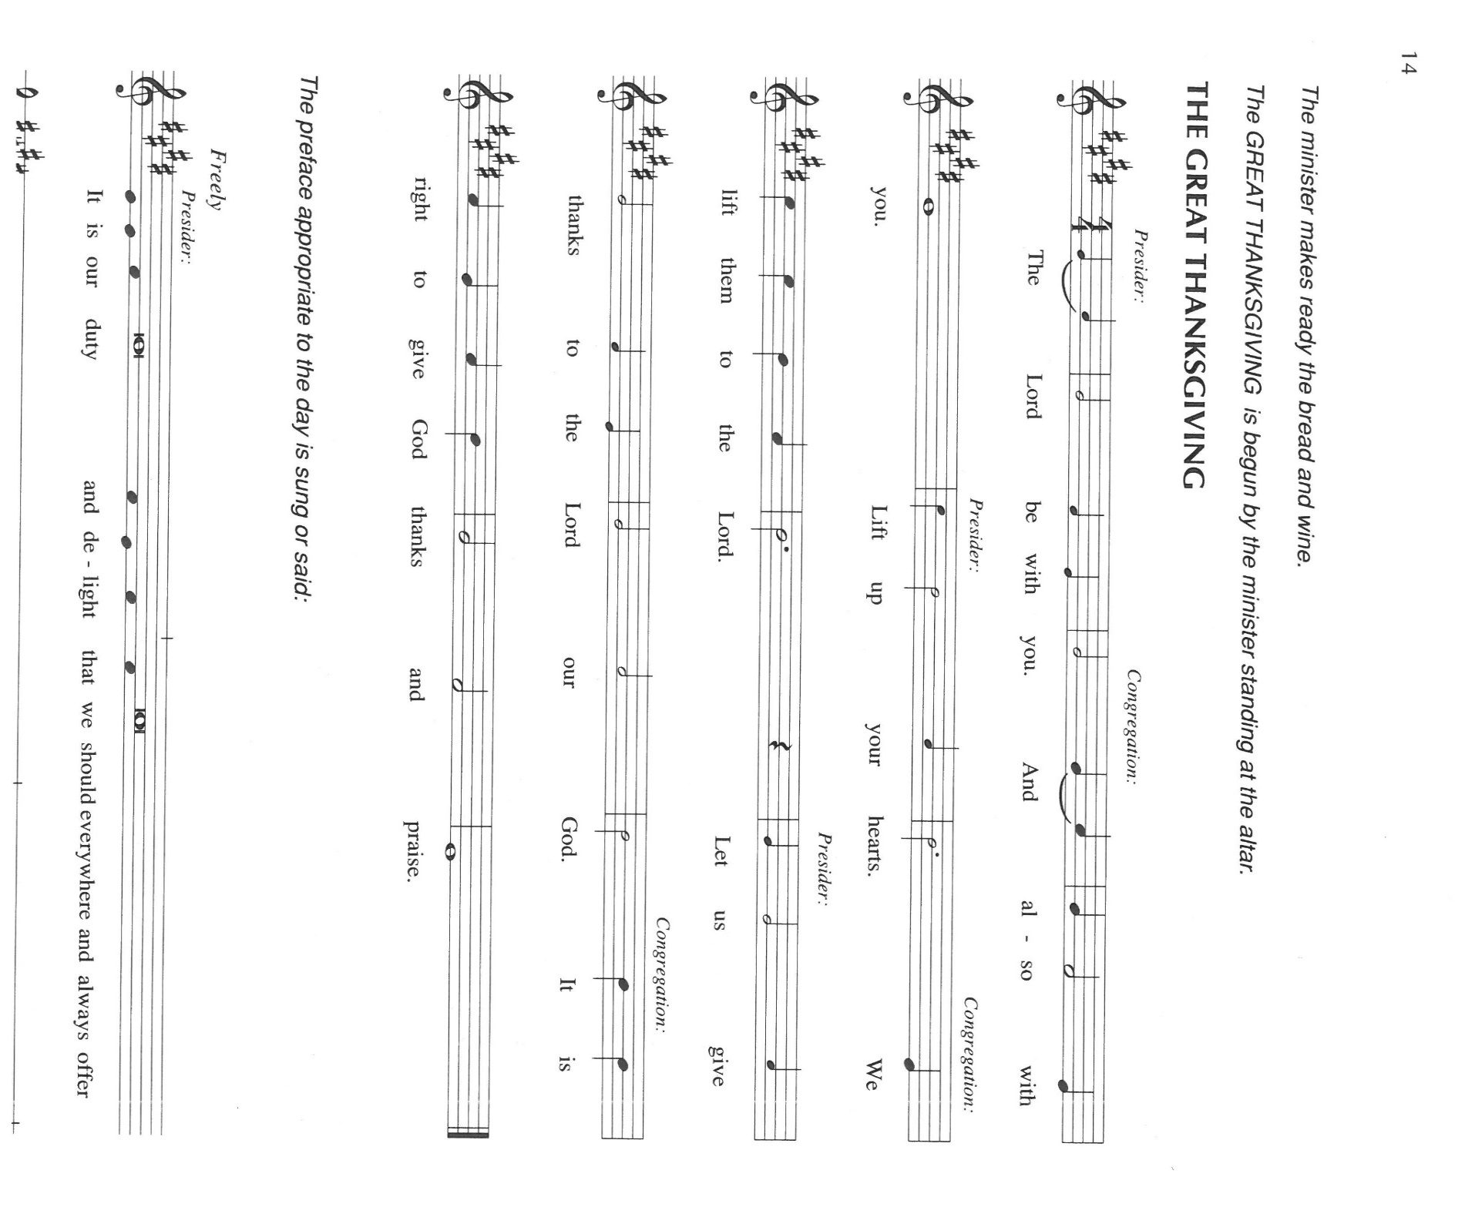

P: It is our duty and delight … join their unending hymn

P: Blessed are You, God and Father of all.
Through creation and covenant, prophet and promise You have called us Your own
and made us Your children.
You pledged Yourself to Abraham and Sarah and their offspring forever.
Through the Law You showed Your people the path of life; when they rejected Your
ways, You did not forsake them but sent prophets to bring them home to You.
In the fullness of time You sent Your Son, making us heirs according to the promise
made to Abraham, and adopting us as Your children through faith.
In Christ You gather to Yourself all people in an eternal embrace where there is
neither Jew nor Greek, slave nor free, male nor female.
In His dying and rising You take away our sin and open us to the gift of everlasting
life.
Bounteous God, as You fed Elijah in the wilderness that he might draw near to Your
holy mountain and come into Your presence,
Make this Bread for the journey our place of encounter with You.
Send Your Holy Spirit upon Your Church, and in the strength of this Food draw us
draw us near to the least and the lost.
Make this bread and cup holy that they may be for us the Body and Blood of Your
Son, Jesus Christ,
Who, in the night ... “Do this for the remembrance of Me.”
As often as we eat ...we proclaim the Lord’s death until He comes.

P: Everlasting God, in Whom deep calls to deep, You speak Your Word of life into
the fullness of silence.
Calm the fury of destruction around any caught up in tornado or hurricane, earth-
quake or fire.
Come to those who yearn for peace or protection.
Quiet every troubled spirit and strengthen every soul cast down.
Silence in us all clamoring for attention that is not Your own.
Give us courage to hear the sound of sheer silence, that we may know Your still,
small voice.
Bring us at last into Your holy presence and gather us with Your saints around the
altar of Your praise,
When all who belong to Christ shall be one in You, eternal Father, in the power of
the Holy Spirit, forever and ever.

C: Amen!

THE LORD’S PRAYER

P: As disciples who follow Jesus on the way to the Kingdom, with persevering faith let us
pray:

C: Our Father, Who art in heaven, hallowed by Thy name.
Thy Kingdom come, Thy will be done on earth as it is in heaven.
Give us this day our daily bread, and forgive us our trespasses as we forgive those
who trespass against us.
And lead us not into temptation, but deliver us from evil.
For Thine is the Kingdom, and the power, and the glory, forever and ever. Amen.

INVITATION TO THE MEAL

P: This is the Lamb of God Who takes away the sin of the world Blessed are those who
are called to the Supper of the Lamb. God’s holy gifts for God’s holy people. Come,
for all is now ready.

The assembly is seated

THE DISTRIBUTION Lamb of God
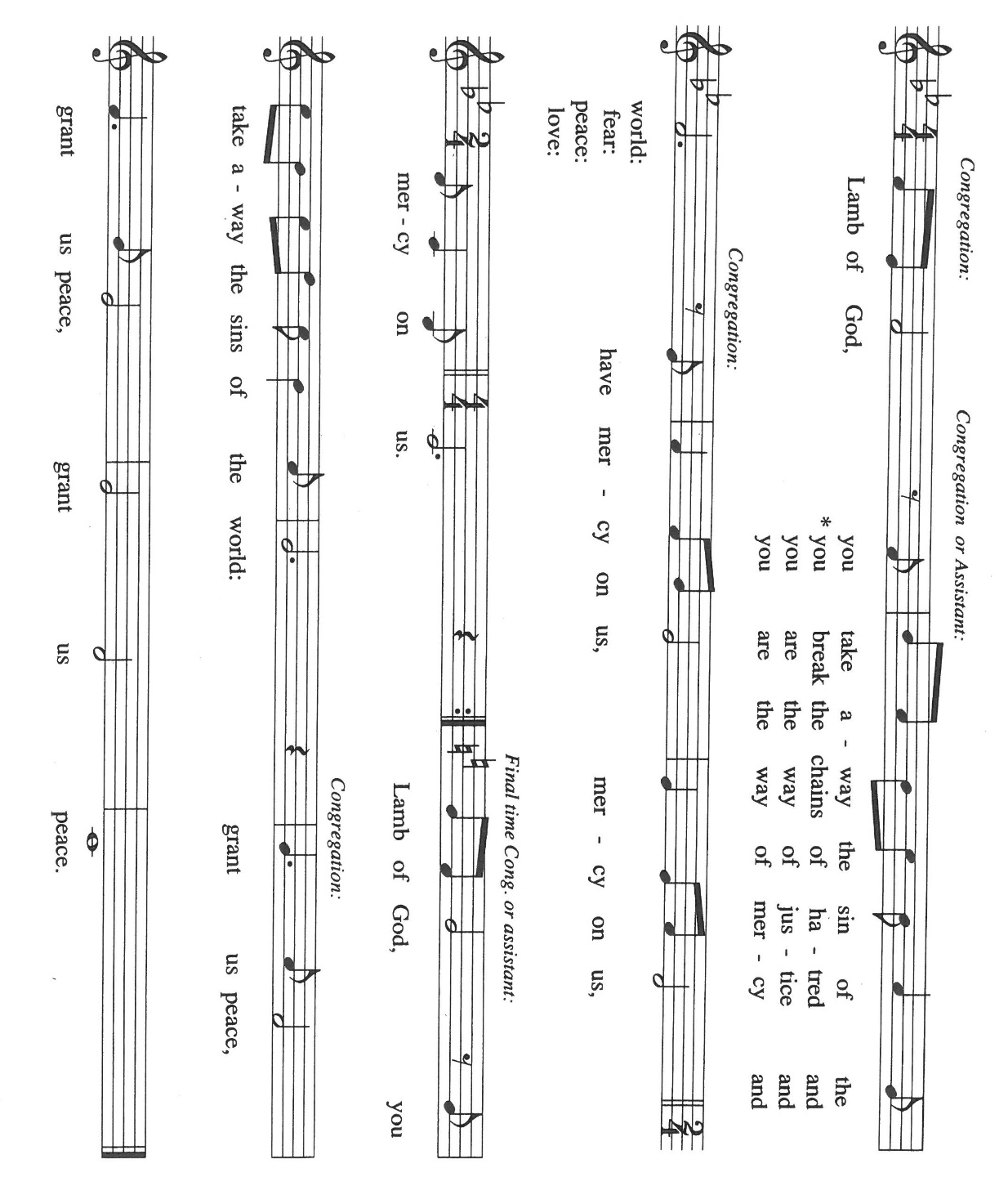
HYMNS DURING DISTRIBUTION 496 One Bread, One Body
620 How Sweet the Name of Jesus Sounds
As you are able please rise

THE POST-COMMUNION BLESSING

P: The Body and Blood of our Lord Jesus Christ strengthen you and keep you in His grace.

C: Amen.

THE POST-COMMUNION PRAYER

A: Let us pray. Almighty God, guide and protect Your people who share in this sacred
mystery. Deliver us from all evil and harm, and by Your Spirit, help us to grow daily
into the fullness of Christ. We ask this through Christ our Lord.

C: Amen.
SENDING
THE BENEDICTION

P: Almighty God: Father, Sonand Holy Spirit, bless you now and forever.

C: Amen.

SENDING SONG 886 O For a Thousand Tongues to Sing

THE DISMISSAL

A: Go in peace and declare how much God has done for you.

C: Thanks be to God!

POSTLUDE Oh, For a Thousand Tongues Robert Hobby

To God Alone Be Glory

The Meditation is from Luke: A Bible Commentary for Teaching and Preaching. Fred
Craddock. (Nashville: John Knox Press, 1990) 117.

The Greeting, Prayers, and Dismissal are adapted from Sundays and Seasons. Copyright
2001 Augsburg Fortress.

The Eucharistic Prayer is adapted from Eucharistic Prayers. Samuel Wells and Abigail
Kocher. (Grand Rapids: Eerdmann’s Publishing Company, 2016) 204-205.

ANNOUNCEMENTS

Please remember to mail your offering to the Church Office at 818 Franklin Street, Michigan City, IN 46360. Another alternative is to give on-line through Tithe.ly. Please see your closure letter for information on how to set up a Tithe.ly account.

St. Paul Members are reminded to have a loved one contact the office if you are hospitalized. Many times, the Pastor doesn’t know someone is in the hospital. If you call and leave a message, please tell us which hospital the patient is at.

Next Sunday’s lessons are 1 Kings 19: 15-16, 19-21; Psalm16; Galations 5: 1, 13-25; Luke 9: 51-62 for those of you who like to study them in advance.

Birthdays: Beverly Coburn (6/21; Diane Gielow (6/24); Lou Ann Shebel (6/ 24);
Muriel Jacobi (6/25)

Anniversaries: Sally & Lee Timm (6/21); George & Donna Ottersen (6/ 22);
Bill & Pam Hackett (6/23)

PRAYER CONCERNS: Audrey Beyer, Ryan Krueger, Donna Bostater, Maxine Powell, Jim Tomscheck, Eloise Ponder, Mark & Jary Tannehill, Leonard Cross, George Ottersen and Annette Scroggin.

If you requested someone’s name to be on the prayer list and are aware that they need continued imminent prayer then contact the church office and let us know. Otherwise we will gradually transfer names to the long-term list.

OFFICE HOURS: Libby will be in the office on Mondays, Wednesdays, and Fridays; volunteers will cover Tuesdays and Thursdays.

Monday & Wednesday 8:00 a.m. – 5 p.m.
Tuesday & Thursday 9:00 a.m. – 12:00 p.m.
Friday 8:00 a.m. – 12:00 p.m.

If you are listening to the worship broadcast on the radio and would like to watch the Sunday morning service live stream follow these steps:

(1) If you have You.Tube available on your TV, search for
St. Paul Lutheran Church Michigan City, IN.

(2) The direct link on the computer is
https://www.youtube.com/channel/UC5AIPNaKr3QN50984jGOa1g.

(3) This link is also on the main page of the church’s website in the church section and will continue to be posted weekly on the St. Paul Facebook page.

And it will always be available on the radio broadcast Sunday mornings at 11:00 a.m. on WEFM (95.9), and on the local cable access station #99 for the previous week’s service on Sundays at 4:00 p.m. and the current service on Wednesdays at 7:00 p.m. and Fridays at 8:30 p.m.

To send e-mail to the church office, please use the following addresses:

Pastor Mark Reshan: seniorpastor@stpaulmichigancity.com

Church Office Secretary (Libby Pollock): churchsecretary@stpaulmichigancity.com

Church Treasurer (Karen Fleming) and Bookkeeper (Billie Atchinson):

finance@stpaulmichigancity.com.

The Good News Newsletter: If you have an article or anything you want included in The Good News please send it to the following e-mail address: splcgoodnews@gmail.com. Pastor Pamela Thiede will be using this e-mail address to assemble The Good News each month. The deadline for getting information to Pastor Pamela will be the 20th of each month.

WORSHIP ATTENDANCE for June 11 and 12, 2022
4:00 p.m. 28
9:00 a.m. 42
Total = 70

The Community Soup Kitchen serving out of First United Methodist is in need of volunteers. Sunday through Tuesday is always need, as is occasionally Wednesdays and Thursdays. Hours are 9:30 a.m. to 1:15 p.m. and it is not necessary to stay the entire time. There is also a need for volunteers to be available to help pick up deliveries from the Food Bank when they arrive. If you are able to help please contact their church office at 872-7200.

2022 Financial Stewardship

Weekly Church Operating Needs (x 2 weeks): $14,116.36
June 4 and 5, and Jun3 11 and 12, 2022
General Fund (including General Memorials): $ 9,883.20
Overage/Shortage: --$ 4,233.16

Restricted Income (not including Memorials)
Supports IK Synod & Church wide Ministries: $430.00
Ministries in our Community/Congregation: $ 50.00
Capital Fund: $ 760.00

Memorials:
General Fund: $ 205.00

The return of coffee and fellowship: on Sunday, June 26, 2022 coffee and fellowship will again be available in the St. Paul Room following the 9:00 a.m. services each Sunday.

JUNE 2022 ACTIVITIES, MEETINGS AND SERVICES

Wednesday, June 1, 2022 at 9:45 a.m. Bible Study/Luther House

at 10:00 a.m. God’s Purls/St. Paul Room

Saturday, June 4, 2022 at 4:00 p.m. Worship Service

Sunday, June 5, 2022 at 9:00 a.m. Worship Service

Tuesday, June 7, 2022 at 9:30 a.m. Charity Circle/Nursery (Green Room)

Wednesday, June 8, 2022 at 10:00 a.m. God’s Purls/St. Paul Room

at 6:00 p.m. Worship & Music Committee Meeting

at 7:00 p.m. Choir Rehearsal

Saturday, June 11, 2022 at 4:00 p.m. Worship Service

Sunday, June 12, 2022 at 9:00 a.m. Worship Service

Monday, June 13, 2022 at 12:30 p.m. Harmony Circle/Nursery (Green Room)

at 3:30 p.m. School Board Meeting/Luther House
Tuesday, June 14, 2022 from open to close GIVE-BACK at Swingbelly’s
Wednesday, June 15, 2022 at 10:00 a.m. God’s Purls/St. Paul Room

Saturday, June 18, 2022 at 4:00 p.m. Worship Service
Sunday, June 19, 2022 at 9:00 a.m. Worship Service

Monday, June 20, 2022 at 4:00 p.m. Finance Committee Meeting/St. Paul Room

at 5:30 p.m. Executive Board Meeting/Luther House

Wednesday, June 22, 2022 at 10:00 a.m. God’s Purls/ St. Paul Room

at 11:00 a.m. – Close GIVE-BACK night at Chili’s in M. C.
Thursday, June 23, 2022 at 5:00p.m. 150th Anniversary Committee Meeting/Luther House

at 5:30 p.m. Church Council Meeting/ St. Paul Room

Saturday, June 25, 2022 at 4:00 p.m. Worship Service

Sunday, June 26, 2022 at 9:00 a.m. Worship Service

Thank$ for $haring
Thanks to all who attended our recent restaurant give back nights. At Holly’s, we raised $143 in March and $186 in May. Our latest Galveston give back raised $300.

This month,we will see you at Chili’s! We’re giving you two coupons so you can invite a friend and give them their own coupon. Remember, the coupon is required for the Give-Back bucks.

