**THE FOURTH SUNDAY OF EASTER**

**HAPPY MOTHER’S DAY**

**May 11, 2025**

Shepherd of tender youth,

Guiding in love and truth through devious ways,

Christ, our triumphant king,

We come thy name to sing

And here our children bring to join thy praise.

Ever be thou our guide,

Our shepherd and our pride, our staff and song;

Jesus, thou Christ of God,

By thine enduring word

Lead us where thou hast trod, make our faith strong.

**Clement of Alexandria, Bishop**

**Third century**

“In the heart of the God of the universe, each child of his is as necessary to him as the fingers are to the hand. In the marvelous design of the universe, not even a sparrow can fall to earth meaninglessly.”

**Toyohiko Kagawa**

From a fifth-century inscription in a church in Rome: Here the innocent sheep, cleansed by the heavenly water, are marked by the hand of the supreme Shepherd. You who have been begotten in this water, come to the unity to which the Holy Spirit calls you, to receive God’s gifts. You have received the cross: learn to escape the storm of the world; that is the great lesson of which this place reminds you.

**Sundays and Seasons**

What are the pastures of these sheep if they are not the deepest joys of the everlasting fresh pastures of paradise? For the pasture of the saints is to see God face to face; when the vision of God never fails, the soul receives its fill of the food of life forever.

And so, dear brothers and sister, let us seek these pastures and there join in the joy of the celebrations of so many citizens of heaven. Let their happiness and rejoicing be an invitation to us. Let our hearts grow warm, let our faith be rekindled, let our desires for heavenly things grow warm; for to love like this is to be on The Way.

**Gregory the Great**

**Sixth century**

**✠ GATHERING ✠**

**✠ In the Name of Jesus ✠**

**INTRODUCTION**

The gift of new life, of eternal life, is the gift of the risen Christ. It is the promise of Jesus. It was true for Dorcas in Joppa. It was true for those “who have come out of the great ordeal” in the Revelation vision. It is true for us and for all the baptized: Surely goodness and mercy shall follow me all the days of my life, and I will dwell in the house of the Lord forever.

**PRELUDE**

**THE EASTER ACCLAMATION**

P: Christ is risen! Alleluia!

**C: Christ is risen indeed! Alleluia!**

**ANNOUNCEMENTS**

*As you are able please rise*

**CONFESSION AND ABSOLUTION**

P: In the name of the Father and of **✠** the Son and of the Holy Spirit.

**C: Amen.**

P: “(The LORD) revives my soul, and guides me along right pathways for His name’s

sake.” (Psalm 23: 3) God seeks to grant us wholeness and healing for our ills. Let us

therefore confess our sins, that by God’s forgiveness we may be “revived” in hope and

joy.

*Silence for self-examination and reflection is kept*

P: Most merciful God,

**C: We confess that we are sinners in need of Your forgiveness. We have “wanted”**

**other gifts than You provide. (Psalm 23: 1) We have followed other “shepherds”**

**who promise fulfillment and happiness. We have strayed from Your “right**

**pathways” and have lost our way. (23: 3) We have listened to other voices than**

**Yours. (John 10: 27) We have failed to feed others with Your life-giving love.**

**For the sake of Your Son, Jesus our Shepherd, have mercy on us. Wipe away our**

**sins, our grief, and our fears, that we may follow where You lead and serve where**

**You call.**

P: “Surely Your goodness and mercy shall follow me all the days of my life ...” (Psalm

23: 6) God’s mercy is for you this Day: for as a called and ordained minister of the

Church of Christ, and by His authority, I therefore declare to you the entire forgiveness

of all your sins, in the name of the Father and of **✠** the Son and of the Holy Spirit.

**C: Amen.**

**GATHERING SONG 847 *Come, Let Us Join Our Cheerful Songs***

**THE GREETING AND PRAYER OF THE DAY**

P: Christ is risen! Alleluia!

**C: Christ is risen indeed! Alleluia!**

P: The grace of our Lord Jesus Christ, the love of God, and the communion of the Holy

Spirit be with you all.

**C: And also with you.**

P: Let us pray. O God of peace, You brought again from the dead our Lord Jesus Christ,

the great shepherd of the sheep. By the blood of Your eternal covenant, make us

complete in everything good that we may do Your will, and work among us all that is

well-pleasing in Your sight, through Jesus Christ, our Savior and Lord, Who lives and

reigns with You and the Holy Spirit, one God, now and forever.

**C: Amen.**

*The assembly is seated*

**✠ WORD ✠**

**FIRST READING Acts 9: 36-43**

*When Dorcas, faithful minister to the widows of Joppa, fell ill and died, Peter raised her back to life through the power of prayer.*

36Now in Joppa there was a disciple whose name was Tabitha, which in Greek is Dorcas. She was devoted to good works and acts of charity. 37At that time she became ill and died. When they had washed her, they laid her in a room upstairs. 38Since Lydda was near Joppa, the disciples, who heard that Peter was there, sent two men to him with the request, "Please come to us without delay."

39So Peter got up and went with them; and when he arrived, they took him to the room upstairs. All the widows stood beside him, weeping and showing tunics and other clothing that Dorcas had made while she was with them. 40Peter put all of them outside, and then he knelt down and prayed. He turned to the body and said, "Tabitha, get up." Then she opened her eyes, and seeing Peter, she sat up.

41He gave her his hand and helped her up. Then calling the saints and widows, he showed her to be alive. 42This became known throughout Joppa, and many believed in the Lord. 43Meanwhile he stayed in Joppa for some time with a certain Simon, a tanner.

The Word of the Lord

**Thanks be to God.**

**THE PSALM: Psalm 23 Read responsively**

1The LORD is my shepherd;

     I shall not be in want.

**2The LORD makes me lie down in green pastures**

**and leads me beside still waters.**

3You restore my soul, O LORD,

     and guide me along right pathway| for Your name's sake.

**4Though I walk through the valley of the shadow of death,**

**I shall fear no evil;**

**for You are with me; Your rod and your staff, they comfort me.**

5You prepare a table before me in the presence of my enemies;

     You anoint my head with oil, and my cup is running over.

**6Surely goodness and mercy shall follow me all the days of my life,**

**and I will dwell in the house of the LORD forever.**

**SECOND READING Revelation 7: 9-17**

*Christ is the shepherd who leads his faithful to springs of the water of life. Christ is also the Lamb who vanquishes sin and suffering, in whose blood the saints have washed their robes and made them white.*

9After this I looked, and there was a great multitude that no one could count, from every nation, from all tribes and peoples and languages, standing before the throne and before the Lamb, robed in white, with palm branches in their hands. 10They cried out in a loud voice, saying,

"Salvation belongs to our God Who is seated on the throne, and to the Lamb!"

11And all the angels stood around the throne and around the elders and the four living creatures, and they fell on their faces before the throne and worshiped God, 12singing,

"Amen! Blessing and glory and wisdom

and thanksgiving and honor

and power and might

be to our God forever and ever!

Amen."

13Then one of the elders addressed me, saying, "Who are these, robed in white, and where have they come from?" 14I said to him, "Sir, you are the one that knows." Then he said to me, "These are they who have come out of the great ordeal; they have washed their robes and made them white in the blood of the Lamb.

15For this reason they are before the throne of God,

and worship Him day and night within His temple,

and the One Who is seated on the throne will shelter them.

16They will hunger no more, and thirst no more;

the sun will not strike them,

nor any scorching heat;

17for the Lamb at the center of the throne will be their shepherd,

and He will guide them to springs of the water of life,

and God will wipe away every tear from their eyes.

The Word of the Lord.

**Thanks be to God.**

*As you are able please rise*

**THE VERSE**

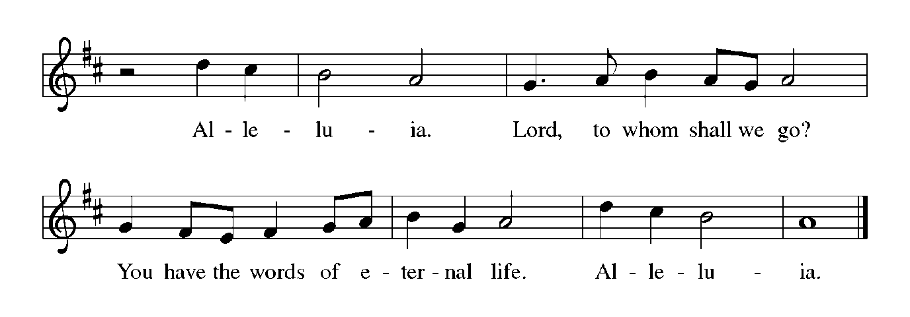

**THE HOLY GOSPEL John 10: 22-30**

*Three times Jesus says that his sheep are secure; no one will snatch them from Jesus' hand or the Father's hand. The sheep have eternal life and so shall never perish.*

P: The Holy Gospel according to St. John, the tenth chapter.

**C: Glory to You, O Lord!**

22At that time the festival of the Dedication took place in Jerusalem. It was winter, 23and Jesus was walking in the temple, in the portico of Solomon. 24So the Judeans gathered around Him and said to Him, "How long will You keep us in suspense? If You are the Messiah, tell us plainly."

25Jesus answered, "I have told you, and you do not believe. The works that I do in My Father's name testify to Me; 26but you do not believe, because you do not belong to My sheep. 27My sheep hear My voice. I know them, and they follow Me. 28I give them eternal life, and they will never perish. No one will snatch them out of My hand. 29What My Father has given Me is greater than all else, and no one can snatch it out of the Father's hand. 30The Father and I are one."

P: The Gospel of the Lord.

**C: Praise to You, O Christ!**

*The assembly is seated*

**THE SERMON**

*Silence for reflection follows the sermon*

*As you are able please rise*

**THE HYMN OF THE DAY 426 *Sing With All the Saints in Glory***

(Sung to the tune of, *Joyful, Joyful, We Adore You)*

**1 Sing with all the saints in glory,**

**sing the resurrection song!**

**Death and sorrow, earth's dark story,**

**to the former days belong.**

**All around the clouds are breaking,**

**soon the storms of time shall cease;**

**in God's likeness we awaken,**

**knowing everlasting peace.**

**2 Oh, what glory, far exceeding**

**all that eye has yet perceived!**

**Holiest hearts for ages pleading**

**never that full joy conceived.**

**God has promised, Christ prepares it,**

**there on high our welcome waits.**

**Ev'ry humble spirit shares it,**

**Christ has passed the eternal gates.**

**3 Life eternal! heav'n rejoices:**

**Jesus lives Who once was dead.**

**Shout with joy, O deathless voices!**

**Child of God, lift up your head!**

**Life eternal! Oh, what wonders**

**crowd on faith; what joy unknown,**

**when, amid earth's closing thunders,**

**saints shall stand before the throne!**

**Text: William J. Irons, 1812-1883, alt.**

**THE NICENE CREED**

A: God has made us His people through our Baptism into Christ. Living together in trust

and hope, we confess our faith.

**C: We believe in one God,**

**the Father, the Almighty,**

**maker of heaven and earth,**

**of all that is, seen and unseen.**

**We believe in one Lord, Jesus Christ,**

**the only Son of God,**

**eternally begotten of the Father,**

**God from God, Light from Light,**

**true God from true God,**

**begotten, not made,**

**of one Being with the Father.**

**Through him all things were made.**

**For us and for our salvation**

**He came down from heaven;**

**by the power of the Holy Spirit**

**He became incarnate from the virgin Mary, and was made man.**

**For our sake He was crucified under Pontius Pilate;**

**He suffered death and was buried.**

**On the third day He rose again**

**in accordance with the Scriptures;**

**He ascended into heaven**

**and is seated at the right hand of the Father.**

**He will come again in glory to judge the living and the dead,**

**and His kingdom will have no end.**

**We believe in the Holy Spirit, the Lord, the giver of life,**

**Who proceeds from the Father and the Son.**

**With the Father and the Son he is worshiped and glorified.**

**He has spoken through the prophets.**

**We believe in one holy catholic and apostolic Church.**

**We acknowledge one Baptism for the forgiveness of sins.**

**We look for the resurrection of the dead,**

**and the life of the world to come. Amen**

**THE PRAYER OF THE CHURCH**

A: In this Eastertide we rejoice together at the resurrection of Christ. That the world may

be commended to the care of the Good Shepherd, let us pray for the whole people of

God in Christ Jesus, and for all people according to their needs.

A: That through Christ’s death and resurrection the Church might be washed clean and

nurtured to greater faithfulness to follow His voice: Lord, in Your mercy,

**C: Hear our prayer.**

A: That Christ may crush the Prince of Darkness, overcome the forces of terrorism, hatred,

warfare, especially in Ukraine, Haiti, Sudan, Darfur, and Gaza; and evil, and grant us

victory over all trials and temptations: Lord, in Your mercy,

**C: Hear our prayer.**

A: That as Peter brought help and life to the widow Tabitha, this congregation might be

inspired to good works, acts of charity, and greater ministry among the poor of our

community: Lord, in Your mercy,

**C: Hear our prayer.**

A: That all mothers, grandmothers, and those who give motherly care might be granted

the strength, wisdom, and compassion to embody God’s own kindness and unfailing

love: Lord, in Your mercy,

**C: Hear our prayer.**

A: That those who are in any want, those who need reviving, guidance, or comfort,

especially the sick: **Kevin Thiede; Martha Schroeder; Russ Fischer; Joyce Stark;**

**Larry Litchford; Carol Radke; and Fred Weiss** might be uplifted by God’s

goodness and mercy: Lord, in Your mercy,

**C: Hear our prayer.**

A: That with all the saints we may join with them and the heavenly choirs to praise Your

name: Lord, in Your mercy,

**C: Hear our prayer.**

P: Hear our prayers, O God, and grant us what we truly need, in the name of and for the

sake of Your Son, Jesus Christ, our risen Savior.

**C: Amen.**

**✠ MEAL ✠**

**THE PEACE**

P: The peace of the risen Lord be with you always.

**C: And also with you.**

*The assembly is seated*

**OFFERING**

**THE VOLUNTARY**

*As you are able please rise*

**THE OFFERTORY**

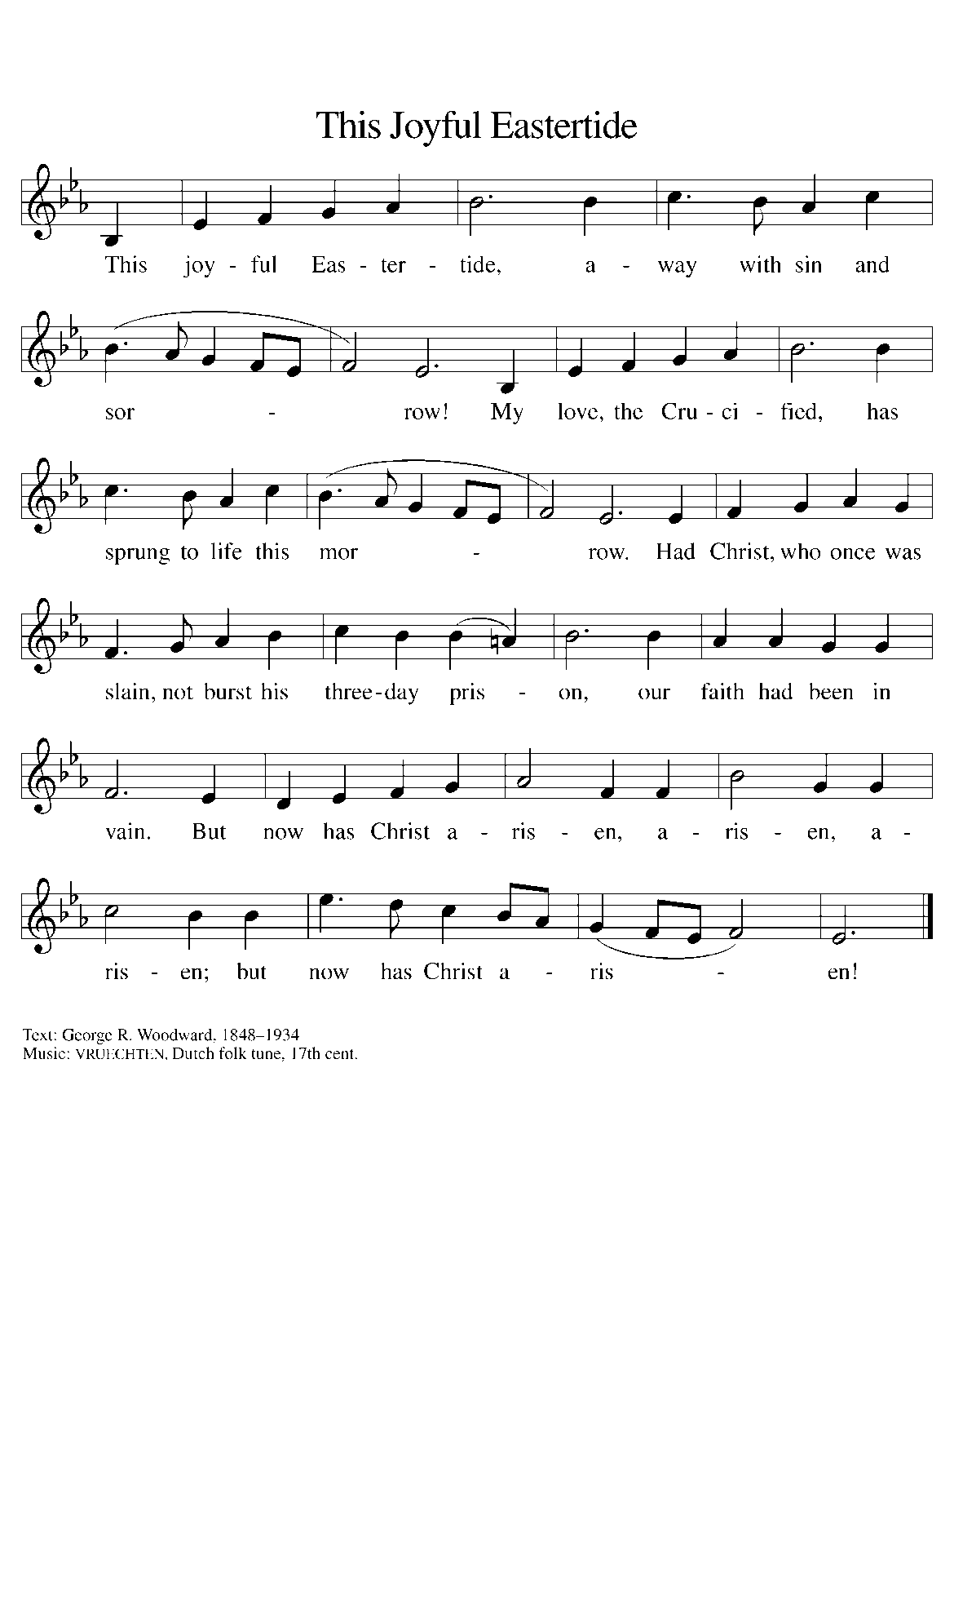

**THE OFFERTORY PRAYER**

A: Let us pray. God of loving care,

**C: You spread before us the Table of Life, and give us the cup of salvation to drink.**

**Receive these gifts we offer You, and keep us always in the fold of Your Son, Jesus**

**Christ, our Shepherd and our Savior. Amen.**

**THE GREAT THANKSGIVING**

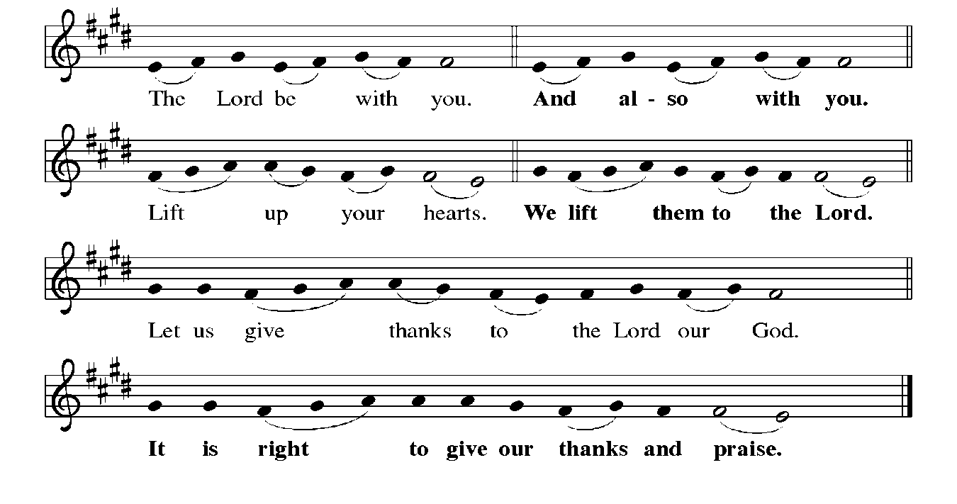

P: It is indeed right, our duty, and our joy … join their unending hymn:

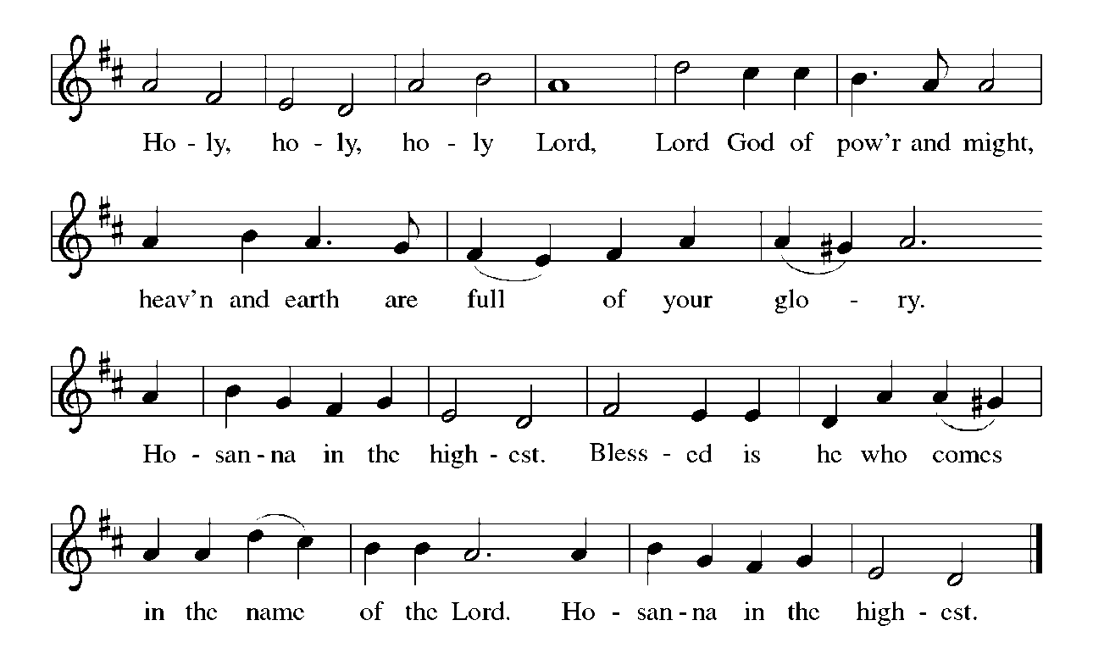

P: Shepherding God, we praise and thank You because You gathered Your flock

around Abraham and Sarah, and through Moses and Joshua Your

brought Your sheep to a place of safety.

In Jesus You came to us as a Passover Lamb to take away the sins of the world.

As our everlasting Good Shepherd You promise that those who hear Your voice

shall never be in want, for You know Your sheep by name, and You call

us Your own and give to each of us a place in the sheepfold of Your

Kingdom.

Sustaining God, as Your lead Your sheep to green pastures and guide them beside

still waters, so You have led us to this Table where in bread and wine You

restore our soul.

Send down Your Holy Spirit and restore Your Church through the abundance of this

sacred Meal.

As we remember the story of Your Son’s life laid down for us, make this bread and

cup holy for us that they may be the Body and Blood of Your Son Jesus

Christ,

Who, in the night ... “Do this for the remembrance of Me.”

As often as we eat ... we proclaim the Lord’s death until He comes.

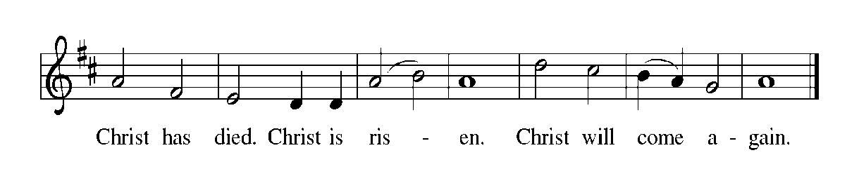

P: Saving God, Your rod and staff comfort all who look to You in faith.

Search our Your sheep that are lost and bring them home.

When You find them in the valley of fear, gather them into Your arms.

When they face evil in the presence of enemies, follow them with Your goodness

and mercy all the days of their life.

On that day when the shadow of death covers them, bring them to dwell in Your

house forever.

Shepherd us with all Your saints of every age into Your glorious presence, where

we shall behold Your Lamb in seated glory, most Holy Trinity, now and

always.

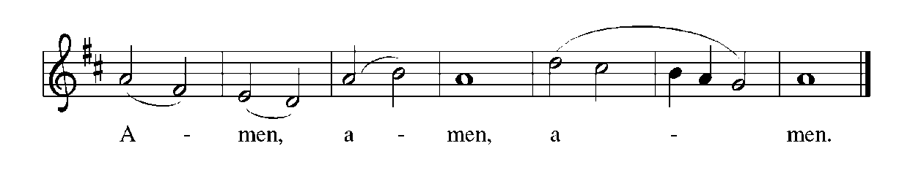

**THE LORD’S PRAYER**

P: Risen from the dead, Jesus lives to intercede for us and join us as He taught us to pray:

**C: Our Father, Who art in heaven, hallowed by Thy name.**

**Thy Kingdom come, Thy will be done on earth as it is in heaven.**

**Give us this day our daily bread, and forgive us our trespasses as we forgive those**

**who trespass against us.**

**And lead us not into temptation, but deliver us from evil.**

**For Thine is the Kingdom, and the power, and the glory, forever and ever. Amen.**

**INVITATION TO THE MEAL**

P: Alleluia! Christ the Lamb of God has been sacrificed. Therefore, let us celebrate His

Feast with joy. Blessed are those who are called to the Supper of the Lamb. God’s

holy gifts for God’s holy people. Come, for all is now ready.

*The assembly is seated*

**THE DISTRIBUTION**

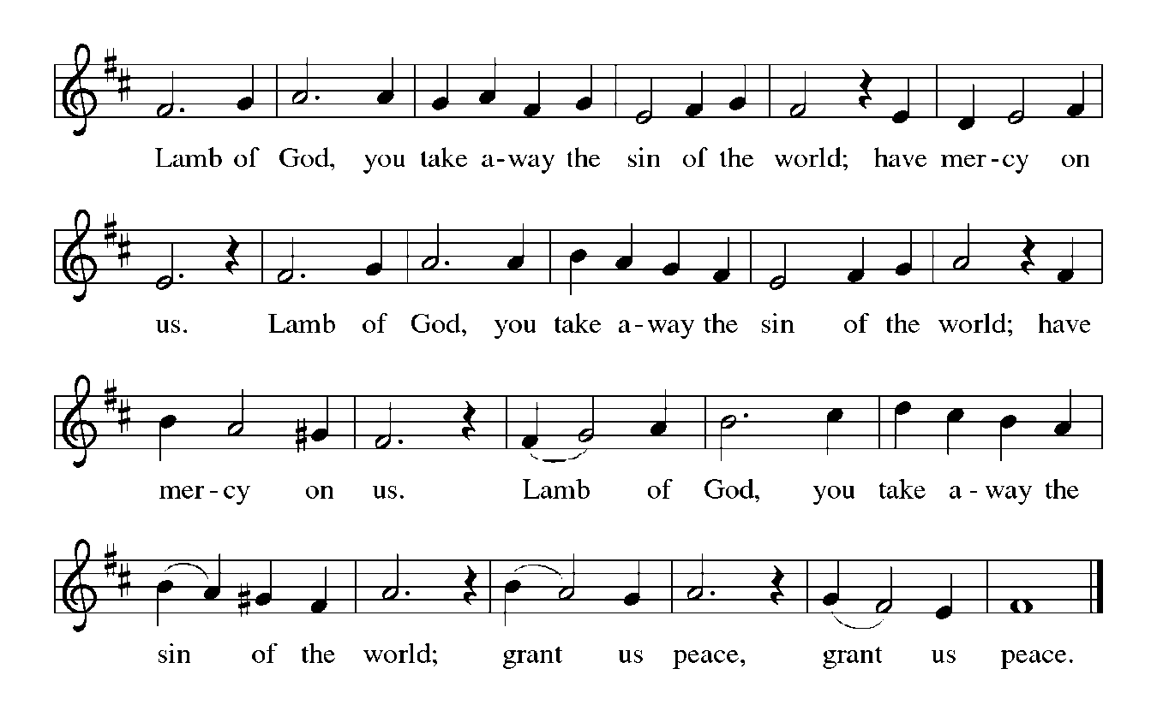

Those wishing to receive the Laying on of Hands, Anointing with Oil, and Prayer for Healing may go to Pastor at the side aisle

**HYMNS DURING DISTRIBUTION 502 *The King of Love My Shepherd Is***

**843 *Praise the One Who Breaks the Darkness***

**427 *For All Your Saints, O Lord***

*As you are able please rise*

**THE POST-COMMUNION BLESSING**

P: The Body and Blood of our Lord Jesus Christ strengthen you and keep you in His grace.

**C: Amen.**

**THE POST-COMMUNION PRAYER**

A: Let us pray. God of steadfast love, watch over the Church redeemed by the blood of

Your Son. May we who share in these holy mysteries come safely to Your eternal

Kingdom, where there is one flock and one shepherd, Your Son, Jesus Christ our Lord.

**C: Amen.**

**✠ SENDING ✠**

**THE BENEDICTION**

P: May God the Father Who raised Christ from the dead open to you the gate of everlasting

life.

**C: Amen.**

P: May God the Son Who burst from the grave give you joy as you celebrate His

resurrection.

**C: Amen.**

P: May God the Holy Spirit Who brought you to birth in Baptism fill you with strength

and peace.

**C: Amen.**

P: Almighty God: Father, Son, **✠** and Holy Spirit bless you now and forever.

**C: Amen.**

**SENDING SONG 768 *Lead Me, Guide Me***

**THE DISMISSAL**

A: Alleluia! Christ is risen!

**C: He is risen indeed! Alleluia!**

A: Go in the peace of Christ, alleluia!

**C: Thanks be to God! Alleluia!**

**POSTLUDE**

**✠ To God Alone Be Glory ✠**

**FYI:**

**In preparation for the Church Congregational Meeting on Sunday,**

**May 18th at 10:15 a.m., copies of the proposed budget for 2025—2026 are available to be picked up on the table in the narthex.**

The Meditations are from *Sundays and Seasons Online.* Copyright 2022 Augsburg Fortress.

**ANNOUNCEMENTS**

**Please remember to mail your offering to the Church Office** at 818 Franklin Street, Michigan City, IN 46360**.** Another alternative is to give on-line through Tithe.ly. Please see your closure letter for information on how to set up a Tithe.ly account.

**St. Paul Members are reminded to have** a loved one contact the office if you are hospitalized. Many times, the Pastor doesn’t know someone is in the hospital. If you call and leave a message, please tell us at which hospital the patient is located.

**Birthdays: Patricia Miller (5/16)**

**Anniversaries: Fred & Judy LaBorn (5/19)**

**PRAYER CONCERNS:** Larry Litchford, Sarah McNabb, Carol Radke, Jeanie Boatman Shepple, Nolan Wilson, Debbie Martin, Mark Tannehill, Brian Wiseman, Kathy Stein, Danielle Schnell, Jan Paholski, Laura Dovey, and Grace Romine.

**OFFICE HOURS:** Libby will be in the office on Mondays, Wednesdays, and Fridays; volunteers will cover Tuesdays and Thursdays.

Monday & Wednesday 8:00 a.m. – 5 p.m.

Tuesday & Thursday 9:00 a.m. – 12:00 p.m.

Friday 8:00 a.m. – 12:00 p.m.

**If you are listening to the worship broadcast on the radio and would like to watch the Sunday morning service live stream follow these steps:**

(1) If you have You Tube available on your TV, search for

**St. Paul Lutheran Church Michigan City, IN.**

(2) The direct link on the computer is

https://www.youtube.com/channel/UC5AIPNaKr3QN50984jGOa1g.

   (3) This link is also on the main page of the church’s website in

the church section and will continue to be posted weekly on the St.

Paul Facebook page.

And it will always be available on the radio broadcast Sunday mornings at 11:00 a.m.

on WEFM (95.9), and on the local cable access station #99 for the previous week’s

service on Sundays at 4:00 p.m. and the current service on Wednesdays at 7:00 p.m.

and Fridays at 8:30 p.m.

**Next Sunday’s lessons are Acts 11: 1-18; Psalm 148; Revelation 21: 1-6; John 13:**

**31-35** for those of you who like to study them in advance.

**To send e-mail to the church office**, please use the following addresses:

Pastor Mark Reshan: seniorpastor@stpaulmichigancity.com

Church Office Secretary (Libby Pollock): churchsecretary@stpaulmichigancity.com

Church Treasurer (Karen Fleming): finance@stpaulmichigancity.com

**The Good News Newsletter**: If you have an article or anything you want included in **The Good News** please send it to the following e-mail address: splcgoodnews@gmail.com. Pastor Pamela Thiede will be using this e-mail address to assemble **The Good News** each month. The deadline for getting information to Pastor Pamela will be the 20th of each month.

**Worship Attendance:**

**Saturday , May 3, 2025 @ 4:00 p.m. 20**

**Sunday, May 4, 2025 @ 9:00 a.m. 71**

**TOTAL 91**

**Copies of the minutes from the March 27, 2025 and the May 1, 2025 Church Council meetings are on the back table in the upper Narthex. They were approved by the council via email.**

**FYI:**

In response to the ever rising costs for postage we will be putting your copy

of the “Good News” in your hanging file folder in the narthex each month

from now on. Those of you who are unable to attend services on a regular

basis may still receive your copies through your email address or in the

U.S. mail. If you normally receive your copy of the newsletter via your

email address anyway, nothing will change for you. Thank you so much for

your understanding and cooperation!

**MISSION OF THE MONTH FOR MAY 2025**

Our Monthly Mission for the month of May, 2025, is Camp Sharing Meadows, part of the Share Foundation. Located in LaPorte, Camp Sharing Meadows is an inclusive Christian camp for adults with intellectual and/or developmental disabilities, where a vibrant blend of community, faith, and creative exploration takes center focus. The camps allow individuals with developmental and intellectual disabilities to have fun while learning faith-based values, participating in various activities, and making lifelong friendships. Monetary and check donations can be made out to the church and marked for Camp Sharing Meadows and placed in the offering plate. Noisy coin offering will also go to the Mission of the Month. Thank you for your generosity!

**ACTIVITIES, EVENTS & MEETINGS**

**May 2025**

**Sunday,** May 4, 2025 @ 9:00 a.m. 3rd Easter Worship Service

Coffee in the St. Paul Room after service

**Wednesday,** May 7, 2025 @ 9:15 a.m.NO BIBLE STUDY TODAY

@ 10:00 a.m. God’s Purls/St. Paul Room

@ 4:30 p.m. Choir Rehearsal/Sanctuary

**@11:00 a.m. – close** **GIVE BACK AT SWINGBELLY’S**

**Saturday,** May 10, 2025 @ 4:00 p.m. 4th Easter Worship Service

**Sunday,** May 11, 2025 @ 9:00 a.m. 4th Easter Worship Service

Coffee in the St. Paul Room after service

**Tuesday,** May 13, 2025 @ 7:00 p.m. Estuary/Luther House

**Wednesday,** May 14, 2025 @ 9:15 a.m. Bible Study/Luther House

@10:00 a.m. God’s Purls/St. Paul Room

@ 3:30p.m. Worship & Music Comm. Mtg./Luther House

@ 4:30 p.m. Choir Rehearsal/Sanctuary

**Saturday,** May 17, 2025 @ 4:00 p.m. 5th Easter Worship Service

**Sunday,** May 18, 2025 @ 9:00a.m. 5th Easter Worship Service

**@10:15 a.m. CONGREGATIONAL MTG/St. Paul Room**

**with a Pot Luck luncheon immediately following**

**Monday,** May 19, 2025 @ 1:00 p.m. Hope Circle/Green Room

@2:00 p.m. Finance Committee Mtg/Luther House

@ 3:00 p.m. Executive Board Meeting/Luther House

**Wednesday,** May 21, 2025 @ 9:15 a.m. Bible Study/Luther House

@10:00 a.m. God’s Purls/St. Paul Room

@ 4:30 p.m. Choir Rehearsal/Sanctuary

**Saturday,** May 24, 2025 @ 4:00 p.m. 6th Easter Worship Service

**Sunday,** May 25, 2025 @ 9:00 a.m. 6th Easter Worship Service Coffee in the St. Paul Room after service

**Monday,** May 26, 2025 **MEMORIAL DAY – OFFICE WILL BE CLOSED**

**Wednesday,** May 28, 2025 @ 9:15 a.m. Bible Study/Luther House

@ 10:00 a.m. God’s Purls/St. Paul Room

@ 4:30 p. m. Choir Rehearsal/Sanctuary

**Thursday,** May 29, 2025 @ 5:30 p.m. Church Council Meeting/St. Paul Room

**Saturday,** May 31, 2025 @ 4:00 p.m. 7th Easter Worship Service

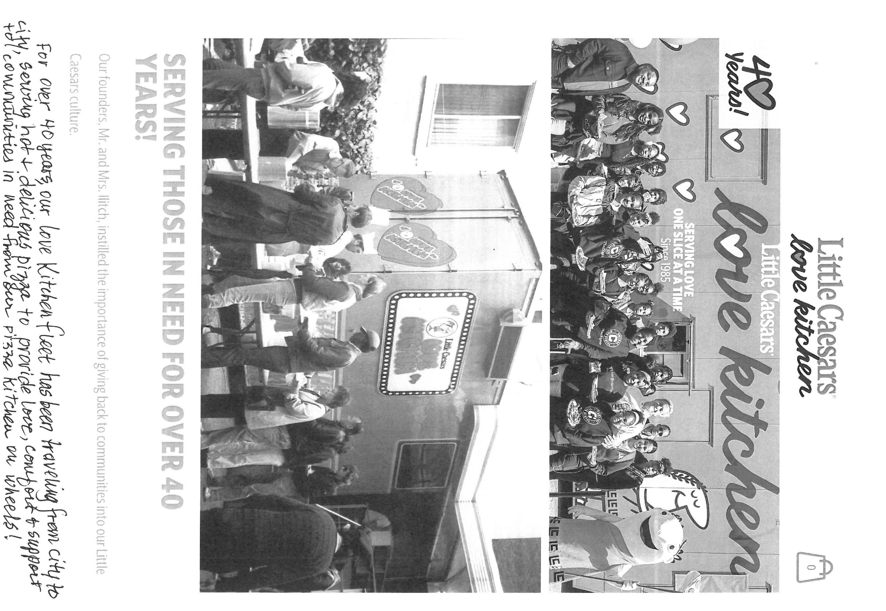

**ATTENTION PLEASE!**

The Love Kitchen was founded in Detroit, Michigan, on April 30, 1985, by Mr. & Mrs. Ilitch, founders of Little Caesar’s Pizza. It is a fully functioning mobile restaurant used to prepare hot pizzas for communities in need such as shelters, soup kitchens, veterans, first responders, disaster relief, etc. On Saturday, May 17, 2025 from 11:00 a.m. – 1:00 p.m. one of their Love Kitchens will be parked in our very own parking lot here at St. Paul Lutheran in Michigan City to provide free pizza to those in need of a meal. Please spread the word!

**THANK YOU!**

Our heartfelt thanks for the memorials sent to the church for our beloved husband and father, Charles W. Ponder. A special thank you to Pastor

Reshan for his caring eulogy at the service. God bless our Angel.

Eloise J. Ponder and family

**A reminder that there will be a memorial service for former member David Meyer on Monday, May 12.** There will be a time of visitation with the family from 12:30-1:15 p.m., pre-service music from 1:15-1:30, and the service will begin at 1:30. Light refreshments will be served afterwards in the St. Paul Room.



**POTLUCK MEAL**

Following the congregational meeting on Sunday, May 18, 2025, we will have a potluck meal. The Council will not be providing the main course this time, so whatever entrees, salads, sides, and desserts we have will come from those who attend. No need to sign up for anything; simply bring a favorite dish to share and enjoy good food and better fellowship following the meeting.