**THE TWENTY-FIFTH SUNDAY AFTER PENTECOST**

**November 14, 2021**

In that hour when darkness like a cloak shall be spread over all things, may Your grace, O Lord, shine on us in the place of the earthly sun.

On that day when all people are called to earthly burial, make us worthy, O Lord, to rejoice in heavenly rest.

In that day when all darkness shall cease, and all are freed from weariness, grant, O Lord, that we may take our light in the joys of the life to come.

**Ephraem, Second century**

**Sermon 13**

“…In a nutshell, apocalyptic literature (of which this chapter in Mark is an example) stems from a worldview that believes that everything happening on earth represents and correlates with a larger, heavenly struggle between good and evil. It therefore reads into earthly events cosmic significance and anticipates future events on earth in light of the coming battle between the forces of God and the devil. Hence, it often tries to make sense of current events and experiences by casting them in a larger, cosmic framework and in this way give comfort to people who are currently suffering or being oppressed.

Because of this dualism, and because apocalyptic literature tends to be highly symbolic, it’s ripe for reading all kinds of things into it – like predictions about the end of the world! But this chapter in Mark – and other passages, notably the book of Revelation – were not written so that we could ferret out signs of the end. Rather, they were written to offer comfort to first-century believes struggling to make sense of their world and lives. For this reason, it’s way more helpful to read this and similar passages in light of the challenges its original readers were facing, challenges that might be akin to some of our own.

From this passage and those to come in this chapter, for instance, we can gather that Mark’s community was not only struggling with the disruptions the fall of the Jerusalem Temple introduced into first-century Judaism and Christianity, but also that they had been harassed by some people claiming to be Jesus or some other messianic figure returned. Mark’s people were literally caught up in “wars and rumors of war” and probably found comfort in the belief that Jesus had already anticipated this and was offering words of encouragement to them through this Gospel.

When it comes to our own day and age, that kind of encouragement is still valuable, for though our wars may be different, yet we are still harassed at times by a fear that the world is falling apart. To twenty-first century believers, just as to first century disciples, Jesus says the same “do not fear.””

**David Lose**

**✠ In the Name of Jesus ✠**

**INTRODUCTION**

November begins with All Saints Day and ends in or near Advent, when we anticipate Christ's coming again. So the readings today tell of the final resurrection and the end time. In the turmoil of hope, fear, and disbelief that these predictions provoke in us, Hebrews sounds a note of confident trust. Christ makes a way for us where there is no way, and we walk it confidently, our hearts and bodies washed in baptismal water, trusting the one who has promised. The more we see the last day approaching, the more important it is to meet together to provoke one another to love.

**✠ GATHERING ✠**

**PRELUDE Ein Feste Burg Timothy Albrecht**

**ANNOUNCEMENTS**

As you are able please rise

**CONFESSION AND ABSOLUTION**

P: In the name of the Father and of ✠ the Son and of the Holy Spirit.

C: **Amen.**

P: “Therefore, my friends, since we have confidence to enter the sanctuary by the blood of Jesus

... and since we have a great high priest over the house of God, let us approach with a true heart

in the full assurance of faith, with our hearts sprinkled clean from an evil conscience and our

bodies washed with pure water.” (Hebrews 10:19, 21) With hearts full of faith and hope, let

us confess our sins.

*Silence for self-examination and reflection is kept*

P: Most merciful God,

C: **We confess that we have sinned against You in thought, word, and deed. Because of**

**hardship and suffering, we have wavered in our hope (Hebrews 10:23). We have believed**

**You to be unfaithful to Your promises (10:23). We have neglected to provoke one another**

**to love and good deeds. We have not encouraged each other to faith and love (10:24).**

**For these and all our sins, known and unknown, O God, we beg Your forgiveness. For**

**the sake of Your Son, Jesus Christ, make us new in Your grace, that we may be made**

**strong in love and service.**

P: “You will show me the path of life, (O God); in Your presence there is fullness of joy ...”

(Psalm 16:11) God’s joy is yours today, for “He Who has promised is faithful.” And God’s

promise is this: as a called and ordained minister of the Church of Christ, and by His authority,

I therefore declare to you the entire forgiveness of all your sins, in the name of the Father and

of ✠ the Son and of the Holy Spirit.

C: **Amen.**

**GATHERING HYMN 509 *God’s Word is Our Great Heritage*  page 12**

**THE GREETING AND PRAYER OF THE DAY**

P: God is Alpha and Omega, the First and the Last,

C: **The One Who is, and Who was, and Who is to come.**

P: The grace of our Lord Jesus Christ, the love of God, and the communion of the Holy Spirit be

with you all.

C: **And also with you.**

P: Let us pray. Almighty God, Your sovereign purpose brings salvation to birth. Give us faith to

be steadfast amid the tumults of this world, trusting that Your Kingdom comes and Your will

is done through Your Son, Jesus Christ, our Savior and Lord.

C: **Amen.**

*The assembly is seated*

**✠ WORD ✠**

**FIRST READING Daniel 12:1-3**

*The book of Daniel represents a kind of literature called "apocalyptic," which is full of bizarre visions, strange symbolism, and supernatural happenings. Arising during times of great persecution, apocalyptic literature employs a vivid language that prevents outsiders to the faith from understanding its content. Overall, it is concerned with God's revelation about the end-time and the coming kingdom of God, when God will vindicate the righteous who have been persecuted.*

"At that time Michael, the great prince, the protector of your people, shall arise. There shall be a time of anguish, such as has never occurred since nations first came into existence. But at that time your people shall be delivered, everyone who is found written in the book. 2Many of those who sleep in the dust of the earth shall awake, some to everlasting life, and some to shame and everlasting contempt.

3Those who are wise shall shine like the brightness of the sky, and those who lead many to righteousness, like the stars forever and ever."

The Word of the Lord.

**Thanks be to God.**

**THE PSALM: Psalm 16** Antiphon by William Beckstrand

Choir sings refrain first, followed immediately by the congregation

and as indicated

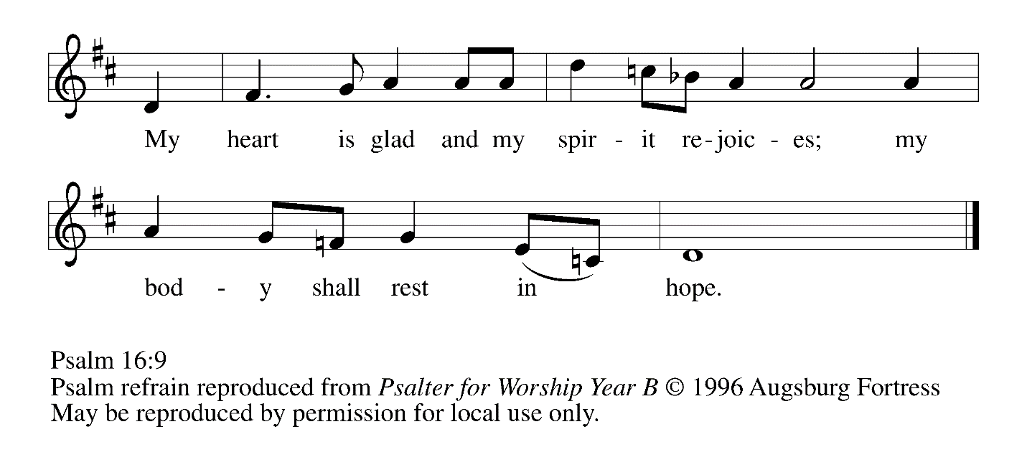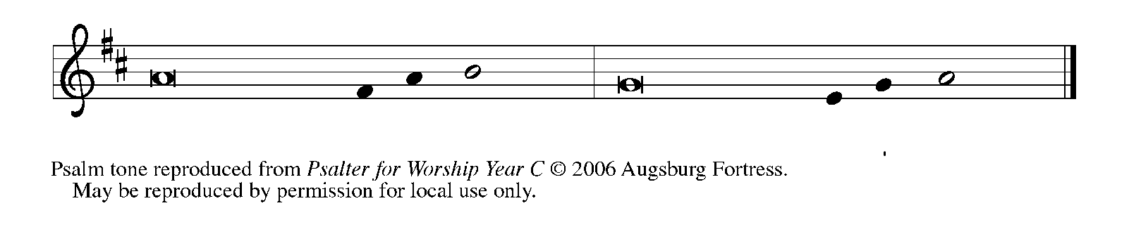

Protect me, O God, for I take ref- | uge in You;*

I have said to the LORD, "You are my Lord, my good a- | bove all other."

**2All my delight is upon the godly that are | in the land,\***

**upon those who are noble a- | mong the people.**

3But those who run after | other gods*

shall have their troubles | multiplied.

**4Their libations of blood I | will not offer,\***

**nor take the names of their gods up- | on my lips. REFRAIN**

5O LORD, You are my portion | and my cup;*

it is You who up- | hold my lot.

**6My boundaries enclose a | pleasant land;\***

**indeed, I have a | goodly heritage.**

7I will bless the LORD Who | gives me counsel;*

my heart teaches me, night | after night.

**8I have set the LORD al- | ways before me;\***

**because He is at my right hand I | shall not fall. REFRAIN**

9My heart, therefore, is glad, and my spir- | it rejoices;*

my body also shall | rest in hope.

**10For you will not abandon me | to the grave,\***

**nor let Your holy one | see the pit.**

11You will show me the | path of life;*

in Your presence there is fullness of joy,

and in Your right hand are pleasures for- | evermore. **REFRAIN**

**SECOND READING Hebrews 10:11-25**

*The letter to the Hebrews presents an extended discussion of how Christ offered himself as a sacrifice so that sinners, cleansed by his blood, might have life. Therefore, the writer concludes, our life together should be marked by confidence, assurance, hope, and encouragement.*

11Every priest stands day after day at his service, offering again and again the same sacrifices that can never take away sins. 12But when Christ had offered for all time a single sacrifice for sins, "He sat down at the right hand of God," 13and since then has been waiting "until His enemies would be made a footstool for His feet." 14For by a single offering He has perfected for all time those who are sanctified.

15And the Holy Spirit also testifies to us, for after saying,

16"This is the covenant that I will make with them

after those days, says the Lord:

I will put my laws in their hearts,

and I will write them on their minds,"

17He also adds,

"I will remember their sins and their lawless deeds no more."

18Where there is forgiveness of these, there is no longer any offering for sin.

19Therefore, my friends, since we have confidence to enter the sanctuary by the blood of Jesus, 20by the new and living way that He opened for us through the curtain (that is, through His flesh), 21and since we have a great priest over the house of God, 22let us approach with a true heart in full assurance of faith, with our hearts sprinkled clean from an evil conscience and our bodies washed with pure water.

23Let us hold fast to the confession of our hope without wavering, for He Who has promised is faithful. 24And let us consider how to provoke one another to love and good deeds, 25not neglecting to meet together, as is the habit of some, but encouraging one another, and all the more as you see the Day approaching.

The Word of the Lord.

**Thanks be to God.**

*As you are able please rise*

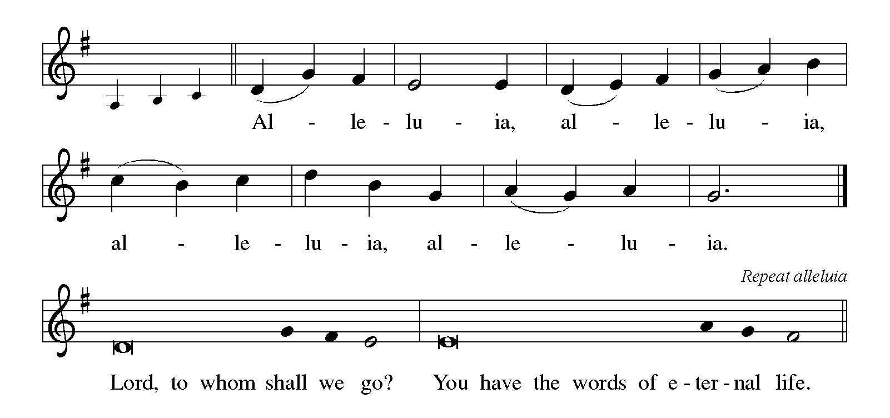

**THE HOLY GOSPEL Mark 13:1-8**

*In the last week of His life, Jesus warned the disciples concerning trials that were to come upon them and upon the world. He exhorts the listener: Do not be alarmed.*

P: The Holy Gospel according to St. Mark, the thirteenth chapter.

C: **Glory to You, O Lord!**

1As Jesus came out of the temple, one of His disciples said to him, "Look, Teacher, what large stones and what large buildings!" 2Then Jesus asked him, "Do you see these great buildings? Not one stone will be left here upon another; all will be thrown down."

3When He was sitting on the Mount of Olives opposite the temple, Peter, James, John, and Andrew asked Him privately, 4"Tell us, when will this be, and what will be the sign that all these things are about to be accomplished?"

5Then Jesus began to say to them, "Beware that no one leads you astray. 6Many will come in My name and say, 'I am he!' and they will lead many astray. 7When you hear of wars and rumors of wars, do not be alarmed; this must take place, but the end is still to come. 8For nation will rise against nation, and kingdom against kingdom; there will be earthquakes in various places; there will be famines. This is but the beginning of the birth pangs."

P: The Gospel of the Lord.

C: **Praise to You, O Christ!**

*The assembly is seated*

**THE SERMON**

*Silence for reflection follows the sermon*

*As you are able please rise*

**THE HYMN OF THE DAY 327 *Through the Night of Doubt and Sorrow* page 13**

**THE APOSTLES' CREED**

A: God has made us His people through our Baptism into Christ. Living together in trust and

hope, we confess our faith.

C: **I believe in God, the Father almighty,**

**creator of heaven and earth.**

**I believe in Jesus Christ, His only Son, our Lord.**

**He was conceived by the power of the Holy Spirit**

**and born of the virgin Mary.**

**He suffered under Pontius Pilate**

**was crucified, died, and was buried.**

**He descended into hell.**

**On the third day He rose again.**

**He ascended into heaven,**

**and is seated at the right hand of the Father.**

**He will come again to judge the living and the dead.**

**I believe in the Holy Spirit,**

**the holy catholic Church,**

**the communion of saints,**

**the forgiveness of sins,**

**the resurrection of the body,**

**and the life everlasting. Amen.**

**THE PRAYER OF THE CHURCH**

A: As creation moves toward fulfillment, let us pray through Jesus, the Son of Man, Who is

coming with great power and glory.

A: That the Church may faithfully share the wisdom handed on to it by God and lead many to

faith and trust in the Lord as the Day of the Lord draws near, we pray, O God:

C: **Let Your Kingdom come.**

A: That nations and peoples engulfed in conflict and war, especially in Syria, the Balkans, and

Ethiopia, may find the path to peace, we pray, O God:

C: **Let Your Kingdom come.**

A: That in the midst of natural disasters, violence, and social upheaval, the people of God will

remain faithful in word and deed to Christ and generously serve all in need, we pray, O God:

C: **Let Your Kingdom come.**

A: That this congregation may be stirred by the Spirit to ever deeper acts of compassion and

charity to those who in their need seek the presence of the Lord, we pray, O God:

C: **Let Your Kingdom come.**

A: That those who suffer from despair, guilt, grief, hunger, homelessness, and sickness, especially:

**. . .**  may find hope in Christ’s words and help from His disciples, we pray, O God:

C: **Let Your Kingdom come.**

A: That with the saints at rest in Christ we too may awake to everlasting life and shine like the

stars for all eternity, we pray, O God:

C: **Let Your Kingdom come.**

P: Loving God, You know our hopes and fears even before we speak them; hear the prayers of

Your people. Help us in our struggle to stay alert that we may be ready for the hour of Your

coming. We ask this through Christ our Lord.

C: **Amen.**

**✠ MEAL ✠**

**THE PEACE**

P: The peace of the Lord be with you always.

C: **And also with you.**

*The assembly is seated*

**THE VOLUNTARY Choir *Commit Your Way*  St. Paul Senior Choir**

*As you are able please rise*

**THE OFFERTORY PRAYER**

A: Let us pray. Gracious God,

C: **In this Eucharist we renew the covenant of our Baptism. Help us, through the offering**

**of ourselves to turn from all things that draw us from Your love that we may be alert and**

**watchful for Your return in glory. We ask this in the name of Jesus the Lord. Amen.**

**THE GREAT THANKSGIVING**

P: The Lord be with you.

C: **And also with you.**

P: Lift up your hearts.

C: **We lift them to the Lord.**

P: Let us give thanks to the Lord our God.

C: **It is right to give Him thanks and praise.**

P: Faithful and abiding God, we give You thanks and praise, for from the foundation of the

world You sought to bring us into covenant relationship with You.

You created us to enjoy You and one another, You called Abraham to lead a family in

Your ways, and through Moses You liberated Your people to be Your companions

forever.

After those days You promised to put Your laws into our hearts and write them in our

minds, and to remember our sins no more.

In Jesus our great High Priest You opened a new and living way into Your presence to

share eternal communion with You.

Inviting God, You bring us to Your Table, meeting true hearts that yearn to come before

You with full assurance of faith.

Give us a double portion of Your Spirit that we may glow with the radiance of Your glory.

Through the power of that same Spirit bless this bread and cup, that they may be for

us the Body and Blood of Your Son Jesus,

Who, in the night … “Do this for the remembrance of Me.”

As often as we eat … we proclaim the Lord’s death until He comes.

C: **Christ has died. Christ is risen. Christ will come again.**

P: Completing and perfecting God, in Your Son’s cross You took on the grief and failure of

the world, and in His resurrection You dismantled the power of sin and death.

Look with mercy on all Your people whose longings are unmet.

When Your children plead for the chance to be creative, productive, or nurturing, give

them gentleness, fulfillment, and purpose.

When Your people long to bring joy into the life of others, comfort to the afflicted, or trust

to the wounded, give them courage, wisdom, and patience.

When Your Kingdom seems far off, strengthen Your Church to wait with faith and hope

and love, until the Day when You are all in all,

One God: Father, Son, ✠and Holy Spirit.

C: **Amen!**

**THE LORD'S PRAYER**

P: With longing for the coming of God’s Kingdom, let us pray as Jesus taught us:

C: **Our Father, Who art in heaven, hallowed be Thy name.**

**Thy Kingdom come, Thy will be done on earth as it is in heaven.**

**Thy will be done on earth as it is in heaven.**

**Give us this day our daily bread, and forgive us our trespasses as we forgive those who**

**trespass against us.**

**And lead us not into temptation but deliver us from evil.**

**For Thine is the Kingdom and the power and the glory forever and ever. Amen.**

**INVITATION TO THE MEAL**

P: This is the Lamb of God Who takes away the sin of the world. Blessed are those who are called

to the Supper of the Lamb. God's holy gifts for God's holy people. Come, for all is now ready.

*The assembly is seated*

**THE DISTRIBUTION**

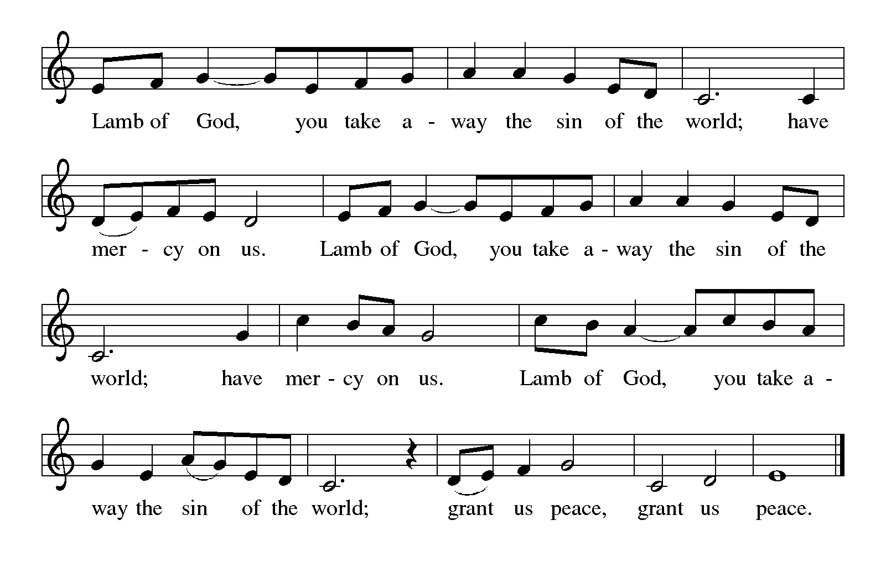

*Those wishing to receive the Laying on of Hands, Anointing with Oil,*

*and prayer for healing are invited to go to Pastor at the side aisle*

**HYMNS DURING DISTRIBUTION 438 *My Lord, What a Morning*  page 14**

**439 *Soon and Very Soon*  page 15**

*As you are able please rise*

**THE POST-COMMUNION BLESSING**

P: The Body and Blood of our Lord Jesus Christ strengthen you and keep you in His grace.

C: **Amen.**

**THE POST-COMMUNION PRAYER**

A: Let us pray. Lord God, in this holy Sacrament You have again refreshed us in Your new

covenant. Through this eating and drinking keep us strong in faith and hope until the Day

when You make the whole creation new. Grant this through Christ our Lord.

C: **Amen.**

**✠ SENDING ✠**

**THE BENEDICTION**

P: Almighty God: Father, Son, ✠ and Holy Spirit bless you now and forever.

C: **Amen.**

**SENDING HYMN 434 *Jesus Shall Reign*  page 16**

**THE DISMISSAL**

A: Go in peace to bear Christ's love to the world.

C: **Thanks be to God!**

**POSTLUDE** ***Duke Street*  Wilbur Held**

***✠ To God Alone Be Glory✠***

The Meditation, Greeting, Prayer of the Church, and Dismissal are adapted from *Sundays and*

*Seasons.* Copyright Augsburg Fortress, 1999.

The Eucharistic Prayer is adapted from *Eucharistic Prayers.* Samuel Wells and Abigail Kocher.

(Grand Rapids: Eerdmann’s Publishing Company, 2016) 326-27.

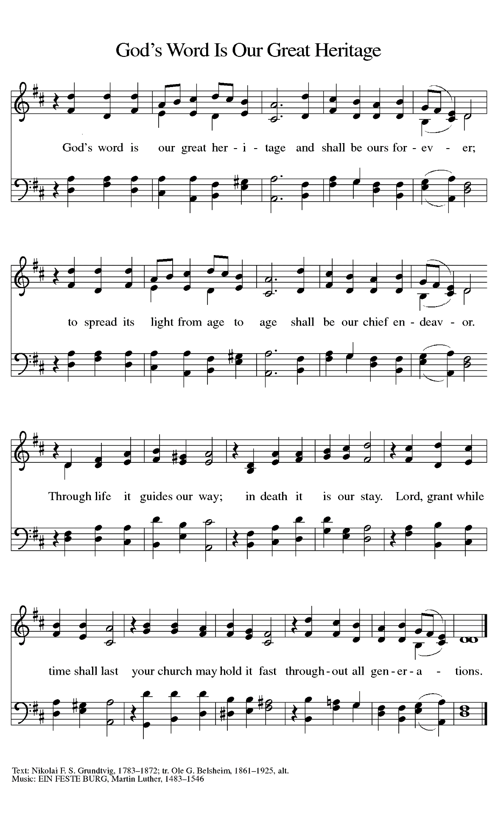

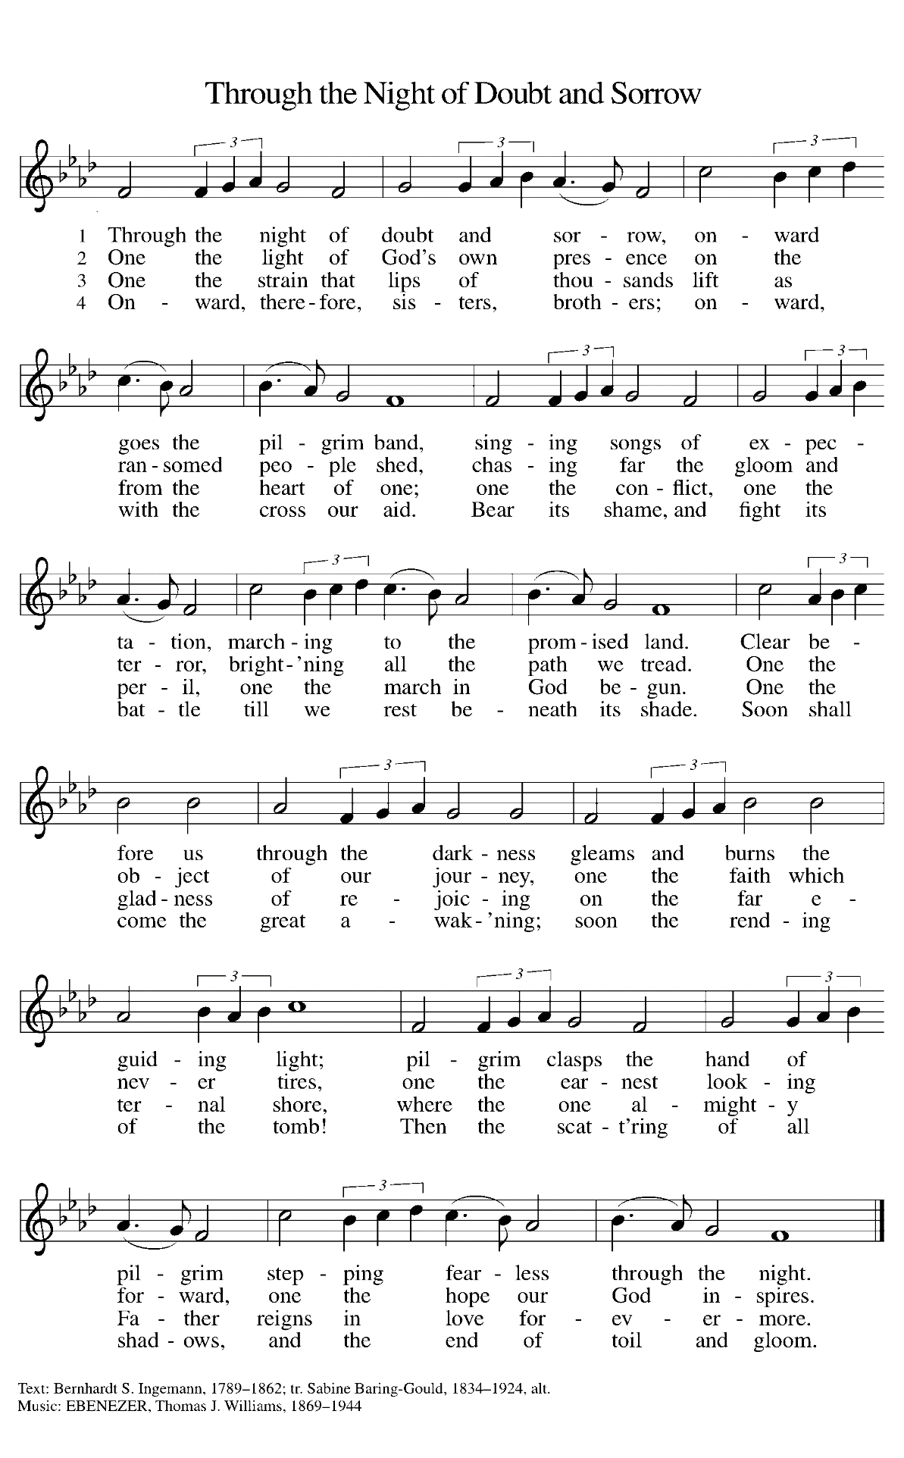

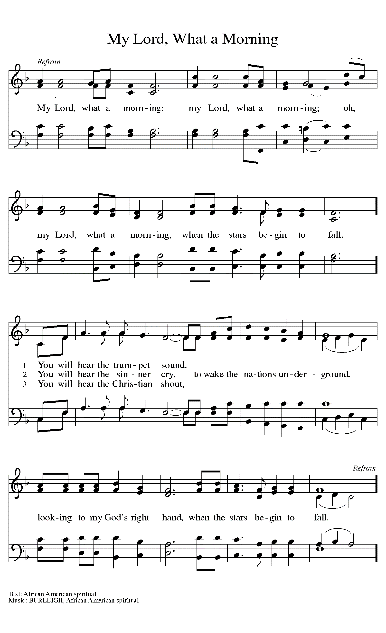

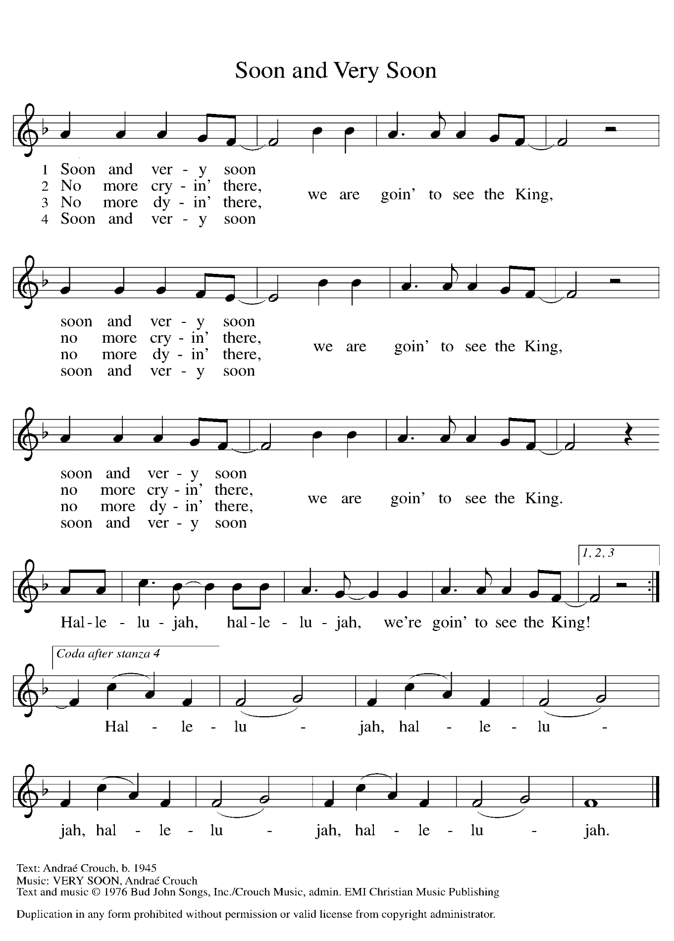

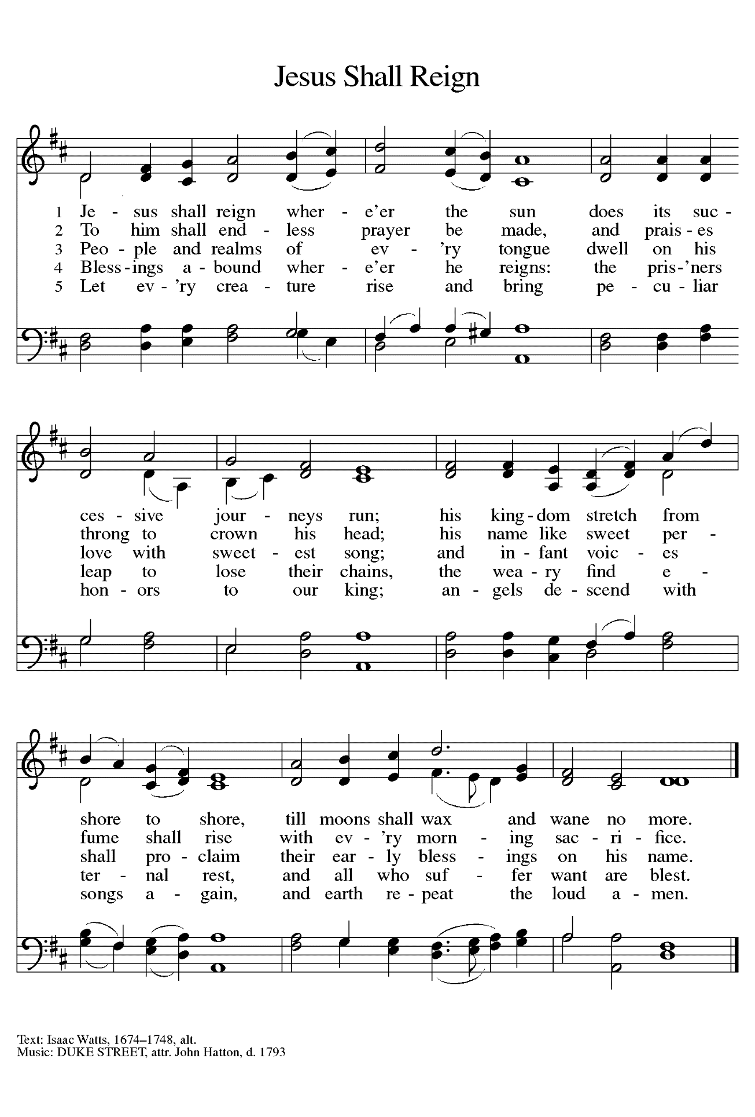

**ANNOUNCEMENTS**

**Please remember to mail your offering to the Church Office** at 818 Franklin Street, Michigan City, IN 46360**.** Another alternative is to give on-line through Tithe.ly. Please see your closure letter for information on how to set up a Tithe.ly account.

**St. Paul Members are reminded to have** a loved one contact the office if you are hospitalized. Many times, the Pastor doesn’t know someone is in the hospital. If you call and leave a message, please tell us which hospital the patient is at.

**Next Sunday’s lessons are Daniel 7: 9-10, 13-14; Psalm 93; Revelations 1: 4b-8; John 18: 33-37** for those of you who like to study them in advance.

**PRAYER CONCERNS:** Kathy Thielman, Audrey Beyer, Joyce and Bethany Manning, Marla Furness, Kay Peglow, Lee Timm, Ryan Krueger, Donna Bostater, Diane Gielow, Jeff Jensen, Maxine Powell, Jess Kalvaitis, Pastor Al Lorentzen, Jan Paholski, Laura Dovey, Heidi Happel, Shane Nevels, Irene Bohnstadt, Joan Coughlin, Jim Tomscheck, Wally & Betty Ratliff, Laura Moore, Cameron Rackard, Erik Tannehill, Ruth Lubs, Ed Gustum, Ken Mulder, Ashton Steele, Christian Martinez, Nancy Wisser, Ryan Sirk, Tyler Brown, Jary Tannehill, Susan McKinnon and Jim Gleason.

**If you requested someone’s name to be on the prayer list and are aware that they need continued imminent prayer then contact the church office and let us know.** Otherwise we will gradually transfer names to the long-term list.

**OFFICE HOURS:** Libby will be in the office on Mondays, Wednesdays, and Fridays; volunteers will cover Tuesdays and Thursdays.

Monday & Wednesday 8:00 a.m. – 5 p.m.

Tuesday & Thursday 9:00 a.m. – 12:00 p.m.

Friday 8:00 a.m. – 12:00 p.m.

**If you are listening to the worship broadcast on the radio and would like to watch the Sunday morning service live stream follow these steps:**

1. If you have You.Tube available on your TV, search for

**St. Paul Lutheran Church Michigan City, IN.**

1. The direct link on the computer is

<https://www.youtube.com/channel/UC5AIPNaKr3QN50984jGOa1g>.

1. This link is also on the main page of the church’s website in the church section and will continue to be posted weekly on the St. Paul Facebook page.

And it will always be available on the radio broadcast Sunday mornings at 11:00 a.m. on WEFM (95.9), and on the local cable access station #99 for the previous week’s service on Sundays at 4:00 p.m. and the current service on Wednesdays at 7:00 p.m. and Fridays at 8:30 p.m.

**To send e-mail to the church office**, please use the following addresses:

 Pastor Mark Reshan: [seniorpastor@stpaulmichigancity.com](mailto:seniorpastor@stpaulmichigancity.com)

 Church Office Secretary (Libby Pollock): [churchsecretary@stpaulmichigancity.com](mailto:churchsecretary@stpaulmichigancity.com)

 Church Treasurer (Karen Fleming) and Bookkeeper (Billie Atchinson):

[finance@stpaulmichigancity.com](mailto:finance@stpaulmichigancity.com).

**The Good News Newsletter**: If you have an article or anything you want included in **The Good News** please send it to the following e-mail address: splcgoodnews@gmail.com. Pastor Pamela Thiede will be using this e-mail address to assemble **The Good News** each month. The deadline for getting information to Pastor Pamela will be the 20th of each month.

**WORSHIP ATTENDANCE for November 6 and 7, 2021**

**4:00 p.m. 50**

**9:00 a.m. 47**

**Total = 97**

**The Community Soup Kitchen serving out of First United Methodist is in need of volunteers.** Sunday through Tuesday is always need, as is occasionally Wednesdays and Thursdays. Hours are 9:30 a.m. to 1:15 p.m. and it is not necessary to stay the entire time. There is also a need for volunteers to be available to help pick up deliveries from the Food Bank when they arrive. If you are able to help please contact their church office at 872-7200.

**MEETINGS & ACTIVITIES IN NOVEMBER**

Worship Service: Saturday, November 13, 2021 at 4:00 pm

Worship Service: Sunday, November 14, 2021 at 9:00 am

Finance Committee: Monday, November 15, 2021 at 4:00 pm/St. Paul Room

Wednesday Bible Study: Wednesday, November 17, 2021 at 9:45 am/ Luther House

Worship Service: Saturday, November 20, 2021 at 4:00 pm

Worship Service: Sunday, November 21, 2021 at 9:00 am

Wednesday Bible Study: Wednesday November 24, 2021 at 9:45 am/Luther House

THANKSGIVING

Worship Service: Saturday, November 27, 2021 at 4:00 pm

Worship Service: Sunday, November 28, 2021 at 9:00 am



**CHRISTMAS POINSETTIAS**

It’s time to start thinking about purchasing a Christmas Poinsettia. Each plant will be in a 6½-inch pot with 3 – 6 blooms. Each plant will cost $6.50 and can be given “in memory of” or “in honor of” a loved one. Please place your order through the church office (219-874-7293); or place your information on an envelope with cash or a check made out to St. Paul Lutheran Church, and place it in the offering plate. You are welcome to take your plant(s) home after the Christmas Eve, Christmas Day, or Sunday (December 26) service. **Orders must be placed by Monday, December 13.** The final count will be turned in that day.



It is not too early to post information about our end-of-Advent and Christmas Eve/Day and following worship services. We will include them in the December newsletter as well, but it might be helpful to mark your calendars now for these special liturgies.

**Saturday, December 18** Fourth Saturday in Advent 4:00 p.m.

**Sunday, December 19** Fourth Sunday in Advent 9:00 a.m.

**Friday, December 24** Christmas Eve 6:00 p.m.

**Saturday, December 25** Christmas Day 10:00 a.m.

**(No 4:00 p.m. worship)**

**Sunday, December 26** The First Sunday of Christmas 9:00 a.m.