-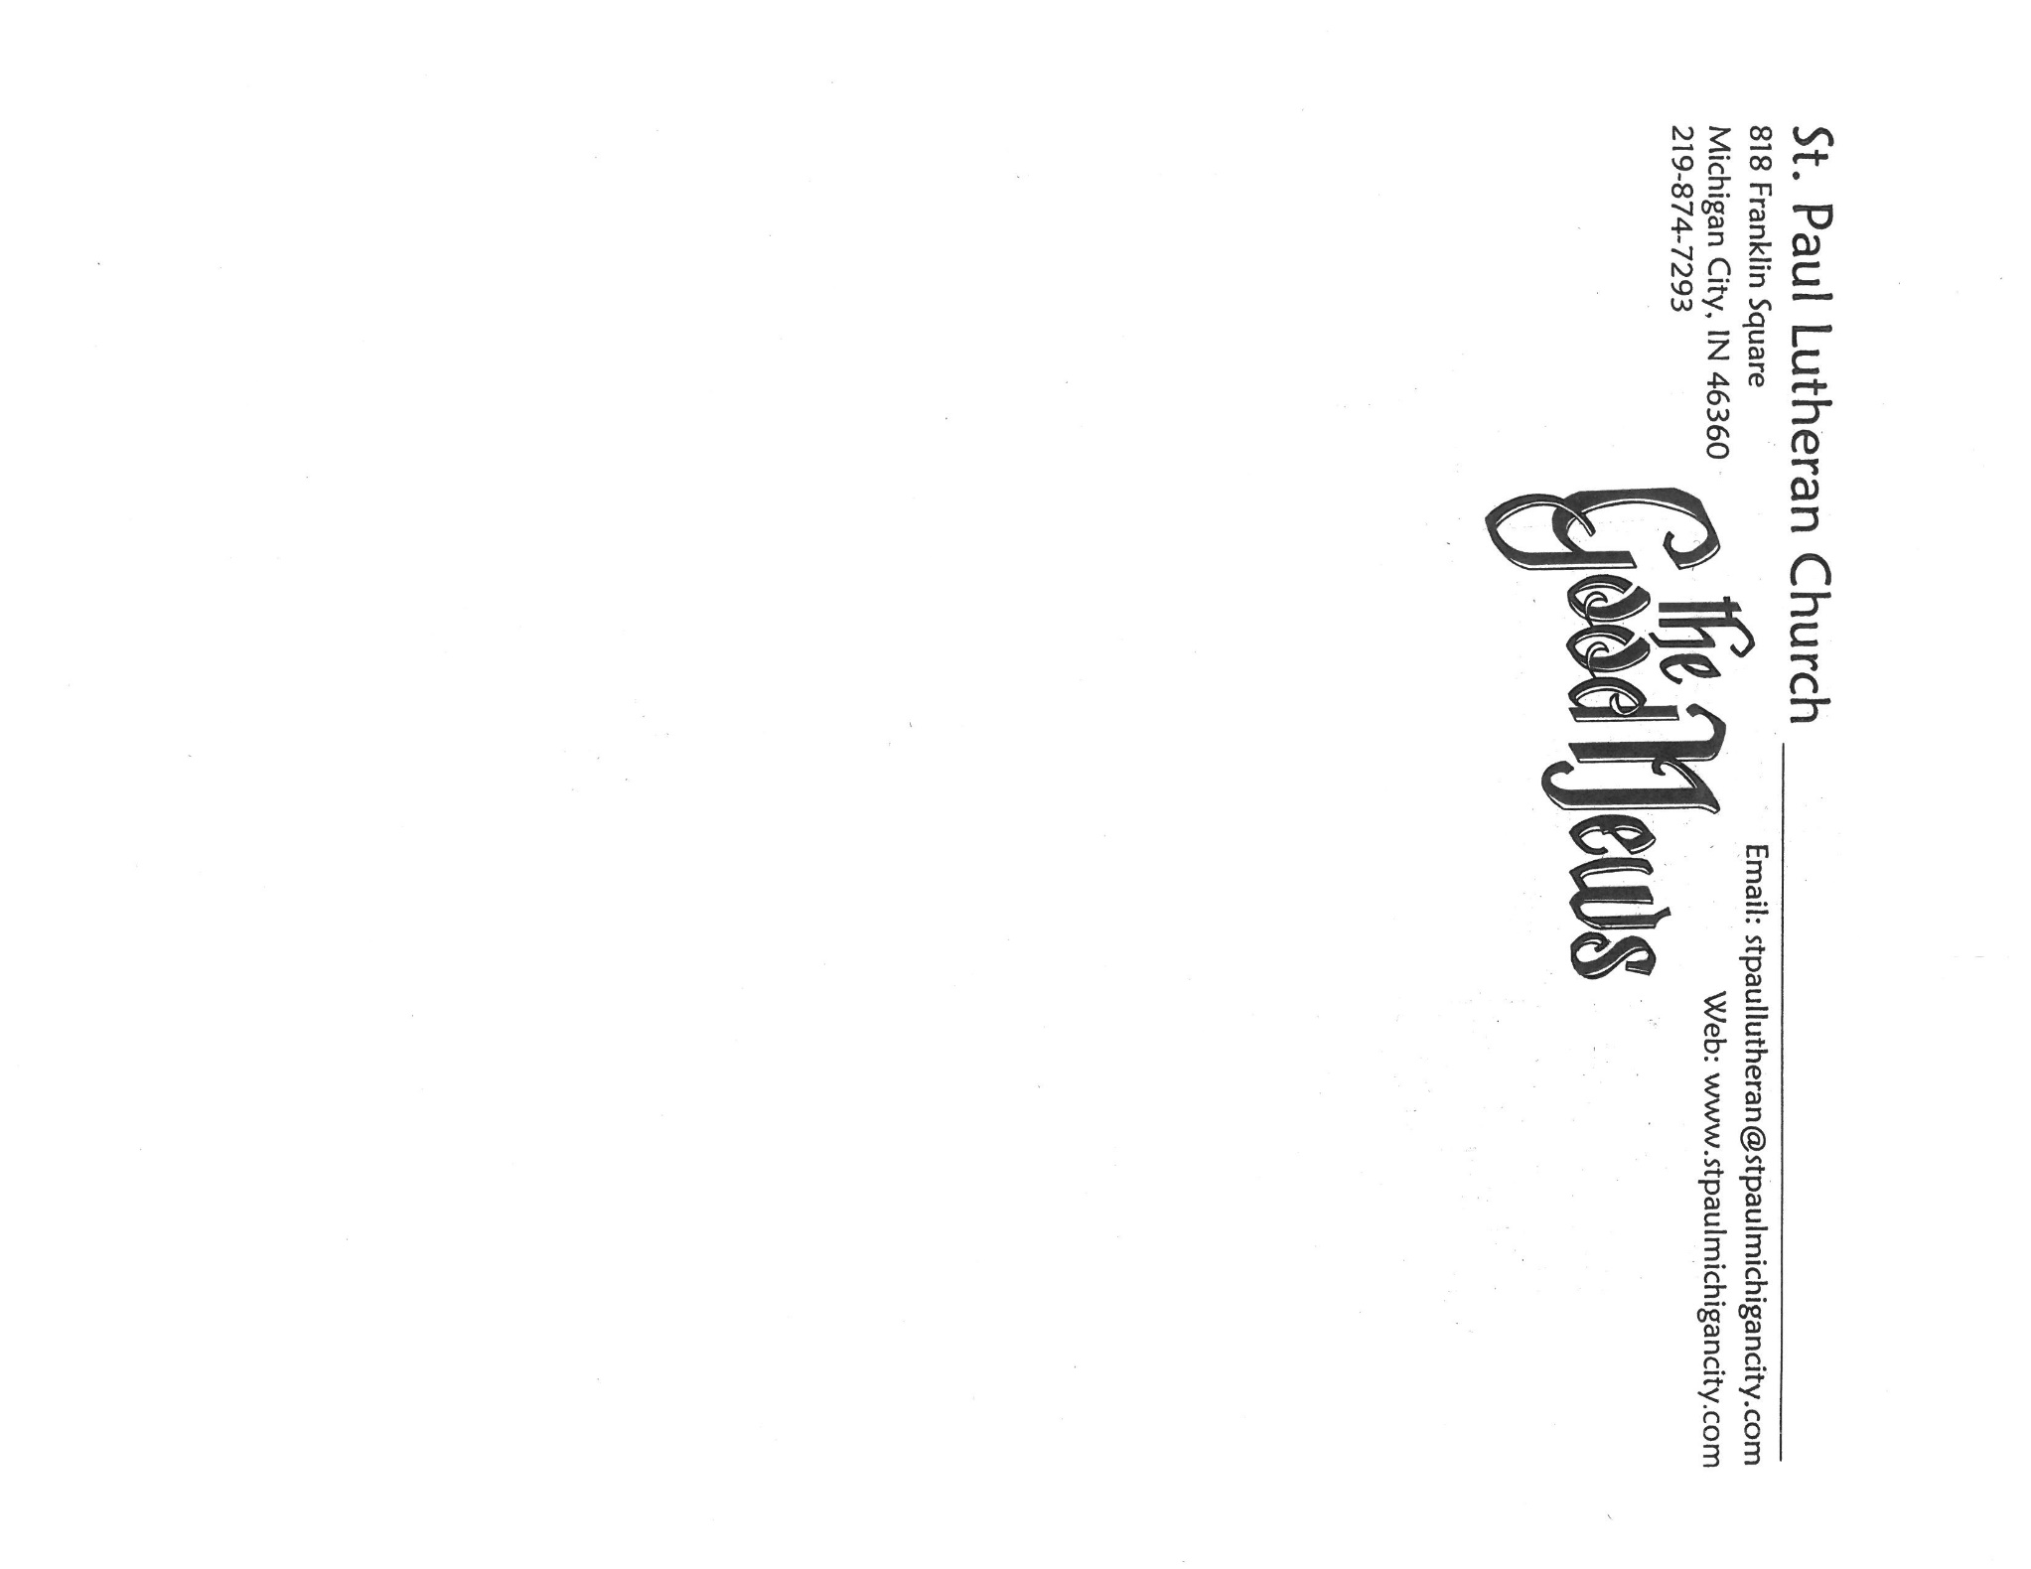
June, 2026
MARK: MY WORDS

When Maggie first came to play for us several years ago, she stated very clearly that she was not an organist. She had never taken organ lessons, had no interest in doing so, and didn’t even like the sound of the organ. At the time, that was fine with us. Many of us missed the sound of the organ during worship; but we were so deeply grateful that we had someone of her skills and ability to play the piano, it was not a big issue for us.
In addition, we thought that she was an interim musician for us until we found a permanent Director of Music that we hoped would use the organ. Obviously, all of that changed and evolved over the past several years. The congregation fell in love with Maggie, her playing, and her rapport with the choir and handbell choir. We offered her the permanent position of Director of Music and were thrilled when she accepted.
And then, one Sunday, to everyone’s surprise and delight, the organ sounded again for the Sending Hymn and Postlude. On her own initiative, Maggie started to take organ lessons from John Carington, who had filled in for us numerous times over the past several years. Though the lessons have been spotty due to schedules, she continues to work with him to expand her knowledge and repertoire for the organ. I think that she has even come to enjoy and appreciate the power and majesty of the instrument . She now regularly plays the Sending Hymn and Postlude on it for both liturgies.
We are happy to announce that there will now be additional opportunities to hear the organ played. For many years/ the Congregational Church on Washington Street sponsored a series of summer recitals at noon every Wednesday on their historic Roosevelt Organ. When the congregation closed, the building was purchased by another community of faith; but the recitals did not continue. The organ was badly in need of repair, and there were not sufficient funds to do so.
Last summer the recitals were held at Trinity Episcopal Church, where George Karst, who often fills in when Maggie is gone, is the organist; but they removed the pipes so work done to repair their roof does not damage them. The series was without a home. George called several weeks ago and asked if we might be interested in hosting the concerts.
After discussion with the executive team, we informed the coordinator of the series that we would be happy to have the recitals here. It is the consensus of local organists that we have the finest instrument in Michigan City and most probably in much of Northwest Indiana. It is likely that many of the organists have never heard or played it. This will get people into the building that perhaps normally would not attend here and give us a chance to show off the organ for local musicians. It will also be a wonderful gift to the community.
The schedule is being formed. When we receive a listing of concerts, we will publish that in the bulletin and on our Facebook page. The recitals will be every Wednesday at noon at least through June and July and perhaps into August. They will last around 45 minutes. We are excited and grateful for this chance to showcase our building and organ. We hope that you will find time to support these local musicians and enjoy the great variety of music that they will bring.



FESTIVAL DAYS OF WORSHIP

The end of May brought three of the six major feast Days of the church year: The Ascension of our Lord (May 16-17); the Day of Pentecost (May 23-24); and The Holy Trinity (May 30-31).
These Days bring the Fifty Days of Easter to their close and usher us into the longest season of the church year, Pentecost. Because it stretches from early June into November, we have always looked for minor festivals or commemorations of important figures of the Church to help break up the monotony of the seemingly endless weeks of Pentecost.
A quick survey seemed to show that there were precious few of such days this summer and fall. The church calendar just isn’t falling in that way. We will remain vigilant and take the opportunity to celebrate such days when they arise over the next months.



MUSICAL SETTING OF THE LITURGY

For some years now, we have turned to Marty Haugen’s “Now the Feast and Celebration” musical setting of the liturgy during the summer. It is a more relaxed accompaniment than those from our red hymnal and has grown to be a great favorite of the congregation. Beginning with our celebration of Pentecost, we will return to that setting and use it throughout the summer until the fall.


CONGRATULATIONS, GRADUATES!

Congratulations to—
- Aiden Squires (grandson of David & Nancy Squires): Summa Cum Laude from South Beloit High School (Illinois) with an Associate of Arts from Rock Valley College
- Daniel Reshan (son of Pastor & Judy Reshan): Bachelor of Science in Astronomy/ Astrophysics from Case Western Reserve University (Cleveland, Ohio)
- Jacob Reshan (son of Pastor & Judy Reshan): Bachelor of Science in Electrical Engineering from Rose-Hulman Institute of Technology (Terre Haute, Indiana)

A PERSONAL NOTE

We are grateful for the interest and support for Dan and Jacob’s completion of their college education. We had a great weekend in Cleveland on May 16-18 for Dan’s ceremony at Case Western Reserve University. He won an award for Outstanding Achievement by a Senior in his major of Astronomy. The graduation was extremely well-planned and executed.
The entire weekend was so impressive and gratifying. It is easy to see why Case has been named one of the top 25 universities in the U. S. by Time Magazine and designated as one of “The New Ivies” (Ivy League caliber schools) by Forbes Magazine.
Next up is Jacob’s graduation from Rose-Hulman Institute of Technology in Terre Haute on May 30. From reports of parents whose children graduated from there, we are expecting no less a wonderful and inspiring ceremony and experience.


I scream, you scream, let's all scream for FREE ice cream on Sunday, July 19! We will be celebrating the church's 150th anniversary with an ice cream social in the St. Paul Room following Sunday morning worship on July 19. Please plan to join us and the Bubble's crew to enjoy an unlimited, no-cost-to-you sundae bar! Come and create your favorite concoction of vanilla, Zanzibar chocolate, strawberry, or butter pecan topped with marshmallow creme, chocolate sauce, hot caramel, whipped topping, sprinkles, or nuts, and of course a cherry on top! Everyone is encouraged to wear their St. Paul 150th anniversary shirts to worship and the ice cream social that day. Bring your friends, bring your family, but most of all, bring your sweet tooth! We can't wait to celebrate 150 years of worship with you and a sweet treat!
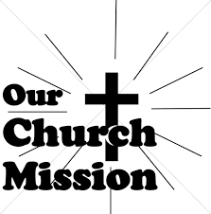

JUNE MONTHLY MISSION –
SERVICE LEAGUE OF MICHIGAN CITY

The Service League of Michigan City is a nonprofit organization of volunteers that loans medical equipment and provides supplemental adult incontinence supplies to the residents of LaPorte County. Equipment loans are for three months, and most items can be borrowed for free. As a nonprofit, they maintain their services through the generosity of community donations, competitive grants, memorials, and member support. The Service League receives no government funds. To help support their generous mission, we will be collecting both monetary donations as well as the following items:
- Disposable gloves
- Disposable Gauze rolls, dressing pads, and surgical tape
- Disposable pull up and tab adult briefs (opened and unopened packages)​
Please make checks payable to St. Paul, mark “Service League” in the memo line, and place in the offering. Noisy Coin Offering for the month of June will also go to the Service League. Items can be placed in the bin in the outer Narthex. Thank you for your generosity each month!



IN MEMORY OF JOHN BENNITT
General Fund from Jim & Sandy Galinowski

IN MEMORY OF MOTHERS RUTH BURNS & HEDWIG HANFT
General Fund from Carol Hanft

IN MEMORY OF FREDERICK WEISS
General Fund from Jana Thomas

IN MEMORY OF DIANE WALTZ
General Fund from Hope Circle (Bev, Lori, Sue, Stacie, Virginia, and Susan)


June Birthdays June Anniversaries
1 Andrea Ottersen 6 Mike & Marge Bockover
2 Bethany Manning 8 Daniel & Brittany Struebing
5 Daniel Struebing 9 Ron & Melinda Nagle
7 Vivian Zellers 12 David & Donna Sutor
8 Richard Cains 13 Tom & Amy Petri
9 Lynne Nevels 15 Douglas & Pamela Kienitz
12 Leigh Coburn 23 William & Pamela Hackett
14 Janet Bakken
Ivye Benson
15 Jacob Ziesmer
16 Jacob Hazel
19 Jeffrey Hazel
20 Jim Schraidt
21 Clara Lorentzen
Beverly Coburn
23 Alex Scheuchner
24 Lou Ann Shebel
Dawn Fitzhugh
25 Muriel Jacobi
26 Helen Hill-Weaver
Daniel Reshan
Jacob Reshan
27 Cynthia Scheuchner
Helena Albertson
Jacob Payne



Long-Term Prayer List

Lucas Bradshaw Laura Dovey Bethany Manning
Debbie Martin Shirley McCarty Sarah McNabb
Jan Paholski Martha Schroeder Jeanie Boatman Shepple
Kathy Stein Mark Tannehill Kathy Thielman
Delores Williams Brian Wiseman

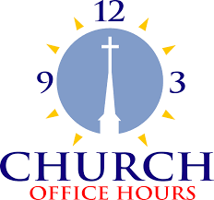

Monday 8:00 a.m. – 5 p.m.
Tuesday 9:00 a.m. – 12:00 noon
Wednesday 8:00 a.m. – 5 p.m.
Thursday 9:00 a.m. – 12 noon
Friday 8:00 a.m. – 12 noon

St. Paul Lutheran Church Staff
Pastor Rev. Mark Reshan
Secretary Libby Pollock
Accompanists Jary Tannehill, Mark Tannehill, Jacob Tannehill
Custodian Mark Kloess

Thank$ for $haring

This month, we are going to Holly’s on Tuesday, June 9. Here are two coupons—one for you and one for a friend.



