THE THIRD SUNDAY OF ADVENT
December 17, 2023

“ ...Perhaps that is why there is so little real joy in our congregations. If we do experience joy, it is too often the ersatz high of a merely emotional rush brought on by an effective music program--joy induced by a pleasing soprano voice backed up by a pre-recorded tape. If the only theology we have to preach is of the pull-yourself-up-by-your-bootstraps variety, then we are doomed. Doom produces gloom.
In our better moments, we know that the ultimate sources of our mourning are more than psychological--they are political, social, maybe even cosmic. This society tries to convince us that if we are hungry for something more than food, if we gaze at the full shop windows at Christmas and can’t find anything we really want, if we wander through the decorated shopping malls in a daze, it is a personal problem, something amiss in our psyche, something in need of corrective therapy.
What if, as Isaiah implies, our problem is as much political as psychological? What if what’s wrong with us is what’s wrong in the whole society, something out of kilter in the cosmos? What if our pain will be soothed by nothing less than the advent of God? The offer of anything less is a cheap substitute, a set-up for even greater despair. Real, full-throated, full-orbed, let loose joy is a gift to those who have heard the testimony: Our God comes ...”
...If we Christians are joyful, ours is not the simple-minded, bubble-brained cheerfulness of those who deny the world’s hunger and pain or who think that somehow, it is all for the best. Joy is to us a gift, a Christmas gift of a God who is never content to leave us be, who intrudes, offers, creates ...”

William Willimon

In the Name of Jesus

GATHERING

INTRODUCTION
"Rejoice always," begins the reading from First Thessalonians. Isaiah and the psalmist make clear that God is turning our mourning into laughter and shouts of joy. "All God's children got a robe," go the words of the spiritual. It is not so much a stately, formal, pressed outfit as it is a set of party clothes, clothes that make us feel happy just to put on. We receive that robe in baptism, and in worship we gather for a foretaste of God's party.

PRE-SERVICE MUSIC You Turned My Mourning Into Dancing The Praise Band
(Tommy Walker)

ANNOUNCEMENTS

As you are able please rise

CONFESSION AND ABSOLUTION

P: In the name of the Father and of the Son and of the Holy Spirit.

C: Amen.

P: “May the God of peace Himself sanctify you entirely; and may your spirit and soul and
body be kept sound and blameless at the coming of our Lord Jesus Christ.” (1
Thessalonians 5: 23) It is God’s desire to keep you holy and acceptable to Him. Let us
therefore confess our sins, that by God’s great mercy, we may again be made
“blameless.”

Silence for self-examination and reflection is kept

P: Most merciful God,

C: We confess that we have sinned against You in thought, word, and deed. Instead
of constant rejoicing we have given ourselves to cynicism and despair. Instead of
giving thanks for the blessings we have we complain about those we do not. (1
Thessalonians 5: 18). We do not hold fast to what is good, and too easily we
embrace what is sinful and hurtful. (5: 21-22). Forgive us, O God, for the sake of
Your Son, Jesus Christ. Send us Your Holy Spirit to help us amend our lives that
we may be prepared for Your advent.

P: Rejoice in the Lord with all your heart. (5: 16) For the sake of Jesus Christ, Who was
given to die for you, God has clothed you with the “garments of salvation” and covered
you with the “robe of righteousness.” Therefore, as a called and ordained minister of
the church of Christ, and by His authority, I therefore declare to you the entire
forgiveness of all your sins, in the name of the Father and of the Son and of the Holy
Spirit.

C: Amen.

P: Show us Your mercy, O Lord:

C: And grant us Your salvation!

GATHERING SONG Band

THE GREETING AND PRAYER OF THE DAY

P: Christ comes to lighten our darkness.

C: Come, Lord Jesus.

P: The grace of our Lord Jesus Christ, the love of God, and the communion of the Holy
Spirit be with you all.

C: And also with you.

P: Let us pray. Stir up the wills of Your faithful people, Lord God, and open our ears to
the words of Your prophets, that, anointed by Your Spirit, we may testify to Your light;
through Jesus Christ, our Savior and Lord, Who lives and reigns with You and the Holy
Spirit, one God, now and forever.

C: Amen.

The assembly is seated

THE LIGHTING OF THE ADVENT LOG

THE HYMN DURING THE LIGHTING 266 All Earth is Hopeful Stanzas, 1-3

P: Let us pray. Blessed are You, O Lord our God, Ruler of the universe. Your prophets
spoke of a day when the desert would blossom and waters would break forth in the
wilderness. Bless us as we light the candles on this log. Strengthen our hearts as we
prepare for the coming of the Lord. May He give water to all who thirst, for He is our
light and our salvation. Blessed be God forever.

C: Amen.

Choir Shines the Light St. Paul Senior Choir
(Lee Dengler)

WORD

FIRST READING Isaiah 61: 1-4, 8-11

Though the people had returned to Jerusalem from exile in Babylon, they continued to face hardship and oppression. In the language of the jubilee year described in Leviticus 25, the prophet, moved by the spirit of the Lord, announces deliverance for those who are oppressed and comfort for those who mourn.

The spirit of the Lord GOD is upon me,
because the LORD has anointed me;
He has sent me to bring good news to the oppressed,
to bind up the brokenhearted,
to proclaim liberty to the captives,
and release to the prisoners;
²to proclaim the year of the Lord’s favor,
and the day of vengeance of our God;
to comfort all who mourn;
³to provide for those who mourn in Zion--
to give them a garland instead of ashes,
the oil of gladness instead of mourning,
the mantle of praise instead of a faint spirit.
They will be called oaks of righteousness,
the planting of the LORD, to display his glory.
⁴They shall build up the ancient ruins,
they shall raise up the former devastations;
they shall repair the ruined cities,
the devastations of many generations.
⁸For I the LORD love justice,
I hate robbery and wrongdoing;
I will faithfully give them their recompense,
and I will make an everlasting covenant with them.
⁹Their descendants shall be known among the nations,
and their offspring among the peoples;
all who see them shall acknowledge
that they are a people whom the LORD has blessed.
¹⁰I will greatly rejoice in the LORD,
my whole being shall exult in my God;
for He has clothed me with the garments of salvation,
He has covered me with the robe of righteousness,
as a bridegroom decks himself with a garland,
and as a bride adorns herself with her jewels.
¹¹For as the earth brings forth its shoots,
and as a garden causes what is sown in it to spring up,
so the Lord GOD will cause righteousness and praise
to spring up before all the nations.

The Word of the Lord.

Thanks be to God.

THE PSALM: Psalm 126 Read responsively

¹When the LORD restored the fortunes of Zion,
then were we like those who dream.

²Then was our mouth filled with laughter,
and our tongue with shouts of joy.
Then they said among the nations,
"The LORD has done great things for them."

³The LORD has done great things for us,
and we are glad indeed.

⁴Restore our fortunes, O LORD,
like the watercourses of the Negeb.

⁵Those who sowed with tears
will reap with songs of joy.

⁶Those who go out weeping, carrying the seed,
will come again with joy, shouldering their sheaves.

SECOND READING 1 Thessalonians 5: 16-24

First Thessalonians is believed to be the earliest of Paul's letters. He concludes his first epistle with joyful admonitions and blessings grounded in the hope of Christ's coming.

Rejoice always,
¹⁷pray without ceasing,
¹⁸give thanks in all circumstances; for this is the will of God in Christ Jesus for you.
¹⁹Do not quench the Spirit.
²⁰Do not despise the words of prophets,
²¹but test everything; hold fast to what is good;
²²abstain from every form of evil.
²³May the God of peace Himself sanctify you entirely; and may your spirit and soul and
body be kept sound and blameless at the coming of our Lord Jesus Christ.
²⁴The One Who calls you is faithful, and He will do this.

The Word of the Lord.

Thanks be to God.

As you are able please rise

THE VERSE

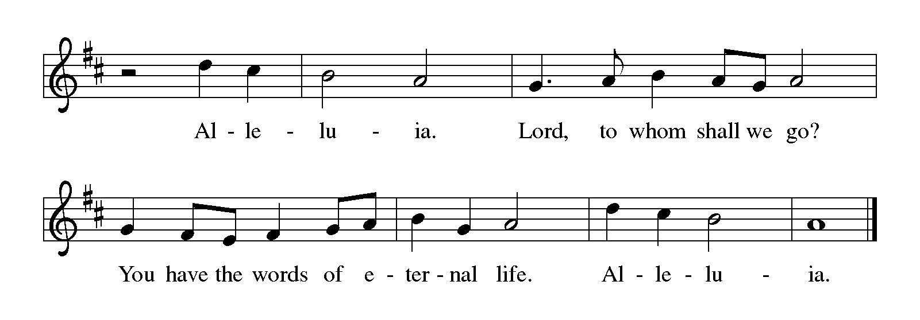
THE HOLY GOSPEL John 1: 1-8, 19-28

John’s gospel describes Jesus as “the light of the world.” John the Baptist is presented as a witness to Jesus, as one who directs attention away from himself to Christ, the true light.

P: The Holy Gospel according to St. John, the first chapter.

C: Glory to You, O Lord!

¹In the beginning was the Word, and the Word was with God, and the Word was God.
²He was in the beginning with God.
³All things came into being through Him, and without Him not one thing came into being. What
has come into being through Him is life,
⁴and the life was the light of all people.
⁵The light shines in the darkness, and the darkness did not overcome it.
⁶There was a man sent from God, whose name was John.
⁷He came as a witness to testify to the light, so that all might believe through him.
⁸He himself was not the light, but he came to testify to the light.
¹⁹This is the testimony given by John when the Judeans sent priests and Levites from
Jerusalem to ask him, "Who are you?"
²⁰He confessed and did not deny it, but confessed, "I am not the Messiah."
²¹And they asked him, "What then? Are you Elijah?" He said, "I am not." "Are you
the prophet?" He answered, "No."
²²Then they said to him, "Who are you? Let us have an answer for those who sent us.
What do you say about yourself?"
²³He said,
"I am the voice of one crying out in the wilderness,
'Make straight the way of the Lord,' "
as the prophet Isaiah said.
²⁴Now they had been sent from the Pharisees.
²⁵They asked him, "Why then are you baptizing if you are neither the Messiah, nor
Elijah, nor the prophet?"
²⁶John answered them, "I baptize with water. Among you stands One Whom you do
not know,
²⁷the One Who is coming after me; I am not worthy to untie the thong of His sandal."
²⁸This took place in Bethany across the Jordan where John was baptizing.

P: The Gospel of the Lord.

C: Praise to You, O Christ!

The assembly is seated

THE SERMON
Silence for reflection follows the sermon

As you are able please rise

THE HYMN OF THE DAY 815 I Want to Walk as a Child of the Light

THE NICENE CREED

A: God has made us His people through our Baptism into Christ. Living together in trust
and hope, we confess our faith.

We believe in one God,
the Father, the Almighty,
Maker of heaven and earth,
of all that is, seen and unseen.

We believe in one Lord, Jesus Christ,
the only Son of God,
eternally begotten of the Father,
God from God, Light from Light,
true God from true God,
begotten, not made,
of one Being with the Father.
Through Him all things were made.
For us and for our salvation
He came down from heaven;
by the power of the Holy Spirit
He became incarnate from the virgin Mary, and was made man.
For our sake He was crucified under Pontius Pilate;
He suffered death and was buried.
On the third day He rose again
in accordance with the Scriptures;
He ascended into heaven
and is seated at the right hand of the Father.
He will come again in glory to judge the living and the dead,
and His kingdom will have no end.

We believe in the Holy Spirit, the Lord, the giver of life,
Who proceeds from the Father and the Son.
With the Father and the Son He is worshiped and glorified.
He has spoken through the prophets.
We believe in one holy catholic and apostolic Church.
We acknowledge one Baptism for the forgiveness of sins.
We look for the resurrection of the dead,
and the life of the world to come. Amen

THE PRAYER OF THE CHURCH

A: Pleading for God’s gift of a renewing and life-giving Spirit, let us offer our prayers to
God for the Church, the world, and all those in need.

A: That all the baptized, anointed by the Spirit, may proclaim the Good News of this year
of the Lord’s favor, we pray to the Lord:

C: Stir up Your power, O Lord, and come.

A: That those in our world held captive to political oppression, economic deprivation, or
religious persecution would find the joy of liberation and freedom, we pray to the Lord:

C: Stir up Your power, O Lord, and come.

A: That in this season of waiting and watching for the Prince of Peace there might be an
end to violence, war, and terrorism, we pray to the Lord:

C: Stir up Your power, O Lord, and come.

A: That in this week this assembly might hold fast to what is good, abstain from every
form of evil, and be kept holy for the coming of the Lord Jesus Christ, we pray to the
Lord:

C: Stir up Your power, O Lord, and come.

A: That those imprisoned by loneliness, weariness, anxiety, homelessness, addiction, and
illness, especially: Pastor Al Lorentzen; Jana Thomas; Venia Wendt; Virginia
Murray; Betty Yourist; Kay Kleinschmidt; and Kim Mitchell might know the
healing Light of Christ, we pray to the Lord:
C: Stir up Your power, O Lord, and come.

A: That those celebrating birthdays, especially Virgil Miller may grow in grace this day
and every day and be filled with grace for the days ahead, we pray to the Lord:

C: Stir up Your power, O Lord, and come.

A: That those who mourn, especially the family and friends of Jim Van Dusen, brother of Betty Yourist, who died in the Lord this week may be comforted by the promise of resurrection to life everlasting and of being reunited with those they love before the throne of the Lamb, we pray to the Lord:

C: Stir up Your power, O Lord, and come.

A: That with the faithful departed, whom God has fully clothed with the garments of
salvation we too may be kept sound and blameless until Christ’s advent, we pray to
the Lord:

C: Stir up Your power, O Lord, and come.

P: Send the Spirit of Jesus upon us, O God, that we may be Your songs of peace and joy
in this world, through Your Son, Jesus Christ our Lord.

C: Amen.
MEAL
THE PEACE

P: The peace of the Lord be with you always.

C: And also with you.

The assembly is seated

THE OFFERING

THE VOLUNTARY Amazing Grace, My Chains Are Gone The Praise Band
(Newton, Tomlin, Giglio)

THE OFFERTORY HYMN 257 Oh, Come, Oh, Come, Emmanuel Stanza 1

THE OFFERTORY PRAYER

A: Let us pray. God of hope,

C: It is Your will that we give thanks at all times and in all ways. With these gifts we
bless You for the abundance of Your love. Receive them for the sake of Your Son,
Jesus Christ. By this Sacrament make us holy in word and deed. By Your Spirit,
keep us faithful to our witness to the true Light, Your Son, Jesus Christ our Lord.
Amen.

THE GREAT THANKSGIVING

P: The Lord be with you.

C: And also with you.

P: Lift up your hearts.

C: We lift them up to the Lord.

P: Let us give thanks to the Lord our God.

C: It is right to give Him thanks and praise.

P: It is indeed right to give You thanks and praise, Lord God, for You have clothed us
with the garments of salvation and covered us with the robe of
righteousness.
In Baptism You forgive our sins, part the waters of our liberation, and bring us to the
safe shore of everlasting life.
In faithfulness You keep our spirit and soul and body blameless until the coming of
Your Son Jesus Christ.
In His death You dismantle the power of death, and in His resurrection You raise up
the joy of everlasting life.
Abiding God, You made an everlasting covenant with Your people, and when that
covenant was jeopardized You sent Your Son Jesus.
In bread and wine He reenacted Your Passover promises, and became the Lamb of
God that takes away our sin.
Send now Your Holy Spirit on us that we may hold fast to what is good and live in
the freedom of being Your children.
Send Your Spirit on this bread and cup, that they may be for us the Body and Blood
of Your Son, Jesus Christ our Lord,
Who, in the night … “Do this for the remembrance of Me.”
As often as we eat ... proclaim the Lord’s death until He comes.

C: Christ has died. Christ is risen. Christ will come again.

P: God of justice, send Your Spirit upon Your people in their wilderness.
Bring good news to the oppressed and all who live with the chains of debt.
Bind up the brokenhearted and any who languish in the slavery of another’s scheming
or the exile of their own folly.
Proclaim liberty to the captives and those who live under the shadow of fear at home,
at work, at school, or in their neighborhood.
Announce release to the prisoners and to all who are incarcerated by their own body
or the travails of their own mind.
Usher in the year of Your favor and deliver Your people from guilt and addiction and
shame.
Provide for those who mourn that they may have a garland instead of ashes, and the
oil of gladness instead of mourning.
Show us Your face, everlasting God: Father, Son, and Holy Spirit.

C: Amen!

THE LORD’S PRAYER

P: Let us pray for the coming of the Kingdom as Jesus taught us:

C: Our Father, Who art in heaven, hallowed be Thy Name.
Thy Kingdom come. Thy will be done on earth as it is in heaven.
Give us this day our daily bread, and forgive us our trespasses as we forgive those
who trespass against us.
And lead us not into temptation, but deliver us from evil.
For Thine is the Kingdom, and the power, and the glory, forever and ever. Amen.

INVITATION TO THE MEAL

P: Behold the Lord Whose advent we await, Who will come with glory on the Day of
judgment. Blessed are those who are called to the Banquet of the Lamb. God’s holy
gifts for God’s holy people. Come, for all is now ready.

THE DISTRIBUTION
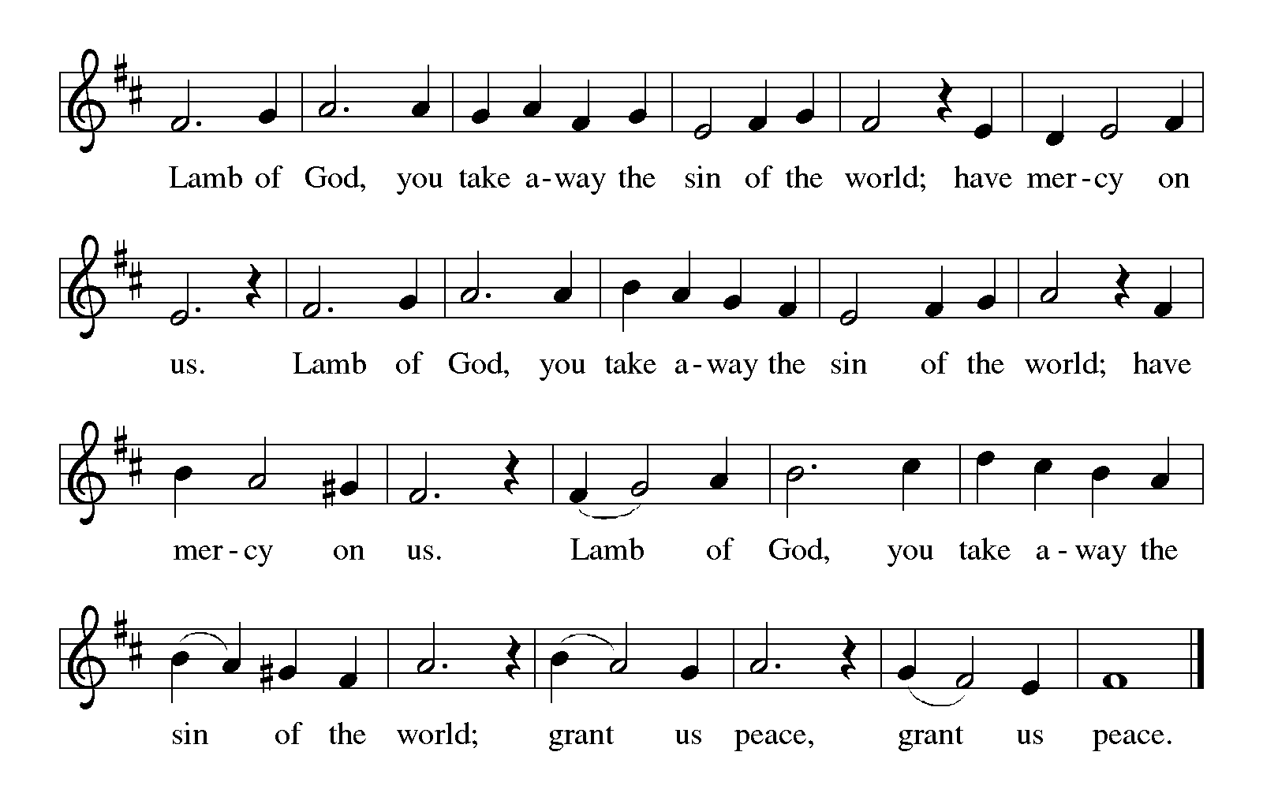
HYMN DURING DISTRIBUTION 239 Hark! The Glad Sound
ELW 250 Blessed Be the God of Israel
ELW 510 Word of God, Come Down to Earth
ELW 253 He Came Down
As you are able please rise

THE POST-COMMUNION BLESSING

P: The Body and Blood of our Lord Jesus Christ strengthen you and keep you in His grace.
C: Amen.

THE POST-COMMUNION PRAYER

A: Let us pray. Lord Jesus, You have again filled our hunger with the good things of Your
Body and Blood. Send us now from this Table in joy. As we journey into the darkness
of this world, do not quench Your Spirit in us, that we may faithfully testify to the
Light, Your Son, Jesus Christ our Lord.

C: Amen.
SENDING

THE BENEDICTION

P: God is faithful, and will strengthen you to the End, as you wait for the revealing of our
Lord Jesus Christ. Almighty God: Father, Son, and Holy Spirit bless you now and
forever.

C: Amen.

THE SENDING HYMN 248 People Look East

THE DISMISSAL

A: Go in peace. Prepare the way of the Lord.

C: Thanks be to God!

POSTLUDE
To God Alone Be Glory

The Meditation is from Proclamation: Interpreting the Lessons of the Church Year.
Advent/Christmas. William Willimon. (Philadelphia: Fortress Press, 1989) 27-28.

The Prayers are adapted from Sundays and Seasons. Copyright 1999 Augsburg Fortress.

ANNOUNCEMENTS

Please remember to mail your offering to the Church Office at 818 Franklin Street, Michigan City, IN 46360. Another alternative is to give on-line through Tithe.ly. Please see your closure letter for information on how to set up a Tithe.ly account.

St. Paul Members are reminded to have a loved one contact the office if you are hospitalized. Many times, the Pastor doesn’t know someone is in the hospital. If you call and leave a message, please tell us which hospital the patient is at.

Next Sunday’s lessons are II Samuel 7: 1-11, 16; Luke 1: 46b-55; Romans 16: 25-27; Luke 1: 26-38 for those of you who like to study them in advance.

Birthdays: Virgil Miller (12/22)

PRAYER CONCERNS: Jana Thomas, Leonard Cross, Margie Torres, Jayla Jacobi, Barbara Reichert, Jim Gleason, Kim Mitchell, Ronwynn Jones, Chris Jones, Ken Rosenbaum, Mark Tannehill; Janice White; Joan Seifert; Virginia Murray, Kay Kleinschmidt and Brian Wiseman.

OFFICE HOURS: Libby will be in the office on Mondays, Wednesdays,
and Fridays; volunteers will cover Tuesdays and Thursdays.

Monday & Wednesday 8:00 a.m. – 5 p.m.
Tuesday & Thursday 9:00 a.m. – 12:00 p.m.
Friday 8:00 a.m. – 12:00 p.m.

If you are listening to the worship broadcast on the radio and would like to watch the Sunday morning service live stream follow these steps:

(1) If you have You Tube available on your TV, search for
St. Paul Lutheran Church Michigan City, IN.

(2) The direct link on the computer is
https://www.youtube.com/channel/UC5AIPNaKr3QN50984jGOa1g.

(3) This link is also on the main page of the church’s website in
the church section and will continue to be posted weekly on the St.
Paul Facebook page.

And it will always be available on the radio broadcast Sunday mornings at 11:00 a.m.
on WEFM (95.9), and on the local cable access station #99 for the previous week’s
service on Sundays at 4:00 p.m. and the current service on Wednesdays at 7:00 p.m. and
Fridays at 8:30 p.m.

The approved and signed minutes of the September 28, 2023 Church Council Meeting are on the table at the back of the church in the Narthex. Please take a copy with you as you go.

To send e-mail to the church office, please use the following addresses:

Pastor Mark Reshan: seniorpastor@stpaulmichigancity.com

Church Office Secretary (Libby Pollock): churchsecretary@stpaulmichigancity.com

Church Treasurer (Karen Fleming): finance@stpaulmichigancity.com

The Good News Newsletter: If you have an article or anything you want included in The Good News please send it to the following e-mail address: splcgoodnews@gmail.com. Pastor Pamela Thiede will be using this e-mail address to assemble The Good News each month. The deadline for getting information to PastorPamela will be the 20th of each month.

WORSHIP ATTENDANCE for December 9 and 10, 2023:
4:00 p.m. 35
9:00 a.m. 58
TOTAL 93

LOOKING FOR IDEAS

We’d like to continue to highlight a different mission each month. We are looking for suggestions! If you volunteer somewhere or have a mission that is close to your heart, please let Paul or Lora Brooks know so we can set up a month to support that cause! Paul: (219) 221-0254, paulbrooks@gmail.com; or Lora: (260) 701-1586, loralmartin15@gmail.com.

December Local Monthly Mission:

December’s local mission is available a little early due to the holidays. An Angel Tree has been placed in the Narthex with angel tags. Each tag is for a gift for a child within our community who is in need and otherwise may not receive a gift for Christmas this year. If you wish to participate, please take a tag and shop for the item listed. Attach the tag to the gift and return it under the tree UNWRAPPED by December 10th. If you’d like to contribute but cannot do the shopping yourself, please let Paul or Lora Brooks know and we would be happy to shop for you. Thanks for your help in bringing joy this Christmas season to the kids within our community!

ADVENT/CHRISTMAS WORSHIP

It has long been a tradition to hold a “Quiet/Senior Communion” service in Advent and Lent. Originally intended as a special service for those who were homebound or in nursing or assisted living facilities to attend worship, in recent years it has expanded to include all (not just “seniors”) who wish to gather for a meaningful spoken service and good food and fellowship afterward. This years’ service will take place on Wednesday, December 20, at 9:00 a.m. instead of 10:00 a.m. as in the past. An invitation letter will go out in early December, but all are welcome. Mark the date and new time on your calendar, and we hope to see you on the 20th.

Saturday, December 23 Holy Communion, 4:00 p.m.
The Fourth Saturday of Advent

Sunday, December 24 Holy Communion, 9:00 a.m.
The Fourth Sunday of Advent

Sunday, December 24 Holy Communion, 6:00 p.m.
Christmas Eve

Monday, December 25 Holy Communion, 9:00 a.m.
Christmas Day Please note the time change

Saturday, December 30 Holy Communion/Lessons and
The First Saturday After Christmas Carols 4:00 p.m.

Sunday, December 31 Holy Communion/Lessons and
The First Sunday After Christmas Carols 9:00 a.m.

2023 Financial Stewardship
Weekly Church Operating Needs (x 2 weeks): $ 14,950.00
December 2 and 3, December 9 and 10, 2023
General Fund (including General Memorials): $ 10,418.00
Overage/Shortage: - $ 4,532.00

Restricted Income (not including Memorials)
Supports IK Synod & Church wide Ministries: $ 433.00

Ministries in our Community/Congregation:
Capital Fund: $ 611.00

Memorials
General Fund: $1,000.00

Deserving Children/November Mission $5.00

ACTIVITIES, EVENTS & MEETINGS
DECEMBER 2023 continued. . .

Sunday, December 17, 2023 @ 9:00 a.m. Worship Service

Tuesday, December 18, 2023 @ 4:00 p.m. Bell Choir Rehearsal

Wednesday, December 20, 2023 @ 9:00 a.m. Quiet/Senior Communion Service
with refreshments & fellowship immediately after
in St. Paul Room

@ 4:00 p.m. Choir Rehearsal

Saturday, December 23, 2023 @ 4:00 p.m. Worship Service/The Fourth Saturday of Advent

Sunday, December 24 Holy Communion, 9:00 a.m.
The Fourth Sunday of Advent

Sunday, December 24 Holy Communion, 6:00 p.m.
Christmas Eve

Monday, December 25 Holy Communion, 9:00 a.m.
Christmas Day Please note the time change

Thursday, December 28 5:30 p.m. Church Council Mtg.

Saturday, December 30 Holy Communion/Lessons and
The First Saturday After Christmas Carols 4:00 p.m.

Sunday, December 31 Holy Communion/Lessons and
The First Sunday After Christmas Carols 9:00 a.m.

