**THE THIRD SUNDAY OF EASTER**

**May 1, 2022**

Like the disciples (in John 21), we come face to face with God, not with a static representation found in a book or enshrined on a wall, cast as a statue or portrayed in the shimmering light of stained glass. (Here) God is found in the rhythm and pulse of human life, in repeated eucharists and repeated exclamations of “I love you,” in repeated revelations to those that saw Christ only yesterday and repeated commissions to go out and gather more fish, in repeated questions from the God who knows everything. In John 21 we see a Jesus resurrected in the hearts of men and women over and over again.

Perhaps the final lesson of chapter 21 is that nothing is ever finished or completely settled in God’s work except the fact of the cross. The resurrection is a time of constant revelation, repeated appearances, question after question, and the presentation of God’s eternal persistence in Jesus. To those of us who seem to forget what God did for us yesterday, the risen Lord appears again and again in the commonplace and the ordinary, the word, the meal, the question.

**Homily Service**

“ …Can’t it be simply that moments of abundance reveal God’s love?

The moment of recognition of Jesus in this story? When lack is transformed to abundance. When despair is moved to hope. When abandonment is replaced with the restoration of relationship…”

“…The whole gospel of John is about abundant grace. Grace upon grace in John 1:16, but after the Prologue, no mention of grace ever again. Why? What good is the incarnation if you can’t touch, taste, smell, see, and hear it? …This fourth resurrection appearance is to reveal that grace upon grace is true. By definition, grace upon grace cannot be restrained to a passage, to a gospel, and that’s the point of John 21. To show, by a ridiculous amount of fish, that God’s grace cannot be limited to the incarnation, to the crucifixion, to the tomb, to the resurrection, and certainly not to the end of a Gospel story called John.

Resurrection is abundance…”

“…The promise for Peter, and for Paul (Acts 9:1-20), and for us? Grace beyond our imagination. Grace beyond our calculation. Grace even beyond our scriptural determination.,.”

“…This is the resurrection story we need. Desperately. All of us. That we will, indeed, experience the truth of the resurrection beyond the empty tomb. That Jesus will always show up on the shore, will invite us to share a meal once again, because abundance really means abundance when it comes to God. Why? Because it seems that God truly does love the world.”

**Karoline Lewis**

**✠ In the Name of Jesus ✠**

**INTRODUCTION**

The disciples make a big splash and breakfast with the risen Jesus in the gospel. Wading in the water (remembering our baptism) and eating with Jesus (celebrating the holy communion) is our weekly encounter with the risen Christ. Jesus asks us, with Peter, again and again: Do you love me? And Jesus invites us, again and again, to follow him, bringing the Easter life to others.

**Philip and James, Apostles**

*Philip was one of the first disciples of Jesus, and called Nathanael to "come and see." He later responded to an Ethiopian official's request for teaching and baptism. Little is known of James, the son of Alphaeus, called "the Less" to distinguish him from another apostle named James.*

**Athanasius, Bishop of Alexandria, died 373**

*Best remembered for defending the teaching that Christ was fully God against those who taught otherwise, Athanasius was an influential church leader around the time of the Council of Nicea. He was banished from Alexandria five times for his forthright views.*

**✠ GATHERING ✠**

**PRELUDE Now All the Vault of Heaven Resounds Robert Hobby**

**THE EASTER ACCLAMATION**

P: Christ is risen! Alleluia!

C: **Christ is risen indeed! Alleluia!**

**ANNOUNCEMENTS**

As you are able please rise

**CONFESSION AND ABSOLUTION**

P: In the name of the Father and of ✠ the Son and of the Holy Spirit.

C: **Amen.**

P: “For (God’s) wrath endures but the twinkling of an eye, His favor for a lifetime.” (Psalm 30:5)

God desires us to daily die to the power of sin in our lives, that we may walk in the newness

of Christ’s life. Let us therefore confess our sin, that we may again receive God’s merciful

“favor” for a “lifetime” of faithful and fruitful living.

*Silence for self-examination and reflection is kept*

P: Most merciful God,

C**: We confess that we have sinned against You in thought, word, and deed. We have been**

**blind to Your presence in our lives and in the world around us. (Acts 9:9) We have not**

**been willing to suffer for the sake of Your name. (9:16) We have lived as though Easter**

**never happened. (John 21:1-8) We do not love You more than all else (21:15) We have**

**not “fed Your sheep” by living out Your love for them. (21:15-17) For these and all our**

**other sins, have mercy on us. Take away our guilt and shame, and clothe us with the joy**

**of Your forgiveness.**

P: “O LORD my God, I cried out to you, and You restored me to health.” (Psalm 30:2) God

answers your confession with a Word that makes you whole: for as a called and ordained

minister of the Church of Christ, and by His authority, I therefore declare to you the entire

forgiveness of all your sins, in the name of the Father and of + the Son and of the Holy Spirit.

C: **Amen.**

**GATHERING HYMN 373 *Christ the Lord is Risen Today!***

**THE GREETING AND PRAYER OF THE DAY**

P: Alleluia! Christ is risen!

C: **He is risen indeed! Alleluia!**

P: The grace of our Lord Jesus Christ, the love of God, and the communion of the Holy Spirit be

with you all.

C: **And also with you.**

P: Let us pray. Eternal and all-merciful God, with all the angels and all the saints we laud Your

majesty and might. By the resurrection of Your Son, show Yourself to us and inspire us to

follow Jesus Christ, our Savior and Lord, Who lives and reigns with You and the Holy Spirit,

one God, now and forever.

C: **Amen.**

*The assembly is seated*

**✠ WORD ✠**

**FIRST READING Acts 9:1-20**

*Saul (later called Paul) appears for the first time in Acts at the stoning of Stephen. He becomes an ardent persecutor of the Christian church. This reading recounts his blinding and conversion experiences on the way to Damascus.*

1Meanwhile Saul, still breathing threats and murder against the disciples of the Lord, went to the high priest 2and asked him for letters to the synagogues at Damascus, so that if he found any who belonged to the Way, men or women, he might bring them bound to Jerusalem. 3Now as he was going along and approaching Damascus, suddenly a light from heaven flashed around him. 4He fell to the ground and heard a voice saying to him, "Saul, Saul, why do you persecute Me?" 5He asked, "Who are you, Lord?" The reply came, "I am Jesus, Whom you are persecuting. 6But get up and enter the city, and you will be told what you are to do."

7The men who were traveling with him stood speechless because they heard the voice but saw no one. 8Saul got up from the ground, and though his eyes were open, he could see nothing; so they led him by the hand and brought him into Damascus. 9For three days he was without sight, and neither ate nor drank.

10Now there was a disciple in Damascus named Ananias. The Lord said to him in a vision, "Ananias." He answered, "Here I am, Lord." 11The Lord said to him, "Get up and go to the street called Straight, and at the house of Judas look for a man of Tarsus named Saul. At this moment he is praying, 12and he has seen in a vision a man named Ananias come in and lay his hands on him so that he might regain his sight."

13But Ananias answered, "Lord, I have heard from many about this man, how much evil he has done to your saints in Jerusalem; 14and here he has authority from the chief priests to bind all who invoke your name." 15But the Lord said to him, "Go, for he is an instrument whom I have chosen to bring my name before Gentiles and kings and before the people of Israel; 16I myself will show him how much he must suffer for the sake of my name."

17So Ananias went and entered the house. He laid his hands on Saul and said, "Brother Saul, the Lord Jesus, Who appeared to you on your way here, has sent me so that you may regain your sight and be filled with the Holy Spirit." 18And immediately something like scales fell from his eyes, and his sight was restored. Then he got up and was baptized, 19and after taking some food, he regained his strength.

For several days he was with the disciples in Damascus, 20and immediately he began to proclaim Jesus in the synagogues, saying, "He is the Son of God."

The Word of the Lord.

**Thanks be to God.**

**THE PSALM: Psalm 30:1-9, 11-13** **Read responsively**

1I will exalt You, O LORD, because You have lifted me up

     and have not let my enemies triumph over me.

**2O LORD my God, I cried out to You,**

**and You restored me to health.**

3You brought me up, O LORD, from the dead;

     You restored my life as I was going down to the grave.

**4Sing praise to the LORD, all you faithful;**

**give thanks in holy remembrance.**

5God's wrath is short; God's favor lasts a lifetime.

     Weeping spends the night, but joy comes in the morning.

**6While I felt secure, I said,**

**"I shall never be disturbed.**

7You, LORD, with Your favor, made me as strong as the mountains."

     Then You hid Your face, and I was filled with fear.

**8I cried to You, O LORD;**

**I pleaded with my Lord, saying,**

9"What profit is there in my blood, if I go down to the pit?

     Will the dust praise you or declare your faithfulness?

**10Hear, O LORD, and have mercy upon me;**

**O LORD, be my helper."**

11You have turned my wailing into dancing;

     You have put off my sackcloth and clothed me with joy.

**12Therefore my heart sings to You without ceasing;**

**O LORD my God, I will give You thanks forever.**

**SECOND READING Revelation 5:11-14**

*The vision of John recorded in the book of Revelation offers a glimpse of cosmic worship on the Lord's Day. At its center is "the Lamb who was slain."*

John writes: 11Then I looked, and I heard the voice of many angels surrounding the throne and the living creatures and the elders; they numbered myriads of myriads and thousands of thousands, 12singing with full voice,

"Worthy is the Lamb that was slaughtered

to receive power and wealth and wisdom and might

and honor and glory and blessing!"

13Then I heard every creature in heaven and on earth and under the earth and in the sea, and all that is in them, singing,

"To the One seated on the throne and to the Lamb

be blessing and honor and glory and might

forever and ever!"

14And the four living creatures said, "Amen!" And the elders fell down and worshiped.

The Word of the Lord.

**Thanks be to God.**

*As you are able please rise*

**THE VERSE**

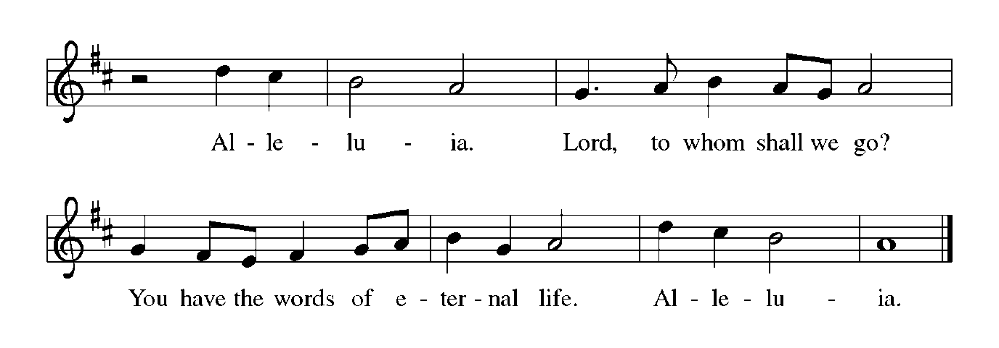

**THE HOLY GOSPEL John 21:1-19**

*The risen Christ blesses His followers and welcomes them to a meal of fellowship and forgiveness.*

P: The Holy Gospel according to St. John, the twenty-first chapter.

C: **Glory to You, O Lord!**

1After He appeared to His followers in Jerusalem, Jesus showed Himself again to the disciples by the Sea of Tiberias; and He showed Himself in this way. 2Gathered there together were Simon Peter, Thomas called the Twin, Nathanael of Cana in Galilee, the sons of Zebedee, and two others of His disciples. 3Simon Peter said to them, "I am going fishing." They said to him, "We will go with you." They went out and got into the boat, but that night they caught nothing.

4Just after daybreak, Jesus stood on the beach; but the disciples did not know that it was Jesus. 5Jesus said to them, "Children, you have no fish, have you?" They answered Him, "No." 6He said to them, "Cast the net to the right side of the boat, and you will find some." So they cast it, and now they were not able to haul it in because there were so many fish.

7That disciple whom Jesus loved said to Peter, "It is the Lord!" When Simon Peter heard that it was the Lord, he put on some clothes, for he was naked, and jumped into the sea. 8But the other disciples came in the boat, dragging the net full of fish, for they were not far from the land, only about a hundred yards off.

9When they had gone ashore, they saw a charcoal fire there, with fish on it, and bread. 10Jesus said to them, "Bring some of the fish that you have just caught." 11So Simon Peter went aboard and hauled the net ashore, full of large fish, a hundred fifty-three of them; and though there were so many, the net was not torn.

12Jesus said to them, "Come and have breakfast." Now none of the disciples dared to ask Him, "Who are you?" because they knew it was the Lord. 13Jesus came and took the bread and gave it to them, and did the same with the fish. 14This was now the third time that Jesus appeared to the disciples after He was raised from the dead.

15When they had finished breakfast, Jesus said to Simon Peter, "Simon son of John, do you love Me more than these?" He said to Him, "Yes, Lord; you know that I love You." Jesus said to him, "Feed My lambs." 16A second time He said to him, "Simon son of John, do you love Me?" He said to Him, "Yes, Lord; You know that I love You." Jesus said to him, "Tend My sheep."

17He said to him the third time, "Simon son of John, do you love Me?" Peter felt hurt because He said to him the third time, "Do you love Me?" And he said to Him, "Lord, You know everything; You know that I love You." Jesus said to him, "Feed My sheep.

18Very truly, I tell you, when you were younger, you used to fasten your own belt and to go wherever you wished. But when you grow old, you will stretch out your hands, and someone else will fasten a belt around you and take you where you do not wish to go." 19(He said this to indicate the kind of death by which he would glorify God.) After this he said to him, "Follow Me."

P: The Gospel of the Lord.

C: **Praise to You, O Christ!**

*The assembly is seated*

**THE SERMON**

*Silence for reflection follows the sermon*

*As you are able please rise*

**THE HYMN OF THE DAY NSB 4 *All Creation Worships You*  p. 18**

**THE NICENE CREED**

A: God has made us His people through our Baptism into Christ. Living together in trust and

hope, we confess our faith.

**We believe in one God,**

**the Father, the Almighty,**

**maker of heaven and earth,**

**of all that is, seen and unseen.**

**We believe in one Lord, Jesus Christ,**

**the only Son of God,**

**eternally begotten of the Father,**

**God from God, Light from Light,**

**true God from true God,**

**begotten, not made,**

**of one Being with the Father.**

**Through Him all things were made.**

**For us and for our salvation**

**He came down from heaven;**

**by the power of the Holy Spirit**

**He became incarnate from the virgin Mary, and was made man.**

**For our sake He was crucified under Pontius Pilate;**

**He suffered death and was buried.**

**On the third day He rose again**

**in accordance with the Scriptures;**

**He ascended into heaven**

**and is seated at the right hand of the Father.**

**He will come again in glory to judge the living and the dead,**

**and His kingdom will have no end.**

**We believe in the Holy Spirit, the Lord, the giver of life,**

**Who proceeds from the Father and the Son.**

**With the Father and the Son He is worshiped and glorified.**

**He has spoken through the prophets.**

**We believe in one holy catholic and apostolic Church.**

**We acknowledge one Baptism for the forgiveness of sins.**

**We look for the resurrection of the dead,**

**and the life of the world to come. Amen**

**THE PRAYER OF THE CHURCH**

A: In this Eastertide the hosts of heaven proclaim, “Worthy is the Lamb Who was slain, to receive

power and wealth and wisdom and honor and glory and blessing.” As we join the worship of

the company of heaven, let us pray for the Church, the world, and all who seek new life in

Christ.

A: That the leaders of the Church and all who respond to Christ’s call may be given the gifts

needed to bear faithful witness to Him, let us pray to the Lord:

C: **Lord, have mercy.**

A: That in all places of violence, terrorism, and unrest, especially Ukraine, Afghanistan; Jerusalem

and Gaza the blindness of hatred might give way to a true vision of peace, let us pray to the

Lord:

C: **Lord, have mercy.**

A: That we in this congregation might show our love for Jesus through our “feeding” and

“tending” of the lost, the poor, and the hurting, let us pray to the Lord:

C: **Lord, have mercy.**

A: That the sick, especially . . . might be clothed with the Lord’s healing and joy, let us pray to

the Lord:

C: **Lord, have mercy.**

A: That those celebrating anniversaries, especially **Charles and Carol Thomas II; Jim and**

**Bernadette Krueger; and Chris and Cynthia Scheuchner** might be filled with grace this

day and every day and grow in grace in the days ahead, let us pray to the Lord:

C: **Lord, have mercy.**

A: That with all the saints, especially **Philip and James, Apostles; and Athanasius, Bishop of**

**Alexandria,** whom we commemorate this Day we might join the victory Song before Your

throne, let us pray to the Lord:

C: **Lord, have mercy.**

P: To the One Who sits upon the throne and to the Lamb be blessing and honor and glory and

might forever and ever.

C: **Amen.**

**✠ MEAL✠**

**THE PEACE**

P: The peace of the risen Lord be with you always.

C: **And also with you.**

*The assembly is seated*

**THE OFFERING**

**THE VOLUNTARY *Mourning Into Dancing*  The Praise Band**

*As you are able please rise*

**THE OFFERTORY**

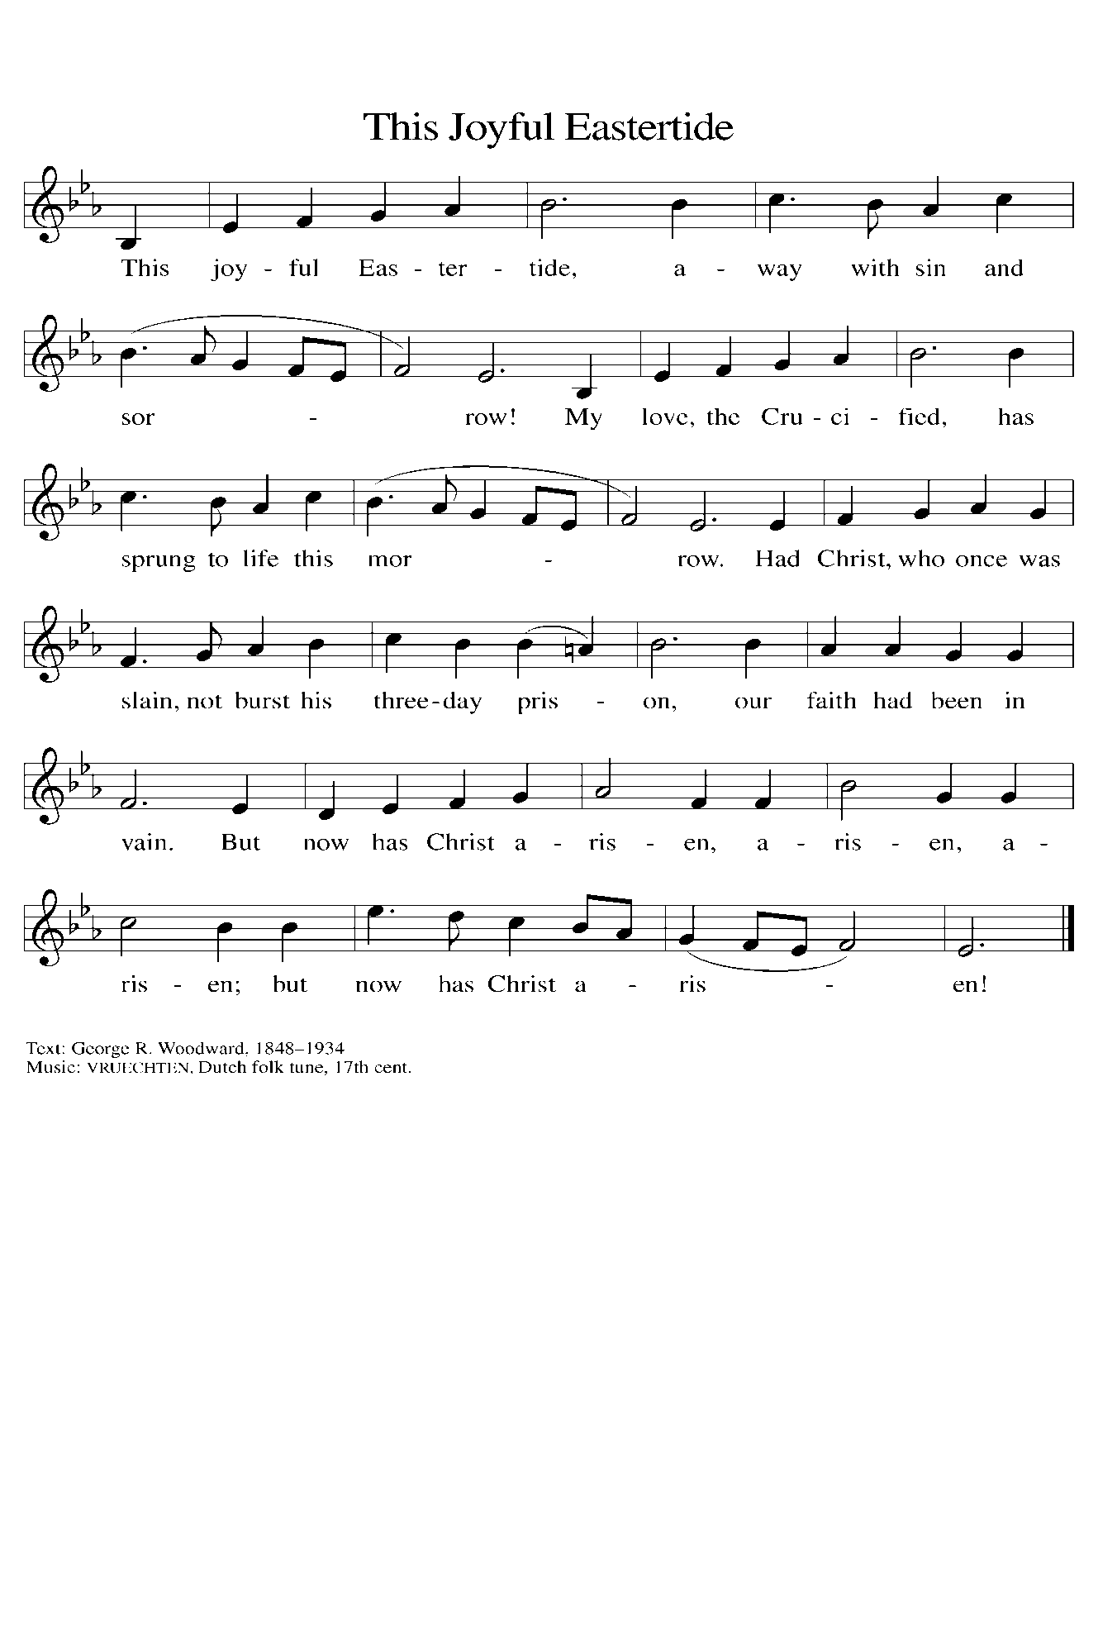

**THE OFFERTORY PRAYER**

A: Let us pray. God our Creator,

C: **You wash away our sins in water, You give us new birth by the Spirit, and redeem us in**

**the blood of Christ. Receive these gifts we offer You, and, as we celebrate the**

**resurrection, renew Your gift of life within us. We ask this in the name of Jesus the Lord.**

**Amen.**

**THE GREAT THANKSGIVING**

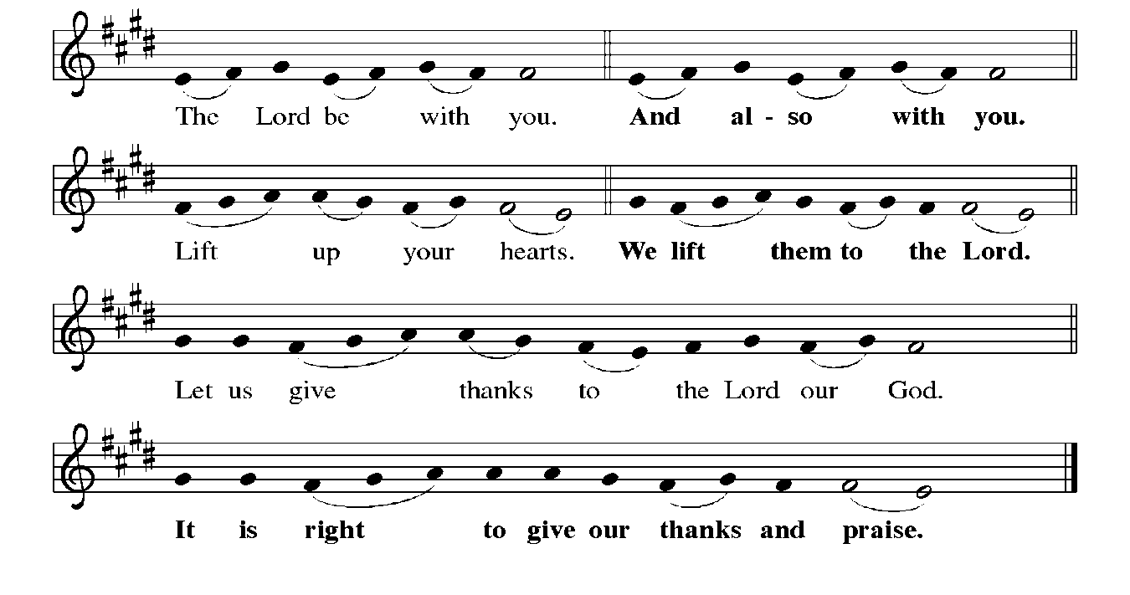

P: It is indeed right, our duty, and our joy … join their unending hymn:

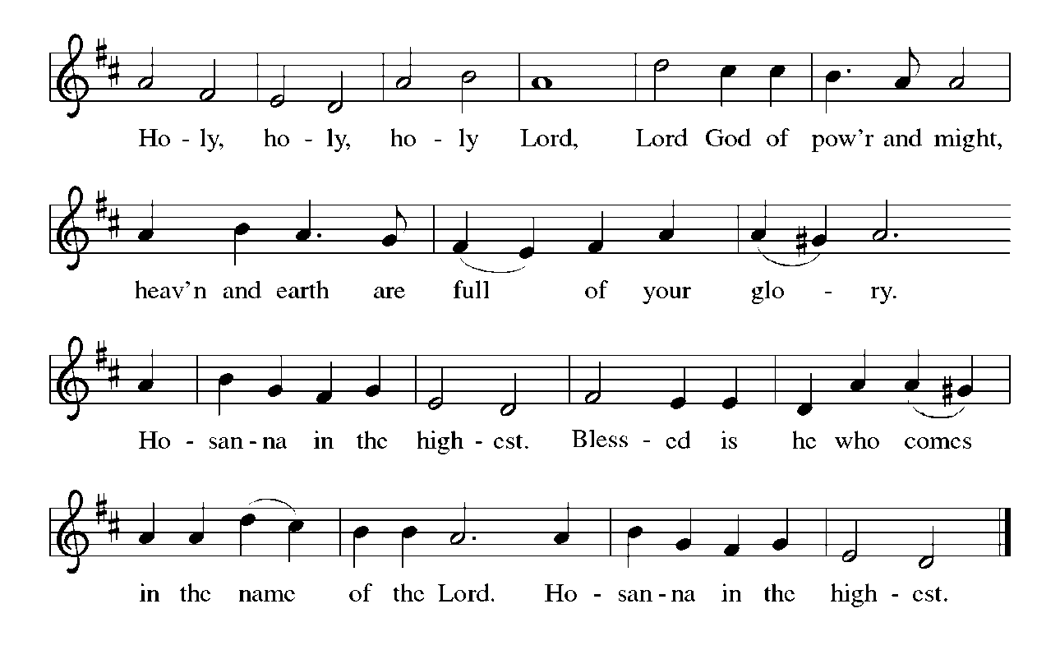

P: Worthy are You, Lord God, and worthy is the Lamb Who was slain to receive wisdom

and might and glory and honor forever and ever.

From the pit of slavery You heard Your people’s cries and drew them up to freedom in

Your service.

Out of the snare of sin You saw the suffering of Your creation and restored the life of

Your faithful ones.

From the grave of death You raised Your Son to life on the third day.

In Him You turn mourning into dancing; You remove the sackcloth of tears and clothe

us with joy.

Providing God, Your Son prepared a simple meal for His disciples which in Your grace

became a resurrection Banquet.

As You revealed Yourself to them, open our hearts to receive in this holy Meal the

miracle of His saving passion.

Send Your Holy Spirit upon Your Church to make our life together a feast for all who

hunger.

Make holy this bread and cup that they may be for us the Body and Blood of Your Son,

Jesus Christ,

Who, in the night … “Do this for the remembrance of Me.”

As often as we eat … we proclaim the Lord’s death until He comes.

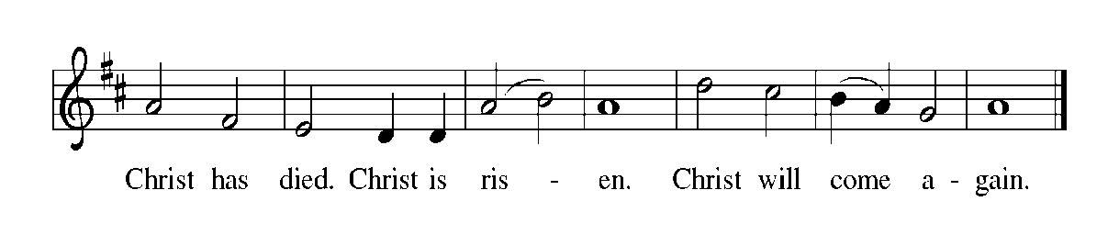

P: Great Shepherd, Your Son is the holy Lamb, and by His blood You have made us Your

own flock.

Feed Your sheep who hunger for the necessities of life, for safe food to eat and clean

water to drink, for protection from fear, for shelter, and for warmth.

Tend Your lambs when they long for love and acceptance and a place to belong.

Make Your Church a sheepfold of grace.

Shepherd all who have suffered harm and look to You for healing and hope.

Turn the sorrow of mourning into one eternal joy in Your presence.

Bring us with all creation to that great Day when we shall fall on our knees and worship

the Lamb in glory, Holy Father, to the power of Your Spirit.

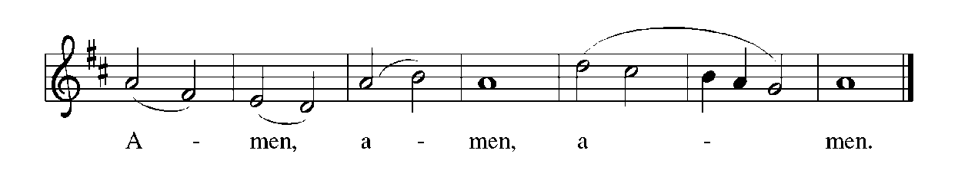

**THE LORD’S PRAYER**

P: Risen from the dead, Jesus lives to intercede for us and join us as He taught us to pray:

C: **Our Father in heaven, hallowed be Your name. Your Kingdom come. Your will be done**

**on earth as it is in heaven. Give us this day our daily bread, and forgive us our sins as we**

**forgive those who sin against us. Save us from the time of trial and deliver us from evil.**

**For the Kingdom, the power, and the glory are Yours, now and forever. Amen.**

**INVITATION TO THE MEAL**

P: Alleluia! Christ the Lamb of God has been sacrificed. Therefore, let us celebrate His Feast

with joy. Blessed are those who are called to the Supper of the Lamb. God’s holy gifts for

God’s holy people. Come, for all is now ready.

*The assembly is seated*

**THE DISTRIBUTION**

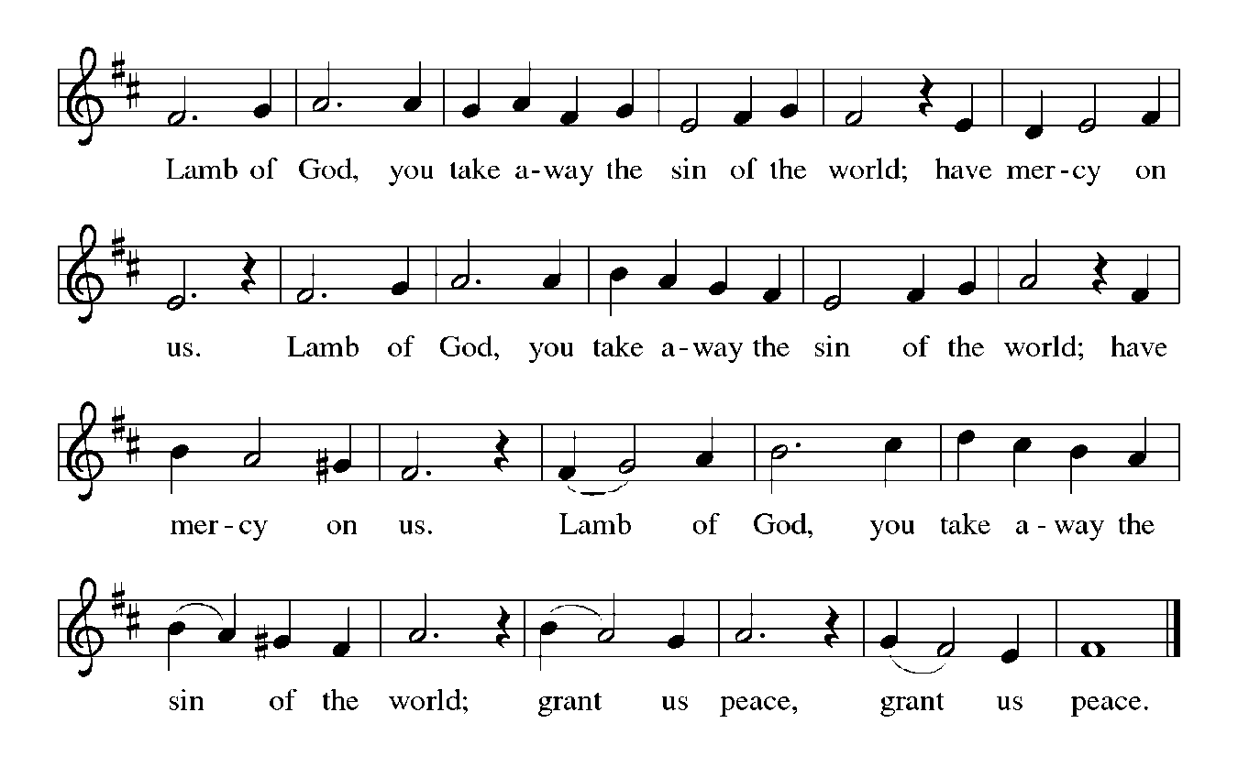

**HYMN DURING DISTRIBUTION 389 *Christ is Alive! Let Christians Sing!***

**817 *You Have Come Down to the Lakeshore***

**NSB 103 *You Are Merciful to Me* p. 19**

**NSB 70 *Open Our Eyes*  p. 20**

*As you are able please rise*

**THE POST-COMMUNION BLESSING**

P: The Body and Blood of our Lord Jesus Christ strengthen you and keep you in His grace.

C: **Amen.**

**THE POST-COMMUNION PRAYER**

A: Let us pray. Loving God, in the breaking of bread we know the risen Lord. Feed us always in

these mysteries, that we may show Your glory to all the world. Grant this through Christ our

Lord.

C: **Amen.**

**✠ SENDING ✠**

**THE BENEDICTION**

P: May God the Father Who raised Christ from the dead open to you the gate of everlasting life.

C: **Amen.**

P: May God the Son Who burst from the grave give you joy as you celebrate His resurrection.

C: **Amen.**

P: May God the Holy Spirit Who brought you to birth in Baptism fill you with strength and peace.

C: **Amen.**

P: Almighty God: Father, Son, ✠ and Holy Spirit bless you now and forever.

C: **Amen.**

**SENDING SONG NSB 105 *You Are My All in All*  p. 21**

**THE DISMISSAL**

A: Alleluia! Christ is risen!

C: **He is risen indeed! Alleluia!**

A: Go in the peace of Christ, alleluia!

C: **Thanks be to God! Alleluia!**

**✠ To God Alone Be Glory ✠**

The Meditation is from *Homily Service.* April, 1986. p. 12.

The Eucharistic Prayer is adapted from *Eucharistic Prayers.* Samuel Wells and Abigail Kocher.

(Grand Rapids: Eerdmann’s Publishing Company, 2016) 164-65.

**ANNOUNCEMENTS**

**Please remember to mail your offering to the Church Office** at 818 Franklin Street, Michigan City, IN 46360**.** Another alternative is to give on-line through Tithe.ly. Please see your closure letter for information on how to set up a Tithe.ly account.

**St. Paul Members are reminded to have** a loved one contact the office if you are hospitalized. Many times, the Pastor doesn’t know someone is in the hospital. If you call and leave a message, please tell us which hospital the patient is at.

**Next Sunday’s lessons are Acts 9: 36-43; Psalm 23; Revelations 7: 9-17; John 10: 22-30** for those of you who like to study them in advance.

**Anniversary: Charles & Carol Thomas II (5/2); James & Bernadette Krueger (5/5);**

**Christian & Cynthia Scheuchner (5/6)**

**PRAYER CONCERNS:** Audrey Beyer, Ryan Krueger, Donna Bostater, Maxine

Powell, Jim Tomscheck, Ken Mulder, Roger Milzarek, Eloise Ponder, Mark & Jary Tannehill and Leonard Cross.

**If you requested someone’s name to be on the prayer list and are aware that they need continued imminent prayer then contact the church office and let us know.**

Otherwise we will gradually transfer names to the long-term list.

**OFFICE HOURS:** Libby will be in the office on Mondays, Wednesdays, and Fridays; volunteers will cover Tuesdays and Thursdays.

Monday & Wednesday 8:00 a.m. – 5 p.m.

Tuesday & Thursday 9:00 a.m. – 12:00 p.m.

Friday 8:00 a.m. – 12:00 p.m.

**If you are listening to the worship broadcast on the radio and would like to watch the Sunday morning service live stream follow these steps:**

(1) If you have You.Tube available on your TV, search for

**St. Paul Lutheran Church Michigan City, IN.**

(2) The direct link on the computer is

https://www.youtube.com/channel/UC5AIPNaKr3QN50984jGOa1g.

(3) This link is also on the main page of the church’s website in the church section and will continue to be posted weekly on the St. Paul Facebook page.

And it will always be available on the radio broadcast Sunday mornings at 11:00 a.m. on WEFM (95.9), and on the local cable access station #99 for the previous week’s service on Sundays at 4:00 p.m. and the current service on Wednesdays at 7:00 p.m. and Fridays at 8:30 p.m.

**To send e-mail to the church office**, please use the following addresses:

Pastor Mark Reshan: [seniorpastor@stpaulmichigancity.com](mailto:seniorpastor@stpaulmichigancity.com)

Church Office Secretary (Libby Pollock): [churchsecretary@stpaulmichigancity.com](mailto:churchsecretary@stpaulmichigancity.com)

Church Treasurer (Karen Fleming) and Bookkeeper (Billie Atchinson):

[finance@stpaulmichigancity.com](mailto:finance@stpaulmichigancity.com).

**The Good News Newsletter**: If you have an article or anything you want included in **The Good News** please send it to the following e-mail address: splcgoodnews@gmail.com. Pastor Pamela Thiede will be using this e-mail address to assemble **The Good News** each month. The deadline for getting information to Pastor Pamela will be the 20th of each month.

**WORSHIP ATTENDANCE for April 23 and 24, 2022**

**4:00 p.m. 20**

**9:00 a.m. 53**

**Total = 73**

**The Community Soup Kitchen serving out of First United Methodist is in need of volunteers.** Sunday through Tuesday is always need, as is occasionally Wednesdays and Thursdays. Hours are 9:30 a.m. to 1:15 p.m. and it is not necessary to stay the entire time. There is also a need for volunteers to be available to help pick up deliveries from the Food Bank when they arrive. If you are able to help please contact their church office at 872-7200.

**Please help us get the word out** that we are once again having our tea. If you have a women’s group, please pass this on to them. As always, the tea is open to all and is our gift to the community. If you have any questions please feel free to call Yvonne Bancroft at 219-872-4280. Thank You!

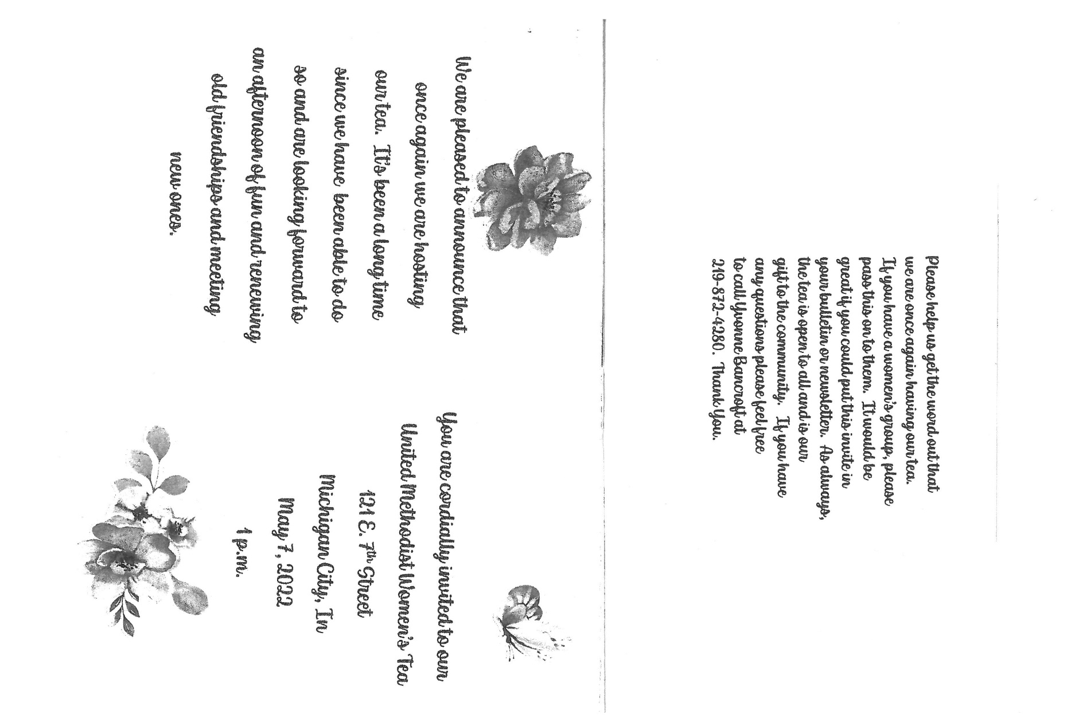

**MAY 2022 ACTIVITIES, MEETINGS AND SERVICES**

Worship Service: Sunday, May 1, 2022 at 9:00 a.m.

Altar Guild: Tuesday, May 3, 2022 at 10:00 a.m./St. Paul Room

Wednesday Bible Study: May 4, 2022 at 9:45 a.m./Luther House

God’s Purls: Wednesday, May 4, 2022 at 10:00 a.m./St. Paul Room

Worship Service: Saturday, May 7, 2022 at 4:00 p.m.

Worship Service: **MOTHER’S DAY Sunday**, May 8, 2022 at 9:00 a.m.

School Board Meeting: Monday, May 9, 2022 at 3:30 p.m./Luther House

Charity Circle: Tuesday, May 10, 2022 at 9:30 a.m./Nursery Room

Wednesday Bible Study: May 11, 2022 at 9:45 a.m./Luther House

God’s Purls: Wednesday, May 11, 2022 at 10:00 a.m./St. Paul Room

Worship & Music Committee: Wednesday, May 11, 2022 at 6:00 p.m.

Choir Rehearsal: Wednesday, May 11, 2022 at 7:00 p.m.

Harmony Circle: Thursday, May 12, 2022 at 1:00 p.m./Nursery Room

Worship Service: Saturday, May 14, 2022 at 4:00 p.m.

Worship Service: Sunday, May 15, 2022 at 9:00 a.m.

Finance Committee Meeting: Monday, May 16, 2022 at 4:00 p.m./St. Paul Room

Executive Board Meeting: Monday, May 16, 2022 at 5:30 p.m./Luther House

Wednesday Bible Study: May 18, 2022 at 9:45 a.m./Luther House

Church Council Meeting: Thursday, May 19, 2022 at 5:30 p.m./St. Paul Room

Worship Service: Saturday, May 21, 2022 at 4:00 p.m.

Worship Service: Sunday, May 22, 2022 at 9:00 a.m.

**SPRING CONGREGATIONAL MEETING: Sunday, May 22, 2022 at 10:15 a.m.**

**With Potluck Luncheon immediately following.**

Wednesday Bible Study: May 25, 2022 at 9:45 a.m./Luther House

God’s Purls: Wednesday, May 25, 2022 at 10:00 a.m./St. Paul Room

Worship Service: Saturday, May 28, 2022 at 4:00 p.m.

Worship Service: Sunday, May 29, 2022 at 9:00 a.m.

