THE THIRD SUNDAY AFTER THE EPIPHANY
January 22, 2023

If we answer the call to discipleship, where will it lead us? What decisions and partings will it demand? To answer the question we shall have to go to Him, for only He knows the answer. Only Jesus Christ, Who bids us follow Him, knows the journey’s end. But we do know that it will be a road of boundless mercy. Discipleship means joy.

Dietrich Bonhoeffer
The Cost of Discipleship

The saints will be within their Creator just as the fish are in the sea. They will drink all they want, without becoming tired and without lessening the amount of water. The more they receive of this sweetness, the more will be their hunger for it. For just as the waves all go toward the sea and all come back, just so the beauty and the sweetness of our Lord, even though they are poured forth everywhere, always return to him. And for that, they can never diminish.

Marguerite d’Oingt
In the Name of Jesus

INTRODUCTION

Jesus begins his public ministry by calling fishers to leave their nets and follow Him. In Jesus the kingdom of God has come near. We who have walked in darkness have seen a great light. We see this light most profoundly in the cross—as God suffers with us and all who are oppressed by sickness, sin, or evil. Light dawns for us as we gather around the word, the font, and the holy table. We are then sent to share the good news that others may be "caught" in the net of God's grace and mercy.

Timothy, Titus, and Silas, missionaries

These three early Christian men were missionary companions of the apostle Paul. Timothy became bishop of Ephesus, Titus bishop of Crete, and Silas was imprisoned with Paul at Philippi until they were delivered by an earthquake.

GATHERING

PRELUDE

ANNOUNCEMENTS

As you are able please rise

P: In the name of the Father and of the Son and of the Holy Spirit.

C: Amen.

P: “Hearken to my voice, O LORD, when I call; have mercy on me and answer me.”
(Psalm 27:10) God is always ready to hear our confession and grant us a new heart and
a right spirit. Let us therefore confess our sins, drawing near to God in humility and
confidence.

Silence for self-examination and reflection is kept

P: Most merciful God,

C: We confess that we are sinners in need of Your forgiveness. We have not sought
You as You desire (Psalm 27:11). We have not been of the same mind and
purpose, and have quarreled with one another (1 Corinthians 1:10-11). We have
neither daily repented (Matthew 4:17), followed Jesus (Matthew 4:19), nor “fished
for people.” You are our “light and our salvation” O God. (Psalm 27:1) To You
we now turn in repentance and trust. For the sake of Your Son, Jesus Christ,
“answer” our cries for “mercy” (Psalm 27:10). Forgive us, renew us, and
strengthen us to follow and serve where Christ leads the way.

P: “Hide not Your face from me, nor turn away Your servant in displeasure.” (Psalm
27:13) God never tires of granting mercy to those who seek Him. Therefore, as a called
and ordained minister of the Church of Christ, and by His authority, I declare to you
the entire forgiveness of all your sins, in the name of the Father and of the Son and
of the Holy Spirit.

C: Amen.

GATHERING HYMN 511 Thy Strong Word

THE GREETING AND PRAYER OF THE DAY

P: To the Church of God in this place, to those who are called to be saints, to all those who
call upon the name of our Lord Jesus Christ:

The grace of our Lord Jesus Christ, the love of God, and the communion of the Holy
Spirit be with you all.

C: And also with you.

P: Let us pray. Lord God, Your lovingkindness always goes before us and follows after
us. Summon us into Your light, and direct our steps in the ways of goodness
that come through the cross of Your Son, Jesus Christ, our Savior and Lord.

C: Amen.

The assembly is seated
WORD

FIRST READING Isaiah 9:1-4

The people in the northern parts of Israel have experienced "gloom" and "darkness" because of the destruction wrought by Assyrian military forces. To these people, the prophet announces the shining of a great light of salvation. Matthew equates this light with the beginning of Jesus' ministry in Galilee.

There will be no gloom for those who were in anguish. In the former time the LORD brought into contempt the land of Zebulun and the land of Naphtali, but in the latter time he will make glorious the way of the sea, the land beyond the Jordan, Galilee of the nations.
²The people who walked in darkness
have seen a great light;
those who lived in a land of deep darkness--
on them light has shined.
³You have multiplied the nation,
you have increased its joy;
they rejoice before you
as with joy at the harvest,
as people exult when dividing plunder.
⁴For the yoke of their burden,
and the bar across their shoulders,
the rod of their oppressor,
you have broken as on the day of Midian.

The Word of the Lord.

Thanks be to God.

THE PSALM: Psalm 27: 1, 4-9 Antiphon by Ronald Nelson
Choir sings refrain first, followed immediately by the congregation
and as indicated

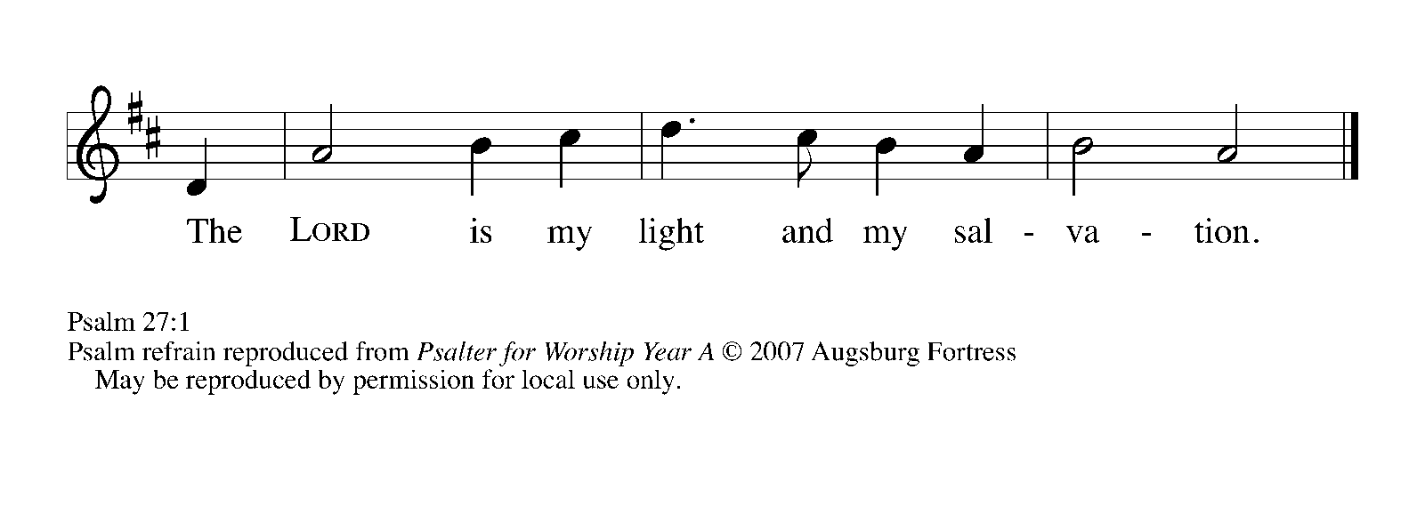

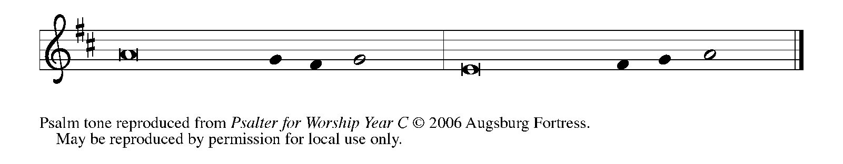

¹The LORD is my light and my salvation; whom then | shall I fear?
The LORD is the stronghold of my life; of whom shall I | be afraid?
⁴One thing I ask of the LORD; one | thing I seek;
that I may dwell in the house of the LORD all the days of my life; to gaze upon the beauty of the LORD and to seek God | in the temple.

⁵For in the day of trouble God will | give me shelter,
hide me in the hidden places of the sanctuary, and raise me high up- | on a rock.

⁶Even now my head is lifted up above my enemies | who surround me.
Therefore I will offer sacrifice in the sanctuary, sacrifices of rejoicing; I will sing and make music | to the LORD. REFRAIN

⁷Hear my voice, O LORD, | when I call;
have mercy on me and | answer me.

⁸My heart speaks Your message— | "Seek My face."
Your face, O LORD, | I will seek.

⁹Hide not Your face from me, turn not away from Your ser- | vant in anger.
Cast me not away—You have been my helper; forsake me not, O God of | my salvation. REFRAIN

SECOND READING 1 Corinthians 1:10-18

Three of the most highly respected missionaries in the early church were Paul, Apollos, and Cephas (also known as Simon Peter). Still, as Paul himself attests, respect for any human leader is misplaced if it becomes divisive or obscures devotion to Christ.

Now I appeal to you, brothers and sisters, by the name of our Lord Jesus Christ, that all of you be in agreement and that there be no divisions among you, but that you be united in the same mind and the same purpose. ¹¹For it has been reported to me by Chloe's people that there are quarrels among you, my brothers and sisters. ¹²What I mean is that each of you says, "I belong to Paul," or "I belong to Apollos," or "I belong to Cephas," or "I belong to Christ."
¹³Has Christ been divided? Was Paul crucified for you? Or were you baptized in the name of Paul? ¹⁴I thank God that I baptized none of you except Crispus and Gaius, ¹⁵so that no one can say that you were baptized in my name. ¹⁶(I did baptize also the household of Stephanas; beyond that, I do not know whether I baptized anyone else.)
¹⁷For Christ did not send me to baptize but to proclaim the gospel, and not with eloquent wisdom, so that the cross of Christ might not be emptied of its power. ¹⁸For the message about the cross is foolishness to those who are perishing, but to us who are being saved it is the power of God.

The Word of the Lord.

Thanks be to God.

As you are able please rise

THE VERSE

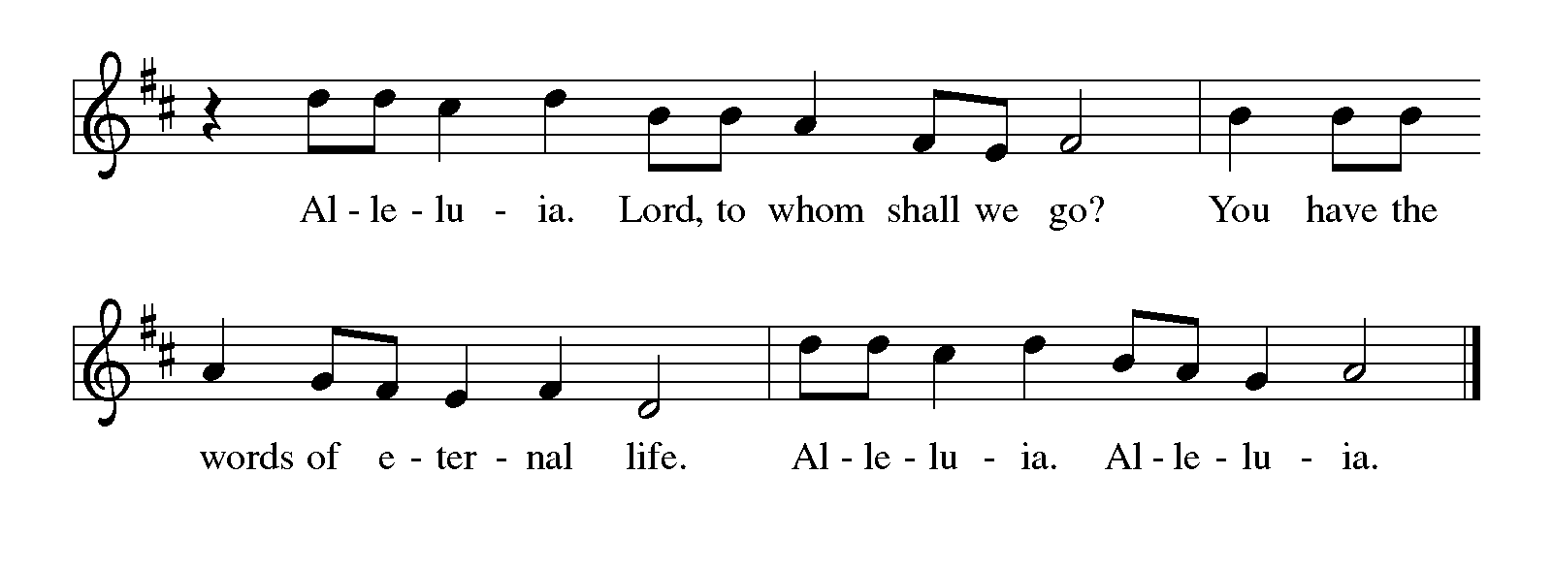THE HOLY GOSPEL Matthew 4:12-23

John the Baptist called everyone to repent, including the ruler Herod, who had him thrown in prison. It was at this point that Jesus began his public ministry, proclaiming the nearness of the reign of God.

P: The Holy Gospel according to St. Matthew, the fourth chapter.

C: Glory to You, O Lord!

Now when Jesus heard that John had been arrested, He withdrew to Galilee. ¹³He left Nazareth and made His home in Capernaum by the sea, in the territory of Zebulun and Naphtali, ¹⁴so that what had been spoken through the prophet Isaiah might be fulfilled:
¹⁵"Land of Zebulun, land of Naphtali,
on the road by the sea, across the Jordan, Galilee of the Gentiles--
¹⁶the people who sat in darkness
have seen a great light,
and for those who sat in the region and shadow of death
light has dawned."
¹⁷From that time Jesus began to proclaim, "Repent, for the kingdom of heaven has come near."
¹⁸As He walked by the Sea of Galilee, He saw two brothers, Simon, who is called Peter, and Andrew his brother, casting a net into the sea--for they were fishermen. ¹⁹And He said to them, "Follow Me, and I will make you fish for people."
²⁰Immediately they left their nets and followed Him. ²¹As He went from there, He saw two other brothers, James son of Zebedee and his brother John, in the boat with their father Zebedee, mending their nets, and He called them. ²²Immediately they left the boat and their father, and followed Him.
²³Jesus went throughout Galilee, teaching in their synagogues and proclaiming the good news of the kingdom and curing every disease and every sickness among the people.

P: The Gospel of the Lord.

C: Praise to You, O Christ!

The assembly is seated

THE SERMON

Silence for reflection follows the sermon

As you are able please rise

THE HYMN OF THE DAY 817 You Have Come Down to the Lakeshore

THE APOSTLES’ CREED

A: God has made us His people through our Baptism into Christ. Living together in trust
and hope, we confess our faith.

C: I believe in God, the Father Almighty,
Creator of heaven and earth.
I believe in Jesus Christ, His only Son, our Lord.
He was conceived by the power of the Holy Spirit,
and born of the Virgin Mary.
He suffered under Pontius Pilate,
was crucified, died, and was buried.
He descended into hell.
On the third day He rose again.
He ascended into heaven,
and is seated at the right hand of the Father.
He will come again to judge the living and the dead.
I believe in the Holy Spirit,
the holy catholic Church,
the communion of saints,
the forgiveness of sins,
the resurrection of the body,
and the life everlasting. Amen.

THE PRAYER OF THE CHURCH

A: Illumined by the light of Christ, united in the same mind and the same purpose, let us
for all nations, and for all in need of His healing presence.

A: That all Christians, divided and often ignorant of one another, may work to move
beyond the quarrels of the past to be unified in ministry and mission to the world, we
pray:

C: Send forth Your light, O God.

A: That nations and peoples overshadowed by the violence of war, terrorism, and ancient
hatreds may see the joyful dawning of peace, we pray:

C: Send forth Your light, O God.

A: That refugees from every country may be sustained in their fear and weariness, and that
agencies who provide food, shelter, and medical care, especially Lutheran Immigration
and Refugee Service may be Your face of compassion, we pray:

C: Send forth Your light, O God.

A: That our congregation, with its diverse gifts, may show to all in need the power of the
cross through our service and compassion, we pray:

C: Send forth Your light, O God.

A: That the sick, and those in need of our prayers, especially . . . may be filled with the
bright light of God’s healing, we pray:

C: Send forth Your light, O God.

A: That those celebrating birthdays, especially Eloise Ponder and Elaine Bogart may
grow in grace this day and every day and be filled with grace for the days ahead, we
pray:

C: Send forth Your light, O God.

A: That those who mourn, especially the family and friends of George Ottersen, who died
in the Lord this week may be comforted by the promise of resurrection to life
everlasting and of being reunited with those they love before the throne of the Lamb,
we pray:

C: Send forth Your light, O God.

A: That with all the saints, especially Agnes, martyr whom we commemorate this Day
we may one day rejoice before the glorious presence of God, we pray:

C: Send forth Your light, O God.

P: O God, You revealed Your will to prophets and sages. By Your Holy Spirit, show us
how to serve You today, that all nations may know You in our love, through Jesus
Christ our Lord.

C: Amen.
MEAL

THE PEACE

P: The peace of the Lord be with you always.

C: And also with you.

THE OFFERING

THE VOLUNTARY Down in the Valley to Pray Althouse

As you are able please rise

THE PRESENTATION OF THE GIFTS 312 Jesus, Come! For We Invite You
(Stanzas 1, 4)

THE OFFERTORY PRAYER
A: Let us pray. Gracious God,

C: In repentance and faith we bring these gifts to You. As Your Kingdom again
comes near to us in this holy Sacrament, by our eating and drinking, unite us with
the mind and purpose of Christ, that we may faithfully shine His light to all the
world. We ask this in the name of Jesus the Lord. Amen.

THE GREAT THANKSGIVING

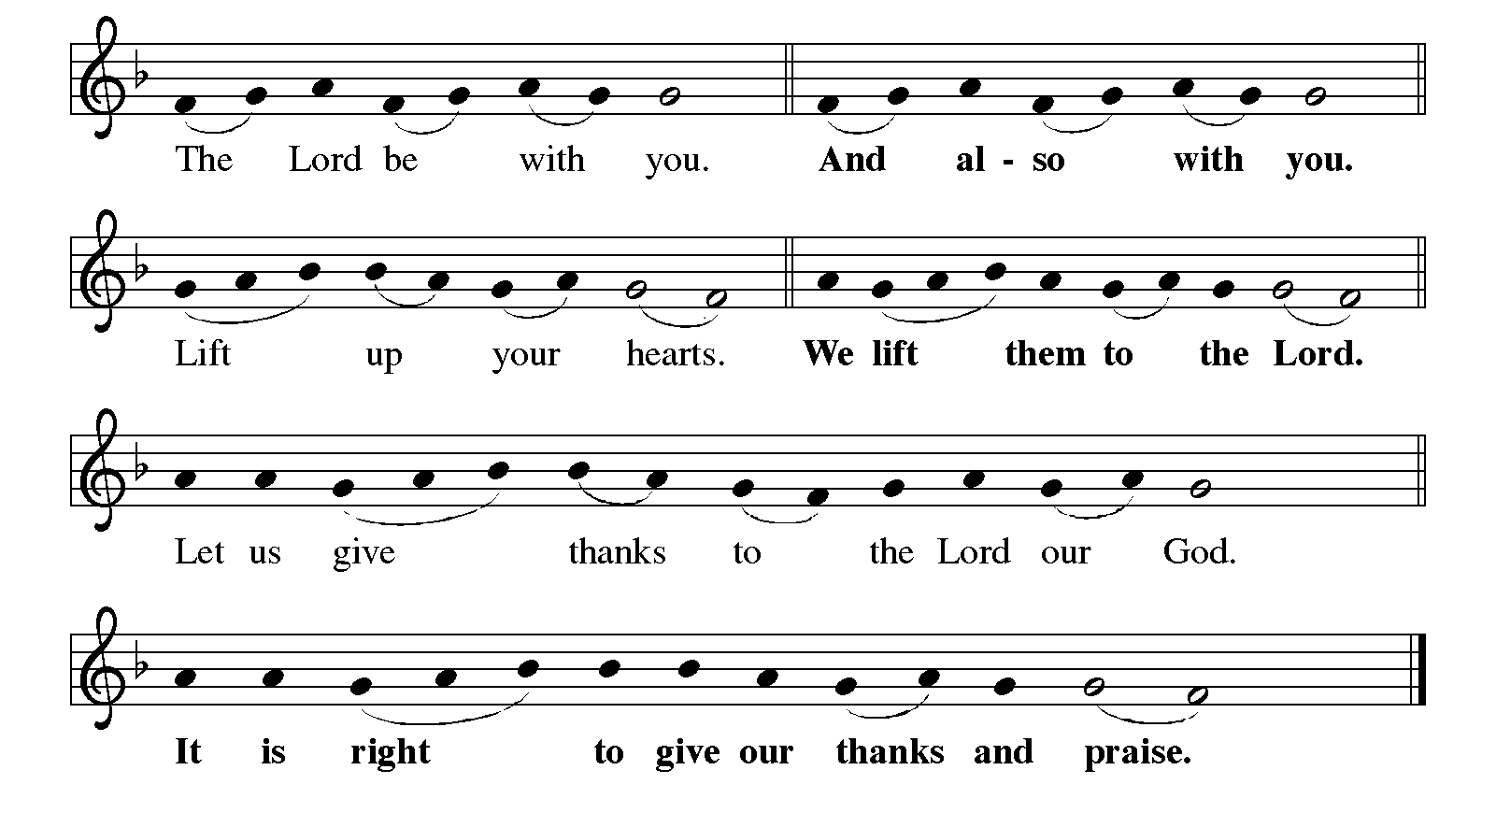

P: It is indeed right, our duty, and our joy …join their unending hymn:
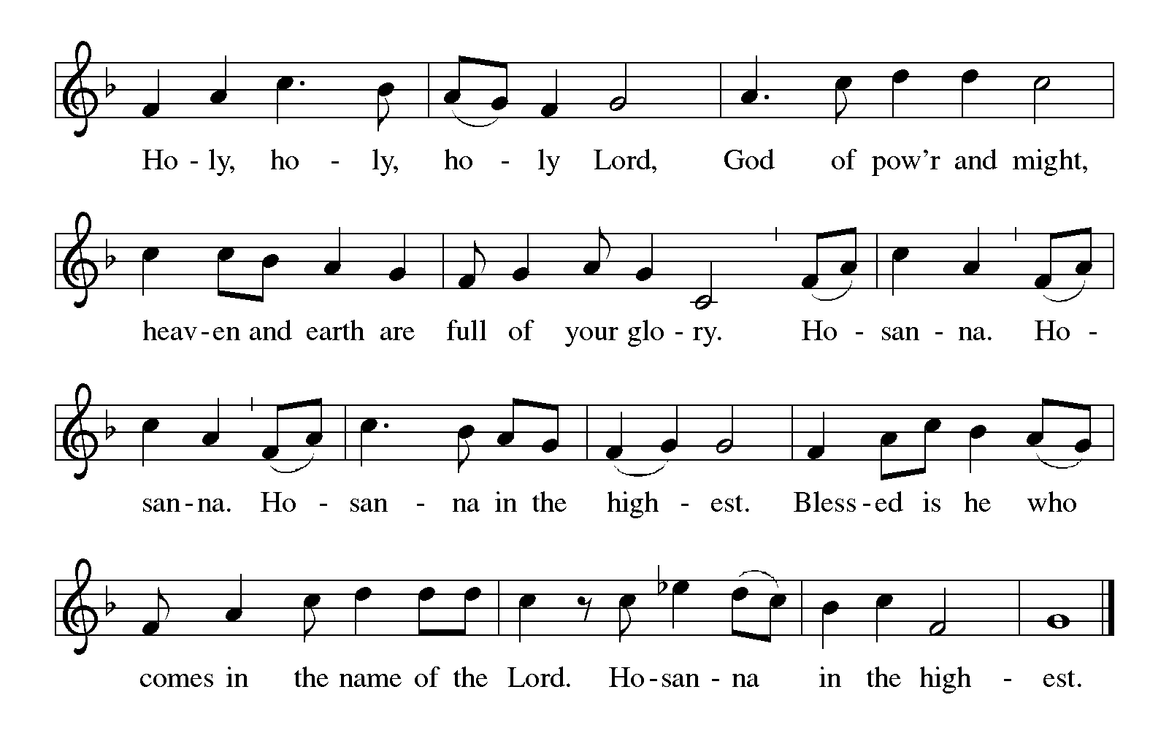
P: Worthy of praise and thanksgiving are You, Lord God, for You summoned all things
into being, and from the beginning You beckoned Your creation to fullness
of life in You.
Through covenant You claimed a people to share Your life; in slavery You called
them to freedom; in exile You summoned them to faithfulness; in their sin
You beckoned them toward Your Light.
From the first day until now You have called creation to share Your goodness.
In Christ You came seeking our salvation with Your very life, bidding us to come and
follow.
Our rejection of Him led to the horror of the cross, but You have drawn us to Yourself
forever through the glory of His resurrection.
Sustaining God, in You many become one.
You gathered fishermen from their nets to become apostles; just so You take grain
from the fields and grapes from the vine to make this holy Meal.
And now You gather us around this Table to remember the story of our redemption.
Make us one body.
Sustain us by the grace of the one Bread we share and one cup of blessing which we
bless.
Send Your Spirit upon this bread and wine that it may be for us the Body and Blood
of Christ;
Who, in the night ... “Do this for the remembrance of Me.”
As often as we eat ... we proclaim the Lord’s death until He comes.
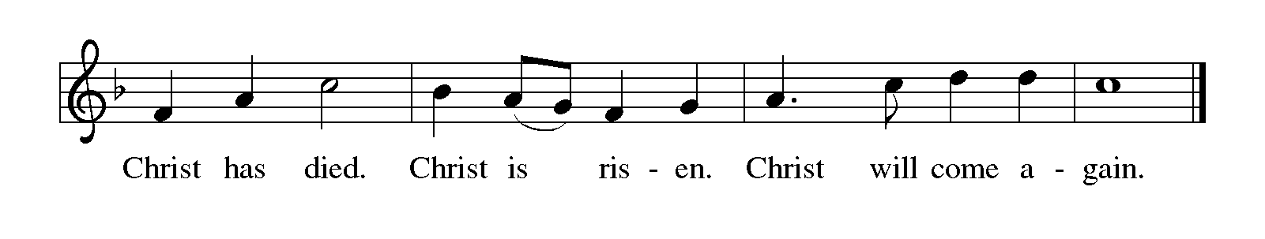
P: Generous God, in Christ You threw wide the net of Your grace, calling disciples one
by one to be Your followers; not in their own righteousness but because You
would have us be Your companions and share Your glory forever.
Reveal in Your Church the wideness of Your mercy.
Bless those today who wonder if they have strayed too far to be found by Your
or to belong among Your people.
Inspire all who struggle to know their purpose in Your Kingdom and long to hear
Your voice.
Beckon Your disciples to come and follow, to work alongside You, casting the
net of grace, until all are gathered and one in You, ever-seeking and
ever-saving God,
Father, Son, and Holy Spirit.
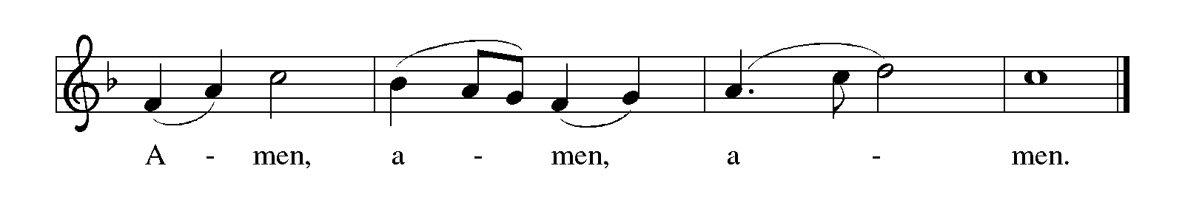
THE LORD’S PRAYER

P: Because in Christ we have received the Spirit of adoption, as daughters and sons of
God, we dare to pray:

C: Our Father in heaven, hallowed be Your name. Your Kingdom come. Your will
be done on earth as in heaven. Give us this day our daily bread, and forgive us
our sins as we forgive those who sin against us. Save us from the time of trial
and deliver us from evil, for the Kingdom, the power, and the glory are Yours,
now and forever. Amen.

INVITATION TO THE MEAL

P: Behold the true Light of the world, the Beloved of God, anointed by the Spirit. Blessed
are those who are called to the Supper of the Lamb. God’s holy gifts for God’s holy
people. Come, for all is now ready.

The assembly is seated

THE DISTRIBUTION

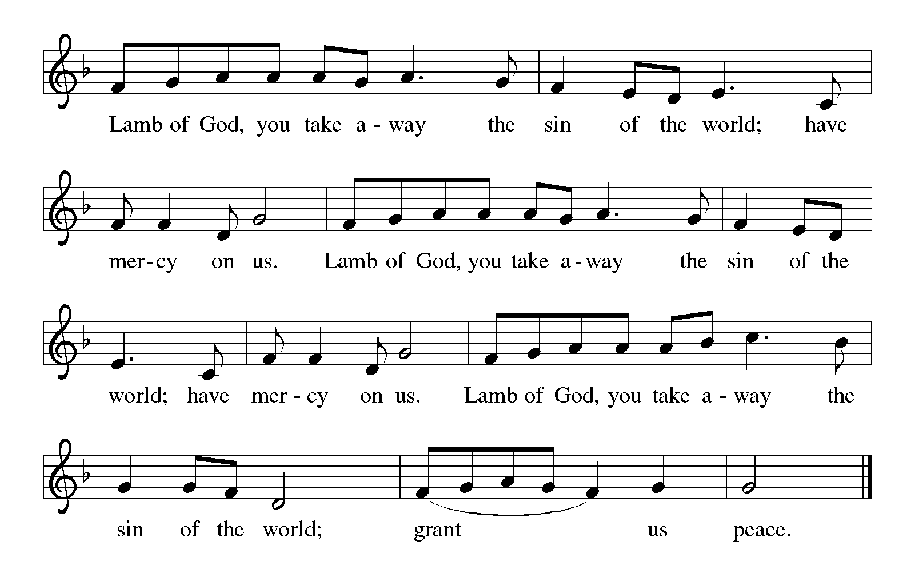

HYMN DURING DISTRIBUTION 574 Here I Am, Lord
NSB 84 The Potter’s Hand
NSB 40 God of the Poor
NSB 77 Seek Ye First
As you are able please rise

THE POST-COMMUNION BLESSING

P: The Body and Blood of our Lord Jesus Christ strengthen you and keep you in His grace.

C: Amen.

THE POST-COMMUNION PRAYER

A: Let us pray. Gracious God, our hands have taken holy things; our lives have been
nourished by the Body and Blood of Your Son. Increase our joy and faith, that we may
be strengthened for service in Your world. Grant this through Christ our Lord.
C: Amen.
SENDING

THE BENEDICTION

P: Almighty God: Father, Son, and Holy Spirit bless you now and forever.

C: Amen.

SENDING HYMN SONG 715 Christ, Be Our Light

THE DISMISSAL
A: You are servants of God; you are light to the nations.
Go in peace. Serve the Lord.

C: Thanks be to God!

To God Alone Be Glory

The Meditation is from Words for Worship. Copyright Augsburg Fortress 2001.

The Prayers, Introduction to the Lord’s Prayer, and Invitation to the Meal are adapted from
Prayers for Sundays and Seasons. Year A. Peter J. Scagnelli. (Chicago: Liturgy
Training Publications, 1998) 27-28.

The Post-Communion Prayer is also adapted from The Book of Alternative Services.
(Toronto: Anglican Book Centre, 1985) 231.

The Eucharistic Prayer is adapted from Eucharistic Prayers. Samuel Wells and Abigail
Kocher. (Grand Rapids: Eerdmann’s Publishing Company, 2016) 84-85.

ANNOUNCEMENTS

Please remember to mail your offering to the Church Office at 818 Franklin Street, Michigan City, IN 46360. Another alternative is to give on-line through Tithe.ly. Please see your closure letter for information on how to set up a Tithe.ly account.

St. Paul Members are reminded to have a loved one contact the office if you are hospitalized. Many times, the Pastor doesn’t know someone is in the hospital. If you call and leave a message, please tell us which hospital the patient is at.

Next Saturday’s lessons are: Micah 6: 1-8; Psalm 15; 1 Corinthians 1: 18-31; and Matthew 5: 1-12 for those of you who like to study them in advance.

Birthdays: Wayne Simerlein (1/25); Elaine Bogart (1/28); Eloise Ponder (1/28)

PRAYER CONCERNS: Audrey Beyer, Ryan Krueger, Donna Bostater, Maxine Powell, Jim Tomscheck, Eloise Ponder, Mark & Jary Tannehill, Marvin Dirks, Leonard Cross, Margie Torres, Dan Pursely, Jayla Jacobi and Barbara Reichert.

OFFICE HOURS: Libby will be in the office on Mondays, Wednesdays, and Fridays; volunteers will cover Tuesdays and Thursdays.

Monday & Wednesday 8:00 a.m. – 5 p.m.
Tuesday & Thursday 9:00 a.m. – 12:00 p.m.
Friday 8:00 a.m. – 12:00 p.m.

If you are listening to the worship broadcast on the radio and would like to watch the Sunday morning service live stream follow these steps:
(1) If you have You.Tube available on your TV, search for
St. Paul Lutheran Church Michigan City, IN.

(2) The direct link on the computer is
https://www.youtube.com/channel/UC5AIPNaKr3QN50984jGOa1g.

(3) This link is also on the main page of the church’s website in the church sec-
tion and will continue to be posted weekly on the St. Paul Facebook page.

And it will always be available on the radio broadcast Sunday mornings at 11:00 a.m. on WEFM (95.9), and on the local cable access station #99 for the previous week’s service on Sundays at 4:00 p.m. and the current service on Wednesdays at 7:00 p.m. and Fridays at 8:30 p.m.
Warren Schacht has generously offered to convert audio tapes and cassettes to CD’s and VHS tapes to DVDs at no charge! He is currently converting our church audio tapes/cassettes and has extended the offer to anyone who is interested in updating their material. You may call him directly at: 219-448-1444 or email him at: w.schacht230@comcast.net. Thank you, Warren!

To send e-mail to the church office, please use the following addresses:

Pastor Mark Reshan: seniorpastor@stpaulmichigancity.com

Church Office Secretary (Libby Pollock): churchsecretary@stpaulmichigancity.com

Church Treasurer (Karen Fleming): finance@stpaulmichigancity.com

The Good News Newsletter: If you have an article or anything you want included in The Good News please send it to the following e-mail address: splcgoodnews@gmail.com. Pastor Pamela Thiede will be using this e-mail address to assemble The Good News each month. The deadline for getting information to Pastor Pamela will be the 20th of each month.

WORSHIP ATTENDANCE for January 14 and January 15, 2023
4:00 p.m. 29
9:00 a.m. 81
TOTAL 110

A Reminder

The discussion group “Estuary” led by Pastor Dale Zylstra meets the second Tuesday of the month in the Luther House at 7:00 p.m. The group addresses topics of interest to the participants and is open to everyone.

In an effort to save money on postage: yearly donation state-ments have been emailed to those members who have email. Any members without email will find your statements in your hanging file folder in the Narthex. If you are unable to attend church please let the church office know so we can send your statement through the regular mail.

ACTIVITIES, EVENTS & MEETINGS
January 2023

Sunday, January 22, 2023 at 9:00 a.m. Worship Service

Monday, January 23, 2023 at 4:00 p.m. Finance Committee Mtg./Luther House

at 5:30 p.m. Executive Board Mtg./Luther House

Wednesday, January 25, 2023 at 9:45 a.m. Bible Study/Luther House

at 10:00 a.m. God’s Purls/St Paul Room

Thursday, January 26, 2023 at 5:00 p.m. Ann. Plan.Comm. Mtg./Luther House

At 5:30 p.m. Church Council Mtg./St. Paul Room

Saturday, January 28, 2023 at 4:00 p.m. Worship Service

Sunday, January 29, 2023 at 9:00 a.m. Worship Service

